**ASSIGNMENT || SQL_DAY_3**

**HARSHIT KUSHMAKAR_16896**

Aggregate Functions:

**1. Find out what is the total LPP(Late Penalty Charges) amount charged for a given period**

**(from to date).**

select * from LMS_REPAYSCH_DTL_Kushmakar;

SELECT SUM(PENALTY_CHARGES) as TOTAL_LPP FROM LMS_REPAYSCH_DTL_Kushmakar where installment_due_date between '10-MAR-2022' and '10-NOV-23';

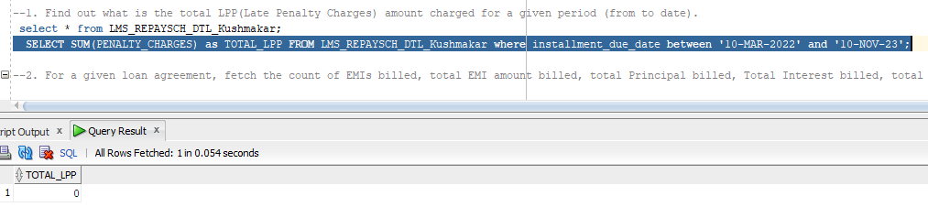

**2. For a given loan agreement, fetch the count of EMIs billed, total EMI amount billed, total**

**Principal billed, Total Interest billed, total Principal paid, total interest paid.**

SELECT count(AGREEMENT_ID) "EMIs billed ",sum(INSTALLMENT_AMOUNT)"EMI amount billed",

sum(PRINCIPAL_COMPONENT ) "total principal billed",sum(INTEREST_COMPONENT) "total interest billed",

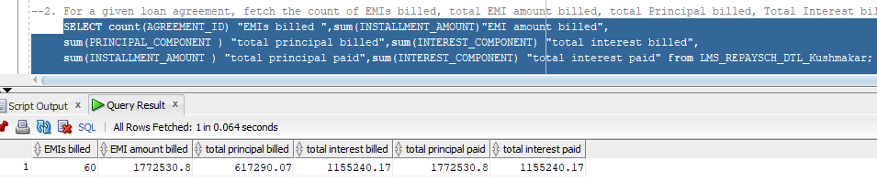 sum(INSTALLMENT_AMOUNT ) "total principal paid",sum(INTEREST_COMPONENT) "total interest paid" from LMS_REPAYSCH_DTL_Kushmakar;

**3. Find the count of all payments which has been made through Cash.**

SELECT * from LMS_CHEQUE_DTL_Kushmakar;

SELECT count(*) from LMS_CHEQUE_DTL_Kushmakar where PAYMENT_MODE = 'C';

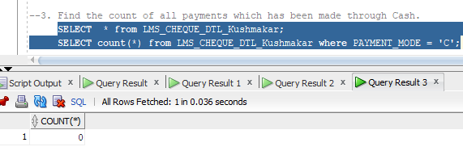

**4. Find the count of All Pending instalments for a particular LoanAgreement.**

SELECT count(AGREEMENT_ID) from LMS_REPAYSCH_DTL_Kushmakar where installement_due_date>(select sysdate “date” from dual);

**5. Find the count of all Active Loans.**

SELECT * from LMS_AGRE_DTL_Kushmakar;

SELECT count(Lessee_ID) from LMS_AGREEMENT_DTL_Kushmakar where loan_disbursal_date>(select sysdate from dual);

**6. Find the sum of all the amounts of the loans being taken by a particular Customer given the**

**customer_id.**

SELECT sum(A.loan_Amount) from LMS_CUSTOMER_kushmakar C join LMS_AGREEMENT_DTL_Kushmakar A on C.CUSTOMER_ID = A.Lessee_Id group by A.Lessee_Id;

**7. Find the sum of all the amounts of the loans being taken by every Customer.**

SELECT sum(Loan_Amount) from LMS_AGREEMENT_DTL_Kushmakar group by Lessee_Id;

**--8. Display the minimum and maximum ROI from the LMS_Agreement_DTL table**

SELECT min(ROI), max(ROI) from LMS_AGREEMENT_DTL_Kushmakar;

**--9. Find the sum of advice amount being generated in a particular month**

SELECT * FROM LMS_TXN_ADVICE_DTL_Kushmakar;

SELECT sum(ADVICEAMT) FROM LMS_TXN_ADVICE_DTL_Kushmakar group by to_char(ADVICEDATE), ('month');

**--10. Find the avg of total interest billed in a particular month.**

**Joins:**

**-- 1. For a given Customer, fetch all the loans being taken by that Customer. Return Customer Name, Product Name, Product Category, Loan Amount, Loan Disbursal Date and Repayment Frequency.**

select C.First_Name,P.Product_Name,P.Product_Category,A.Loan_Amount,A.Loan_Disbursal_Date,

A.Repayment_Frequency from LMS_CUSTOMER_Kushmakar C

join LMS_AGREEMENT_Kushmakar A on C.Customer_Id=A.Lessee_ID join

LMS_Product_Kushmakar P on A.Product_Code=P.Product_Code;

**--2. For a given Loan agreement, fetch all the advices generated to date. Return Agreement ID,Customer Name, Advice ID, Advice date, Payment or Receipt, Advice Amount, Paid to date.**

SELECT

A.Agreement_ID,C.First_Name,T.Txn_Advice_ID,T.ADVICEDATE,P.Payment_ID,T.ADVIC

EAMT,P.Payment_Date FROM

LMS_AGREEMENT_Kushmakar A

JOIN LMS_CUSTOMER_Kushmakar C ON A.lessee_id=C.Customer_Id

JOIN LMS_TXN_ADVICE_Kushmakar T ON T.CASE_ID=A.Agreement_ID

JOIN LMS_PAYMENT_Kushmakar P ON P.Txn_Advice_ID=T.Txn_Advice_ID

WHERE Agreement_ID='&AGR_ID';

**--3. For a given receipt cheque Number, please find out the advices which have been settled with it.**

SELECT * FROM LMS_TXN_ADVICE_Kushmakar T

JOIN

LMS_PAYMENT_Kushmakar P ON P.Txn_Advice_id=T.TxnAdviceid

JOIN

LMS_CHEQUE_Kushmakar C ON P.Cheque_Id=C.Cheque_Id

WHERE Cheque_Num='&Cheque_Num';

**--4. Find out how many payments have been made by a customer against a given Agreement ID**

SELECT COUNT(*) FROM

LMS_AGREEMENT_Kushmakar A

JOIN LMS_TXN_ADVICE_Kushmakar T ON a.agreement_id =T.caseid

JOIN LMS_PAYMENT_Kushmakar P ON t.TxnAdviceid=p.txn_advice_id

WHERE A.Agreement_ID='&AGR_ID';

**--5. For a given loan agreement, get the count and total payments amount received by payment mode (Cheque, Cash…).**

SELECT COUNT(*),SUM(C.Cheque_Amount) FROM

LMS_AGREEMENT_Kushmakar A

JOIN LMS_TXN_ADVICE_Kushmakar T ON a.agreement_id =t.caseid

JOIN Lms_payment_Kushmakar P ON t.txnadviceid=p.txn_advice_id

JOIN LMS_CHEQUE_Kushmakar C ON p.cheque_id=c.cheque_id

WHERE A.Agreement_ID='&AGR_ID'

AND c.Payment_Mode='C' OR c.Payment_Mode='Q';

**--6. For a given loan, get the total count and amount of payments received from the customer that have bounced.**

SELECT COUNT(*),SUM(C.Cheque_Amount) FROM

LMS_AGREEMENT_Kushmakar A

JOIN LMS_TXN_ADVICE_Kushmakar T ON a.agreement_id =t.caseid

JOIN lms_payment_Kushmakar P ON t.txnadviceid=p.txn_advice_id

JOIN LMS_CHEQUE_Kushmakar C ON p.cheque_id=c.cheque_id

WHERE A.Agreement_ID='&AGR_ID'

AND c.status='B';

**--7. Get the count and total payments amount received by payment mode (Cheque, Cash…) for all the Loan Agreements.**

SELECT COUNT(*),SUM(C.Cheque_Amount) FROM

LMS_AGREEMENT_Kushmakar A

JOIN LMS_TXN_ADVICE_Kushmakar T ON a.agreement_id =t.caseid

JOIN lms_payment_Kushmakar P ON t.txnadviceid=p.txn_advice_id

JOIN LMS_CHEQUE_Kushmakar C ON p.cheque_id=c.cheque_id

WHERE c.Payment_Mode='C' OR c.Payment_Mode='Q';

**--8. For a given Customer find out the total number of installments which had not been paid for all the loans being taken by that Customer.**

**--9. For a given Customer, find out how many loans the Customer has taken are Asset based. Return the Customer Name, Product Name and Loan Amount.**

**--10. Get the total Installment amount billed to date.**

Select SUM(installment_amount) from lms_repaysch_Kushmakar r

where r.installment_due_date <= '&date';

**--11. Write a query to find out those customers who have paid all the instalments on time.**

SELECT c.customer_id,

c.first_name,

c.last_name,

a.lessee_id

FROM LMS_CUSTOMER_Kushmakar c

JOIN LMS_AGREEMENT_Kushmakar a ON C.Customer_Id=a.lessee_id

JOIN LMS_REPAYSCH_Kushmakar R ON R.Agreement_ID=A.Agreement_ID

JOIN LMS_TXN_ADVICE_Kushmakar T ON A.Agreement_ID=T.CaseId

JOIN LMS_PAYMENT_Kushmakar P ON T.TxnAdviceid=P.Txn_Advice_id

WHERE P.Payment_Date <=R.Installment_Due_Date;

**--12. For a given loan agreement id, find out the details of the product. Return Product name, max_tenure, min_tenure, asset based, secured/Unsecured loan.**

SELECT p.Product_Name,p.Max_Tenure,p.Min_Tenure,pc.Asset_Based,pc.secured_loan

from LMS_PRODUCT_Kushmakar p

join LMS_AGREEMENT_Kushmakar a on p.product_code = a.product_code

join LMS_PRODUCT_CATEGORY_Kushmakar pc on p.Product_Category=pc.Category_ID

where a.agreement_id= '&agreement_id';

**--13. Given a PropInstID, find out the loan agreement details of that PropInstID.**

select * from LMS_AGREEMENT_Kushmakar ag join LMS_REPAYSCH_Kushmakar r on ag.Agreement_ID

=r.Agreement_ID where r.PropInstID='&PropInstID';

**--14. Display a report of all the installments of a particular loan agreement id. Return loan amount, installment amount, principal component, interest component.**

select Loan_Amount,Installment_Amount,Prinicipal_Component,Interest_Component from

LMS_AGREEMENT_Kushmakar ag join LMS_REPAYSCH_Kushmakar r on

ag.Agreement_ID=r.Agreement_ID where

ag.Agreement_ID= '&Agreement_ID';

**--15. Write a query to find out who all customers have taken the home loan.**

Select * from LMS_CUSTOMER_Kushmakar c

join LMS_AGREEMENT_Kushmakar a

on c.customer_id=a.lessee_id

where a.agreement_id like '%Home%';