**Assignment: SQL Day-4**

**HARSHIT KUSHMAKAR | 16896**

**Subqueries:**

**1. Create a query to display the Customer Name and Date of Birth of all the Customers who are**

**younger than Customer ‘David’.**

SELECT FIRST_NAME, DATE_OF_BIRTH From LMS_CUSTOMER_Kushmakar where

DATE_OF_BIRTH > (select DATE_OF_BIRTH FROM LMS_CUSTOMER_Kushmakar where FIRST_NAME = 'Divya');

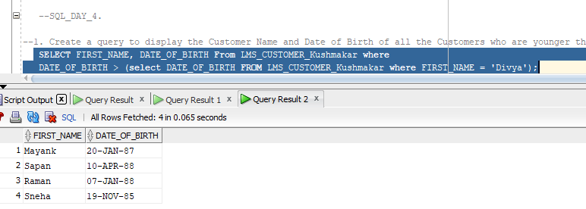

**2. Find out all the Customers who have more than 1 loan. Return Customer name and number**

**of loans.**

SELECT FIRST_NAME from LMS_CUSTOMER_Kushmakar

WHERE CUstomer_ID = (Select Lessee_ID from LMS_AGREEMENT_DTL_Kushmakar group by Lessee_ID having count(*)>1);

**3. Find out all the customers who have more than 1 loan of tenure greater than 5 years and**

**repayment frequency is Quarterly. Return Customer Name, Product Name, Loan Disbursal**

**Date and Loan Amount.**

**4. Write a query to display the customer id, customer first name of all customers whose**

**designation is same as any customer whose last name contains a ‘U’.**

SELECT CUstomer_id,First_Name from LMS_CUSTOMER_Kushmakar

where Designation = any(Select designation From LMS_CUSTOMER_Kushmakar where last_name like '%u%');

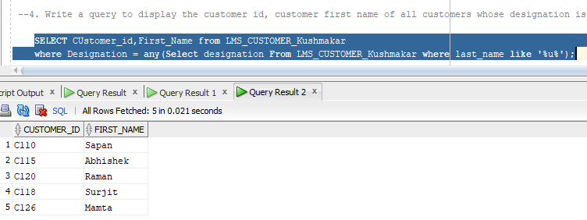

**5. Write a query to fetch all the loan details whose disbursal date is greater than the disbursal**

**date of the loans being taken by a Customer ‘David’.**

SELECT * FROM LMS_AGREEMENT_DTL_Kushmakar WHERE LOAN_Disbursal_Date>(select Loan_Disbursal_Date from LMS_AGREEMENT_DTL_Kushmakar

where Lessee_ID = (Select Customer_Id from LMS_CUSTOMER_kushmakar where First_NAME='puneet'));

**6. Write a query to fetch all the loan details whose loan amount is greater than the average of**

**loan amounts being disbursed till date sorted descending.**

SELECT * FROM LMS_AGREEMENT_DTL_Kushmakar

WHERE Loan_Amount >(select avg (Loan_Amount) from LMS_AGREEMENT_DTL_Kushmakar) order by loan_Disbursal_Date desc;

**7. Write a query to find all the customers who took all products (all loan types available).**

**8. Write a query to fetch those loans where loan amount exceeds everyone’s credit limit.**

SELECT Lessee_ID, AGREEMENT_ID FROM LMS_AGREEMENT_DTL_Kushmakar

WHERE Loan_Amount>ALL (select Monthly_Income from LMS_CUSTOMER_Kushmakar);

**9. Write a query to fetch those customers whose monthly expenses are greater than average**

**monthly expenses of all customers.**

SELECT FIRST_NAME from LMS_CUSTOMER_kushmakar

Where Total_Monthly_Expense> (select avg(Total_Monthly_Expense) from LMS_CUSTOMER_Kushmakar);

**10. Write a query to find out those customers who have paid the least penalty charges on the**

**Installments.**

SELECT FIRST_NAME from LMS_CUSTOMER_kushmakar where Customer_Id in (select Lessee_ID from LMS_AGREEMENT_DTL_Kushmakar

where AGREEMENT_ID in(select AGREEMENT_ID from LMS_REPAYSCH_DTL_Kushmakar

where Penalty_Charges in (select least (penalty_Charges) from LMS_REPAYSCH_DTL_Kushmakar)));

**Views:**

**1. Create a view on LMS_CHEQUE_DTL table based on Cheque_num, deposit_date,**

**cheque_amount, payment_mode and status. Change the column names to ‘Cheque**

**Number’, ‘Date’, ‘Amount’, and ‘Mode’ respectively. Name the view as ChequeDetails_VU.**

create view Cheque_view_Kushmakar as

select Cheque_num "Cheque_number" , deposit_date "Date" , cheque_amount "Amount", payment_mode "Mode" ,status

from LMS_CHEQUE_DTL_Kushmakar;

**2. Confirm that the view works. Display only the Cheque number and Date from the above**

**View.**

Select "Cheque_number", "Date" from Cheque_View_kushmakar;

**3. Create a view which take care of all the Loan Agreements of HOME LOAN Type only. Name**

**the view as HOME_LOAN_VU. Confirm that the view works.**

Create view HOME_LOAN_Vu_Kushmakar as

select * from LMS_AGREEMENT_DTL_Kushmakar where Agreement_Id like '%Home';

select * from HOME_LOAN_VU_Kushmakar;

**4. Create a view which displays all the Loans being taken by the Customers. The view contains**

**Customer Name, Product Name, Loan Amount, Disbursal Date and instalment amount.**

**Customer name should contain both First name and last name.**

**5. Confirm that the view works.**

SELECT * from CUSTOM_Loan_kushmakar;

**6. Create a view based on Customer name and count of all the loans being taken by the**

**Customer whose repayment frequency is Monthly.**

create view CUSTOM_LOAN_VU_KUshmakar as select C.First_Name, A.Agreement_Id as "COUNT"

from LMS_AGREEMENT_DTL_Kushmakar A join LMS_CUSTOMER_Kushmakar C on C.Customer_Id =

A.Lessee_Id where Repayment_Frequency = 'M';

**7. Confirm that the view works.**

Select * from CUSTOM_LOAN_VU_Kushmakar;

**8. Create a view based on Product Name, sum of total pending instalments sorted descending.**

**9. Create a view based on Customer Name, Gender, Contact number, Profession, Monthly**

**income and monthly expense.**

create view CUSTOM_view_Kushmakar as select First_Name , Gender, Contact_Number, profession,

Monthly_Income,Total_Monthly_expense from LMS_CUSTOMER_Kushmakar;

**10. Check whether the above view is updatable or not. If not, why?**

