**Assignment: SQL Day-1**

**HARSHIT KUSHMAKAR | 16896**

**DDL (Data Definition Language):**

**CREATE TABLE LMS_CUSTOMER_M_kushmakar(**

**Customer_ID VARCHAR(20) NOT NULL,**

**First_Name VARCHAR(20) NOT NULL,**

**Last_Name VARCHAR(20),**

**Gender VARCHAR(1) NOT NULL,**

**Date_Of_Birth DATE NOT NULL,**

**Contact_Number VARCHAR(10) NOT NULL,**

**Email_Address VARCHAR(40) NOT NULL,**

**Monthly_Income NUMBER(8,2) NOT NULL,**

**Profession VARCHAR(40),**

**Total_Monthly_Expense NUMBER(8,2) NOT NULL,**

**Designation VARCHAR(40),**

**Company_Name VARCHAR(40)**

**);**

****SELECT * FROM LMS_CUSTOMER_M_kushmakar;**

**--2. Create the table LoanProductCategory based on the following instance chart.**

CREATE TABLE LMS_PRODUCT_CATEGORY_M_kushmakar(

category_ID VARCHAR(10) NOT NULL,

Category_Name VARCHAR(50) NOT NULL,

Asset_Based VARCHAR (1) NOT NULL check(Asset_based IN('Y','N')),

Description VARCHAR(150),

SecuredLoan VARCHAR(2) NOT NULL, check(securedLoan in('S','US'))

);

***SELECT * FROM LMS_PRODUCT_CATEGORY_M_kushmakar;***



**--3. Create the table LoanProduct based on the following instance chart.**

CREATE TABLE LMS_Product_M_kushmakar(

Product_Code VARCHAR(20) NOT NULL,

Product_Name VARCHAR(100) NOT NULL,

Product_Description VARCHAR(200),

Product_Category VARCHAR(10) NOT NULL,

Max_Tenure Number(2),

Min_Tenure Number(2)

);

***SELECT * FROM LMS_Product_M_kushmakar;***



**--4 Create the table Loan_Agreement based on the following instance chart.**

CREATE TABLE LMS_AGREEMENT_DTL_kushmakar(

Agreement_ID VARCHAR(20) NOT NULL,

Lessee_ID VARCHAR(100) NOT NULL,

Tenure Number(2),

ROI NUMBER(3,1),

Loan_Amount NUMBER(10,2),

Repayment_Frequency VARCHAR(2),

Loan_Disbursal_Date DATE,

Status VARCHAR(10),

Product_Code VARCHAR(20) NOT NULL,

Constraint chk1234Kush check(Repayment_Frequency IN('M','Y','Q','HY')),

Constraint chk12345Kush check(Status IN('Pending','Approved', 'Rejected', 'Active', 'Closed'))

);



***SELECT * FROM LMS_AGREEMENT_DTL_kushmakar;***

**--5. Create the table EMI_Schedule**

CREATE TABLE LMS_REPAYSCH_DTL_kushmakar(

Agreement_id Varchar(20)NOT NULL,

PropInstID Number(8) GENERATED BY DEFAULT AS IDENTITY,

Installment_Amount Number(8,2)NOT NULL,

Installment_Number Number(3) NOT NULL,

Principal_Component Number(8,2) NOT NULL,

Interest_ComponentNumber Number(8,2) NOT NULL,

Balance_Principal_Amount Number(8,2)NOT NULL,

Penalty_Charges Number(8,2),

Installment_Due_Date Date NOT NULL

);

***SELECT * FROM*** LMS_REPAYSCH_DTL_kushmakar***;***

**--6. Create the table Transaction_Type.**

CREATE TABLE LMS_TXNTYPE_M_kushmakar(

Txn_Type VARCHAR(20) Not Null,

Description VARCHAR(100),

Constraint chk12345Kush1 check(Txn_Type IN('Installment', 'LPP '))

);



***SELECT * FROM* LMS_TXNTYPE_M_kushmakar*;***

**--7. Create the table Advice.**

CREATE TABLE LMS_TXN_ADVICE_DTL_kushmakar(

Txn_Advice_ID Number(8) GENERATED BY DEFAULT AS IDENTITY,

Adviceamt Number(8,2) Not Null,

AdviceDate Date Not Null,

Case_Id Varchar(20),

TxnID Number(8) Not Null,

TxnType Varchar(20) Not Null

);

***SELECT * FROM LMS_TXN_ADVICE_DTL_kushmakar;***



**--8. Create the table Payment.**

CREATE TABLE LMS_CHEQUE_DTL_kushmakar(

Cheque_Id NUMBER(8) GENERATED BY DEFAULT AS IDENTITY,

Payment_Mode VARCHAR(1) NOT NULL,

Cheque_Num VARCHAR(50) NOT NULL,

Cheque_Date DATE,

Cheque_Amount NUMBER(10,2), Drawn_On_Bank VARCHAR(50),

Deposit_Date DATE, 

Status VARCHAR(1)

check(Status IN('C' ,'D' ,'X' ,'R')),

check(Cheque_Num IN('Instrument')),

check(Payment_Mode IN('C','Q','D','T'))

);

***SELECT * FROM LMS_CHEQUE_DTL_kushmakar;***

***--9. Create the table Receipt_Allocation.***

CREATE TABLE LMS_PAYMENT_DTL_kushmakar(

Payment_ID Number(8) unique not null,

Cheque_ID Number(8) unique not null,

Payment_Date Date NOT NULL,

Status Varchar(1) NOT NULL check(Status IN('c','N')),

Txn_Advice_Id Number(8)NOT NULL

);

**10. select table_name from user_tables;**

**11. Alter the tables to add the primary key as per the below given chart Primary Key Reference Name Table Name Column Name:-**

ALTER TABLE LMS_CUSTOMER_M00

ADD CONSTRAINT LMS_CUSTOMER_M00_PK PRIMARY KEY (Customer_ID);

ALTER TABLE LMS_PRODUCT_CATEGORY_M_kushmakar

ADD CONSTRAINT LMS_PRODUCT_CAT_M_kushmakar_PK PRIMARY KEY (Category_ID);

ALTER TABLE LMS_PRODUCT_M_kushmakar

ADD CONSTRAINT LMS_PRODUCT_M_kushmakar_PK_ PRIMARY KEY (Product_Code);

ALTER TABLE LMS_AGREEMENT_DTL_kushmakar

ADD CONSTRAINT LMS_AGREEMENT_DTL_kushmakar_PK PRIMARY KEY (Agreement_ID);

ALTER TABLE LMS_REPAYSCH_DTL_kushmakar

ADD CONSTRAINT LMS_REPAYSCH_DTL_kushmakar_PK PRIMARY KEY (PropInstID);

ALTER TABLE LMS_TXN_ADVICE_DTL_kushmakar

ADD CONSTRAINT LMS_TXNTYPE_M_kushmakar_PK PRIMARY KEY (TxnType);

ALTER TABLE LMS_TXN_ADVICE_DTL_kushmakar

ADD CONSTRAINT LMS_TXN_ADVICE_DTL_kushmakar_PK PRIMARY KEY (Txn_Advice_ID);

ALTER TABLE LMS_CHEQUE_DTL_kushmakar

ADD CONSTRAINT LMS_CHEQUE_DTL_kushmakar_PK PRIMARY KEY (Cheque_ID);

ALTER TABLE LMS_PAYMENT_DTL_kushmakar

ADD CONSTRAINT LMS_PAYMENT_DTL_kushmaka_PK PRIMARY KEY (Payment_ID);

**--12. Alter the tables to add the foreign keys as per the below given chart**

Alter table LMS_Product_M_kushmakar

ADD CONSTRAINT LMS_Product_Cat_FK_kushmakar

FOREIGN KEY (Product_Category) REFERENCES LMS_Product_Category_M_kushmakar (Category_ID);

Alter table LMS_Agreement_DTL_kushmakar

ADD CONSTRAINT LMS_Agreement_Dtl_FK1_kushmakar

FOREIGN KEY (Lessee_ID) REFERENCES LMS_Customer_M_kushmakar(Customer_ID);

Alter table LMS_Agreement_DTL_kushmakar

ADD CONSTRAINT LMS_Agreement_Dtl_FK2_kushmakar

FOREIGN KEY (Product_Code) REFERENCES LMS_Product_M_kushmakar (Product_Code);

Alter table LMS_Repaysch_DTL_kushmakar

ADD CONSTRAINT LMS_Repaysch_DTL_FK_kushmakar

FOREIGN KEY (Agreement_Id) REFERENCES LMS_Agreement_DTL_kushmakar (Agreement_Id);

Alter table LMS_TXN_ADVICE_DTL_kushmakar

ADD CONSTRAINT LMS_TXN_ADVICE_DTL_FK1_kushmakar

FOREIGN KEY (TxnType) REFERENCES LMS_TXNTYPE_M_kushmakar (Txn_Type);

Alter table LMS_TXN_ADVICE_DTL_kushmakar

ADD CONSTRAINT LMS_TXN_ADVICE_DTL_FK2_kushmakar

FOREIGN KEY (Case_Id) REFERENCES LMS_AGREEMENT_DTL_kushmakar (Agreement_id);

Alter table LMS_TXN_ADVICE_DTL_kushmakar

ADD CONSTRAINT LMS_TXN_ADVICE_DTL_FK3_kushmakar

FOREIGN KEY (TxnId) REFERENCES LMS_REPAYSCH_DTL_kushmakar (PropInstID);

Alter table LMS_PAYMENT_DTL_kushmakar

ADD CONSTRAINT LMS_Payment_Dtl_FK1_kushmakar

FOREIGN KEY (Cheque_Id) REFERENCES LMS_CHEQUE_DTL_kushmakar(Cheque_id);

Alter table LMS_PAYMENT_DTL_kushmakar

ADD CONSTRAINT LMS_Payment_Dtl_FK2_kushmakar

FOREIGN KEY (Txn_Advice_Id) REFERENCES LMS_TXN_ADVICE_DTL_kushmakar(Txn_Advice_id);

**--13. Modify the Customer table to allow for longer Customer Last Names. Confirm your modification.**

ALTER TABLE LMS_CUSTOMER_M00 MODIFY last_Name VARCHAR(30) NOT NULL;

**--14. Create the table Customer2 based on the structure of Customer table. Include only the Customer_id, first_name, email_address, profession, monthlyIncome. Name the columns in your new table as ID, NAME, EMAIL, PROFESSION, INCOME.**

CREATE TABLE CUSTOMER_kushmakar(

ID VARCHAR(20)NOT NULL,

NAME VARCHAR(20)NOT NULL,

EMAIL VARCHAR(40)NOT NULL,

PROFESSION VARCHAR(40),

INCOME NUMBER(8,2)

);



**--15. Drop the table Customer2;**

**drop table CUSTOMER_kushmakar;**



**--16. Query the recycle bin to see whether the table is present.**

SELECT *FROM RECYCLEBIN WHERE ORIGINAL_NAME ='CUSTOMER_kushmakar';

**--17. Undrop the table Customer2.**

FLASHBACK TABLE CUSTOMER_kushmakar TO BEFORE DROP;

**--18. Drop the column FIRST_NAME from the Customer2 table. Confirm your modification by checking the description of the table.**

ALTER TABLE CUSTOMER_Kushmakar

DROP COLUMN NAME;

SELECT* FROM CUSTOMER_KUSHMAKAR;

DML (Data Manipulation Language):

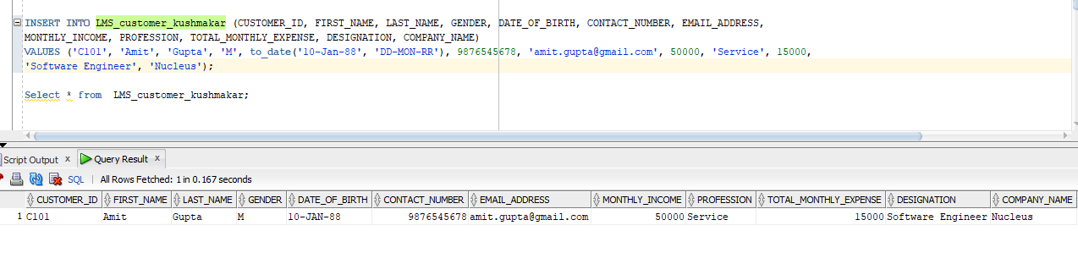--1.**Create an INSERT statement to add the first row of the data in the Customer table being created. Do not list the columns in the INSERT Clause. Do not enter all rows yet.**

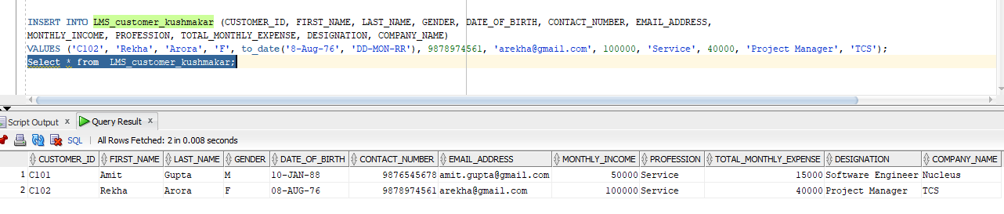**--2. Populate the CUSTOMER table with the second row of sample data from the preceeding list. This time, list the columns explicitly in the INSERT clause**

**--3) Confirm your addition to the table.**



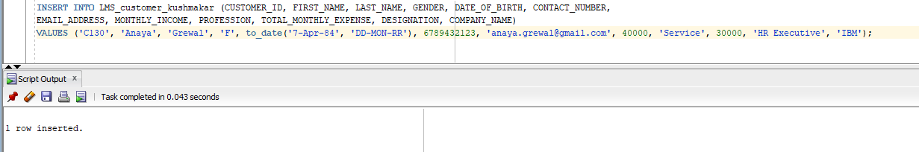**--4) Write an insert statement in a dynamic reusable script file named loadcust.sql to load rows into the CUSTOMER table. Save this script to a file named lab_01_04.sql.**

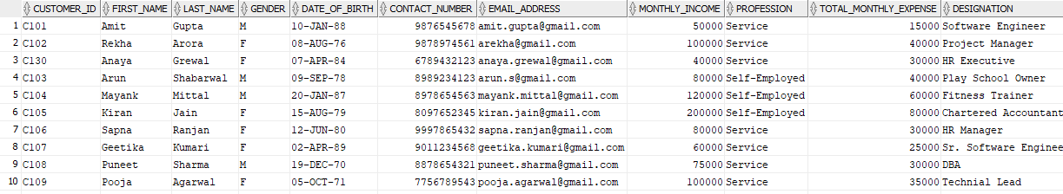**5) Populate the table with the next 10 rows of sample data by running the insert statement in the script that you created in Step 4.**

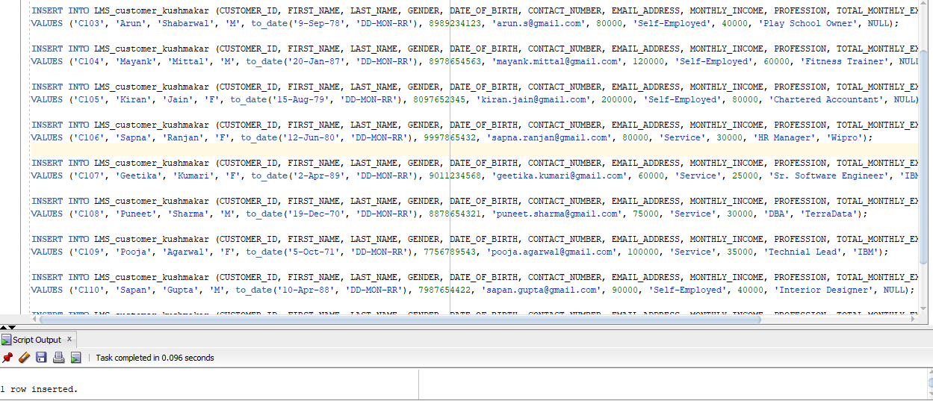

**6) Populate the table with the remaining rows of sample data using the excel file.**

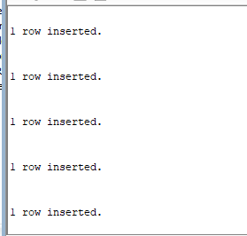

**7) Confirm your additions to the table.**

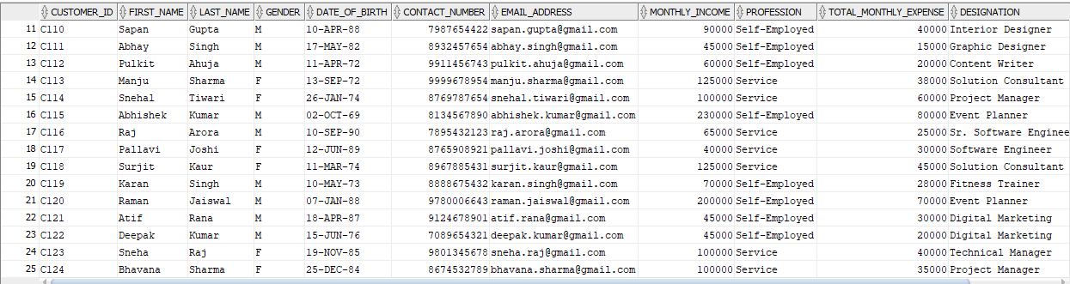

**8. Make the data additions permanent.**

**--9. In the same manner, insert the rows in the rest of the tables.**

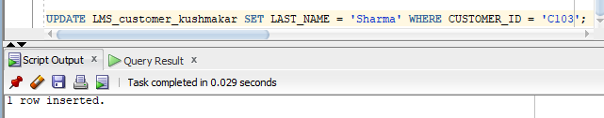**--10) Change the last name of the Customer 3 to ‘Sharma’.**

**11. Change the Profession, designation and Company Name of Customer 4 to ‘Service’ , ‘Asst Manager’ , ‘Wipro’ respectively.** 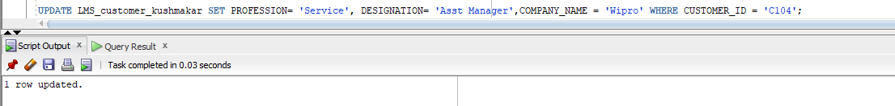

**12) Delete the customer whose monthly income is less than 40000.**

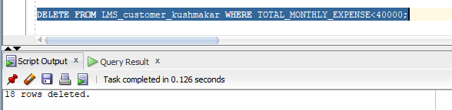

13) Delete the Loans from LoanAgreement table whose disbursal date is before 2000.



14) Commit all pending changes.

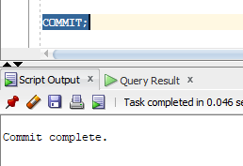

**Control Data Transactions:**

15. In the Customer table, insert two more rows from the sample data listed in Step by using the

statements in the script that you created in Step. Run the statement in the script

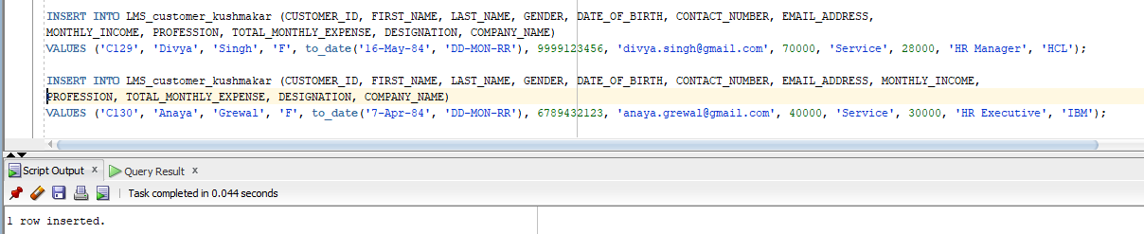

16. Mark an intermediate point in the processing of the transaction

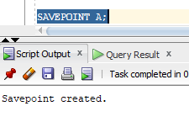

17. Empty the entire table

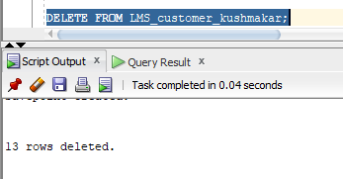

18. Confirm that the table is empty

19. Discard the most recent DELETE without discarding the earlier INSERT operations.

20. Confirm that the new row is still intact

21. Make the data addition permanent

