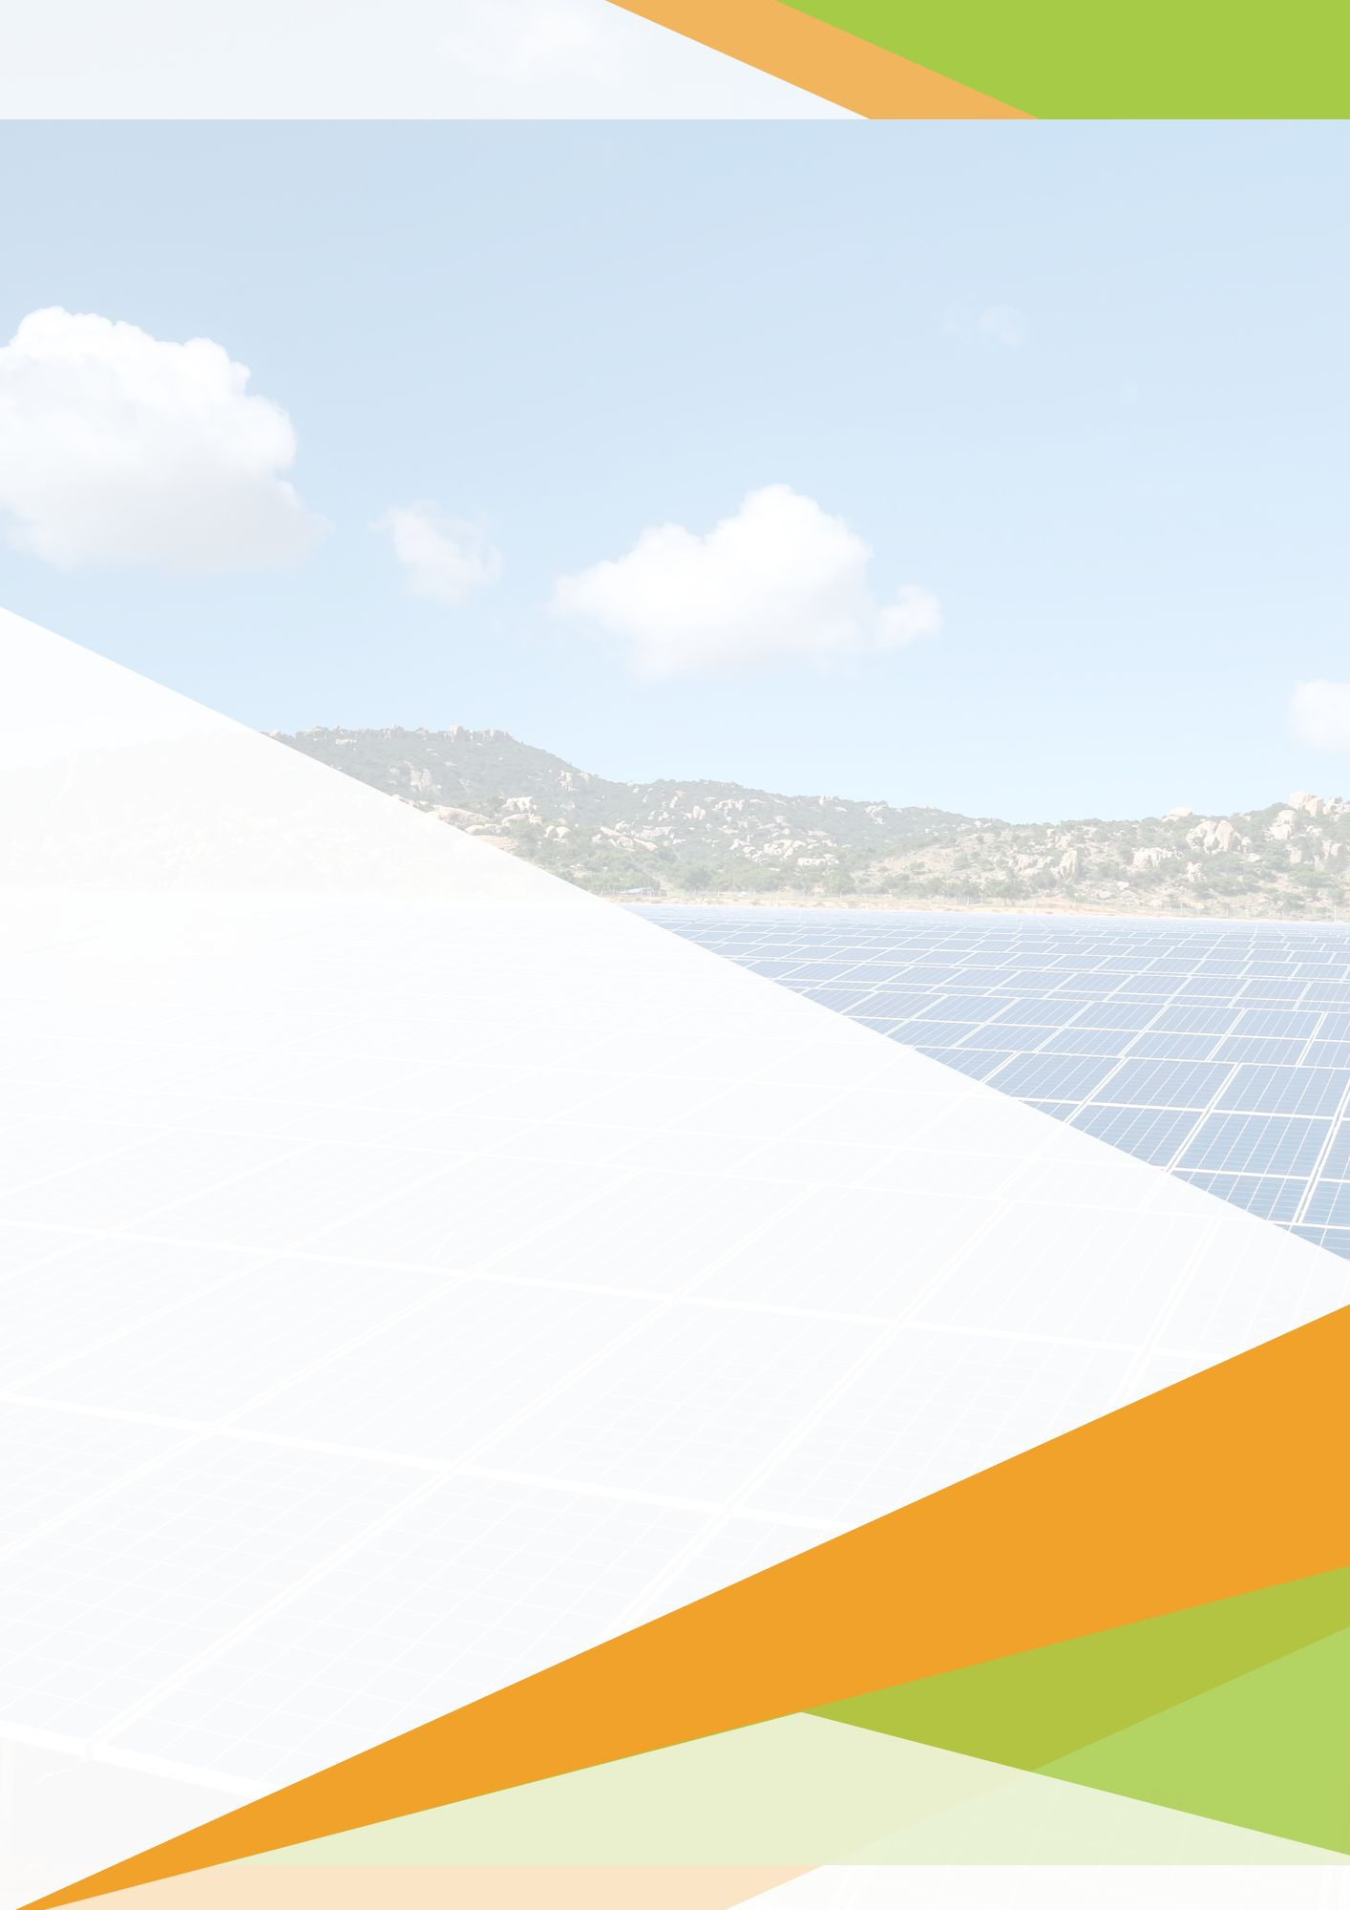

**Ref No:** {reference}  
**Date:** {date}

**{projectSize} (kW)   
Solar Proposal**

**Prepared For:**

{customerName},  
{customerPhone},  
{customerAddress}.

**Prepared By:**{companyPoc},{companyName},  
{companyPhone},  
{companyAddress}.

# Welcome

**Ref. No.:** {reference}

**Date:** {date}

To,  
**{customerName},**  
{customerAddress}.  
  
**Sub:** Proposal for Supply & Installation of **{projectSize} (kW)** Grid Connected Solar PV Power Plant.

With reference to above said subject, we are very much thankful to you for showing your interest in our service. Based on the information provide by you, we are pleased to quote our offer for supply & Installation of Grid Connected Solar PV Power Plant.

Inter-connected with the electric utility grid or the meters, these systems are also called ‘GridTie Systems’. The DC power is converted into AC power by an inverter. These systems allow users to mobilize the energy provided by the Sun and feed the left overs to the grid which helps in cutting down costs. During the evening or in the absence of sunlight, power can be drawn from the grid, thus eliminating the need for battery banks.

**The benefits include:**

* Limitless power supply which is free of cost.
* Net metering in ‘Grid-Tie Systems’ helps in calculating exported surplus power to the grid which contributes to a reduction in your electricity bill.
* It is easy to maintain and low on operation investments.

Thanks & Regards,

**{companyPoc}**

{companyPhone}

{companyName}

# On Grid Solar PV Systems (Diagram for reference)

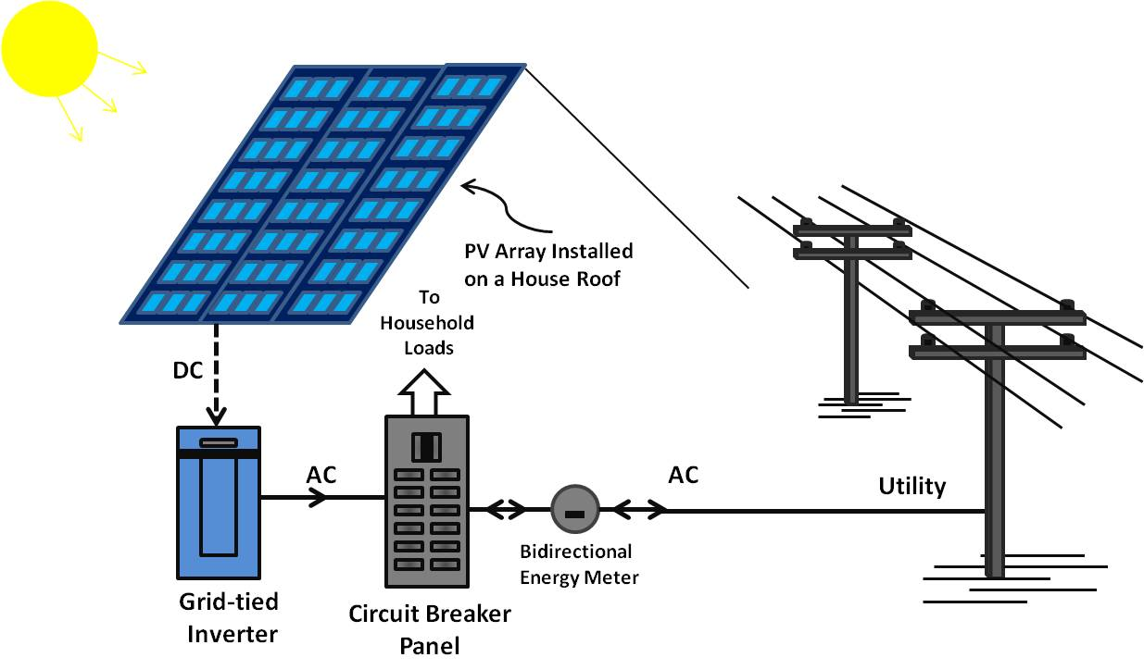

Why **{companyName}** !!

* We are MNRE Approved EPC
* Free Walk-Through Energy Audit.
* Customized solutions that work for you.
* Net-metering & Tax Deprecation Support.
* Assistance for Government Subsidy.
* Prompt Service Supports.
* Transparent Business.
* Monitoring system.

**Solar Components:**

* PV Module / Panel
* Module Mounting Structure
* Cables
* AC & DC Distribution Box
* Solar Grid-tied Inverter
* AC Distribution Box
* Earthing System

# Bills of Material

**Panel:**

Watt Peak: {wattPeak}   
Panel Qty: {noOfPanels} Nos

Make/Brand: {panelBrand}  
Panel Type: {panelType}

**Inverter:**

Size: {projectSize} (kW)  
Quantity: {quantity} Nos

Make/Brand: {inverterMake}  
Phase: {phase}

**Cable: Warranty:**

Make/Brand: {cableMake}  
AC Cable: {ac}  
DC Cable: {dc}

Panel: {panelWarranty}  
Inverter: {inverterWarranty}  
Balance Of System: {bosWarranty}

**Structure:**

Description: {structureDes}

**Balance of System:**

{#all}

{text}

{/all}

|  |  |
| --- | --- |
| **BOS Warranty** | **{bosWarranty}** |

# Solar Savings & Payback Period

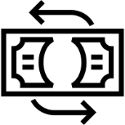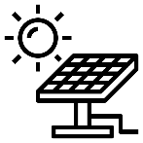

Payback  
Period

**{payBackPeriod} Years**

Average Yearly Generation

**{totalYearly} Units**

Average Annual  
Savings

**Rs. {solarSavings}**



Project Cost

**Rs. {costToCust}**

Trees Saved

**{treeSaved} Trees**

Co2 Reduction

**{co2Reduction} Tones**



# Expected Monthly Generation & Savings

|  |  |  |
| --- | --- | --- |
| Months | Generation (Units) | Savings (Rs.) |
| January | {january_generation} | {january_savings} |
| February | {february_generation} | {february_savings} |
| March | {march_generation} | {march_savings} |
| April | {april_generation} | {april_savings} |
| May | {may_generation} | {may_savings} |
| June | {june_generation} | {june_savings} |
| July | {july_generation} | {july_savings} |
| August | {august_generation} | {august_savings} |
| September | {september_generation} | {september_savings} |
| October | {october_generation} | {october_savings} |
| November | {november_generation} | {november_savings} |
| December | {december_generation} | {december_savings} |

# Commercial Offer & Payment Schedule

Price Quote & Payment schedule for **{projectSize} (kW)** Grid Tie Rooftop Solar System:

|  |  |  |  |  |
| --- | --- | --- | --- | --- |
| **Description** | **Price** | **GST Rate** | **GST** | **Total Price** |
| System Price | {systemPrice} | {gstRate}% | {gstPrice} | {totalPrice} |
| Additional Charges | {addCharges} |  |  | {addCharges} |
| Net meter liaising charges | {netLia} |  |  | {netLia} |
| **Cost to Customer** | | | | {costToCust} |
| MNRE Subsidy | {subsidy} |  |  | {subsidy} |
| **Effective Price After Subsidy** | | | | {effPrice} |
|  | | | | |  |

**Payment Terms:**

{#paymentTerms}

{text}

{/paymentTerms}

**Payment Mode:** {paymentMode}

**Bank Details:**

{#companyBankDetails}

{text}

{/companyBankDetails}

# Project Timeline

# Scope of Work

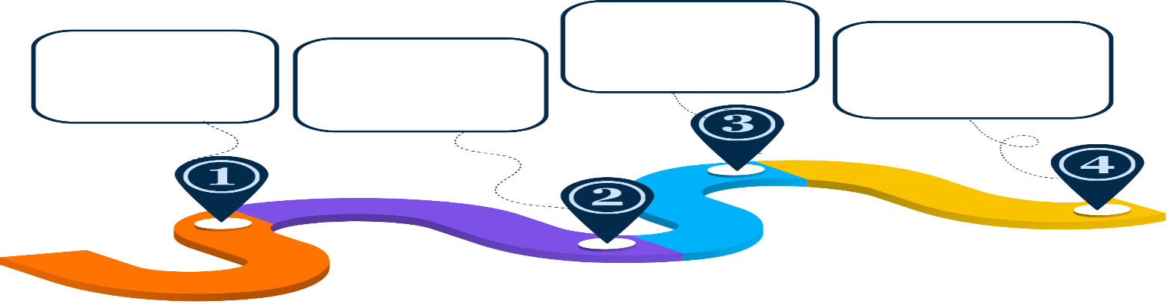

Finalization of Design and Drawings

Engineering, Procurement, and Supply of Material

Solar Plant Installation

Commissioning and Testing

**7 Days**

**15 Days**

**20 Days**

**14 Days**

|  |
| --- |
| **Our Scope** |
| {#ourScopeDetails}  {text}  {/ourScopeDetails} |

|  |
| --- |
| **Customer Scope** |
| {#customerScopeDetails}  {text}  {/customerScopeDetails} |

# General Terms & Conditions

{#companyTermsConditions}

{text}

{/companyTermsConditions}

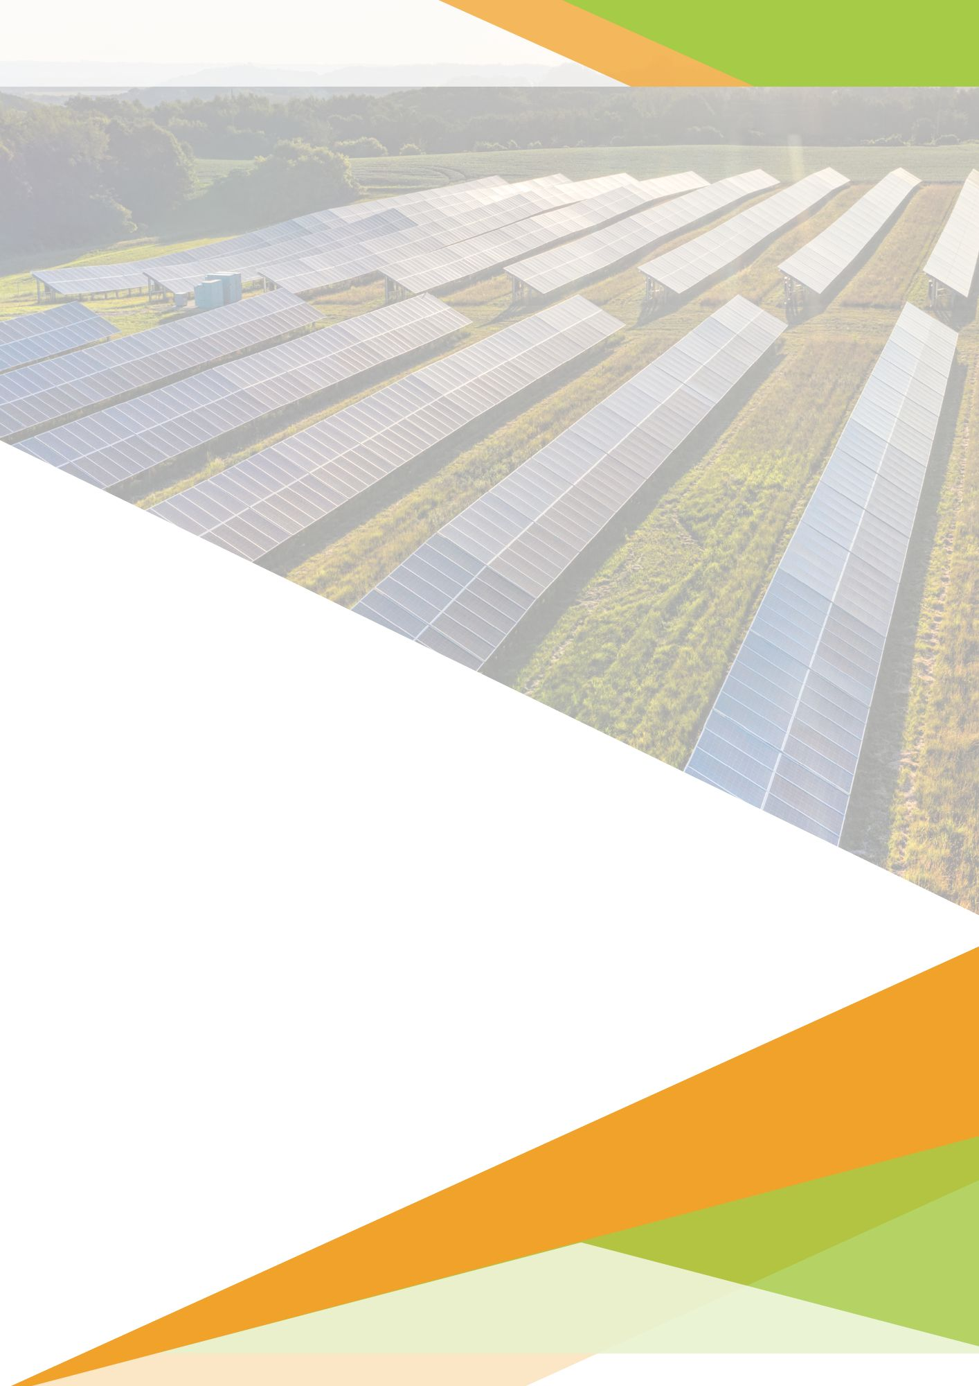



**Thank You!**

For Further Inquiries Connect with us at:

**Address:** {companyAddress}

**Phone:** {companyPhone}

**Mail:** {companyMail}

**GSTIN:** {companyGst}