**Functional Requirements**

1. User Registration:

1. Users can register themselves by providing their personal details(e.g name, ph no, password, etc).

2. View All Centers:

1. Users can view a list of all fitness centers available.
2. Users can see each centre’s details i.e centre’s name, location, available slots.

3. View Gym Availability:

1. Users can check the availability of slots for a specific fitness center on a particular day.
2. Our system Would display the available slots along with the number of remaining seats for each slot.

4. Booking a Slot:

1. Users can book a workout slot for a specific fitness center, date, and time slot if seats are available.
2. A user's booking should be confirmed only if there are sufficient seats in the selected slot.
3. If a user successfully books a slot, our system will update the seat availability for that slot.
4. If a user attempts to book multiple slots for the same time slot, the old booking for that time slot will be automatically removed.
5. If we have no availability in a particular slot, the user will have a waitlist status.
   1. Available status options -> confirmed/waitlist/canceled

6. Prevent Overbooking:

1. Our system will prevent overbooking of slots at any fitness center.
2. If a user tries to book a slot that is already fully booked, an error message will be displayed.(bonus)

7. View User's Plan(Bonus):

1. Users should be able to view their workout plan based on the selected day and fitness center. Like their History which Includes Present & Past Bookings.
2. The plan should display the user's booked slots and any slots they are on the waiting list for.

8. Slot Cancellation(Bonus):

1. Users should have the option to cancel their booked slots.
2. When a user cancels a slot, our system should update seat availability and promote the next user on the waiting list if applicable.

—----------------------------------------------------------------------------------

**Non - Functional Requirements**

* Code Should be modular
* It Should follow Design Principles like SOLID
* Code Design Should be Extensible

—----------------------------------------------------------------------------------

**Actors & their Roles**

In the FlipFit system, there are several actors who interact with the application. Here are the identified actors:

1. **Users / Gym Users**: The primary actor in the system who interacts with the application.

Users can register, view fitness centers, check slot availability, book slots, view their plans, cancel bookings, and receive notifications.

**2.** **FlipFit System/ Super Admin**: An administrative user with special privileges who can onboard new users and new Fitness Centers.It will also Help in Auto Assigning and Giving the confirmed seats to the Waitlisted Candidates. input and manage slot information, manage fitness center details, and oversee the system's operation.

**3. Gym Owner/ Fitness Center :** Input slot information, Manage fitness center details, and provide facilities to our Valuable Customers..

—----------------------------------------------------------------------------------

**UML Diagrams**

**Use Case Diagram : -**

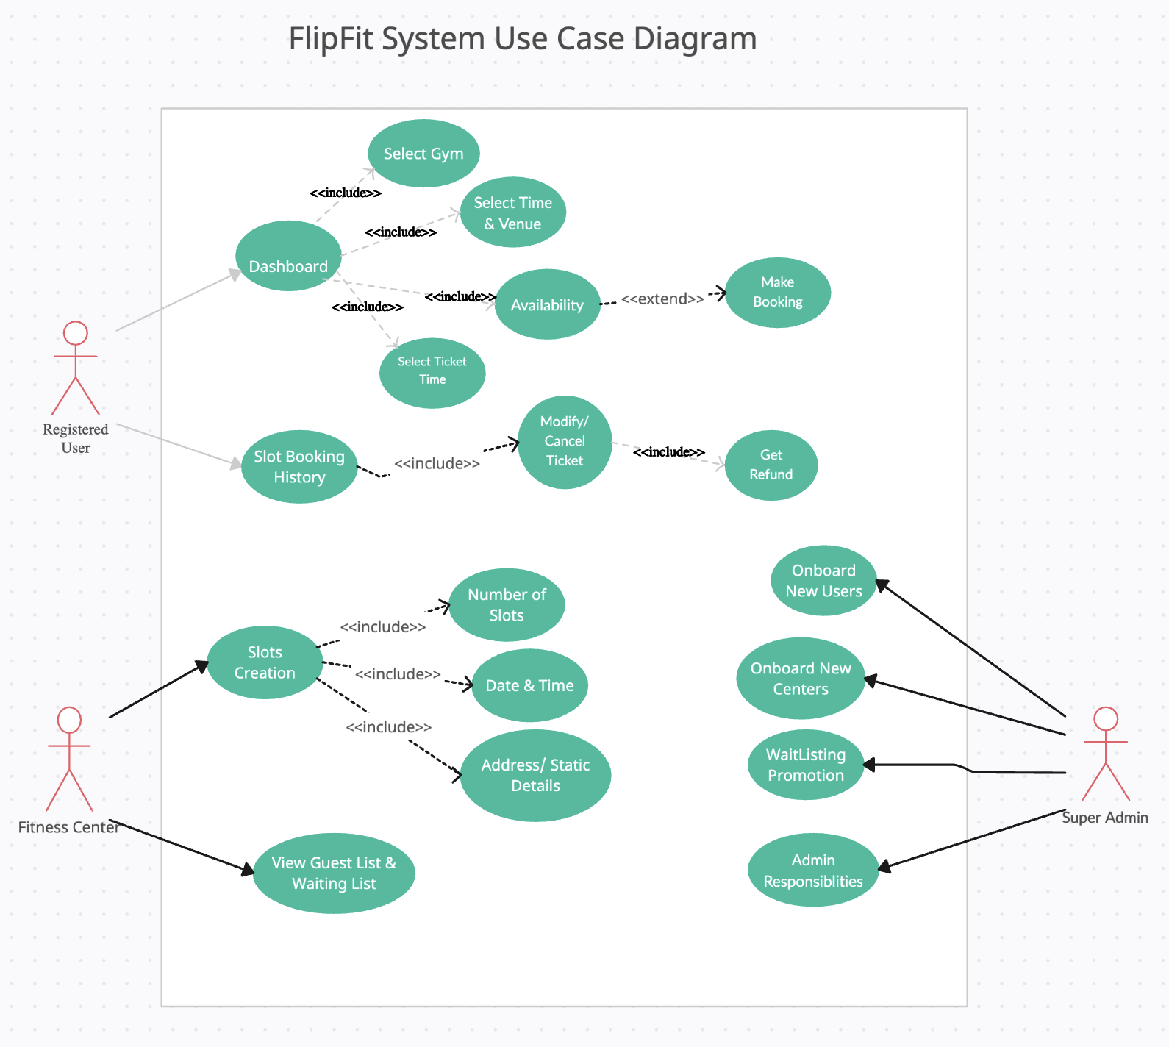

**Activity Diagram :-**

1. **Gym Owner Activity Diagram**

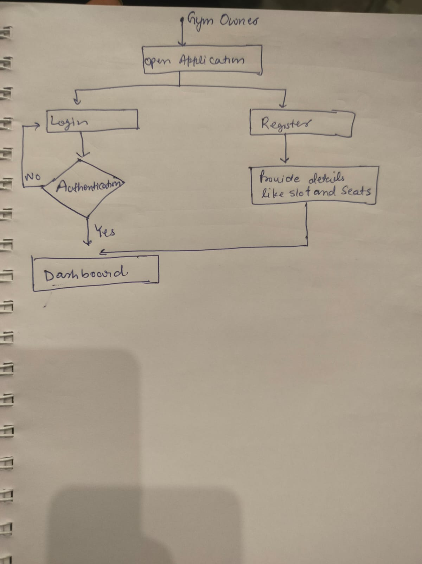

**B. User Activity Diagram**

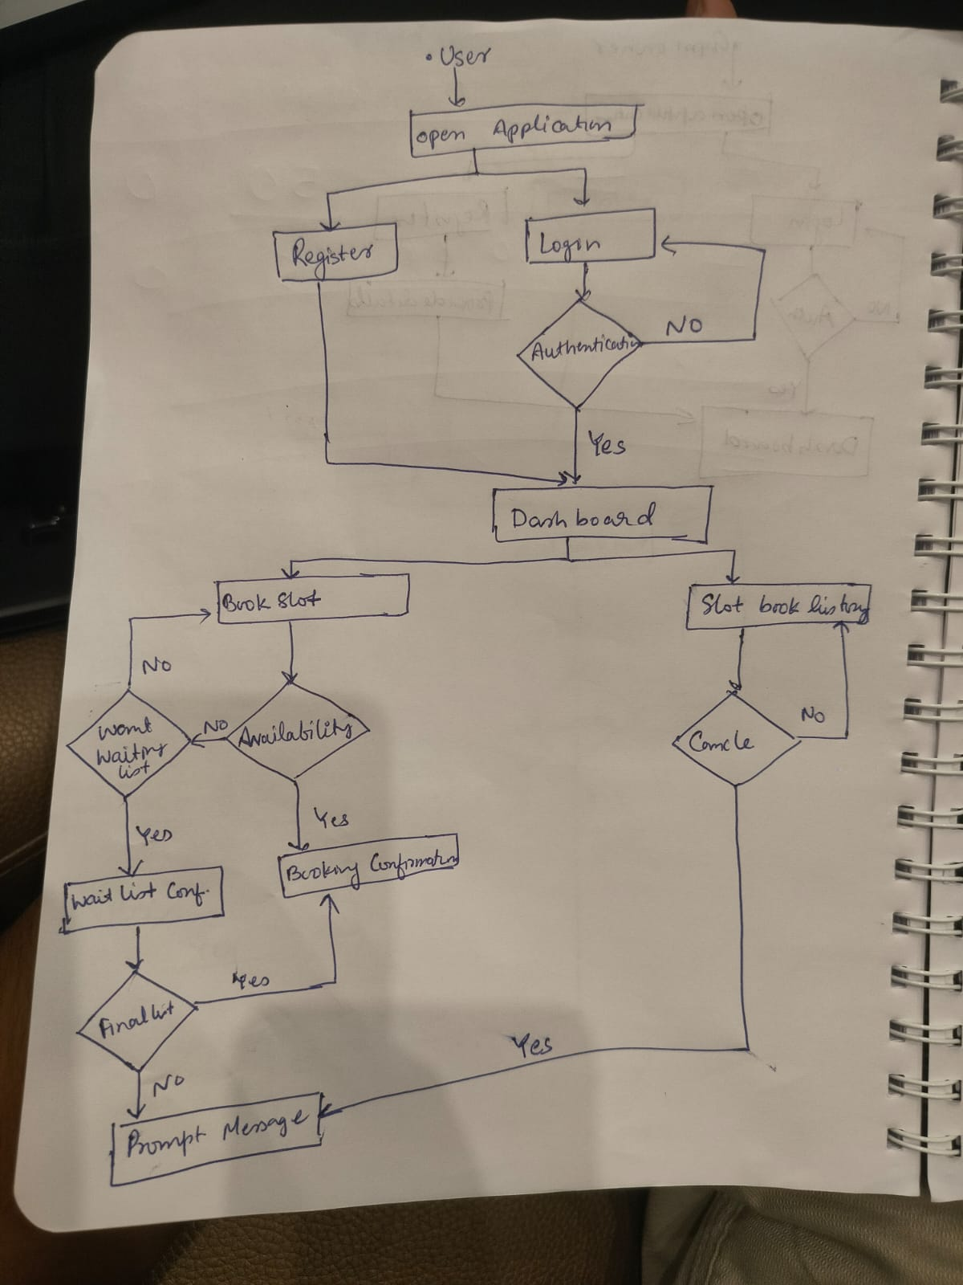

**Class Diagram**

