**Mock-up Screenshots: GoAyur**

**This document contains the initial mock-up screenshots of the GoAyur project.**

**Logo:**



**1. Flash Screen**

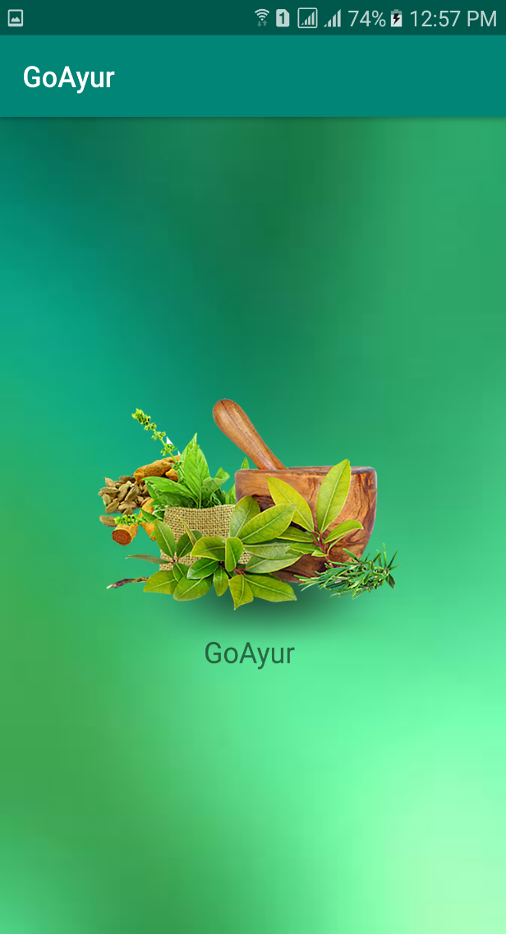

**2. Login Screen**

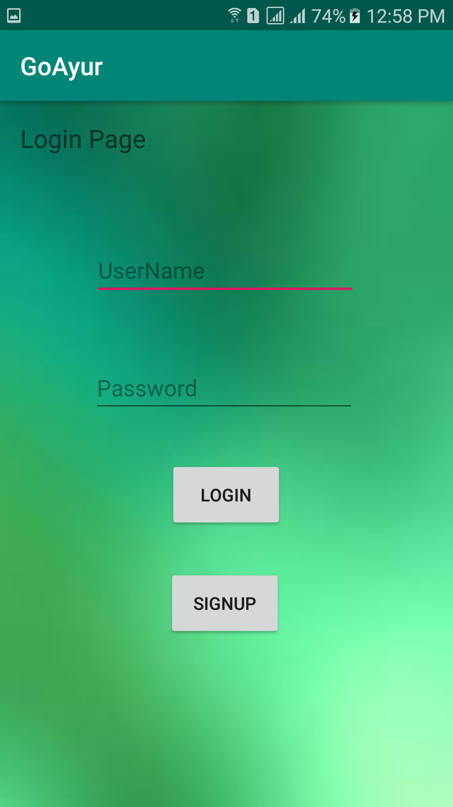

**3. Registration Screen**

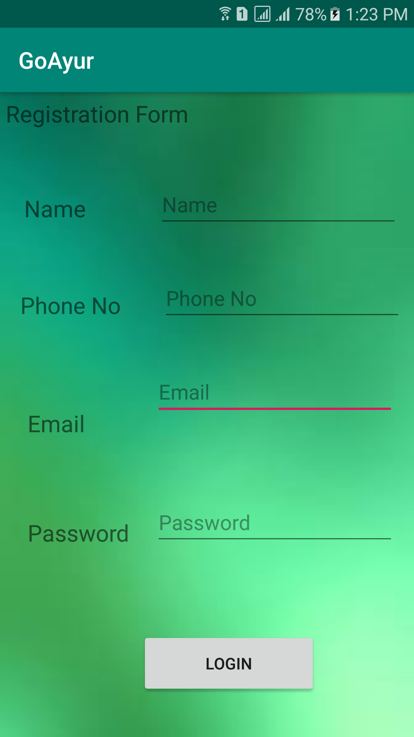

**4. Home Page**

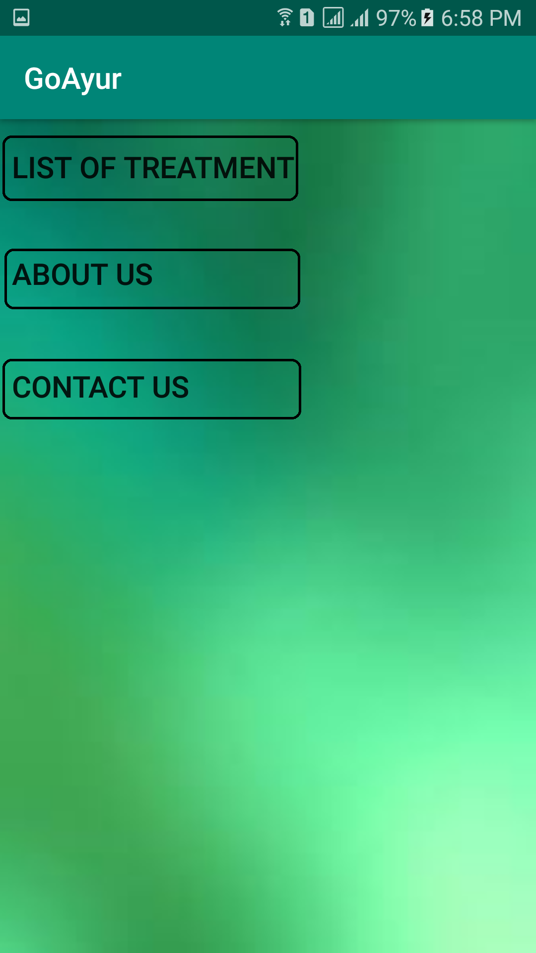

**5. List of treatments**

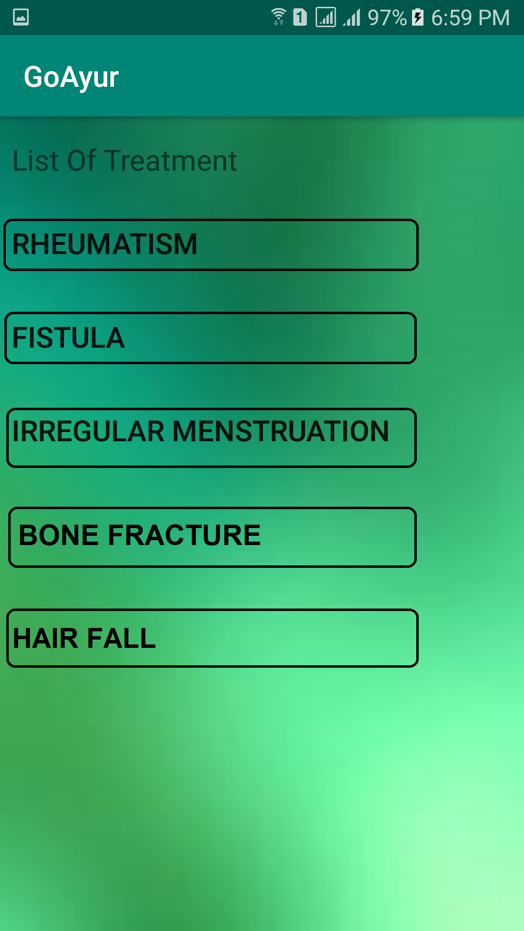

**6. Located places (Where treatment is available. List with Name, availability, address, map and appointment link)**

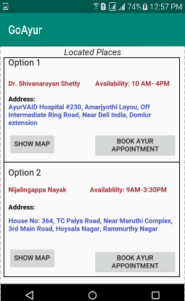

**7. Map display with direction for the address**

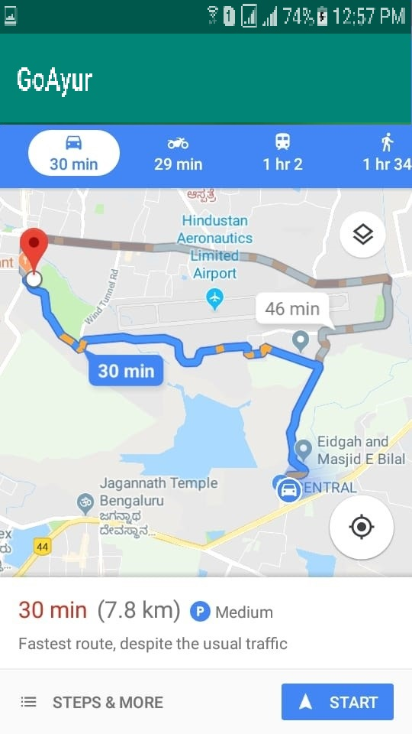

**8. Book appointment screen**

