Wireframe Document

Analyzing Amazon Sales Data

Harshit Kumar Pathak

Overview

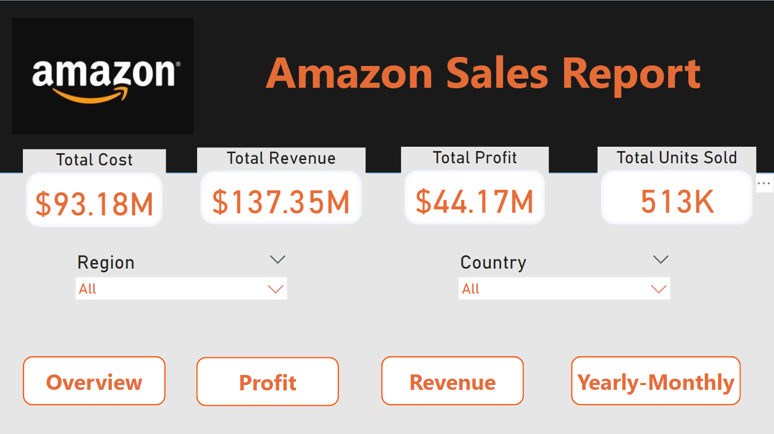

In this page, we tried to interpret Total Cost, Total Revenue, Total Profit and Total Units Sold for various Regions and Countries.

Profit

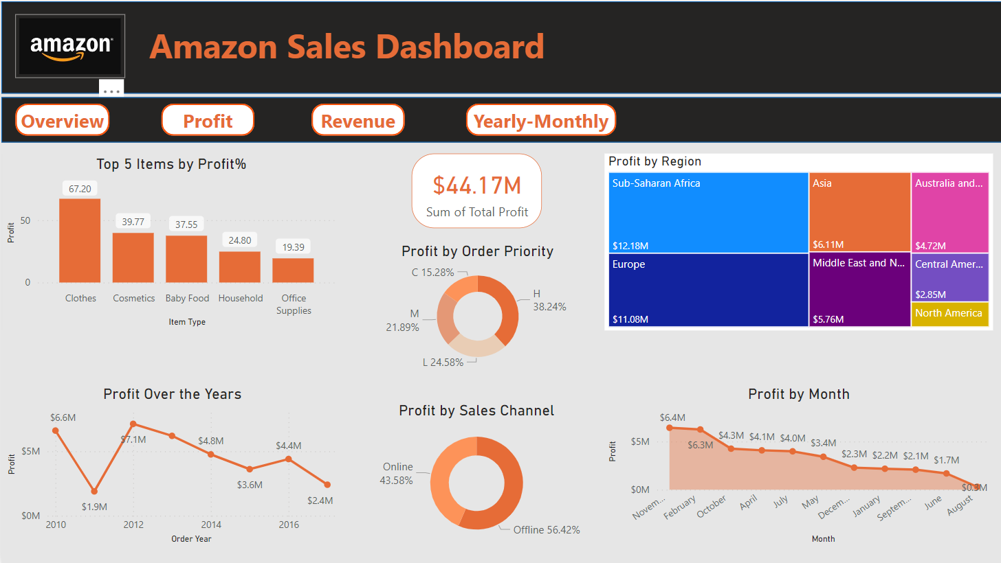

In this Page, we tried to interpret and visualize the following-

* Top 5 Items by Profit %
* Profit Over the Years & Monthly Profit
* Top Profitable Regions
* Profit by Order Priority
* Profit by Sales Channel

Revenue

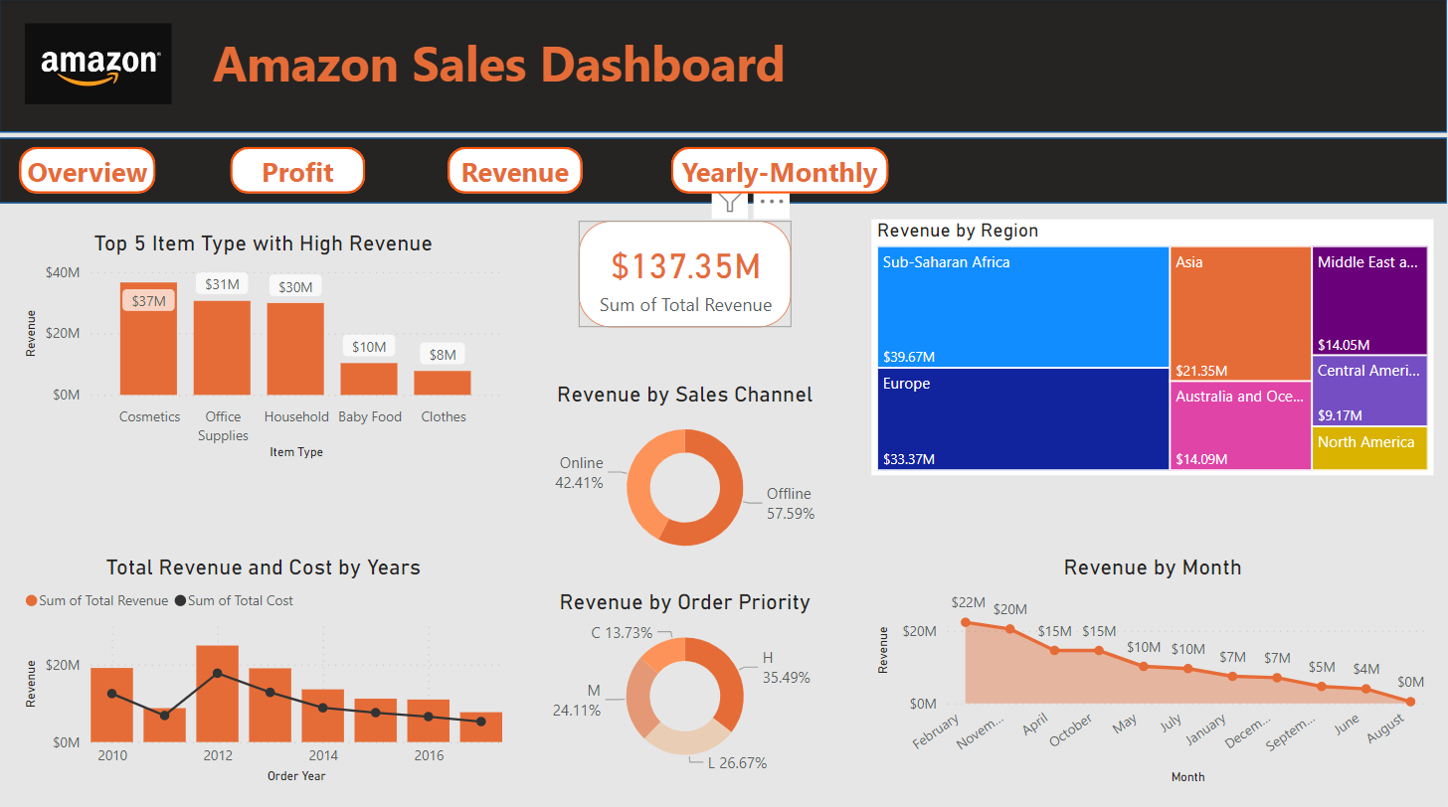

In this Page, we tried to interpret and visualize the following-

* Top 5 Items with High Revenue
* Total Revenue and Cost Over the Years
* Monthly Revenue
* Regional Revenue
* Revenue by Order Priority
* Revenue by Sales Channel

Yearly-Monthly

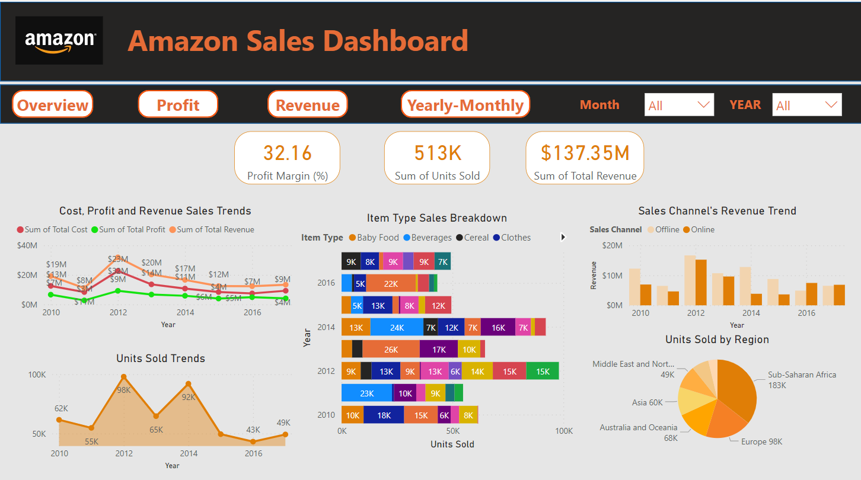

In this Page, we tried to interpret and visualize the following-

* Cost Profit & Revenue Trend over the year
* Units Sold Trend
* Sale’s Channel Revenue Trend
* Units Sold by Region
* Items Sales Breakdown