BanderSnatch Game

Description

This is a game based on the movie BanderSnatch movie. In this player will get a question and two choices on every level. Among those two choices they will have to choose one. After choosing, they will again get a question untill the game ends. If both the Choices of that question are wrong then the game will automatically get redirected to the previous question/level.

This game is made in JavaSe. I havve used Tree DataStructers to create this game. All the questions are in form fo nodes each having variables to store the question and choices string. It also has pointers to point on left, right and parent nodes. It has data variables which contains information to identify if the user has won or loose this game.

Instructions to play.

- With each question player will get two choicesm choose any of the choice by pressing left direction key for left choice, right key for right choice and up key for previous choice.
- Once you have reached the correct node the game will end.

Real Game Steps.

Instructions Window.
This is the welcome window of the game. It contains the description about the game and instructions to play it.We can begin the game by clicking on ‘Start Playing’ button.

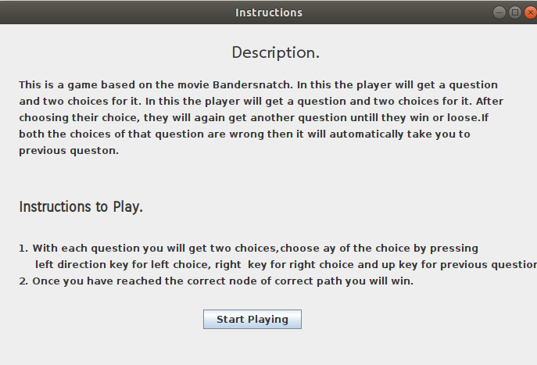

Question Format.
This is the first queston, all question are in this format only. Each of them has left and right choice we can choose by left and right direction key respectively.
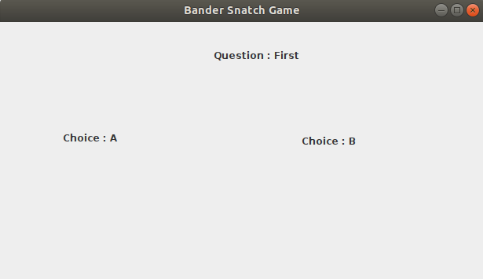

Wrong Path.
If you get to a choice which has end of game and it is not the correct end then the game will show a pop-up message saying “Wrong Path”.
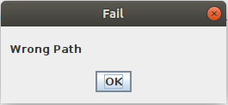

Both Choice are wrong.
If you both the choices for a path are wrong then the game will show a pop-up saying
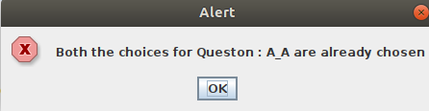

Winner!!
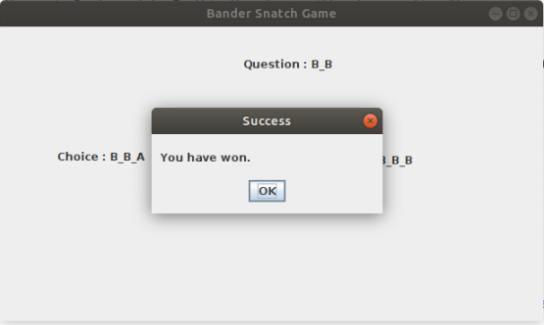
Once you have reached the destined choice. You will win the game.

