Library Mangement using JavaSE

This is JavaSe based project of Library Management using graphical programming. Using this project a complete management of a library of an institution can be done. A beginner’s project with a simple and dynamic code.

Overview.

- Interconnected window based operations.
- MySQL database for using relations and login of faculties.
- Database containing tables of data of all the peoples used in this project.

Contents

1. Home Window

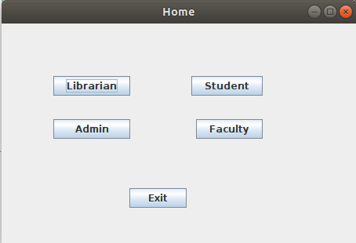

This is the start of the project, projects starts from here. Home window gives us login options, as who wants to login in the system. Options are following Librarian, Admin, Student and Faculty.
Home window also has Exit button if we want to exit project.

2. Login Window
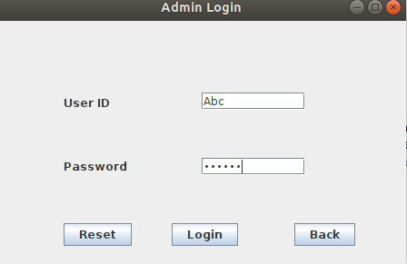

Whichever option we choos will take us to a login window of that person, like if you choose Admin then a login window will appear asking for UserID and Passoword.
This operation is same for all the given four operations. Faculty login if you choose Faculty and so on.

3. Admin operations
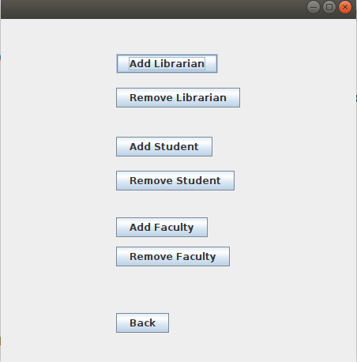

If you have login as Admin then an window will appear named Admin operations.
This window will have all the operation you can perform as Admin of Library.

These operations are as follows.
- Add Librarian
- Remove Librarian
- Add Student
- Remove Student
- Add Faculty
- Remove Faculty

If you choose any of the operation then another window will appear like if we choose Add Librarian then this window will appear.
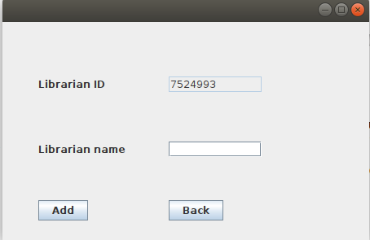

This Id is generated automatically by this alogorithm.
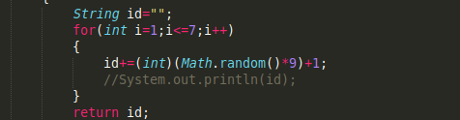

After adding Librarian’s name we can add that librarian and a table that we made in the database.

And if we choose Remove Librarian then this window will appear asking us for the id and name of the Librarian that we want to remove.
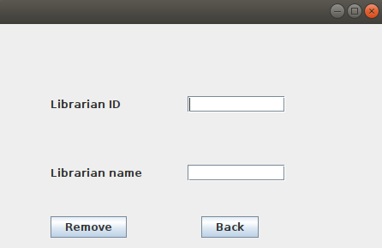

We can simply remove the librarian and all the data of that librarian will be removed from the Librarian table.

All other adding and removing has same procedure as above.

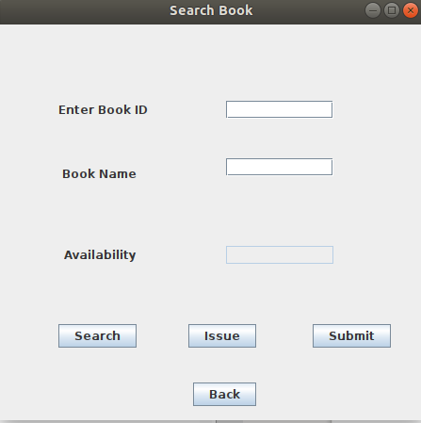
3. Operations for Faculty,Student and Faculty.

Student, Faculty and Librarian, all 3 have similar operaion. They can Search, Issue and Submit any book that is available in the Library’s Database.

Performing any of the operation from Issue or Submit will also change the quantity of the book issued or submitted.
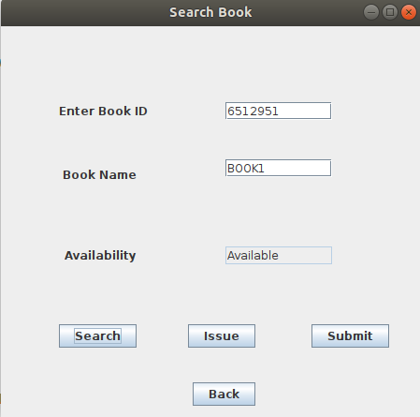

And this how our project Library Management works.

