Pizza Shop Website using Python, Flask and MySQL
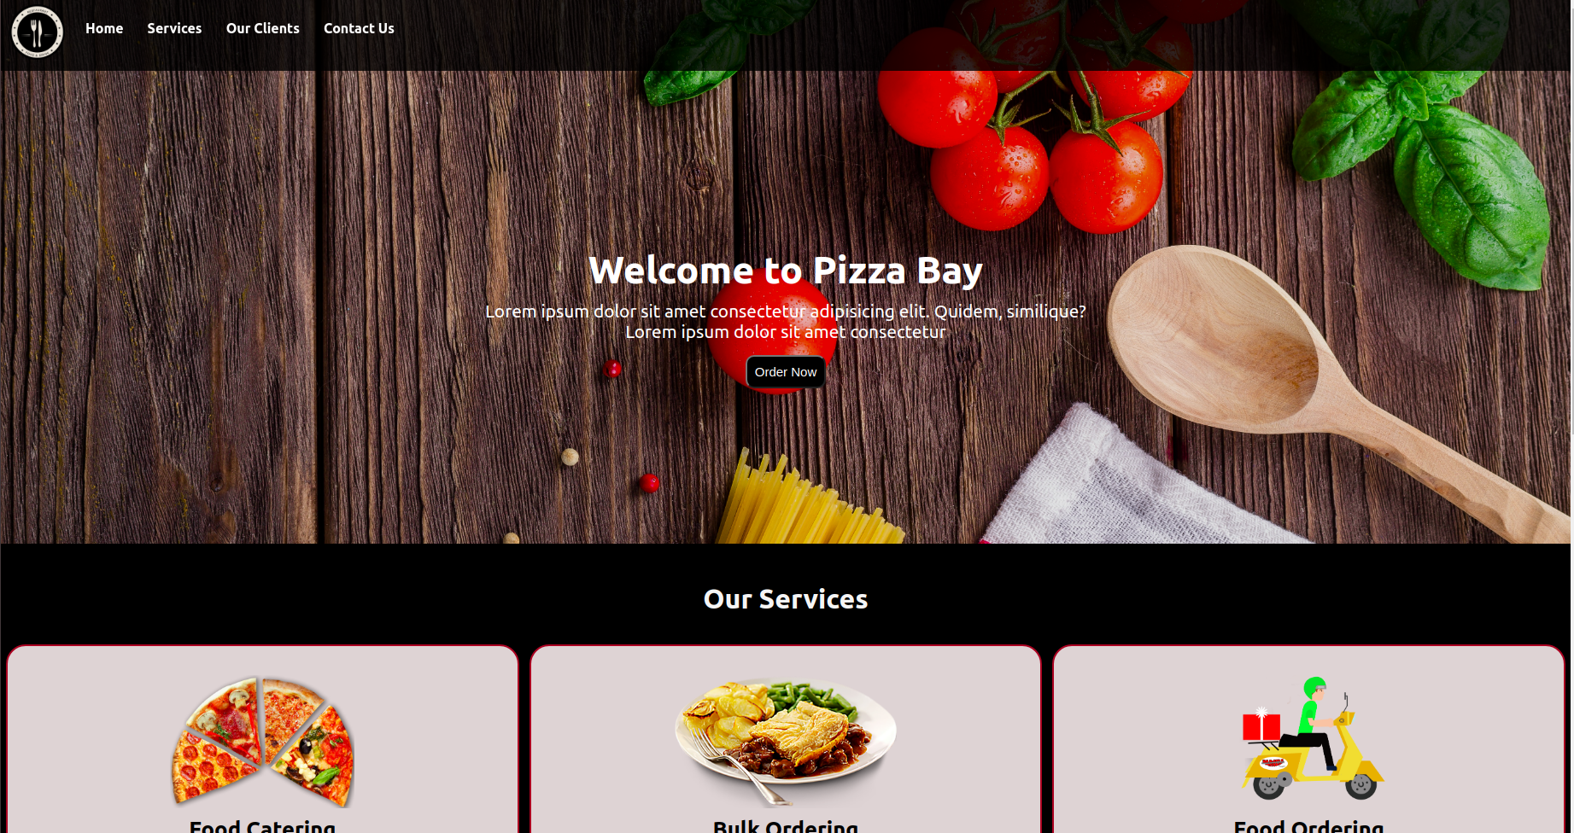

- Description

This website is made using HTML5 ,CSS, Python, Flask and MySQL.

The fronted part of the website is made using HTML5 and CSS.
The backend part is made using Python and Flask.
MySQL is used for database operations.

- Responsive

This is a completely responsive webiste which have 2 stylesheets that make it layout friendly on any device.

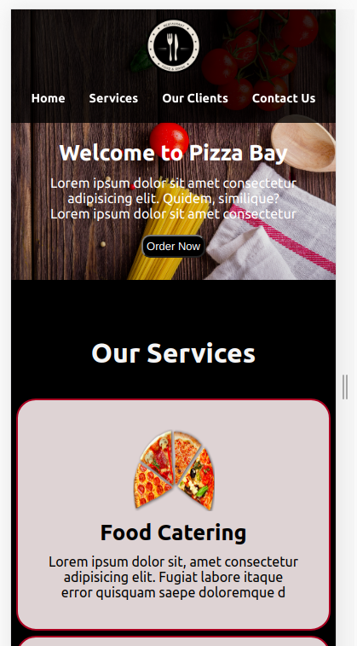

- Contact Section

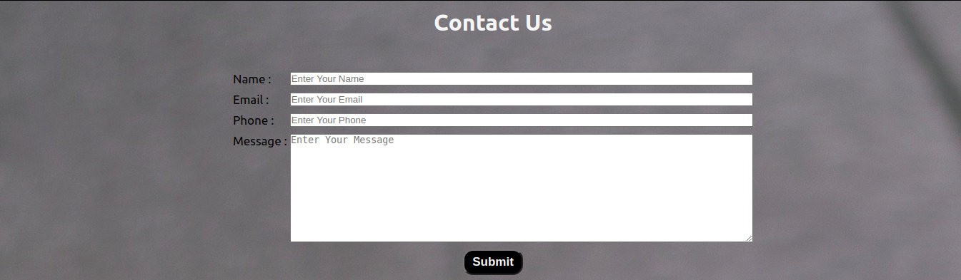

Contact Section is made of label and input boxes. It also has Submit button with type=”submit”.

Clicking on Submit button sends a POST request to server and the Python alogrithm runs to fetch values from webpage and store them on database.

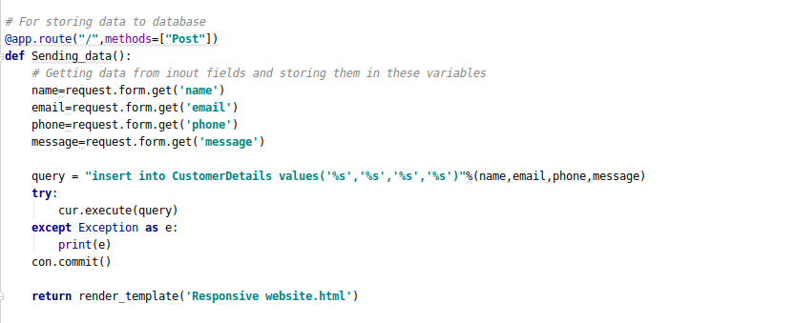

- Database

In this project we use Database and we have Table named CutomerDetails.

Sturcture of the Table:
