**Tic Tac Toe**

This is the virtual version of real life game called Tic Tac Toe.

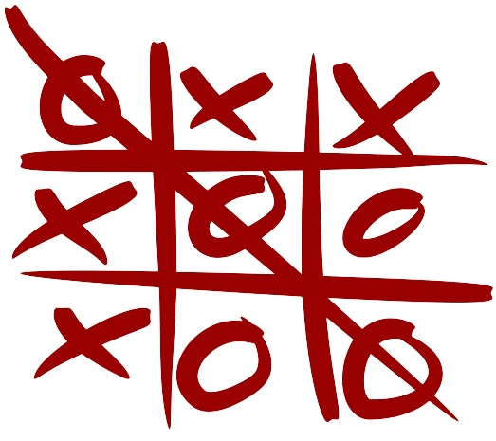

The game begins with, computer asking for both the player’s name.

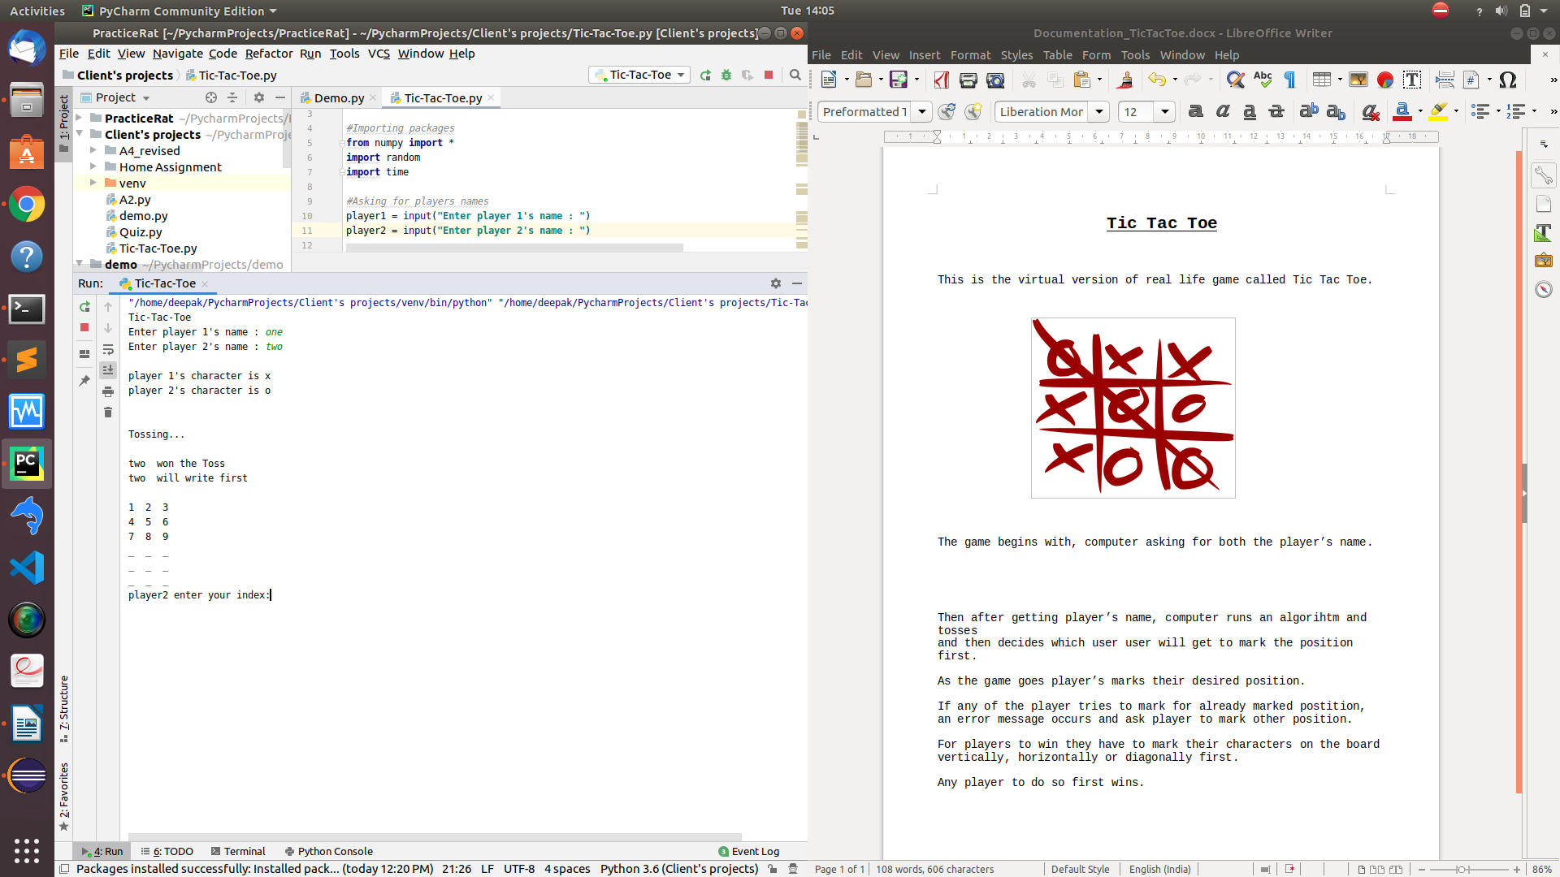

Then after getting player’s name, computer runs an algorihtm and tosses and then decides which user user will get to mark the position first.

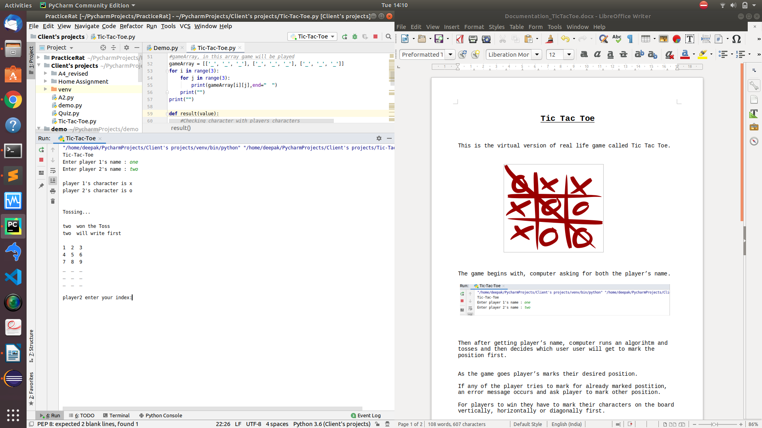

As the game goes player’s marks their desired position.

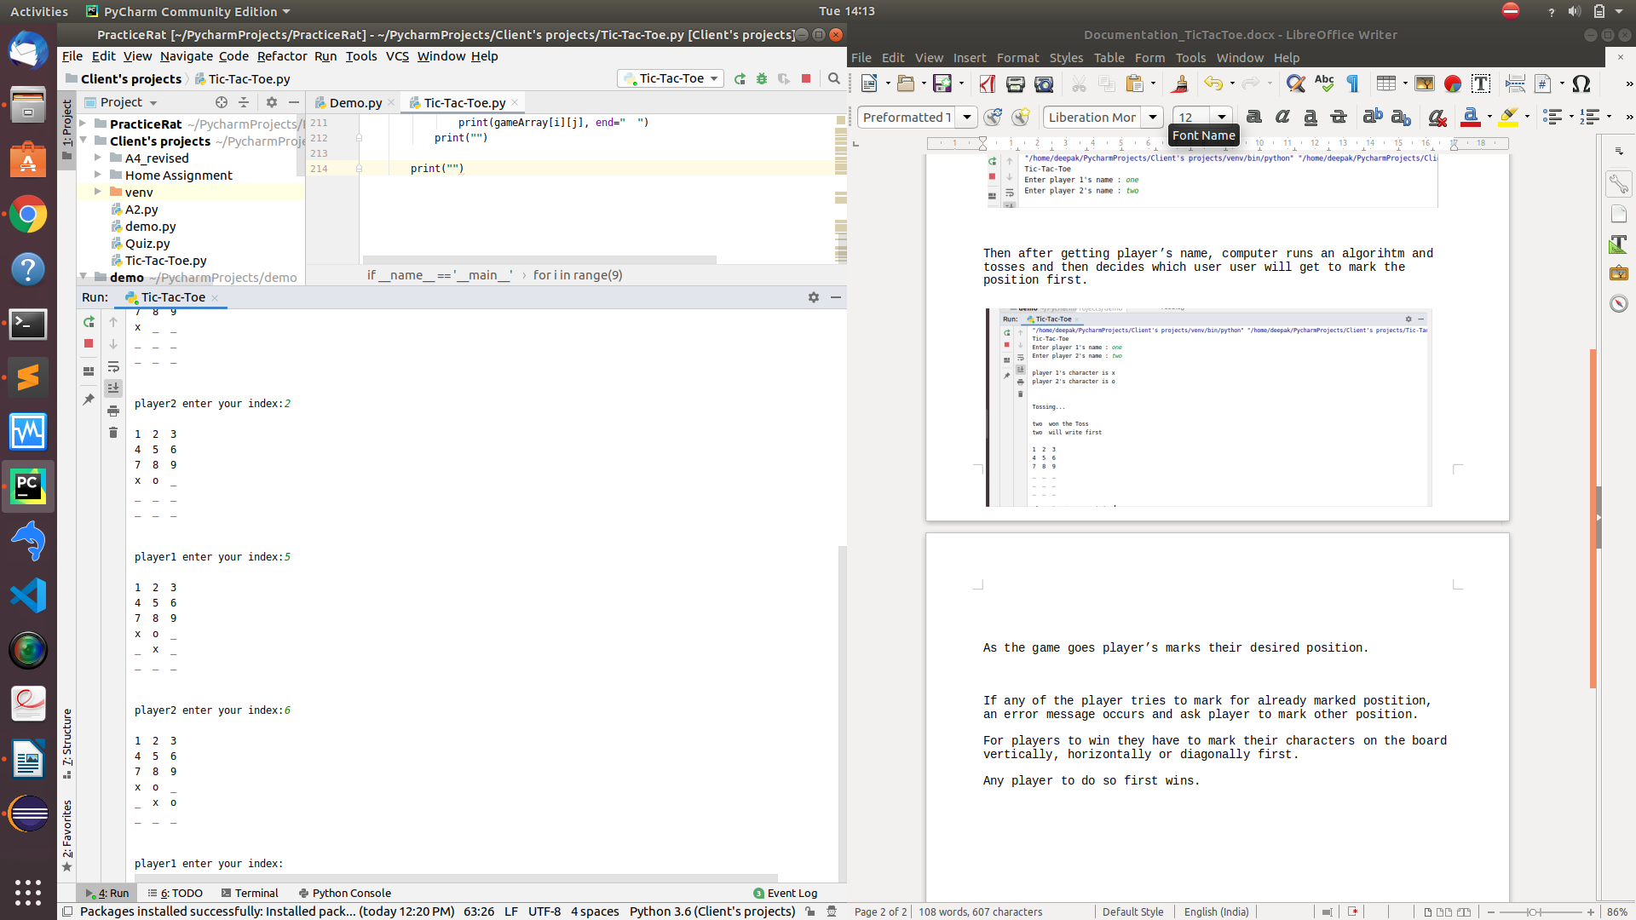

If any of the player tries to mark for already marked postition, an error message occurs and ask player to mark other position.

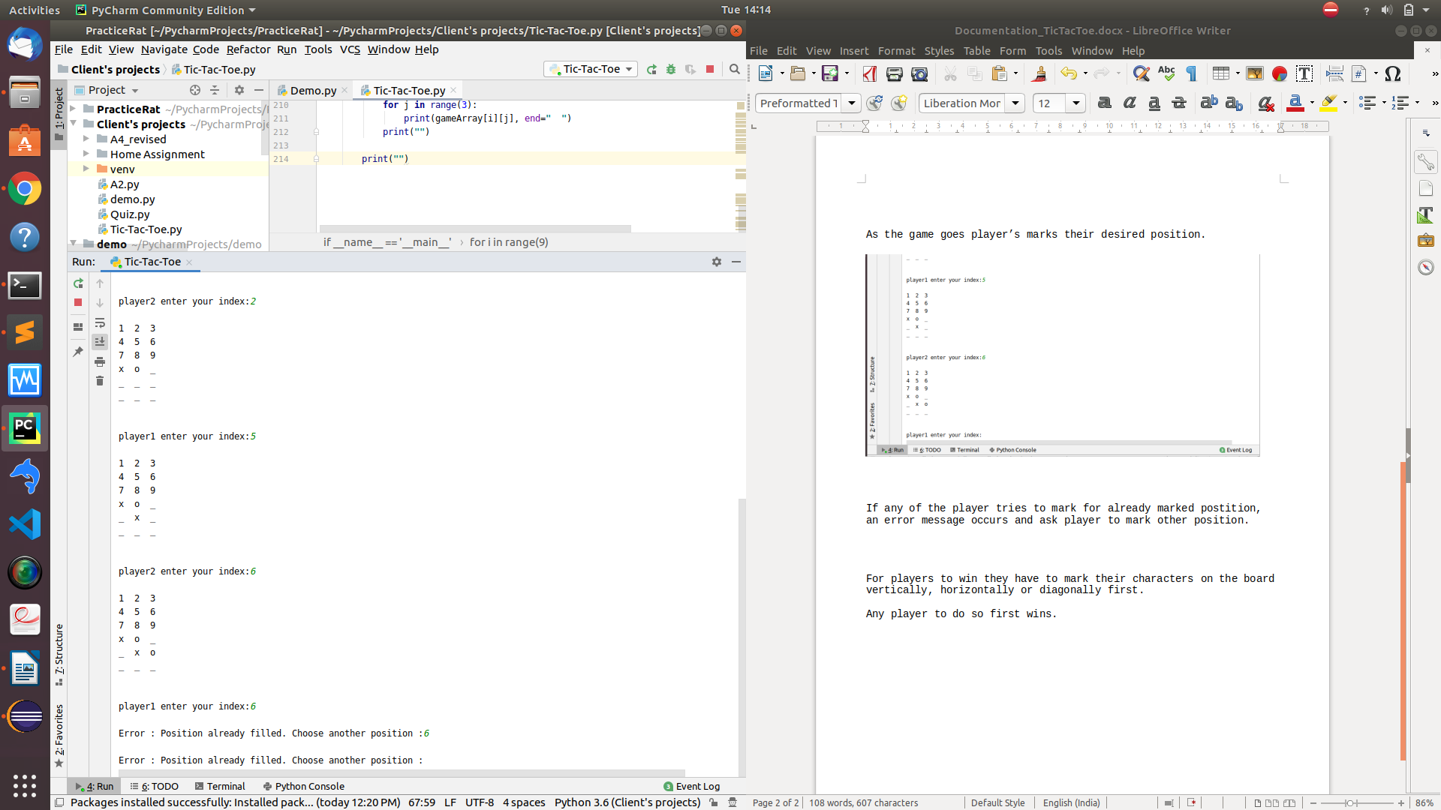

For players to win they have to mark their characters on the board vertically, horizontally or diagonally first.

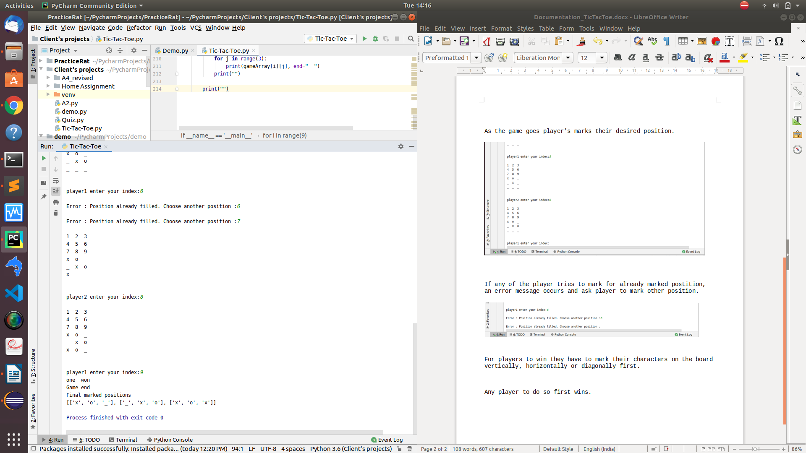

Any player to do so first wins. And the game stops.

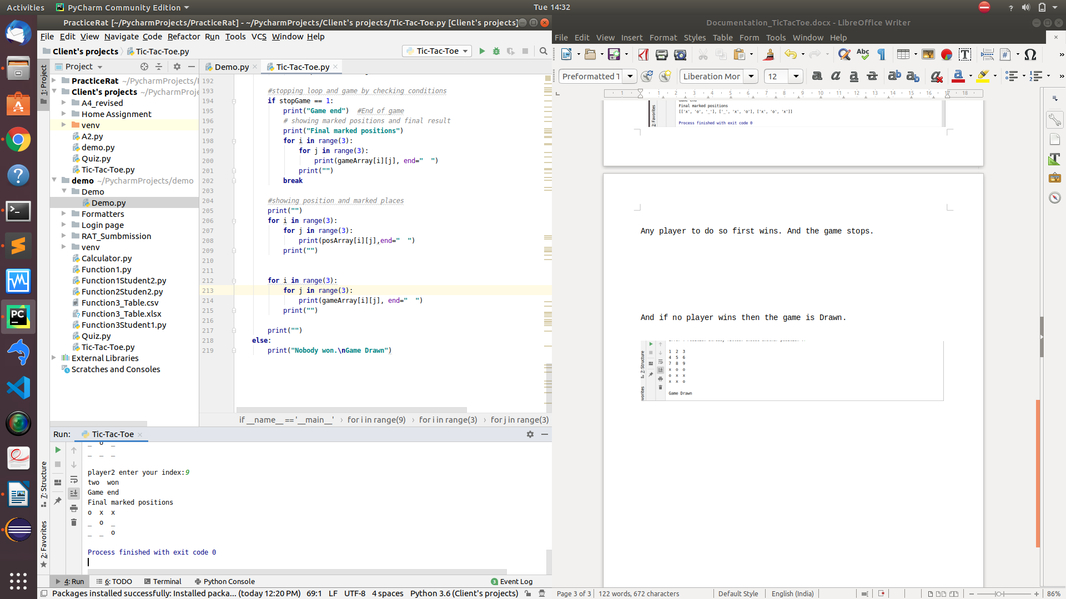

And if no player wins then the game is Drawn.

