**Application:** Weather Report App

**Author:** Harshit Shah

**Install Application:**

* Unzip file ‘Shah_Harshit_A1.zip’ and extract the project folder ‘WeatherFromZipWebApp’.
* Install latest version of NetBeans IDE 8.1 with latest glassfish server (version: 4.1.1 used in this app.)
* Open NetBeans IDE and select option ‘FILE -> Open Project’.

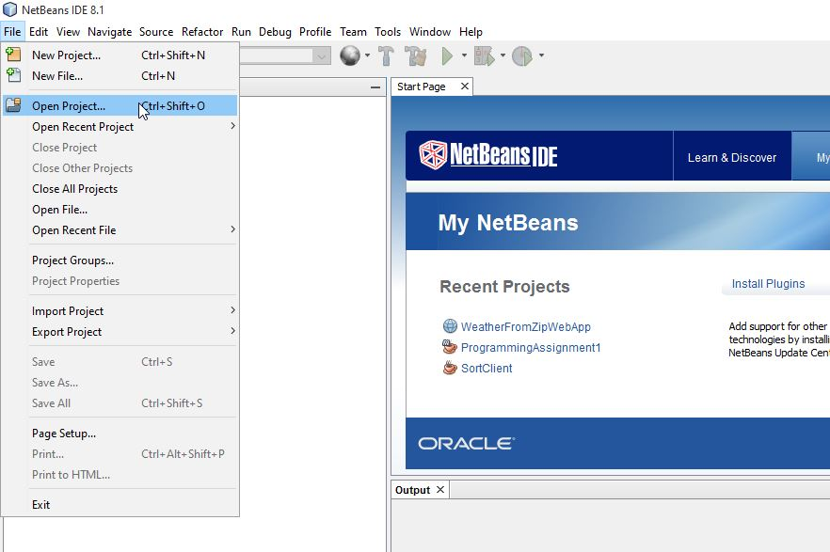

* Now select extracted directory ‘WeatherFromZipWebApp’ from ‘Open Project’ dialog.

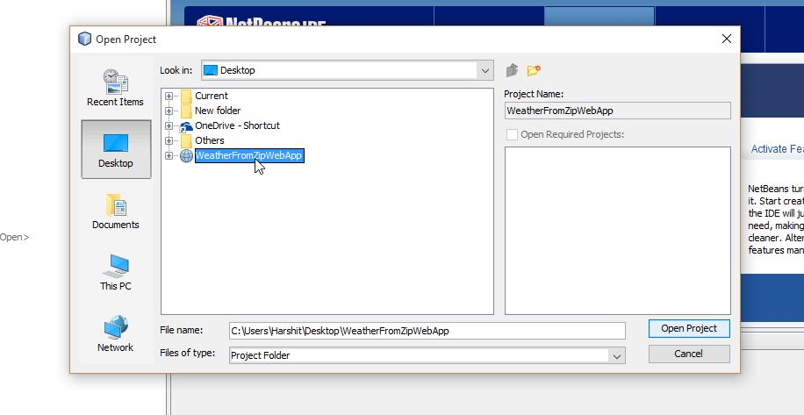

* You may get ‘Resolve Problems’ pop up as below. Resolve them.

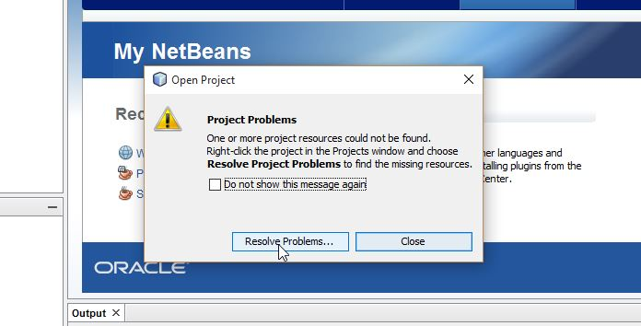

* Now you will see a project window and error symbol on the project.

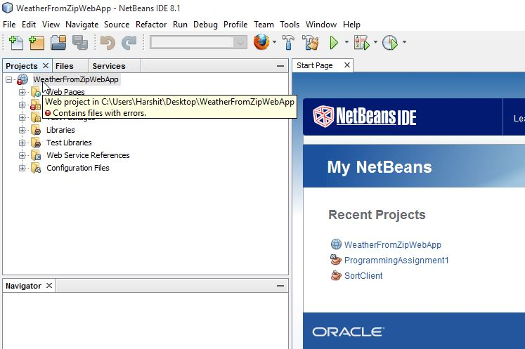

* Ignore this warning and right click on the project and select ‘Build’ option to build the project. This will remove all errors as ‘wsdl’ classes are loading at runtime.

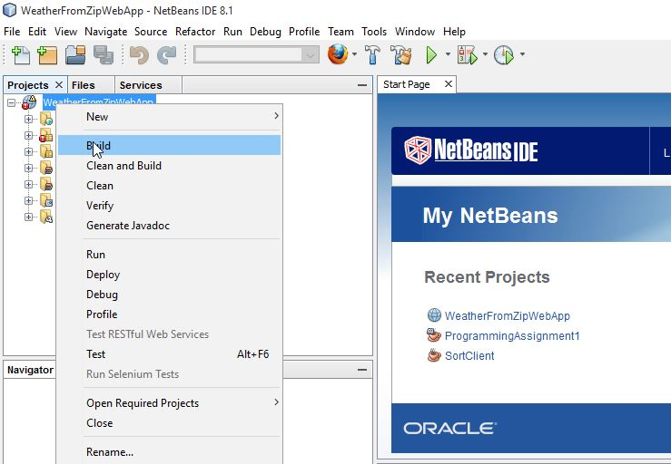

* Finally run the project.

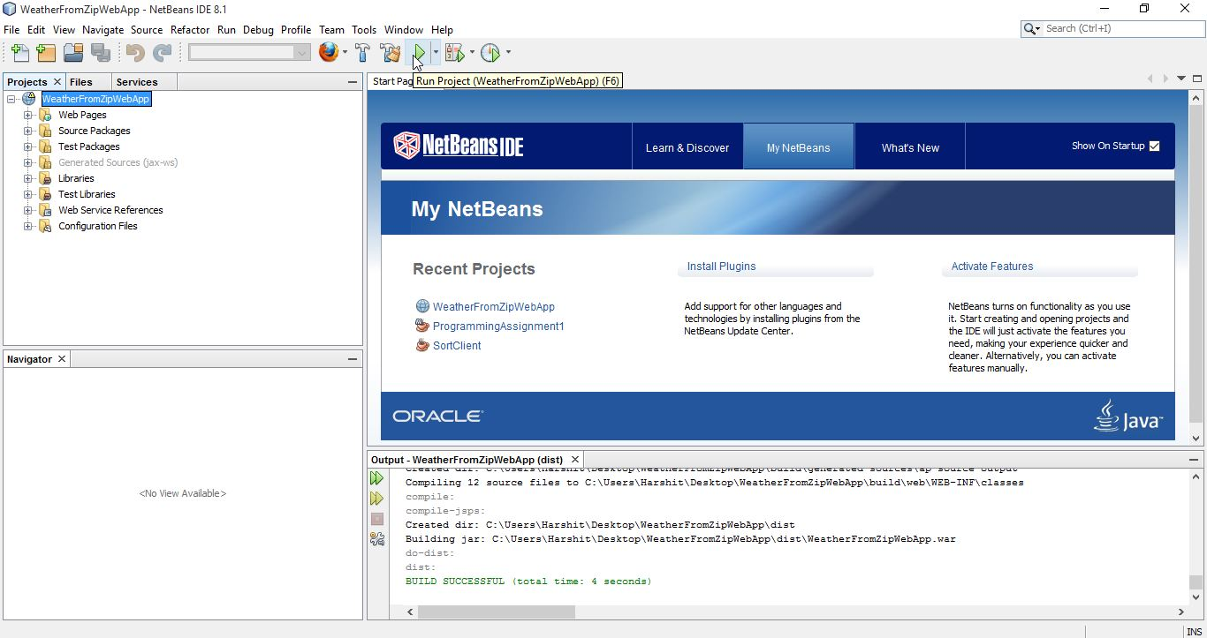

**Test Application:**

* After successfully building and running the project on Glassfish server. It will automatically open the browser page at (<http://localhost:8080/WeatherFromZipWebApp/>) address as below.

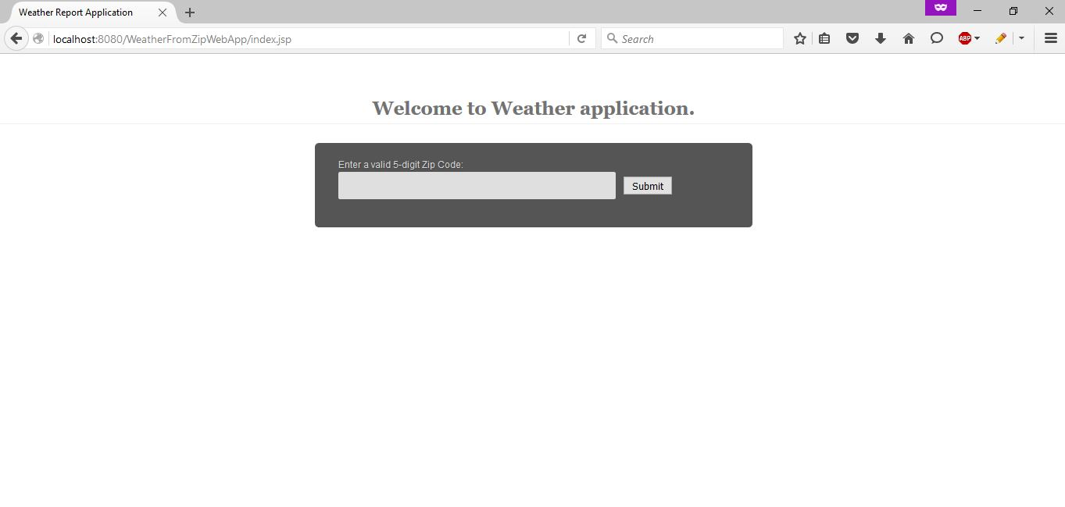

* Follow other screenshots from ‘Design document’ to test the application further.