Q1 - What key performance indicators (KPIs) would you suggest to track mental health trends over time in this dataset?

* KPI to track would include :
* Gender based health trends
* Occupation based health trends
* Stress Rates
* Treatment Rate over time (to identify how many individuals seeking treatment )

Q2 - How would you propose utilizing this dataset to identify unmet mental health needs in different demographic groups (e.g., gender, occupation)?

Ans - To identify the unmet mental health conditions I would recommend to group the data based on the demographics groups and then go on to calculate how many individuals from each group got the help needed and how many did not get the needed help. Below are the summary on the basis of the demographic group gender and occupation.

Q3 - What recommendations would you provide to healthcare organizations for creating targeted mental health awareness campaigns based on the behavioral data in the dataset?

While designing mental health campaign keep focus on habits of the patients like design the campaign to encourage the patients to have a walk regularly don’t stay indoors for longer period of times, and if encounter mood swings consult someone.

Q4 -What trends from the dataset could help healthcare providers prioritize mental health resources for high-risk populations?

Trends like having family history of mental illness specially in males as they have higher numbers in unmet health conditions and also if they are staying indoor for a longer period of times and having increased stress levels counld act as the high risk populations, and the healthcare providers can look into them

Q5 – How can the patterns observed in the Growing_Stress and Coping_Struggles columns inform HR strategies for workplace mental health initiatives?

As the person with the numbers in the struggles increases then the number of the then the person tend to have more mental illness as compared to person who is able to cope with their struggles

Q6 - How could insurance companies use this dataset to better understand mental health risk factors and adjust premiums accordingly?

Insurance companies should opt to identify high risk populations like men because they tend to not opt for medical attention, and also employees who are having high stress levels and not able to cope with the struggles and after identifying these persons adjust your premiums accordingly

Q7 How would you use the data to make recommendations on improving access to mental health treatment options for various demographic groups?

Corporate ,students and male are the one recommended from various demographics so as to improve their mental health access to treatment options.

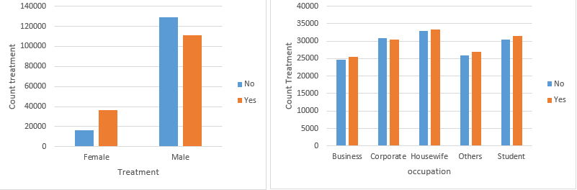

Q8- What potential revenue streams or business opportunities can arise for healthcare platforms that integrate predictive models from this dataset to provide early mental health support?

* Subscription-based wellness programs – personalized mental health plans for persons with mental health issues.
* Corporate mental health solutions – B2B services for employee well-being.
* Insurance partnerships – charge higher to person having high risk of mental issue using the model, premium discounts for healthy cstomers and also to those who involve in checkups.

Q9 How can the data help in crafting policies that support employee mental health in industries with high levels of stress (e.g., based on occupation trends)?

**Identifying At-Risk Occupations/Individuals**: Analyze the data to identify which occupations report higher levels of stress, mood swings, and coping struggles. This information can help target specific industries for mental health initiatives and also the specific persons who might be at the risk .

**Understanding Demographic Trends**: Examine how different demographic groups (e.g., gender) within stressful occupations experience mental health challenges.

**Creating Awareness Campaigns for Specific Individuals**: Use data-driven insights to inform employees about mental health resources and support available to them, increasing utilization of these services.

Q10; What correlations in the dataset would help a mental health startup target specific user groups for mental wellness apps or services?

Correlation among family history and mental health history, between gender and mental health history ,gender and treatment ,days indoor growing stress and mental health can help startup to target the user for mental wellness app.

Q11. What specific strategies would you recommend for businesses looking to reduce stress and improve well-being in their workforce, based on insights from Days_Indoors and Mood_Swings?

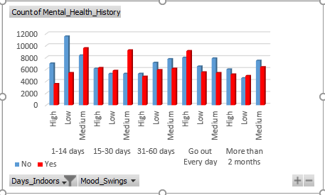

* Healthy Work Environment:
* Regular Check-Ins:
* Social Interaction Opportunities:
* Flexible Work Arrangements:
* Access to Counseling Services:

Q12 How can mental health clinics use the care_options and family_history data to offer more personalized treatment plans to patients?

If the patient has a family history he should be taken care of with personalized treatment plans And if the patient does not have care option available he should be provided with the nursing care to be look after

Q13 What demographic groups show the highest levels of mental health struggles, and how can businesses develop targeted wellness programs?

|  |  |  |  |
| --- | --- | --- | --- |
| **Count of Mental_Health_History** | **Mental Health** |  |  |
| **Demographics** | **No** | **Yes** | **Grand Total** |
| Female | 17303 | 16093 | 33396 |
| Male | 86715 | 76875 | 163590 |
| **Grand Total** | **104018** | **92968** | **196986** |

Male have higher mental cases businesses can develop wellness programs which are targeted around them .

Q14. How would you design a dashboard for a healthcare business to track trends in Mental_Health_History and treatment outcomes over time?

* Gender based health trends
* Occupation based health trends
* Stress Rates
* Treatment Rate over time (to identify how many individuals seeking treatment )

Q15 What actionable steps would you suggest for companies to offer better mental health support based on the Work_Interest and Coping_Struggles columns?

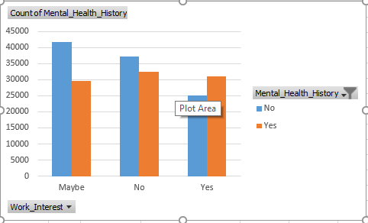

* Flexible Work Arrangements
* Promote Work-Life Balance
* Regular Check-Ins and Support Groups

Q16 : How would you propose a marketing strategy for a mental health platform targeting individuals with high Growing_Stress levels?

* Target stressed professionals, students, and self-employed individuals, and know about theri struggles
* Provide stress-relief tools (meditation, counseling).
* Collaborate with companies and universities for wellness programs.
* Use data to personalize stress-relief suggestions and resources for individuals.

Q17 What interventions can organizations implement to improve mental health outcomes for remote or isolated workers, based on the Days_Indoors data?

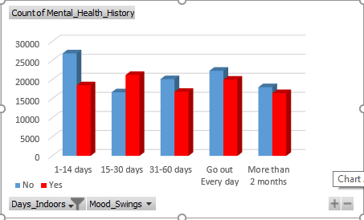

* Encouraging socialising with persons
* Flexible Working Hours
* Mental Health Resources
* Physical Activity Programs

Q18 What business recommendations would you provide for companies to better accommodate employees with a history of mental health issues?

* Promote Mental Health Check-Ins
* Stress Reduction Initiatives
* Flexible Work Options
* Include interaction activities and encourage them
* Regular Checkin on if the employee is struggling or not
* Monitoring mood swings and stress levels of employees

Q19 What operational changes can be suggested to healthcare facilities based on the patterns observed in treatment and mental_health_interview data?

Treatment is taken by less number of men as compared to women we need to change this and treatment should be taken by each and every employee regardless of gender

Q20 How can businesses identify and support employees who are at risk of burnout or stress-related issues from the dataset’s behavioral and sentiment features?

* Monitor Behavioral Patterns
* Provide Mental Health Support Based on History
* Customised Interventions for Identified Risks
* Periodic Checks on the Identified history

Problem Statement :

**Which demographics (e.g., gender, occupation) exhibit patterns of higher psychological stress?**

The dataset contains demographic features such as:

* **Gender**
* **Occupation**
* **Self-employed**
* **Country**

We will assume that males have higher stress levels as compared to females?

We will assume that corporates have higher stress levels as compared to other occupations?