Portfolio Case Study
Advanced Business Intelligence Project — Task 5
Harshit Kumar Singh • 21/09/2026 • Power BI

1. Business Problem
Sales leadership needs a unified view of regional performance, customer profitability, and growth trends to guide marketing and retention decisions.

2. Dataset Overview
Summarize the data you used.
Field | Details
Source | Excel dataset (Task4_Sample_Dataset.xlsx) — 3 related tables
Tables | Orders, Customers, Products (+ Calendar table, jo DAX se banaya tha)
Time period | Jan 2023 – Dec 2024
Row count | Orders: 1,200 rows · Customers: 40 rows · Products: 52 rows

3. Data Cleaning Summary
List the cleaning steps you performed before modeling.
- Set correct data types for all columns (dates, numbers, text) across Orders, Customers, and
Products tables
- Promoted the first row as column headers after importing from Excel
- Standardized and cleaned column names (e.g., renamed Segment column) for consistency
- Verified Customer_ID and Product_ID keys matched correctly across tables for accurate relationships

4. Data Modeling Diagram
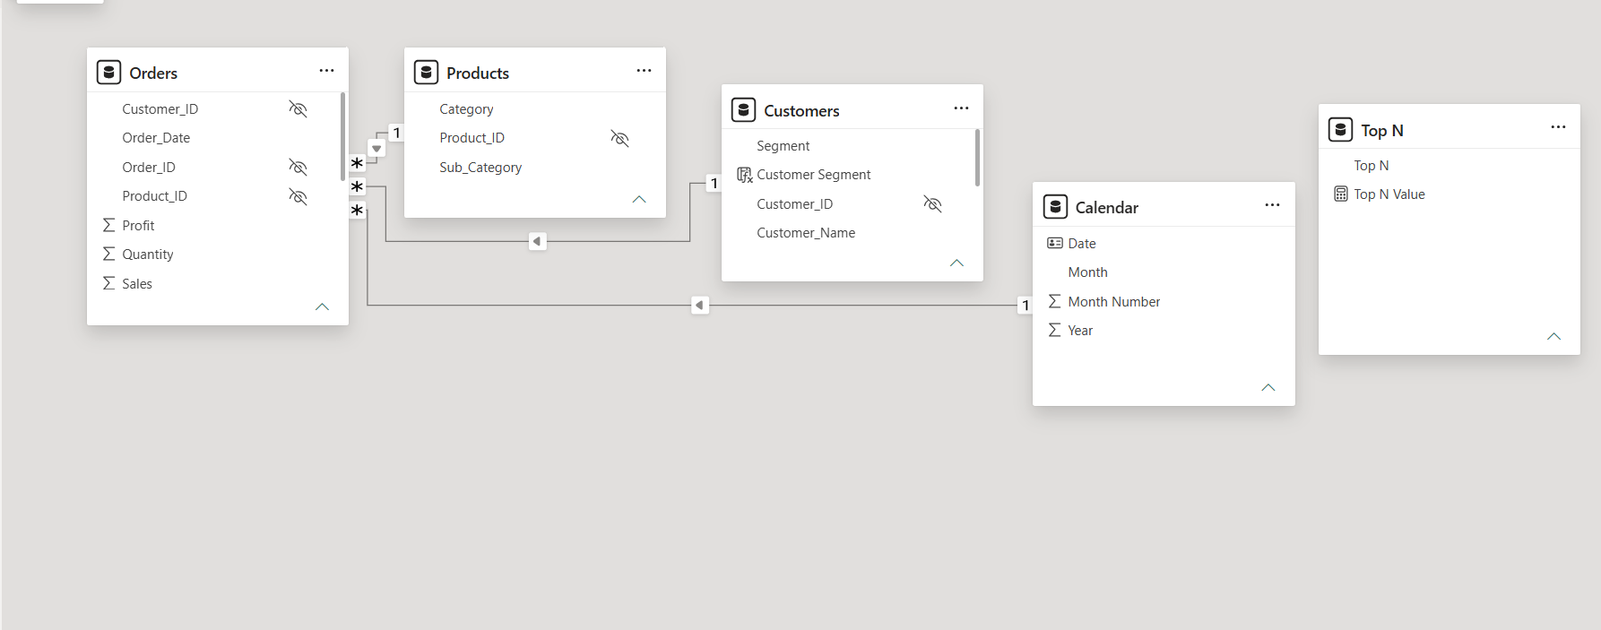

5. KPIs & DAX Measures
List every measure you created, in plain language, and what it tells the business.
Measure | Business purpose
Customer Rank | Ranks customers by total sales to surface top/bottom performers
Top N Sales | Lets viewer dynamically choose Top 5/10/20 customers
Customer Segment | Buckets customers into High / Medium / Low value by profit
YoY Growth % | Shows year-over-year sales growth trend

6. Dashboard Screenshots
Screenshots of the finished, optimized dashboard (overview page, insight section)
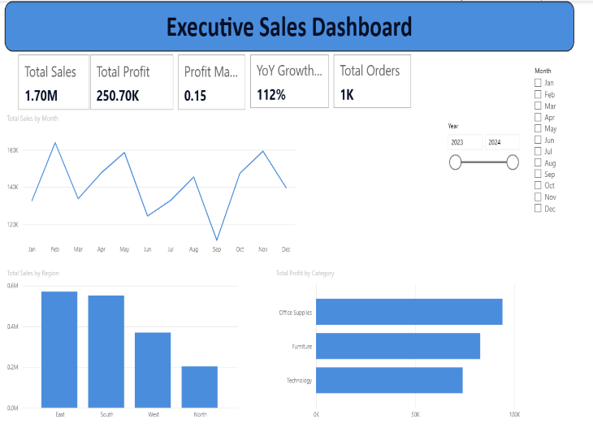
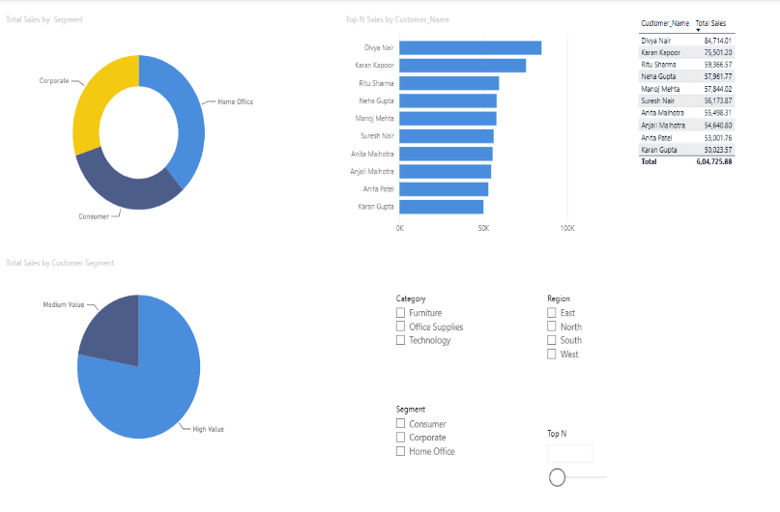

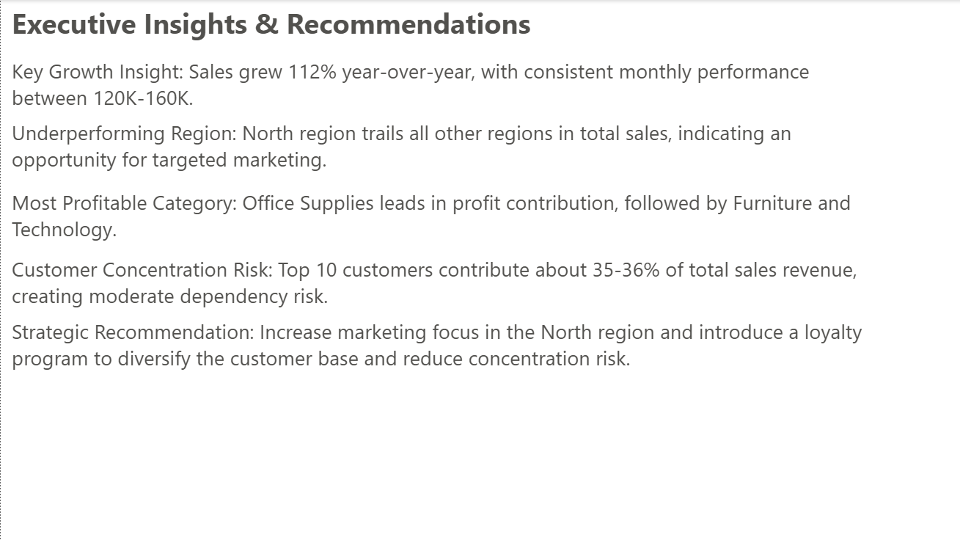

7. Business Insights
Write the 4-5 findings your Insight Section surfaces, in plain business language, backed by numbers.
- Key Growth Insight: Sales grew 112% year-over-year, with consistent monthly performance between 120K-160K.
- Underperforming Region: North region trails all other regions in total sales, indicating an opportunity for targeted marketing.
- Most Profitable Category: Office Supplies leads in profit contribution, followed by Furniture and Technology.
- Customer Concentration Risk: Top 10 customers contribute about 35-36% of total sales revenue, creating moderate dependency risk.

8. Strategic Recommendations
Turn each insight into an action the business could take.
- Increase marketing focus in the North region to close the performance gap with other regions
- Introduce a customer loyalty program to diversify the customer base and reduce dependency on
the top 10 customers.

9. Tools Used
- Power BI Desktop, DAX, Power Query, Power BI Service
- Excel for initial data checks

10. Learning Outcomes
Reflect on what you learned completing Task 5.
- Wrote advanced DAX using RANKX, CALCULATE, and SAMEPERIODLASTYEAR
- Built dynamic Top-N filtering with What-if parameters
- Applied segmentation logic to support marketing decisions
- Optimized a data model for dashboard performance
- Delivered an executive-ready, published BI project

Published dashboard link: Executive Overview - Power BI file - Power BI

