**FRS**

Description Of Data To Be Entered:

The data is entered by the admin or user to the system to maintain the employee details. The data should have:

1. Name of employee.
2. User id of employee.
3. Email of employee.
4. DOB of employee.

Once the employee has registered the admin will send mail to set the password.

Description Of Operation On Each Screen:

LOGIN SCREEN:

USER:

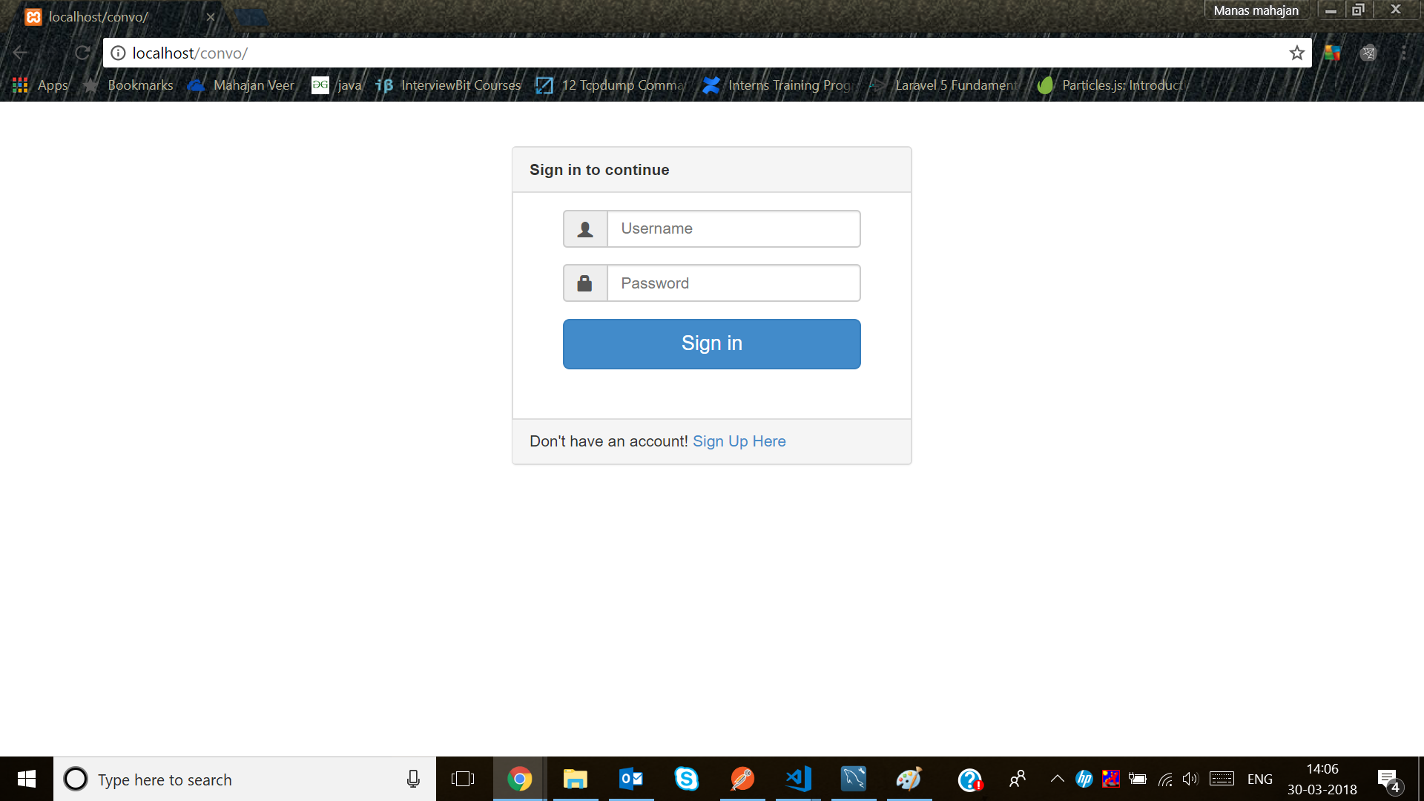

The login screen contains two fields,

1.username

2.password

This data is maintained in a database for verification purposes. The system matches the credentials with the database, if the information entered matches then the user is allowed to enter the system.

Dashboard:

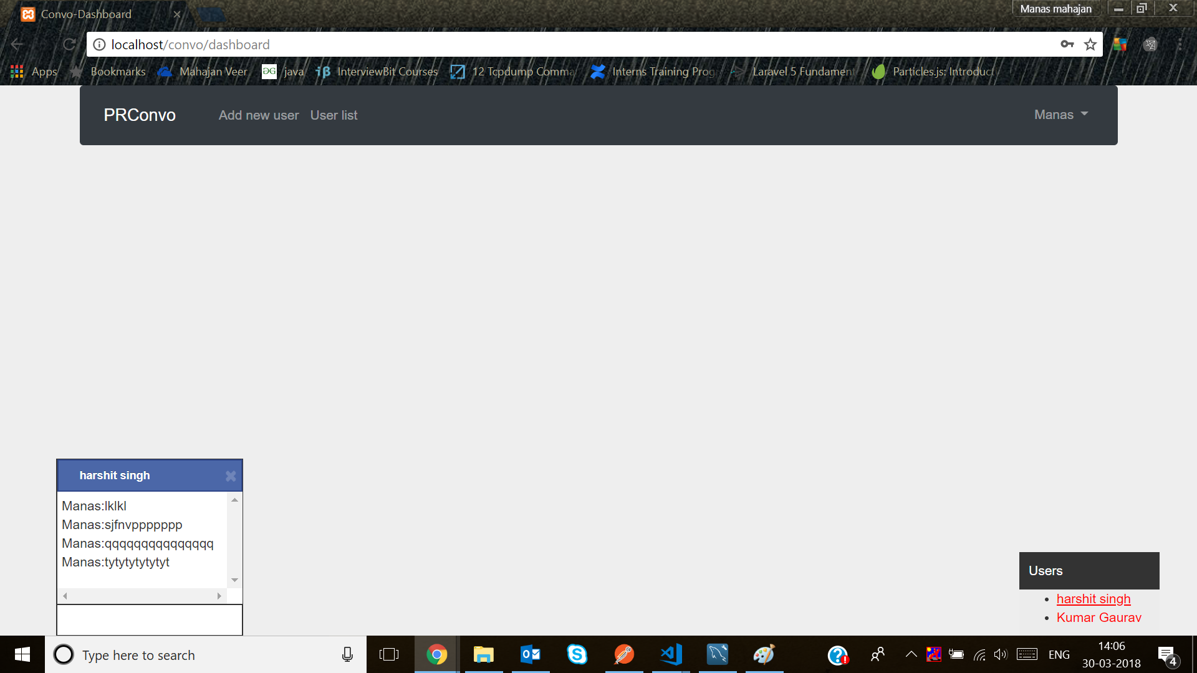

There are 5 options for the admin:

1. Add New User
2. Send link to activate user
3. Change his credentials.
4. Chat to other people
5. Logout

The user has only 3 options:

1. Change his credentials
2. Chat to other people
3. Logout

WORK-FLOW DESCRIPTION:

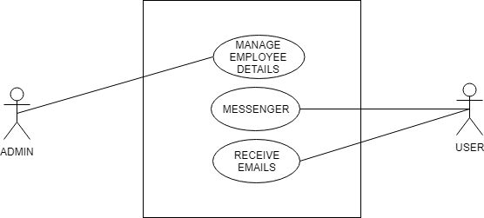

Use Case Diagram

The flow can be explained as:

First verification is done, if the details match then the system checks that the person is admin or a user. According to the situation the user is given access.

USER:

When a user is logged in the system will show the messages that was sent to the user. On his birthday an email with greetings will be delivered to the user and will be shown on the homepage and If there is a birthday of any other employee an invitation email will be sent one day prior.

The user can go to the messenger to talk to other employees. A list of all the employees will be provided from the user can find a particular employee to talk to.

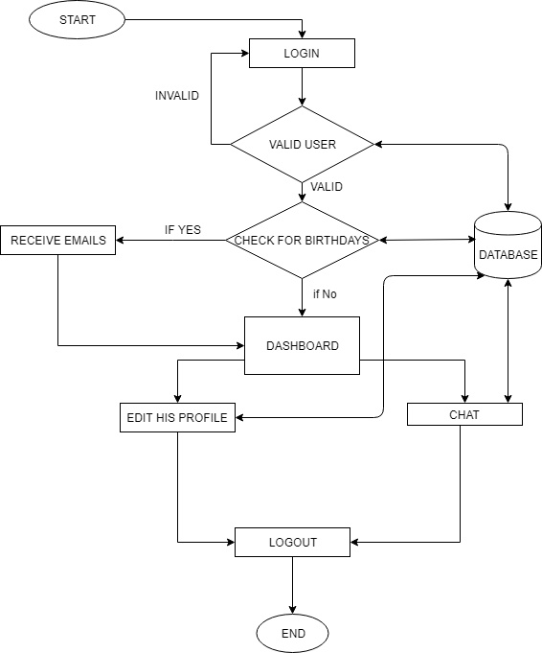

User flow diagram

ADMIN:

When the admin logs in the system he will also see the emails of the birthday and invitations. The admin has a feature to chat as well as to add or update information of the employees to the system.

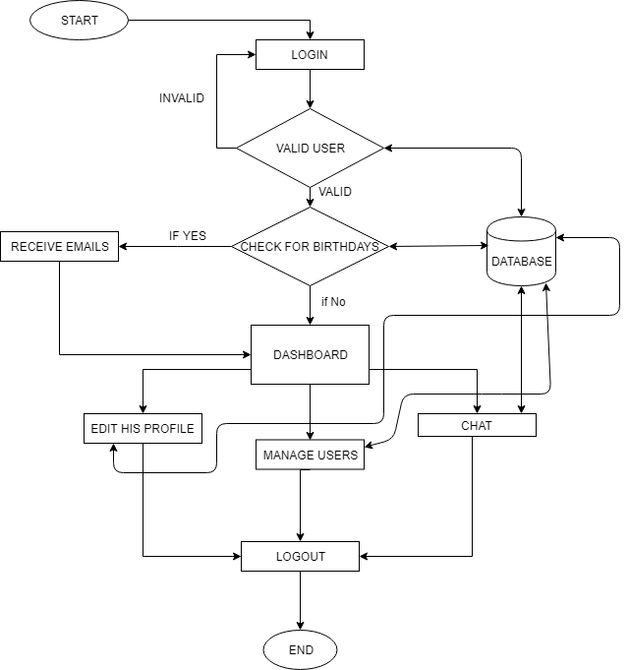

HOW THE REQUIREMENTS ARE MET:

The requirement of the project was to make a system that would send greetings to the employees on their birthday and notification mail to other employees one day prior to the birthday. Along with this a feature is to be made where the employees can chat or talk to each other.

The project meets the requirement as the system will send emails that are automatically generated as per the requirement. The messenger feature will allow the employees to talk to each other.