A Project Evaluation Report submitted for Database Management System

(UCS310) by

|  |  |
| --- | --- |
| **Name of student** | **Roll number** |
| **Akshita** | **102103470** |
| **Harshit Sharma** | **102103461** |
| **Vineet Jain** | **102103465** |
|  |  |

**Submitted to Dr. Palak Goyal**



**Airport Management System**

**DEPARTMENT OF CSED**

**THAPAR INSTITUTE OF ENGINEERING AND TECHNOLOGY, (A DEEMED TO BE UNIVERSITY), PATIALA, PUNJAB**

**INDIA**

**Jan-May 2023**

**Table of Contents**

1. Introduction including requirements analysis (1-2 pages)
2. ER- Diagram
3. ER to Table
4. Normalization
5. SQL & PL/SQL (Stored Procedure and Functions, Cursors, Triggers) Snapshots with output.
6. Conclusion

1. **Introduction including requirements analysis**

#### **Domain**: Airport Management System

## Requirements of the system:

* The system is based on airport management. Airport management system primarily deals with management of airport, airlines and passengers. The system provides broad overview of underlying operational factors that influence the airport management.
* The database system has the data of all commercial service airports.
* An airport is located in a city.
* All International airlines operating through various countries across the world have their offices located in all major cities and airports they cover. Hence, an airport may have many airline offices.
* Every airline is identified uniquely by an airline code. Airline code is a two-letter airline designator. Airline also has three-digit code which is printed on an air ticket.

Airline Code

|  |  |  |
| --- | --- | --- |
| Airline Name | IATA Airline code/IATA Designator | 3-DIGIT CODE |
| American Airlines | AA | 1 |
| Air India Limited | AI | 98 |
| Lufthansa | LH | 220 |
| British Airways | BA | 125 |
| Qatar Airways | QR | 157 |
| Jet Airways | 9W | 589 |
| Emirates | EK | 176 |
| Ethiad Airways | EY | 607 |

Reference: <http://www.iata.org/publications/Pages/code-search.aspx>

* Airline companies serve flights.
* Every flight is uniquely identified by a flight code. Flight code is a combination of an airline code and four-digit number.
  + Flight takes off from one airport and lands on another airport. Therefore, most important aspect of a flight is, its source and destination. Source and destination airports are identified using an airport's IATA code.
* International Air Transport Airport code is simply a location identifier. IATA code is a three-letter code designating many airports across the world. These codes are prominently displayed on baggage tags and printed on an air ticket.

Airport Code

|  |  |
| --- | --- |
| Airport Name | IATA Airport code |
| Louisville International Airport | SDF |
| Chandigarh International Airport | IXC |
| Dallas/Fort Worth International Airport | DFW |
| Indira Gandhi International Airport | DEL |
| Chhatrapati Shivaji International Airport | BOM |
| San Francisco International Airport | SFO |
| Frankfurt Airport | FRA |
| George Bush Intercontinental Airport | IAH |
| John F. Kennedy International Airport | JFK |
| Tampa International Airport | TPA |

Reference: <http://www.iata.org/publications/Pages/code-search.aspx>

* Flight has an arrival time, departure time, duration. Flight has three types of classes- business, economy and first class.
* Flight can be of two types such non-stop flight and a connecting flight.
* Connecting flight is a flight which takes intermediate stop and changes a flight possibly change of an airline. But we are assuming that connecting flight does not change a flight that is at each stop, after layover time gets over, passengers aboard the same flight
* Flight serves passengers. Flight carries passengers from source to destination.
* A passenger is uniquely identified by a passenger id and a passport number.
  + Every passenger has details such as name, address, age, sex, phone.
* For a passenger to travel by a flight, he needs a ticket. A ticket or air ticket is used to confirm that an individual has reserved a seat on a flight. With the ticket, a passenger is allowed to board the flight.
  + An air ticket has information such as the passenger's name, the issuing airline, ticket number, source, destination, journey date, seat no, class, fare.
  + Ticket number is the combination of airline's 3-digit code, 4-digit form number, 6-digit serial number.
* Hence, depending on airline, source, destination, journey date and most importantly class, which a passenger chooses fare or price of an air ticket is determined.
* A passenger can book one or multiple tickets. The day on which he books an air ticket is a booking date. Similarly, a passenger can cancel one or multiple tickets. The day on which he cancels an air ticket is cancellation date and there will be a surcharge that a passenger has to pay after cancelling a ticket.
* Every airport has employees working for it.
  + Every employee is identified by SSN. Every employee has an information such name, address, phone, age, sex, salary.
  + Employees in the role of administrative support, engineer, traffic controller and airport authority work at the airport.
  + Every airline needs administrative support staff to keep the office running smoothly. The different positions include secretaries, data entry workers, receptionists, communications and PR specialists and human resources department.
  + There are different types of engineers who work specifically with information technologies, electronics, flight structure, environmental regulations, etc.
  + Traffic Monitor works in different shifts such as day or night.
  + There are different positions that airport authorities might work at such as manager, attendee, assistant, pilot, etc.
* Employees working in the role of administrative support may help passengers with various tasks such as booking a flight ticket, solving passenger's questions, etc.

# 

CITY

|  |  |  |
| --- | --- | --- |
| CNAME | STATE | COUNTRY |

AIPORT

|  |  |  |
| --- | --- | --- |
| AP_NAME | STATE | COUNTRY |

AIRLINE

|  |  |  |
| --- | --- | --- |
| AIRLINEID | AL_NAME | THREE_DIGIT_CODE |

FLIGHT

|  |  |  |  |  |  |  |  |
| --- | --- | --- | --- | --- | --- | --- | --- |
| FLIGHT_CODE | SOURCE | DESTINATION | ARRIVAL | DEPARTURE | STATUS | DURATION | FLIGHTTYP |
| LAYOVER_TIME | NO_OF_STOPS |  | | | | | |

PASSENGER

|  |  |  |  |  |  |  |  |  |
| --- | --- | --- | --- | --- | --- | --- | --- | --- |
| PID | PASSPORTNO | FNAME | M | LNAME | ADDRESS | PHONE | AGE | SEX |

TICKET

|  |  |  |  |  |  |  |
| --- | --- | --- | --- | --- | --- | --- |
| TICKET_NUMBER | SOURCE | DESTINATION | DATE_OF_TRAVEL | SEATNO | CLASS | PRICE |

EMPLOYEE

|  |  |  |  |  |  |  |  |  |  |
| --- | --- | --- | --- | --- | --- | --- | --- | --- | --- |
| SSN | FNAME | M | LNAME | ADDRESS | PHONE | AGE | SEX | JOBTYPE | SALARY |

1. **ER- Diagram**

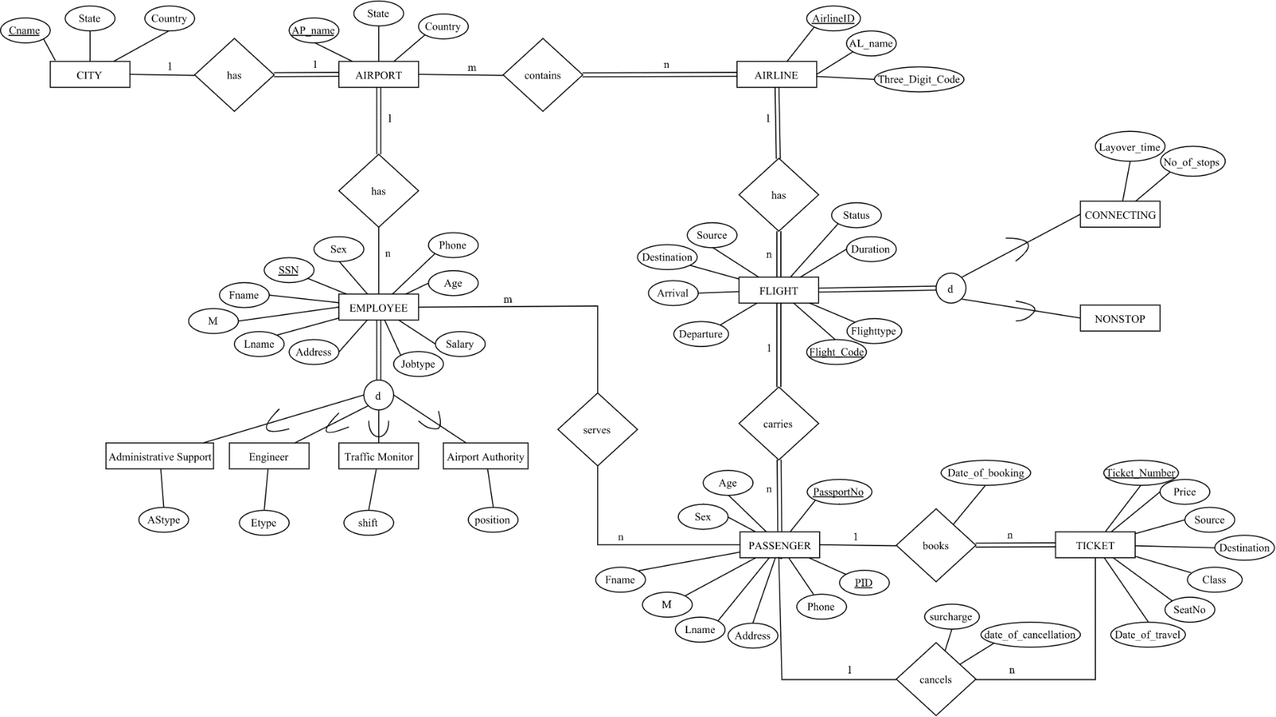

Airport Management System ER Diagram

# **ER to Table**

ER diagram contains following relationships

|  |  |  |  |
| --- | --- | --- | --- |
| Entity 1 | Name of the Relationship | Entity 2 | Cardinality |
| City | has | Airport | 1:1 |
| Airport | contains | Airline | m : n |
| Airport | has | Employee | 1 : n |
| Airline | has | Flight | 1 : n |
| Flight | carries | Passengers | 1 : n |
| Employee | serves | Passengers | m : n |
| Passenger | books | Ticket | 1 : n |
| Passenger | cancels | Ticket | 1 : n |

|  |  |
| --- | --- |
| Type of the binary relationship | Relationships in the system |
| one-to-one | (1 A city has only one airport. |
| one-to-many | 1. An airline has multiple flights, that is many flights belong to the same airline company. 2. A flight carries many passengers. 3. A passenger can book one or more tickets. 4. A passenger can cancel one or more tickets. |
| many-to-many | All International airlines operating through various countries across the world have their offices located in all major cities and airports they cover. Hence, an  airport may have many airline offices. |

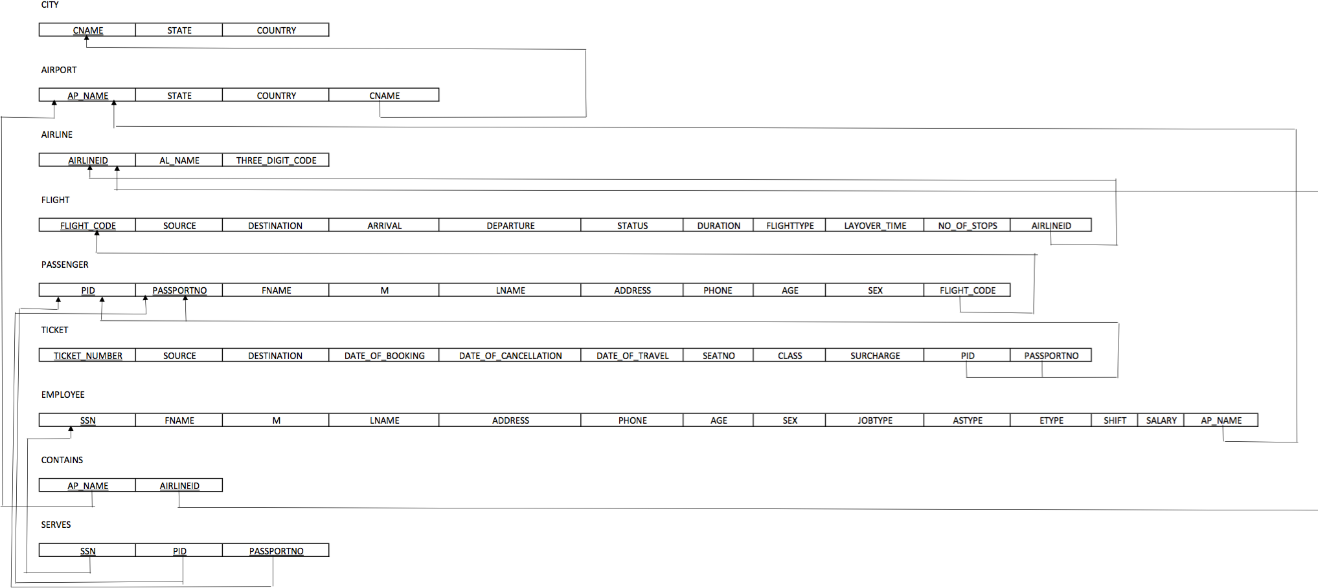

# **NORMALIZATION**

|  |  |
| --- | --- |
| FUNCTIONAL DEPENDECIES |  |
| PASSPORTNO -> FNAME, M, LNAME, ADDRESS, PHONE, AGE, SEX | Violates 2NF |
| PID -> FLIGHT_CODE | Violates 2NF |
| DATE_OF_BOOKING, SOURCE, DESTINATION, CLASS -> PRICE | Violates 3NF |
| DATE_OF_CANCELLATION -> SURCHARGE | Violates 3NF |
| JOBTYPE -> SALARY | Violates 3NF |

Normalizing 3NF

NORMALIZATION

CITY (CNAME, STATE, COUNTRY)

AIRPORT (AP_NAME, STATE, COUNTRY, CNAME)

AIRLINE (AIRLINEID, AL_NAME, THREE_DIGIT_CODE)

CONTAINS (AIRLINEID, AP_NAME)

FLIGHT (FLIGHT_CODE, SOURCE, DESTINATION, ARRIVAL, DEPARTURE, STATUS, DURATION, FLIGHTTYPE, LAYOVER_TIME, NO_OF_STOPS, AIRLINEID)

PASSENGER1 (PID, PASSPORTNO)

PASSENGER2(PASSPORTNO, FNAME, M, LNAME, ADDRESS, PHONE, AGE, SEX)

PASSENGER3 (PID, FLIGHT_CODE)

TICKET1 (TICKET_NUMBER, SOURCE, DESTINATION, DATE_OF_BOOKING, DATE_OF_TRAVEL, SEATNO, CLASS, DATE_OF_CANCELLATION, PID, PASSPORTNO)

TICKET2 (DATE_OF_BOOKING, SOURCE, DESTINATION, CLASS, PRICE)

TICKET3 (DATE_OF_CANCELLATION, SURCHARGE)

EMPLOYEE1 (SSN, FNAME, M, LNAME, ADDRESS, PHONE, AGE, SEX, JOBTYPE, ASTYPE, ETYPE, SHIFT, POSITION, AP_NAME)

EMPLOYEE2(JOBTYPE, SALARY)

SERVES (SSN, PID, PASSPORTNO)

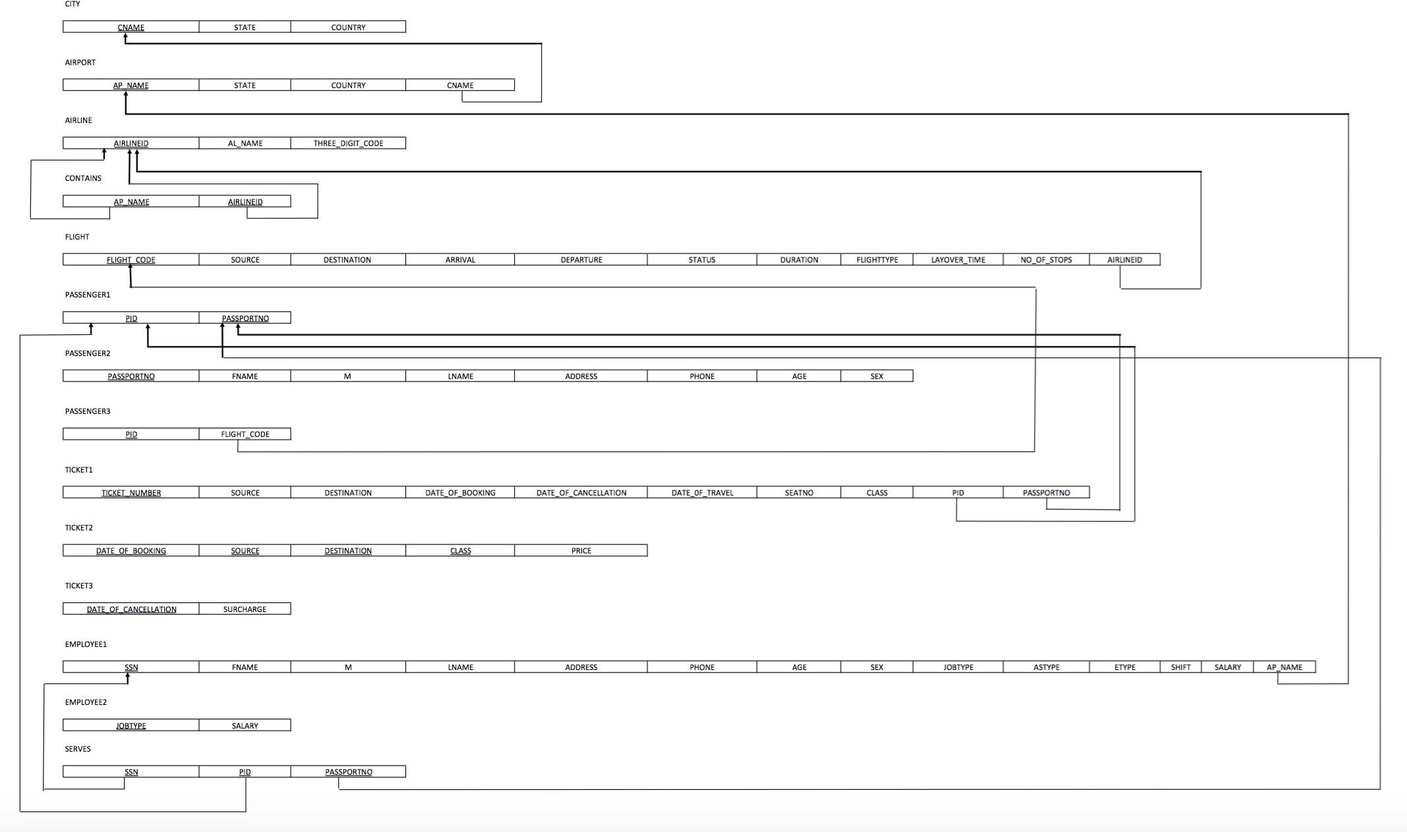

# **SQL & PL/SQL**

-- -- Inserting Table: CITY--

-- CREATE TABLE CITY

-- (CNAME VARCHAR(15) NOT NULL, STATE VARCHAR(15),

-- COUNTRY VARCHAR(30), PRIMARY KEY(CNAME));

-- -- Inserting values of Table: CITY--

-- INSERT INTO CITY (CNAME, STATE, COUNTRY) VALUES('Louisville','Kentucky','United States');

-- INSERT INTO CITY (CNAME, STATE, COUNTRY) VALUES ('Chandigarh','Chandigarh','India');

-- INSERT INTO CITY (CNAME, STATE, COUNTRY) VALUES ('Fort Worth','Texas','United States');

-- INSERT INTO CITY (CNAME, STATE, COUNTRY) VALUES('Delhi','Delhi','India');

-- INSERT INTO CITY (CNAME, STATE, COUNTRY) VALUES('Mumbai','Maharashtra','India');

-- INSERT INTO CITY (CNAME, STATE, COUNTRY) VALUES('San Francisco', 'California', 'United States');

-- INSERT INTO CITY (CNAME, STATE, COUNTRY) VALUES('Frankfurt','Hesse','Germany');

-- INSERT INTO CITY (CNAME, STATE, COUNTRY) VALUES('Houston','Texas','United States');

-- INSERT INTO CITY (CNAME, STATE, COUNTRY) VALUES('New York City','New York','United States');

-- INSERT INTO CITY (CNAME, STATE, COUNTRY) VALUES('Tampa', 'Florida', 'United States');

-- -- Inserting Table: AIRPORT--

-- CREATE TABLE AIRPORT

-- (AP_NAME VARCHAR(100) NOT NULL, STATE VARCHAR(15),

-- COUNTRY VARCHAR(30), CNAME VARCHAR2(15), PRIMARY KEY(AP_NAME),

-- FOREIGN KEY(CNAME) REFERENCES CITY(CNAME) ON DELETE CASCADE);

-- --Inserting values for Table: AIRPORT--

-- INSERT INTO AIRPORT (AP_NAME, STATE, COUNTRY, CNAME) VALUES('Louisville International Airport','Kentucky','United States','Louisville');

-- INSERT INTO AIRPORT (AP_NAME, STATE, COUNTRY, CNAME) VALUES('Chandigarh International Airport','Chandigarh','India','Chandigarh');

-- INSERT INTO AIRPORT (AP_NAME, STATE, COUNTRY, CNAME) VALUES('Dallas/Fort Worth International Airport','Texas','United States','Fort Worth');

-- INSERT INTO AIRPORT (AP_NAME, STATE, COUNTRY, CNAME) VALUES('Indira GandhiInternational Airport','Delhi','India','Delhi');

-- INSERT INTO AIRPORT (AP_NAME, STATE, COUNTRY, CNAME) VALUES('Chhatrapati Shivaji International Airport','Maharashtra','India','Mumbai');

-- INSERT INTO AIRPORT (AP_NAME, STATE, COUNTRY, CNAME) VALUES('San Francisco International Airport','California', 'United States','San Francisco');

-- INSERT INTO AIRPORT (AP_NAME, STATE, COUNTRY, CNAME) VALUES('Frankfurt Airport','Hesse','Germany','Frankfurt');

-- INSERT INTO AIRPORT (AP_NAME, STATE, COUNTRY, CNAME) VALUES('George Bush Intercontinental Airport','Texas','United States','Houston');

-- INSERT INTO AIRPORT (AP_NAME, STATE, COUNTRY, CNAME) VALUES('John F. Kennedy International Airport','New York','United States','New York City');

-- INSERT INTO AIRPORT (AP_NAME, STATE, COUNTRY, CNAME) VALUES('Tampa International Airport','Florida', 'United States','Tampa');

-- -- Inserting Table: AIRLINE--

-- CREATE TABLE AIRLINE

-- (AIRLINEID VARCHAR(3) NOT NULL, AL_NAME VARCHAR2(50), THREE_DIGIT_CODE VARCHAR(3), PRIMARY KEY(AIRLINEID));

-- -- Inserting values for Table: AIRLINE --

-- INSERT INTO AIRLINE (AIRLINEID, AL_NAME, THREE_DIGIT_CODE) VALUES('AA','American Airlines','001');

-- INSERT INTO AIRLINE (AIRLINEID, AL_NAME, THREE_DIGIT_CODE) VALUES('AI','Air India Limited','098');

-- INSERT INTO AIRLINE (AIRLINEID, AL_NAME, THREE_DIGIT_CODE) VALUES('LH','Lufthansa', '220');

-- INSERT INTO AIRLINE (AIRLINEID, AL_NAME, THREE_DIGIT_CODE) VALUES('BA','British Airways','125');

-- INSERT INTO AIRLINE (AIRLINEID, AL_NAME, THREE_DIGIT_CODE) VALUES('QR','Qatar Airways','157');

-- INSERT INTO AIRLINE (AIRLINEID, AL_NAME, THREE_DIGIT_CODE) VALUES('9W','Jet Airways','589');

-- INSERT INTO AIRLINE (AIRLINEID, AL_NAME, THREE_DIGIT_CODE) VALUES('EK','Emirates','176');

-- INSERT INTO AIRLINE (AIRLINEID, AL_NAME, THREE_DIGIT_CODE) VALUES('EY','Ethiad Airways','607');

-- -- Inserting Table: CONTAINS--

-- CREATE TABLE CONTAINS (AIRLINEID VARCHAR(3) NOT NULL,AP_NAME VARCHAR(100) NOT NULL, PRIMARY KEY(AIRLINEID, AP_NAME),

-- FOREIGN KEY(AIRLINEID) REFERENCES AIRLINE(AIRLINEID) ON DELETE CASCADE, FOREIGN KEY(AP_NAME) REFERENCES AIRPORT(AP_NAME) ON DELETE CASCADE);

-- -- Inserting values into Table: CONTAINS--

-- INSERT INTO CONTAINS (AIRLINEID, AP_NAME) VALUES('AA','Louisville International Airport');

-- INSERT INTO CONTAINS (AIRLINEID, AP_NAME) VALUES('AA','John F. Kennedy International Airport');

-- INSERT INTO CONTAINS (AIRLINEID, AP_NAME) VALUES('AA','George Bush Intercontinental Airport');

-- INSERT INTO CONTAINS (AIRLINEID, AP_NAME) VALUES('AA','San Francisco International Airport');

-- INSERT INTO CONTAINS (AIRLINEID, AP_NAME) VALUES('AA','Tampa International Airport');

-- INSERT INTO CONTAINS (AIRLINEID, AP_NAME) VALUES('AI','Chandigarh International Airport');

-- INSERT INTO CONTAINS (AIRLINEID, AP_NAME) VALUES('AI','Dallas/Fort Worth International Airport');

-- INSERT INTO CONTAINS (AIRLINEID, AP_NAME) VALUES('AI','Indira GandhiInternational Airport');

-- INSERT INTO CONTAINS (AIRLINEID, AP_NAME) VALUES('AI','Chhatrapati Shivaji International Airport');

-- INSERT INTO CONTAINS (AIRLINEID, AP_NAME) VALUES('AI','George Bush Intercontinental Airport');

-- INSERT INTO CONTAINS (AIRLINEID, AP_NAME) VALUES('LH','Chhatrapati Shivaji International Airport');

-- INSERT INTO CONTAINS (AIRLINEID, AP_NAME) VALUES('LH','Frankfurt Airport');

-- INSERT INTO CONTAINS (AIRLINEID, AP_NAME) VALUES('LH','John F. Kennedy International Airport');

-- INSERT INTO CONTAINS (AIRLINEID, AP_NAME) VALUES('LH','San Francisco International Airport');

-- INSERT INTO CONTAINS (AIRLINEID, AP_NAME) VALUES('LH','Dallas/Fort Worth International Airport');

-- INSERT INTO CONTAINS (AIRLINEID, AP_NAME) VALUES('BA','John F. Kennedy International Airport');

-- INSERT INTO CONTAINS (AIRLINEID, AP_NAME) VALUES('BA','Chhatrapati Shivaji International Airport');

-- INSERT INTO CONTAINS (AIRLINEID, AP_NAME) VALUES('BA','Chandigarh International Airport');

-- INSERT INTO CONTAINS (AIRLINEID, AP_NAME) VALUES('BA','Frankfurt Airport');

-- INSERT INTO CONTAINS (AIRLINEID, AP_NAME) VALUES('BA','San Francisco International Airport');

-- INSERT INTO CONTAINS (AIRLINEID, AP_NAME) VALUES('QR','Chhatrapati Shivaji International Airport');

-- INSERT INTO CONTAINS (AIRLINEID, AP_NAME) VALUES('QR','Dallas/Fort Worth International Airport');

-- INSERT INTO CONTAINS (AIRLINEID, AP_NAME) VALUES('QR','John F. Kennedy International Airport');

-- INSERT INTO CONTAINS (AIRLINEID, AP_NAME) VALUES('QR','Tampa International Airport');

-- INSERT INTO CONTAINS (AIRLINEID, AP_NAME) VALUES('QR','Louisville International Airport');

-- -- Inserting Table: FLIGHT--

-- CREATE TABLE FLIGHT

-- (FLIGHT_CODE VARCHAR(10) NOT NULL, SOURCE VARCHAR(3),

-- DESTINATION VARCHAR(3), ARRIVAL VARCHAR(10), DEPARTURE VARCHAR(10),

-- STATUS VARCHAR(10), DURATION VARCHAR(30), FLIGHTTYPE VARCHAR(10), LAYOVER_TIME VARCHAR(30), NO_OF_STOPS INT,

-- AIRLINEID VARCHAR(3), PRIMARY KEY(FLIGHT_CODE),

-- FOREIGN KEY(AIRLINEID) REFERENCES AIRLINE(AIRLINEID) ON DELETE CASCADE);

-- -- Inserting values into Table: FLIGHT—

-- INSERT INTO FLIGHT(FLIGHT_CODE, SOURCE, DESTINATION, ARRIVAL, DEPARTURE, STATUS, DURATION, FLIGHTTYPE, LAYOVER_TIME, NO_OF_STOPS, AIRLINEID) VALUES('AI2014','BOM','DFW','02:10','03:15','On-time','24hr','Connecting',3,1,'AI');

-- INSERT INTO FLIGHT(FLIGHT_CODE, SOURCE, DESTINATION, ARRIVAL, DEPARTURE, STATUS, DURATION, FLIGHTTYPE, LAYOVER_TIME, NO_OF_STOPS, AIRLINEID) VALUES('QR2305','BOM','DFW','13:00','13:55','Delayed','21hr','Non-stop',0,0,'QR');

-- INSERT INTO FLIGHT(FLIGHT_CODE, SOURCE, DESTINATION, ARRIVAL, DEPARTURE, STATUS, DURATION, FLIGHTTYPE, LAYOVER_TIME, NO_OF_STOPS, AIRLINEID)VALUES('EY1234','JFK','TPA','19:20','20:05','On-time','16hrs','Connecting',5,2,'EY');

-- INSERT INTO FLIGHT(FLIGHT_CODE, SOURCE, DESTINATION, ARRIVAL, DEPARTURE, STATUS, DURATION, FLIGHTTYPE, LAYOVER_TIME, NO_OF_STOPS, AIRLINEID) VALUES('LH9876','JFK','BOM','05:50','06:35','On-time','18hrs','Non-stop',0,0,'LH');

-- INSERT INTO FLIGHT(FLIGHT_CODE, SOURCE, DESTINATION, ARRIVAL, DEPARTURE, STATUS, DURATION, FLIGHTTYPE, LAYOVER_TIME, NO_OF_STOPS, AIRLINEID) VALUES('BA1689','FRA','DEL','10:20','10:55','On-time','14hrs','Non-stop',0,0,'BA');

-- INSERT INTO FLIGHT(FLIGHT_CODE, SOURCE, DESTINATION, ARRIVAL, DEPARTURE, STATUS, DURATION, FLIGHTTYPE, LAYOVER_TIME, NO_OF_STOPS, AIRLINEID) VALUES('AA4367','SFO','FRA','18:10','18:55','On-time','21hrs','Non-stop',0,0,'AA');

-- INSERT INTO FLIGHT(FLIGHT_CODE, SOURCE, DESTINATION, ARRIVAL, DEPARTURE, STATUS, DURATION, FLIGHTTYPE, LAYOVER_TIME, NO_OF_STOPS, AIRLINEID) VALUES('QR1902','IXC','IAH','22:00','22:50','Delayed','28hrs','Non-stop',5,1,'QR');

-- INSERT INTO FLIGHT(FLIGHT_CODE, SOURCE, DESTINATION, ARRIVAL, DEPARTURE, STATUS, DURATION, FLIGHTTYPE, LAYOVER_TIME, NO_OF_STOPS, AIRLINEID)VALUES('BA3056','BOM','DFW','02:15','02:55','On-time','29hrs','Connecting',3,1,'BA');

-- INSERT INTO FLIGHT(FLIGHT_CODE, SOURCE, DESTINATION, ARRIVAL, DEPARTURE, STATUS, DURATION, FLIGHTTYPE, LAYOVER_TIME, NO_OF_STOPS, AIRLINEID) VALUES('EK3456','BOM','SFO','18:50','19:40','On-time','30hrs','Non-stop',0,0,'EK');

-- INSERT INTO FLIGHT(FLIGHT_CODE, SOURCE, DESTINATION, ARRIVAL, DEPARTURE, STATUS, DURATION, FLIGHTTYPE, LAYOVER_TIME, NO_OF_STOPS, AIRLINEID) VALUES('9W2334','IAH','DEL','23:00','13:45','On-time','23hrs','Direct',0,0,'9W');

-- -- Inserting Table: PASSENGER1--

-- CREATE TABLE PASSENGER1 (PID INT NOT NULL,

-- PASSPORTNO VARCHAR(10) NOT NULL, PRIMARY KEY(PID, PASSPORTNO));

-- -- Inserting values in table: PASSENGER1--

-- INSERT INTO PASSENGER1(PID, PASSPORTNO) VALUES(1,'A1234568');

-- INSERT INTO PASSENGER1(PID, PASSPORTNO) VALUES(2,'B9876541');

-- INSERT INTO PASSENGER1(PID, PASSPORTNO) VALUES(3,'C2345698');

-- INSERT INTO PASSENGER1(PID, PASSPORTNO) VALUES(4,'D1002004');

-- INSERT INTO PASSENGER1(PID, PASSPORTNO) VALUES(5,'X9324666');

-- INSERT INTO PASSENGER1(PID, PASSPORTNO) VALUES(6,'B8765430');

-- INSERT INTO PASSENGER1(PID, PASSPORTNO) VALUES(7,'J9801235');

-- INSERT INTO PASSENGER1(PID, PASSPORTNO) VALUES(8,'A1122334');

-- INSERT INTO PASSENGER1(PID, PASSPORTNO) VALUES(9,'Q1243567');

-- INSERT INTO PASSENGER1(PID, PASSPORTNO) VALUES(10,'S1243269');

-- INSERT INTO PASSENGER1(PID, PASSPORTNO) VALUES(11,'E3277889');

-- INSERT INTO PASSENGER1(PID, PASSPORTNO) VALUES(12,'K3212322');

-- INSERT INTO PASSENGER1(PID, PASSPORTNO) VALUES(13,'P3452390');

-- INSERT INTO PASSENGER1(PID, PASSPORTNO) VALUES(14,'W7543336');

-- INSERT INTO PASSENGER1(PID, PASSPORTNO) VALUES(15,'R8990566');

-- Inserting Table: PASSENGER2--

-- CREATE TABLE PASSENGER2 (PASSPORTNO VARCHAR(10) NOT NULL, FNAME VARCHAR(20),

-- M VARCHAR(1), LNAME VARCHAR(20),ADDRESS VARCHAR(100), PHONE INT,AGE INT,

-- SEX VARCHAR(1),PRIMARY KEY(PASSPORTNO));

-- --Inserting VALUES IN TABLE: PASSENGER2--

-- INSERT INTO PASSENGER2(PASSPORTNO,FNAME,M,LNAME,ADDRESS,PHONE,AGE,SEX) VALUES('A1234568','ALEN','M','SMITH','2230 NORTHSIDE, APT 11, ALBANY, NY',8080367290,30,'M');

-- INSERT INTO PASSENGER2(PASSPORTNO,FNAME,M,LNAME,ADDRESS,PHONE,AGE,SEX) VALUES('B9876541','ANKITA','V','AHIR','3456 VIKAS APTS, APT 102,DOMBIVLI, INDIA',8080367280,26,'F');

-- INSERT INTO PASSENGER2(PASSPORTNO,FNAME,M,LNAME,ADDRESS,PHONE,AGE,SEX) VALUES('C2345698','KHYATI','A','MISHRA','7820 MCCALLUM COURTS, APT 234, AKRON, OH',8082267280,30,'F');

-- INSERT INTO PASSENGER2(PASSPORTNO,FNAME,M,LNAME,ADDRESS,PHONE,AGE,SEX) VALUES('D1002004','ANKITA','S','PATIL','7720 MCCALLUM BLVD, APT 1082, DALLAS, TX',9080367266,23,'F');

-- INSERT INTO PASSENGER2(PASSPORTNO,FNAME,M,LNAME,ADDRESS,PHONE,AGE,SEX) VALUES('X9324666','TEJASHREE','B','PANDIT','9082 ESTAES OF RICHARDSON, RICHARDSON, TX',9004360125,28,'F');

-- INSERT INTO PASSENGER2(PASSPORTNO,FNAME,M,LNAME,ADDRESS,PHONE,AGE,SEX) VALUES('B8765430','LAKSHMI','P','SHARMA','1110 FIR HILLS, APT 903, AKRON, OH',7666190505,30,'F');

-- INSERT INTO PASSENGER2(PASSPORTNO,FNAME,M,LNAME,ADDRESS,PHONE,AGE,SEX) VALUES('J9801235','AKHILESH','D','JOSHI','345 CHATHAM COURTS, APT 678, MUMBAI, INDIA',9080369290,29,'M');

-- INSERT INTO PASSENGER2(PASSPORTNO,FNAME,M,LNAME,ADDRESS,PHONE,AGE,SEX) VALUES('A1122334','MANAN','S','LAKHANI','5589 CHTHAM REFLECTIONS, APT 349 HOUSTON, TX',9004335126,25,'F');

-- INSERT INTO PASSENGER2(PASSPORTNO,FNAME,M,LNAME,ADDRESS,PHONE,AGE,SEX) VALUES('Q1243567','KARAN','M','MOTANI','4444 FRANKFORD VILLA, APT 77, GUILDERLAND, NY',9727626643,22,'M');

-- INSERT INTO PASSENGER2(PASSPORTNO,FNAME,M,LNAME,ADDRESS,PHONE,AGE,SEX) VALUES('S1243269','ROM','A','SOLANKI','7720 MCCALLUM BLVD, APT 2087, DALLAS, TX',9004568903,60,'M');

-- INSERT INTO PASSENGER2(PASSPORTNO,FNAME,M,LNAME,ADDRESS,PHONE,AGE,SEX) VALUES('E3277889','John','A','GATES','1234 BAKER APTS, APT 59, HESSE, GERMANY',9724569986,10,'M');

-- INSERT INTO PASSENGER2(PASSPORTNO,FNAME,M,LNAME,ADDRESS,PHONE,AGE,SEX) VALUES('K3212322','SARA','B','GOMES','6785 SPLITSVILLA, APT 34, MIAMI, FL',9024569226,15,'F');

-- INSERT INTO PASSENGER2(PASSPORTNO,FNAME,M,LNAME,ADDRESS,PHONE,AGE,SEX) VALUES('P3452390','ALIA','V','BHAT','548 MARKET PLACE, SAN Francisco, CA',9734567800,10,'F');

-- INSERT INTO PASSENGER2(PASSPORTNO,FNAME,M,LNAME,ADDRESS,PHONE,AGE,SEX) VALUES('W7543336','JOHN','P','SMITH','6666 ROCK HILL, APT 2902, TAMPA, FL',4624569986,55,'M');

-- INSERT INTO PASSENGER2(PASSPORTNO,FNAME,M,LNAME,ADDRESS,PHONE,AGE,SEX) VALUES('R8990566','RIA','T','GUPTA','3355 PALENCIA, APT 2065, MUMBAI, INDIA',4724512343,10,'M');

-- -- Inserting Table: PASSENGER3--

-- CREATE TABLE PASSENGER3 (PID INT NOT NULL, FLIGHT_CODE VARCHAR(10), PRIMARY KEY(PID),

-- FOREIGN KEY(FLIGHT_CODE) REFERENCES FLIGHT(FLIGHT_CODE) ON DELETE CASCADE);

-- -- Inserting values into Table: PASSENGER3--

-- INSERT INTO PASSENGER3(PID, FLIGHT_CODE) VALUES(1,'AI2014');

-- INSERT INTO PASSENGER3(PID, FLIGHT_CODE) VALUES(2,'LH9876');

-- INSERT INTO PASSENGER3(PID, FLIGHT_CODE) VALUES(3,'9W2334');

-- INSERT INTO PASSENGER3(PID, FLIGHT_CODE) VALUES(4,'QR1902');

-- INSERT INTO PASSENGER3(PID, FLIGHT_CODE) VALUES(5,'EY1234');

-- INSERT INTO PASSENGER3(PID, FLIGHT_CODE) VALUES(6,'BA3056');

-- INSERT INTO PASSENGER3(PID, FLIGHT_CODE) VALUES(7,'9W2334');

-- INSERT INTO PASSENGER3(PID, FLIGHT_CODE) VALUES(8,'AA4367');

-- INSERT INTO PASSENGER3(PID, FLIGHT_CODE) VALUES(9,'QR1902');

-- INSERT INTO PASSENGER3(PID, FLIGHT_CODE) VALUES(10,'EK3456');

-- INSERT INTO PASSENGER3(PID, FLIGHT_CODE) VALUES(11,'BA1689');

-- INSERT INTO PASSENGER3(PID, FLIGHT_CODE) VALUES(12,'QR1902');

-- INSERT INTO PASSENGER3(PID, FLIGHT_CODE) VALUES(13,'AI2014');

-- INSERT INTO PASSENGER3(PID, FLIGHT_CODE) VALUES(14,'BA1689');

-- INSERT INTO PASSENGER3(PID, FLIGHT_CODE) VALUES(15,'QR2305');

-- -- Inserting Table: EMPLOYEE1—

-- CREATE TABLE EMPLOYEE1 (SSN INT NOT NULL, FNAME VARCHAR2(20),

-- M VARCHAR(1), LNAME VARCHAR(20),

-- ADDRESS VARCHAR(100), PHONE INT,

-- AGE INT,SEX VARCHAR(1), JOBTYPE VARCHAR(30), ASTYPE VARCHAR(30), ETYPE VARCHAR(30), SHIFT VARCHAR(20), POSITION VARCHAR(30),AP_NAME VARCHAR(100), PRIMARY KEY(SSN),

-- FOREIGN KEY(AP_NAME) REFERENCES AIRPORT(AP_NAME) ON DELETE CASCADE);

-- -- Implementing Business Rule Using Check Constraint--

-- -- AGE OF AN EMPLOYEE WORKING FOR AN AIRPORT SHOULD NOT BE GREATER THAN 65--

-- ALTER TABLE EMPLOYEE1

-- ADD CONSTRAINT AGE_LIMIT CHECK(AGE < 65);

-- -- Example Of Violation Of Check Constraint--

-- INSERT INTO EMPLOYEE1(SSN, FNAME, M, LNAME, ADDRESS, PHONE, AGE, SEX, JOBTYPE, ASTYPE, ETYPE, SHIFT, POSITION, AP_NAME)VALUES(123456799,'RAM','M','SHARMA','731 HILL TOWN, ARLINGTON, TX',4356789365, 66,'M','ADMINISTRATIVE SUPPORT','RECEPTIONIST','','','','Louisville International Airport');

-- -- Inserting values in table: EMPLOYEE1 --

-- INSERT INTO EMPLOYEE1(SSN, FNAME, M, LNAME, ADDRESS, PHONE, AGE, SEX, JOBTYPE, ASTYPE, ETYPE, SHIFT, POSITION, AP_NAME)VALUES(123456789,'LINDA','M','GOODMAN','731 Fondren, Houston, TX',4356789345, 35,'F','ADMINISTRATIVE SUPPORT','RECEPTIONIST','','','','Louisville International Airport');

-- INSERT INTO EMPLOYEE1(SSN, FNAME, M, LNAME, ADDRESS, PHONE, AGE, SEX, JOBTYPE, ASTYPE, ETYPE, SHIFT, POSITION, AP_NAME)VALUES(333445555,'JOHNY','N','PAUL','638 Voss, Houston, TX',9834561995, 40, 'M','ADMINISTRATIVE SUPPORT','SECRETARY','','','','Louisville International Airport');

-- INSERT INTO EMPLOYEE1(SSN, FNAME, M, LNAME, ADDRESS, PHONE, AGE, SEX, JOBTYPE, ASTYPE, ETYPE, SHIFT, POSITION, AP_NAME)VALUES(999887777,'JAMES','P','BOND','3321 Castle, Spring, TX',9834666995, 50,'M','ENGINEER','','RADIO ENGINEER','','','Louisville International Airport');

-- INSERT INTO EMPLOYEE1(SSN, FNAME, M, LNAME, ADDRESS, PHONE, AGE, SEX, JOBTYPE, ASTYPE, ETYPE, SHIFT, POSITION, AP_NAME)VALUES(987654321,'SHERLOCK','A','HOLMES','123 TOP HILL, SAN Francisco,CA',8089654321, 47,'M','TRAFFIC MONITOR','','','DAY','','San Francisco International Airport');

-- INSERT INTO EMPLOYEE1(SSN, FNAME, M, LNAME, ADDRESS, PHONE, AGE, SEX, JOBTYPE, ASTYPE, ETYPE, SHIFT, POSITION, AP_NAME)VALUES(666884444,'SHELDON','A','COOPER','345 CHERRY PARK, HESSE,GERMANY',1254678903, 55, 'M','TRAFFIC MONITOR','','NIGHT','','','Frankfurt Airport');

-- INSERT INTO EMPLOYEE1(SSN, FNAME, M, LNAME, ADDRESS, PHONE, AGE, SEX, JOBTYPE, ASTYPE, ETYPE, SHIFT, POSITION, AP_NAME)VALUES(453453453,'RAJ','B','SHARMA','345 FLOYDS, MUMBAI,INDIA',4326789031, 35, 'M','AIRPORT AUTHORITY','','','','MANAGER','Chhatrapati Shivaji International Airport');

-- INSERT INTO EMPLOYEE1(SSN, FNAME, M, LNAME, ADDRESS, PHONE, AGE, SEX, JOBTYPE, ASTYPE, ETYPE, SHIFT, POSITION, AP_NAME)VALUES(987987987,'NIKITA','C','PAUL','110 SYNERGY PARK, DALLAS,TX',5678904325, 33,'F','ENGINEER','','AIRPORT CIVIL ENGINEER','','','Dallas/Fort Worth International Airport');

-- INSERT INTO EMPLOYEE1(SSN, FNAME, M, LNAME, ADDRESS, PHONE, AGE, SEX, JOBTYPE, ASTYPE, ETYPE, SHIFT, POSITION, AP_NAME)VALUES(888665555,'SHUBHAM','R','GUPTA','567 CHANDANI CHOWK, DELHI, INDIA',8566778890, 39,'M','ADMINISTRATIVE SUPPORT','DATA ENTRY WORKER','','','','Indira GandhiInternational Airport');

-- INSERT INTO EMPLOYEE1(SSN, FNAME, M, LNAME, ADDRESS, PHONE, AGE, SEX, JOBTYPE, ASTYPE, ETYPE, SHIFT, POSITION, AP_NAME)VALUES(125478909,'PRATIK','T','GOMES','334 VITRUVIAN PARK, ALBANY, NY',4444678903, 56,'M','TRAFFIC MONITOR','','DAY','','','John F. Kennedy International Airport');

-- INSERT INTO EMPLOYEE1(SSN, FNAME, M, LNAME, ADDRESS, PHONE, AGE, SEX, JOBTYPE, ASTYPE, ETYPE, SHIFT, POSITION, AP_NAME)VALUES(324567897,'ADIT','P','DESAI','987 SOMNATH, CHANDIGARH, INDIA',2244658909, 36,'M','TRAFFIC MONITOR','','DAY','','','Chandigarh International Airport');

-- -- Inserting Table: EMPLOYEE2 --

-- CREATE TABLE EMPLOYEE2 (JOBTYPE VARCHAR(30) NOT NULL, SALARY INT,

-- PRIMARY KEY(JOBTYPE));

-- --INSERTING VALUES INTO TABLE: EMPLOYEE2 --

-- INSERT INTO EMPLOYEE2(JOBTYPE, SALARY)VALUES('ADMINISTRATIVE SUPPORT',50000); INSERT INTO EMPLOYEE2(JOBTYPE, SALARY)VALUES('ENGINEER',70000);

-- INSERT INTO EMPLOYEE2(JOBTYPE, SALARY)VALUES('TRAFFIC MONITOR',80000); INSERT INTO EMPLOYEE2(JOBTYPE, SALARY)VALUES('AIRPORT AUTHORITY',90000);

-- -- Inserting Table: SERVES --

-- CREATE TABLE SERVES (SSN INT NOT NULL, PID INT NOT NULL,

-- PASSPORTNO VARCHAR(10) NOT NULL, PRIMARY KEY(SSN, PID, PASSPORTNO),

-- FOREIGN KEY(SSN) REFERENCES EMPLOYEE1(SSN) ON DELETE CASCADE,

-- FOREIGN KEY(PID, PASSPORTNO) REFERENCES PASSENGER1(PID, PASSPORTNO) ON DELETE CASCADE);

-- -- INSERTING VALUES INTO TABLE: SERVES --

-- INSERT INTO SERVES(SSN, PID, PASSPORTNO) VALUES(123456789,1,'A1234568');

-- INSERT INTO SERVES(SSN, PID, PASSPORTNO) VALUES(123456789,15,'R8990566');

-- INSERT INTO SERVES(SSN, PID, PASSPORTNO) VALUES(123456789,9,'Q1243567');

-- INSERT INTO SERVES(SSN, PID, PASSPORTNO) VALUES(888665555,4,'D1002004');

-- INSERT INTO SERVES(SSN, PID, PASSPORTNO) VALUES(888665555,13,'P3452390');

-- INSERT INTO SERVES(SSN, PID, PASSPORTNO) VALUES(333445555,10,'S1243269');

-- INSERT INTO SERVES(SSN, PID, PASSPORTNO) VALUES(333445555,12,'K3212322');

-- INSERT INTO SERVES(SSN, PID, PASSPORTNO) VALUES(888665555,12,'K3212322');

-- INSERT INTO SERVES(SSN, PID, PASSPORTNO) VALUES(123456789,7,'J9801235');

-- INSERT INTO SERVES(SSN, PID, PASSPORTNO) VALUES(888665555,7,'J9801235');

-- -- Inserting Table: TICKET1 --

-- CREATE TABLE TICKET1

-- (TICKET_NUMBER VARCHAR(13) NOT NULL, SOURCE VARCHAR(3),

-- DESTINATION VARCHAR(3), DATE_OF_BOOKING DATE, DATE_OF_TRAVEL DATE, SEATNO VARCHAR(5), CLASS VARCHAR(15),

-- DATE_OF_CANCELLATION DATE, PID INT,

-- PASSPORTNO VARCHAR(10),

-- FOREIGN KEY(PID, PASSPORTNO) REFERENCES PASSENGER1(PID, PASSPORTNO) ON DELETE CASCADE);

-- -- Adding CHECK constraint on an attribute TICKET_NUMBER --

-- ALTER TABLE TICKET1

-- ADD CONSTRAINT TICKET_NO_LENGTH CHECK(LENGTH(TICKET_NUMBER)=13);

-- -- Checking Violation Of A Constraint--

-- INSERT INTO TICKET1(TICKET_NUMBER, SOURCE, DESTINATION, DATE_OF_BOOKING, DATE_OF_CANCELLATION, DATE_OF_TRAVEL, SEATNO, CLASS, PID, PASSPORTNO) VALUES(00112341111221,'BOM','DFW','11-MAY-16','','15-DEC-16','32A','ECONOMY',1,'A1234568');

-- -- Inserting values into Table: TICKET1--

-- --INSERTING INTO TABLE: TICKET1--

-- INSERT INTO TICKET1(TICKET_NUMBER, SOURCE, DESTINATION, DATE_OF_BOOKING, DATE_OF_CANCELLATION, DATE_OF_TRAVEL, SEATNO, CLASS, PID, PASSPORTNO) VALUES(0011234111122,'BOM','DFW','11-MAY-16','','15-DEC-16','32A','ECONOMY',1,'A1234568');

-- INSERT INTO TICKET1(TICKET_NUMBER, SOURCE, DESTINATION, DATE_OF_BOOKING, DATE_OF_CANCELLATION, DATE_OF_TRAVEL, SEATNO, CLASS, PID, PASSPORTNO) VALUES(0984567222299,'JFK','BOM','11-JUN-16','10-DEC-16','20-DEC- 16','45D','ECONOMY',2,'B9876541');

-- INSERT INTO TICKET1(TICKET_NUMBER, SOURCE, DESTINATION, DATE_OF_BOOKING, DATE_OF_CANCELLATION, DATE_OF_TRAVEL, SEATNO, CLASS, PID, PASSPORTNO) VALUES(1768901333273,'IAH','DEL','21-AUG-16','','25-DEC-16','1A','BUSINESS',3,'C2345698');

-- INSERT INTO TICKET1(TICKET_NUMBER, SOURCE, DESTINATION, DATE_OF_BOOKING, DATE_OF_CANCELLATION, DATE_OF_TRAVEL, SEATNO, CLASS, PID, PASSPORTNO) VALUES(5890987441464,'IXC','IAH','10-AUG-16','','12-JAN-17','20C','FIRST-CLASS',4,'D1002004');

-- INSERT INTO TICKET1(TICKET_NUMBER, SOURCE, DESTINATION, DATE_OF_BOOKING, DATE_OF_CANCELLATION, DATE_OF_TRAVEL, SEATNO, CLASS, PID, PASSPORTNO) VALUES(1577654664266,'JFK','TPA','13-JUN-16','','10-DEC-16','54E','ECONOMY',5,'X9324666');

-- INSERT INTO TICKET1(TICKET_NUMBER, SOURCE, DESTINATION, DATE_OF_BOOKING, DATE_OF_CANCELLATION, DATE_OF_TRAVEL, SEATNO, CLASS, PID, PASSPORTNO) VALUES(2206543545545,'BOM','DFW','11-NOV-16','','12-FEB-17','43B','ECONOMY',6,'B8765430');

-- INSERT INTO TICKET1(TICKET_NUMBER, SOURCE, DESTINATION, DATE_OF_BOOKING, DATE_OF_CANCELLATION, DATE_OF_TRAVEL, SEATNO, CLASS, PID, PASSPORTNO) VALUES(7064321779737,'IAH','DEL','15-NOV-16','','25-DEC-16','27B','FIRST-CLASS',7,'J9801235');

-- INSERT INTO TICKET1(TICKET_NUMBER, SOURCE, DESTINATION, DATE_OF_BOOKING, DATE_OF_CANCELLATION, DATE_OF_TRAVEL, SEATNO, CLASS, PID, PASSPORTNO) VALUES(1571357215116,'SFO','FRA','15-OCT-16','','18-DEC-16','34E','ECONOMY',8,'A1122334');

-- INSERT INTO TICKET1(TICKET_NUMBER, SOURCE, DESTINATION, DATE_OF_BOOKING, DATE_OF_CANCELLATION, DATE_OF_TRAVEL, SEATNO, CLASS, PID, PASSPORTNO) VALUES(1570864987655,'IXC','IAH','12-NOV-16','','30-DEC-16','54C','ECONOMY',9,'Q1243567');

-- INSERT INTO TICKET1(TICKET_NUMBER, SOURCE, DESTINATION, DATE_OF_BOOKING, DATE_OF_CANCELLATION, DATE_OF_TRAVEL, SEATNO, CLASS, PID, PASSPORTNO) VALUES(1579283997799,'BOM','SFO','22-JAN-16','','15-DEC-16','38A','ECONOMY',10,'S1243269');

-- INSERT INTO TICKET1(TICKET_NUMBER, SOURCE, DESTINATION, DATE_OF_BOOKING, DATE_OF_CANCELLATION, DATE_OF_TRAVEL, SEATNO, CLASS, PID, PASSPORTNO) VALUES(1255701876107,'FRA','DEL','19-OCT-16','','31-DEC-16','57F','ECONOMY',11,'E3277889');

-- INSERT INTO TICKET1(TICKET_NUMBER, SOURCE, DESTINATION, DATE_OF_BOOKING, DATE_OF_CANCELLATION, DATE_OF_TRAVEL, SEATNO, CLASS, PID, PASSPORTNO) VALUES(1251334499699,'IXC','IAH','20-NOV-16','','12-JAN-17','45D','ECONOMY',12,'K3212322');

-- INSERT INTO TICKET1(TICKET_NUMBER, SOURCE, DESTINATION, DATE_OF_BOOKING, DATE_OF_CANCELLATION, DATE_OF_TRAVEL, SEATNO, CLASS, PID, PASSPORTNO) VALUES(1258776199490,'BOM','DFW','13-MAY-16','25-MAY-16','15-DEC- 16','37C','ECONOMY',13,'P3452390');

-- INSERT INTO TICKET1(TICKET_NUMBER, SOURCE, DESTINATION, DATE_OF_BOOKING, DATE_OF_CANCELLATION, DATE_OF_TRAVEL, SEATNO, CLASS, PID, PASSPORTNO) VALUES(5891155114477,'FRA','DEL','26-JUN-16','','23-DEC-16','55C','ECONOMY',14,'W7543336');

-- INSERT INTO TICKET1(TICKET_NUMBER, SOURCE, DESTINATION, DATE_OF_BOOKING, DATE_OF_CANCELLATION, DATE_OF_TRAVEL, SEATNO, CLASS, PID, PASSPORTNO) VALUES(5893069766787,'BOM','DFW','11-AUG-16','','22-DEC-16','33F','ECONOMY',15,'R8990566');

-- -- Inserting Table: TICKET2--

-- CREATE TABLE TICKET2 (DATE_OF_BOOKING DATE NOT NULL, SOURCE VARCHAR(3) NOT NULL, DESTINATION VARCHAR(3) NOT NULL, CLASS VARCHAR(15) NOT NULL, PRICE INT,

-- PRIMARY KEY(DATE_OF_BOOKING, SOURCE, DESTINATION, CLASS));

-- -- Inserting Values into: TICKET2 --

-- INSERT INTO TICKET2(DATE_OF_BOOKING, SOURCE, DESTINATION, CLASS, PRICE) VALUES('11-MAY-16','BOM','DFW','ECONOMY',95000);

-- INSERT INTO TICKET2(DATE_OF_BOOKING, SOURCE, DESTINATION, CLASS, PRICE) VALUES('11-JUN-16','JFK','BOM','ECONOMY',100000);

-- INSERT INTO TICKET2(DATE_OF_BOOKING, SOURCE, DESTINATION, CLASS, PRICE) VALUES('21-AUG-16','IAH','DEL','BUSINESS',200000);

-- INSERT INTO TICKET2(DATE_OF_BOOKING, SOURCE, DESTINATION, CLASS, PRICE) VALUES('10-AUG-16','IXC','IAH','FIRST-CLASS',150000);

-- INSERT INTO TICKET2(DATE_OF_BOOKING, SOURCE, DESTINATION, CLASS, PRICE) VALUES('13-JUN-16','JFK','TPA','ECONOMY',98000);

-- INSERT INTO TICKET2(DATE_OF_BOOKING, SOURCE, DESTINATION, CLASS, PRICE) VALUES('11-NOV-16','BOM','DFW','ECONOMY',125000);

-- INSERT INTO TICKET2(DATE_OF_BOOKING, SOURCE, DESTINATION, CLASS, PRICE) VALUES('15-NOV-16','IAH','DEL','FIRST-CLASS',195000);

-- INSERT INTO TICKET2(DATE_OF_BOOKING, SOURCE, DESTINATION, CLASS, PRICE) VALUES('15-OCT-16','SFO','FRA','ECONOMY',170000);

-- INSERT INTO TICKET2(DATE_OF_BOOKING, SOURCE, DESTINATION, CLASS, PRICE) VALUES('12-NOV-16','IXC','IAH','ECONOMY',140000);

-- INSERT INTO TICKET2(DATE_OF_BOOKING, SOURCE, DESTINATION, CLASS, PRICE) VALUES('22-JAN-16','BOM','SFO','ECONOMY',45000);

-- INSERT INTO TICKET2(DATE_OF_BOOKING, SOURCE, DESTINATION, CLASS, PRICE) VALUES('19-OCT-16','FRA','DEL','ECONOMY',100000);

-- INSERT INTO TICKET2(DATE_OF_BOOKING, SOURCE, DESTINATION, CLASS, PRICE) VALUES('20-NOV-16','IXC','IAH','ECONOMY',120000);

-- INSERT INTO TICKET2(DATE_OF_BOOKING, SOURCE, DESTINATION, CLASS, PRICE) VALUES('13-MAY-16','BOM','DFW','ECONOMY',65000);

-- INSERT INTO TICKET2(DATE_OF_BOOKING, SOURCE, DESTINATION, CLASS, PRICE) VALUES('26-JUN-16','FRA','DEL','ECONOMY',80000);

-- INSERT INTO TICKET2(DATE_OF_BOOKING, SOURCE, DESTINATION, CLASS, PRICE) VALUES('11-AUG-16','BOM','DFW','ECONOMY',98000);

-- -- Inserting Table: TICKET3 --

-- CREATE TABLE TICKET3 (DATE_OF_CANCELLATION DATE NOT NULL, SURCHARGE INT,

-- PRIMARY KEY(DATE_OF_CANCELLATION));

-- -- INSERTING VALUES INTO TABLE: TICKET3 --

-- INSERT INTO TICKET3(DATE_OF_CANCELLATION, SURCHARGE) VALUES('10-DEC-16',75000);

-- INSERT INTO TICKET3(DATE_OF_CANCELLATION, SURCHARGE) VALUES('25-MAY-16',25000);

**PROCEDURE:-**

2.1 -- CREATE OR REPLACE PROCEDURE DFWECONOMYPASSENGERS

-- AS

-- CURSOR ECOPASSDETAILS IS

-- SELECT

-- al.AL_NAME,fl.FLIGHT_CODE,p2.FNAME,p2.LNAME,p2.PASSPORTNO,t.CLASS,t.DATE_OF_TRAVEL,t.DESTINATION,t.SOURCE,t.SEATNO,t.TICKET_NUMBER

-- FROM

-- Airline al,Flight fl,PASSENGER1 p1,PASSENGER2 p2,PASSENGER3 p3,TICKET1 t

-- WHERE

-- al.AIRLINEID = fl.AIRLINEID AND p1.PID = p3.PID AND p1.PASSPORTNO = p2.PASSPORTNO AND fl.FLIGHT_CODE = p3.FLIGHT_CODE AND t.PASSPORTNO = p2.PASSPORTNO AND t.CLASS = 'ECONOMY' AND t.DESTINATION = 'DFW';

-- PASSDETAILS ECOPASSDETAILS%rowtype;

-- BEGIN

-- OPEN ECOPASSDETAILS;

-- LOOP

-- FETCH ECOPASSDETAILS INTO PASSDETAILS;

-- EXIT WHEN ECOPASSDETAILS%NOTFOUND;

-- dbms_output.put_line (

-- PASSDETAILS.AL_NAME || ' ' || PASSDETAILS.FLIGHT_CODE || ' ' || PASSDETAILS.FNAME || ' ' || ASSDETAILS.LNAME || ' ' || PASSDETAILS.PASSPORTNO || ' ' || PASSDETAILS.CLASS || ' ' || PASSDETAILS.SOURCE || ' ' || PASSDETAILS.SEATNO || ' ' || PASSDETAILS.TICKET_NUMBER

-- );

-- END LOOP;

-- CLOSE ECOPASSDETAILS;

-- END DFWECONOMYPASSENGERS;

-- execute DFWECONOMYPASSENGERS;

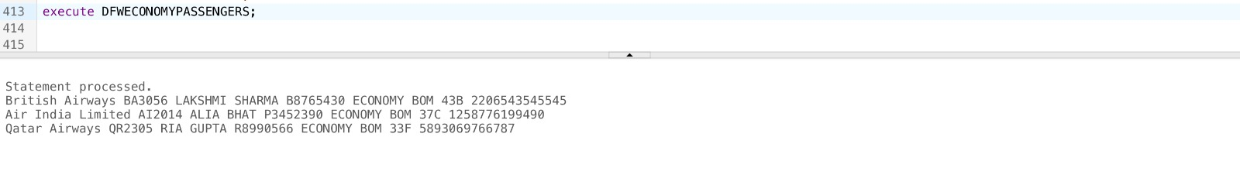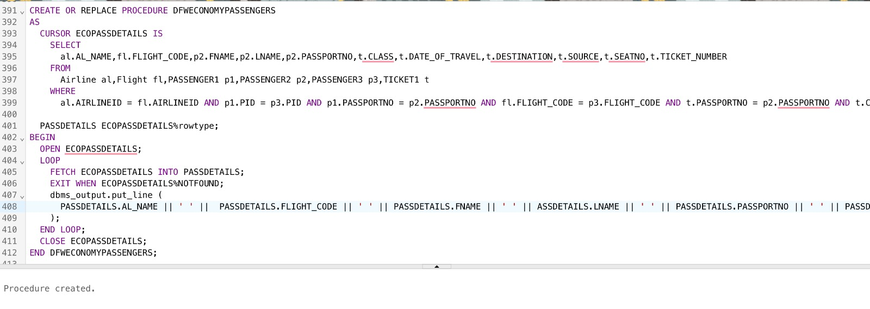

2.2 -- CREATE OR REPLACE PROCEDURE FLIGHTSBYSTATUS (IN_STATUS IN VARCHAR) AS

-- CURSOR fSTATUS is

-- SELECT DISTINCT F.FLIGHT_CODE ,AL.AL_NAME ,F.ARRIVAL,F.DEPARTURE, F.SOURCE,F.DESTINATION,F.STATUS,F.FLIGHTTYPE

-- FROM AIRLINE AL,AIRPORT AP, FLIGHT F WHERE AL.AIRLINEID=F.AIRLINEID

-- AND F.STATUS =IN_STATUS;

-- FlightStatus fSTATUS%rowtype;

-- BEGIN

-- Open fSTATUS ; LOOP

-- fetch fSTATUS into FlightStatus; EXIT WHEN fSTATUS%NOTFOUND;

-- DBMS_OUTPUT.PUT_LINE (FlightStatus.FLIGHT_CODE || ' ' || FlightStatus.AL_NAME || ' ' || FlightStatus.ARRIVAL || ' ' || FlightStatus.departure|| ' ' ||FlightStatus.Source || ' ' || FlightStatus.DESTINATION || ' ' || FlightStatus.STATUS || ' ' || FlightStatus.FLIGHTTYPE);

-- END LOOP;

-- CLOSE fSTATUS;

-- END FLIGHTSBYSTATUS;

-- EXECUTE FLIGHTSBYSTATUS('On-time');

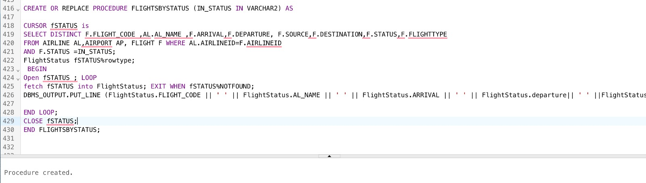

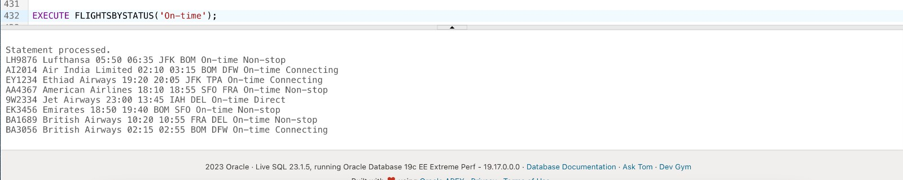

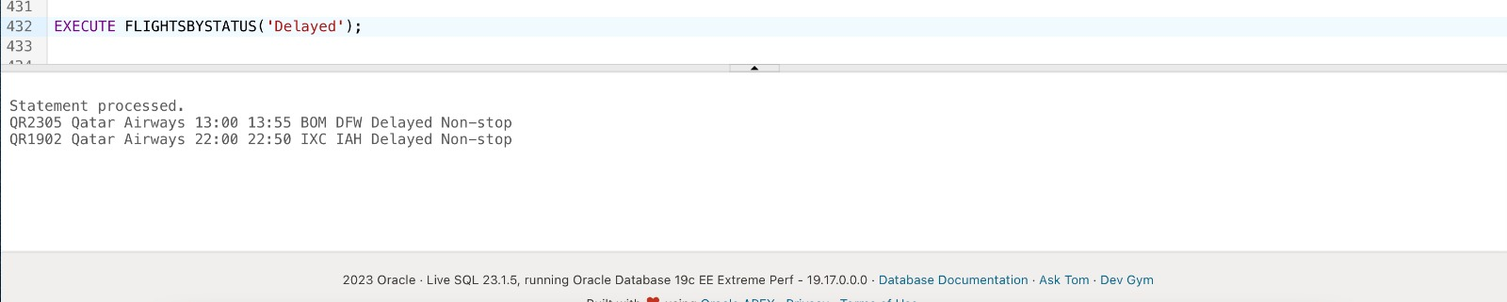

**Functions:-**

1.

CREATE OR REPLACE FUNCTION GET_EMPLOYEE_COUNT(AP_NAME IN VARCHAR)

RETURN NUMBER

IS

EMP_COUNT NUMBER;

BEGIN

SELECT COUNT(*) INTO EMP_COUNT

FROM EMPLOYEE1

WHERE AP_NAME = ap_name;

RETURN EMP_COUNT;

END;

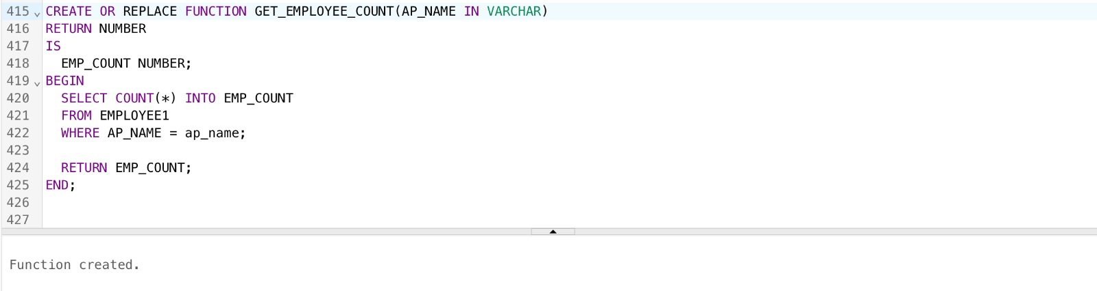

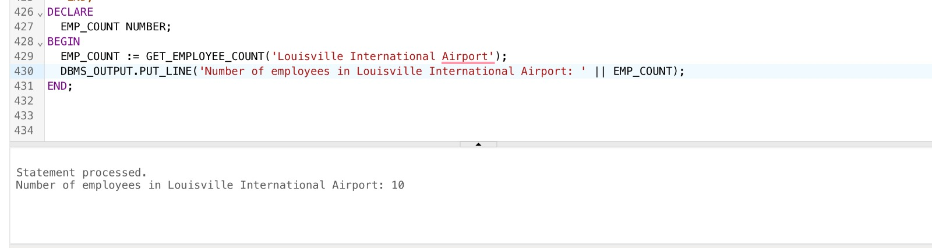

2.

CREATE OR REPLACE FUNCTION check_ticket_and_employee_age(ticket_num IN VARCHAR, emp_age IN NUMBER) RETURN VARCHAR AS

ticket_length CONSTANT NUMBER := 13;

result VARCHAR(100);

BEGIN

-- Check the length of the air ticket number

IF LENGTH(ticket_num) = ticket_length THEN

result := 'Air ticket number is valid';

ELSE

result := 'Air ticket number should be exactly 13 digits';

END IF;

-- Check the age of the employee

IF emp_age > 65 THEN

result := result || '; Employee age should not be greater than 65';

END IF;

RETURN result;

END;

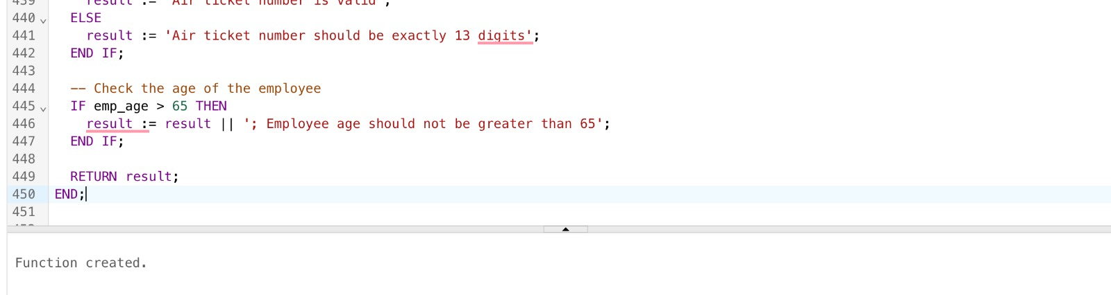

**Cursors:-**

1.

DECLARE

CURSOR ticket_cursor IS

SELECT DATE_OF_BOOKING, SOURCE, DESTINATION, CLASS, PRICE

FROM TICKET2;

-- Declare variables to hold the values from each row

v_date_of_booking DATE;

v_source VARCHAR2(3);

v_destination VARCHAR2(3);

v_class VARCHAR2(15);

v_price INT;

BEGIN

-- Open the cursor

OPEN ticket_cursor;

-- Loop through each row and retrieve the values

LOOP

FETCH ticket_cursor INTO v_date_of_booking, v_source, v_destination, v_class, v_price;

EXIT WHEN ticket_cursor%NOTFOUND;

-- Print the values to the console (or perform other actions as desired)

DBMS_OUTPUT.PUT_LINE('Date of Booking: ' || v_date_of_booking || ', Source: ' || v_source ||

', Destination: ' || v_destination || ', Class: ' || v_class || ', Price: ' || v_price);

END LOOP;

-- Close the cursor

CLOSE ticket_cursor;

END;

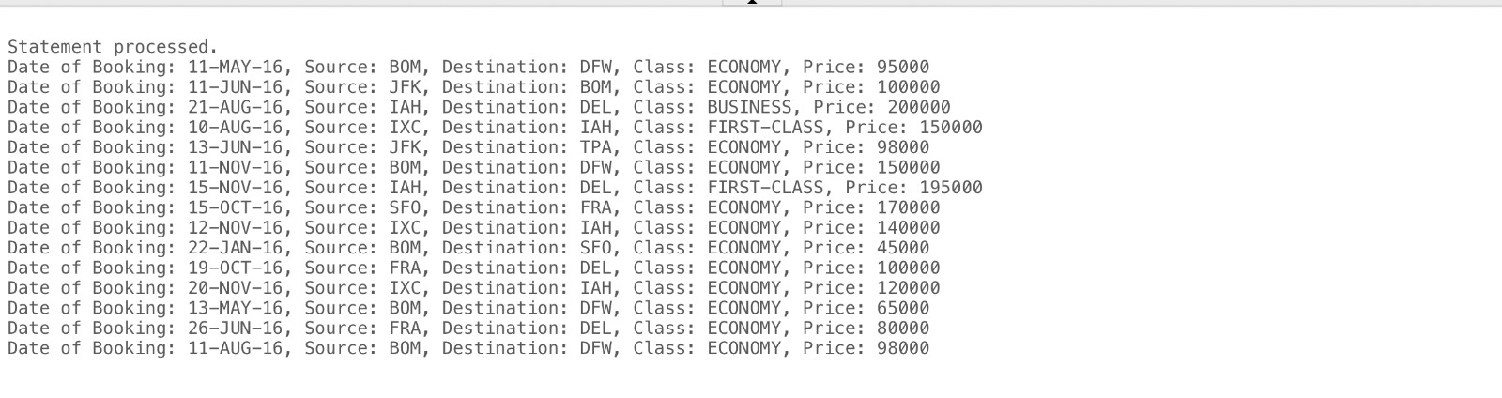

2.

DECLARE

CURSOR employee_cursor IS

SELECT SSN, FNAME, M, LNAME, ADDRESS, PHONE, AGE, SEX, JOBTYPE, ASTYPE, ETYPE, SHIFT, POSITION, AP_NAME

FROM EMPLOYEE1;

ssn EMPLOYEE1.SSN%TYPE;

fname EMPLOYEE1.FNAME%TYPE;

m EMPLOYEE1.M%TYPE;

lname EMPLOYEE1.LNAME%TYPE;

address EMPLOYEE1.ADDRESS%TYPE;

phone EMPLOYEE1.PHONE%TYPE;

age EMPLOYEE1.AGE%TYPE;

sex EMPLOYEE1.SEX%TYPE;

jobtype EMPLOYEE1.JOBTYPE%TYPE;

astype EMPLOYEE1.ASTYPE%TYPE;

etype EMPLOYEE1.ETYPE%TYPE;

shift EMPLOYEE1.SHIFT%TYPE;

position EMPLOYEE1.POSITION%TYPE;

ap_name AIRPORT.AP_NAME%TYPE;

BEGIN

OPEN employee_cursor;

LOOP

FETCH employee_cursor INTO ssn, fname, m, lname, address, phone, age, sex, jobtype, astype, etype, shift, position, ap_name;

EXIT WHEN employee_cursor%NOTFOUND;

-- Do something with the fetched data, e.g. print it out

DBMS_OUTPUT.PUT_LINE(ssn || ' ' || fname || ' ' || m || ' ' || lname || ' ' || address || ' ' || phone || ' ' || age || ' ' || sex || ' ' || jobtype || ' ' || astype || ' ' || etype || ' ' || shift || ' ' || position || ' ' || ap_name);

END LOOP;

CLOSE employee_cursor;

END;

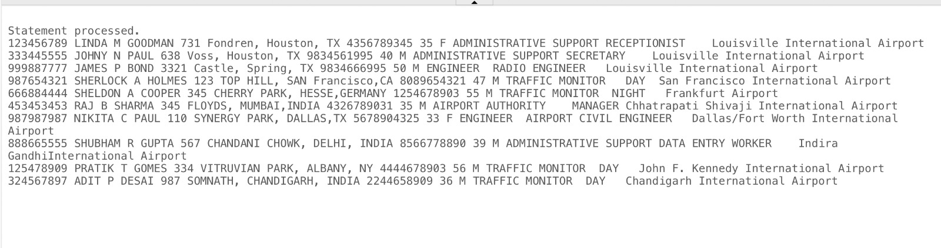

**TRIGGERS:-**

1. Trigger for, when a flight is delayed, it is logged into different tables.

**-**- CREATE TABLE DELAYED_FLIGHTS (

-- FLIGHT_CODE VARCHAR2(20),

-- DESTINATION VARCHAR(20),

-- SOURCE VARCHAR(20),

-- AIRLINEID VARCHAR(20),

-- REPORT_TIME DATE

-- );

-- CREATE OR REPLACE TRIGGER DELAYEDFLIGHTS

-- AFTER INSERT ON FLIGHT

-- FOR EACH ROW

-- BEGIN

-- IF UPDATING('STATUS') THEN

-- INSERT INTO DELAYED_FLIGHTS (FLIGHT_CODE, SOURCE, DESTINATION , AIRLINEID ,REPORT_TIME

-- ) VALUES(:NEW.FLIGHT_CODE,:NEW.SOURCE,:NEW.DESTINATION,:NEW.AIRLINEID,sysdate

-- );

-- END IF;

-- END;

-- /

-- INSERT INTO FLIGHT (FLIGHT_CODE, SOURCE, DESTINATION, ARRIVAL, DEPARTURE, STATUS, DURATION, FLIGHTTYPE, LAYOVER_TIME, NO_OF_STOPS, AIRLINEID) VALUES ('QR129','BOM','DFW','02:10','03:15','Delayed','24hr','Connecting',3,1,'AI');

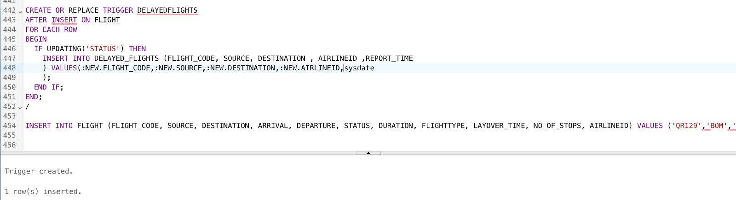

1. Trigger to update TICKET_PRICE_HISTORY table when the price of the air ticket is updated in TICKET2 table.

-- CREATE TABLE TICKET_PRICE_HISTORY (DATE_OF_BOOKING DATE NOT NULL, SOURCE VARCHAR(3) NOT NULL, DESTINATION VARCHAR(3) NOT NULL, CLASS VARCHAR2(15) NOT NULL, PRICE INT,

-- PRIMARY KEY(DATE_OF_BOOKING, SOURCE, DESTINATION, CLASS));

-- CREATE A TRIGGER TICKET_PRICE_HISTORY --

-- CREATE OR REPLACE TRIGGER TRIGG_TICKET_PRICE_HISTORY BEFORE UPDATE OF PRICE

-- ON TICKET2 FOR EACH ROW

-- BEGIN

-- INSERT INTO TICKET_PRICE_HISTORY

-- VALUES(:OLD.DATE_OF_BOOKING, :OLD.SOURCE, :OLD.DESTINATION, :OLD.CLASS, :OLD.PRICE);

-- END;

--LET'S UPDATE A PRICE OR FARE OF AN AIR TICKET --

-- UPDATE TICKET2 SET PRICE=150000

-- WHERE DATE_OF_BOOKING = TO_DATE('11-NOV-16','DD-MON-YY') AND SOURCE='BOM'

-- AND DESTINATION='DFW' AND CLASS='ECONOMY';

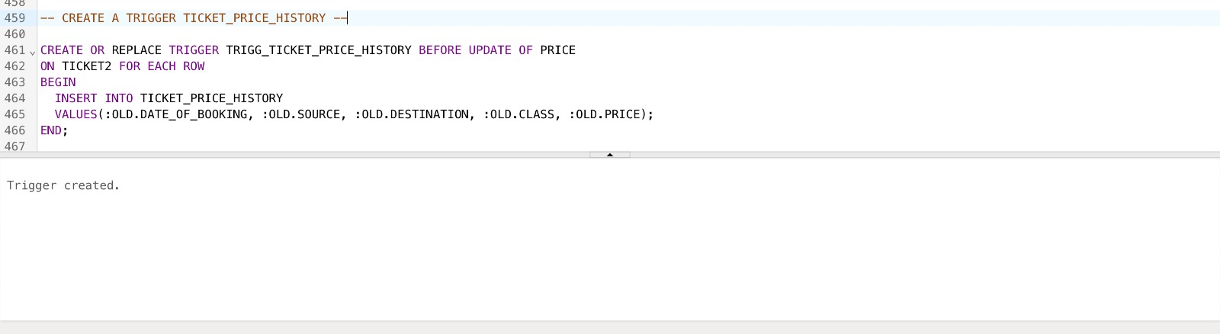

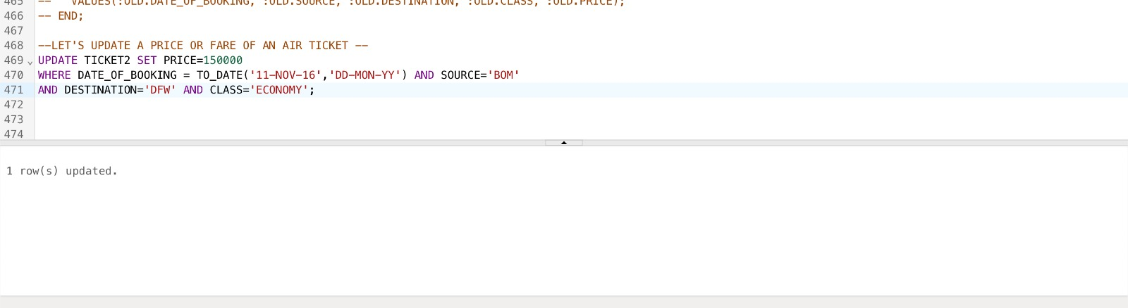

# **Conclusion**

# In conclusion, the Airport Management System designed and developed using a DBMS provides an efficient and effective solution for managing various airport operations. The system is designed to handle multiple tasks such as flight scheduling, passenger management, baggage handling, and employee management.The database design of the system is based on a relational model, which allows for easy data retrieval, storage, and manipulation. The system also includes security features such as user authentication and authorization, ensuring the protection of sensitive data.Through the development of the airport management system, it is evident that the use of a DBMS provides significant advantages in terms of data management and system performance. The system provides real-time access to critical information, which enables airport authorities to make informed decisions promptly.Overall, the airport management system developed using a DBMS provides a reliable and efficient solution for airport operations management. Future enhancements to the system may include additional features such as real-time flight tracking and passenger self-service kiosks to further streamline airport operations.