Student Performance Prediction
Using SPSS and Python (Machine Learning)
Name: ____________________ Roll No: ____________
Submission Date: 8 October 2026

1. Problem Statement
Academic results depend on many factors such as study habits, attendance, earlier performance and home environment. This project builds predictive models that estimate a student's final score from these factors, so that students who are at risk can be identified early and supported.

2. Objectives
- Explore the factors that relate to final score.
- Build a multiple linear regression model in SPSS.
- Build and compare Linear Regression and Random Forest models in Python.
- Identify the most important predictors of performance.

3. Tools Used
- IBM SPSS Statistics: descriptives, correlation, regression, ANOVA.
- Python 3 with pandas, scikit-learn, matplotlib and seaborn.

4. Dataset Description
The dataset has 400 student records and 8 variables. The target variable is final_score (0 to 100). There are no missing values or duplicate rows.
Variable | Type | Description
study_hours | Numeric | Weekly study hours
attendance | Numeric | Attendance percentage
previous_score | Numeric | Score in previous exam
sleep_hours | Numeric | Average sleep per night
absences | Numeric | Number of days absent
internet_access | Categorical | Yes / No
parental_education | Categorical | School / Graduate / Postgraduate
final_score | Numeric (target) | Final exam score

5. Data Preparation
- Checked for missing values and duplicates (none found).
- Converted categorical variables to numeric form (dummy variables in Python, RECODE in SPSS).
- Split data 80% training and 20% testing (random_state = 42).

6. Exploratory Data Analysis
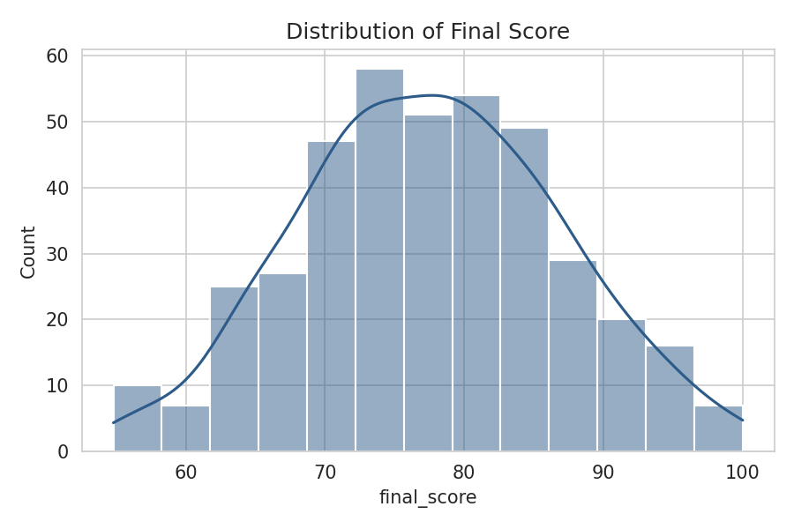
Figure 1: Distribution of final score
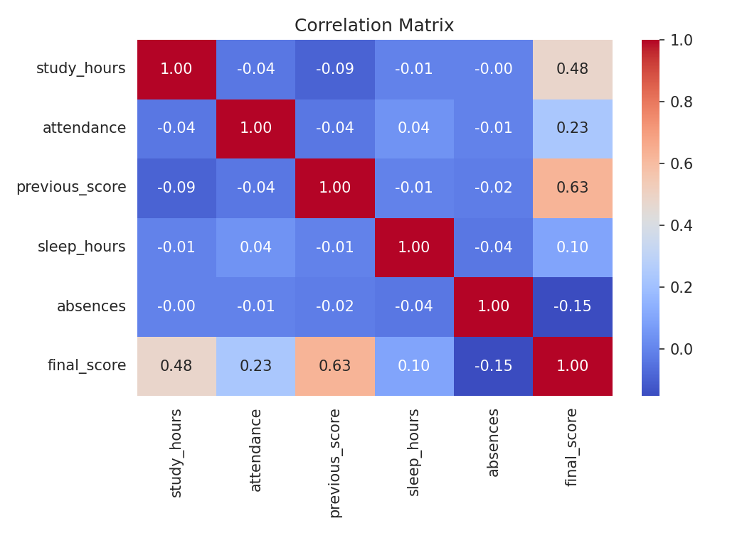
Figure 2: Correlation matrix
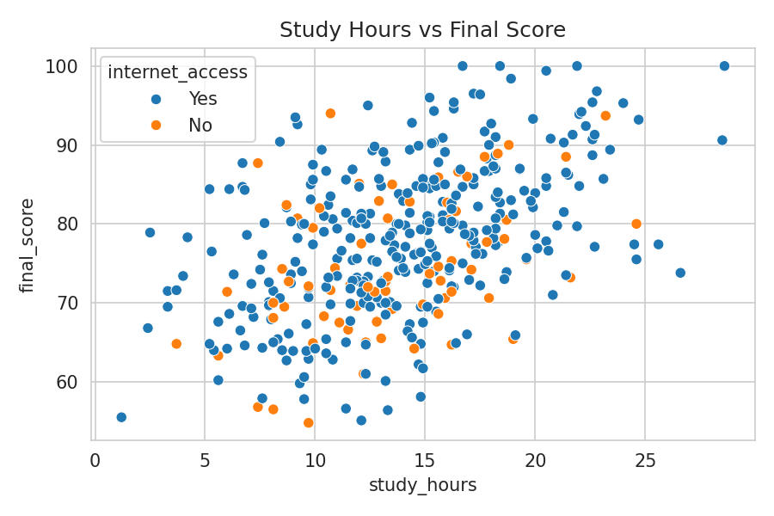
Figure 3: Study hours vs final score
Study hours, previous score and attendance show a positive relationship with final score, while absences show a negative relationship.

7. SPSS Analysis
The SPSS syntax file (student_performance_spss.sps) runs descriptive statistics, correlation, multiple linear regression with residual plots and collinearity checks, and a one-way ANOVA of score by parental education. Run the file in SPSS and paste your own output screenshots here.
[Paste SPSS output screenshots: Descriptives, Correlations, Model Summary, ANOVA table, Coefficients]

8. Python Machine Learning Models
Two models were trained and evaluated on the 20% test set, and also with 5-fold cross-validation.
Model | R² | MAE | RMSE | CV R²
Linear Regression | 0.87 | 2.892 | 3.629 | 0.805
Random Forest | 0.787 | 3.922 | 4.641 | 0.689

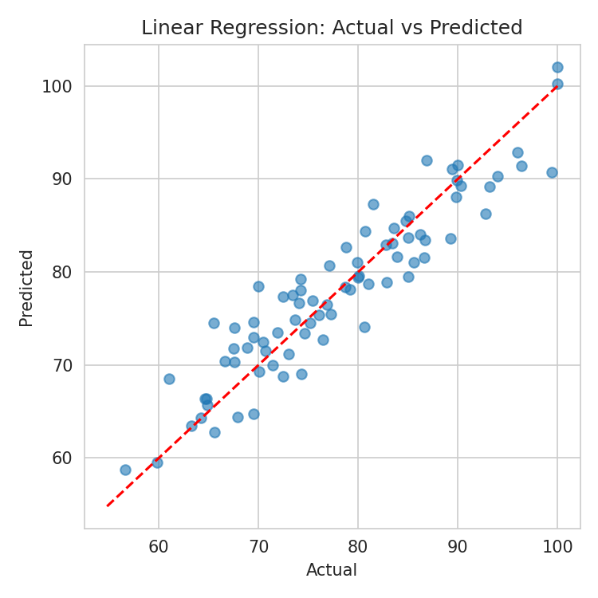
Figure 4: Actual vs predicted (Linear Regression)
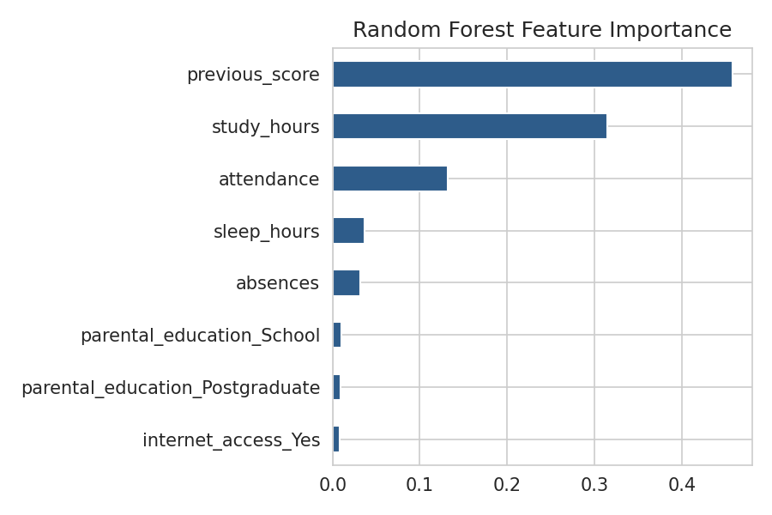
Figure 5: Random Forest feature importance

9. Results and Discussion
- Linear Regression performed best (R² = 0.87, MAE = 2.892 marks), better than Random Forest (R² = 0.787).
- The linear model fits well because the relationships in this data are mostly linear and the dataset is small.
- The strongest predictors by Random Forest importance were previous_score (0.458), study_hours (0.315) and attendance (0.132).
- Each extra weekly study hour is associated with about 1.08 more marks, and each absence with about 0.54 fewer marks, holding other factors constant.

10. Conclusion
The models can predict final score with an average error of roughly 3 marks. Previous performance and study hours matter most, so early support for students with low prior scores and low study time can improve outcomes.

11. Limitations and Future Work
- The dataset is limited to 400 records and a small set of features.
- Future work: more data, other models (Gradient Boosting), hyperparameter tuning, and a simple web app for predictions.

12. How to Reproduce
- Run student_performance_project.py to regenerate data, charts and results.
- Open student_performance_spss.sps in SPSS, set the file path to student_data.csv, and run all.

