Q 5 . Fibonaaci series using recursion ?

#include<iostream>

using namespace std;

int fib(int);

main(){

int n ;

cout<<"enter the value for which you have print till which term";

cin>>n;

for(int i=0;i<=n;i++){

int z=fib(i);

cout<<z;

}

}

int fib(int n){

if(n==0){

return 0;

}

else if(n==1){

return 1;

}

else{

return fib(n-1) +fib(n-2);

}

}

Output:

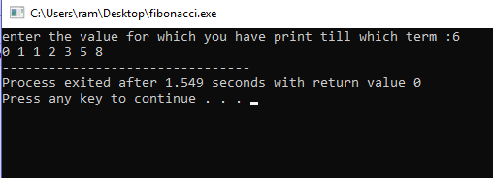

Q .2 Fibonaci series without recursion?

Ans

#include<iostream>

using namespace std;

main(){

int a=0 ,b=1 ,temp=0,n ;

cout<<"enter the value to which term you have to print the fibonacci series is :";

cin>>n;

for(int i=0;i<n;i++){

cout<<temp<<" ";

a=b;

b=temp;

temp=a+b;

}

}

output

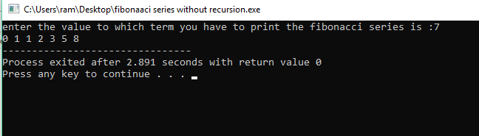

Q 3 Factorial of number with recursion ?

#include<stdio.h>

int fact(int n);

main()

{

int n,z;

printf("enter the number:");

scanf("%d",&n);

z=fact(n);

printf("factorial of number is %d",z);

}

int fact ( int n){

int z;

if (n==0||n==1){

return 1;

}

else{

return z=n\*fact(n-1);

}

}

Output

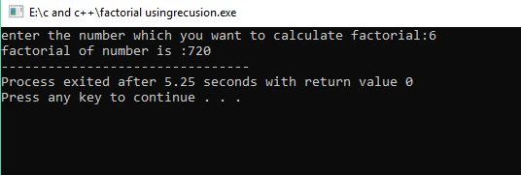

Q 2. Factorial of number without recursion ??

#include<iostream>

using namespace std;

main(){

int n,sum=1;

cout<<"enter the number which you want to calculate factorial:";

cin>>n;

for(int i=1;i<=n;i++){

sum=sum\*i;

}

cout<<"factorial without recusion :"<<sum;

}

Output

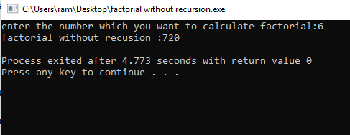

Q . WAP of Exponential function E^x?

#include<stdio.h>

#include<math.h>

using namespace std;

main(){

int x;

float sum=1,fact=1;

printf("enter the number which you want to calculate factorial:");

scanf("%d",&x);

for(int i=1;i<=x;i++){

fact=fact\*i;

sum=sum +pow(x,i)/fact;

}

printf( "e^ %d =%f",x,sum);

}

Output :

