Software Requirements Specification (SRS)
Project: Survey Management System (SMS)
Version: 1.0
Authors: Harshit Vaish, Nakka Gopya, Bhavya K, Devika N
Date:
Methodology: Agile (Scrum, 1-week sprints)
Revision history
Version | Date | Author | Change Summary | Approval
1.0 | 18-10-2026 | Harshit Vaish, Nakka Gopya, Bhavya K, Devika N | Initial SRS with use-case diagrams and RTM

Approvals
Role | Name | Signature / Email | Date
Course Coordinator

INTRODUCTION
Purpose
This document is the Software Requirements Specification for a web-based Survey Management System. It defines the functional and non-functional requirements, security requirements, interfaces and verification criteria for the system. It is the baseline for the Software Architecture and Design Specification (SAD) and the Software Test Plan (STP).
Scope
The system lets survey creators build well-defined surveys, lets respondents take them, and consolidates the responses into results and charts. It covers user accounts, survey authoring, survey publishing and sharing, response collection, and results analysis and export. It excludes payment or incentive handling, third-party panel recruitment, and advanced statistical analysis.
Audience
Developers, QA engineers, DevOps engineers, instructors and project evaluators.
Definitions:
SMS: Survey Management System
RBAC: Role-Based Access Control
TLS: Transport Layer Security
WCAG: Web Content Accessibility Guidelines
CI/CD: Continuous Integration / Continuous Delivery
Development Approach
Requirements are maintained as a product backlog. Each FR maps to a user story, and stories are grouped into epics (Authentication, Survey Builder, Publishing and Sharing, Survey Taking, Results). Work is completed in sprints.
Overall Description
2.1 Product Perspective
The SMS is a standalone web application with a browser front end, a REST back-end API and a relational database. It sends email through an external SMTP service (used for password reset). It is built and deployed through a CI/CD pipeline using open-source tools.
2.2 Major Product Functions
- Register, log in and manage access by role
- Create and edit surveys with multiple question types
- Publish surveys, close them, and share them by link or QR code
- Collect responses with validation and duplicate prevention
- Support anonymous responses
- Consolidate results per question and display them as charts and export results as CSV and PDF
2.3 User Roles:
- Survey Creator: Registered user who makes, publishes and analyzes surveys.
- Respondent: Person who takes a survey. May be registered or anonymous. Expects a fast, simple, mobile-friendly experience.
- Administrator: Manages the platform, users and surveys.
2.4 Operating Environment
- Client: latest versions of Chrome, Firefox, Edge and Safari on desktop or mobile
- Server: Linux container (Docker) on a cloud platform
- Database: relational database
- Network: HTTPS over the public internet
2.5 Constraints
- Only open-source tools and platforms are used.
- Source is kept in Git with all changes delivered through the CI/CD pipeline
- The hosting platform provides HTTPS certificates.

3. External Interface Requirements
3.1 User Interfaces
A responsive web UI with a clear menu per role: a creator dashboard, a survey builder, a survey-taking page, and a results page with charts. The UI must be usable on mobile and desktop devices and must meet the accessibility requirement NFR-005.
3.2 Hardware Interfaces
None
3.3 Software Interfaces
- REST API over HTTPS using JSON between frontend and backend
- Relational database access.
- SMTP interface for transactional email
- Optional QR-code and PDF generation libraries.
3.4 Communications
All traffic uses HTTPS with TLS 1.2 or higher.
4. System Features - Functional Requirements
Each requirement below includes acceptance criteria and a reference test case. IDs follow SVY-F-###.
4.1 Authentication and Access Control
Description: Account creation, login and RBAC for Creators, Respondents and Administrators.
Req ID | Requirement (the system shall...) | Type | Priority | Source / Stakeholder | Acceptance Criteria / Test Case | Comments / Dependencies
SVY-F-001 | Allow a user to register and log in using an email address and password. | Functional | High | All users | AC-001: A valid registration creates an account and a valid login starts a session. Invalid inputs are rejected and error occurs. Test: TC-Auth-01 | Depends on SR-002
SVY-F-002 | Enforce RBAC with the roles Creator, Respondent and Administrator. | Functional | High | Administrator | AC-002: A Respondent cannot open creator pages and a Creator cannot open admin pages.  Test: TC-Auth-02 | Depends on SR-003
SVY-F-003 | Allow a user to reset a forgotten password through link sent to their registered email. | Functional | Medium | All users | AC-003: The link works once and expires after 30 minutes. The old password stops working after reset. Test: TC-Auth-03 | Requires SMTP service

4.2 Survey Creation and Management
Description: Creators build surveys while they are in draft state.
Req ID | Requirement (the system shall...) | Type | Priority | Source / Stakeholder | Acceptance Criteria / Test Case | Comments / Dependencies
SVY-F-004 | Let a Creator create a survey with a title, description and optional open and close dates. | Functional | High | Creator | AC-004: A survey with a title is saved in draft state; a close date earlier than the open date is rejected.  Test: TC-Srv-01 | Requires SVY-F-001
SVY-F-005 | Support the question types single choice, multiple choice, text, rating scale, and dropdown. | Functional | High | Creator | AC-005: A question of each type can be added, saved and delivered correctly to a respondent. Test: TC-Srv-02
SVY-F-006 | Let a Creator mark each question as mandatory or optional. | Functional | High | Creator | AC-006: A mandatory question blocks submission when unanswered.  Test: TC-Srv-03 | Used by SVY-F-011
SVY-F-007 | Let a Creator edit, reorder and delete questions while the survey is in draft. | Functional | High | Creator | AC-007: Changes persist and are reflected in preview. Edit is blocked after publishing.  Test: TC-Srv-04 | Depends on SVY-F-008
SVY-F-008 | Support the survey lifecycle states Draft, Published and Closed, and lock the structure once it is published. | Functional | High | Creator | AC-008: A published survey accepts responses. A closed survey rejects them.  Test: TC-Srv-05 | Also closes automatically at the close date

4.3 Publishing and Sharing
Description: Distribute surveys to respondents.
Req ID | Requirement (the system shall...) | Type | Priority | Source / Stakeholder | Acceptance Criteria / Test Case | Comments / Dependencies
SVY-F-009 | Generate a unique link and a QR code(optional) that can be shared for each published survey. | Functional | High | Creator | AC-009: The link opens the correct survey and the QR code decodes to the same link. Test: TC-Pub-01 | QR library

4.4 Taking the Survey
Description: Respondents complete surveys.
Req ID | Requirement (the system shall...) | Type | Priority | Source / Stakeholder | Acceptance Criteria / Test Case | Comments / Dependencies
SVY-F-010 | Let a respondent complete and submit a survey and validate that all mandatory questions are answered. | Functional | High | Respondent | AC-011: Submission with a missing mandatory answer shows an error on that question. A complete submission is stored and a confirmation is shown.  Test: TC-Resp-01 | Depends on SVY-F-006
SVY-F-011 | Prevent a respondent from submitting more than once to a survey configured as single-response. | Functional | High | Creator | AC-012: A second submission from the same account (or same browser token for anonymous users) is rejected with a message. Test: TC-Resp-02
SVY-F-012 | Support anonymous responses when the Creator enables the option, and store no respondent identity for such responses. | Functional | Medium | Respondent, Creator | AC-013: An anonymous response in the database and in exports contains no user identifier or email. Test: TC-Resp-03

4.5 Results and Analytics
Description: Combining and exporting responses.
Req ID | Requirement (the system shall...) | Type | Priority | Source / Stakeholder | Acceptance Criteria / Test Case | Comments / Dependencies
SVY-F-013 | Combine responses per question, showing counts, percentages and averages for rating questions. | Functional | High | Creator | AC-014: Computed values match a manually calculated reference data set. Test: TC-Res-01
SVY-F-014 | Display unified results as charts on the results page. | Functional | High | Creator | AC-015: Each choice-based question shows a chart consistent with the table values. Test: TC-Res-02 | Depends on SVY-F-013
SVY-F-015 | Let a Creator export survey results as CSV or PDF files. | Functional | Medium | Creator | AC-016: Downloaded files open correctly and contain all responses and summary values. Test: TC-Res-03 | Only the owning Creator may export

5. Non-Functional Requirements
NFRs below are measurable and tied to test plans. IDs SVY-NF-###.
Req ID | Requirement | Category | Priority | Acceptance Criteria / Measurement
SVY-NF-001 | Pages and API calls shall respond within 2 seconds for 95% of requests under normal load. | Performance | High | 95th percentile at or below 2 s in a load test. Test: TC-Perf-01
SVY-NF-002 | The system shall support at least 500 concurrent respondents without errors or response degradation beyond NFR-001. | Scalability | High | Load test with 500 virtual users shows error rate below 1%. Test: TC-Perf-02
SVY-NF-003 | The system shall provide 99.5% monthly availability, excluding planned maintenance. | Reliability | High | Uptime monitor report shows at least 99.5% per month. Test: Ops report
SVY-NF-004 | The UI shall be responsive from 360 px to 1920 px width and work on the latest Chrome, Firefox, Edge and Safari. | Usability / Portability | High | Layout checks pass on listed browsers and viewport sizes. Test: TC-UX-01
SVY-NF-005 | The code shall have at least 80% test coverage, checked automatically on every build. | Maintainability | Medium | Build fails if coverage is below 80%. Test: CI coverage report
Accessibility (WCAG 2.1 AA, keyboard navigation, color contrast) is treated as a quality target for the UI and is verified in the accessibility test suite in Section 6.
5.1 Security
5.1.1 Security Objectives
ID | Objective | Description
SO-1 | Confidentiality | Only authorized users can view survey data. Anonymous responses cannot be traced back to a respondent.
SO-2 | Integrity | Responses and results cannot be altered or fabricated, for example by duplicate or automated submissions.
5.1.2 Security Requirements
Req ID | Requirement (the system shall...) | Type | Priority | Acceptance Criteria / Test Case
SVY-SR-001 | use TLS 1.2 or higher for all network connections. | Security | High | HTTP is redirected to HTTPS and older TLS versions are refused. Test: TC-Sec-01
SVY-SR-002 | Store passwords only as hashes using bcrypt or Argon2. | Security | High | Database inspection shows no plaintext passwords. Test: TC-Sec-02
SVY-SR-003 | Perform authorization checks on every endpoint so a Creator can access only their own surveys and results. | Security | High | Accessing another user's survey ID returns error. Test: TC-Sec-03
SVY-SR-004 | The system shall check all user input and block harmful content to prevent SQL injection and XSS. | Security | High | Injection and script payloads are rejected or escaped. Test: TC-Sec-04
SVY-SR-005 | Apply rate limiting and CAPTCHA on login and survey submission endpoints. | Security | Medium | Repeated requests beyond the limit receive HTTP 429. Test: TC-Sec-05

6. Quality attributes & Acceptance tests
- Exit criteria: All High-priority functional requirements are implemented and verified, no critical NFR failures remain, and the RTM shows all test cases passed.
- Acceptance test suites: Authentication, Survey Builder, Publishing, Survey Taking, Results, Performance, Security and Accessibility.
7. System models and diagrams
7.1 Use-Case Diagram 1: Survey Creation and Management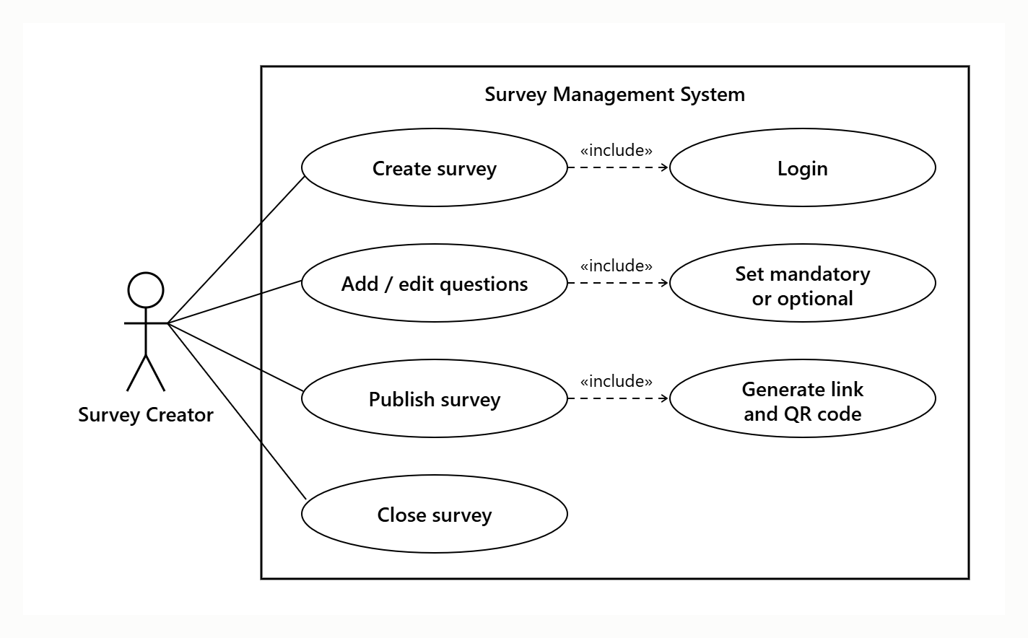
7.2 Use-Case Diagram 2: Taking Surveys and Viewing Results

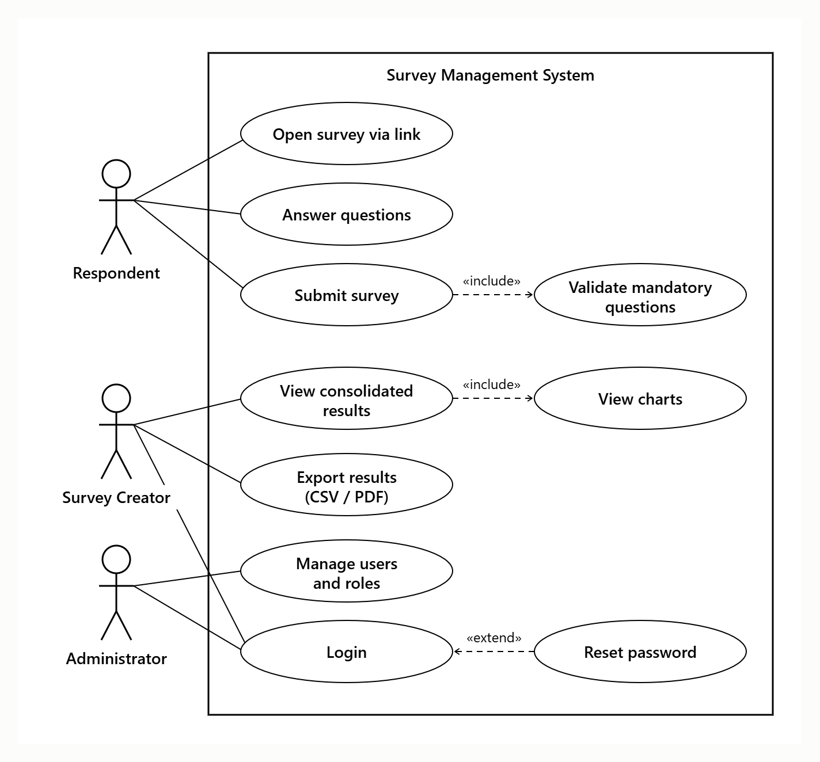

8. Requirements Traceability Matrix (RTM)
Status: N = Not started, P = In progress, A = Accepted.
Req ID | Requirement (short) | Section | Epic / Sprint | Module | Test Case(s) | Status
SVY-F-001 | Register and log in | 4.1 | Auth / Sprint 1 | AuthModule | TC-Auth-01 | N
SVY-F-002 | Role-based access | 4.1 | Auth / Sprint 1 | AuthModule | TC-Auth-02 | N
SVY-F-003 | Password reset | 4.1 | Auth / Sprint 1 | AuthModule | TC-Auth-03 | N
SVY-F-004 | Create survey | 4.2 | Builder / Sprint 1 | SurveyModule | TC-Srv-01 | N
SVY-F-005 | Question types | 4.2 | Builder / Sprint 1 | SurveyModule | TC-Srv-02 | N
SVY-F-006 | Mandatory / optional | 4.2 | Builder / Sprint 1 | SurveyModule | TC-Srv-03 | N
SVY-F-007 | Edit / reorder / delete questions | 4.2 | Builder / Sprint 2 | SurveyModule | TC-Srv-04 | N
SVY-F-008 | Lifecycle and structure lock | 4.2 | Builder / Sprint 2 | SurveyModule | TC-Srv-05 | N
SVY-F-009 | Link and QR code | 4.3 | Publishing / Sprint 2 | SharingModule | TC-Pub-01 | N
SVY-F-010 | Complete and submit with validation | 4.4 | Taking / Sprint 3 | ResponseModule | TC-Resp-01 | N
SVY-F-011 | Prevent duplicate submissions | 4.4 | Taking / Sprint 3 | ResponseModule | TC-Resp-02 | N
SVY-F-012 | Anonymous responses | 4.4 | Taking / Sprint 3 | ResponseModule | TC-Resp-03 | N
SVY-F-013 | Consolidated results | 4.5 | Results / Sprint 3 | ResultsModule | TC-Res-01 | N
SVY-F-014 | Charts | 4.5 | Results / Sprint 3 | ResultsModule | TC-Res-02 | N
SVY-F-015 | CSV / PDF export | 4.5 | Results / Sprint 4 | ResultsModule | TC-Res-03 | N
SVY-NF-001 | Response time | 5 | Hardening / Sprint 4 | All | TC-Perf-01 | N
SVY-NF-002 | 500 concurrent users | 5 | Hardening / Sprint 4 | All | TC-Perf-02 | N
SVY-NF-003 | Availability | 5 | Deployment / Sprint 4 | Infrastructure | Ops report | N
SVY-NF-004 | Responsive UI | 5 | All sprints | Web UI | TC-UX-01 | N
SVY-NF-005 | 80% test coverage | 5 | Sprint 0 onward | CI pipeline | CI coverage report | N
SVY-SR-001 | TLS 1.2+ | 5.1 | Sprint 4 | Infrastructure | TC-Sec-01 | N
SVY-SR-002 | Password hashing | 5.1 | Sprint 1 | AuthModule | TC-Sec-02 | N
SVY-SR-003 | Server-side authorisation | 5.1 | Sprint 1 | AuthModule | TC-Sec-03 | N
SVY-SR-004 | Input validation | 5.1 | Sprint 4 | All | TC-Sec-04 | N
SVY-SR-005 | Rate limiting / CAPTCHA | 5.1 | Sprint 4 | AuthModule, ResponseModule | TC-Sec-05 | N

