2026
Internship Project
MBA BA
1st Year- 2nd Trimester

[ Social Media User Analysis]

Social Media User Analysis:
Instagram Usage Intensity and Psychological Well-being

INDEX
S.NO | TOPIC | PG.NO
1 | List of Charts, Figures and Tables | 03-05
2 | Project Cover Sheet | 06
3 | Weekly Report | 07
4 | Executive Summary | 08
5 | Project Milestones | 08
6 | Introduction | 09
7 | Domain Understanding | 09
8 | Scenario Explanation | 10
9 | Project Definition | 11
10 | Problem Statement | 11
11 | Project Objectives | 12
12 | Project Requirements | 12
13 | Project Scope | 13
14 | Project Life Cycle | 13
15 | Business Process Flowchart | 14
16 | KPIs – Key Performance Indicators | 15-16
17 | ERD – Entity Relationship Diagram | 17
18 | Research Questions | 18
19 | Data Cleaning [ETL] – Extract Transform and Load | 18-19
20 | EDA – Exploratory Data Analysis | 19-49
21 | Findings & Insights | 50
22 | Recommendations & Suggestions | 50-51
23 | Conclusion | 52
24 | Bibliography | 52

List of Charts
S.No | Chart Name | Pg. No
1 | Chart 1: Demographic Overview | 19
2 | Chart 2: Instagram Usage Distribution | 20
3 | Chart 3: Psychological Well-being Score Distributions | 21
4 | Chart 4: Age Distribution of Instagram Users | 22
5 | Chart 5: Gender Distribution | 22
6 | Chart 6: Number of Users by Country | 23
7 | Chart 7: Daily Active Minutes on Instagram | 23
8 | Chart 8: Average Stress Score Rises with Daily Instagram Usage | 24
9 | Chart 9: Happiness Declines as Instagram Usage Increases | 25
10 | Chart 10: Daily Active Minutes vs Stress Score | 25
11 | Chart 11: Daily Active Minutes vs Happiness | 26
12 | Chart 12: Stress Level Distribution by Gender | 27
13 | Chart 13: Average Stress Score by Country | 27
14 | Chart 14: Average Daily Minutes by Income Level | 28
15 | Chart 15: Reels Watched Per Day vs Stress Score | 29
16 | Chart 16: Happiness Score Distribution by Country (Bar) | 29
17 | Chart 17: Sessions Per Day vs Stress Score | 30
18 | Chart 18: Users by Subscription Status | 31
19 | Chart 19: Content Type Preference – Stress and Usage Comparison | 31
20 | Chart 20: Number of Instagram Users by Country (Map) | 32
21 | Chart 21: Average Stress by Employment Status | 33
22 | Chart 22: Average Daily Minutes by Age Group | 33
23 | Chart 23: High vs Low Stress Users Comparison | 34
24 | Chart 24: Correlation Heatmap – All Numeric Variables | 35
25 | Chart 25: Correlation Heatmap – Key Variables | 36
26 | Chart 26: Top 15 Variables Correlated with Stress Score | 37
27 | Chart 27: Average Daily Instagram Minutes by Country | 37
28 | Chart 28: Instagram Users Active by Month | 38
29 | Chart 29: Instagram Account Growth Over Years | 39
30 | Chart 30: Average Daily Instagram Minutes by Day of Week | 40
31 | Chart 31: Happiness Score Distribution by Country (Line) | 40

List of Figures
S.No | Figure Name | Pg. No
1 | ERD – Entity Relationship Diagram | 17
2 | Business Process Flowchart (Analytical Approach) | 14

List of Tables
S.No | Table Name | Pg. No
1 | Table 1: Data Dictionary – Variable Descriptions | 10-11
2 | Table 2: Key Performance Indicators (KPIs) | 15-16
3 | Table 3: Tools & Technologies Used | 14
4 | Table 4: Data Structure & Volume Summary | 10
5 | Table 5: Project Approach – Weekly Activities | 07
6 | Table 6: Team Members | 05

Project Cover Sheet
Project Title | Social Media User Analysis | Course | MBA (BA)
Date of Submission | 02/04/2026 | Guide Name | Mrs. R. Renuka

TEAM MEMBERS
SNO | NAME | HALL TICKET NO
1 | Harshit Pandey | 25MG202A05
2 | Trisha Patnam | 25MG202A10

Signature: ___________________________

Guide: ___________________________

Date: ___________________________

Weekly Report
Week | Key Activities
Week 1 | - Choose Domain -  - Data Collection  - Formulate the problem statement – Define objectives of the study
Week 2 | - Understanding Data  - Data Cleaning  - Business Context & Data Description sections
Week 3–4 | - Perform EDA  - Visualize Intermediate results
Week 5 | - Evaluate and interpret results  - Document key insights  - Business recommendations
Week 6 | - Finalize report  - Prepare Charts and Presentation Slides
Week 7 | - Submit Report and present

Executive Summary
This project titled "Social Media User Analysis" is a data analytics study focused on understanding user behaviour, engagement patterns, and psychological well-being in the context of Instagram usage. It involves analysing large volumes of user data to identify patterns, relationships, and trends between social media activity and its impact on users' mental and lifestyle indicators.
This analysis is widely applicable in social media platforms. By examining user activity data such as daily active minutes, sessions per day, reels watched, and engagement metrics, the study helps uncover hidden behavioural insights. For example, higher screen time and frequent sessions may be associated with increased stress levels or reduced happiness. These insights are derived using data analysis techniques such as Exploratory Data Analysis and predictive modelling.
The domain is highly relevant in today's digital era, where social media usage is rapidly increasing and significantly influencing human behaviour. This study supports important applications such as improving user well-being, optimizing platform design, enhancing engagement strategies, and promoting responsible digital usage.
In essence, Social Media User Analysis enables organizations and researchers to leverage user data for better decision-making, improving user experience, promoting mental well-being, and creating a balanced digital ecosystem.

Project Milestones
Timeline | Milestone
Week 1 | Domain selection, data collection, problem formulation
Week 2 | Data understanding, cleaning, business context draft
Week 3–4 | EDA completion, Intermediate result visualizations
Week 5 | Result Interpretation, Insights documentation, Recommendations
Week 6 | Report finalization, charts and presentation preparation
Week 7 | Final submission and presentation

Introduction
Social media has become an inseparable part of modern human life. Instagram, with over 2 billion monthly active users, is one of the most widely used platforms globally. Users interact daily through reels, feeds, stories, and messages, spending significant time on the platform. While this engagement drives platform growth, it also raises important questions about its impact on human psychology, behaviour, and lifestyle.
This project analyses Instagram user data to understand the relationship between usage intensity and psychological well-being. By applying data analytics techniques on a dataset of approximately 1,00,000 user records, the study uncovers meaningful patterns that can guide both platform developers and end users towards healthier digital habits.

Domain Understanding
The domain of this project is Social Media Analytics with a focus on User Behaviour Analysis and Digital Well-being. Social media analytics involves the collection, measurement, analysis, and interpretation of data from social media platforms to drive business decisions and understand user behaviour.
Instagram, as a visual-first platform, generates unique behavioural data including content consumption patterns (reels, stories, feed), engagement actions (likes, comments, shares), direct messaging, and usage time metrics. When combined with psychological well-being indicators like stress scores and happiness scores, this data provides a rich foundation for understanding the holistic impact of social media usage.
This domain is increasingly important as governments, health organizations, and technology companies recognize the role of digital platforms in shaping mental health outcomes, especially among younger demographics.

Scenario Explanation
Instagram's 2 billion+ users spend significant portions of their daily lives consuming reels, scrolling feeds, and interacting through sessions. The platform is designed to maximize engagement through personalized algorithms, infinite scrolling, and short-form video content. While this drives high engagement metrics, the psychological consequences for users remain poorly understood from a data-driven perspective.
Heavy Instagram users report rising stress levels and declining happiness, but neither users nor platform developers have had access to actionable, data-driven insights into which specific usage behaviours are most harmful to mental health. There is a critical gap between platform engagement metrics (which platforms optimize for) and user well-being metrics (which users need).
This project addresses this gap by analysing real-world user data to map the relationship between specific usage behaviours and psychological outcomes. The analysis covers:
- Usage intensity metrics: daily active minutes, sessions per day, reels watched
- Engagement metrics: likes, comments, DMs, stories, engagement scores
- Psychological indicators: stress scores (0–40 scale), happiness scores (1–10 scale)
- Lifestyle variables: sleep hours, exercise, BMI, blood pressure
- Demographic factors: age, gender, country, income level, employment status

Project Definition
This project is defined as a descriptive and exploratory data analytics study titled "Social Media User Analysis: Instagram Usage Intensity and Psychological Well-being." The project uses a dataset of ~1,00,000 Instagram user records to perform systematic analysis of usage patterns and their psychological outcomes.
The project falls under the discipline of Business Analytics with applications in the technology, mental health, and marketing sectors. The primary deliverable is a comprehensive analytical report supported by data visualizations, statistical findings, and business recommendations.

Problem Statement
Instagram's 2 billion+ users spend excessive time on reels, feeds, and sessions daily, yet there is no clear data-driven understanding of how these specific usage behaviours impact psychological well-being. Heavy Instagram users report rising stress and declining happiness, but neither users nor platforms have actionable insight into which usage patterns are most harmful to mental health.
This project addresses the need for a comprehensive, data-backed analysis that identifies the specific behaviours and usage intensities most strongly associated with adverse psychological outcomes, enabling evidence-based recommendations for both platform design and user behaviour.

Project Objectives
- To analyse social media usage patterns and user engagement metrics across different demographic segments.
- To examine the relationship between Instagram usage intensity and psychological well-being indicators including stress and happiness.
- To analyse how demographic factors such as age, gender, and education level influence digital behaviour patterns.
- To evaluate associations between social media usage and lifestyle indicators such as sleep, exercise, and physical health.
- To provide actionable recommendations for platform improvements and responsible usage strategies based on data insights.

Project Requirement

Tools & Technologies Used
Tool | Purpose
Python | Data preprocessing, analysis, implementing the project logic
Pandas & NumPy | Data manipulation, cleaning, numerical computations and handling datasets
Matplotlib & Seaborn | Data visualization (bar charts, heatmaps, scatter plots) and statistical plots
Excel | Initial data viewing, cleaning, and basic analysis
Kaggle | Open-source dataset and reference for real-world Instagram user data

Hardware Requirements
- Personal Computer / Laptop with minimum 8GB RAM
- Stable internet connection for dataset download and library installation
- Minimum 10GB free storage for dataset and output files

Project Scope
This project covers the analysis of approximately 1,00,000 Instagram user records containing 56 variables spanning demographics, usage behaviour, engagement metrics, psychological well-being, and lifestyle indicators. The scope includes:
- Demographic analysis across gender, age, country, income level, and employment status
- Usage behaviour analysis: daily active minutes, sessions per day, reels watched, story views
- Engagement analysis: likes, comments, DMs, follower counts, engagement scores
- Psychological well-being: stress scores and happiness scores
- Lifestyle correlation: sleep, exercise, BMI, blood pressure
- Temporal analysis: monthly activity, year-on-year account growth
The project does not include predictive modelling beyond correlation analysis and does not involve primary data collection.

Project Life Cycle
The project followed a structured seven-week life cycle aligned with standard data analytics methodology:
Phase 1 – Problem Definition (Week 1)
Domain selection (social media analytics), dataset identification from Kaggle, problem statement formulation, and objective definition.
Phase 2 – Data Acquisition & Understanding (Week 2)
Dataset download and import into Python environment, initial exploration of data shape (99,999 rows × 56 columns), column identification, and variable classification.
Phase 3 – Data Cleaning & Preparation (Week 2)
Missing value check, duplicate detection, data type correction, column name standardization, and creation of derived variables.
Phase 4 – Exploratory Data Analysis (Weeks 3–4)
Systematic visualization of all key variables using histograms, bar charts, scatter plots, pie charts, heatmaps, and line charts. Correlation analysis performed across usage, engagement, and well-being variables.
Phase 5 – Insight Generation (Week 5)
Key patterns identified, business implications derived, and findings documented based on EDA results.
Phase 6 – Report & Presentation (Week 6)
Final documentation prepared, charts organized, and presentation slides created.
Phase 7 – Submission (Week 7)
Final report submitted and project presented to faculty guide.

Business Process Flowchart

Analytical Approach
1. Understanding the Business Problem
- The main objective is to understand how social media usage affects user behaviour and mental well-being.
- The analysis focuses on identifying patterns between usage, engagement, lifestyle, and psychological factors.
2. Exploratory Data Analysis (EDA)
- Analysed user data such as daily active minutes, sessions, engagement, and lifestyle variables.
- Used visualizations like bar charts, histograms, and scatter plots to identify trends and relationships.
3. Data Transformation
- Created new variables such as engagement score and usage intensity.
- Prepared and organized the dataset for better analysis and visualization.
4. Application of Analytical Techniques
- Used correlation analysis to study relationships between variables like usage time, stress, and happiness.
- Identified patterns showing how different factors influence user behaviour and well-being.
5. Feature Selection & Filtering
- Selected important features such as usage metrics, engagement data, and psychological scores.
- Removed unnecessary or less relevant variables to improve analysis accuracy.
6. Interpretation of Results
- Identified key insights such as higher usage leading to increased stress levels.
- Observed that balanced usage is associated with better happiness and lifestyle outcomes.
7. Business Application
- Recommendations include promoting healthy usage, improving app features, and enhancing user experience.
- Insights can be used for better content strategies, user engagement, and well-being improvement.

KPIs – Key Performance Indicators
# | KPI Name | Description
1 | Average Daily Active Minutes | Measures the average time users spend on Instagram per day, indicating overall platform usage intensity.
2 | Sessions per Day | Shows how frequently users open and interact with Instagram in a single day, indicating user activity levels.
3 | Average Reels Watched per Day | Measures the number of reels consumed by users daily, helping understand content consumption behaviour.
4 | User Engagement Score | Represents the overall interaction level of users based on actions like likes, comments, and shares.
5 | Average Number of Likes and Comments | Measures how actively users engage with posts and content on the platform.
6 | Follower Count | Indicates the reach and popularity of users on Instagram.
7 | Stress Score | Measures the level of stress experienced by users (scale 0–40), helping analyse the impact of social media usage on well-being.
8 | Happiness Score | Represents users' self-reported happiness level (scale 1–10), which helps evaluate overall user well-being.
9 | Engagement Rate | Measures the ratio of interactions (likes, comments, shares) to followers, indicating how actively users engage with content.
10 | Average Session Length | Measures the average time spent in each session, showing how long users stay active during a single visit.

ERD – Entity Relationship Diagram
The Entity Relationship Diagram below illustrates the data model for the Social Media User Analysis dataset. It shows the relationships between the key entities: User, Usage Behaviour, Engagement Metrics, Psychological Well-being, and Lifestyle Indicators.
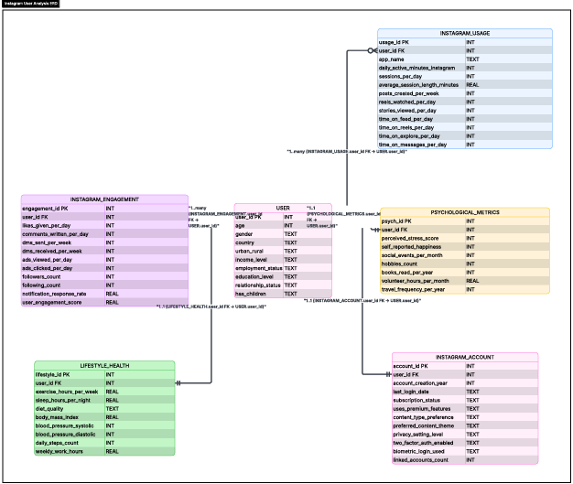

Research Questions
RQ1: Usage and Well-being
- Is there a significant positive relationship between daily Instagram active minutes and user stress scores?
- Does increased Instagram usage correlate with lower happiness scores among users?
RQ2: Content Consumption
- Do users who watch more reels per day exhibit higher stress levels compared to moderate viewers?
- Is there an addictive usage pattern identifiable from reels consumption data?
RQ3: Demographic Influence
- Do younger age groups spend significantly more time on Instagram than older groups?
- Are stress levels consistent across genders, or does usage impact genders differently?
RQ4: Engagement vs Well-being
- Does higher engagement (likes, comments, shares) always translate to higher user happiness?
- Can high engagement coexist with high stress, indicating a complex relationship between engagement and well-being?
RQ5: Lifestyle Associations
- Is heavy social media usage associated with reduced sleep hours or exercise frequency?
- Do lifestyle variables (sleep, exercise) show meaningful correlation with platform usage intensity?

Data Cleaning [ETL] – Extract Transform and Load

Data Description
The dataset used in this project was obtained from Kaggle and contains detailed information about Instagram users. Each record represents an individual user and includes data related to their demographics, social media usage, engagement behaviour, psychological well-being, and lifestyle habits.

Attribute | Details
Initial Shape | 99,999 rows × 56 columns
Final Shape After Cleaning | 99,999 rows × 56 columns (no missing values found)
File Format | .xlsx (Microsoft Excel)

Data Preprocessing Steps
1. Data Loading
The dataset was imported into Python using pandas from an Excel/CSV file. The initial shape and column names were verified to ensure complete data loading.
2. Data Cleaning
- Missing values and duplicate records were checked and handled properly.
- No missing values were found in the final dataset. This ensures the dataset is accurate and reliable for analysis.
3. Data Formatting
- Data types were corrected (numerical and categorical variables).
- Column names were standardized for consistency and easy usage.
4. Data Transformation
- New variables like engagement score were created from existing columns.
- Additional calculations were done to make the data more useful for analysis.
5. Data Structuring
- The dataset was organized into categories: usage, engagement, and lifestyle.
- This makes the data easier to understand and analyse systematically.
6. Preparation for Analysis
- Relevant columns were selected and outliers were checked.
- Final cleaned dataset was prepared for EDA and correlation modelling.

EDA – Exploratory Data Analysis

Basic Exploration
Metric | Value
Number of Users | ~1,00,000 users
Number of Features | 56 columns
Average Daily Active Minutes | ~188 minutes
Average Sessions per Day | ~5–7 sessions
Average Engagement Score | Moderate
Average Stress Score | Medium (~20/40)
Average Happiness Score | Moderate (~5.5/10)

Visual Representation (Graphs)
Chart 1: Demographic Overview
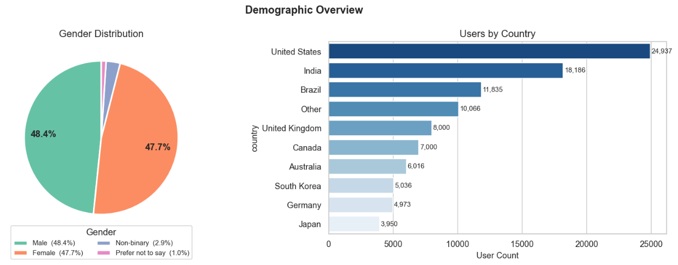
Interpretation
The analysis shows a balanced gender distribution, with males (48.4%) and females (47.7%) forming the majority of users, while only a small percentage belongs to other categories. In terms of location, most users are from the United States, India, and Brazil, with moderate presence in countries like the UK and Canada.

Chart 2: Instagram Usage Distribution
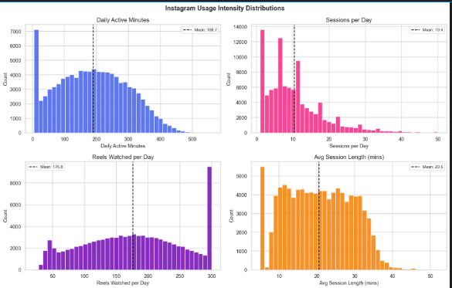
Interpretation
Most users spend a moderate amount of time on Instagram, with daily active minutes centred around the average (~188 minutes). The sessions per day distribution is mostly concentrated at lower to moderate levels (~10 sessions), showing frequent but short interactions. Reels watched per day indicates high short-form content consumption, highlighting the popularity of reels as a key engagement feature.
Chart 3: Psychological Well-being Score Distributions
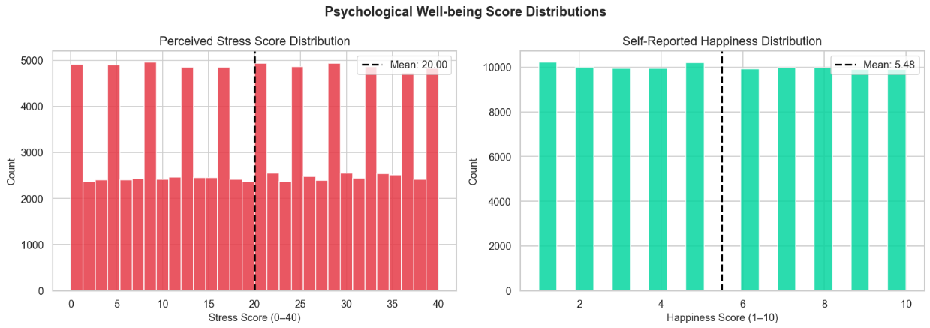
Interpretation
The stress score distribution shows a moderate average (~20 on a scale of 0–40). The happiness score distribution shows an average around 5.5 on a scale of 1–10. Overall, users are neither extremely stressed nor extremely happy, showing a balanced but moderate psychological state indicating measurable but not extreme social media impact on well-being.

Chart 4: Age Distribution of Instagram Users
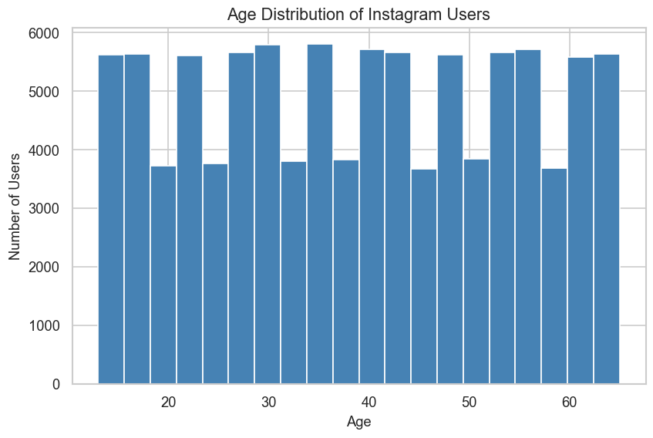
Interpretation
Users are distributed across a wide age range, with usage slightly higher in the 20–40 age range. However, other age groups also show strong participation, indicating that Instagram has a broad and diverse user base suitable for targeting different age segments.

Chart 5: Gender Distribution
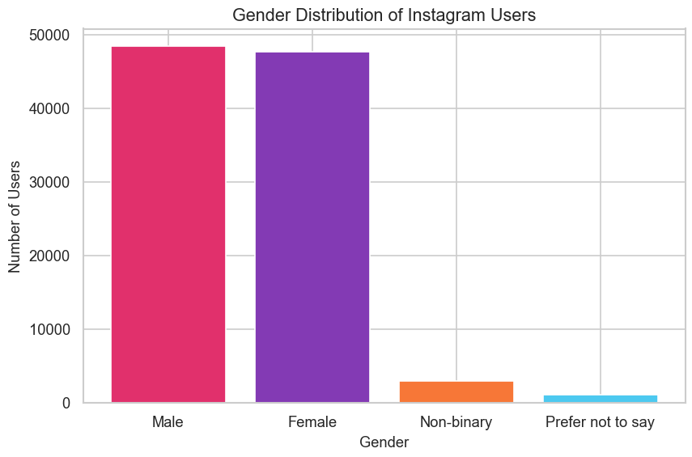
Interpretation
Male and female users are nearly equal in number, with males slightly higher. Non-binary and "prefer not to say" categories represent a small proportion. The platform is inclusive with most users identifying within primary gender categories.
Chart 6: Number of Users by Country
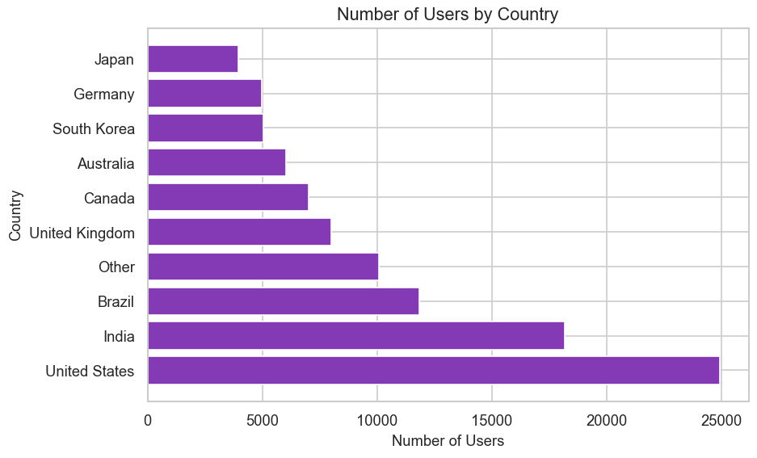
Interpretation
The United States has the highest number of users, followed by India and Brazil. The UK, Canada, and Australia have moderate user counts, while Japan, Germany, and South Korea have comparatively lower numbers. These regions represent the primary markets for targeted engagement strategies.

Chart 7: Daily Active Minutes on Instagram
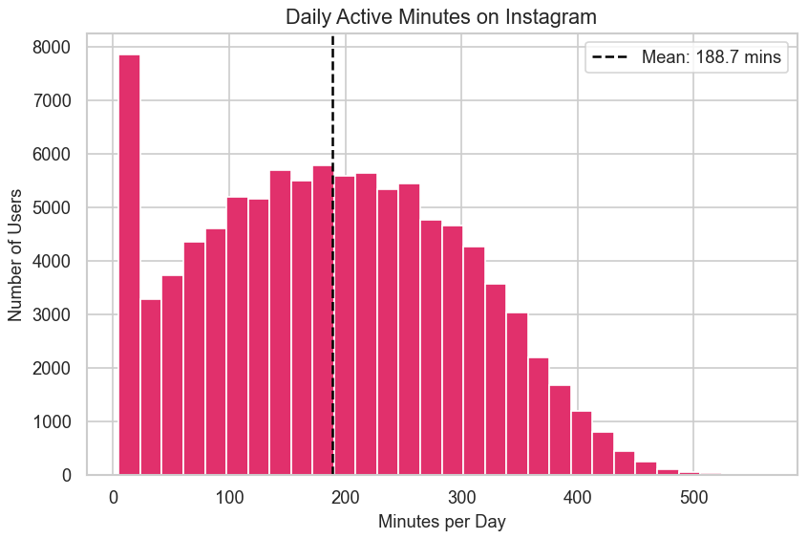
Interpretation
Most users spend between 100 to 300 minutes on Instagram daily with an average of ~188 minutes. A smaller group of heavy users spends above 400 minutes, indicating potential overuse. Very few users have extremely low usage.

Chart 8: Average Stress Score Rises with Daily Instagram Usage
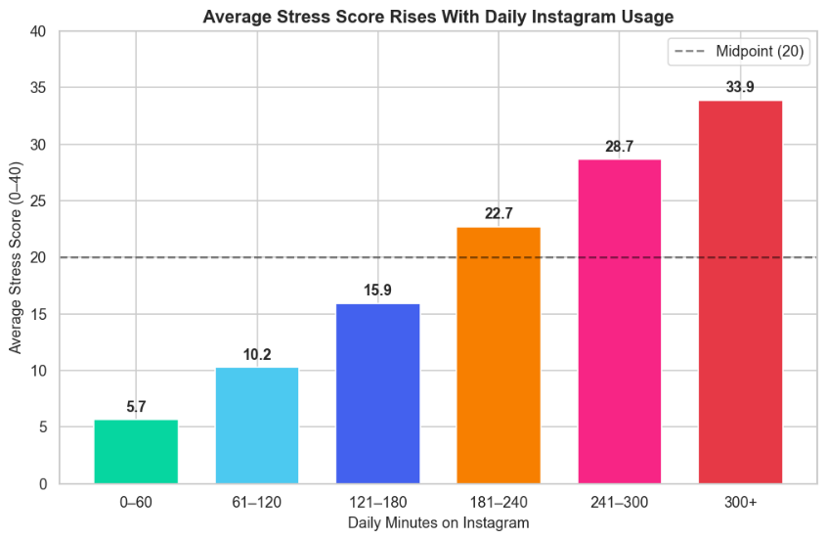
Interpretation
A clear increase in stress levels is observed as daily Instagram usage increases. Users spending 0–60 minutes show low stress (~5.7), while those spending 300+ minutes show stress ~33.9. The midpoint stress level (20) is crossed after the 180–240 minutes range, confirming that higher usage is associated with above-average stress.

Chart 9: Happiness Declines as Instagram Usage Increases
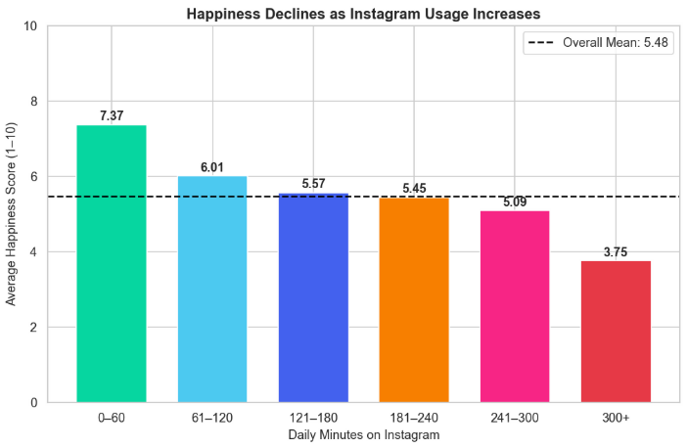
Interpretation
Happiness levels decrease steadily as Instagram usage increases. Users spending 0–60 minutes have the highest happiness (~7.37), while those spending 300+ minutes have the lowest (~3.75). This steady decline confirms the inverse relationship between usage intensity and happiness.

Chart 10: Daily Active Minutes vs Stress Score
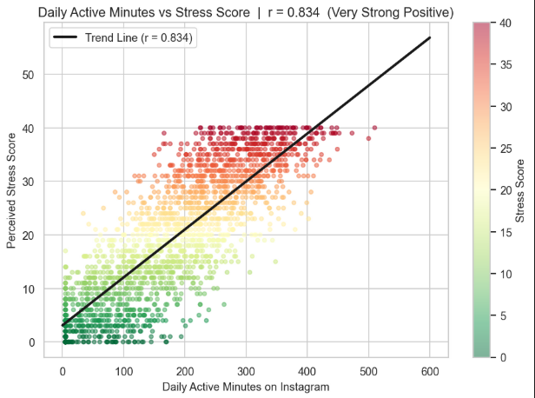
Interpretation
The scatter plot shows a strong positive relationship (r = 0.834) between daily Instagram usage and stress levels. As daily active minutes increase, stress scores increase significantly, confirming that heavy usage is a strong predictor of elevated stress.

Chart 11: Daily Active Minutes vs Happiness
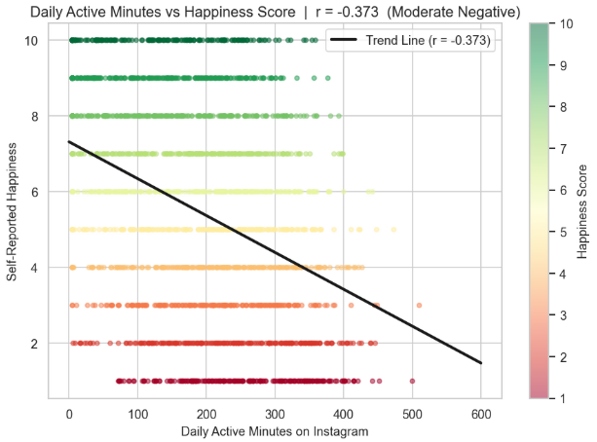
Interpretation
The scatter plot shows a moderate negative relationship (r = -0.373) between daily Instagram usage and happiness. As daily active minutes increase, happiness scores tend to decrease. Lower-usage users generally report higher happiness.

Chart 12: Stress Level Distribution by Gender
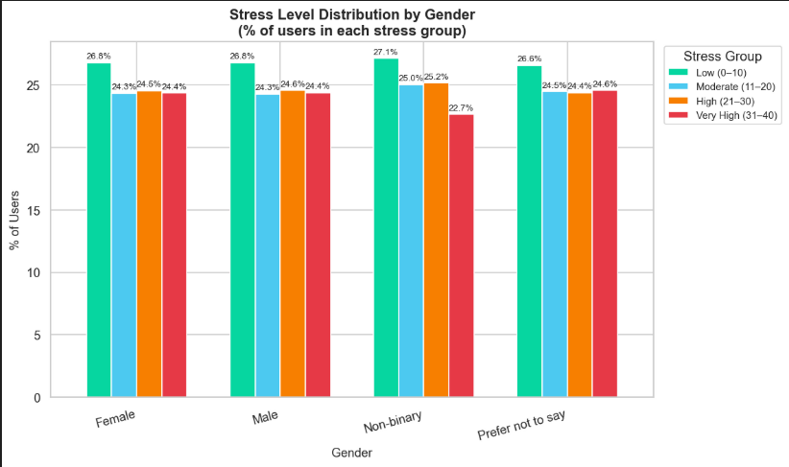
Interpretation
Stress levels are fairly similar across all gender groups. For both male and female users, the percentage distribution across stress levels is nearly equal, indicating no major gender-based difference in stress impact from Instagram usage.
Chart 13: Average Stress Score by Country
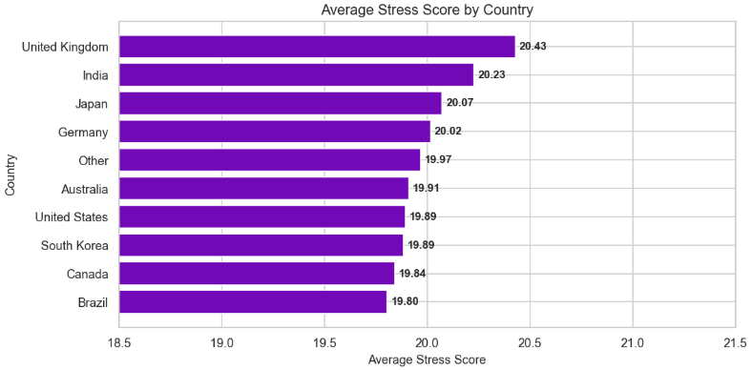
Interpretation
Average stress levels are very similar across countries, with all values close to ~20. The UK and India show slightly higher stress, while Brazil and Canada show slightly lower values. The minimal cross-country variation indicates stress patterns are consistent globally.
Chart 14: Average Daily Minutes by Income Level
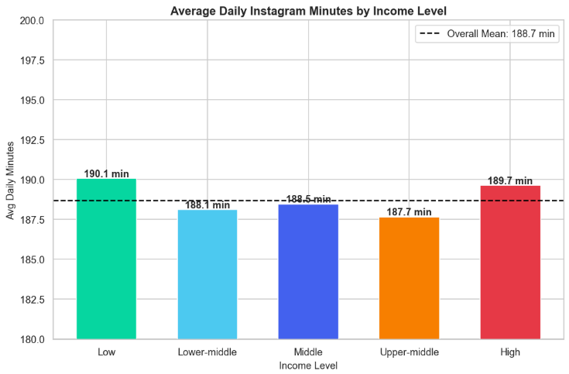
Interpretation
Average daily Instagram usage is similar across all income levels (~188.7 minutes overall). Users in low and high income groups spend slightly more time. The minimal income-based differences indicate that Instagram usage is not significantly influenced by income level.

Chart 15: Reels Watched Per Day vs Stress Score
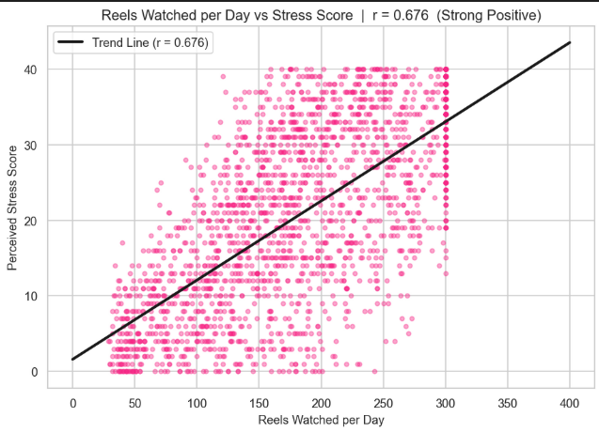
Interpretation
A strong positive relationship (r = 0.676) exists between reels watched per day and stress levels. Users watching more reels show higher stress scores, making reels consumption a significant driver of psychological impact on users.
Chart 16: Happiness Score Distribution by Country (Bar)
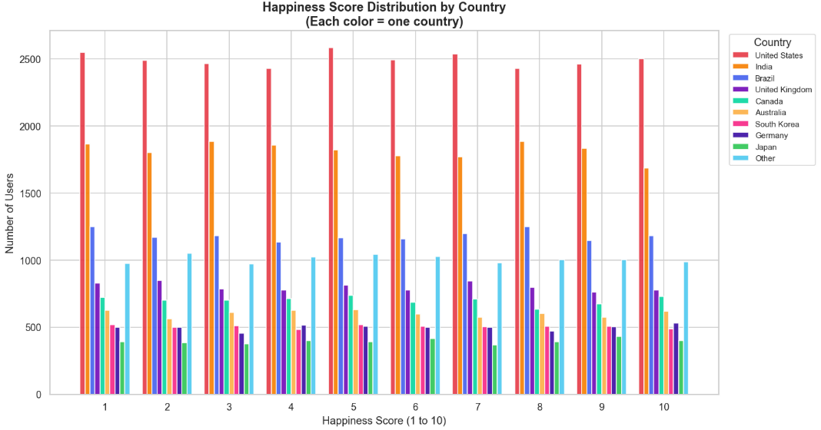
Interpretation
Happiness scores are fairly evenly distributed across all countries with no major differences between them. The United States and India have higher user counts across all happiness levels due to larger sample sizes, but proportional distributions are similar across nations.
Chart 17: Sessions Per Day vs Stress Score
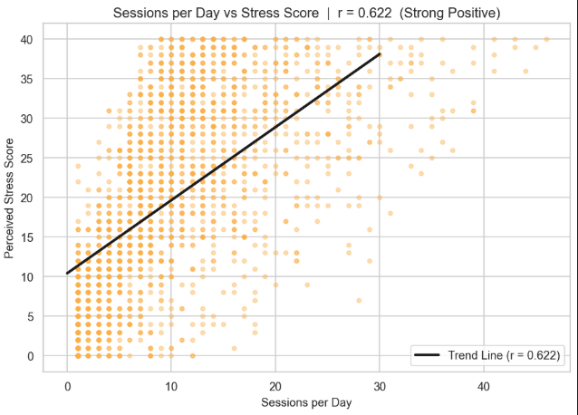
Interpretation
A strong positive relationship (r = 0.622) exists between sessions per day and stress levels. Users who open Instagram more frequently show higher stress scores, indicating that session frequency is a meaningful predictor of stress alongside total usage time.

Chart 18: Users by Subscription Status
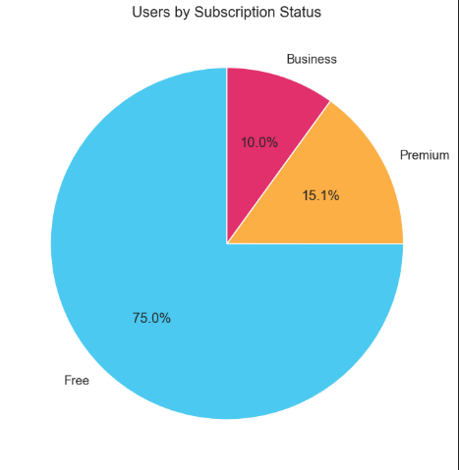
Interpretation
75% of users are on the free version of Instagram, while 15.1% use premium and 10% use business accounts. This indicates that most users prefer the free version, with only a limited number willing to pay for additional features.
Chart 19: Content Type Preference – Stress and Usage Comparison
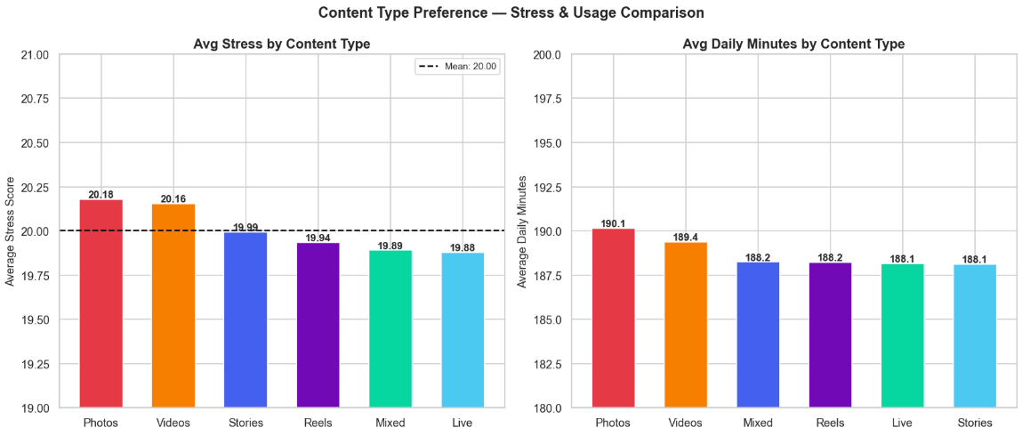

Interpretation
Average stress levels and usage time are very similar across all content types. Users preferring photos and videos show slightly higher stress and usage, while live, mixed, and reels content show marginally lower values. No single content type significantly increases stress compared to others.
Chart 20: Number of Instagram Users by Country (Map)
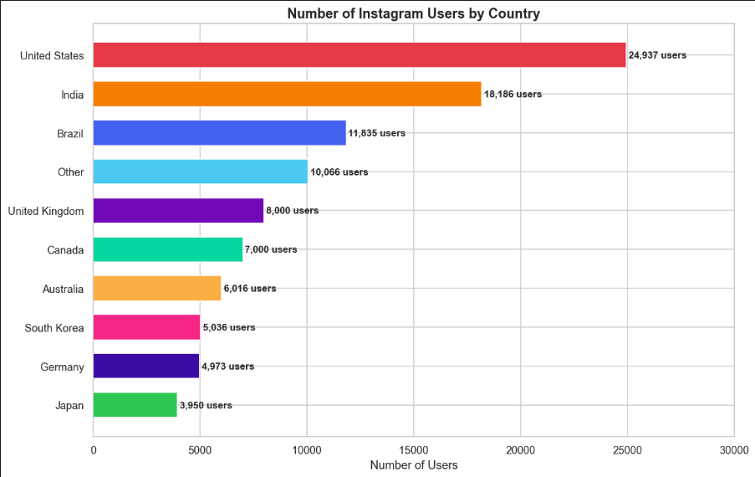
Interpretation
The United States has the highest user count (~24,937), followed by India (~18,186) and Brazil (~11,835). These three countries dominate the user base. The UK, Canada, and Australia have moderate counts, while South Korea, Germany, and Japan have comparatively lower numbers.

Chart 21: Average Stress by Employment Status
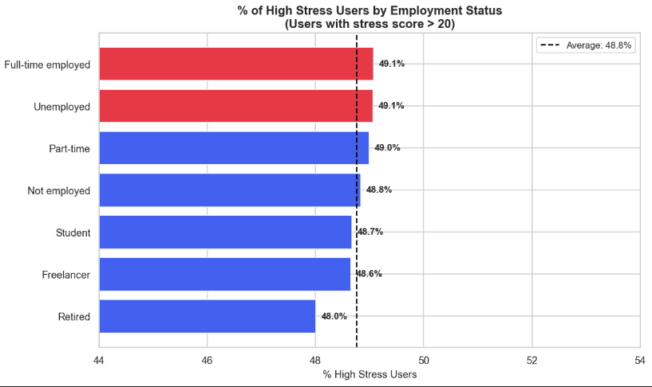
Interpretation
High stress percentage is very similar across all employment categories (48–49%). Full-time employed and unemployed users show slightly higher stress (~49.1%), while retired users show the lowest (~48.0%). The minimal variation indicates employment status has limited impact on Instagram-related stress.
Chart 22: Average Daily Minutes by Age Group
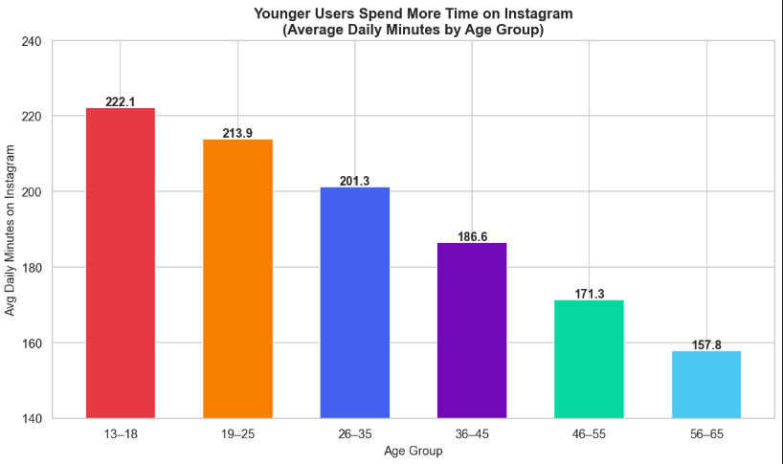

Interpretation
Younger users spend more time on Instagram. The 13–18 age group has the highest usage (~222 minutes), followed by 19–25 (~213 minutes) and 26–35 (~201 minutes). Usage gradually decreases with age, with the 56–65 group showing the lowest (~158 minutes).
Chart 23: High vs Low Stress Users Comparison
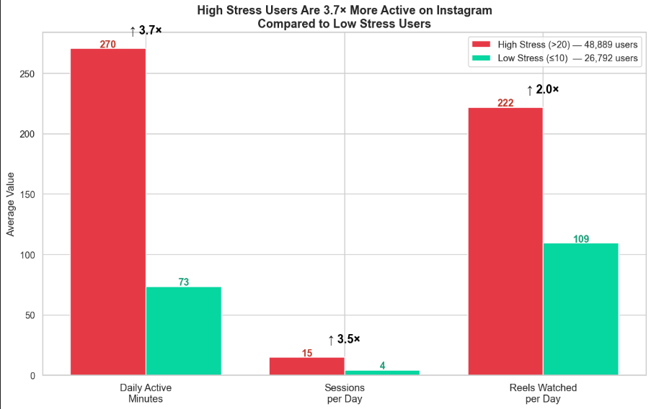
Interpretation
High-stress users are significantly more active on Instagram. They spend ~270 daily minutes versus ~73 for low-stress users (3.7x more), have ~15 sessions per day versus 4, and watch ~222 reels versus 109. This comparison powerfully illustrates the usage-stress relationship.

Chart 24: Correlation Heatmap – All Numeric Variables
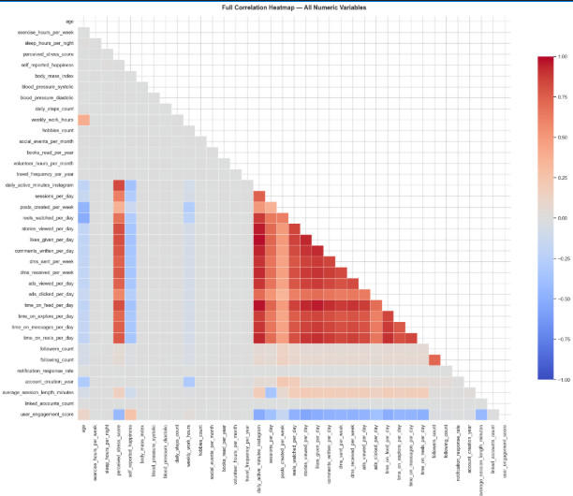
Interpretation
A strong positive cluster exists among usage variables (daily minutes, sessions, reels, likes, comments). Users highly active in one behaviour tend to be active in others. A noticeable positive relationship between usage and stress is visible, while lifestyle variables (sleep, exercise) show weaker correlations with usage.

Chart 25: Correlation Heatmap – Key Variables
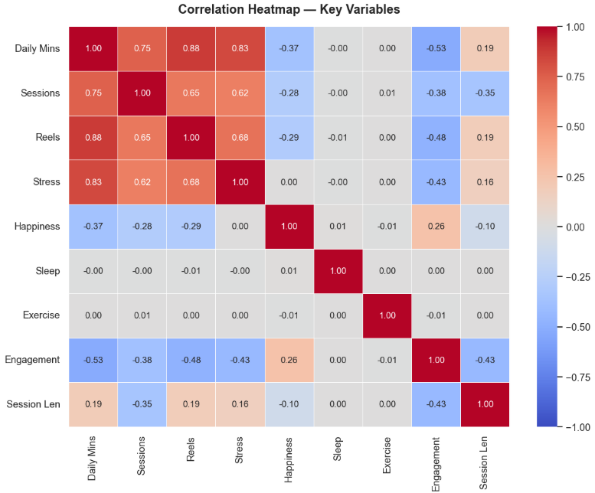
Interpretation
Strong positive relationships exist among usage variables (0.65–0.88). Usage and stress show strong positive correlation (up to 0.83). Happiness shows negative correlation with usage variables (-0.28 to -0.37). Engagement shows negative relationships with stress, while sleep and exercise have minimal direct correlation with usage intensity.

Chart 26: Top 15 Variables Correlated with Stress Score
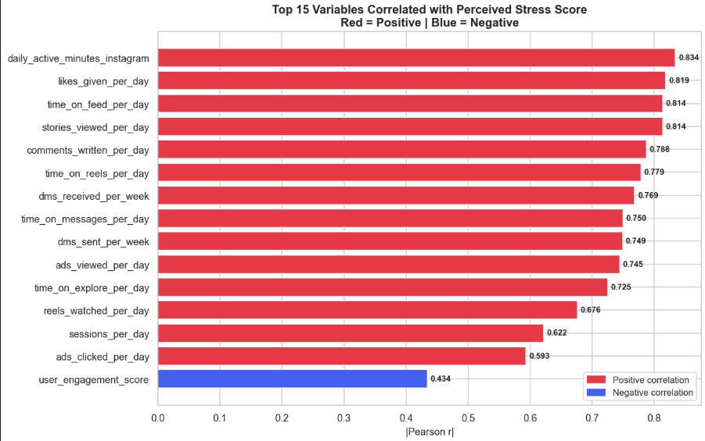
Interpretation
Most variables show strong positive correlation with stress. The highest are daily active minutes (0.834), likes given (0.819), time on feed/stories (~0.814), and comments written (0.788). Only engagement score shows a negative correlation (-0.434), suggesting quality engagement may buffer against stress somewhat.
Chart 27: Average Daily Instagram Minutes by Country
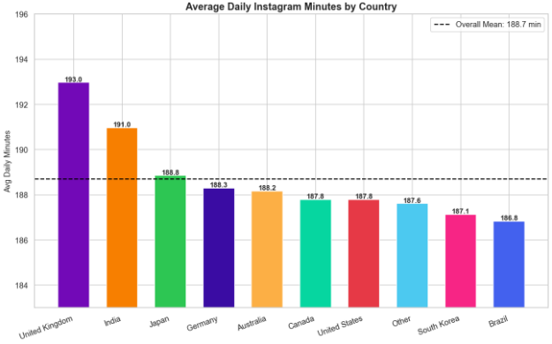

Interpretation
Average daily usage is very similar across all countries (~188.7 minutes overall). The UK and India show slightly higher usage, while Brazil and South Korea are slightly lower. The consistency across geographies confirms that Instagram's usage patterns are globally uniform.
Chart 28: Instagram Users Active by Month
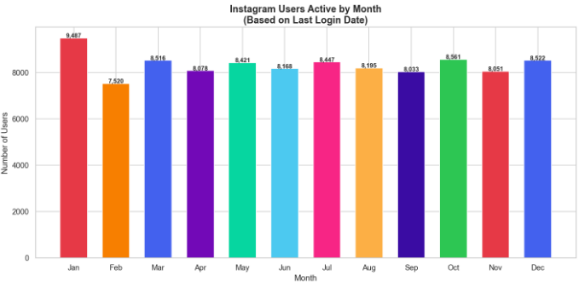
Interpretation
Monthly active users remain fairly consistent throughout the year. January has the highest activity (~9,487), while February shows a slight drop (~7,520). Other months show relatively stable patterns with slight peaks in March, May, July, October, and December.
Chart 29: Instagram Account Growth Over Years
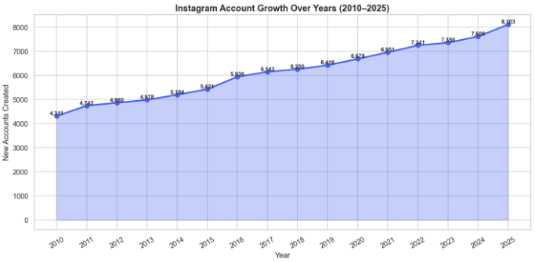

Interpretation
A steady increase in new Instagram accounts from 2010 to 2025, from ~4,300 accounts in 2010 to over 8,100 by 2025. No major drops indicate consistent platform growth. Growth becomes slightly faster after 2015, reflecting increasing platform popularity.
Chart 30: Average Daily Instagram Minutes by Day of Week
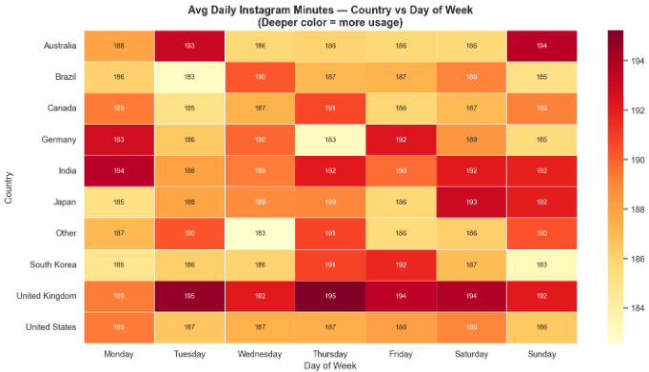
Interpretation
Instagram usage is fairly consistent across all days of the week with slight variations. Some countries like the UK and India show slightly higher usage on certain days (especially mid-week and weekends). A small increase in weekend usage (Friday–Sunday) suggests higher leisure-time activity.

Chart 31: Happiness Score Distribution by Country (Line)
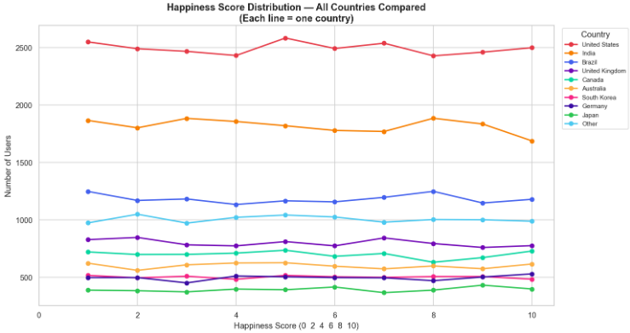
Interpretation
Happiness scores are consistent across all countries, with similar distribution patterns from score 1 to 10. The US and India have higher user counts at each level due to larger sample sizes. No sharp peaks or drops indicate users are spread across all happiness levels rather than concentrated in one category.

Findings & Insights

Findings
1. High Usage → Higher Stress
- Users with more daily active minutes and sessions per day tend to have higher stress scores.
- Excessive scrolling (especially reels) is strongly linked to mental fatigue.
- Overuse negatively impacts psychological well-being.
2. Moderate Usage → Better Happiness
- Users with balanced usage (not too high, not too low) show higher happiness scores.
- Controlled engagement leads to a positive user experience.
- Balanced usage is healthy usage.
3. Reels Consumption Drives Addictive Behaviour
- Users watching more reels per day spend more total time on the app and have more daily sessions.
- Indicates an addictive behaviour pattern driven by short-form content.
- Reels are a major driver of both engagement and overuse.
4. Engagement ≠ Well-being
- High engagement (likes, comments, activity) does not always increase happiness.
- Being active on the platform does not equate to being mentally healthy.
5. Demographics Influence Usage
- Younger users (13–25) spend significantly more time and show higher engagement.
- Some demographic groups show higher stress levels due to heavier usage patterns.
6. Lifestyle Impact
- Users with poor sleep and less physical activity show higher stress and lower happiness.
- Social media usage is linked with real-life lifestyle habits.

Insights
1. Social Media Platforms Encourage Overuse
- Features like infinite scrolling and reels increase usage time but can lead to user burnout.
- Platforms must balance engagement optimization with user well-being.
2. Healthy Users = Long-Term Users
- Users with moderate usage stay active longer and have better experiences.
- Sustainable growth depends on supporting user well-being, not just maximizing engagement.
3. Engagement Metrics Are Misleading
- High likes and comments do not necessarily indicate happy users.
- Platforms focusing only on engagement metrics may inadvertently ignore mental health impact.
- Well-being KPIs should be tracked alongside standard engagement metrics.
4. Personalization Opportunity
- Different user segments behave differently – one strategy does not fit all.
- AI can be used to recommend healthy usage patterns and personalize content based on well-being indicators.

Recommendations & Suggestions
1. Introduce Usage Control Features
- Implement screen time alerts and daily usage limits for users.
- Add "Take a Break" reminders for users with above-average usage patterns.
- These features help reduce overuse and associated stress levels.
2. Smart Content Recommendation
- Reduce repetitive reel-heavy content delivery for heavy users.
- Promote educational content, positive content, and content aligned with user well-being.
- Reduces content addiction loops and improves user well-being.
3. Mental Health Indicators in App
- Show users weekly usage reports and mood tracking features.
- Display personalized insights connecting usage behaviour to well-being indicators.
- Helps users become self-aware and take corrective action voluntarily.
4. Target High-Risk Users
- Identify users with high usage combined with high stress through data analysis.
- Proactively provide notifications, wellness suggestions, and usage moderation tools.
5. Improve Algorithm Ethics
- Avoid promoting addictive content loops that maximize session time at the expense of well-being.
- Balance engagement optimization with well-being indicators in recommendation algorithms.
- Ethical AI in content recommendation builds better brand trust and long-term user loyalty.
6. Lifestyle Integration
- Encourage offline activities, fitness challenges, and social connections beyond the platform.
- Connect digital behavior insights with healthy habits to promote overall user wellness.

Conclusion
The Social Media User Analysis reveals that while Instagram successfully drives user engagement, excessive usage leads to higher stress and lower happiness, whereas moderate and balanced usage results in better well-being. This indicates that increased activity on the platform does not always translate into positive user experience.
Key findings from this analysis include:
- Strong positive correlation (r = 0.834) between daily active minutes and stress scores confirms that higher usage directly increases psychological stress.
- Happiness shows a consistent negative trend with usage intensity, declining from ~7.37 (low usage) to ~3.75 (heavy usage).
- Reels consumption is a major driver of addictive usage patterns, with heavy reel watchers showing significantly more sessions and total time on platform.
- High engagement metrics do not guarantee user happiness – some of the most engaged users also report high stress levels.
- Younger users (ages 13–25) are the most vulnerable demographic with highest usage and highest stress correlation.
- Usage patterns are globally consistent, indicating platform design influences user behaviour across all geographies.

Therefore, social media platforms should move beyond focusing only on engagement metrics and prioritize promoting healthy and sustainable usage. By leveraging data-driven insights and encouraging balanced digital behaviour, platforms can improve user well-being while ensuring long-term growth and retention.
This project demonstrates the significant value of data analytics in understanding the intersection of digital behaviour and human psychology. With further integration of real-time data, machine learning models, and behavioural analytics, the findings of this study can be scaled to support enterprise-level platform decision-making and public health policy formulation.

Bibliography
1. Kaggle Dataset – Social Media / Instagram User Data
https://www.kaggle.com/
2. Python Documentation (for analysis tools used)
https://docs.python.org/
3. Libraries: Pandas, NumPy, Matplotlib, Seaborn
4. Han, J., Kamber, M., & Pei, J. (2011). Data Mining: Concepts and Techniques (3rd ed.). Morgan Kaufmann.
5. McKinney, W. (2017). Python for Data Analysis. O'Reilly Media.
6. VanderPlas, J. (2016). Python Data Science Handbook. O'Reilly Media.

