CE613A: Computer Methods in Hydraulics & Hydrology  
**Assignment – 11**

**HARSH JHA(241030040)**

Watershed Delineation and Dam Impact Analysis on PANDU River Basin using QGIS

# Introduction

This report addresses the geospatial analysis carried out for the Kanpur area and the **PANDU watershed**. The tasks were performed using Google Earth Engine and GIS tools, including watershed delineation, LULC classification, stream network extraction, and dam impact assessment. The results are summarized with relevant maps and statistical data.

# DEM and LULC Download for Kanpur Area

**Latitude (Y-axis):**

* Southern boundary: **26.500° N**
* Northern boundary: **30.000° N**

**Longitude (X-axis):**

* Western boundary: **77.500° E**
* Eastern boundary: **80.000° E**

# Watershed Delineation

The Pandu watershed was delineated with the outlet located at Panki .Sub-basins and stream networks were generated using hydrological analysis tools.  
  
Steps in QGIS:  
1. Load the DEM raster into QGIS.  
2. Go to Processing Toolbox > SAGA > Terrain Analysis - Hydrology.  
3. Run “Fill sinks (Wang & Liu)” to prepare DEM.  
4. Use “Catchment area (Parallel)” to compute flow accumulation.  
5. Select outlet point (Panki) using shapefile or manually digitized point.  
6. Run “Watershed basins” to delineate entire basin.  
7. Run “Channel network and drainage basins” to extract sub-basins and stream network.  
  
Map Generated: Stream Network with delineated watershed  
Includes hillshade and elevation from DEM.

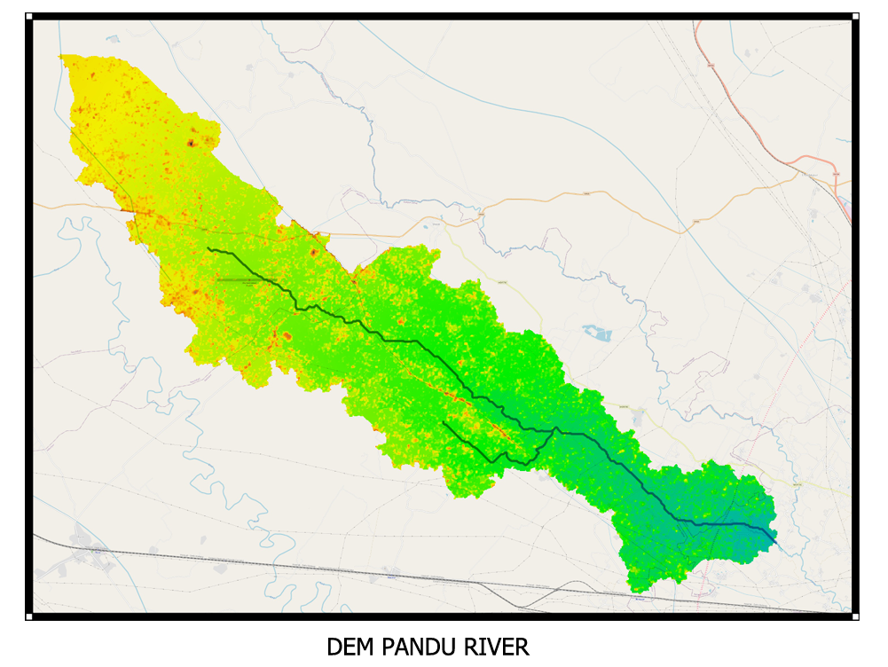

Figure: Stream network with delineated watershed as background.

# LULC Type Percentage in the Watershed

LULC analysis of the delineated watershed was performed, and the area under different LULC classes was estimated. Below is the LULC distribution in percentage:

Steps in QGIS:  
1. Load the LULC raster and delineated watershed shapefile.  
2. Use “Clip Raster by Mask Layer” to cut LULC raster to watershed boundary.  
3. Use “Raster layer zonal statistics” to extract area per LULC class.  
4. Export table to Excel or CSV to calculate percentage:  
 Percentage = (Class Area / Total Watershed Area) × 100  
  
  
  
Hydrological Insight:  
Open forests contribute to moderate runoff. Dense vegetation improves infiltration, reducing peak discharge.

Map Generated: LULC Map with Legend and Table

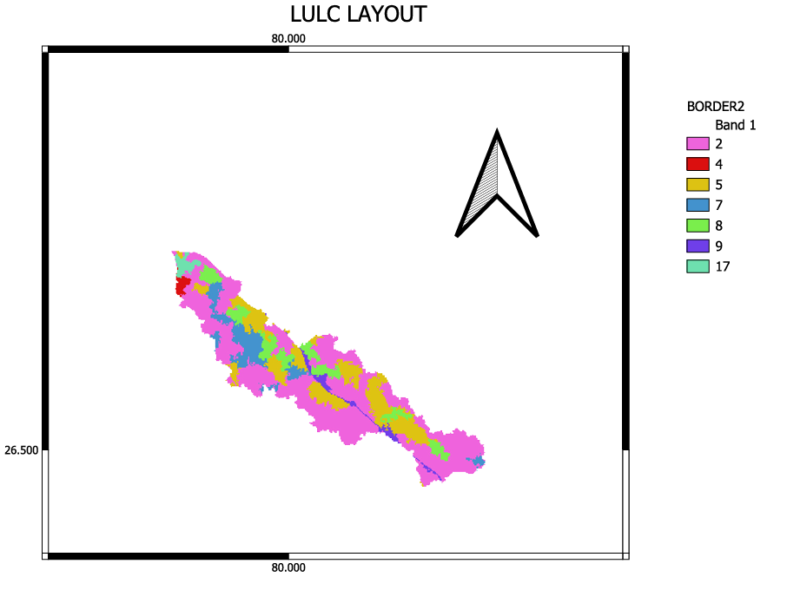

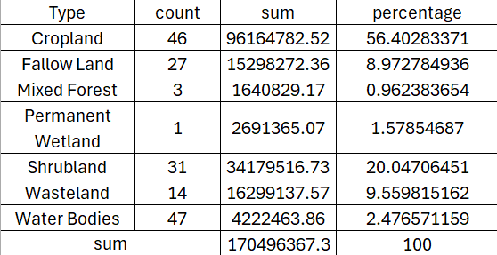

Figure: LULC map and land use statistics for the watershed.

Dominant LULC types include Cropland (56.40%) and Shrubland (20.04%), followed by Shrubland and Cropland. This distribution suggests high runoff potential and low infiltration due to minimal vegetation cover and impervious surfaces.

# Dam Impact Analysis

A hypothetical dam with HFL set at 130 meters above MSL was considered near Panki. The flood inundation analysis estimated the total inundated area and the volume of water stored behind the dam.

DATA:

Minimum land elevation above MSL:149 m

Maximum land elevation above MSL :127 m

High Flood Level (HFL) at 130 meters above mean sea level

Height of dam :19 m

Steps in QGIS:  
1. Load the DEM and convert to elevation contours.  
2. Select contour at 400 m to define inundation level.  
3. Use Raster Calculator:  
 "DEM" < =130  
 to create a binary raster showing inundated area.  
4. Use “Raster layer statistics” to compute:  
 - Pixel count  
 - Total area (Pixel count × pixel area)

5. Use “Volume calculation” plugin or Raster Surface Volume in GRASS for storage volume estimation.  
  
Map Generated: Flood Inundation Map with Outlet Marked

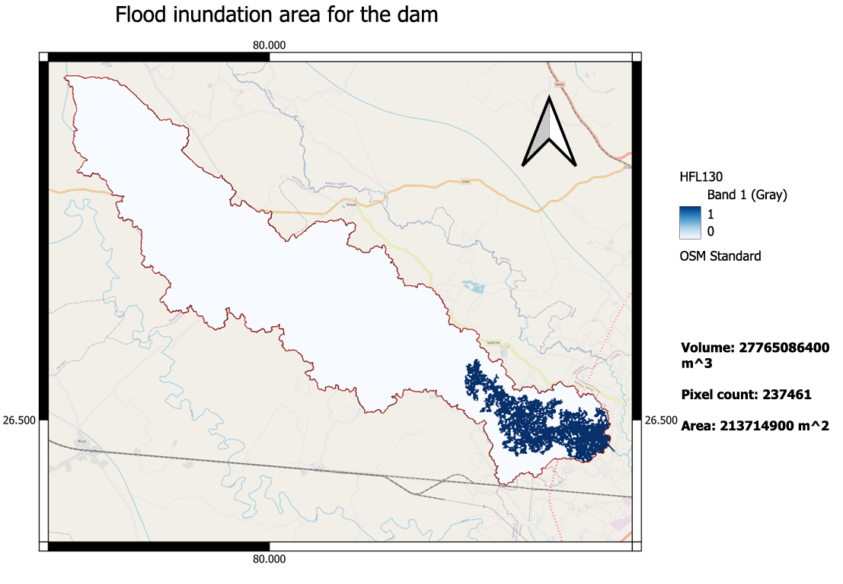

Figure: Flood inundation area for the proposed dam.

Estimated flood volume: 27765086400 m³  
Pixel count: 237461  
Inundated area: 2,137,14900 m²

# Map Preparation

The following maps were prepared as part of the spatial analysis for the watershed and dam scenario:  
A. Stream Network with Watershed Delineation  
B. LULC Map with Dominant Type Identification  
C. Flood Inundation Area for Hypothetical Dam  
D. Tabulated Report with Storage Volume  
All maps include:  
- Titles   
- North Arrow  
- Scale Bar)

- Legend  
- Proper Projection

*********