|  |
| --- |
| > dataFile <- read.csv("C:/Users/Harsh Kevadia/Downloads/data CS553.csv")  > set.seed(20)  >  > clust <- kmeans(dataFile[,-1],2,nstart = 20)  >  > clust  K-means clustering with 2 clusters of sizes 7, 2  Cluster means:  Malware detection infection bot technique systems  1 0.2316943 0.2148682 0.4297364 0.5792359 0.4708338 0.000000  2 1.2163953 0.7520387 0.0000000 0.4054651 0.0000000 1.504077  Clustering vector:  [1] 1 1 1 2 2 1 1 1 1  Within cluster sum of squares by cluster:  [1] 13.064436 1.788732  (between_SS / total_SS = 29.3 %)  Available components:  [1] "cluster" "centers" "totss" "withinss" "tot.withinss" "betweenss" "size"  [8] "iter" "ifault"  >  > table(clust$cluster,dataFile[,1])    c1 c2 c3 c4 c5 m1 m2 m3 m4  1 1 1 1 0 0 1 1 1 1  2 0 0 0 1 1 0 0 0 0 |
|  |
| |  | | --- | | > | |

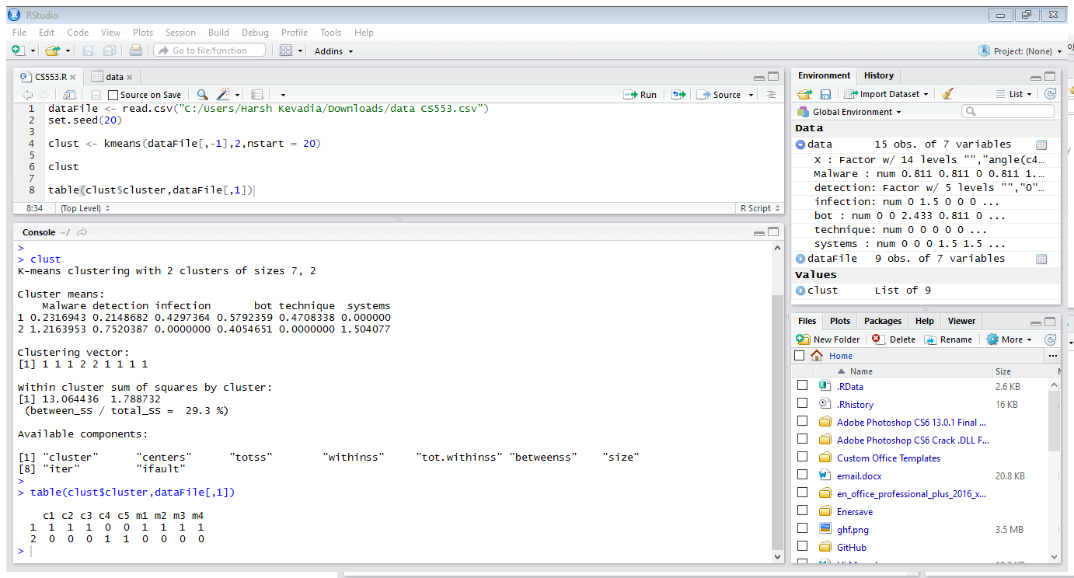

dataFile <- read.csv("C:/Users/Harsh Kevadia/Downloads/data CS553.csv")

set.seed(20)

clust <- kmeans(dataFile[,-1],2,nstart = 20)

clust

table(clust$cluster,dataFile[,1])