Amazon Brazil Data Analysis – Insights for Amazon India
SQL analysis in PostgreSQL 16 · Database: amazon_analysis · Schema: amazon_brazil

1. Objective
Analyse Amazon Brazil's orders, payments, products, sellers and customers to find trends, customer behaviour and preferences that Amazon India can use to make better launch and growth decisions.

2. Data preparation
- Each sheet of the source workbook was saved as a CSV (customers, orders, order_items, product, seller, payments).
- Database amazon_analysis and schema amazon_brazil were created; tables were defined with primary keys and foreign keys (see 01_setup_schema.sql).
- CSVs were imported in foreign-key order. Row counts: customers 99,441; orders 99,441; order_items 112,650; product 32,951; seller 3,095; payments 103,886. All foreign keys validated with no orphans.
- Orders span 4-Sep-2016 to 17-Oct-2018; Sep–Oct 2018 contain very few orders.

3. Assumptions used in the queries
- Order-level sales / order value = payments.payment_value (what the customer paid).
- Product- and category-level revenue = order_items.price (payments cannot be split per product); each order_items row = 1 unit sold.
- Repeat-purchase questions use customer_unique_id, because customer_id is issued per order. III.5 uses customer_id as the required output specifies.
- All order statuses are included, as in the raw data.
- No product-name column exists, so I.3's 'Smart' filter is applied to product_category_name.

4. Key insights at a glance
- Payments: credit card is used in 77% of orders; boleto (cash-like) in 20% → India needs strong UPI and COD alongside card EMI.
- Retention: 96.7% of customers ordered only once → retention/loyalty is the biggest opportunity.
- Categories: health & beauty, watches & gifts, bed-bath-table, sports and computer accessories generate the most revenue.
- Seasonality: sales peak March–August (top months May, Aug, Jul); February and June are softer.
- Data quality: 614 products lack a valid category – enforce validation at listing.

Analysis I – Basic SQL

Q I.1 Average payment value per payment type
Context: To simplify financial reports, round the average payment value of each payment type to an integer and sort ascending.
SQL query and output:
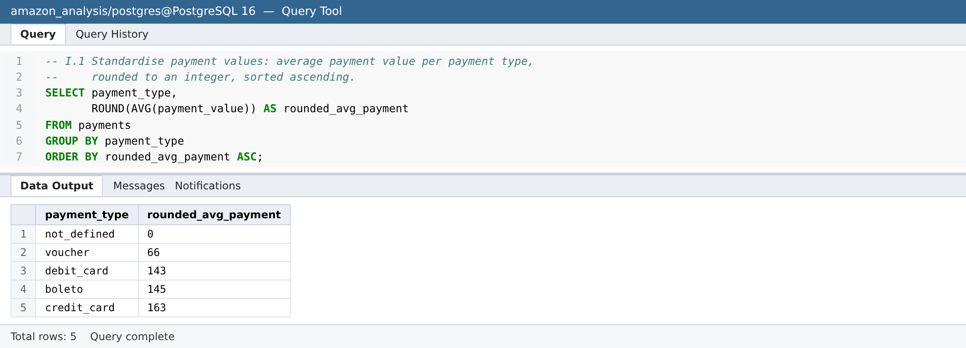
Analysis:
- Credit card has the highest average ticket (163 BRL), followed by boleto (145) and debit card (143).
- Vouchers average only 66 BRL – they are mostly used as a partial payment/top-up alongside another method.
- 'not_defined' (3 records, 0 BRL) is junk data and should be cleaned.
Recommendation: In India, keep credit cards (with EMI) as the high-ticket payment rail, position vouchers/gift cards as small-value top-ups, and add validation so payments cannot be stored with an undefined type.

Q I.2 Share of orders by payment type
Context: Calculate the percentage of total orders that used each payment type (1 decimal), descending.
SQL query and output:
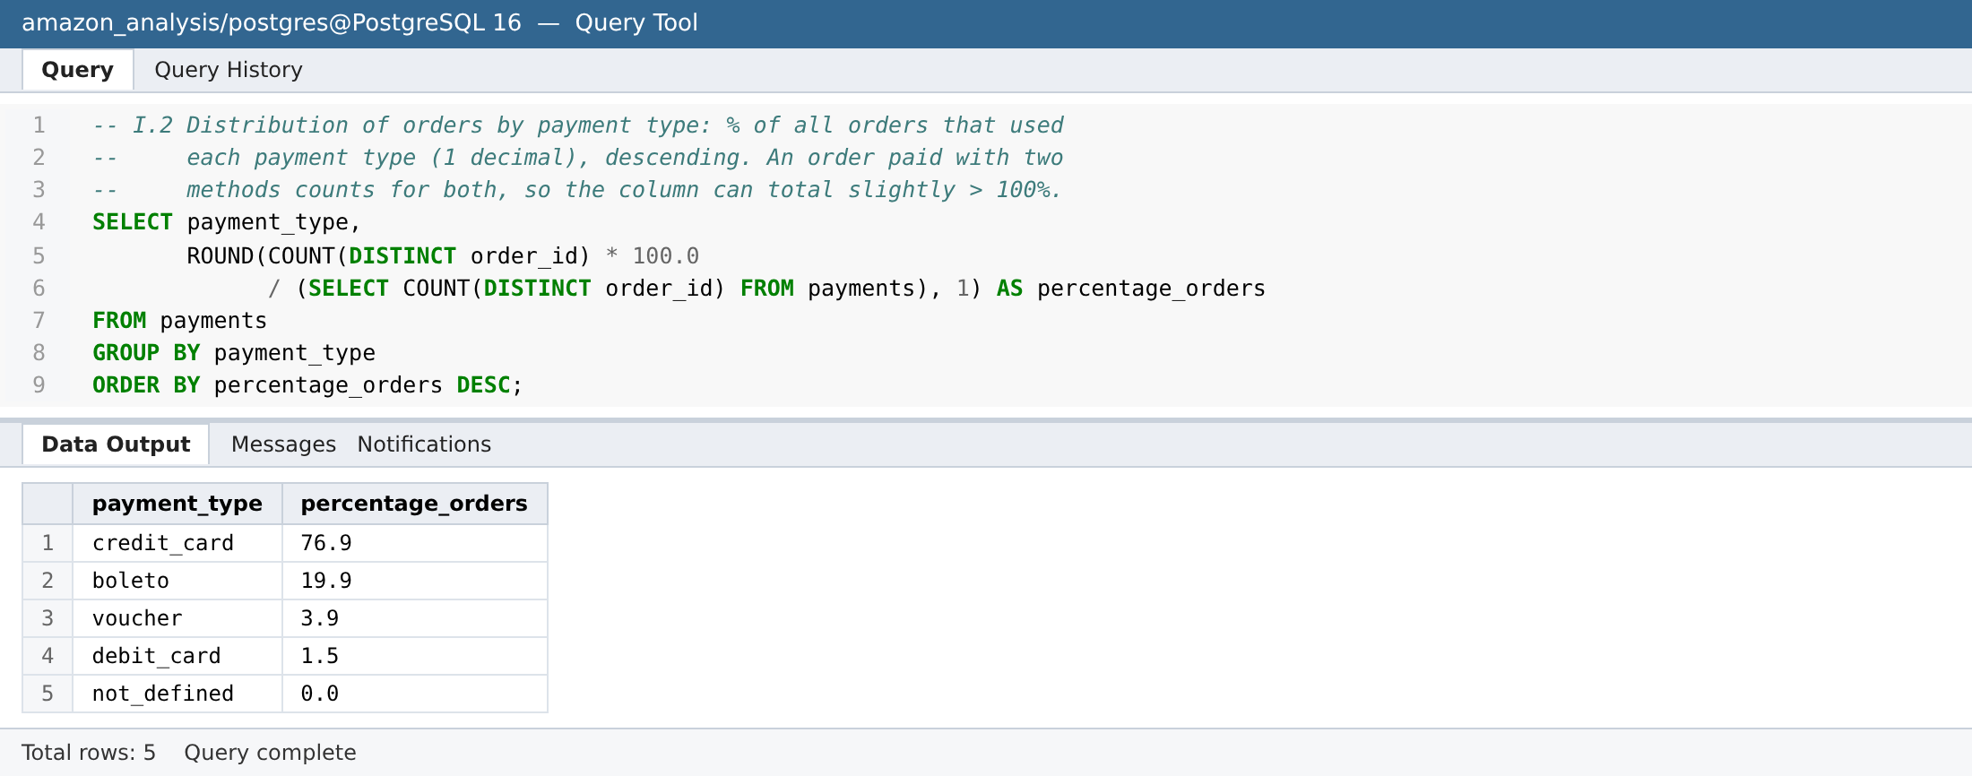
Analysis:
- Credit card is used in 76.9% of orders; boleto (a cash-like bank slip) in 19.9%; voucher 3.9%; debit card only 1.5%.
- 2,246 orders combine two payment types (mostly card + voucher), so the column totals slightly above 100%.
Recommendation: Boleto's 20% share shows a large segment that prefers non-card, pay-later-in-cash methods. India's equivalents are Cash-on-Delivery and UPI – both must be first-class options, alongside card EMI.

Q I.3 'Smart' products priced 100–500 BRL
Context: List products priced between 100 and 500 BRL whose name contains 'Smart', sorted by price descending.
SQL query and output:
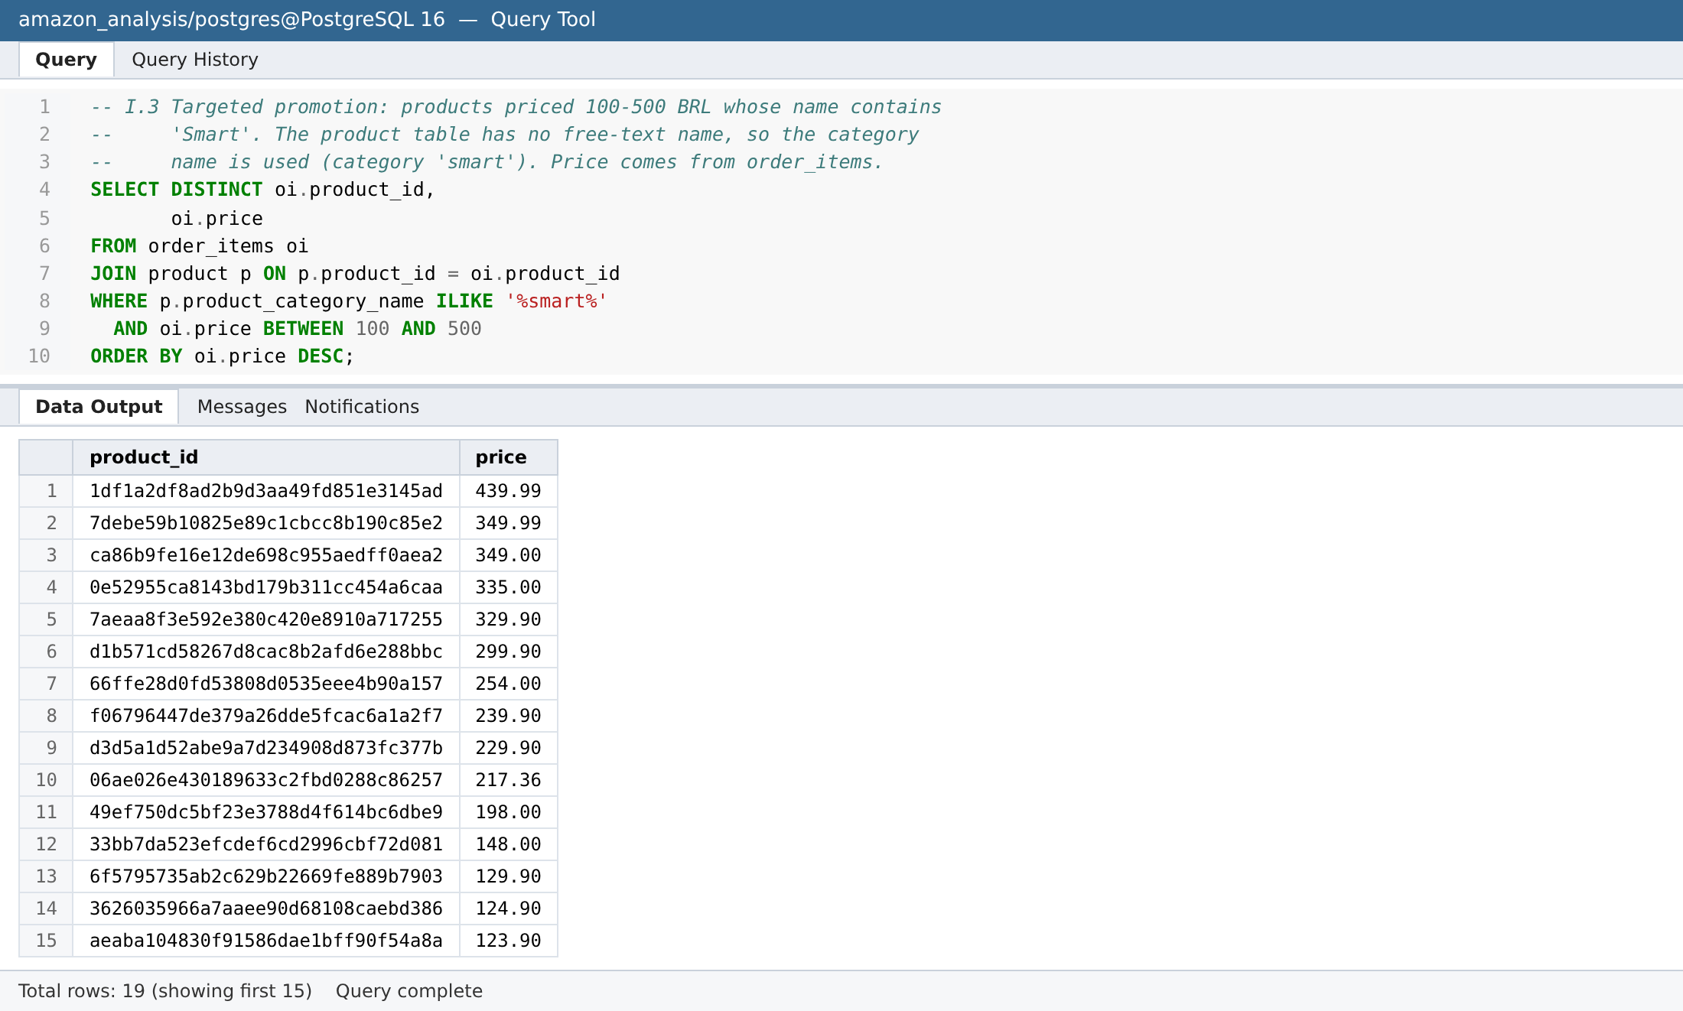
Analysis:
- The product table has no free-text product name, so the match is applied to the category name – the dataset has a category named 'smart' (50 products).
- 19 product/price combinations fall in the 100–500 BRL band, from 439.99 down to 100.00 BRL; most sit between 100 and 350 BRL.
- Product aeaba104… appears at both 123.90 and 100.00 BRL – sellers changed its price over time.
Recommendation: Build a 'Smart devices under ₹X' promotion around the 100–350 BRL equivalent band where most of these products sit, and track price changes per product to time discounts.

Q I.4 Top 3 months by total sales
Context: Find the three calendar months with the highest total sales value (rounded to integer).
SQL query and output:
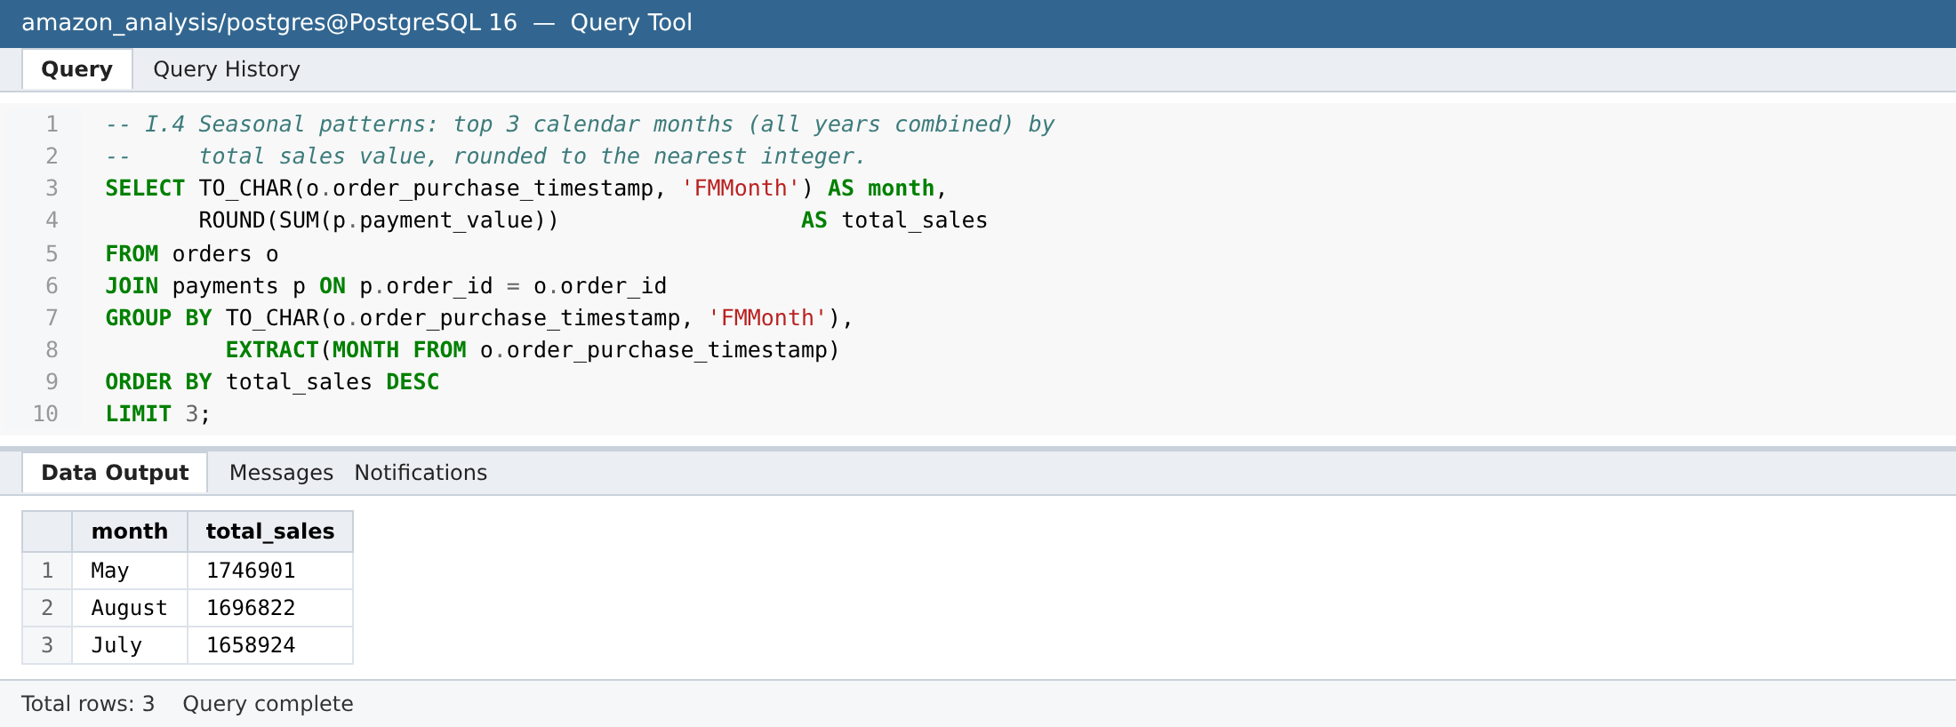
Analysis:
- May (1.75M BRL), August (1.70M) and July (1.66M) are the top months.
- Sales concentrate in mid-year (Mar–Aug). Note: the data spans Sep-2016 to Oct-2018, so Jan–Aug have two full years of data while Sep–Dec have mostly one, which favours the mid-year months.
Recommendation: Plan inventory and marketing capacity for peak periods. For India, map the idea – not the months – to local peaks (Diwali/festive season Oct–Nov, end-of-season sales), and normalise by number of years when comparing months.

Q I.5 Categories with price difference > 500 BRL
Context: Find categories where max price − min price exceeds 500 BRL.
SQL query and output:
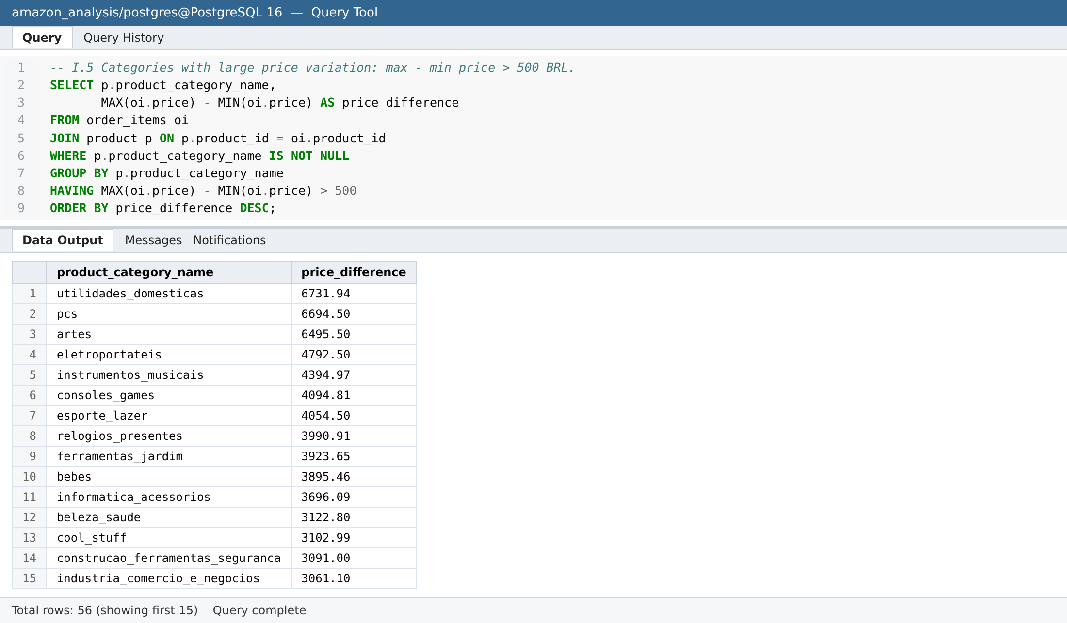
Analysis:
- 56 categories have a price spread above 500 BRL.
- The widest spreads are housewares/utilidades_domesticas (6,731.94), pcs (6,694.50) and artes (6,495.50) – these categories mix budget and premium items.
Recommendation: For wide-spread categories, add price-band filters and separate 'budget' and 'premium' merchandising so customers reach relevant products quickly.

Q I.6 Consistency of transaction amounts
Context: Rank payment types by standard deviation of transaction amount, smallest first.
SQL query and output:
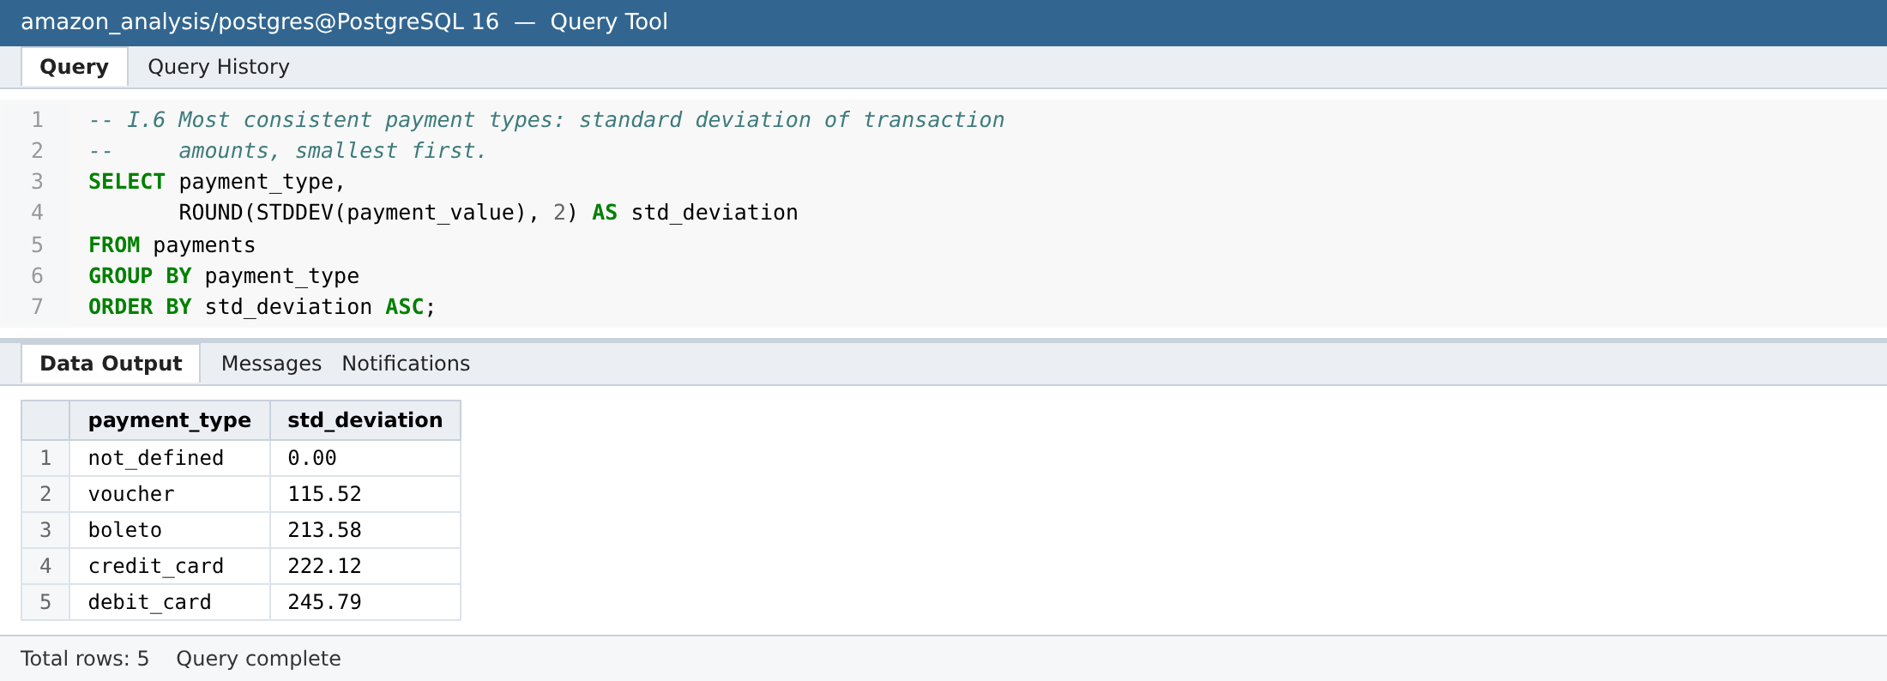
Analysis:
- Voucher is the most consistent (σ = 115.52 BRL), then boleto (213.58), credit card (222.12) and debit card (245.79).
- not_defined has σ = 0 only because its 3 rows are all zero.
Recommendation: Voucher amounts are predictable and suit fixed-value promotions. Card payments vary widely, so fraud and risk rules for cards should be value-aware rather than flat thresholds.

Q I.7 Products with missing / single-character category
Context: List products whose category name is NULL or a single character.
SQL query and output:
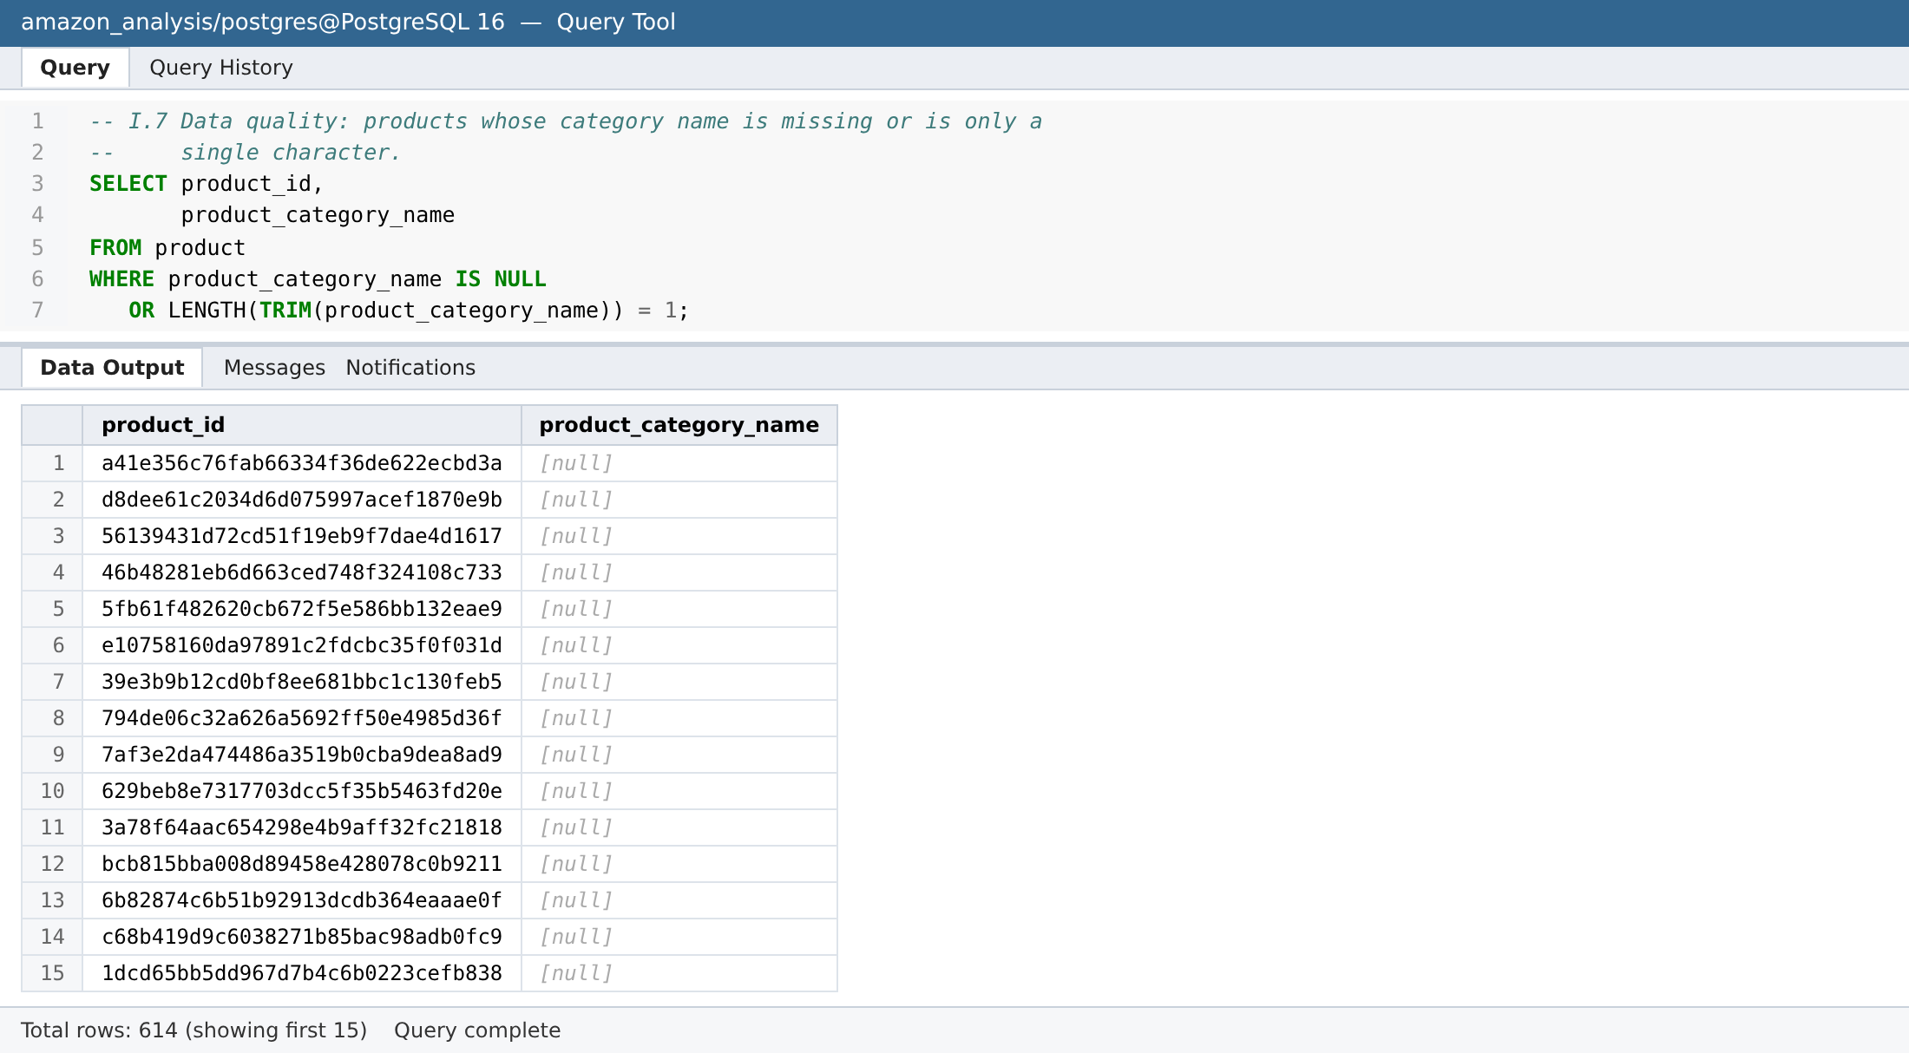
Analysis:
- 614 products are affected: 610 with no category and 4 with one-letter categories ('w', 'c', 't', 'f') – about 1.9% of the catalogue.
- These products also have NULL name/description lengths and photo counts, i.e. the listing is incomplete.
Recommendation: Make category a mandatory, drop-down-validated field at listing time in India, and run a backfill for the existing 614 products.

Analysis II – Joins & Temp Tables

Q II.1 Payment type by order-value segment
Context: Segment orders into Low (<200), Medium (200–1000) and High (>1000) BRL and count each payment type per segment.
SQL query and output:
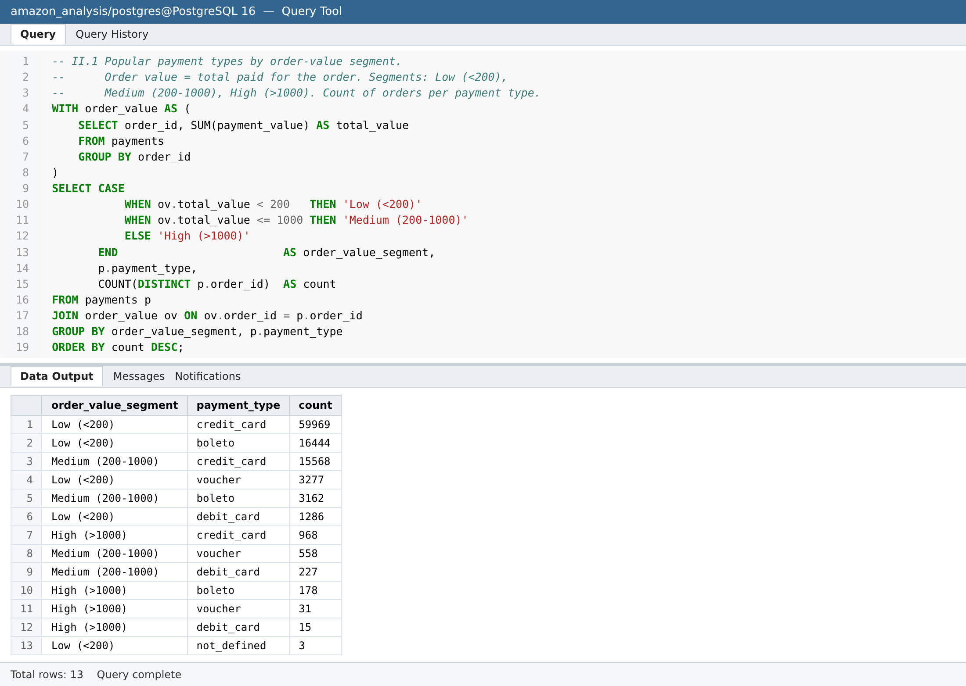
Analysis:
- Most orders are Low value (≈81k of ≈101k). Credit card dominates every segment.
- Credit card's share rises with order value: ~74% of Low orders, ~80% of Medium and ~81% of High orders; boleto falls from ~20% to ~15%.
- Debit card and voucher are almost absent from High-value orders.
Recommendation: Offer no-cost EMI and card offers on high-value carts, and keep UPI/COD friction-free for the low-value orders that form the bulk of volume.

Q II.2 Price range and average price per category
Context: Calculate min, max and average price per category, sorted by average price descending.
SQL query and output:
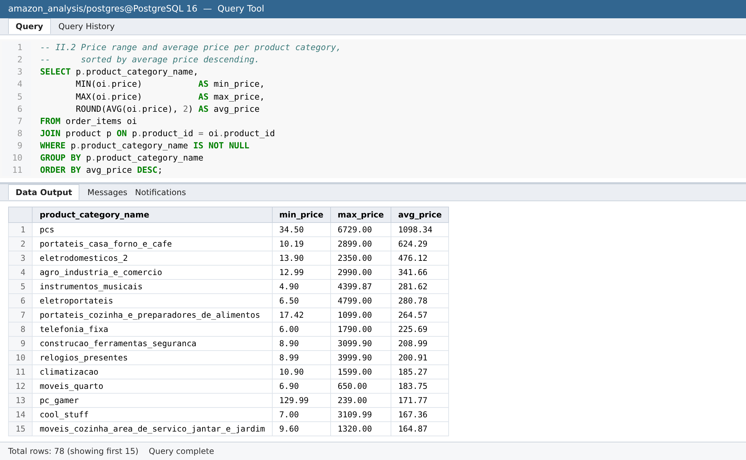
Analysis:
- 'pcs' (computers) has by far the highest average price (1,098 BRL), followed by small kitchen appliances (portateis_casa_forno_e_cafe, 624) and appliances (eletrodomesticos_2, 476).
- Lowest-priced categories include flowers (34), diapers/hygiene (40) and home comfort (25).
Recommendation: High-ticket categories (computers, appliances) need EMI, extended warranty and strong delivery guarantees; low-ticket categories are suited to bundles and subscribe-and-save.

Q II.3 Customers with more than one order
Context: Find customers (customer_unique_id) with more than one order, with their order count.
SQL query and output:
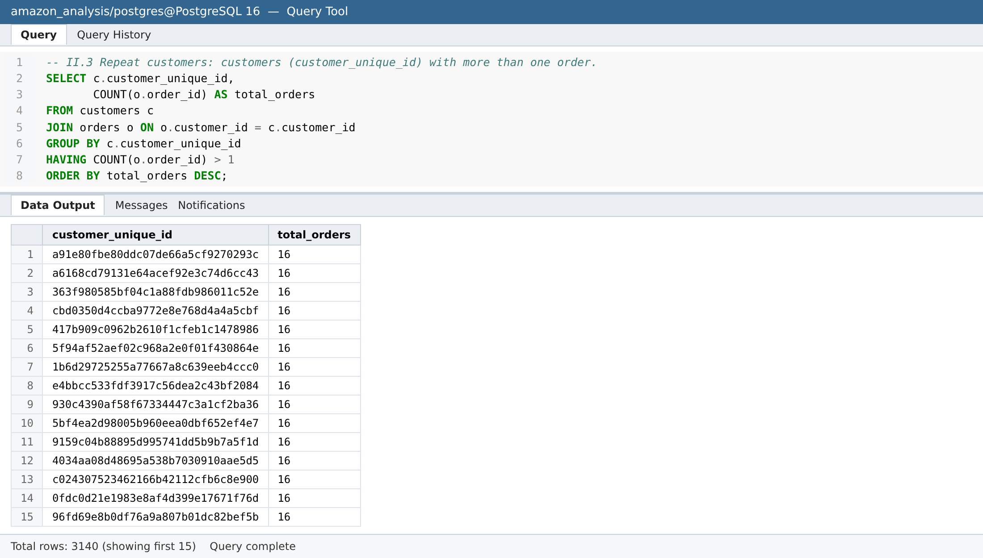
Analysis:
- Only 3,140 of 95,077 unique customers (3.3%) have ordered more than once.
- The most frequent customers have 16 orders each.
Recommendation: Repeat purchase is the biggest gap. Amazon India should invest early in retention: Prime-style membership, reorder reminders and post-delivery engagement.

Q II.4 Customer types using a temporary table
Context: Classify customers as New (1 order), Returning (2–4) or Loyal (>4) using a temporary table, update it and join it to customers.
SQL query and output:
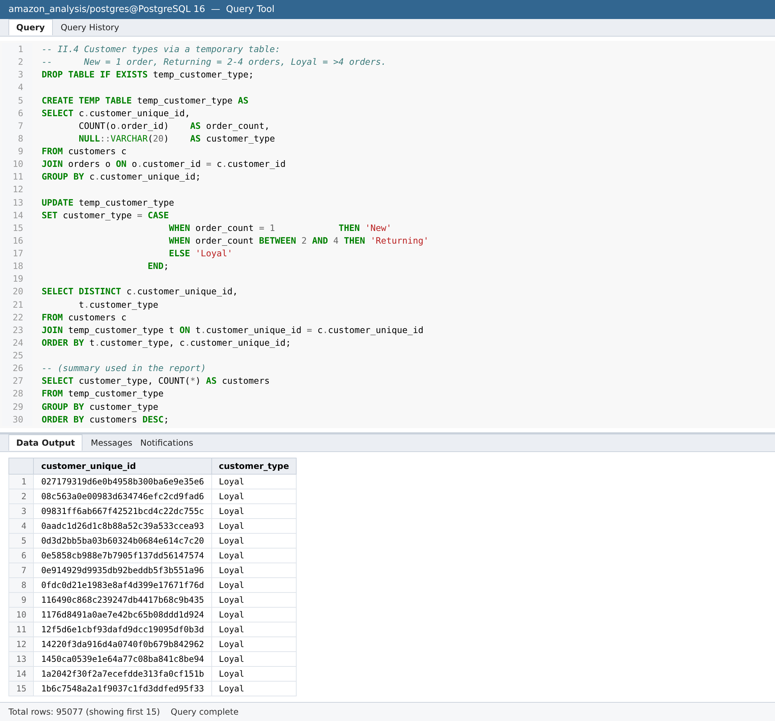
Segment summary:
customer_type | customers
New | 91,937
Returning | 3,020
Loyal | 120
Analysis:
- New: 91,937 (96.7%); Returning: 3,020 (3.2%); Loyal: 120 (0.13%).
- The temp table is created with order counts, the customer_type column is filled with an UPDATE, and the result is joined to customers for display.
Recommendation: Target 'New' customers with a second-order incentive (the key conversion step) and give 'Loyal' customers early access and exclusive perks.

Q II.5 Top 5 categories by revenue
Context: Use joins to compute total revenue per category and show the top 5.
SQL query and output:
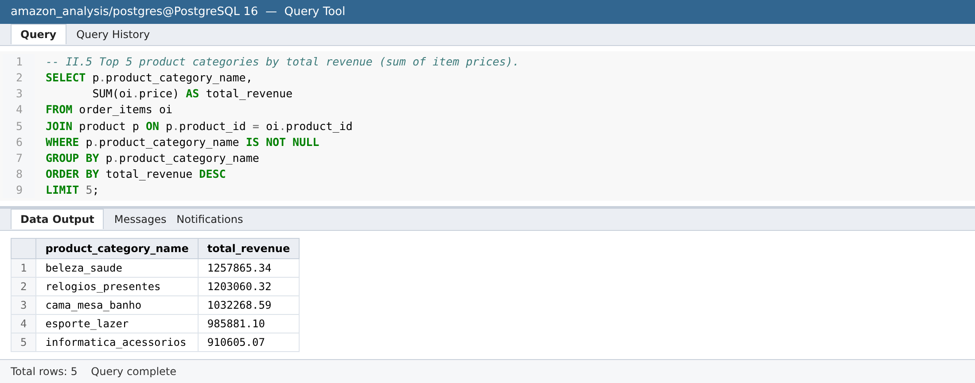
Analysis:
- 1. beleza_saude (health & beauty) – 1.26M BRL; 2. relogios_presentes (watches & gifts) – 1.20M; 3. cama_mesa_banho (bed, bath & table) – 1.03M; 4. esporte_lazer (sports & leisure) – 0.99M; 5. informatica_acessorios (computer accessories) – 0.91M.
Recommendation: Prioritise seller onboarding and assortment depth in beauty & personal care, watches & gifting, home furnishing, sports and computer accessories for the India launch.

Analysis III – Subqueries, CTEs & Window Functions

Q III.1 Total sales by season (subquery)
Context: Use a subquery to label each order by season (Spring Mar–May, Summer Jun–Aug, Autumn Sep–Nov, Winter Dec–Feb) and total the sales.
SQL query and output:
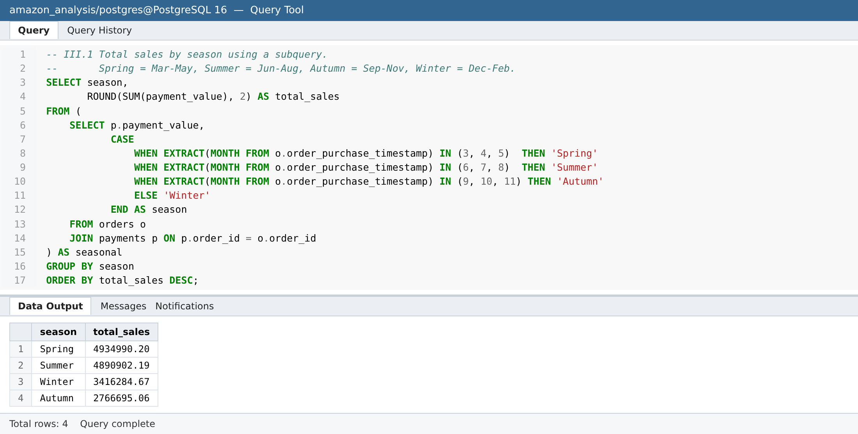
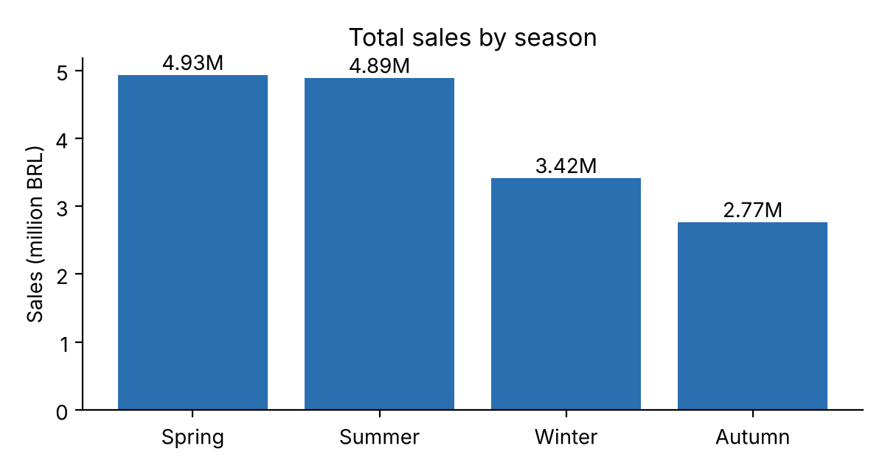
Analysis:
- Spring 4.93M BRL ≈ Summer 4.89M > Winter 3.42M > Autumn 2.77M.
- Autumn is understated because Sep–Oct 2018 contain almost no data (dataset ends), yet it still includes the Nov-2017 Black Friday spike.
Recommendation: Plan stock and promotions around the March–August high season. For India, align the equivalent push with the festive (Oct–Nov) season.

Q III.2 Products sold above average quantity (subquery)
Context: Use a subquery to keep only products whose total quantity sold exceeds the average quantity per product.
SQL query and output:
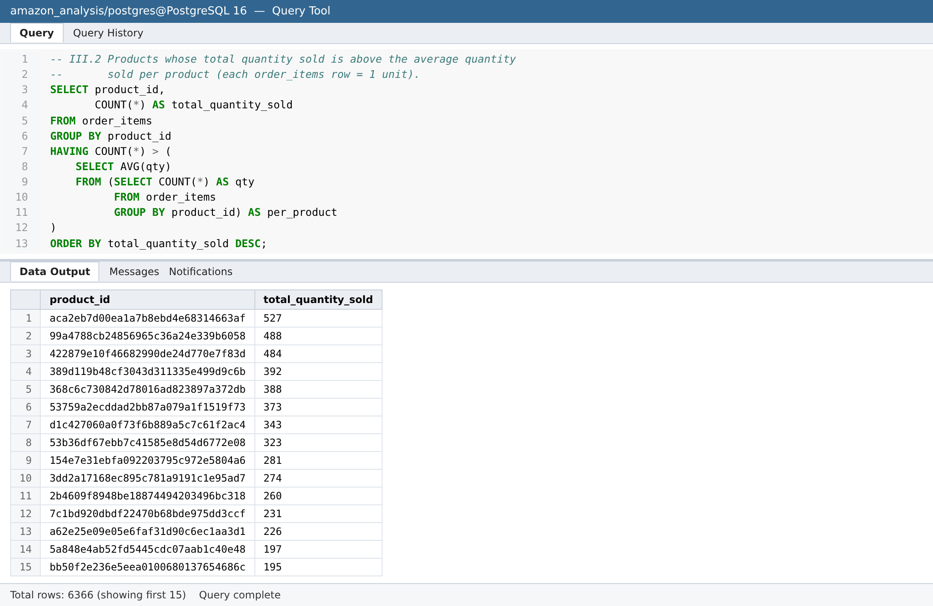
Analysis:
- The average product sells 3.42 units; 6,366 products (19% of the catalogue) sell more than that.
- The best seller (aca2eb7d…) sold 527 units – a long-tail catalogue where ~20% of products drive most volume.
Recommendation: Ensure the above-average products are always in stock (and prioritised for fulfilment-centre placement) in India.

Q III.3 Monthly revenue trend, 2018
Context: Compute total revenue per month in 2018, identify peak and low periods, export to Excel and chart.
SQL query and output:
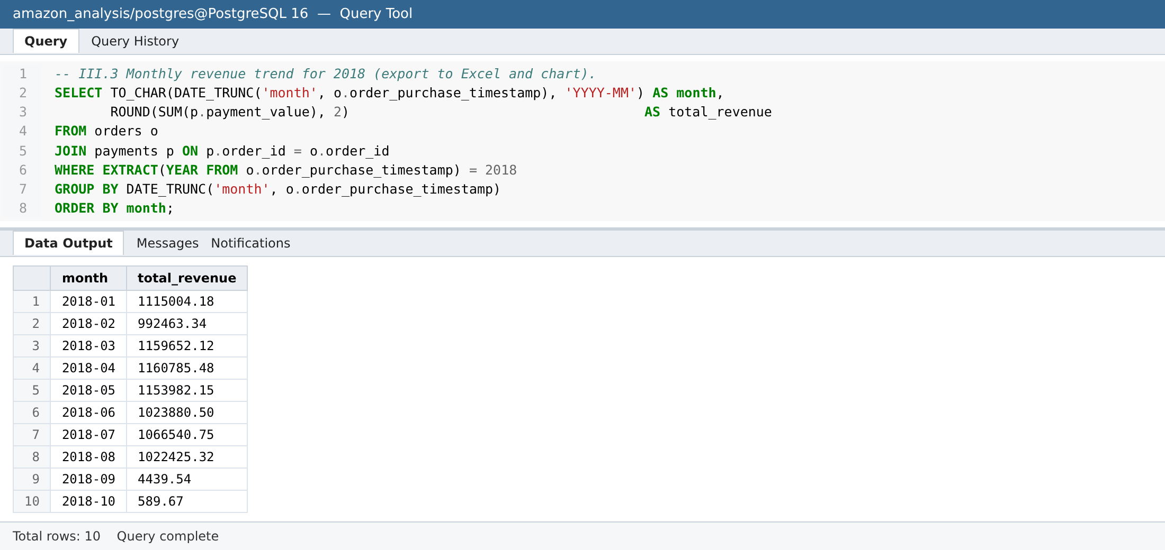
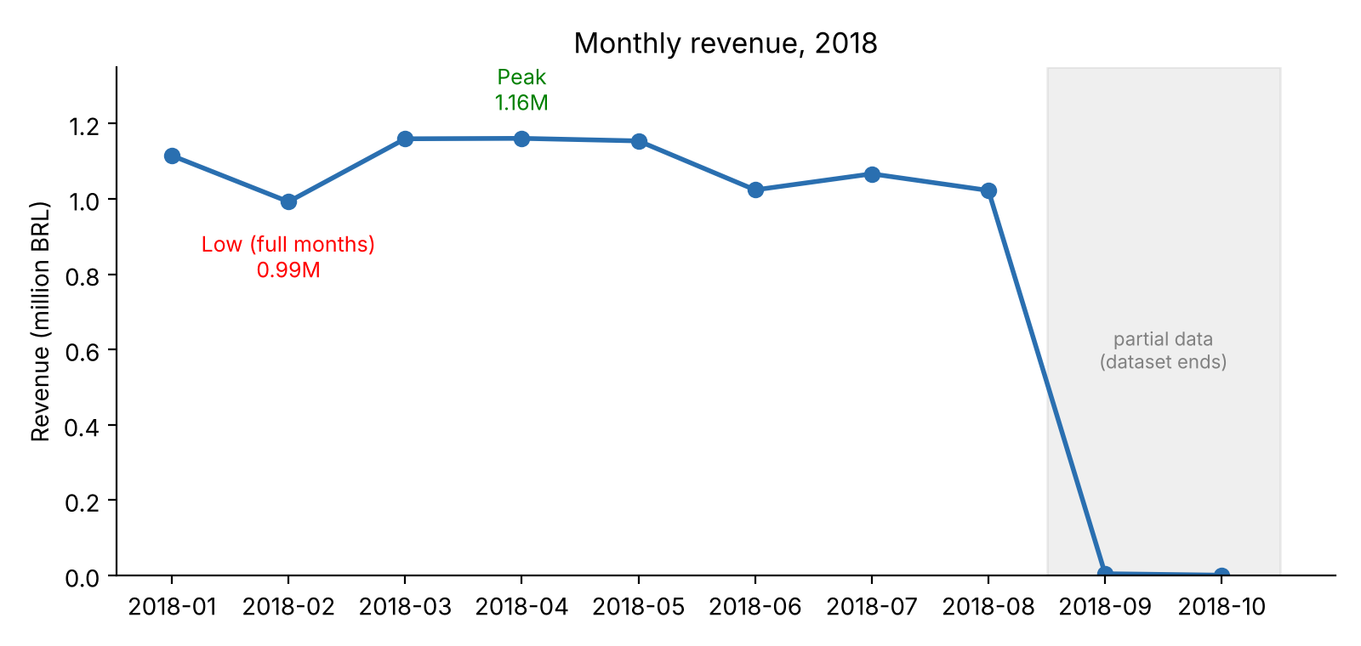
Analysis:
- Peak: April 2018 (1.16M BRL), with March–May all ≈1.15–1.16M.
- Lowest full month: February 2018 (0.99M); June and August also dip to ≈1.02M.
- September (4.4k) and October (0.6k) are partial months at the end of the data, not real collapses.
Recommendation: Use March–May as the benchmark peak for capacity planning; run demand-generation campaigns in February and June to smooth troughs.

Q III.4 Loyalty segmentation (CTE)
Context: Using a CTE, classify customers as Occasional (1–2 orders), Regular (3–5) or Loyal (>5) and count each segment; chart the proportions in Excel.
SQL query and output:
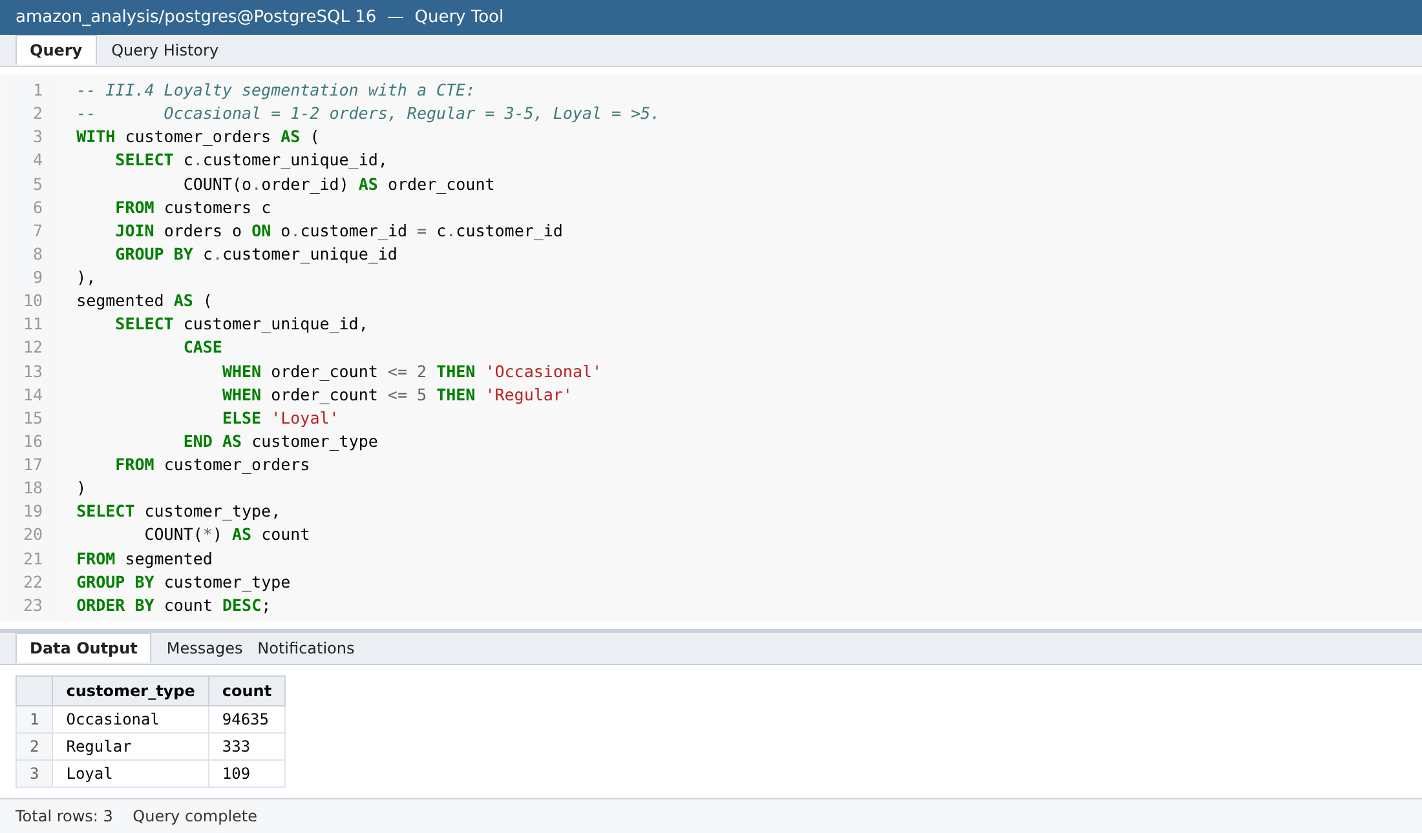
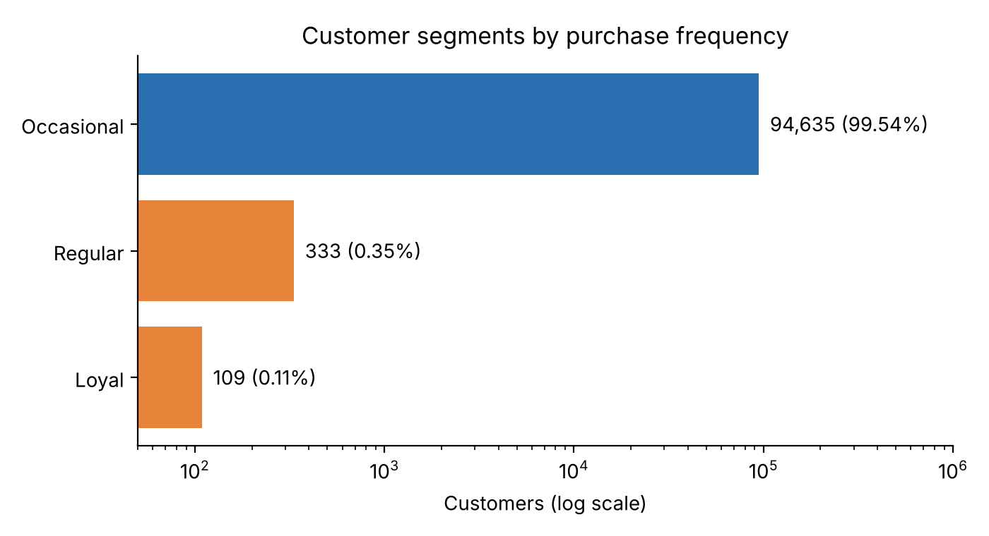
Analysis:
- Occasional: 94,635 (99.53%); Regular: 333 (0.35%); Loyal: 109 (0.11%).
- Because Occasional dwarfs the others, the Word chart uses a log scale; the Excel workbook contains the requested pie chart.
Recommendation: Design the loyalty programme to move Occasional buyers to a 3rd order (e.g. tiered rewards unlocking at order 3), not only to reward the tiny Loyal group.

Q III.5 Top 20 customers by average order value
Context: Rank customers by average order value and return the top 20.
SQL query and output:
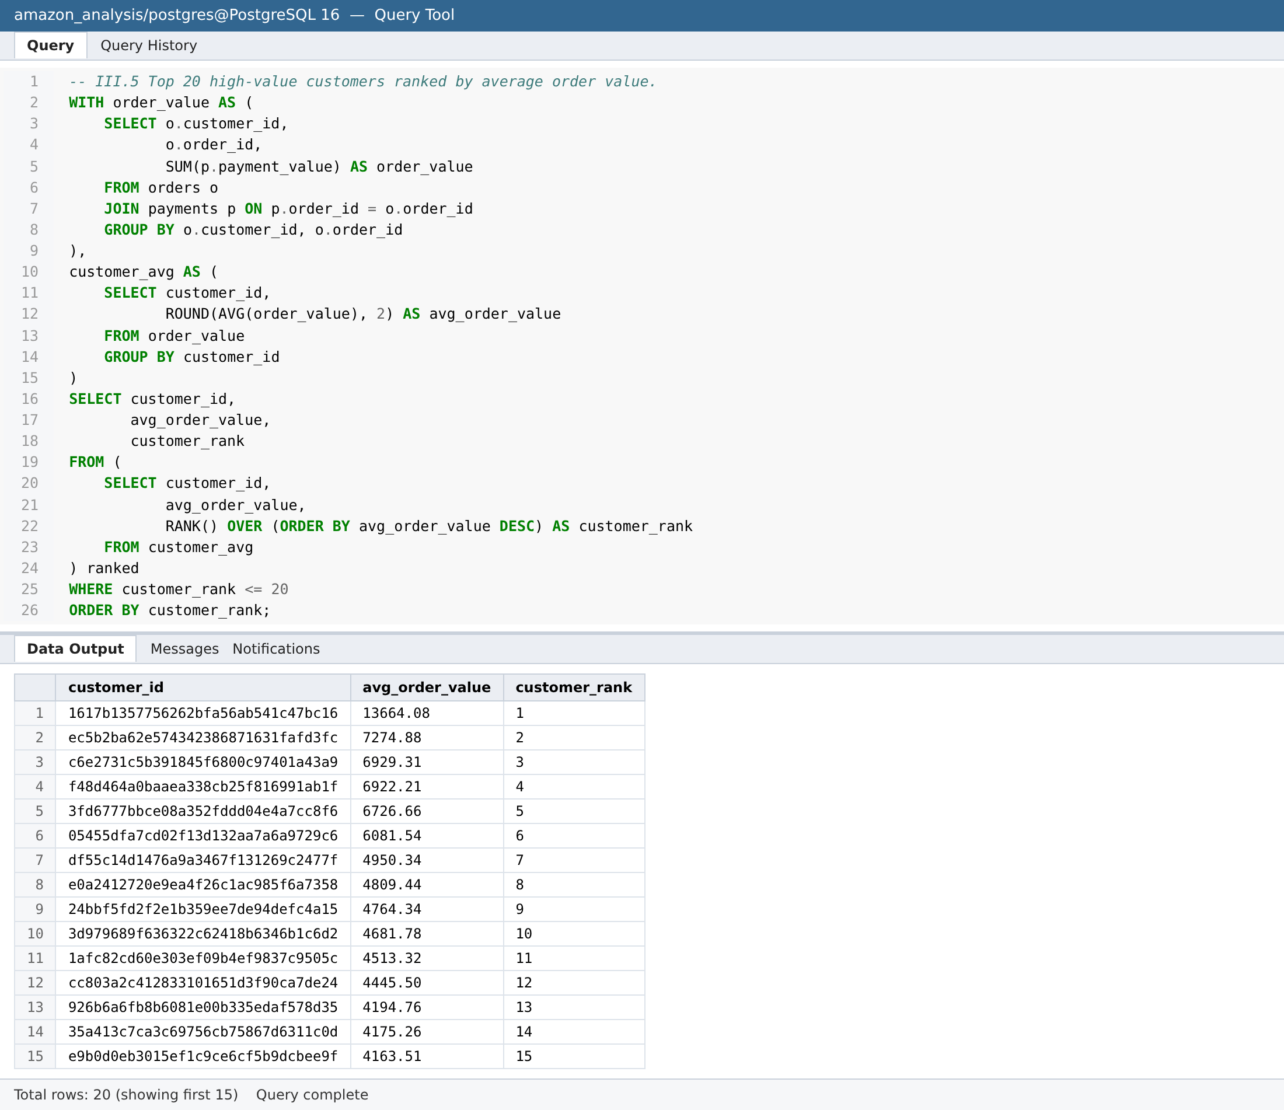
Analysis:
- The top customer's average order is 13,664 BRL; #20 is 3,826.80 BRL.
- customer_id is generated per order in this dataset, so each customer_id has exactly one order and the average equals that order's value.
Recommendation: Invite these high-value customers to an exclusive rewards tier (concierge support, premium delivery). In India, rank on a person-level ID so repeat high spenders are captured.

Q III.6 Cumulative monthly sales per product (recursive CTE)
Context: Using a recursive CTE, compute each product's cumulative sales month by month from its first sale.
SQL query and output:
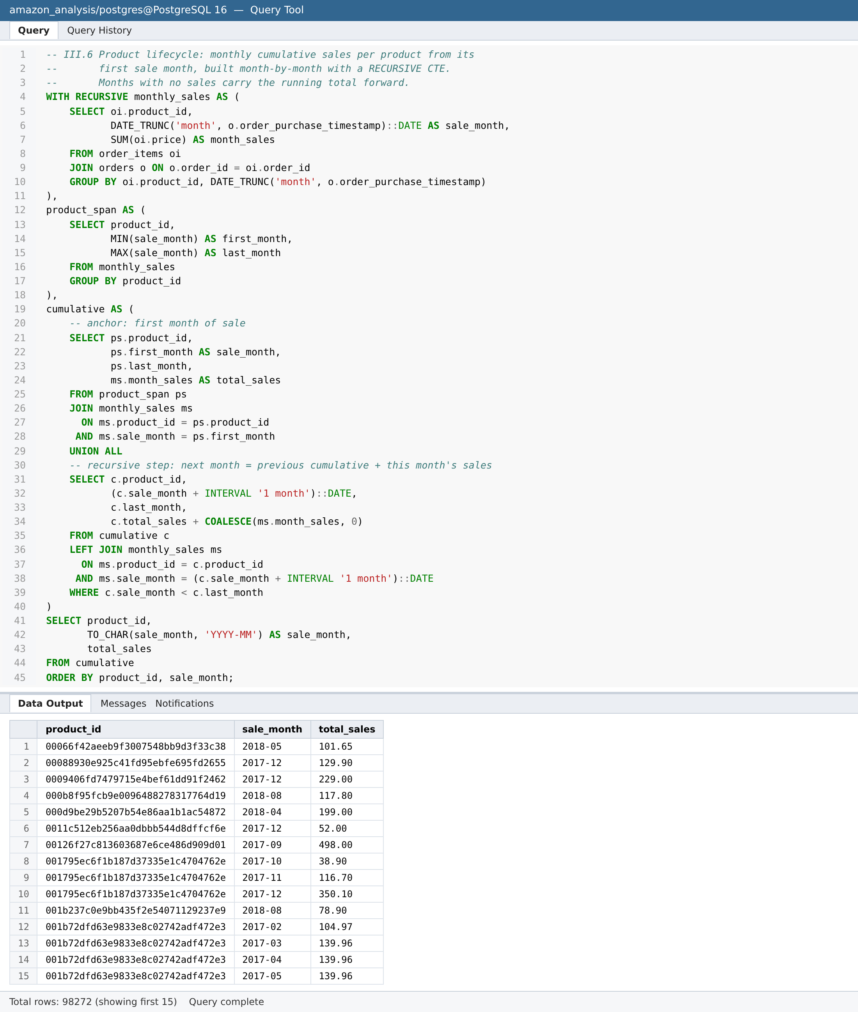
Analysis:
- The anchor row is each product's first sale month; each recursive step adds one month and that month's sales (0 if none), up to the product's last sale month.
- Output: 98,272 product-month rows. Example – the best seller aca2eb7d… grew from 375 BRL (Jul-2017) to 37,609 BRL (Aug-2018), with growth flattening after May 2018.
Recommendation: Use these lifecycle curves to spot products that are plateauing (time for promotion or replacement) versus still accelerating (increase stock).

Q III.7 Month-over-month sales growth by payment method, 2018
Context: Compute monthly sales per payment method in 2018 and the % change from the previous month (LAG window function).
SQL query and output:
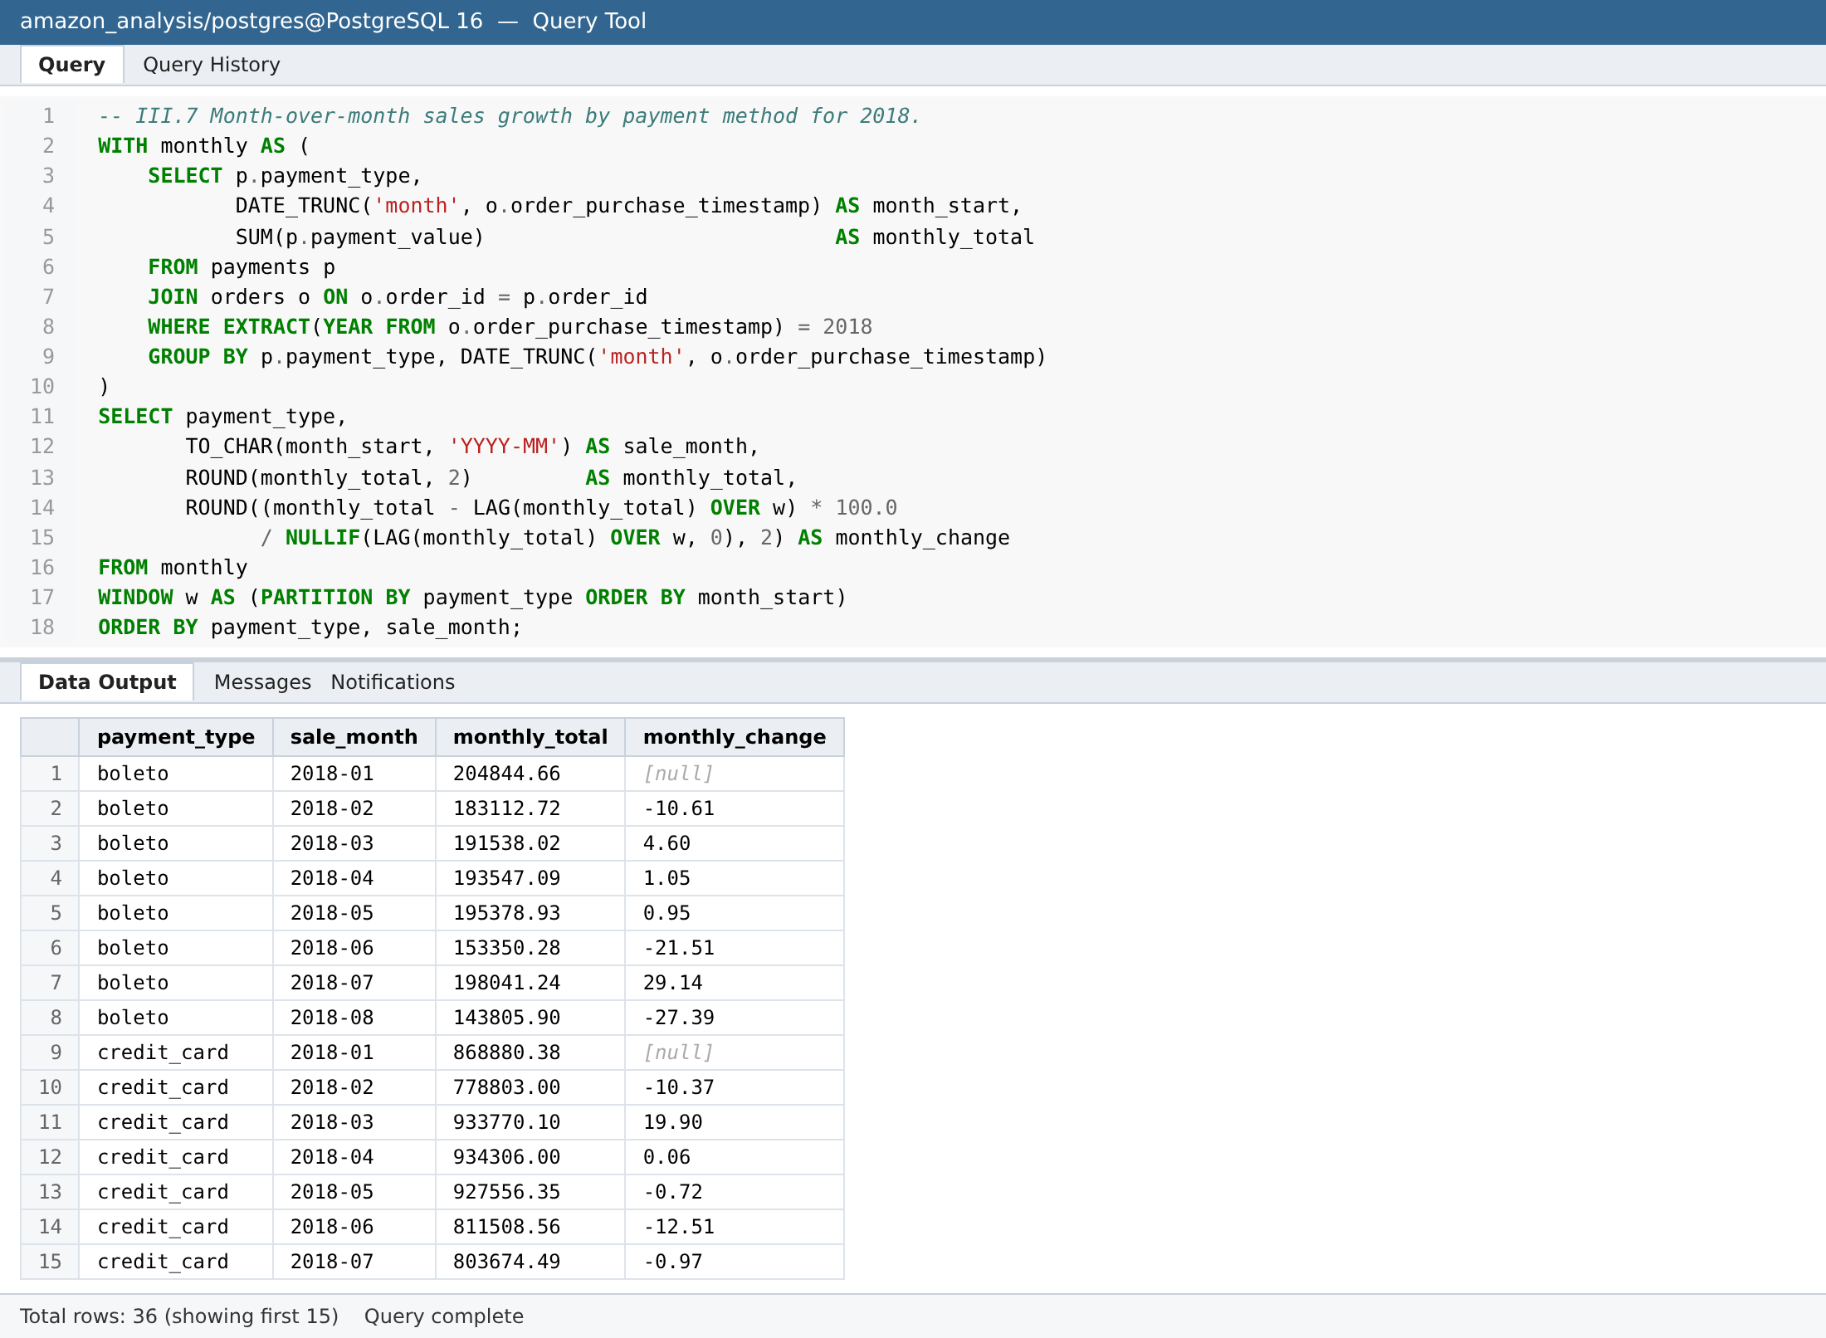
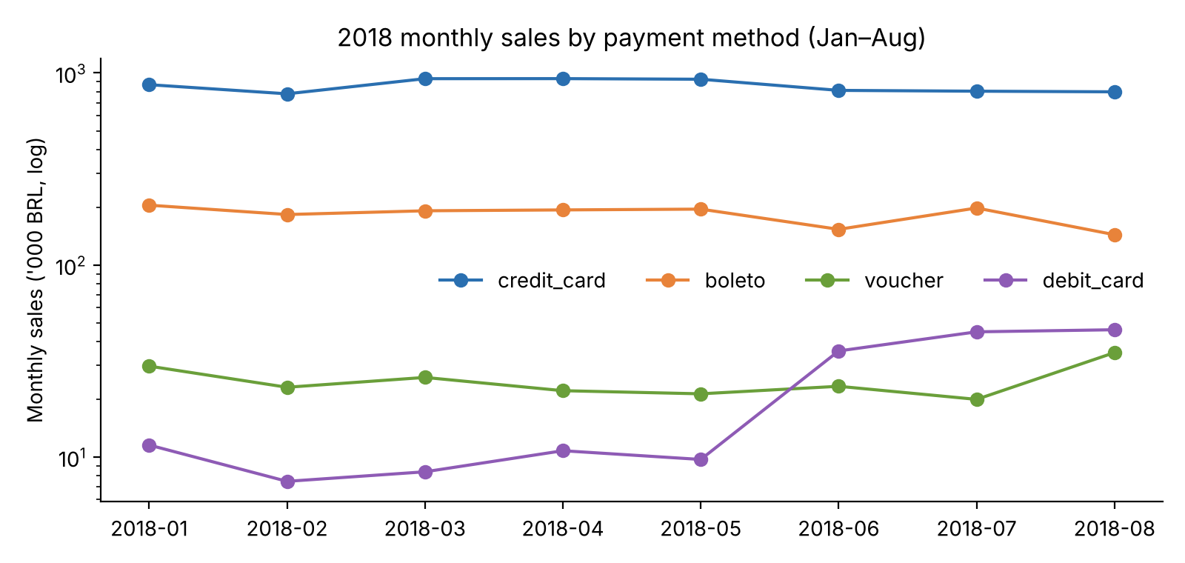
Analysis:
- Credit card is stable (≈0.78–0.93M/month; largest moves +19.9% in March and −12.5% in June).
- Debit card jumped +267% in June 2018 and stayed at that higher level (~45k/month) – a step change in adoption.
- Boleto fell 21.5% in June then recovered +29% in July; vouchers are volatile (+75% in August).
- Sep/Oct values are partial-month data.
Recommendation: Debit's jump shows how quickly a payment method can grow when friction is removed – promote UPI/debit adoption in India with launch offers and track MoM growth per method.

5. Recommendations for Amazon India
- Payments: Launch with UPI and Cash-on-Delivery as first-class options (Brazil's boleto shows ~20% of buyers avoid cards), and no-cost EMI on carts above the high-value threshold where card share is highest.
- Retention & loyalty: With 96.7% one-time buyers in Brazil, build a membership/loyalty programme from day one, with a strong second- and third-order incentive.
- Category focus: Prioritise beauty & personal care, watches & gifting, home furnishing, sports and computer accessories; use price-band merchandising in wide-range categories (housewares, PCs, arts).
- Seasonal planning: Plan inventory and logistics capacity for peak periods; map Brazil's mid-year peak to India's festive season and use promotions to lift trough months.
- High-value customers: Create an exclusive rewards tier for the top spenders (avg orders 3.8k–13.7k BRL) and identify them using a person-level customer ID.
- Inventory: Keep the ~20% of above-average-selling products always in stock; use cumulative-sales curves to spot plateauing products.
- Data quality: Enforce mandatory, validated product categories and payment types at entry; backfill the 614 incomplete products.

6. Files submitted
- 01_setup_schema.sql – database, schema, table creation and import steps.
- 02_analysis_queries.sql – all 19 queries with context comments.
- Amazon_Brazil_Analysis_Results.xlsx – query outputs, with the III.3 line chart and III.4 pie chart.

