**Risk Metrics from Historical Returns**

Risk is an inherent aspect of investing, and understanding it is crucial for evaluating the performance and resilience of mutual funds and ETFs. In this section, we introduce and calculate core risk metrics that quantify a fund's potential downside and variability in returns. These metrics – volatility, drawdowns, and Value-at-Risk – are widely used in portfolio management to assess risk and make informed investment decisions.

We demonstrate the computation of these risk metrics using the SPY ETF, which tracks the S&P 500 index and serves as a benchmark for U.S. equity performance. The metrics are calculated based on historical data, and their implications for fund risk are discussed. To provide a broader perspective, the appendix extends the analysis to 10 additional funds, enabling a comparative evaluation of risk across different investment strategies and asset classes.

**1. Volatility**

Volatility measures the variability or dispersion of a fund's returns over time. It reflects the level of uncertainty or risk associated with the fund's performance. Volatility is calculated as the standard deviation of the fund’s historical daily returns. The graph below shows the rolling volatility of the SPY ETF using a 20-day window.

**2. Drawdowns**

Absolute drawdown quantifies the decline in the Net Asset Value (NAV) of a fund from its historical peak. It measures the worst-case loss in absolute terms. Relative drawdown represents the percentage decline from the historical peak NAV. It normalizes drawdowns for easier comparison across funds. The following graphs show the absolute and relative drawdowns of the SPY ETF.

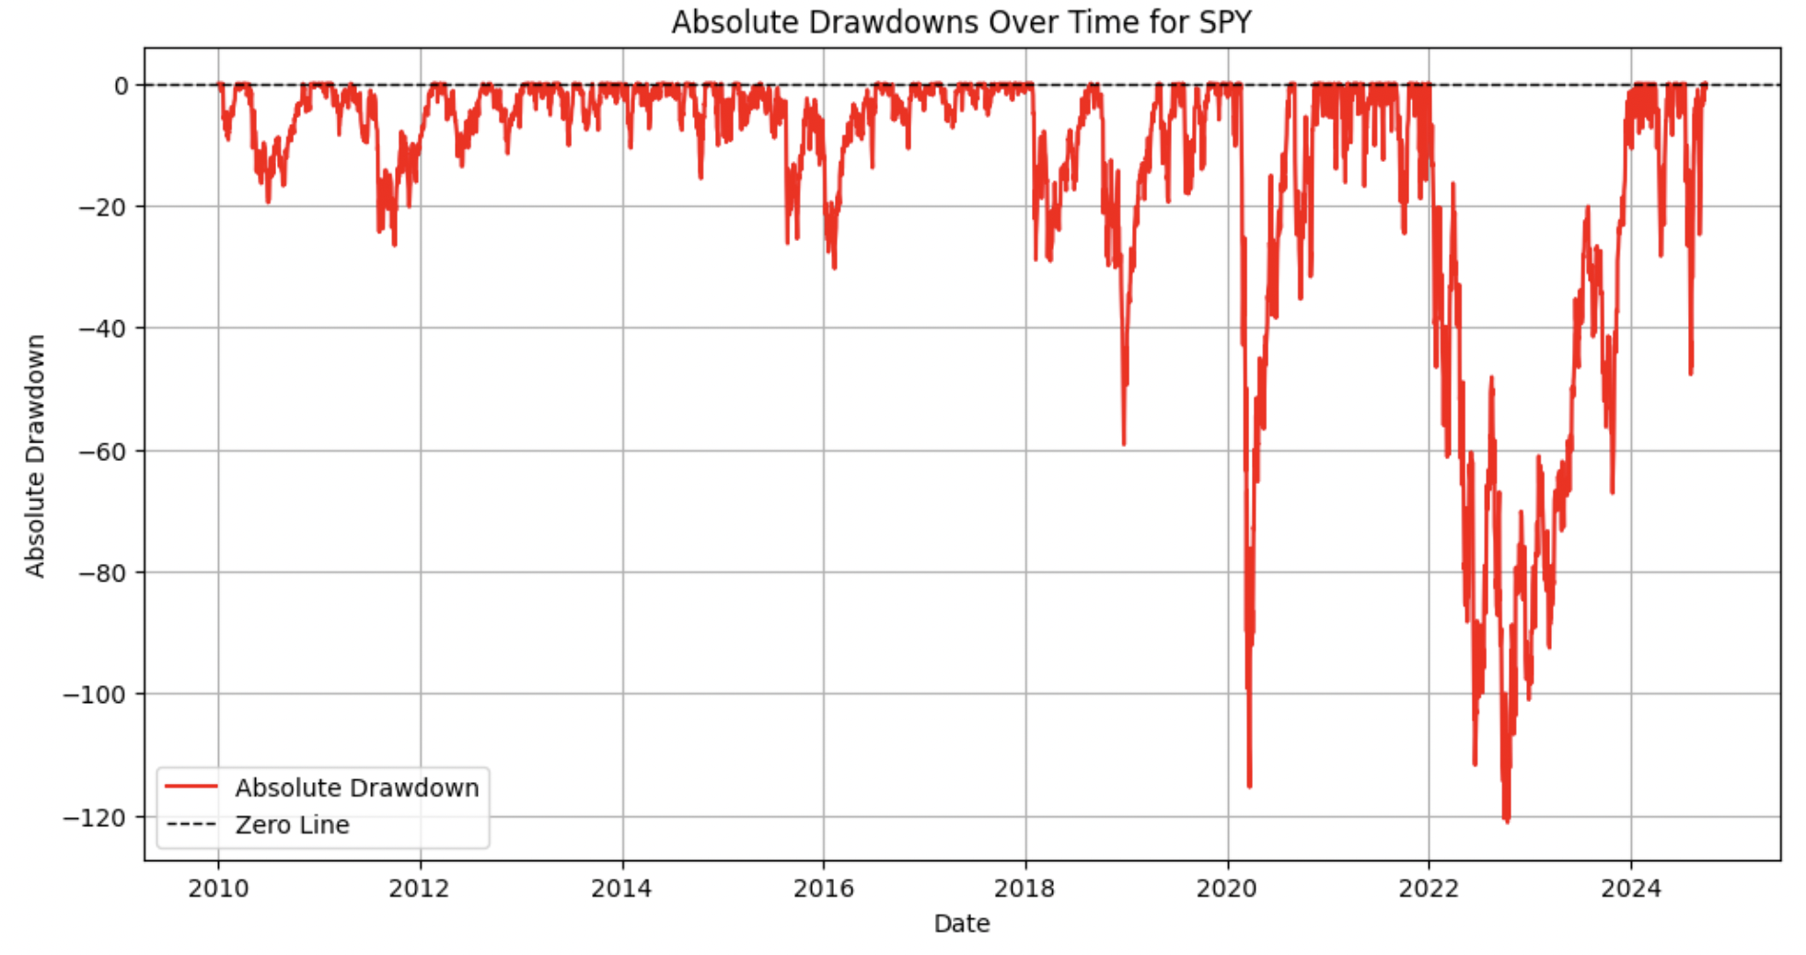

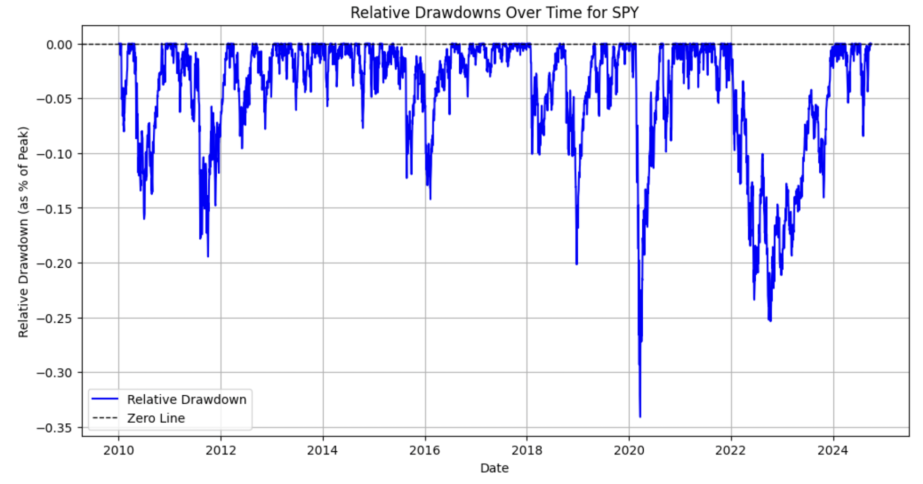

**3. Frequency, Duration, and Magnitude of Drawdowns**

Drawdown frequency counts the number of distinct drawdown events where the fund’s NAV drops below a predefined threshold. It reflects how often a fund experiences significant declines. Drawdown duration measures the length of time (in days) that the fund remains in a drawdown state, from peak to recovery. Finally, drawdown magnitude quantifies the severity of each drawdown, typically expressed as the average or maximum relative drawdown over all observed periods.

**4. Value-at-Risk**

VaR estimates the maximum expected loss at a given confidence level over a specific time horizon. It is widely used to assess the potential downside risk. For example, at 95% confidence, the 5th percentile of the return’s distribution represents the VaR.

**Usage of risk metrics for the composite risk index**

The composite risk index is designed to quantify and compare the risk levels of different mutual funds and ETFs. This index aggregates multiple risk dimensions into a single, interpretable score for each fund, allowing for straightforward comparisons and categorization into risk tiers.

In the index, we combine the following metrics:

1. **Volatility**: Captures the variability of returns, providing an overall measure of the fund's risk.
2. **Max Relative Drawdown**: Measures the worst peak-to-trough percentage decline, reflecting the fund's resilience during downturns.
3. **Value at Risk**: Quantifies the maximum expected loss at a given confidence level (95%), highlighting tail risk.
4. **Drawdown Frequency**: Indicates how often the fund experiences significant declines, providing insights into the persistence of downside risk.
5. **Average Drawdown Magnitude**: Measures the average severity of drawdowns, complementing the maximum relative drawdown.

To ensure comparability across funds, all metrics are normalized to a common scale using min-max normalization. This prevents metrics with different units or scales from dominating the index. Each metric is then weighted based on its importance.

We assign the following weights:

1. Volatility: 30%
2. Max Relative Drawdown: 25%
3. Value at Risk: 25%
4. Drawdown Frequency: 10%
5. Average Drawdown Magnitude: 10%

The final risk index is calculated as a weighted sum of these normalized metrics, resulting in a single risk score per fund. Higher values indicate higher risk.