**TITLE OF YOUR PROJECT**

PROJECT REPORT for

CSE3002-Internet and Web Programming

*Submitted by*

**HARSH KAILASH (18BCE1340)**

**ANKAN MAL(18BCE1094)**

*To*

**DR. S. JUSTUS**

**BACHELOR OF TECHNOLOGY**

*in*

**COMPUTER SCIENCE AND ENGINEERING**



May 2020

**Table of contents**

**Content Page no.**

* Abstract 3
* Introduction 4
* Requirements 5
* Design diagrams 10
* The coding 14
* Screenshots 21

**ABSTRACT**

An employee can submit the resume from the home without going to the company. We are going to design the website for the company CAREER MANAGEMENT SOLUTION. There will be two-person CANDIDATE and HR who can do different tasks.

**INTRODUCTION**

TASK THAT CANDIDATE CAN PERFORM-:

* Candidates can upload their data either in a pdf form or he will have to fill the form then and there on the web page itself.
* They can review their form and check/ edit it.
* The form that they will submit will be stored in the database of the company.

TASK THAT HR CAN PERFORM-:

* They can retrieve the data from the database.
* The data for them will only be available in read-only format that means he cannot modify the data.
* Upon reviewing the data, they will be able to either select the employee or reject her/him.

**Requirements**

**TOOLS-:** Xampp Webserver (Apache and MySQL)  
**SCRIPTING LANGUAGE-:**

1. HTML- for frontend and backend
2. PHP- to connect two pages and to connect pages to database
3. CSS- to design the pages
4. JAVA SCRIPT

**Design Diagrams**

**Class diagram**

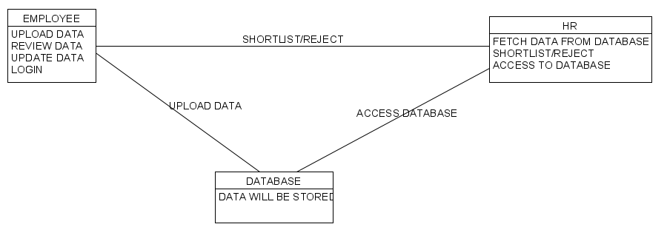

**Sequence Diagram**

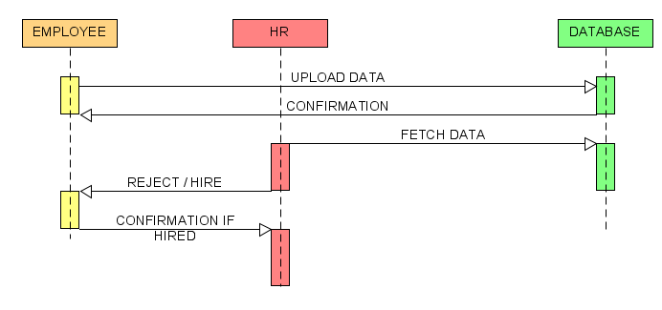

**Activity Diagram**

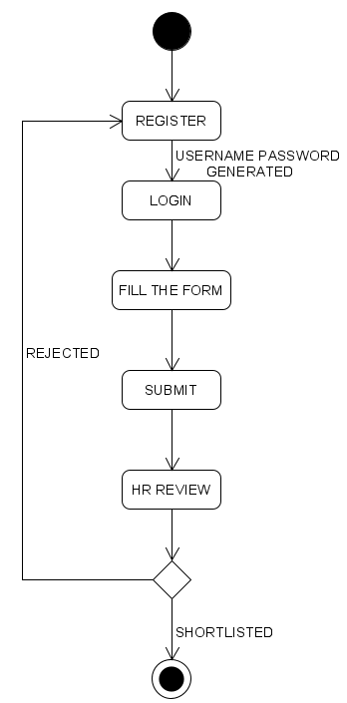

**Data Flow Diagram**

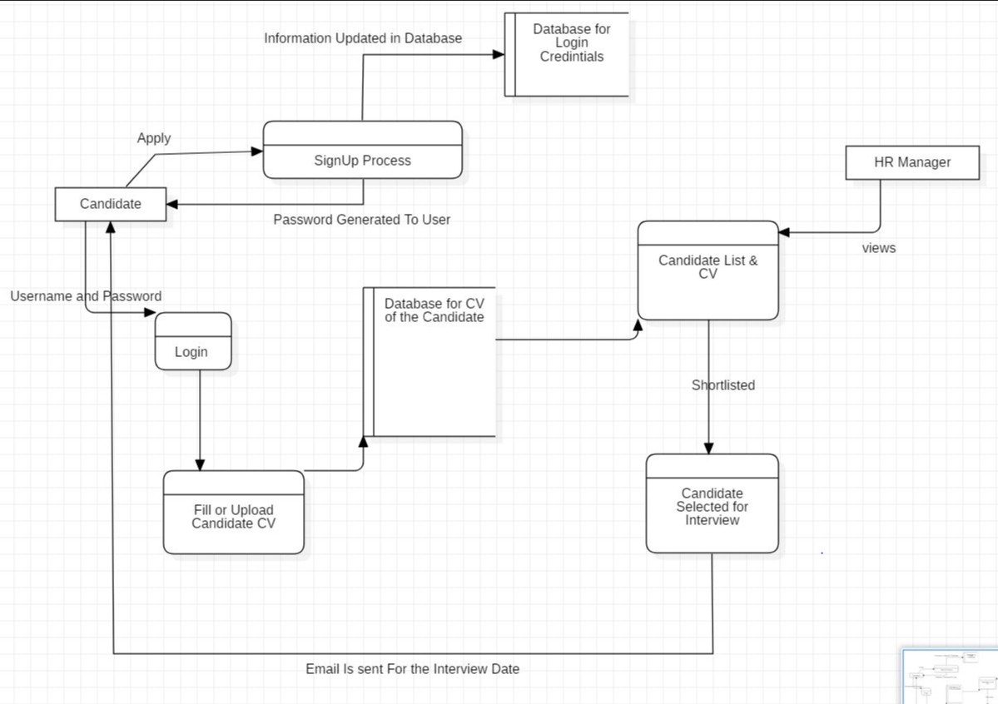

**The Coding**

Sample code

**REGISTRATION PAGE**

<?php

require 'assets/php/1.php';

require 'assets/php/2.php';

?>

<html>

<head>

<title>LOGIN PAGE</title>

<link rel="stylesheet" href="assets/css/login.css">

</head>

<body bgcolor=lightblue>

<!-- Modal action sends the input of the form to the page specified -->

<form class="modal" action="login.php" method="POST">

<br><br>

<br>

<b>First Name</b><br>

<input type="text" placeholder="First Name" name="First_Name"

value="<?php

if(isset($_SESSION['First_Name'])) //isset($_SESSION[]) is responsible for not deleting the element if it follows the format

{

echo $_SESSION['First_Name'];

} ?>" required style="margin-left: 0px;"><br>

<?php if(in_array("your first name should be between 2 and 25 characters <br>", $error_array)) echo "your first name should be between 2 and 25 characters <br>"; ?>

<!-- checks whether it is in the array and if the name is entered wrong then it displays the appropriate message -->

<br>

<b>Last Name</b><br>

<input type="text" placeholder="Last Name" name="Last_Name"

value="<?php

if(isset($_SESSION['Last_Name']))//isset($_SESSION[]) is responsible for not deleting the element if it follows the format

{

echo $_SESSION['Last_Name'];

} ?>" required style="margin-left: 0px;"><br>

<?php if(in_array("your last name should be between 2 and 25 characters <br>", $error_array)) echo "your last name should be between 2 and 25 characters <br>"; ?>

<br>

<b>E-mail</b><br>

<input type="Email" placeholder="E-mail" name="Email1" required

value="<?php

if(isset($_SESSION['Email1']))//isset($_SESSION[]) is responsible for not deleting the element if it follows the format

{

echo $_SESSION['Email1'];

} ?>"><br>

<br>

<b>Confirm Email</b><br>

<input type="Email" placeholder="confirm E-mail" name="Email2" required

value="<?php

if(isset($_SESSION['Email2']))//isset($_SESSION[]) is responsible for not deleting the element if it follows the format

{

echo $_SESSION['Email2'];

} ?>"><br>

<?php if(in_array("email already in use <br>", $error_array)) echo "email already in use <br>";

else if(in_array("invalid email format <br>", $error_array)) echo "invalid email format <br>";

else if(in_array("Emails don't match <br>", $error_array)) echo "Emails don't match <br>";

?>

<br>

<b>Password</b><br>

<input type="password" placeholder="Password" name="psw1" required><br><br>

<b>Confirm Password</b><br>

<input type="password" placeholder="Password" name="psw2" required><br><br>

<?php if(in_array("your password do not match <br>", $error_array)) echo "your password do not match <br>";

else if(in_array("your passwords can only contain english caharacters or numbers <br>", $error_array)) echo "your passwords can only contain english caharacters or numbers <br>";

else if(in_array("your password must be between 5 and 30 characters <br>", $error_array)) echo "your password must be between 5 and 30 characters <br>";

?>

<input type="submit" style="margin-left: 270px;" name="submit_btn">

<input type="checkbox" checked="checked" name="remember" style="height:15px; margin-left: 80px;"><font size="5"> Remember me</font>

<?php if(in_array("<span style='color:red;'> Yaayyyy signup successful. Now you can login </span>", $error_array)) echo "<span style='color:red;'> Yaayyyy signup successful. Now you can login </span>";?>

<b style="font-size:20px; margin-left: 50px">Forgot <a href="#">password?</a></b>

</form>

</body>

</html>

**CONNECTION TO DATABASE**

<?php

ob_start(); //turns on output buffering...php is loaded to browser in section this tag saves the data when the php is loading

session_start(); //starts the session and stores all the values in it. values will be in the field if it follows the format

$con=mysqli_connect("localhost","root","","iwp"); //$con helps in declaring connection variable....hostname,uname,psw,tablename

if(mysqli_connect_errno()) //returns error when trying to connect to database

{

echo "failed to connect to database: ". mysqli_connect_errorno(); //echo=print..... dot is used to connect strings in database

}

?>

**ENTERING VALUE TO DATABASE**

<?php

//declaring variables

$fname=""; //first name

$lname=""; //last name

$em=""; //email1

$em2=""; //email2

$psw=""; //password1

$psw2=""; //password2

$date=""; //date the user signed up

$error_array=array(); //holds error message now it is empty array

if(isset($_POST['submit_btn'])) //if submit button is pressed then execute this if

{

//first name

$fname=strip_tags($_POST['First_Name']); //strip tags will delete any unwanted tags post is the method name

$fname=str_replace(' ','', $fname); //remove unwanted spaces from the name

$fname=ucfirst(strtolower($fname)); //firstly convert all the letter to lower case and then capitalize the first variable

$_SESSION['First_Name']=$fname; //stores the first name into session variable

//last name

$lname=strip_tags($_POST['Last_Name']); //strip tags will delete any unwanted tags post is the method name

$lname=str_replace(' ', '', $lname); //remove unwanted spaces from the name

$lname=ucfirst(strtolower($lname)); //firstly convert all the letter to lower case and then capitalize the first variable

$_SESSION['Last_Name']=$lname; //stores the last name into session variable

//email

$em=strip_tags($_POST['Email1']); //strip tags will delete any unwanted tags post is the method name

$em=str_replace(' ', '', $em); //remove unwanted spaces from the name

$em=ucfirst(strtolower($em)); //firstly convert all the letter to lower case and then capitalize the first variable

$_SESSION['Email1']=$em; //stores the Email1 into session variable

//email2

$em2=strip_tags($_POST['Email2']); //strip tags will delete any unwanted tags post is the method name

$em2=str_replace(' ', '', $em2); //remove unwanted spaces from the name

$em2=ucfirst(strtolower($em2)); //firstly convert all the letter to lower case and then capitalize the first variable

$_SESSION['Email2']=$em2; //stores the Email2 into session variable

//password

$psw=strip_tags($_POST['psw1']); //strip tags will delete any unwanted tags post is the method name

$psw2=strip_tags($_POST['psw2']); //strip tags will delete any unwanted tags post is the method name

//we dont need to remove any spaces or convert upper to lower case for password

$date=date("d-m-y"); //current date

if($em==$em2)

{

if(filter_var($em,FILTER_VALIDATE_EMAIL)) //checks whether email is in valid format or not

{

$em=filter_var($em,FILTER_VALIDATE_EMAIL);

$em_check=mysqli_query($con,"SELECT email FROM users WHERE email='$em'"); //checks whether email is already present or not

$n_rows=mysqli_num_rows($em_check);

if($n_rows > 0)

{

array_push($error_array,"email already in use <br>");

}

}

else

{

array_push($error_array,"invalid email format <br>");

}

}

else

{

array_push($error_array,"Emails don't match <br>");

}

if(strlen($fname)>25 || strlen($fname)<2)

{

array_push($error_array,"your first name should be between 2 and 25 characters <br>");

}

if(strlen($lname)>25 || strlen($lname)<2)

{

array_push($error_array,"your last name should be between 2 and 25 characters <br>");

}

if($psw != $psw2)

{

array_push($error_array,"your password do not match <br>");

}

else

{

if(preg_match('/[^A-Za-z0-9]/', $psw)) //password must be in A-Z a-z 0-9

array_push($error_array,"your passwords can only contain english caharacters or numbers <br>");

}

if(strlen($psw)>30 || strlen($psw)<5)

{

array_push($error_array,"your password must be between 5 and 30 characters <br>");

}

if(empty($error_array))

{

$psw=md5($psw);//encrypts the passwords in the database

//generate username by concatenating first and last name

$username=strtolower($fname . "_" . $lname);

$check_username_query=mysqli_query($con,"SELECT username FROM users WHERE username='$username'"); //checks for the uniqueness of username

$i=0;

//if username exist add number to usuer name

while(mysqli_num_rows($check_username_query) !=0)

{

$i++;

$username=$username . "_" . $i;

$check_username_query=mysqli_query($con,"SELECT username FROM users WHERE username='$username'"); //checks untill the username created by adding a number is unique

}

//random profile pics assignment

$r=rand(1,4); //selects random number between 1 to 4

if($r==1)

$profile_pic="assets/images/profile_pics/default/1.png";

else if($r==2)

$profile_pic="assets/images/profile_pics/default/2.png";

else if($r==3)

$profile_pic="assets/images/profile_pics/default/3.png";

else if($r==4)

$profile_pic="assets/images/profile_pics/default/4.png";

$query=mysqli_query($con, "INSERT INTO users VALUES('', '$fname', '$lname', '$username', '$em', '$psw', '$date', '$profile_pic')");

array_push($error_array, "<span style='color:red;'> Yaayyyy signup successful. Now you can login </span>");

//clear sessons variable

$_SESSION['First_Name']="";

$_SESSION['Last_Name']="";

$_SESSION['Email1']="";

$_SESSION['Email2']="";

}

}

?>

**Screenshots**

CANDIDATE CAN REGISTER FROM THIS PAGE

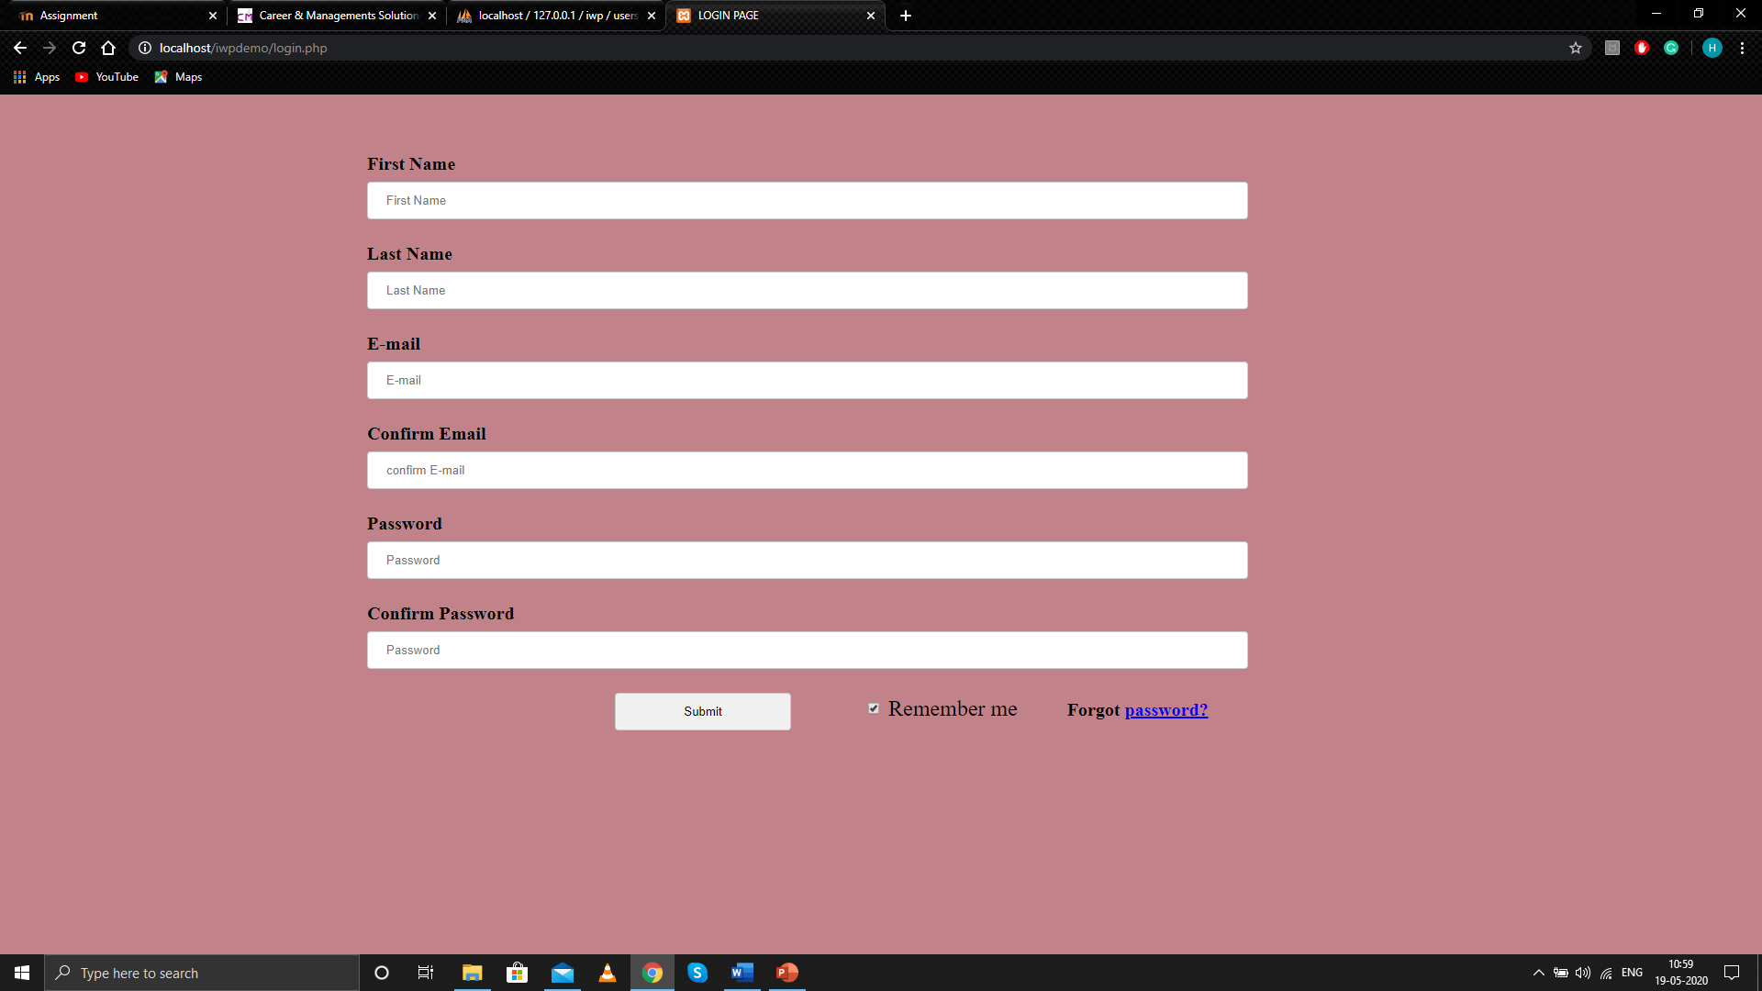

CANDIDATE CAN FILL IN THE FORM LIKE THIS

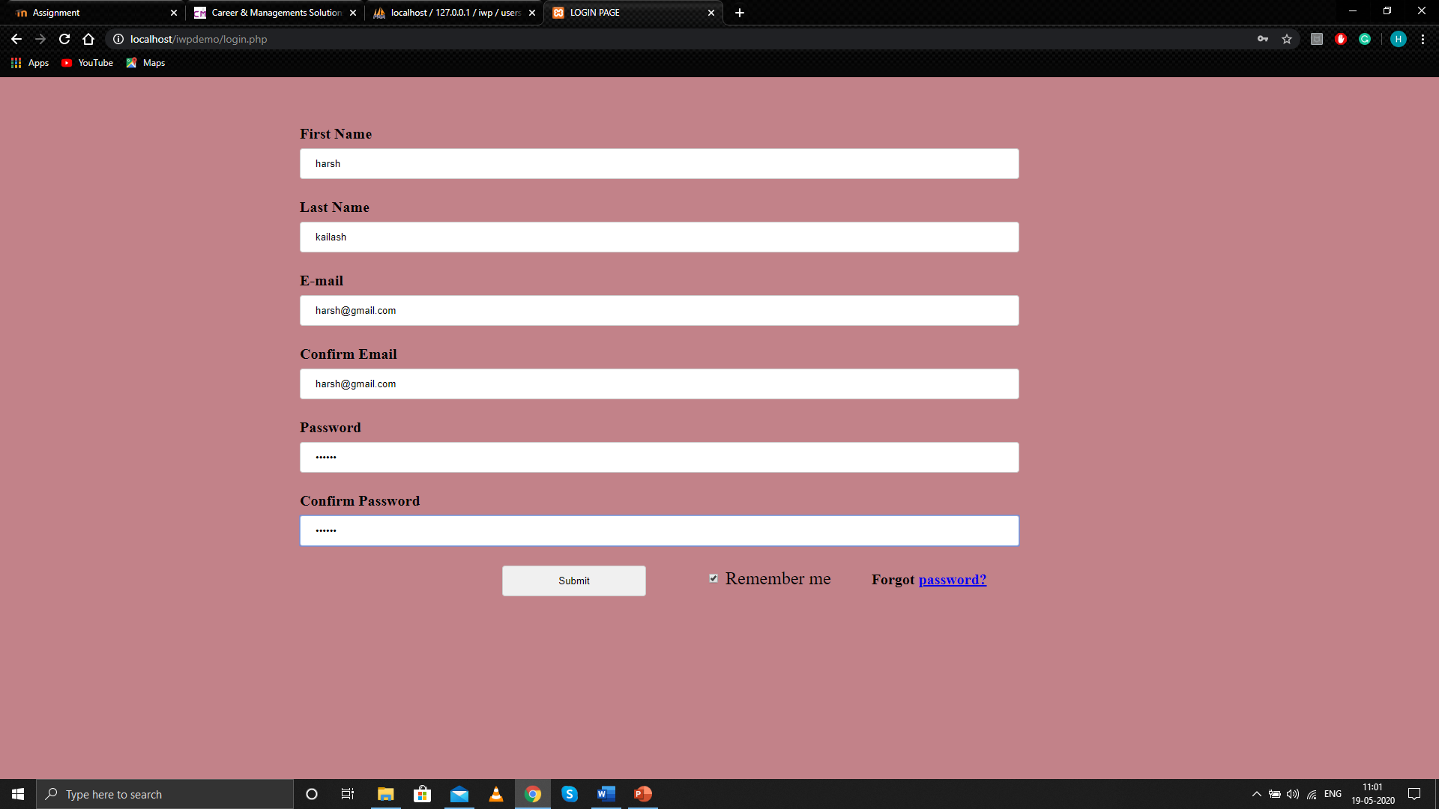

ON SUCCESSFUL SUBMISSION THIS WILL BE DISPLAYED

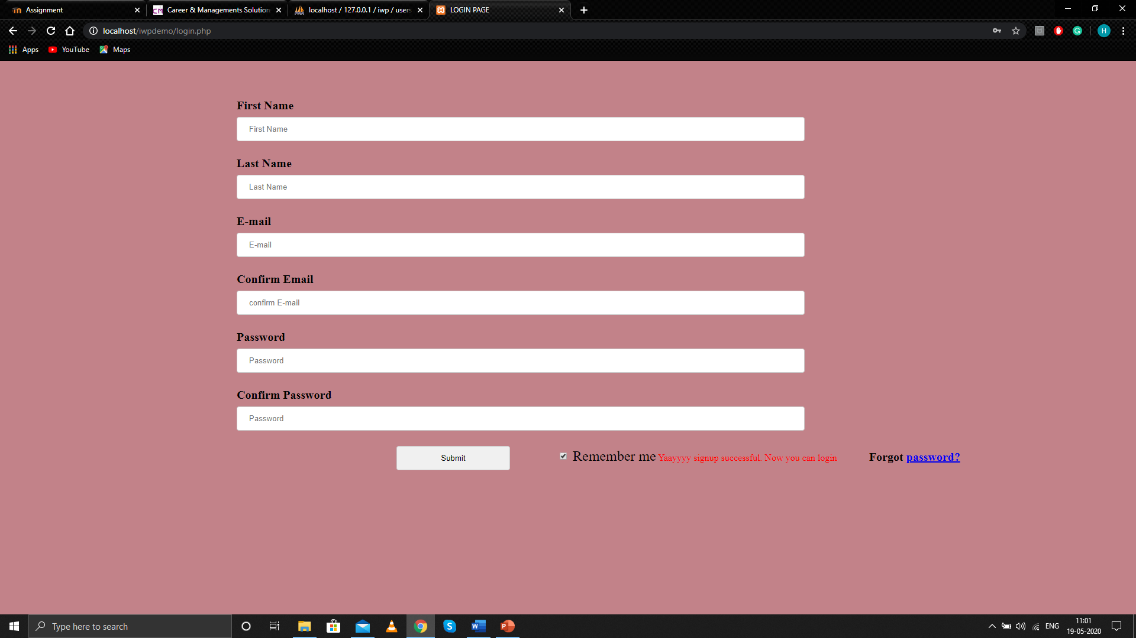

DATABASE WILL BE UPDATED AND USER NAME WILL BE GENERATED

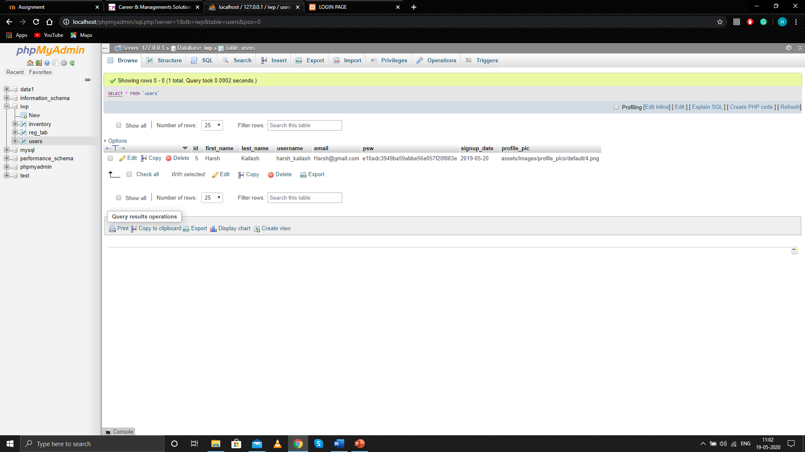

IF CANDIDATES WITH SAME NAME REGISTER

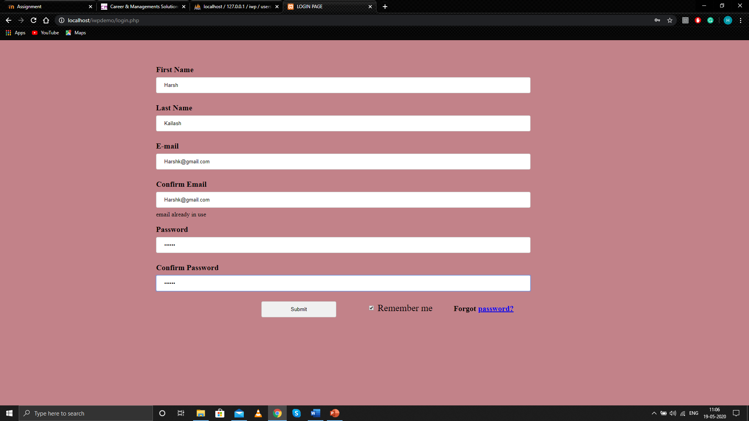

DATABASE WILL BE UPDATED AND USER NAME WILL BE GENERATED LIKE THIS

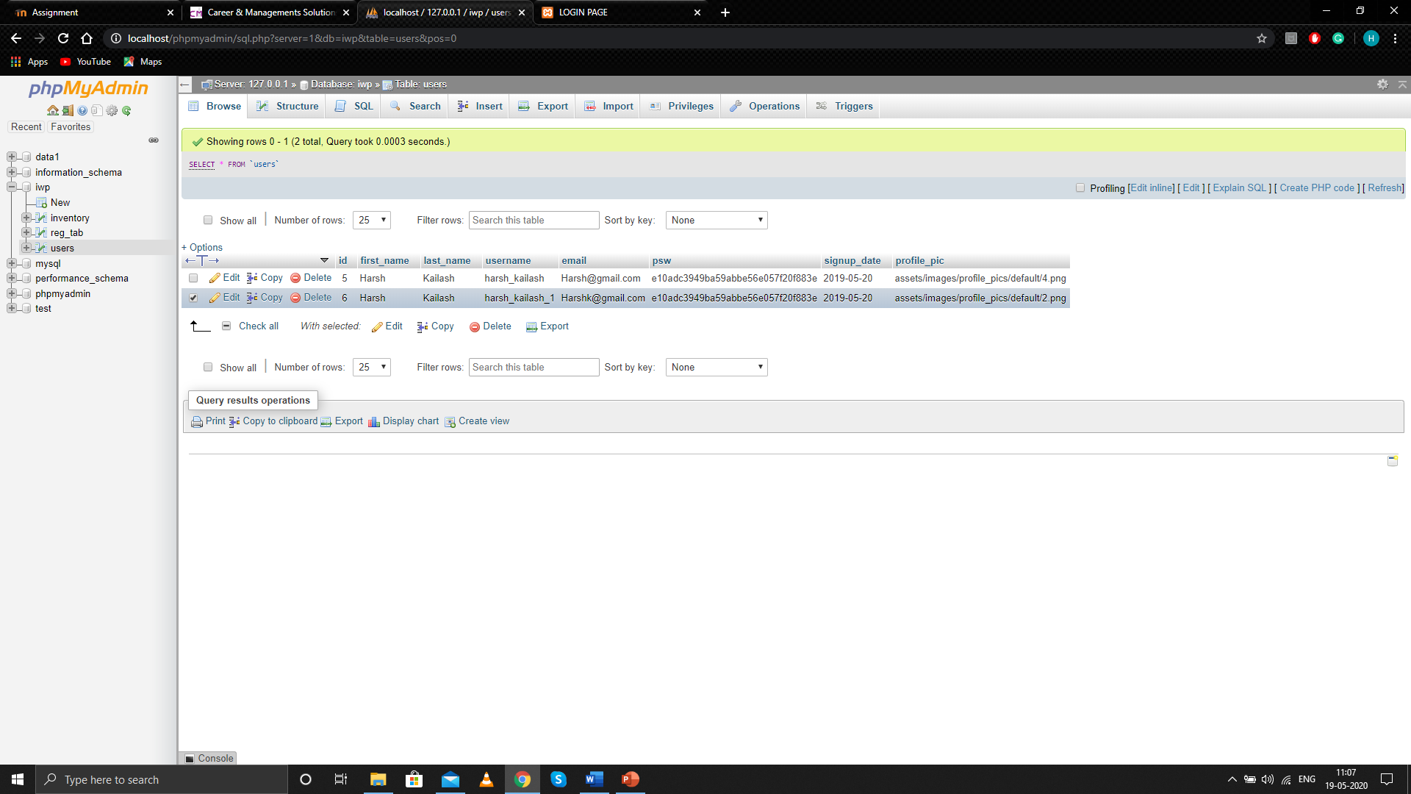

IF A CANDIDATE IS ENTERING A MAIL ID WHICH IS ALREADY PRESENT IN DATABASE OR VIOLATING PASSWORD RULE THEN

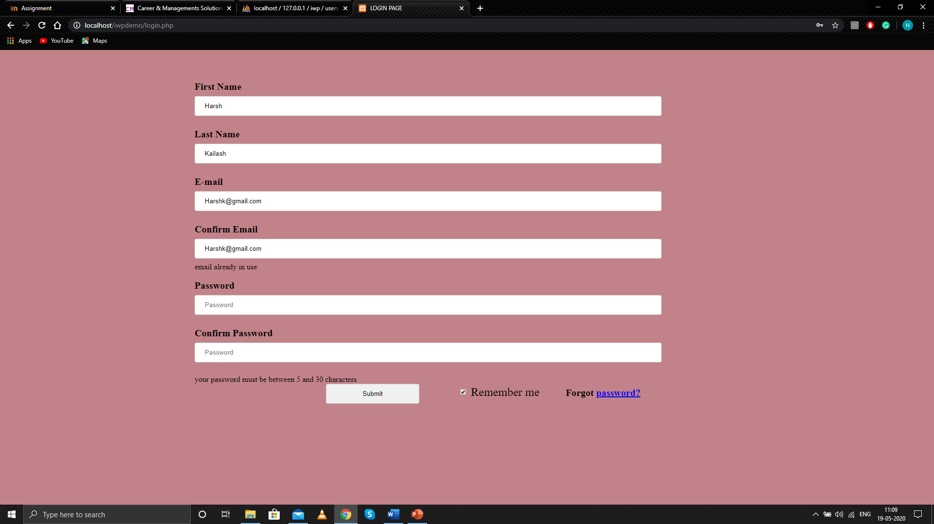

ON SUCCESSFUL REGISTRATION NOW THE CANDIDATE CAN LOGIN

