EMPLOYEE BURNOUT RATING PREDICTION
End-to-End Machine Learning Project Report
Dataset: Employee Burnout Analysis (train.csv)
Covers Units 1-4: Data Understanding, EDA, Data Cleaning, Automated EDA,
Feature Selection, Model Building, Evaluation, and Improvement.

1. Understanding the Data (Unit 1)
The dataset contains 10000 rows and 9 columns.

Numerical Columns
- Designation, Resource Allocation, Mental Fatigue Score, Burn Rate

Categorical Columns
- Gender, Company Type, WFH Setup Available (plus Employee ID as an identifier and Date of Joining as a date field)

Missing Values
Column | Missing Count | Missing %
Resource Allocation | 622 | 6.22%
Mental Fatigue Score | 957 | 9.57%
Burn Rate | 481 | 4.81%

Duplicate Values
Duplicate rows found: 0

Dataset Summary
Key descriptive statistics for the numeric columns (from dataset_summary.csv):
Column | Mean | Std | Min | Max
Designation | 2.183 | 1.143 | 0 | 5
Resource Allocation | 4.498 | 2.053 | 1 | 10
Mental Fatigue Score | 5.731 | 1.922 | 0 | 10
Burn Rate | 0.452 | 0.199 | 0 | 1

2. Exploratory Data Analysis (Units 1 & 2)

Histograms
Distribution of the four numeric columns:
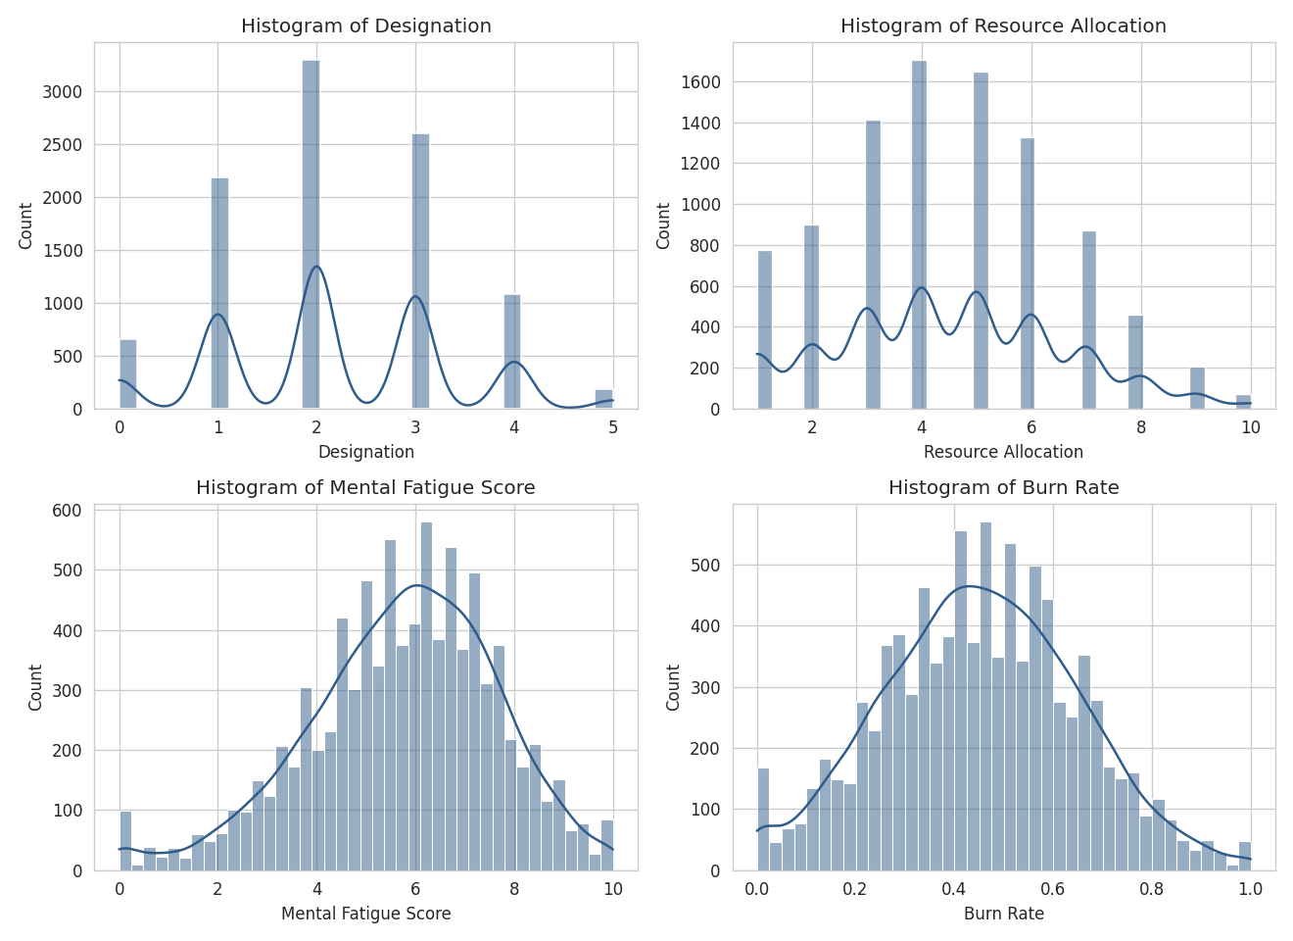

Box Plots
Box plots reveal potential outliers, especially in Mental Fatigue Score and Burn Rate:
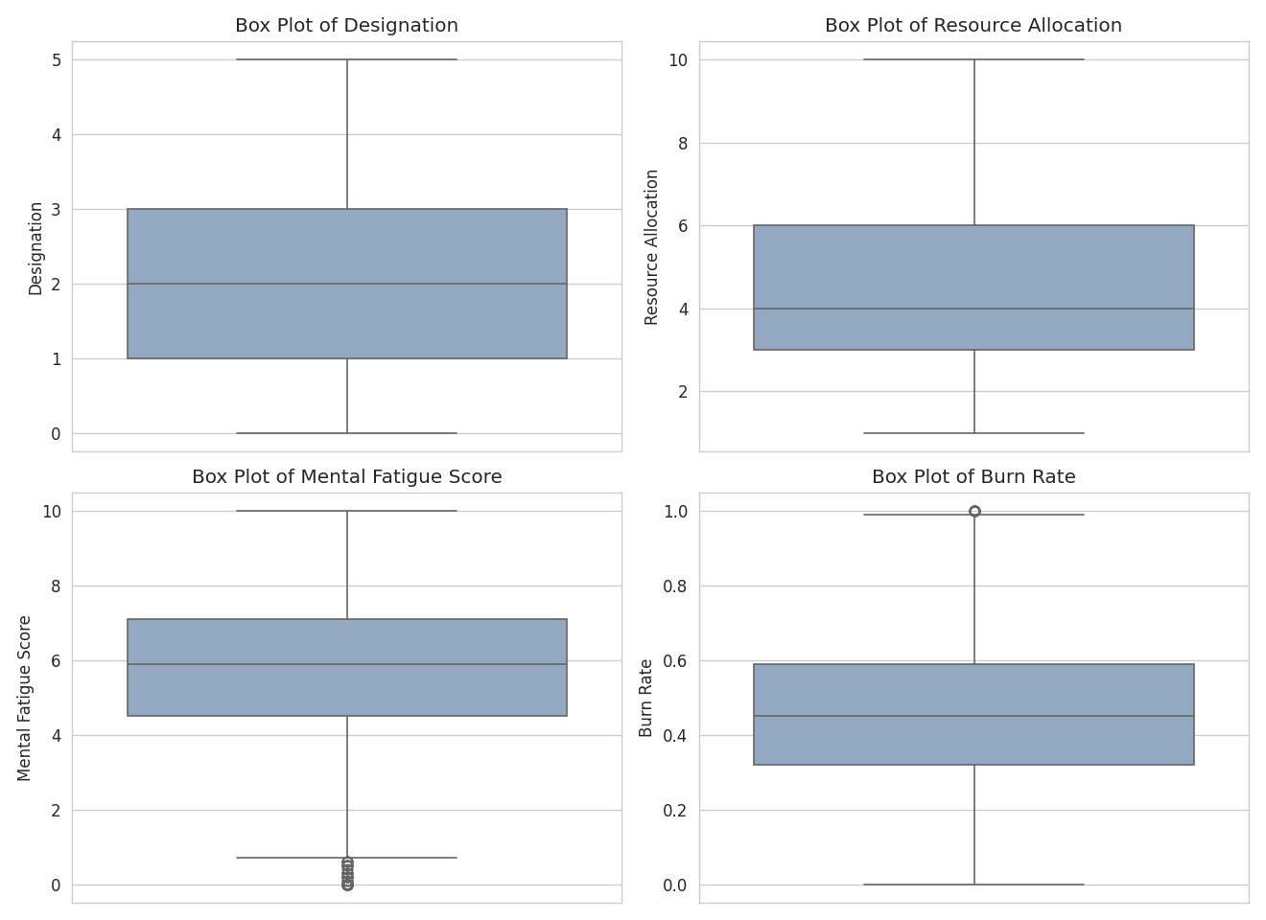

Pie Charts
Category-wise proportions for Gender, Company Type, and WFH Setup Available:
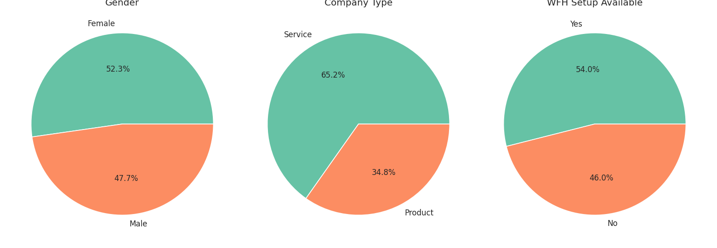

Bar Chart
Average Burn Rate compared across Company Type:
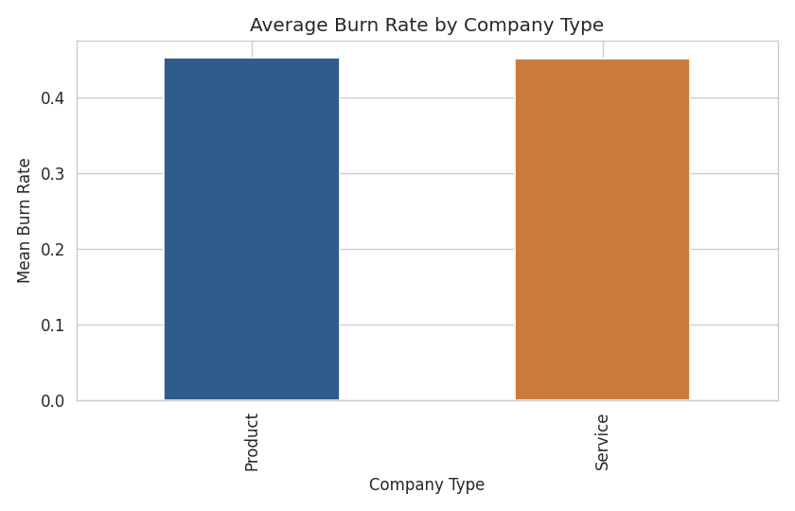

Correlation Matrix
Correlation between numeric features and the target variable:
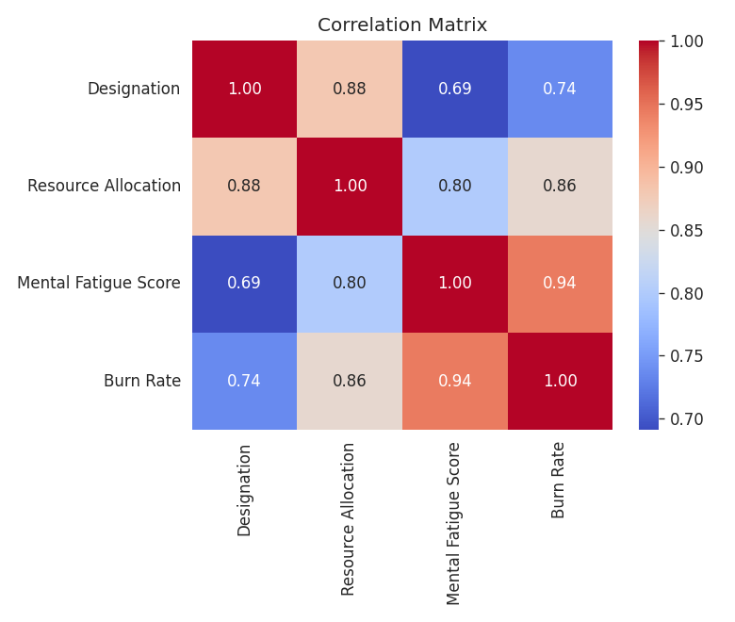

EDA Report Summary
- Mental Fatigue Score has the strongest correlation with Burn Rate (r = 0.944).
- Resource Allocation is also strongly correlated with Burn Rate (r = 0.857).
- Designation shows a moderate positive correlation with Burn Rate (r = 0.737).
- Numeric features are approximately normally distributed with mild skew; categorical features are reasonably balanced.

3. Handling Missing Values & Outliers (Unit 2)

Missing Value Treatment
- Rows with a missing target (Burn Rate) were removed, since the label cannot be reliably imputed.
- Missing values in Resource Allocation and Mental Fatigue Score were filled using the column median.
- Rows before cleaning: 10000 | Rows after cleaning: 9519

Outlier Treatment (IQR Method)
Column | Lower Bound | Upper Bound | Outliers Found
Resource Allocation | -1.5 | 10.5 | 0
Mental Fatigue Score | 1.4 | 10.2 | 207
Burn Rate | -0.085 | 0.995 | 33
Outliers were capped (winsorized) to the IQR bounds rather than removed, to preserve sample size.

Before vs After Comparison
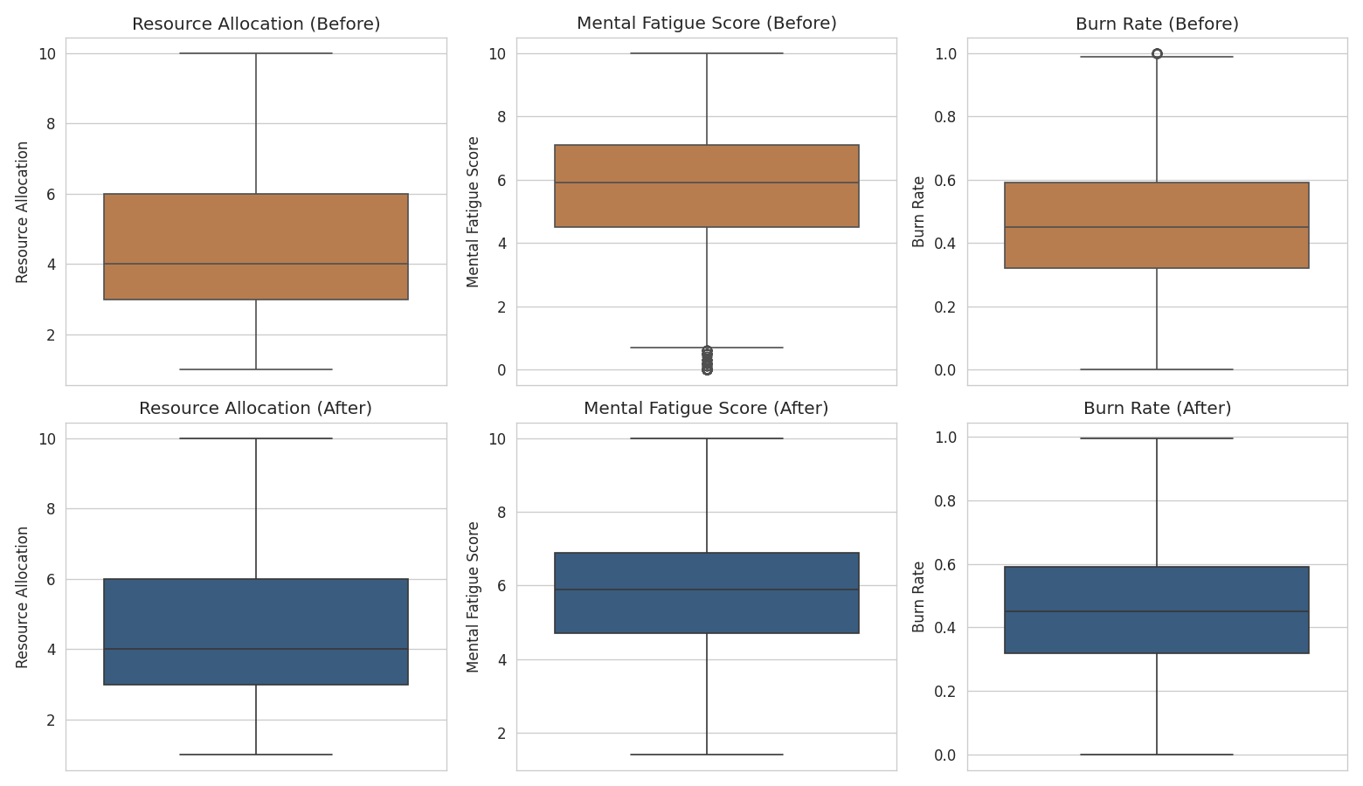
After treatment, extreme values are pulled within the IQR bounds while the overall mean and distribution shape are preserved.

4. Automated EDA (Unit 2)
Standard automated-EDA libraries (Pandas Profiling / ydata-profiling, Sweetviz, AutoViz, D-Tale) require an internet connection to install, which was not available in this environment. An equivalent self-contained HTML profiling report was generated programmatically, covering column types, missing values, unique-value counts, and summary statistics for every column.
Output file: output/automated_eda_report.html (included in the project submission).

5. Feature Selection (Unit 3/4)

Dependent Variable (Target)
- Burn Rate — continuous value (0 to 1) representing burnout severity.

Independent Variables (Features)
- Gender
- Company Type
- WFH Setup Available
- Designation
- Resource Allocation
- Mental Fatigue Score

Train-Test Split
- Training set: 7615 rows (80%)
- Test set: 1904 rows (20%)
Categorical features (Gender, Company Type, WFH Setup Available) were label-encoded, and all features were standardized using StandardScaler before modeling.

6. Build ML Model (Unit 4)
Since Burn Rate is a continuous numeric target, this is a regression problem. A Linear Regression model was built as the baseline model.
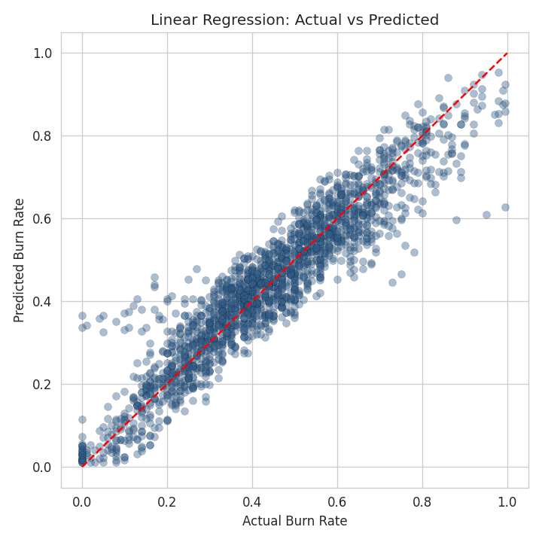

Feature Coefficients
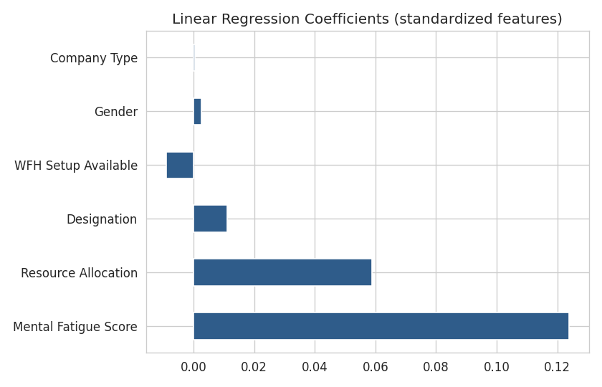
Mental Fatigue Score has the largest positive coefficient, confirming it is the strongest driver of burnout in the linear model.

7. Model Evaluation (Units 3 & 4)
Metric | Value
R² Score | 0.8785
MSE | 0.005
RMSE | 0.0708
MAE | 0.0535
An R² of 0.8785 means the model explains about 88% of the variance in Burn Rate. The low RMSE (0.0708) relative to the 0-1 target scale indicates good prediction accuracy.
Note: this is a regression problem, so classification metrics (Accuracy, Precision, Recall, F1) do not apply.

8. Improve Model (Unit 4)

Cross-Validation & Regularization
Model | Test R² | Test RMSE | CV R² (mean) | CV R² (std)
LinearRegression | - | - | 0.8668 | 0.0064
Ridge (alpha=1.0) | 0.8785 | 0.0708 | 0.8668 | 0.0064
Lasso (alpha=0.001) | 0.8783 | 0.0708 | 0.8668 | 0.0065
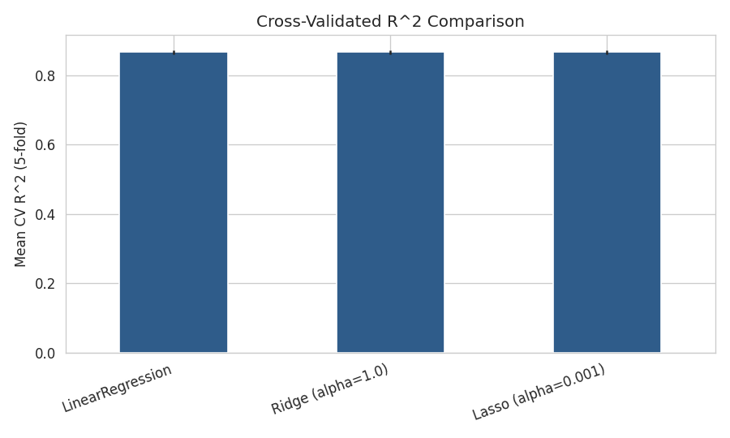
5-fold cross-validation confirms the model generalizes consistently (low standard deviation across folds). Ridge and Lasso regularization were applied to test for overfitting; results are nearly identical to plain Linear Regression, indicating the baseline model was not overfitting and regularization was not strictly necessary for this dataset.

9-10. Python Code & Program Results
The complete pipeline (data understanding through model improvement) is implemented in full_analysis.py, included in the project submission. Key excerpt — model building and evaluation:
lr = LinearRegression()
lr.fit(X_train_scaled, y_train)
y_pred = lr.predict(X_test_scaled)

r2 = r2_score(y_test, y_pred)
mse = mean_squared_error(y_test, y_pred)
rmse = np.sqrt(mse)
mae = mean_absolute_error(y_test, y_pred)

Program output (Results): R² = 0.8785, MSE = 0.005, RMSE = 0.0708, MAE = 0.0535.
Full console output, CSV summaries, and all charts are included in the /output and /plots folders of the submission.

11. Conclusion & Future Scope

Findings
- Mental Fatigue Score is the single strongest predictor of employee Burn Rate, followed by Resource Allocation and Designation.
- The Linear Regression model achieved a strong R² of 0.8785 on unseen test data, meaning it explains roughly 88% of the variation in burnout.
- Cross-validation confirmed the model is stable and not overfitting; regularized variants (Ridge, Lasso) performed nearly identically.
- Missing values (5-10% across three columns) and a modest number of outliers were present but manageable through median imputation and IQR capping.

Future Scope
- Try non-linear models (Random Forest, Gradient Boosting) to potentially capture interaction effects between features.
- Collect additional features such as working hours, leave patterns, or manager feedback to improve predictive power.
- Deploy the model as a live dashboard/API for HR teams to flag high-risk employees in real time.
- Re-validate the model periodically as workplace patterns evolve (e.g., hybrid work trends).

12. Soft Copy Submission Contents
The final submission package includes:
- full_analysis.py — complete Python source code for the pipeline
- train.csv — the original dataset used
- This report (Employee_Burnout_Project_Report.docx)
- output/ folder — dataset_summary.csv, before_after_comparison.csv, model_improvement_comparison.csv, results_summary.json, automated_eda_report.html
- plots/ folder — all generated charts (histograms, box plots, pie charts, bar chart, correlation matrix, before/after comparison, actual vs predicted, feature coefficients, model comparison)

