2014

Website Requirement Document

Sarbjit Singh

Ekomsys.com

Contents

Features 3

Scalable 3

Elegant UI 3

Search 3

News 3

Administrative Console 3

Payment Gateway 4

Browser Compatibility 4

Detail Requirements 4

Kinds of users 4

Home Page 4

Requirements for Navigation Pane 4

Requirement for welcome message 5

Requirement for News 5

Requirement for Footer 5

News Page 6

Requirement for News Page 6

Contact Us Page 6

Requirement for contact us page 7

About Us Page 7

Requirement for ‘Company Overview’ Section 7

Requirement for ‘Vision’ Section 8

Requirement for ‘Our Business’ Section 8

Products Page 8

Ekomsys Multimedia SDK Description 8

Demo Request Page Requirements 12

Buy Product Page Requirements 12

Support renewal 13

Customer Login Page Requirements 13

Bug Tracking System 14

Wiki 14

**Table of Figures**

Figure 1 Sample Navigation Pane 5

Figure 2 Home page footer 6

Figure 3 Contact Us Page 7

Figure 4 9

Figure 5 Block diagram of servers 9

Overview

This document is used as a requirement document for the creation of the website for Ekomsys.com. Ekom system is a new startup company that is coming in market with variety of products. Right now the company is majorly focusing on creating software for broadcast applications. Various products that company is bringing in market are following:

* **Ekomsys Multimedia SDK**: SDK to develop TV broadcast software.

**Note**: In future, company can focus on other areas of software and hardware development and thus the website should be inclined to both hardware and software.

Requirements

# Features

Company is focusing on creation of website which should be appealing to the customer and at the same time should provide with all the functionalities that are must for a software company to grow. Various features from a very higher level can be summarized in the following paragraphs:

## Scalable

The website shall be scalable. In future if new products needs to be added on website it should be easy and website design shall support scalability.

## Elegant UI

The look and feel shall be very elegant without using too much bright colors. The user navigation shall be easy and the user shall be able to browse the services and products easily.

## Search

Website shall have a search functionality that can be used to search the content in the website itself.

## News

Administrator shall be able to post news on the website using a control panel and that news shall be reflected on the company’s main page using some scrolling or some visually appealing manner.

## Administrative Console

Website shall have an admin console which can be used to get the web stats as well as to configure various parts of the website.

## Payment Gateway

User shall be able to buy the software online using the payment gateway.

## Browser Compatibility

Website shall support major browsers e.g. IE, Firefox and Safari

# Detail Requirements

## Kinds of users

* Administrator: User who has all the access and can add or remove other users on website.
* License Managers: User who can add assign a license to the customer and also can remove the customer from the system
* Content Managers: Users who can add content to the website.
  + Can add news
  + Can manage blogs or wiki
  + Can edit and change the pages of website

## Home Page

The sample home page can be found at following link:

<http://demo.templatesquare.com/html/genesis/genesis-default/index.html>

This link actually provides the look and feel that is required in the final website. Various links that should be provided on the website are:

* Home
* News
* About Us
* Contact Us
* Products

These links should be visible on every page so that user can easily navigate through the pages. Refer to the link above for more clarification.



Figure 1 Sample Navigation Pane

### Requirements for Navigation Pane

1. Shall be visible on each page.
2. Selected link should be shaded as shown in figure.
3. Color selection should be used same as shown in figure above with diagonal running lines from top to bottom.
4. Left corner should be filled with company logo ( Need to decide on that and can be updated later)
5. Various submenus should pop up using an animation. (Refer to the link above for more clarification)
6. Search function shall be available on the navigation bar.

### Requirement for welcome message

On the home page apart from the navigation panel and graphics of the product, there shall be a welcome message to the customers telling them about our company. The content of the same is shown below:

*“Welcome to our website:*

*The Ekom systems LLC is dedicated to provide software services to the customers in the form of finished products as well as in the form of software libraries that the customers can use in their proprietary applications. Software is written by using the best technologies in the market.*

*We strive to provide the excellence by making sure that every bit of our code is tested by the experts in the field and that we provide the support required by our customers. We are working with the excellent group of people whose dedication along with the use of advance technology helps us to get excellent results consistently.*

*We understand the market needs and work proactively to satisfy those needs thus making sure we grow along with our customers in the market. We also understand the value of time and importance of innovation to survive in this competitive market.”*

The above section reflects the reference content and shall be used as a direction; it can be tweaked as per the designer to reflect more appropriate content and to make it more professional.

### Requirement for News

On the home page user shall be able to see the latest 2-3 news links that are posted by the administrator. The news should be links which user can click to read the news in more details on the news page.

### Requirement for Footer

On the home page there should be footer which similar to navigation pane should be available on every page. The sample footer is shown below:

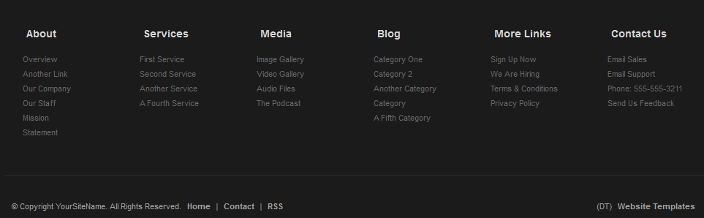

Figure 2 Home page footer

1. It shall be available on every page.
2. The background graphics should be consistent to navigation pane.
3. It shall have links to every major page (refer to the navigation pane links section )
4. The major links should also have sub links to the sub sections in the page.
5. Copyright notice shall be present.

## News Page

News page will be used for any announcements that company wants to communicate. The sample format of the news page can be found at following link:

<http://www.apple.com/hotnews/>

### Requirement for News Page

1. Every news shall have a headline.
2. Every news shall have a date when it was posted.
3. The format of the news shall be as indicated in the link above.
4. The font and the color of the text shall be consistent with the home page of the website.
5. No more than 10 news shall be shown on the page at a time.
6. There shall be an option to post a small image along with the news.
7. The news shall be fetched from the backend database.

The actual content of the news section can be added later but for development needs any dummy data can be used.

## Contact Us Page

This page shall be used by the user to contact company. User shall have an option to send the comments and a message to the company. The contact us page shall be similar to the link given below.

<http://demo.templatesquare.com/html/genesis/genesis-default/contact.html>

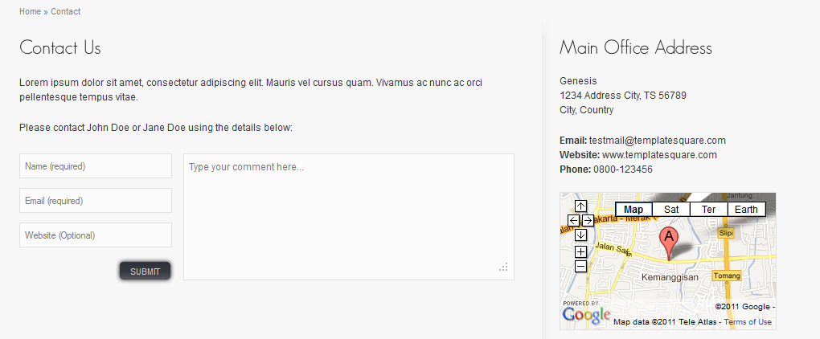

Figure Contact Us Page

### Requirement for contact us page

1. UI shall conform to the link above.
2. Office address shall be:
   1. *“20 Descanso Dr, Unit 1314, San Jose, CA, 95134”*
   2. Email: [*Sarbjit@ekomsys.com*](mailto:Sarbjit@ekomsys.com)
3. Google map needs to be embedded and shall be dependent on the address shown. In case the address is changed the Google map shall automatically reflect that.

## About Us Page

This page shall give all the information about the company which shall include following:

* Company overview
* Mission and Vision
* Our Business

### Requirement for ‘Company Overview’ Section

Content for this section is given below:

*“The Ekom systems LLC is dedicated to provide software services to the customers in the form of finished products as well as in the form of software libraries that the customers can use in their proprietary applications. Software is written by using the best technologies in the market.*

*We strive to provide the excellence by making sure that every bit of our code is tested by the experts in the field and that we provide the support required by our customers. We are working with the excellent group of people whose dedication along with the use of advance technology helps us to get excellent results consistently.*

*We understand the market needs and work proactively to satisfy those needs thus making sure we grow along with our customers in the market. We also understand the value of time and importance of innovation to survive in this competitive market.”*

### Requirement for ‘Vision’ Section

Content for this section is given below:

*“ Ekomsys’s vision is to become the leading software and hardware solution provider for various industries thus enabling them to grow. This is clearly reflected in the company’s motto “Growing together”. Ekomsys works on following core principles to achieve this:*

* *Innovation to bring the best in the market.*
* *Motivation to the employees and culture where human values comes first.*
* *Knowledge of various upcoming technologies in the market to keep an eye on emerging markets.*
* *An open mind to learn from the competition and respect the accomplishment of the competitors.*

### Requirement for ‘Our Business’ Section

Content for this section is given below:

*“Our business is focused on creating software libraries for other products to use. We are providing our customers with a SDK that can be used to create applications for TV broadcast industry.”*

## Products Page

This page shall highlight the products of the company. Customer shall be able to buy product from this page or request a demo. Various products that the company offers are below:

### Ekomsys Multimedia SDK Description

Content for this product is following:

*“Ekomsys Multimedia SDK is the product intended for the developers to easily create multimedia application. TV broadcast industry can benefit from this SDK to quickly create applications to broadcast content. Various sub systems of the SDK are:*

1. *Ekomsys Player Server*
2. *Ekomsys CG Server*
3. *Ekomsys Live Server*
4. *Ekomsys Rendering Server*
5. *Ekomsys Media Doctor*

The various sub systems shall have a different page that contains the context diagram showing how it fits in the overall architecture and the content giving details about the component. The graphics can be created separately but dummy graphics can be used for development.

Figure

Figure Block diagram of servers

Rendering Server

Live Server

CG Server

Player Server

TCP/IP

TCP/IP

TCP/IP

#### Ekomsys Player Server

Ekomsys player server is a process that accepts commands from the client and plays the multimedia files and sends the content to rendering server to be rendered on hardware cards or to stream the content to a remote media server. Various features that it supports are:

* Seamless player, no gap is perceived between different tracks.
* Supports most of the file formats.
* Resizes the frame as per the format set for broadcasting.
* Resamples audio to fit the format set for broadcasting.
* Supports cropping the video frame at run time.
* Supports option to maintain the aspect ratio and change the aspect ratio.
* Supports media inspection to prevent damaged media to disrupt the playback.
* Supports playing a selected audio or video stream from the file.
* Supports playing streaming content from internet.
* Supports fetching the snapshot of any queued track.
* Supports GPU filters to resize the frame and letterboxing.
* Supports automatic audio balancing of the tracks.

#### Ekomsys CG Server

Ekomsys CG server is a process that accepts commands from the client and generates the animation containing text, flash or any image. The overlay data is then sent to rendering server which mixes the content with any other data from other subsystems. Various features are given below:

* Supports various objects as part of animations
  + Flash object
  + Video object
  + Image object
  + Various shapes like circle and rectangle
  + Browser objects to render web pages
  + HTML text object
* Intuitive xml based animation composition.
* Using 3D rendering engine as backend.
* Supports 3D animations.
* Supports various effects using shaders.
* Supports infinite number of layers.
* Supports various compositors for various effects on the screen.
* Anti-aliased rendering of text and shapes.
* Supports masking on video object.

#### Ekomsys Live Server

Ekomsys Live server is a process that accepts commands from the client and captures frames from various live devices like TV tuner cards and Decklink capture card. It supports capturing from multiple sources in parallel. The data is sent to rendering server for rendering on hardware. Various features are given below:

* Supports capturing from decklink card.
* Supports capturing from TV tuner cards.
* Supports capturing from live streaming source.
* Supports capturing from multiple sources in parallel.
* User can selectively send any capturing to rendering server for rendering.
* Supports chroma keying using both static and video files as background.
* Supports masking the output using any image file.

#### Ekomsys Rendering Server

Ekomsys Rendering server is a process that is used as a video and audio mixer and is used to render output to various devices as desired by the user. Various features are given below:

* Supports rendering to Decklink card.
* Supports publishing content to media servers e.g. Adobe Flash Media Server
* Supports streaming the content as rtsp stream and acts as streaming server.
* Supports rendering on another monitor and soundcard for low cost broadcasting solution.
* Supports writing the output to a file.
* Supports rendering to multiple devices simultaneously.
* Supports getting snapshot of final output.
* Supports layers, any output can be rendered on any layer.

## Demo Request Page Requirements

When user clicks a link on products page to request a demo, this page shall be opened to get user information. Following information shall be collected from user on this page:

* Name
* Email address
* Company name(optional)
* Contact address
* Contact number
* Products that user is interested in (from drop down menu, initially contains only Multimedia SDK)
* Referred by
* Text box for additional comments

This page shall have a captcha verification to avoid spam. When user submits this information the system shall generate an email with all this information and send it to the configured (configured through control panel) recipient. The email shall have a link to accept or reject this request. When user accepts the request the system shall send an email to the customer with a link to download the SDK and also a demo serial number for demo license.

## Buy Product Page Requirements

When user decides to buy a product this page shall be used to get all basic information about the user. This information shall include following:

1. Name
2. Username
3. password
4. Email
5. Company name
6. Company address/Address
7. Nature of business
8. Contact number
9. Referred by

On submitting this information the user shall be taken to payment gateway where he will finish the payment process. On successful completion of that process system shall generate login information for that client using the information he already provided. All this information shall be saved in database. System shall generate an email containing the information about this transaction and send it to the configured email, which can be configured through control panel. The email contains a link which can be used to assign a license to the customer. When license manager clicks the link it shall open a login page where he can login and after successful login shall be taken to another page where all the information about the client is already filled in except the license keys.

The license manager shall be able to assign the license by typing key manually in text box and commit it to database. There shall be a link to send an email to customer with the license keys for the product. There shall be a text box to add any additional information is license manager wants to add.

### Support renewal

The system shall register this date when customer bought the product in database and shall send the reminder to customer in form of email when his support is about to finish. By default the customer gets 1 year support with purchase of product. The email shall contain a link to renew the support. When customer clicks that link it shall take him to the page where he can buy support for additional year on the product. After buying the support the system shall update the customers support expiration date.

## Customer Login Page Requirements

When customers bought the product system creates login information for that customer. When customer uses that information to login this page shall show the product bought by the customer and all the information of the customer. Customer shall be able to edit all the personal information except the license keys and support expiration date. This page shall contain following links:

* Buy support for product for another year.
* Download link for the bought product
* Any patches that were released for that product within the support period e.g. if customer’s support is expiring on 1 Jan 2015 and he bought product on 1 Jan 2014 than any updates on product within that duration shall be available on this page for download.
* A link to submit a bug using bug tracking web application (shall be installed separately)
* A link to ask for any information in form of email to technical department.
* A link to download any beta software.

Database Requirements

The backend database shall be MySQL. Various benefits of using MySQL are following:

* Open source database, free to use.
* Reliable and stable database.
* Support by various websites hosting companies.

Various requirements of the database are following:

1. Tables shall be normalized to ensure the separation of data in different tables.
2. Queries shall be optimized to make the fetching of data efficient from the tables.

Miscellaneous Requirements

## Bug Tracking System

A bug tracking system shall be installed on the server and shall be configured so that technical department receives an email whenever a bug is logged and customers shall receive an email when a bug is fixed and updated patch is available to download. Only customers who bought the product shall be able to log a bug.

## Wiki

A wiki shall be installed on server that can be edited by content manager users to publish product related help pages and API documents.