**Problem statement:**

1. How many people in the world speak ‘proficient’ English (meaning suitable for business or academic work)?
2. How has that evolved over the past 100 years?
3. How is it likely to evolve over the next 100 years?

**Analysis:**

**For Data Preparation:**

Used several tools like Nitro PDF editor pro version, Microsoft Excel and Tableau.



The excel contains the consolidated version created after mining data from various files at: <https://www.ef.edu/epi/downloads/>

**For Data understanding:**

Analyzed the data and created visualization for better understanding using Tableau.

<https://public.tableau.com/views/EFEnglishProficiencyIndex-Report/Dashboard1?:embed=y&:display_count=yes&publish=yes&:toolbar=no>

**Observations from other sources:**

As per current situation, English is spoken at a useful level by around 1.75 billion people worldwide.

According to recent Cambridge study:

* In countries and territories where English is not a native or official language, over 2/3rd of the employers say that English is important for their business. This was proved from survey results which showed that English language skills are important for over 95% of employers in many countries and territories where English is not an official language.
* 90% of people from more than 20 countries say English is important for their business and economy, some of the examples of such countries are: Saudi Arabia, Denmark, India, Hong Kong, Jordan, United States, Belgium, Italy, Switzerland, Lithuania, Canada, United Kingdom, Singapore, Australia, Malaysia, Portugal, New Zealand, Ireland, Germany.
* Over 75 % people from non-English speaking countries agree that English language is crucial in following industries: IT / Computer Services, Consulting / Professional Services, Travel / Leisure / Hospitality, Electronics / High Technology, Manufacturing / Engineering, Transportation / Distribution, Telecoms, Energy, Law, Aerospace / Defense.

The most important prospect of Language is that it is strongly linked to global demographic shifts as well as it is the economic prowess of a nation among other things.

English is the language of global business, and the globalization trend is predicted to grow even further.

Hence, we can say that English is immensely important wherever you are in the world for business.

As per analysis:

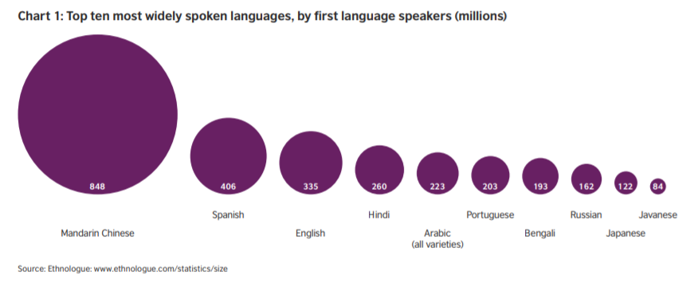

* China is the largest market for English language learning and will outnumber native English speakers in the rest of the world.
* It is also interesting to observe that, majority of population speaking Chinese/ Mandarin are also learning English to excel in today’s world.

Below chart shows most popular languages used on Internet:

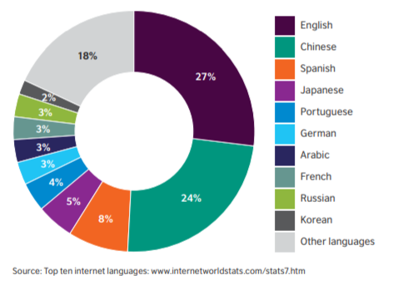

With the growing innovation and technology trends, if population of China has started learning English to use as their business language, then the consolidated number of English-speaking population would increase further resulting in over 50% of world population.

Spanish is the 2nd most important language to learn for UK people after English due to several economic, trade and political reasons.

Another interesting observation was, the number of English users will be affected by population changes according to the study by UniLang Language Community Forum.

**Observations from EPI reports:**

* English correlates with key eco-nomic and social indicators
* Working Population or people from age18-30 tend to have higher EPI compared to others.
* Middle east and Latin American countries have lower English proficiency than compared to European nations
* Population with Higher EPI tends to have higher individual earning power.
* The percentage of people with Internet access—increases for each EF EPI proficiency band
* English proficiency can be positively correlated with several key measures of innovation, including research and development spending
* It can be said that English efficiency improves as countries develop as results from HDI index comparison with each EF EPI proficiency band shows that, English and quality of life are positively correlated.

**Final Verdict / Conclusion:**

Based on analysis of various sources like articles, blogs, Cambridge case study and EPI indexes from 2011-2017, the trend of English language being used for business and economic by countries is increasing around the world.

1. 43.75 % of total audited countries for 2017 are proficient in speaking English suitable for business and academic work. The countries with moderate, high and very high proficiency levels contributed toward this result.
2. Over the past 100 years, the use of English language has increased considerately.

The top 3 factors that decided these results are:

* Economic factors
* Cultural Educational and diplomatic factors
* Balancing factors

1. There is though competition from other Languages like Spanish, Mandarin, German, Hindi /Urdu, but the number of English learners is also increasing around the world. Hence, English will hold the upper hold over other languages, but the final trend of evolution will also be decided based on population and economic shifts around the world over the next 100 years.