**Lab Practical #04:**

Installation of Network Simulator (Packet Tracer) and Implement different LAN topologies.

**Practical Assignment #04:**

1. **Create a simple network with switch and two or more pc. Also check connectivity between them using ping command or PDU utility.**
2. **Implement different topologies in packet tracer.**
   1. **Bus**

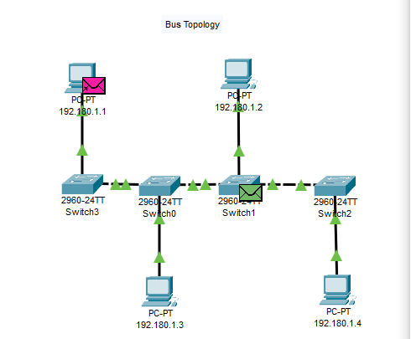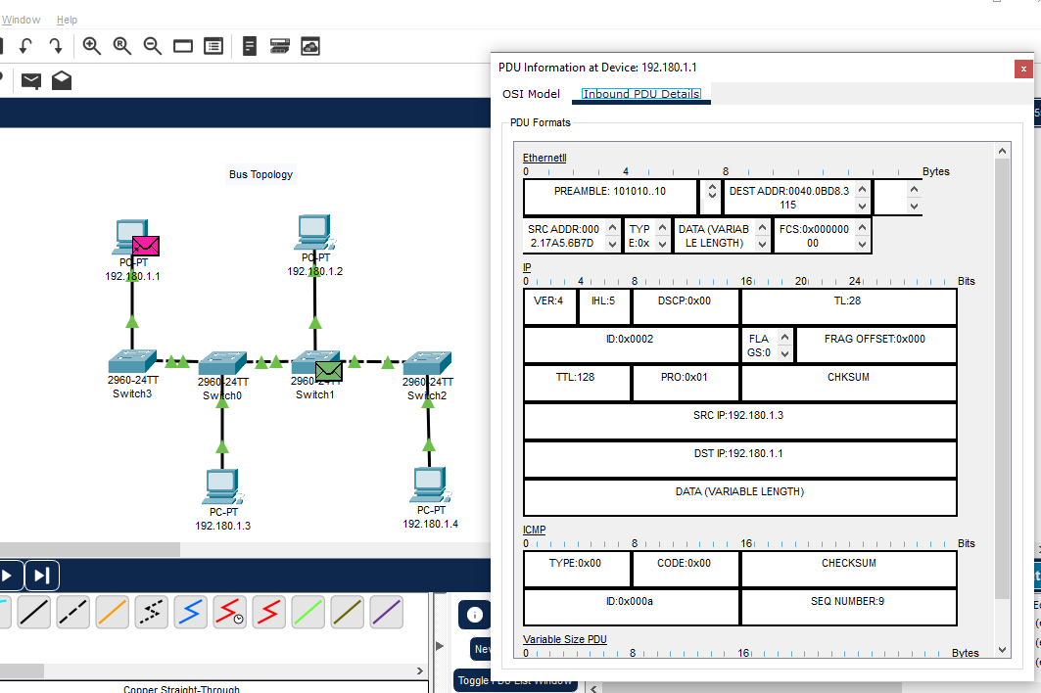

* 1. **Ring**

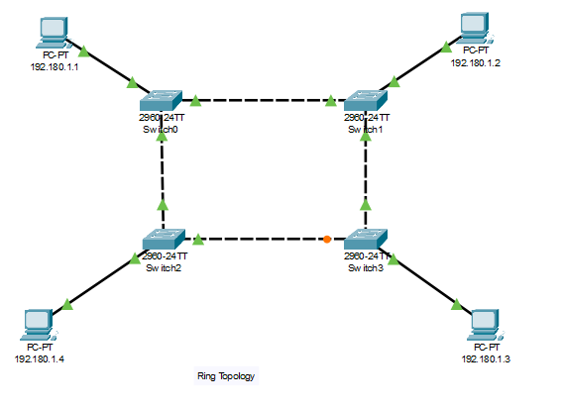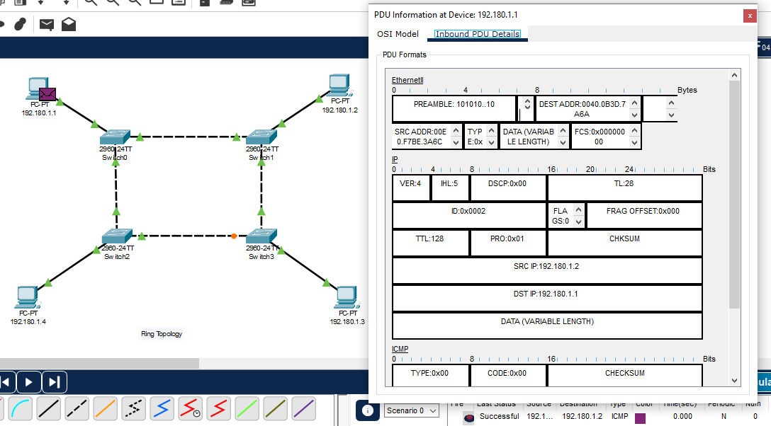

* 1. **Star**

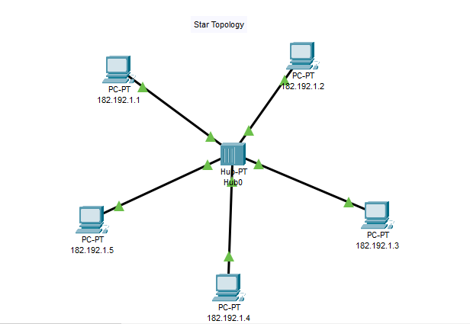

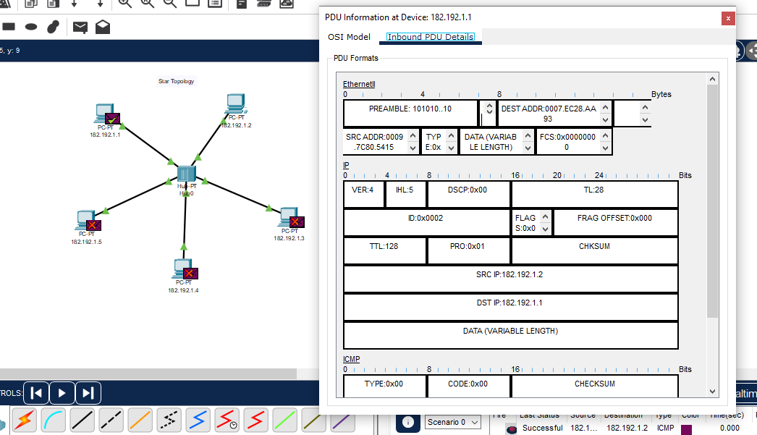

* 1. **Mesh**

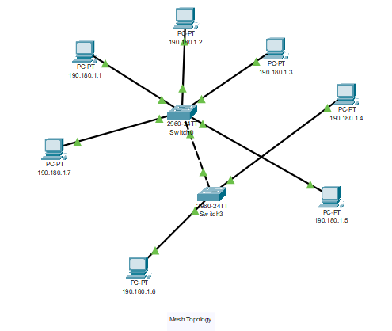

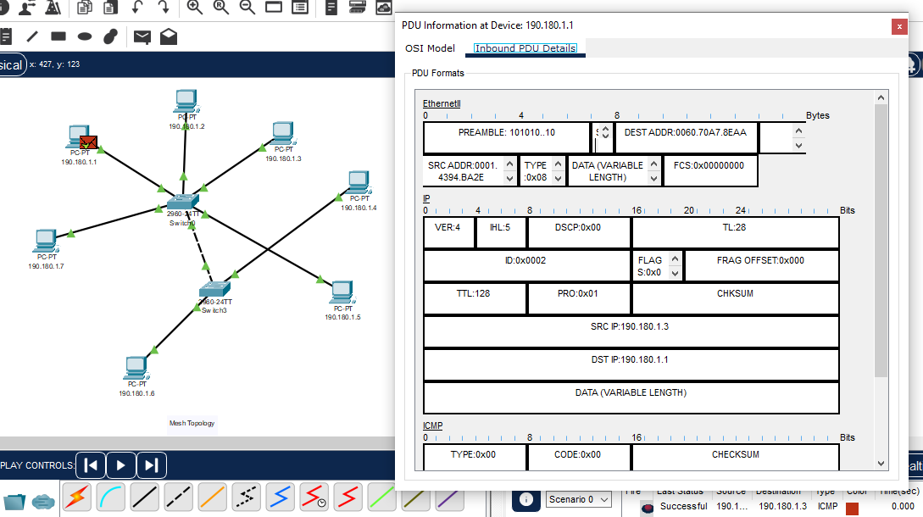

* 1. **Tree**

