Date: / /

# Lab Practical #01:

Study of basic networking commands and IP configuration.

# Practical Assignment #01:

1. Perform and explain various networking commands listed below:
   1. ipconfig
   2. ping
   3. getmac
   4. systeminfo
   5. traceroute / tracert
   6. netstat
   7. nslookup
   8. hostname
   9. pathping
   10. arp

## ipconfig

Description:

The default is to display only the IP address, subnet mask and default gateway for each adapter bound to TCP/IP

|  |  |  |
| --- | --- | --- |
| **No.** | **Option** | **Description** |
| **1** | ipconfig /? | Display this help message |
| **2** | Ipconfig/all | Display full configuration information |
| **3** | ipconfig /release | Release the IPv4 address for the specified adapter |
| **4** | ipconfig /renew | Renew the IPv4 address for the specified adapter |
| **5** | ipconfig /displaydns | Display the contents of the DNS Resolver Cache |

Date: / /

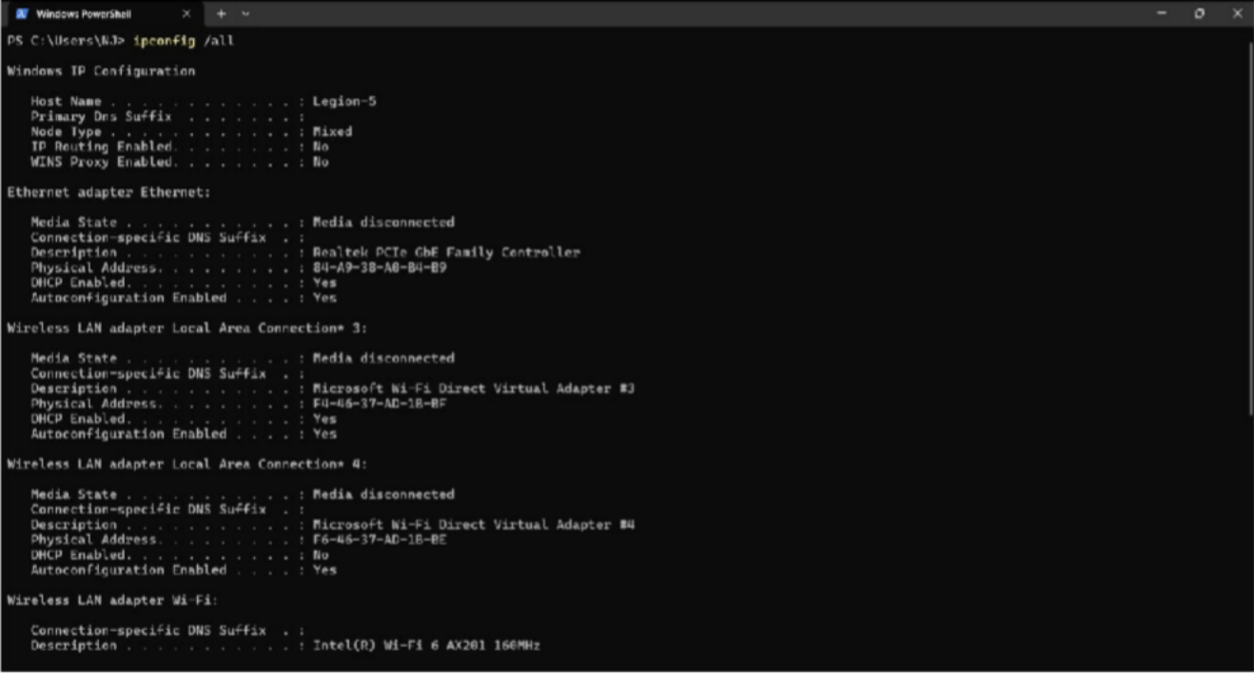Implementation:

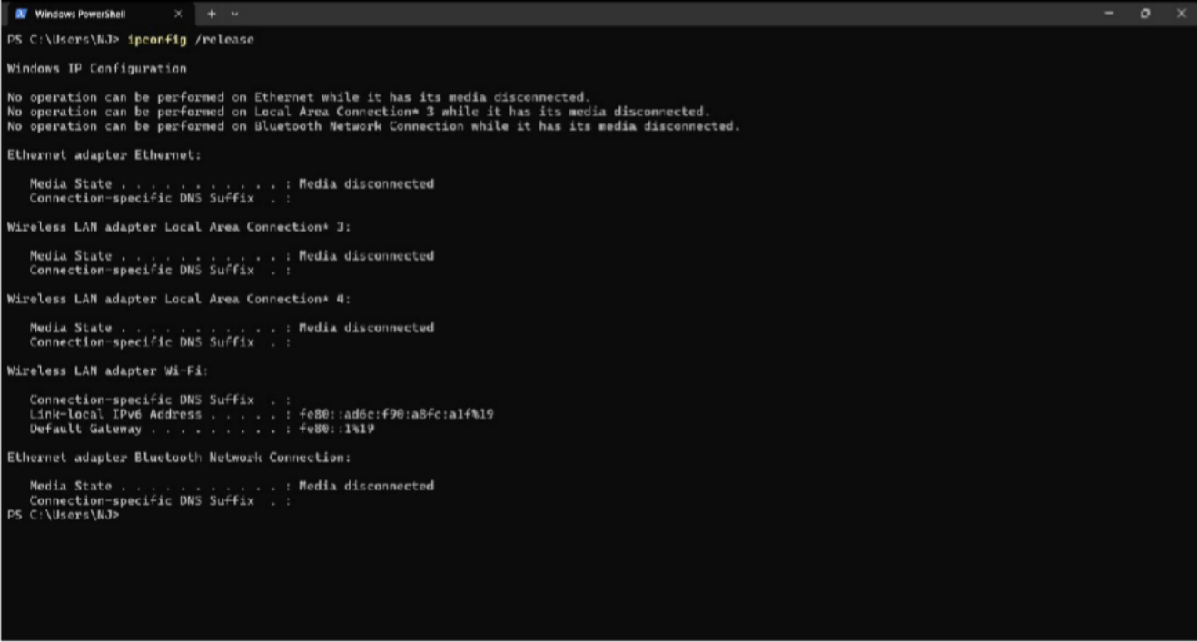

Date: / /

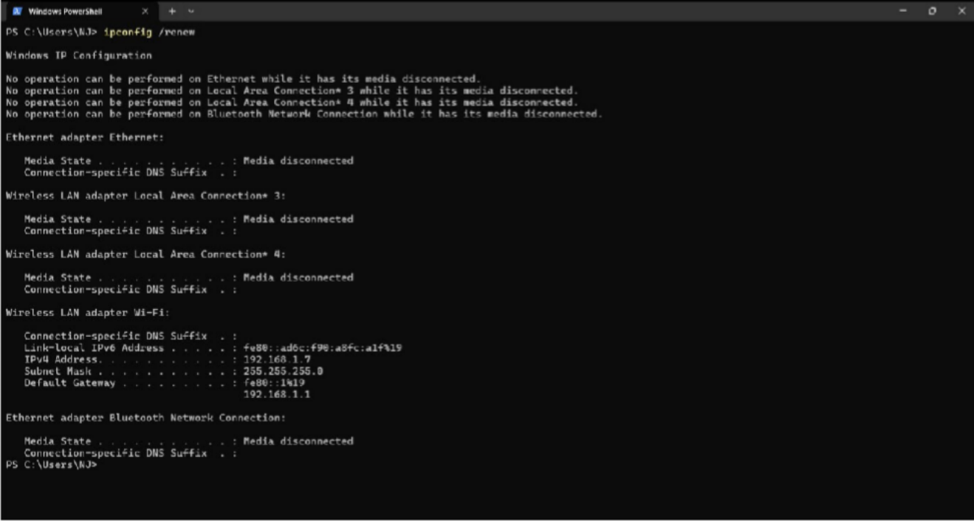

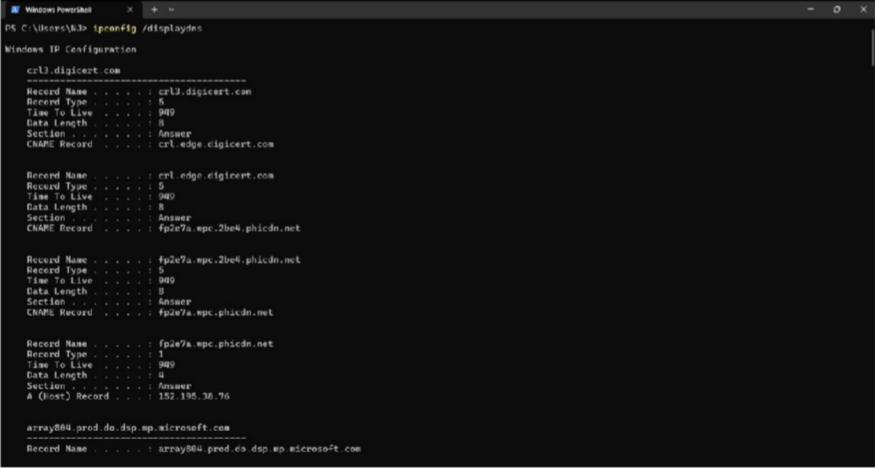

Date: / /

## ping

Description:

The ping command is a network utility used to test the reachability of a host on an Internet Protocol (IP) network and to measure the round-trip time for messages sent from the originating host to a destination computer

|  |  |  |
| --- | --- | --- |
| **No.** | **Option** | **Description** |
| **1** | ping -t | Ping the specified host until stopped |
| **2** | ping -a | Resolve addresses to hostnames |
| **3** | ping -n count | Number of echo requests to send |
| **4** | ping -f | Set Don't Fragment flag in packet (IPv4-only). |
| **5** | ping -l size | Send buffer size. |

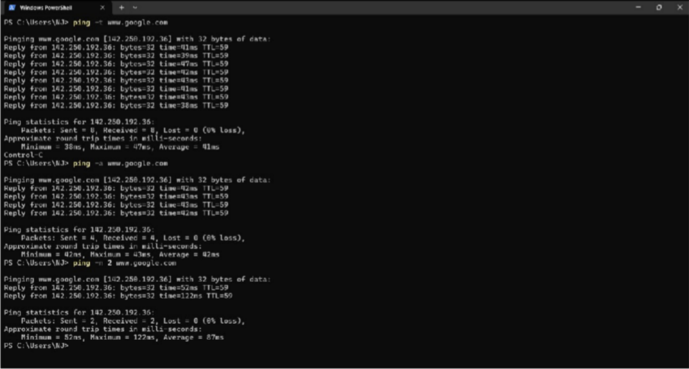Implementation:

Date: / /

## getmac

Description:

This tool enables an administrator to display the MAC address for network adapters on a system.

|  |  |  |
| --- | --- | --- |
| **No.** | **Option** | **Description** |
| **1** | getmac/ S system | Specifies the remote system to connect to |
| **2** | getmac/ U [domain\]user | Specifies the user context under which the command should execute. |
| **3** | getmac/ P [password] | Specifies the password for the given  user context. Prompts for input if omitted |
| **4** | getmac/ FO format | Specifies the format in which the output is to be displayed.  Valid values: "TABLE", "LIST", "CSV" |
| **5** | getmac/ V | Specifies that verbose output is displayed. |

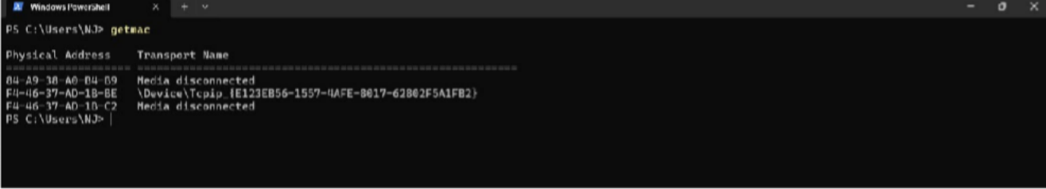Implementation:

1. **systeminfo Description:**

This tool displays operating system configuration information for a local or remote machine, including service pack levels

|  |  |  |
| --- | --- | --- |
| **No.** | **Option** | **Description** |
| **1** | systeminfo/ S system | Specifies the remote system to connect to |
| **2** | systeminfo/ U [domain\]user | Specifies the user context under which the command should execute. |
| **3** | systeminfo/ P [password] | Specifies the password for the given  user context. Prompts for input if omitted |
| **4** | systeminfo/ FO format | Specifies the format in which the output is to be displayed.  Valid values: "TABLE", "LIST", "CSV" |
| **5** | systeminfo/ ? | Displays this help message |

Date: / /

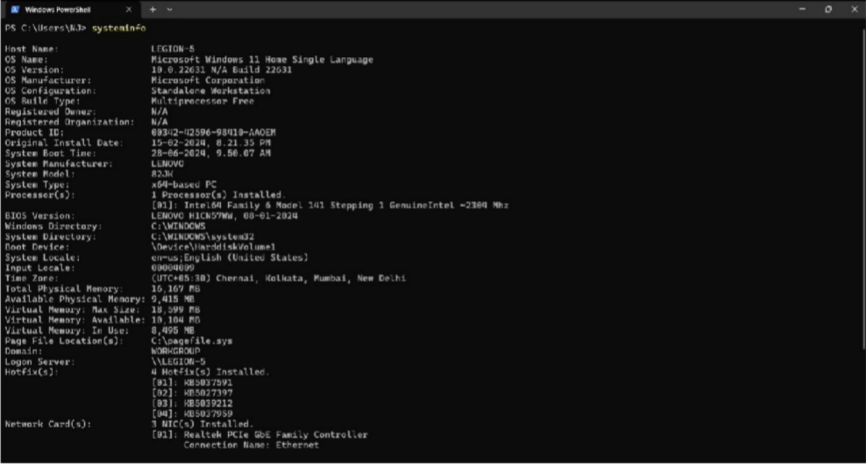Implementation:

## traceroute / tracert

Description:

Tracert, short for traceroute, is like a digital detective. It traces the route taken by your data, revealing each hop (router) it encounters and the time it takes to reach it

|  |  |  |
| --- | --- | --- |
| **No.** | **Option** | **Description** |
| **1** | tracert -d | Do not resolve addresses to hostnames. |
| **2** | tracert -h maximum_hops | Maximum number of hops to search for target |
| **3** | tracert -j host-list | Loose source route along host-list (IPv4-only). |
| **4** | tracert -R | Trace round-trip path (IPv6-only). |
| **5** | tracert -4 | Force using IPv4. |

Date: / /

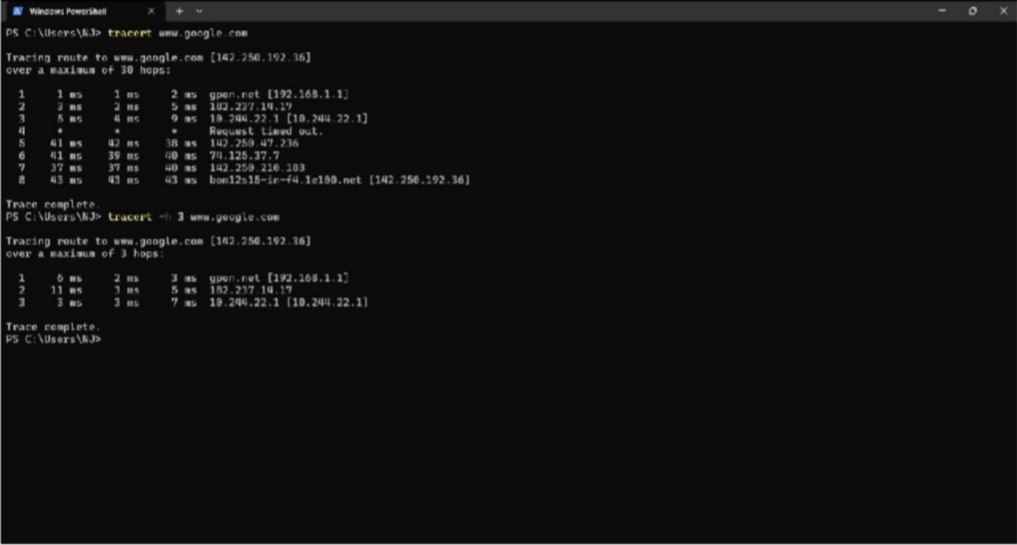Implementation:

## netstat

Description:

Displays protocol statistics and current TCP/IP network connections

|  |  |  |
| --- | --- | --- |
| **No.** | **Option** | **Description** |
| **1** | netstat -a | Displays all connections and listening ports |
| **2** | netstat -e | Displays Ethernet statistics. This may be combined with the -s option. |
| **3** | netstat -f | Displays Fully Qualified Domain Names (FQDN) for foreign addresses |
| **4** | netstat -i | Displays the time spent by a TCP connection in its current state |
| **5** | netstat -n | Displays addresses and port numbers in numerical form. |

Date: / /

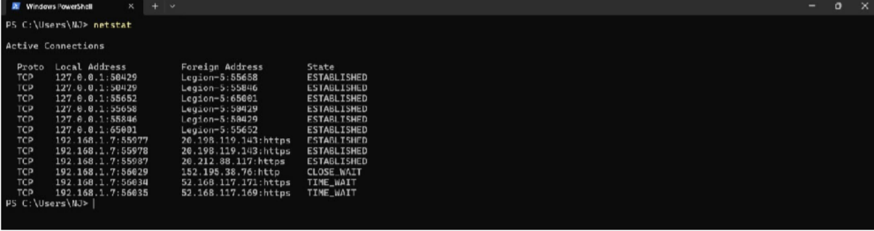Implementation:

## nslookup

Description:

The nslookup command is a network administration tool used for querying the Domain Name System (DNS) to obtain domain name or IP address mapping information

|  |  |  |
| --- | --- | --- |
| **No.** | **Option** | **Description** |
| **1** | nslookup /? | Display this help message |

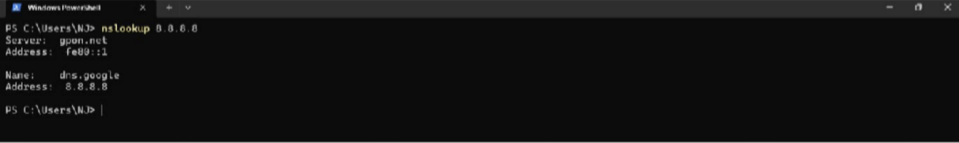Implementation:

## hostname

Description:

Prints the name of the current host

|  |  |  |
| --- | --- | --- |
| **No.** | **Option** | **Description** |
| **1** | hostname /? | Display this help message |

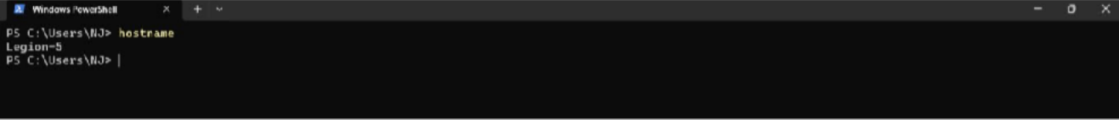Implementation:

Date: / /

## pathping

Description:

Provides information about network latency and network loss at intermediate hops between a source and destination

|  |  |  |
| --- | --- | --- |
| **No.** | **Option** | **Description** |
| **1** | pathping -g host-list | Loose source route along host-list. |
| **2** | pathping -h maximum_hops | Maximum number of hops to search for target. |
| **3** | pathping -i address | Use the specified source address. |
| **4** | pathping -n | Do not resolve addresses to hostnames |
| **5** | pathping- p period | Wait period milliseconds between pings. |

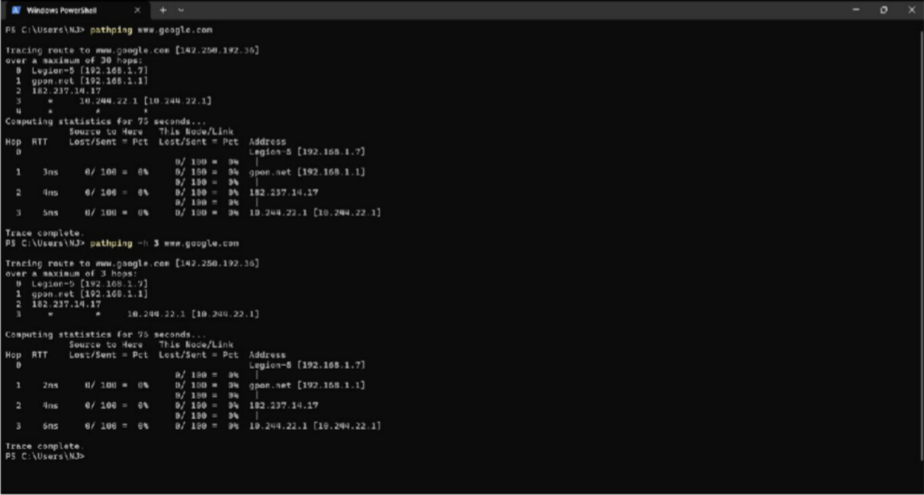Implementation:

Date: / /

## arp

Description:

Displays and modifies the IP-to-Physical address translation tables used by address resolution protocol (ARP).

|  |  |  |
| --- | --- | --- |
| **No.** | **Option** | **Description** |
| **1** | arp /? | Display this help message |
| **2** | arp -a | Displays current ARP entries by interrogating the current protocol data. If inet_addr is specified, the IP and Physical addresses for only the specified computer are displayed. If more than  one network interface uses ARP, entries for each ARP table are displayed. |
| **3** | arp -v | Displays current ARP entries in verbose mode. All  invalid entries and entries on the loop-back interface will be shown. |
| **4** | arp -d | Deletes the host specified by inet_addr. inet_addr may be wildcarded with * to delete all hosts |
| **5** | arp -s | Adds the host and associates the Internet address inet_addr with the Physical address eth_addr.  The Physical address is given as 6 hexadecimal bytes separated by hyphens. The entry is permanent. |

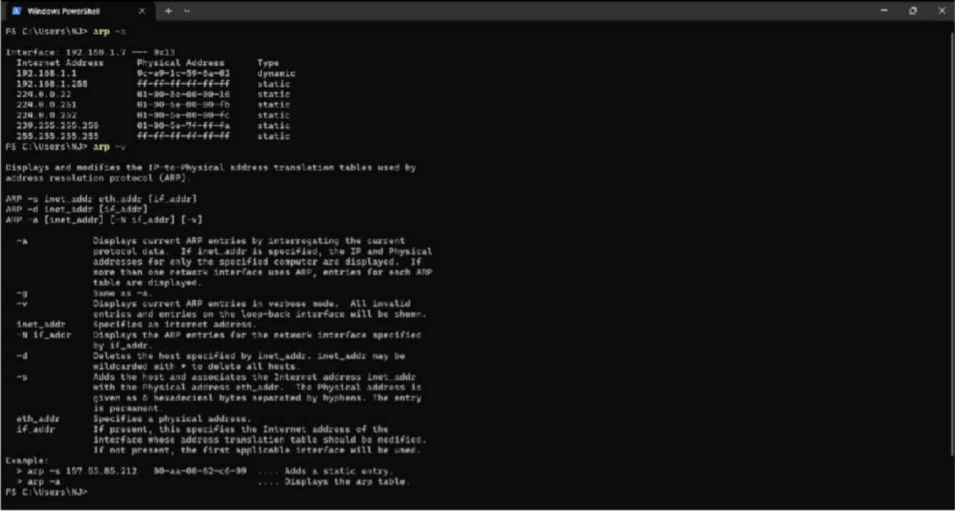Implementation:

**10**

**EnrollmentNo:-23010101140**

**|B.Tech.CSE**