**Date: / /**

# Lab Practical #03:

Study of different types of network cables & connectors and crimping a LAN.

# Practical Assignment #03:

1. List various networks cable. Also, write short description.
2. Difference between guided and unguided media.
3. Give cross-wired cable and straight through cable diagram (Color Code wise).

## List various networks cable and connectors. Also, write short description.

* 1. **Coaxial Cables:**
     + A coaxial cable is used to carry high-frequency electrical signals with low losses.
     + It uses 10Base2 and 10Base5 Ethernet variants.
     + It has a copper conductor in the middle that is surrounded by a dielectric insulator generally made of PVC or Teflon.
     + The dielectric insulator is surrounded by a plaited conducting metallic shield which reduces Electromagnetic Interference of the metal and outside interference and finally, the metallic shield is covered by a plastic covering called a sheath usually made of PVC or some other fire-resistant plastic material.
     + Its maximum transmission speed is 10 Mbps. It is usually used in telephone systems, cable TV, etc.

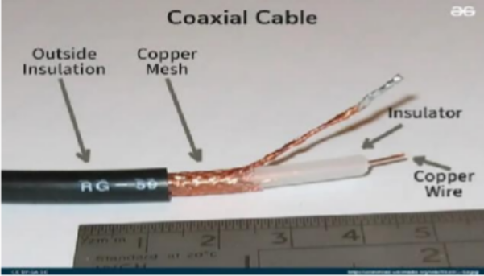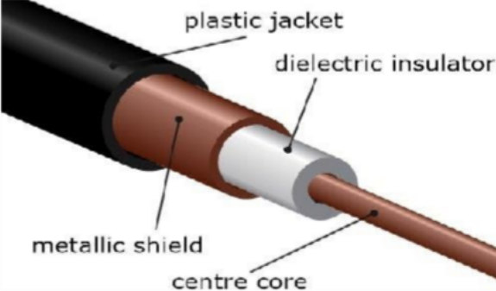

## Twisted Pair Cable:

* + - A twisted pair is a copper wire cable in which two insulated copper wires are twisted around each other to reduce interference or crosstalk.
    - It uses 10BASE-T, 100BASE-T, and some other newer ethernet variants. It uses RJ-45 connectors.
    - Types of Twisted Pair Cable
      1. Shielded Twisted Pair (STP) Cable:
         * In STP the wires are covered by a copper braid covering or a foil shield, this foil shield adds a layer that protects it against interference leaking into and out of the cable. Hence, they are used for longer distances and higher transmission rates.
      2. Unshielded Twisted Pair (UTP) Cable:

**Date: / /**

* + - * + Unshielded twisted pair cable is one of the most commonly used cables in computer networks at present time. UTP consists of two insulated copper wires twisted around one another, the twisting of wires helps in controlling interference.

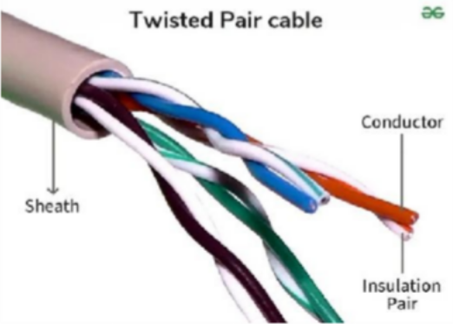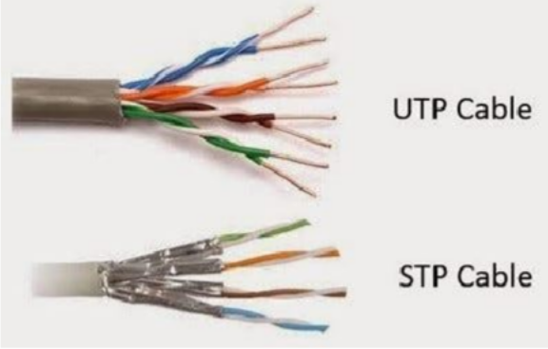

## Fiber Optic Cable:

* + - Fiber optic cables use optical fibers which are made of glass cores surrounded by several layers of covering material generally made of PVC or Teflon.
    - It transmits data in the form of light signals due to which there are no interference issues in fiber optics.
    - Fiber optics can transmit signals over a very long distance as compared to twisted pairs or coaxial cables.
    - It uses 10BaseF, 100BaseFX, 100BaseBX, 100BaseSX, 1000BaseFx, 1000BaseSX, and 1000BaseBx ethernet variants.
    - Hence, it is capable of carrying information at a great speed.

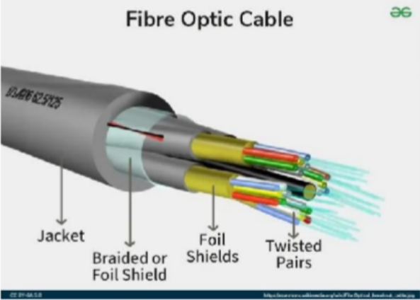

**Date: / /**

## Difference between guided and unguided media.

|  |  |  |
| --- | --- | --- |
| **Basis of comparison** | **Guided Media** | **Unguided Media** |
| **Meaning** | **It is a communication channel that uses a physical medium to transmit signals from one point to another, with the help of a guided medium,**  **like a fiber optic cable or a wire.** | **It is a communication channel that uses a wireless medium to transmit signals from one point to another without the help of any**  **physical medium.** |
| **Examples** | **Coaxial cable, fiber optic cable, and**  **Twisted-pair cable.** | **Microwaves, infrared waves, and**  **radio waves.** |
| **Applications** | **It is a wired LAN, WAN, and point-to- point communication system.** | **It is wireless LANs, WANs, cellular networks, and satellite communication.** |
| **Advantages** | **It is a secure transmission with high data transfer speeds, immune to external interference, and low error**  **rates.** | **It can transmit signals through obstacles, is easy to deploy, and covers a wide area.** |
| **Disadvantages** | **Its range is limited, susceptible to damage and interference, and costly to install and maintain.** | **It has high error rates, low data transfer speeds, is vulnerable to external interference, and limited**  **security.** |
| **Use Cases** | **It is an Ethernet cable for local networks, fiber optic cables for long- distance communication, and coaxial cables for cable TV.** | **In this, Wi-Fi for wireless internet access, Bluetooth for short-range device communication, and satellite communication for**  **remote locations** |
| **Examples of Devices** | **Routers, optical transmitters, optical**  **receiver, Ethernet switch** | **Bluetooth , Wi-Fi router, cellular**  **phone, and satellite dish.** |

**Date: / /**

## Give cross-wired cable and straight through cable diagram (Color Code wise).

* 1. Cross-wired Cable Diagram (Color Code)

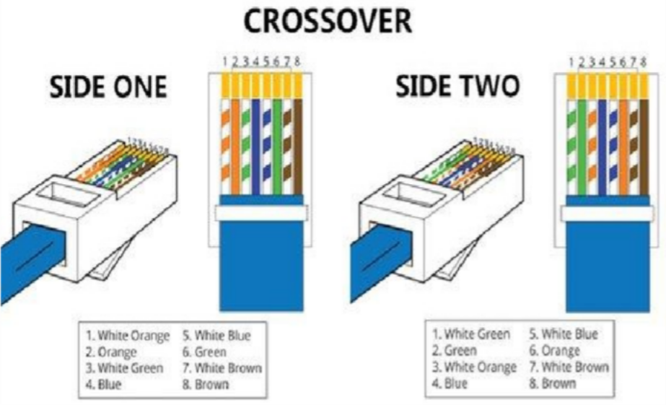

* 1. Straight Through Cable Diagram (Color Code)

