DEMONSTRATION:  
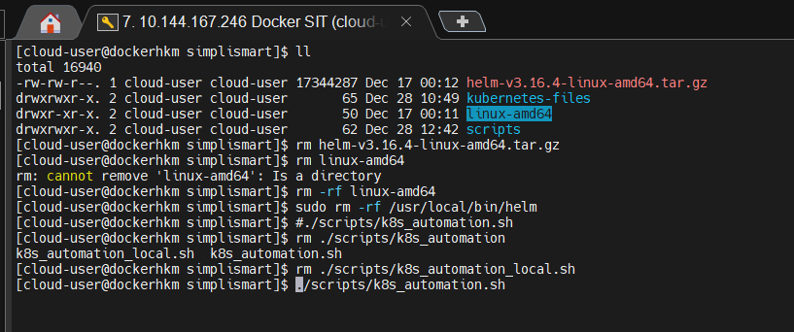

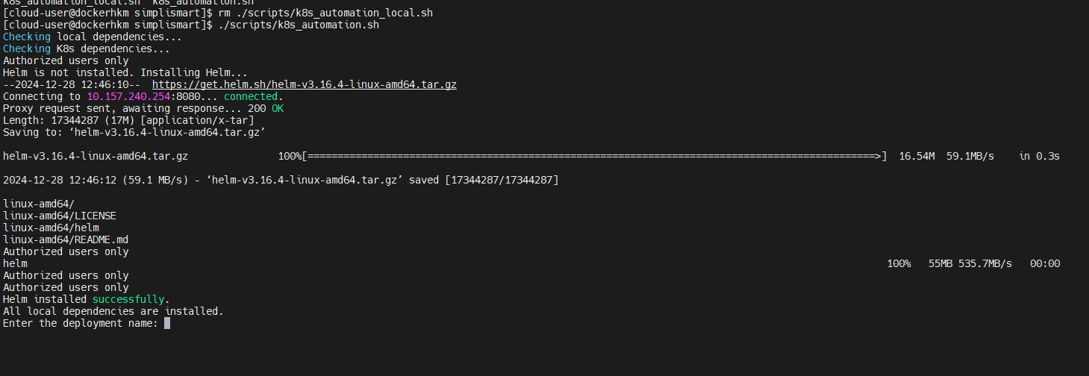

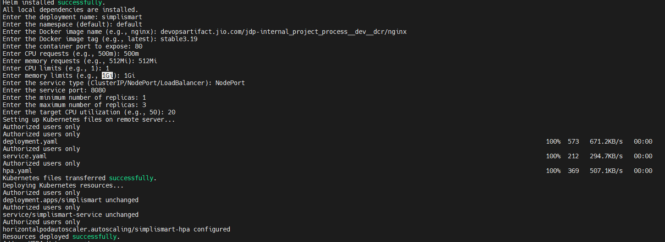

FOR KEDA I HAVE SOME RESTRICTIONS IN MY CURREENT ENVIRONMENT NEED TO WHITELIST THE URL THAT’LL take some time.



FINAL DEPLOYMENT

