Machine Learning 2

Homework 3

Group 8

Anton Zeltser

Harsha Nandeeshappa

**Problem1. Factor Graphs and Messages**

1)

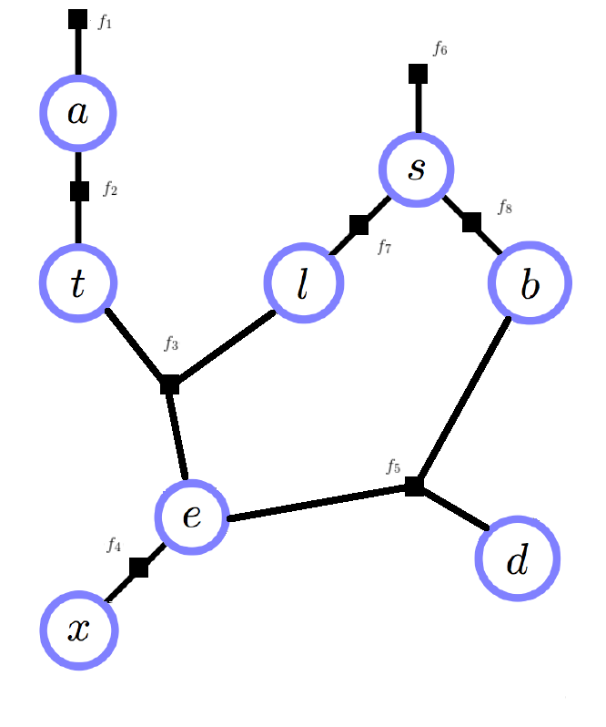

2)



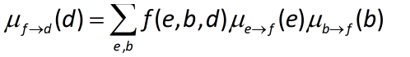

3)





**Problem2. Hidden Markov Model**

1)

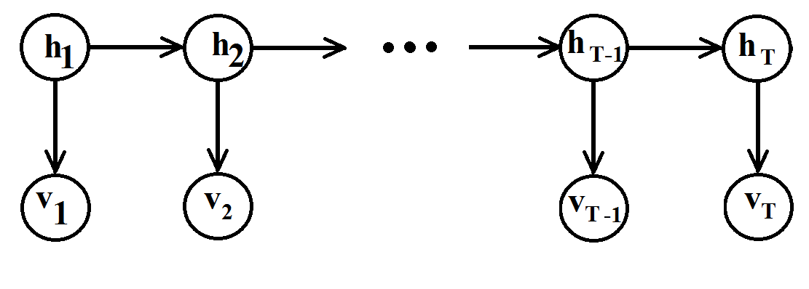

2)

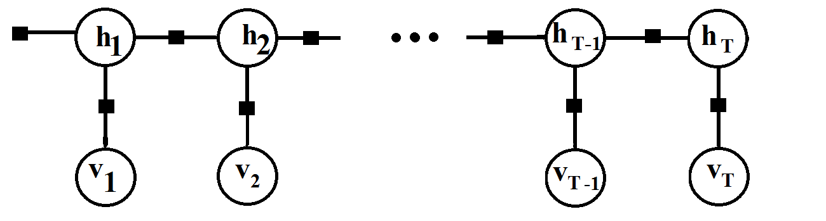

3)





4.

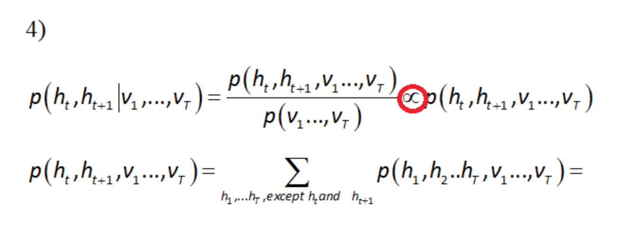

**Problem 3.**

1 -- ${{ v}_{t} and h}_{t}$ corresponds to visible and hidden state respectively.

$v_{t}$ is the visible(observed) states i.e the keypad buttons that are pressed. It’s domain is 2,3,4,5,6,7,8,9 .

$h_{t}$ corresponds to hidden states i.e actual alphabet the user intended to type while pressing a keypad button. It could be any alphabet depending on the language used. We have chooses the language is English. It’s domain is a,b,c,d,e,f,g,h,i,j,k,l,m,n,o,p,q,r,s,t,u,v,w,x,y,z.

2 – We need to learn transition matrix(P(${{ h}_{t}|h}_{t+1}$)) , Initial matrix((P(ht)) ),

Emmision Matrix ((P(${v|h}_{t}$)) for t = 1 to T

3 – Transition matrix – using corpus/book

Initial Matrix – Using book or text messages

Emmision Matrix – By observing the behavior of keypad when key is pressed. i.e what letters are output when a key is pressed.

4 – Inference step is finding $h_{t}$ given ${ v}_{t}$.

How quickly – In this experiment, it depends on the n-grams we chose. It can be done quickly if we use log of the terms which replaces multiplication by additions.

5 – We think HMM is good model for this problem.

Also it depends on how many states are there in ${ h}_{i}$ and that depends on the n-gram we choose.

We can infer better (meaning more accurate) with bigger n in n-grams, but this takes more computations.

**Problem 4**

1 –

**Sum of the rows of P =**

[ 2.15606161 0.14042886 0.46731331 0.50520068 6.07112797 0.34045886

0.29531875 0.97819872 2.4403277 0.01834861 0.05808857 0.90730752

0.29239429 1.28481483 2.57223902 0.49137424 0.01654401 1.42908813

1.31282881 1.39167035 1.93624418 0.25365599 0.07372152 0.08910132

0.42961227 0.0485299 ]

**Sum of the rows of Q =**

[ 0.33333333 0.33333333 0.33333333 0.33333333 0.33333333 0.33333333

0.33333333 0.33333333 0.33333333 0.33333333 0.33333333 0.33333333

0.33333333 0.33333333 0.33333333 0.25 0.25 0.25 0.25

0.33333333 0.33333333 0.33333333 0.25 0.25 0.25 0.25 ]

**Sum of the rows of R =**

[ 1.]

**Sum over the columns of P =**

[ 1. 1. 1. 1. 1. 1. 1. 1. 1. 1. 1. 1. 1. 1. 1. 1. 1. 1.

1. 1. 1. 1. 1. 1. 1. 1.]

**Sum over the columns of Q =**

[ 1. 1. 1. 1. 1. 1. 1. 1.]

**Sum over the columns of R =**

[ 0.11175651 0.03844518 0.0436817 0.04429776 0.02921892 0.04639531

0.01348001 0.05792446 0.0670187 0.00610194 0.00418042 0.02559589

0.03869454 0.02187019 0.07309131 0.05152915 0.00457646 0.02757609

0.05349468 0.14958563 0.01122112 0.01029703 0.06160616 0.00164283

0.00605794 0.00066007]

**2.**

P – Transition Matrix

Q- Emmision Matrix

R- Initial Matrix

**3. <code>**

**4.<code>**

**5. – We need to compute**

T[0] = R[v1]

Then compute

T[vi] *Q[vi ,hi+1] * P[h, hi+1]

And update T with maximum likelihood every iteration.

**6<code>**

**7**

Given sequence - 6224463

Most likely h - oachind

Given sequence - 53276464

Most likely h - learogng