[2048 × 1365](https://www.google.com/url?sa=i&source=images&cd=&ved=2ahUKEwiWifXft5zlAhUGup4KHZFoCdAQjRx6BAgBEAQ&url=https%3A%2F%2Fwww.blogto.com%2Frestaurants%2Fbeach-hill-smokehouse-toronto%2F&psig=AOvVaw3Tmp19m69A2P49Gy-6WGCx&ust=1571165897606148" \t "_blank)

Tyrone’s Smokehouse & Bar – Harsh Patel

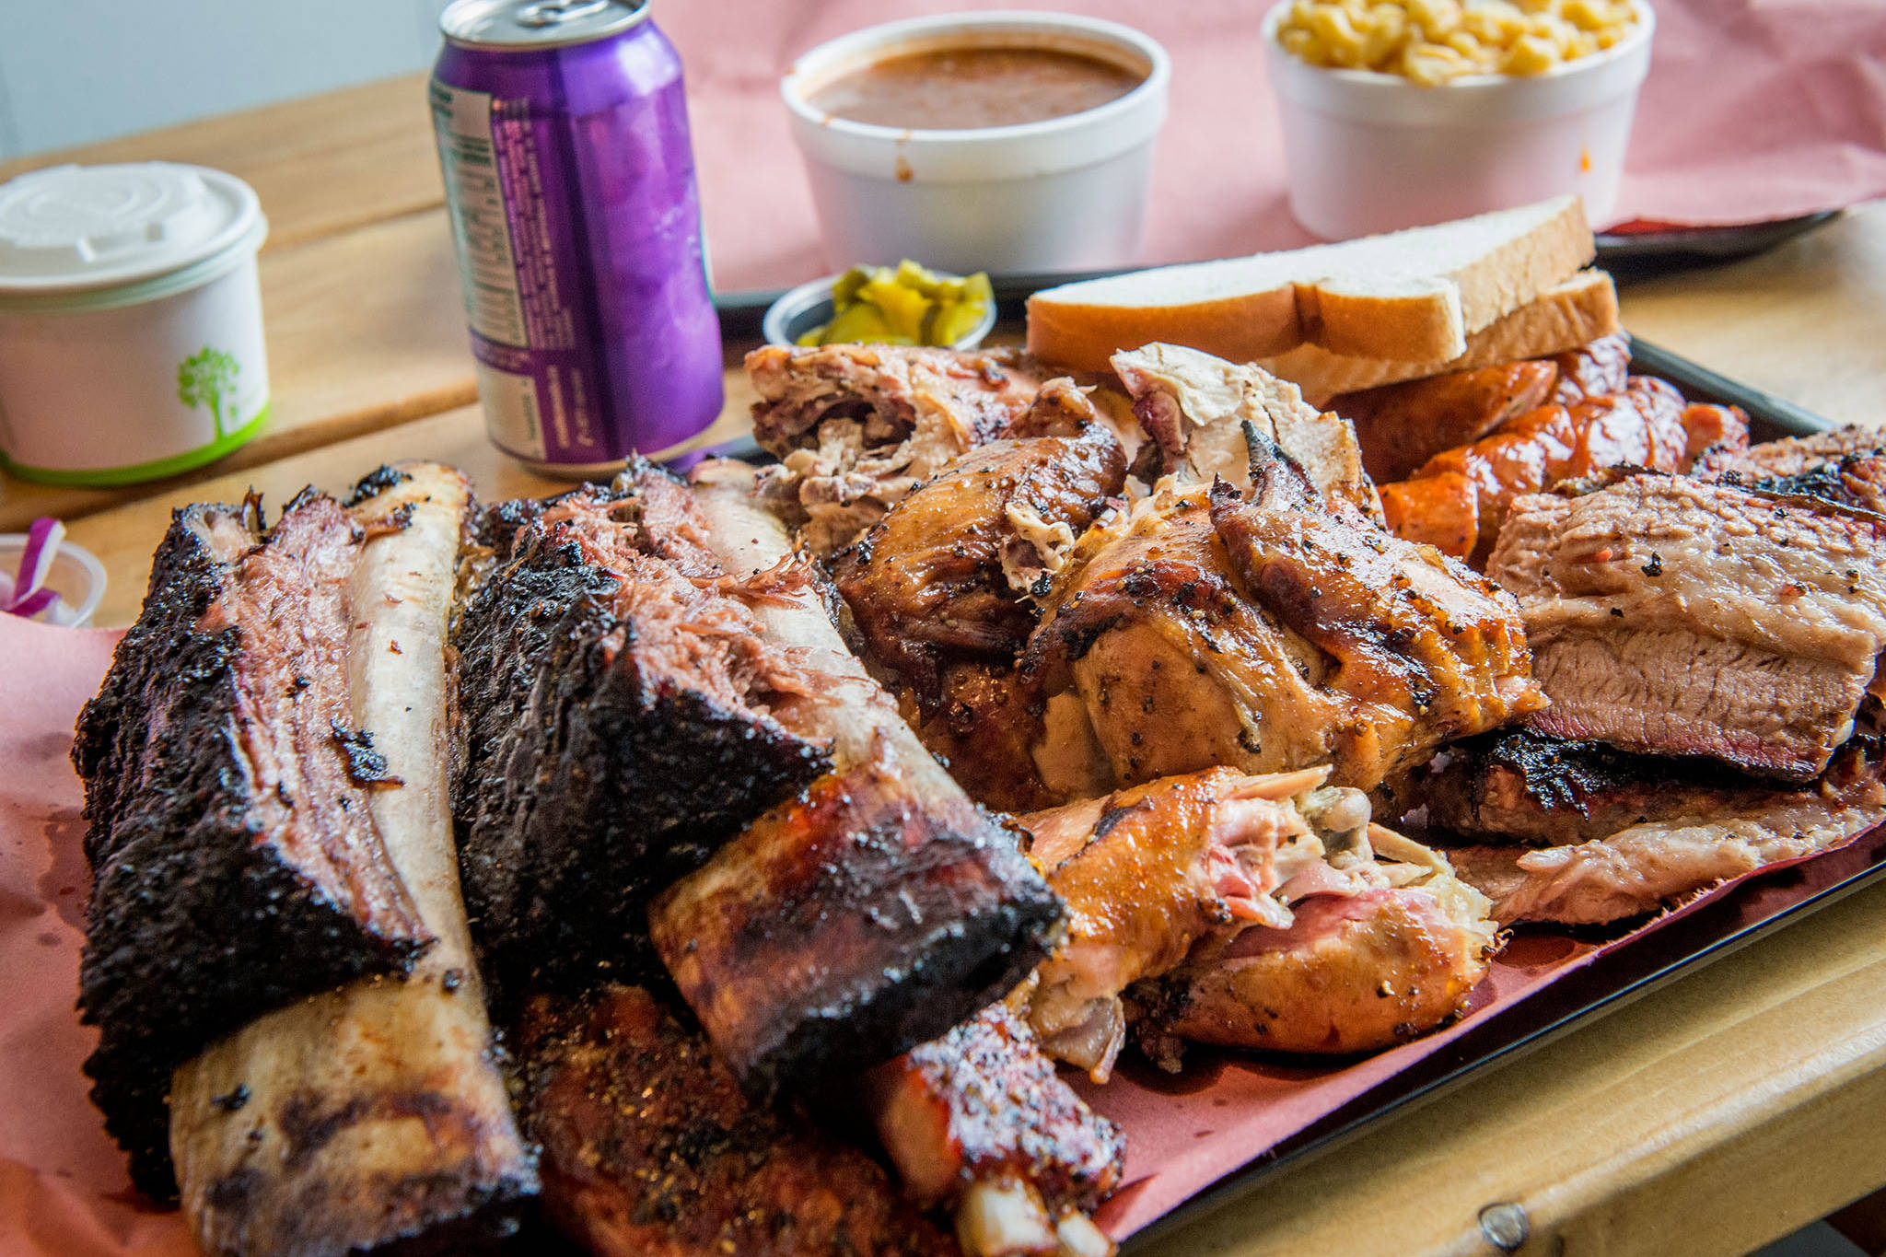

Tyrone’s Smokehouse focuses on real, unprocessed food to enhance the culinary experience through modern styles of cuisine. Emphasizing bringing out flavors of fresh ingredients, our cuisine ranges from vegetarian and gluten free options to smoked meat.

Link to webpage: <http://tyronesmokehouse.com>

|  |  |
| --- | --- |
| Boston Pizza  <https://bostonpizza.com/en/index.html> | Main page has membership program, deal of the day and other offers  Links below for policies, about them, job application  Navigation bar for takeout, menu, locations, membership login |
| Mohave Smokehouse & Bar  <https://www.mohavesmokehouse.com> | Menu, mission statement, links to Facebook & twitter are on main page  Pictures various food items are on main page  Navigation bar at top of webpage with contact, catering and events |
| Burger King  <https://burgerking.ca> | Background info, Social media, Deals on main page  Links below to about page, membership, career  Navigation bar with menu, offers, location and search |
| McDonalds  <https://www.mcdonalds.com/ca/en-ca.html> | Deals, Membership program, McDonalds app on main page  Links below showing about page, job application, contacting, policies  Navigation bar with menu location, search, latest info |
| La Jawab Indian & Hakka Chinese Cuisine  <https://www.trylajawab.com/> | Popular meals, about them, contact info, location all on main page  Links to social medias, policies below  Navigation bar to menu, photos of their food, jobs, facilities |

A client would be looking for:

* The menu
* The hours of operation
* The location
* limited time offers
* online booking
* reviews
* frequently asked questions with answers
* Contacting the restaurant
* About the restaurant
* Job opportunity
* Membership program
* Sections for easy navigation

The purpose is to inform a customer about the restaurant’s goals, information about what food they serve and answer and questions a customer may have. The short-term goals of a restaurant would be to try and create new deals to generate more profit and if they are a newer restaurant, they would try and create a clientele. Another short-term goal is to create new food items on the menu to attract more customers. The long-term goals of a restaurant would be to increase their clientele. They would hold specific events to attract more ethnic groups and diversify their customers. My target audience is all ages. There would be meals mostly for adults with some kids’ meals if people bring their family. Also, there will be drinks limited to people over the age of 18. They will know the general theme that this is a place to come for dinner and also a bar for older people during late nights. They will want to find out any deals that are happening and specific items on the menu. They will also want to know the location and hours of operation. The audience will access the site by putting the name of the restaurant in google or putting the restaurant’s URL in the search bar. The website can be organized with the specific sections at the top, such as a menu tab, questions tab, a main deal and etc. The main page should be able to entice the customer and then the other pages should be more information about the restaurant.

Plan:

Class 1- Find Different Restaurants & Possible name of my own restaurant

Class 2 - Research about the restaurants and their various features

Class 3 – Finish Research, start planning website design, get peer feedback

Class 4 – Create Menu, Location & Hours of operation, online booking Page

Class 5 – Create FAQ, Review, Restaurant Info Page, Job Application

Class 6 – Create Membership, Main Page

Design:

Site Name: Tyrone’s Smokehouse & Bar

URL: <http://tyronesmokehouse.com>

Pages: Home, Menu, FAQ, Reviews, Hours of Operation & Location, Job Application, Restaurant background, online reservation, membership

Layout Diagram:

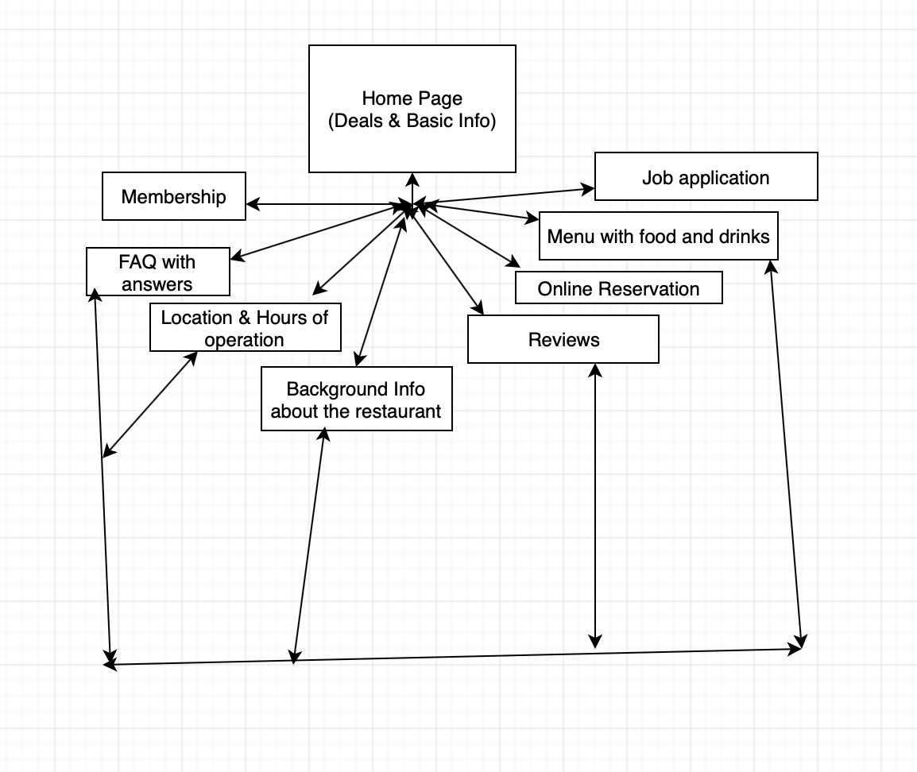

Website Information Content:

|  |  |  |  |
| --- | --- | --- | --- |
| Title Page | Major Content | Links | Images |
| Main Page | Popular foods with images  Membership Page  Navigation Bar to other pages  Links at bottom for further information | <http://tyronesmokehouse.com> | Images of 3 meals, logos of different social media, logo of Tyrone’s smokehouse and bar |
| Membership | Membership Info with some basic rewards  Link for them to become a member through a survey | <http://tyronesmokehouse.com/membership> |  |
| Menu | Picture of the Menu with all the different categories like Pork, Tacos, Drinks | <http://tyronesmokehouse.com/menu> | Images of different foods on the menu |
| Location & Hours | Picture of Location  Hours of Operation in a list | <http://tyronesmokehouse.com/LocationHours> | Image of map on google |
| Reviews | Reviews from customers with option to submit a review | <http://tyronesmokehouse/reviews> |  |
| Online Reservation | Make an online reservation to the restaurant through a forum | <http://tyronesmokehouse/reserve> |  |
| About us | Owners story, Mission Statement | <http://tyronesmokehouse/about> | Image of owner |
| Job application | Submit a Job application to work and get paid | <http://tyronesmokehouse/jobs> | Image of Worker |

Website Presentation:

Color Scheme: Red, Grey, Black & White

Layouts done on separate sheet of paper

Process Journal:

Coding Started in 5th class

In 5th class – Started Main page, collected all images necessary, finished location/hours page

In 6th class – finished all websites half way, received peer evaluation from two classmates, complete rest at home

At home – completed code based on feedback

Evaluation:

Comments from Nihal:

* Include Copyright statement in footer
* Add images to different pages that are mainly text such as forums
* Good inclusion of every page that a normal restaurant would have
* Remove FAQ page as a lot of restaurants do not have that page

Comments from Anya:

* The design seemed a little complicated Navigation wise – made more sense when website was completed
* Round off logo so it does not seem too abrupt
* Add images to forums
* Good inclusion of everything
* Good color scheme

Changes made:

* Removal of FAQ page
* Rounded off Logo
* Incorporated more images
* Added copyright message

Evaluation Questions:

1. The color scheme worked well as it reflected the theme of the restaurant. The overall design of the webpage was appealing and professional
2. I removed the FAQ page because it looked unnecessary to the whole product, included more picture to make it physically appealing.
3. I learned that putting together a complete website is a lot of work, and you should have the information required to inform a customer about your restaurant. I also learned that you should have a professional design while keeping it aesthetically pleasing to the eyes to retain audience.

Evaluation Scores:

Nihal: 60/60

Anya: 59/60