Assignment 1
Roll no. MT2019514_MT2019137_MT2018508

Given data contains:

Total 768 entries.
Pregnancies: 742 are not null 26 are null
Glucose : 752 are not null 16 are null
bloodPressure: no null values
skinthickness: 746 are not null 22 are null
insulin: no null values
BMI : 757 are not null 11 are null
DiabetesPedigreeFunction: 768 non-null
Age : 749 non-null 19 are null
Outcome : 768 non-null

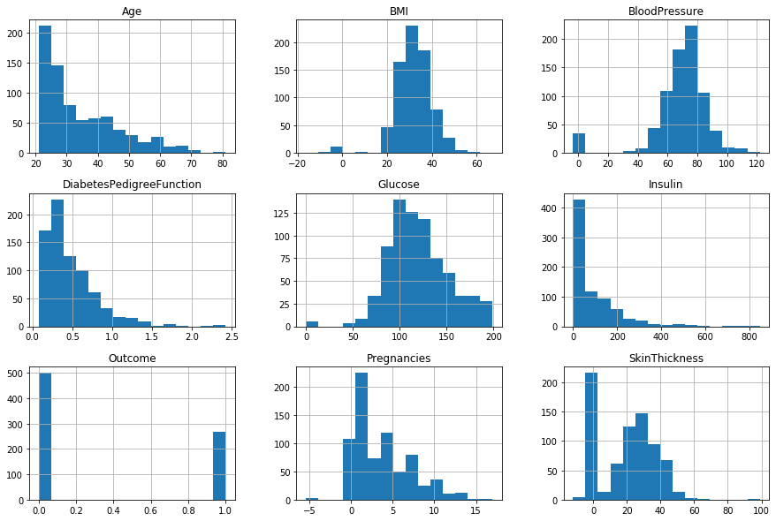
These histograms makes the values more clearer.
We can see that there are more 0 values in BMI and Insulin columns

Above histograms shows that there are outliers ,we can use the box plot to get more insights about it

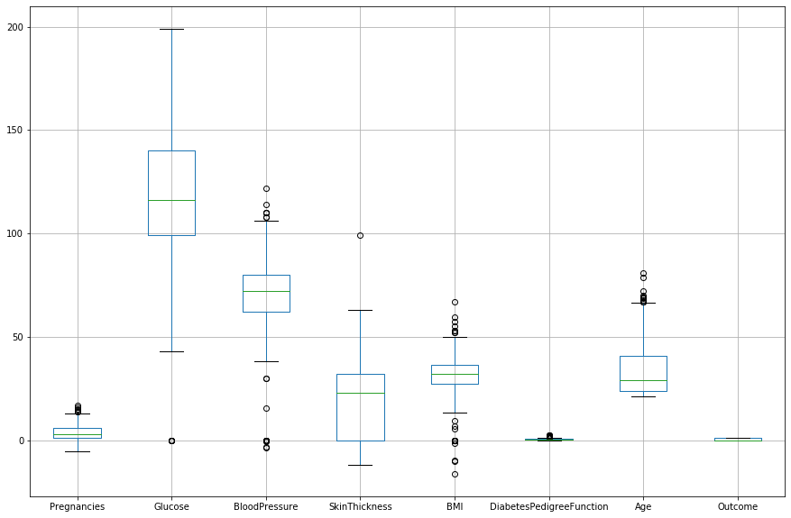

Data cleaning: Preprocessing

- Replacing the null values in Pregnancies columns with median value to keep the uniformity of the data
- Glucose null values are filled with mean, since there are only 16 null values, so no need for interpolation.

- Glucose 0 values are filled with the mean, Glucose has high correlation with the output, and replacing it with mean doesn’t effects standard deviation too much.
- BMI has 11 NULL values, So replacing it with mean.

- Filling null values in a Age with the mean

Dealing with outliers:
Above box plot shows many outliers, which are dealt as :

- Dropping the rows which contain the negative values of BMI

- Dropping the rows containing negative value of Pregnancy, since the values provided in the column of Pregnancies are negative.
- Blood pressure can't be below 20, so there might be some error in data collection but dropping these 35 rows will effect the model so we use the random() to randomly redistribute this data in the range of 10% of it's mean.
- Dropping the SkinThickness outliers, less then 0.
There are still many zero values in our most relevant features , interpolating them is a good idea,
- Replacing the 0 values in SkinThickness 0 with Null and then doing and interpolation technique to fill them. Replacing the zero values of BMI with it's mean because BMI can't be zero and it is one of the relevant feature.
- There is more than 350 zero values in insulin but with some domain knowledge it seen that the Diabates depand on the insulin level so we have to find a technique to fill the zero values, in order to do this again interpolation is used. But since it the most relevant feature according to medical knowledge, finding the best fit among the methods (cubic, polynomial, quadratic, the best correlation) among all these is the quadratic one.

Finally checking the cleaned data and selecting the best features to use in the model.
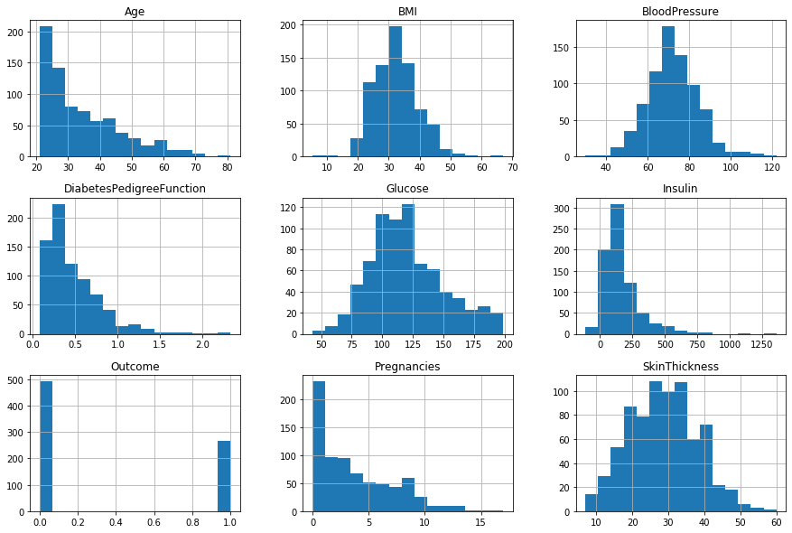
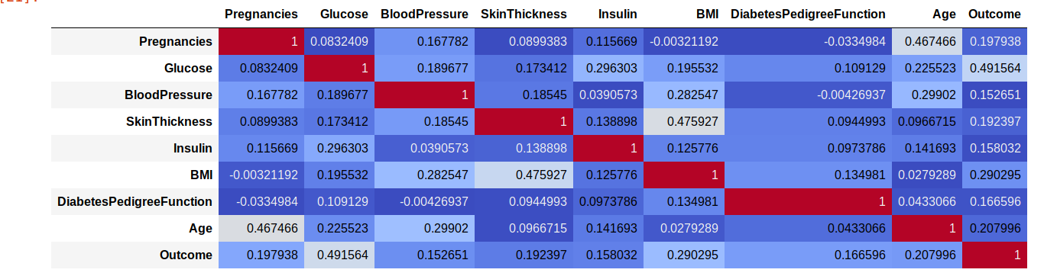
The Features having high correlation with the outputs are used in the model. Also the most relavant features will be used in practical implemantations are 'Glucose','BMI', 'SkinThickness','Age','Insulin',’Diabetespedigreefunction’.
Selecting the model and training it, Finally!!

Using the Logistic regression model for the given dataset. This model is best for univariate classification. And also the data given only requires a “Yes” or “No” as an output and the output is not pipelined.
Splitting the data set in 80:20 ratio for training and testing.
Selecting the regularisation parameter to 0.5 and attaching the balanced weights to the feautres we get the most efficient model that doesn’t overfit or underfit the data.
Final RESULTS ARE :
the Model is the score (Accuracy) is :
0.81578

