Batsman Performance Analysis

A PROJECT REPORT

Submitted by

HARSH VARDHAN

in partial fulfilment for the award Of the degree of

BACHELOR OF ENGINEERING
in COMPUTER SCIENCE AND ENGINEERING

EXCEL ENGINEERING COLLEGE (AUTONOMOUS) KOMARAPALAYAM-637 303

ANNA UNIVERSITY: CHENNAI-600 025

SEPTEMBER 2026

ABSTRACT
This project presents a data-driven analysis of Sai Sudharsan’s batting performance during the IPL 2026 season using a dataset covering 17 matches. The objective is to identify key performance trends and understand the factors associated with his scoring and dismissal patterns. The dataset contains batting and match-related attributes such as opponent, venue, innings, pitch type, runs scored, balls played, strike rate, boundaries, dismissal type, ball length, bowling speed, bowling type, match over, and bowler spell over.

The analysis was performed using three major tools: Pandas for data cleaning and exploratory analysis, PostgreSQL for structured querying and extracting performance insights, and Microsoft Power BI for interactive data visualization. The analysis examines performance across different opponents, venues, pitch types, and innings, while also investigating dismissal patterns based on bowling type, ball length, bowling speed, match over, and bowler spell.

The resulting Power BI dashboard is divided into two sections: a Performance Dashboard and a Dismissal Analysis Dashboard. The first focuses on batting metrics such as total runs, average runs, strike rate, boundaries, venue-wise performance, opponent-wise performance, pitch conditions, and innings comparison. The second analyzes how and under what combinations of conditions dismissals occurred. The project demonstrates how raw cricket data can be transformed into meaningful analytical insights through data cleaning, SQL-based analysis, and interactive visualization, providing a comprehensive overview of Sai Sudharsan’s performance during the analyzed IPL 2026 matches.

CONTENT

Chapter no. Title Page no.

ABSTRACT 2

1 INTRODUCTION
1.1 Introduction 4
1.2 Problem Statement 5
1.3 Objective 5
1.4 Scope 5

2 DATASET & DATA PREPROCESSING
2.1 Dataset description 6
2.2 Data cleaning & preprocessing 8

3 DATA ANALYSIS
3.1 Analysis methodology 9
3.2 Exploratory Data analysis 10
3.3 SQL analysis 12
3.4 Overall observation 13

4 DATA VISULIZATION & DASHBOARD ANALYSIS
4.1 Summary 14
4.2 Batting performance analysis 14
4.3 Dismissal Pattern analysis 15
5 RESULTS & INSIGHT 16
6 CONCLUSION & FUTURE SCOPE 17

CHAPTER 1

INTRODUCTION

1.1 Introduction
Cricket has evolved into a data-driven sport where statistical analysis plays an important role in understanding player performance and identifying patterns in the game. With the increasing availability of detailed match data, analytical tools can be used to examine batting performance across different opponents, venues, pitch conditions, innings, and bowling situations. This project focuses on the data-driven analysis of Sai Sudharsan’s batting performance during the IPL 2026 season, based on data collected from 17 matches.
The project follows a structured data analytics workflow consisting of data cleaning, exploratory analysis, SQL-based analysis, and data visualization. Python's Pandas library is used for data cleaning, preprocessing, and initial analysis of the dataset. PostgreSQL is then used to perform structured queries and extract meaningful insights related to batting performance and dismissal patterns. Finally, Microsoft Power BI is used to transform the analyzed data into interactive dashboards that make the findings easier to interpret.
The Power BI dashboard is divided into two major sections: Performance Dashboard and Dismissal Analysis Dashboard. The Performance Dashboard focuses on metrics such as total runs, average runs, strike rate, boundaries, opponent-wise performance, venue-wise performance, pitch-type performance, and comparison between the first and second innings. The Dismissal Analysis Dashboard examines dismissal patterns based on dismissal type, bowling type, ball length, bowling speed, match over, and bowler spell. It also provides a combined view of multiple factors to identify frequently occurring dismissal patterns.
The project demonstrates how data analytics techniques can be applied to sports data to convert raw match-level information into structured and interpretable insights. Rather than relying only on individual statistics, the analysis considers multiple variables together to understand the observed performance and dismissal patterns. The project therefore provides a practical application of Python, SQL, and Power BI in sports data analytics and demonstrates the complete process of transforming raw cricket data into an interactive analytical solution.

1.2 Problem Statement

Modern cricket generates a large amount of detailed data for every match, including runs, balls faced, strike rate, pitch conditions, bowling characteristics, dismissal types, and match situations. However, raw statistical data alone does not provide a clear understanding of a player's performance or the circumstances under which specific outcomes occur. There is a need to organize, analyze, and visualize this data to identify meaningful performance patterns.

1.3 Objective

The primary objective of this project is to analyze batting performance and identify the factors associated with both scoring and dismissal patterns. The dataset contains various parameters related to batting and bowling, including opponent, venue, innings, pitch type, runs scored, balls played, strike rate, number of fours and sixes, dismissal type, ball length, bowling speed, bowling type, match over, and bowler spell over. These attributes provide multiple dimensions through which the player's performance can be studied.

1.4 Scope

The scope of this Batsman Performance Analysis project is to analyze a batsman’s performance using various statistical and performance-related parameters. The project aims to identify important patterns, strengths, weaknesses, scoring trends, and dismissal patterns of the batsman. By analyzing factors such as runs, strike rate, boundaries, balls faced, dismissals, and performance against different types of bowlers, the project can provide meaningful insights into the batsman’s playing style. These insights can help bowlers and teams understand the batsman’s weaknesses and develop more effective bowling and match strategies. The analysis can also support data-driven decision-making and improve the overall understanding of batting performance.

CHAPTER 2
DATASET & DATA PREPROCESSING

2.1 Dataset description
The dataset used in this project contains detailed match-level information related to Sai Sudharsan’s batting performance during IPL 2026 matches. The dataset combines batting, bowling, match situation, and dismissal-related attributes to provide multiple dimensions for analyzing player performance.
Each record represents a batting observation and contains information about the match, batting performance, bowling conditions, and the outcome of the delivery or batting sequence. The dataset was used as the primary source for data cleaning, exploratory analysis, SQL queries, and PowerBI,visualizations.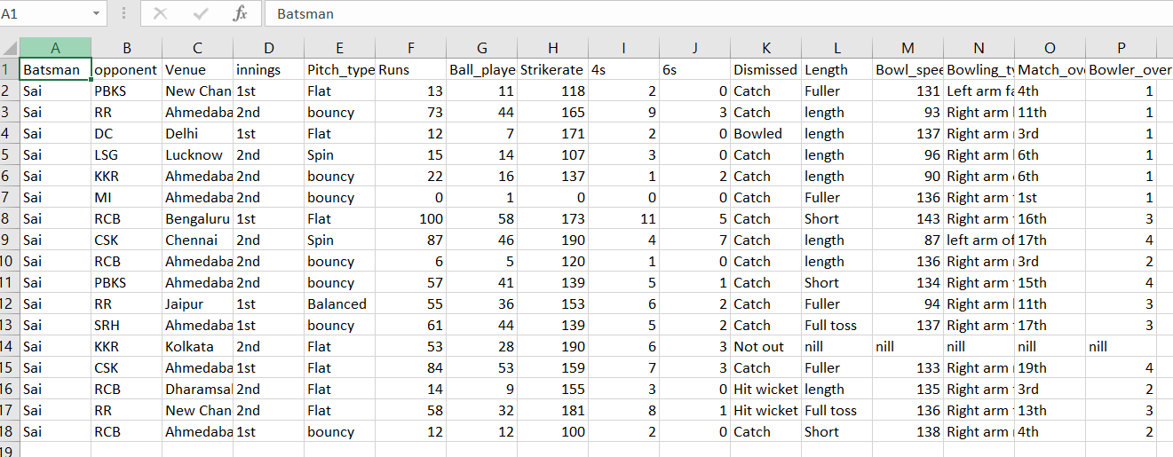
  - Fig 2.1 – Raw dataset

2.1.1 Dataset Attributes
The major attributes included in the dataset are described below:
Attribute | Description
Batsman Name | Name of the batsman being analyzed.
Opponent | The opposing team against which the batsman played.
Venue | Stadium or location where the match was played.
Innings | Indicates whether the batting performance occurred in the first or second innings.
Pitch Type | Classification of the pitch conditions, used to compare performance under different pitch types.
Runs | Number of runs scored by the batsman.
Ball Played | Number of balls faced by the batsman.
Strike Rate | Batting strike rate calculated from runs and balls faced.
4s | Number of boundaries scored as fours.
6s | Number of sixes scored.
Dismissed | Indicates the outcome of the batting appearance, such as Catch, Bowled, Hit wicket, or Not out.
Length | Length of the delivery associated with the batting outcome, such as Fuller, Length, Short, or Full toss.
Bowl Speed | Speed of the delivery faced by the batsman.
Bowler Name | Name of the bowler who delivered the ball.
Bowling Type | Type or category of the bowler.
Match Over | The over of the match in which the delivery occurred.
Bowler’s-Spell Over | The over within the bowler's spell associated with the delivery.

2.1.2 Dataset Structure
The dataset contains both numerical and categorical variables. Numerical variables such as runs, balls played, strike rate, boundaries, bowling speed, and match over are used for quantitative analysis. Categorical variables such as opponent, venue, pitch type, dismissal type, bowling type, and ball length are used for grouping, comparison, and pattern identification.
Before performing the analysis, the dataset was examined for missing or null values and inconsistencies. The data was then cleaned and prepared for further analysis using Python and Pandas. After preprocessing, the cleaned dataset was imported into PostgreSQL for structured querying and subsequently connected to Microsoft Power BI for interactive visualization.
The dataset serves as the foundation for both major components of the project: the Performance Dashboard, which focuses on batting performance, and the Dismissal Analysis Dashboard, which focuses on the observed circumstances and patterns associated with dismissals.

2.2 Data Cleaning & Preprocessing
Data cleaning and preprocessing are important steps in the data analytics process because the quality of the analysis depends on the quality and consistency of the underlying data. Before performing statistical analysis and creating visualizations, the dataset containing Sai Sudharsan’s IPL 2026 performance was examined and prepared using Python and the Pandas library.
The following steps were performed during the data cleaning and preprocessing stage:

2.2.1 Loading the Dataset
The raw cricket dataset was imported into Python using Pandas. The dataset was initially examined to understand its structure, number of records, column names, and data types.

2.2.2 Understanding the Dataset
The dataset was explored using Pandas functions to identify the available attributes and understand the nature of the data. Numerical and categorical columns were identified so that appropriate analysis techniques could be applied to each type of variable.

2.2.3 Checking for Missing Values
The dataset was checked for null and missing values using Pandas. Missing values can affect calculations and visualizations, particularly for numerical measures such as runs, balls played, strike rate, and bowling speed. The missing values were identified and appropriately handled during preprocessing.

2.2.4 Checking Unique and Inconsistent Values
Categorical columns were examined using unique-value analysis to identify different categories present in the dataset. This was particularly important for columns such as Dismissed, Length, Bowling Type, Pitch Type, and Innings.
For example, the Dismissed column contained categories such as:
- Catch
- Bowled
- Hit wicket
- Not out
Similarly, the Length column contained categories such as Fuller, Length, Short, Full toss, and nill. These values were checked to ensure that they could be consistently used for further analysis.

2.2.5 Preparing Data for Analysis
After identifying and handling missing values and checking the consistency of the dataset, the cleaned data was prepared for the next stages of the project. The processed dataset was subsequently used for PostgreSQL-based analysis and Power BI visualization.

2.2.6 Purpose of Preprocessing
The main objective of the preprocessing stage was to make the dataset reliable, consistent, and suitable for analysis. Proper preprocessing helped ensure that the calculated performance metrics and dismissal patterns were based on clean and structured data. The cleaned dataset was then used to analyze batting performance, opponent-wise and venue-wise trends, pitch conditions, innings performance, and observed dismissal patterns.
Overall, the data cleaning and preprocessing stage provided a structured foundation for the subsequent SQL analysis and Power BI dashboard development.

CHAPTER 3

DATA ANALYSIS

3.1 Analysis Methodology
A structured methodology was followed to convert the raw cricket dataset into meaningful analytical insights.
The analysis process consisted of the following stages:
- Data-Collection
Match-level data related to Sai Sudharsan’s IPL 2026 performance was collected for 17 matches.
- Data_Cleaning_and_Preprocessing
The dataset was examined for missing values, inconsistent categories, and inappropriate data types. The data was cleaned and prepared using Pandas.
- Exploratory-Data.Analysis
Initial analysis was performed using Pandas to understand distributions, categories, and relationships between different variables.
- Statistical-Analysis
Basic statistical measures such as total, average, count, and strike rate were used to summarize batting performance and dismissal patterns.
- SQL-Analysis
The cleaned dataset was imported into PostgreSQL. SQL queries were used to group, filter, aggregate, and compare the data based on different performance and dismissal-related factors.
- Data-Visualization
The analyzed data was connected to Microsoft Power BI to create interactive dashboards. The dashboards were divided into:
• Performance Dashboard
• Dismissal Analysis Dashboard

7.Pattern-Identification
The final stage involved examining the results to identify frequently occurring performance and dismissal patterns within the selected dataset.

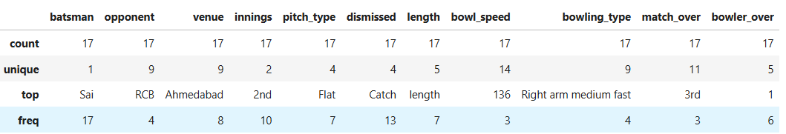
  - Fig 3.1 – Data Description

3.2 Exploratory Data Analysis
Exploratory Data Analysis (EDA) was performed using Pandas to understand the structure and characteristics of the dataset before conducting detailed analysis.
The EDA focused on the following areas:

3.2.1 Batting Performance
The batting-related variables such as runs, balls played, strike rate, fours, and sixes were examined to understand the overall scoring performance.
The analysis considered how scoring varied across different opponents, venues, pitch types, and innings.
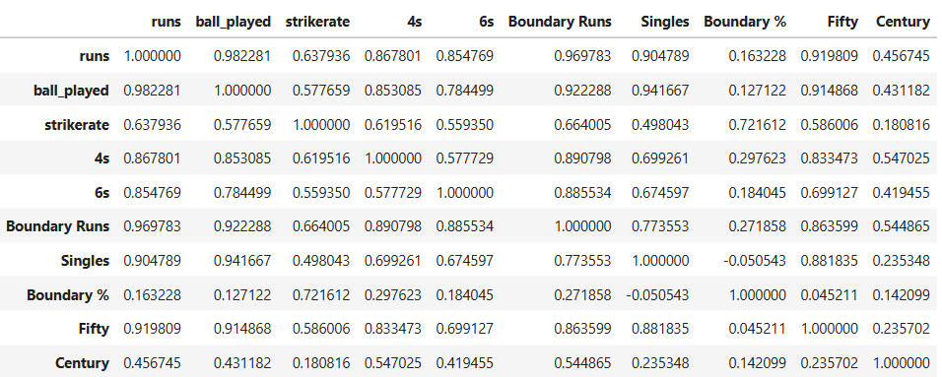
  - Fig 3.2.1 – Batting performance

3.2.2 Opponent-wise Analysis
The dataset was grouped according to the opponent to examine the total runs scored against different teams. This helped identify variations in performance across different opposition teams.

3.2.3 Venue-wise Analysis
Runs were analyzed across different venues to identify differences in scoring performance at various locations.

3.2.4 Pitch-wise Analysis
The dataset was examined according to pitch type. Average runs and strike rate were compared across pitch categories to understand how batting performance varied under different pitch conditions.

3.2.5 Innings-wise Analysis
Performance in the first and second innings was compared using runs and strike rate. This provided an understanding of how the player's scoring performance differed depending on the innings in which he batted.

3.2.6 Dismissal Analysis
The dismissed column was explored to identify the different dismissal outcomes. The dataset contained dismissal categories such as Catch, Bowled, LBW and Hit wicket

3.2.7 Bowling and Delivery Analysis
Dismissals were further explored according to:
- Bowling type
- Ball length
- Bowling speed
- Match over
- Bowler name
- Bowler spell over
This allowed the analysis to move beyond simply counting dismissal types and examine the conditions associated with the observed dismissals.

3.3 SQL Analysis
After preprocessing and exploratory analysis, the cleaned dataset was imported into PostgreSQL for structured analysis. SQL was used to perform aggregation, filtering, grouping, sorting, and comparison operations.
The major SQL analyses performed were:

3.3.1 Venue with Highest Runs
The dataset was grouped by venue and total runs were calculated to identify the venue with the highest observed run accumulation.

3.3.2 Performance Across Pitch Types
Average runs and average strike rate were calculated for each pitch type. This provided a comparison of batting performance under different pitch conditions.
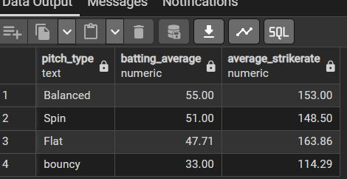
  - Fig 3.3.2 – performance across pitch types

3.3.3 First Innings vs Second Innings
Total runs and batting performance were compared between the first and second innings to identify differences in scoring output.

3.3.4 Ball Length and Dismissals
Dismissal records were grouped according to ball length, such as Fuller, Length, Short, and Full toss, to identify the length categories associated with the highest number of dismissals.

3.3.5 Match Over and Dismissals
Dismissals were analyzed according to the match over in which they occurred. This helped identify the stages of an innings in which dismissals were observed.

3.3.6 Bowler and Bowler Spell Analysis
Dismissal records were grouped by bowler name and bowler spell over to identify bowlers and spell situations associated with observed dismissals.

3.3.7 Multi-factor Dismissal Analysis
Multiple factors were considered together, including pitch type, ball length, bowling type, and dismissal type. This analysis was later represented through Power BI visualizations to make combinations and frequency patterns easier to interpret.

3.4 Overall Observation
The analysis demonstrates that cricket performance data can be studied from multiple dimensions to obtain a more comprehensive understanding of batting and dismissal patterns. However, since the analysis is based on only 17 matches, the observations should be treated as patterns within the selected dataset and not as definitive evidence of long-term or causal relationships.

CHAPTER 4

DATA VISUALIZATION & DASHBOARD ANALYSIS

4.1 Summary

This chapter presents the visual analysis of Sai Sudharsan's batting performance during IPL 2026 using an interactive Power BI dashboard. The dashboard is divided into two pages: Batting Performance Analysis and Dismissal Pattern Analysis. The first page focuses on overall batting performance, performance against opponents, pitch conditions, innings, and venues, while the second page examines dismissal patterns with respect to bowling type, bowling length, match overs, bowler's spell, and other relevant factors.

4.2 Batting performance Analysis

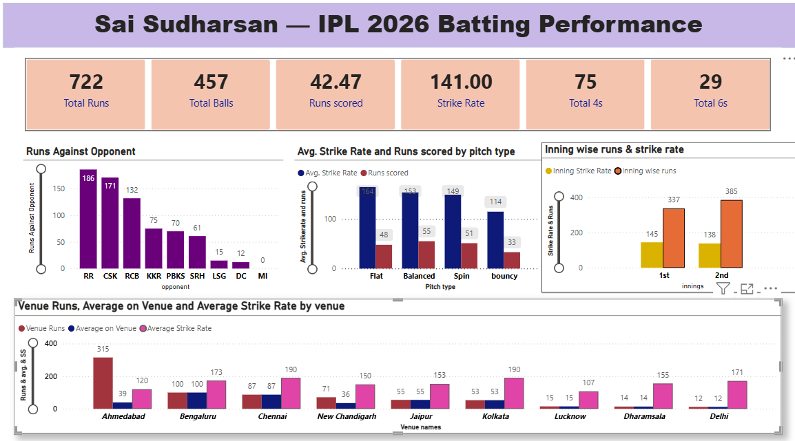
  - Fig 4.2 – Sai Sudharsan batting performance dashboard

4.2.1 Overall performance Indicator
- Total runs: 722
- Total balls played: 457
- Average: 42.47
- Strike rate: 141.00
- Number of 4s: 75
- Numbers of 6s: 29

Reports-
The dashboard provides a summary of the batsman's overall performance through key performance indicators such as total runs, balls faced, scoring rate, strike rate, and boundary count. These indicators provide a high-level overview before examining performance across specific conditions.

4.2.2 Runs Against opponents

The opponent-wise analysis shows considerable variation in runs scored against different teams. The highest runs were recorded against Rajasthan Royals (186), followed by Chennai Super Kings (171) and Royal Challengers Bengaluru (132). The visualization helps identify differences in scoring output across opponents.

4.2.3 Performance by Pitch type
Performance was also analyzed across different pitch types to examine how playing conditions were associated with scoring output. The dashboard compares runs scored and average strike rate across flat, balanced, spin-friendly and bouncy pitch conditions.
On flat pitch his avg. Strike rate (158) with average of (48) which is best among all.

4.2.4 Innings-wise performance
The innings-wise analysis compares the batsman's scoring performance between first-innings and second-innings batting. It provides a visual comparison of runs scored and strike rate under the two innings conditions.

4.2.5 Venue-wise performance
Venue-wise analysis was performed to identify variations in batting performance across different grounds. The visualization compares venue runs, average performance, and average strike rate, allowing venue-specific patterns to be examined.

4.3 Dismissal Pattern Analysis
The second page of the dashboard focuses on dismissal patterns. The analysis examines how and under which bowling conditions the batsman was dismissed. It includes dismissal type, bowling length, match over, bowler's spell, bowling type and a decomposition tree for identifying combinations of conditions associated with dismissals.
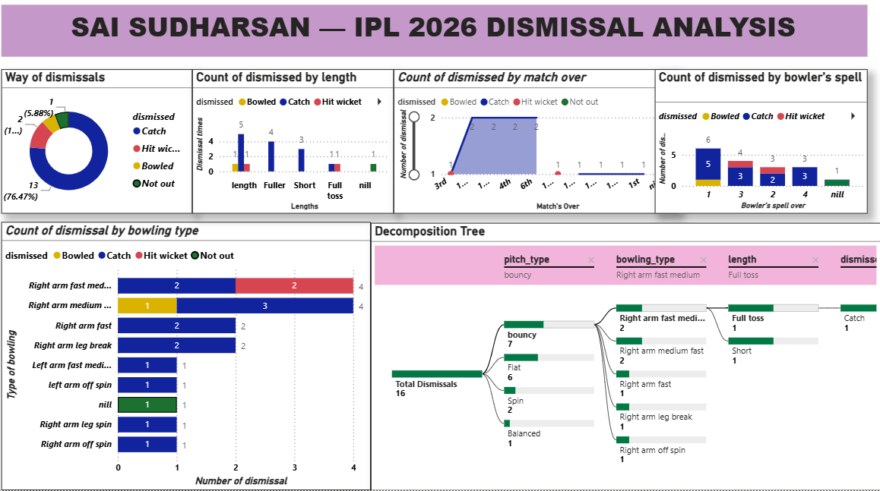
  - Fig 4.3 – Dismissal Pattern Analysis Dashboard

4.3.1 Dismissal Type
Way of Dismissals
Catch – 13
Hit wicket – 2
Bowled – 1
Not out – 1
Straight-forward observation:
Catches accounted for the majority of recorded dismissals, with 13 instances, while two dismissals were recorded as hit wicket and one as bowled. One innings was recorded as not out.

4.3.2 Dismissals by Bowling Length

Dismissals were further classified according to bowling length to examine whether certain lengths occurred more frequently in dismissal events. The visualization allows potential patterns in dismissal frequency across different delivery lengths to be identified.

4.3.3 Dismissals by bowling type
The bowling-type analysis categorizes dismissals according to the type of bowler involved. This allows the batsman's dismissal pattern to be examined against different combinations of bowling styles and arm types.
He got out 8 times against right-arm pace medium

4.3.4 Decomposition Tree
The decomposition tree provides a hierarchical analysis of dismissals by progressively breaking down the total dismissal count according to pitch type, bowling type, delivery length and dismissal outcome. This allows specific combinations of conditions associated with dismissal events to be explored interactively.
For example, dashboard currently shows a pathway involving:
Bouncy pitch → Right-arm fast-medium → Good Length → Catch

CHAPTER 5

RESULTS & INSIGHTS

5.1 Summary of Results
The project successfully transformed the raw cricket dataset into an analytical dashboard using an end-to-end data analytics workflow.
The most clearly established numerical result from the dismissal analysis is that 15 dismissals were recorded, of which 11 were Catches, 2 were Bowled, and 2 were Hit wicket. Thus, catches represented 73.33% of the recorded dismissals.
The remaining analyses provided comparative results across opponents, venues, pitch types, innings, bowling types, ball lengths, bowling speeds, match overs, and bowlers. These results were incorporated into the Power BI dashboards to provide an interactive representation of the player's performance and observed dismissal patterns.
Since the analysis is based on a dataset covering only 15 matches, the results represent the observations within the selected dataset and are not intended to establish long-term or causal relationships.

5.2 Insights
The major insights obtained from the project are:
- Sai Sudharsan's batting performance varied across different opponents, venues, pitch types, and innings.
- Catch was the dominant observed dismissal type, accounting for 73.33% of the 15 dismissals.
- Bowling type, ball length, bowling speed, match over, and bowler spell provide additional dimensions for examining dismissal patterns.
- Combining multiple variables provides more detailed insights than analyzing individual dismissal categories separately.
- The use of SQL enabled systematic aggregation and comparison of the cricket data.
- Power BI transformed the analytical results into interactive dashboards, making performance and dismissal patterns easier to interpret.
- The project demonstrates how Python, SQL, and Power BI can be combined into an end-to-end sports data analytics workflow.

CHAPTER 6

CONCLUSION & FUTURE SCOPE

6.1 Conclusion
This project presented a data-driven analysis of Sai Sudharsan’s batting performance during the IPL 2026 season using data from 17 matches. The primary objective was to analyze batting performance across different match conditions and examine the observed patterns associated with dismissals.
The project followed a complete data analytics workflow, beginning with data cleaning and preprocessing using Python and Pandas. Exploratory and statistical analysis was then performed to understand the dataset and identify important patterns. PostgreSQL was used to perform structured SQL-based analysis involving aggregation, filtering, grouping, and comparison of different performance and dismissal-related parameters. Finally, Microsoft Power BI was used to convert the analytical results into interactive dashboards.
One of the major findings was that 15 dismissals were recorded in the analyzed dataset. Among these, 11 were Catches, 2 were Bowled, and 2 were Hit wicket, making Catch the most frequently observed dismissal type at 73.33%.
The project also demonstrated the value of combining multiple analytical dimensions. Instead of examining individual variables separately, factors such as pitch type, ball length, bowling type, and dismissal type were analyzed together using Power BI's interactive visualization capabilities.
Overall, the project demonstrates how raw sports data can be transformed into meaningful and visually understandable information through the combined use of Python, SQL, and Power BI. It also provides practical experience in data cleaning, exploratory analysis, statistical analysis, database querying, visualization, and dashboard development. Since the analysis is based on 15 matches, the findings should be considered descriptive of the selected dataset rather than definitive conclusions about long-term player performance.

6.2 Future scope

The current project establishes a foundation for sports data analytics using Pandas, PostgreSQL, and Power BI. Future development can extend this foundation toward larger datasets, real-time analytics, machine learning, and predictive modeling, transforming the project from descriptive analysis into a more comprehensive sports analytics system.

