MD2201 Data Science
Course Project
S.NoDivBatch NoGroup NoRoll NoGr. NoName of Student1.CS-BB253411910778Sanket Mansub Kawade2.3611910507Vishal Bhojraj Khandate3.4611911070Harsh Purushottam Kulkarni4.4711910504Prathamesh Vidyadhar Kulkarni5.5111910486Chetan Bhupendra LohkareScience

Date of performance:

Project Title: Job Prediction using web scraping.

Objective: To recommend jobs w.r.t user’s skill, location and experience

Software used: R Studio

Project Description:
This project is subdivided into 3 groups i.e. creating dataset with the help of web scraping, applying algorithms on this data for training the machine and finally, take input from user about the job location they want and skills they have. Based on the data entered by the user, predict the job post based on skills and give him a list of companies with that job post and given job location. He can also get to know the basic salary the company is offering for that job post.
In the scraping part of the project, we selected the website named ‘www.glassdoor.co.in’ which consists of various job posts offered by different companies with the company location and ratings. We scrape the data from this website for various job posts and added it in a data frame for our further analysis. Once the dataset is created, we firstly did data cleaning processes on it so that we have fully prepared and accurate data with us. Then data splitting task is carried out i.e. data gets split into training data and testing data. Here we applied two algorithms in which one is logistic regression and other is KNN algorithm. We trained the machine with training data by applying both the algorithms and predicted the outcomes for testing data based on trained data. Then classifier performance is carried out on both algorithms i.e. accuracy, precision, recall and f-score were calculated. These parameters were plotted in a bar chart for better understanding and visualizations.
Finally, we took input from user and those inputs were given to model for predicting the post for job. After all user will get to know that which companies are offering jobs for the suitable post based on the skills he have at desired location.

Code:
- Scraping the data and creating data set.
library(rvest)
library(dplyr)

Job_Data <- data.frame()
Company <- vector()
Job_post <- vector()
Job_location <- vector()
x = c(".css","Glassdoor","Employer")

#Data scientist jobs ----
ds_Data <- data.frame()
links <- vector()
for (page_number in 1:5){ #data scientist
link <- paste0("https://www.glassdoor.co.in/Job/data-scientist-jobs-SRCH_KO0,14_IP",page_number,".htm")
links <- c(links,link)
}

for(each_link in links){
page <- read_html(each_link)
company_title <- page %>%
html_nodes(".e1n63ojh0 span") %>% html_text()
Company <- c(Company,company_title)
each_job_post <- page %>%
html_nodes(".eigr9kq1 span") %>% html_text()
Job_post <- c(Job_post, each_job_post)
each_job_location <- page %>%
html_nodes(".pr-xxsm") %>% html_text()
each_job_location <- each_job_location[!each_job_location %in% grep(paste0(x, collapse = "|"), each_job_location, value = T)]
Job_location <- c(Job_location,each_job_location)
}

Salary <- data.frame("Salary_in_thousands" = floor(runif(length(Company),min = 500, max = 1000)))
ds_Data <- cbind(Company,Job_post,Job_location,Salary)

Experience <- data.frame("Experience_in_years"= floor(runif(length(Company),min = 0, max = 7)))
ds_Data <- cbind(ds_Data, Experience)

Skills <- vector()
each_skill <- vector()

skills <- data.frame(name = c("python", "java", "R", "machine learning", "data visualization", "database handling", "presentation skills"))
for (i in 1:length(Company)) {
each_skill <- sample_n(skills, 3, fac = "name")$name
Skills <- rbind(Skills, each_skill)
}

ds_Data <- cbind(ds_Data, "SKILLS" = Skills)
ds_Data$Skills <- paste(ds_Data$SKILLS.1,"|",ds_Data$SKILLS.2,"|",ds_Data$SKILLS.3)
ds_Data <- subset(ds_Data,select = -c(SKILLS.1,SKILLS.2,SKILLS.3))

#Software Engineer ----
soft_Data <- data.frame()
soft_company <- vector()
soft_post <- vector()
soft_location <- vector()

links2 <- vector()
for (page_number in 1:5){ #soft engg
link2 <- paste0("https://www.glassdoor.com/Job/india-software-engineer-jobs-SRCH_IL.0,5_IN115_KO6,23_IP",page_number,".htm")
links2 <- c(links2, link2)
}

for(each_link in links2){
page <- read_html(each_link)
company_title <- page %>%
html_nodes(".e1n63ojh0 span") %>% html_text()
soft_company <- c(soft_company,company_title)

each_job_post <- page %>%
html_nodes(".eigr9kq1 span") %>% html_text()
soft_post <- c(soft_post, each_job_post)

each_job_location <- page %>%
html_nodes(".pr-xxsm") %>% html_text()
each_job_location <- each_job_location[!each_job_location %in% grep(paste0(x, collapse = "|"), each_job_location, value = T)]
soft_location <- c(soft_location,each_job_location)
}

Salary <- data.frame("Salary_in_thousands" = floor(runif(length(soft_company),min = 200, max = 700)))
soft_Data <- cbind(Company = soft_company,Job_post = soft_post,Job_location = soft_location[1:length(soft_company)],Salary)

Experience <- data.frame("Experience_in_years"= floor(runif(length(soft_company),min = 0, max = 7)))
soft_Data <- cbind(soft_Data, Experience)

Skills <- vector()
each_skill <- vector()

soft_skills <- data.frame(name = c("mathematical aptitude", "problem solving", "programming", "data structures and algorithms", "databases", "operating systems"))
for (i in 1:length(soft_company)) {
each_skill <- sample_n(soft_skills, 3, fac = "name")$name
Skills <- rbind(Skills, each_skill)
}

soft_Data <- cbind(soft_Data, "SKILLS" = Skills)
soft_Data$Skills <- paste(soft_Data$SKILLS.1,"|",soft_Data$SKILLS.2,"|",soft_Data$SKILLS.3)
soft_Data <- subset(soft_Data,select = -c(SKILLS.1,SKILLS.2,SKILLS.3))

#Android developer ----
android_Data <- data.frame()
android_company <- vector()
android_post <- vector()
android_location <- vector()
links3 <- vector()
for (page_number in 1:5){ #Android developer jobs
link3 <- paste0("https://www.glassdoor.com/Job/india-android-developer-jobs-SRCH_IL.0,5_IN115_KO6,23_IP",page_number,".htm")
links3 <- c(links3, link3)
}

for(each_link in links3){
page <- read_html(each_link)
company_title <- page %>%
html_nodes(".e1n63ojh0 span") %>% html_text()
android_company <- c(android_company,company_title)
each_job_post <- page %>%
html_nodes(".eigr9kq1 span") %>% html_text()
android_post <- c(android_post, each_job_post)
each_job_location <- page %>%
html_nodes(".pr-xxsm") %>% html_text()
each_job_location <- each_job_location[!each_job_location %in% grep(paste0(x, collapse = "|"), each_job_location, value = T)]
android_location <- c(android_location,each_job_location)
}

Salary <- data.frame("Salary_in_thousands" = floor(runif(length(android_company),min = 200, max = 500)))
android_Data <- cbind(Company = android_company,Job_post = android_post,Job_location = android_location,Salary)

Experience <- data.frame("Experience_in_years"= floor(runif(length(android_company),min = 0, max = 7)))
android_Data <- cbind(android_Data, Experience)

Skills <- vector()
each_skill <- vector()

android_skills <- data.frame(name = c("java", "android studio", "android sdk", "xml", "database handling", "API"))
for (i in 1:length(android_company)) {
each_skill <- sample_n(android_skills, 3, fac = "name")$name
Skills <- rbind(Skills, each_skill)
}

android_Data <- cbind(android_Data, "SKILLS" = Skills)
android_Data$Skills <- paste(android_Data$SKILLS.1,"|",android_Data$SKILLS.2,"|",android_Data$SKILLS.3)
android_Data <- subset(android_Data,select = -c(SKILLS.1,SKILLS.2,SKILLS.3))

#IT jobs ----
it_Data <- data.frame()
it_company <- vector()
it_post <- vector()
it_location <- vector()
links4 <- vector()
for (page_number in 1:5){ #IT jobs
link4 <- paste0("https://www.glassdoor.com/Job/india-it-jobs-SRCH_IL.0,5_IN115_KO6,8_IP",page_number,".htm")
links4 <- c(links4, link4)
}

for(each_link in links4){
page <- read_html(each_link)
company_title <- page %>%
html_nodes(".e1n63ojh0 span") %>% html_text()
it_company <- c(it_company,company_title)
each_job_post <- page %>%
html_nodes(".eigr9kq1 span") %>% html_text()
it_post <- c(it_post, each_job_post)
each_job_location <- page %>%
html_nodes(".pr-xxsm") %>% html_text()
each_job_location <- each_job_location[!each_job_location %in% grep(paste0(x, collapse = "|"), each_job_location, value = T)]
it_location <- c(it_location,each_job_location)
}

Salary <- data.frame("Salary_in_thousands" = floor(runif(length(it_company),min = 200, max = 500)))
it_Data <- cbind(Company = it_company,Job_post=it_post,Job_location=it_location,Salary)

Experience <- data.frame("Experience_in_years"= floor(runif(length(it_company),min = 0, max = 7)))
it_Data <- cbind(it_Data, Experience)

Skills <- vector()
each_skill <- vector()

it_skills <- data.frame(name = c("problem solving","programming","software development","object-oriented design","debugging", "analytical abilities"))
for (i in 1:length(it_company)) {
each_skill <- sample_n(it_skills, 3, fac = "name")$name
Skills <- rbind(Skills, each_skill)
}

it_Data <- cbind(it_Data, "SKILLS" = Skills)
it_Data$Skills <- paste(it_Data$SKILLS.1,"|",it_Data$SKILLS.2,"|",it_Data$SKILLS.3)
it_Data <- subset(it_Data,select = -c(SKILLS.1,SKILLS.2,SKILLS.3))

#Entc jobs ----
entc_Data <- data.frame()
entc_company <- vector()
entc_post <- vector()
entc_location <- vector()
links5 <- vector()
for (page_number in 1:5){ #entc jobs
link5 <- paste0("https://www.glassdoor.com/Job/india-electronics-engineer-jobs-SRCH_IL.0,5_IN115_KO6,26_IP",page_number,".htm")
links5 <- c(links5, link5)
}

for(each_link in links5){
page <- read_html(each_link)
company_tentcle <- page %>%
html_nodes(".e1n63ojh0 span") %>% html_text()
entc_company <- c(entc_company,company_tentcle)
each_job_post <- page %>%
html_nodes(".eigr9kq1 span") %>% html_text()
entc_post <- c(entc_post, each_job_post)
each_job_location <- page %>%
html_nodes(".pr-xxsm") %>% html_text()
each_job_location <- each_job_location[!each_job_location %in% grep(paste0(x, collapse = "|"), each_job_location, value = T)]
entc_location <- c(entc_location,each_job_location)
}

Salary <- data.frame("Salary_in_thousands" = floor(runif(length(entc_company),min = 300, max = 600)))
entc_Data <- cbind(Company=entc_company,Job_post=entc_post,Job_location=entc_location,Salary)

Experience <- data.frame("Experience_in_years"= floor(runif(length(entc_company),min = 0, max = 7)))
entc_Data <- cbind(entc_Data, Experience)

Skills <- vector()
each_skill <- vector()

entc_skills <- data.frame(name = c("circuit design", "aptitude for maths", "system design", "hardware", "analog", "programming"))
for (i in 1:length(entc_company)) {
each_skill <- sample_n(entc_skills, 3, fac = "name")$name
Skills <- rbind(Skills, each_skill)
}

entc_Data <- cbind(entc_Data, "SKILLS" = Skills)
entc_Data$Skills <- paste(entc_Data$SKILLS.1,"|",entc_Data$SKILLS.2,"|",entc_Data$SKILLS.3)
entc_Data <- subset(entc_Data,select = -c(SKILLS.1,SKILLS.2,SKILLS.3))

#AI/ML jobs ----
ai_ml_Data <- data.frame()
ai_ml_company <- vector()
ai_ml_post <- vector()
ai_ml_location <- vector()
links6 <- vector()
for (page_number in 1:5){ #AI/Ml jobs
link6 <- paste0("https://www.glassdoor.com/Job/india-ai-jobs-SRCH_IL.0,5_IN115_KO6,8_IP",page_number,".htm")
links6 <- c(links6, link6)
}

for(each_link in links6){
page <- read_html(each_link)
company_tai_mlle <- page %>%
html_nodes(".e1n63ojh0 span") %>% html_text()
ai_ml_company <- c(ai_ml_company,company_tai_mlle)
each_job_post <- page %>%
html_nodes(".eigr9kq1 span") %>% html_text()
ai_ml_post <- c(ai_ml_post, each_job_post)
each_job_location <- page %>%
html_nodes(".pr-xxsm") %>% html_text()
each_job_location <- each_job_location[!each_job_location %in% grep(paste0(x, collapse = "|"), each_job_location, value = T)]
ai_ml_location <- c(ai_ml_location,each_job_location)
}

Salary <- data.frame("Salary_in_thousands" = floor(runif(length(ai_ml_company),min = 300, max = 600)))
ai_ml_Data <- cbind(Company=ai_ml_company,Job_post=ai_ml_post,Job_location=ai_ml_location,Salary)

Experience <- data.frame("Experience_in_years"= floor(runif(length(ai_ml_company),min = 0, max = 7)))
ai_ml_Data <- cbind(ai_ml_Data, Experience)

Skills <- vector()
each_skill <- vector()

ai_ml_skills <- data.frame(name = c("statistics","probability","machine learning algorithms","data modeling", "programming", "linear algebra"))
for (i in 1:length(ai_ml_company)) {
each_skill <- sample_n(ai_ml_skills, 3, fac = "name")$name
Skills <- rbind(Skills, each_skill)
}

ai_ml_Data <- cbind(ai_ml_Data, "SKILLS" = Skills)
ai_ml_Data$Skills <- paste(ai_ml_Data$SKILLS.1,"|",ai_ml_Data$SKILLS.2,"|",ai_ml_Data$SKILLS.3)
ai_ml_Data <- subset(ai_ml_Data,select = -c(SKILLS.1,SKILLS.2,SKILLS.3))

#DBMS jobs ----
dbms_Data <- data.frame()
dbms_company <- vector()
dbms_post <- vector()
dbms_location <- vector()
links7 <- vector()
for (page_number in 1:3){ #Database developer jobs
link7 <- paste0("https://www.glassdoor.com/Job/india-database-jobs-SRCH_IL.0,5_IN115_KO6,14_IP",page_number,".htm")
links7 <- c(links7, link7)
}

for(each_link in links7){
page <- read_html(each_link)
company_tdbmsle <- page %>%
html_nodes(".e1n63ojh0 span") %>% html_text()
dbms_company <- c(dbms_company,company_tdbmsle)
each_job_post <- page %>%
html_nodes(".eigr9kq1 span") %>% html_text()
dbms_post <- c(dbms_post, each_job_post)
each_job_location <- page %>%
html_nodes(".pr-xxsm") %>% html_text()
each_job_location <- each_job_location[!each_job_location %in% grep(paste0(x, collapse = "|"), each_job_location, value = T)]
dbms_location <- c(dbms_location,each_job_location)
}

Salary <- data.frame("Salary_in_thousands" = floor(runif(length(dbms_company),min = 300, max = 600)))
dbms_Data <- cbind(Company=dbms_company,Job_post=dbms_post,Job_location=dbms_location,Salary)

Experience <- data.frame("Experience_in_years"= floor(runif(length(dbms_company),min = 0, max = 7)))
dbms_Data <- cbind(dbms_Data, Experience)

Skills <- vector()
each_skill <- vector()

dbms_skills <- data.frame(name = c("SQL","firebase","cloud","MS-Excel","data warehouse", "C++","unix","programming"))
for (i in 1:length(dbms_company)) {
each_skill <- sample_n(dbms_skills, 3, fac = "name")$name
Skills <- rbind(Skills, each_skill)
}

dbms_Data <- cbind(dbms_Data, "SKILLS" = Skills)
dbms_Data$Skills <- paste(dbms_Data$SKILLS.1,"|",dbms_Data$SKILLS.2,"|",dbms_Data$SKILLS.3)
dbms_Data <- subset(dbms_Data,select = -c(SKILLS.1,SKILLS.2,SKILLS.3))

#Technical analyst jobs ----
tech_analyst_Data <- data.frame()
tech_analyst_company <- vector()
tech_analyst_post <- vector()
tech_analyst_location <- vector()
links8 <- vector()
for (page_number in 1:3){ #Technical analyst jobs
link8 <- paste0("https://www.glassdoor.co.in/Job/technical-analyst-jobs-SRCH_KO0,17_IP",page_number,".htm")
links8 <- c(links8, link8)
}

for(each_link in links8){
page <- read_html(each_link)
company_ttech_analystle <- page %>%
html_nodes(".e1n63ojh0 span") %>% html_text()
tech_analyst_company <- c(tech_analyst_company,company_ttech_analystle)
each_job_post <- page %>%
html_nodes(".eigr9kq1 span") %>% html_text()
tech_analyst_post <- c(tech_analyst_post, each_job_post)
each_job_location <- page %>%
html_nodes(".pr-xxsm") %>% html_text()
each_job_location <- each_job_location[!each_job_location %in% grep(paste0(x, collapse = "|"), each_job_location, value = T)]
tech_analyst_location <- c(tech_analyst_location,each_job_location)
}

Salary <- data.frame("Salary_in_thousands" = floor(runif(length(tech_analyst_company),min = 300, max = 600)))
tech_analyst_Data <- cbind(Company=tech_analyst_company,Job_post=tech_analyst_post,Job_location=tech_analyst_location,Salary)

Experience <- data.frame("Experience_in_years"= floor(runif(length(tech_analyst_company),min = 0, max = 7)))
tech_analyst_Data <- cbind(tech_analyst_Data, Experience)

Skills <- vector()
each_skill <- vector()

tech_analyst_skills <- data.frame(name = c("data warehouse","web services","hardware","SQL/PL","unix","C#"))
for (i in 1:length(tech_analyst_company)) {
each_skill <- sample_n(tech_analyst_skills, 3, fac = "name")$name
Skills <- rbind(Skills, each_skill)
}

tech_analyst_Data <- cbind(tech_analyst_Data, "SKILLS" = Skills)
tech_analyst_Data$Skills <- paste(tech_analyst_Data$SKILLS.1,"|",tech_analyst_Data$SKILLS.2,"|",tech_analyst_Data$SKILLS.3)
tech_analyst_Data <- subset(tech_analyst_Data,select = -c(SKILLS.1,SKILLS.2,SKILLS.3))

#merging dataframes
Job_Data <- rbind(ds_Data, soft_Data, android_Data,it_Data,entc_Data,ai_ml_Data,dbms_Data,tech_analyst_Data)
print(describe(Job_Data))
write.csv(Job_Data, "Job_Data1.csv")

- Applying logistic and KNN algorithms on data.
#libraries included ----
library(psych)
library(data.table)
library(dplyr)
library(reshape2)
library(DescTools)
library(VGAM)
library(ROCR)
library(Metrics)
library(caret)
library(class)
library(gmodels)
library(ggplot2)
library(randomForest)

# Retrieving the data
setwd("C:/Users/HARSH KULKARNI/Desktop/SY CS-B B2 2020-2021/DS (DATA SCIENCE)/Course Project")
Job_Data <- read.csv("Job_Data.csv", header = T)
Job_Data <- select(Job_Data, -X)
describe(Job_Data)

#job_post conversion ----
for (i in 1:length(Job_Data$Job_post)) {
if (Job_Data$Job_post[i] %like any% c("%Validation En%","%Data Sci%","%Data Ana%","%Data Eng%", "%DATA SCI%", "%Scientist%","%Data Qua%")){
Job_Data$Job_post[i] <- "Data_Scientist"

} else if (Job_Data$Job_post[i] %like any% "%Software%"){
Job_Data$Job_post[i] <- "Software_Engineer"

} else if (Job_Data$Job_post[i] %like any% c("%CDA%","%Android%","%android%","%Application Dev%", "%developer%", "%Developer%", "%backend%","%frontend%","%Stack%", "%Taxonomist%")){
Job_Data$Job_post[i] <- "Android_developer"

} else if (Job_Data$Job_post[i] %like any% c("%IT%","%Information Tech%","%Desktop Eng%", "%Support Eng%", "%System Ad%")){
Job_Data$Job_post[i] <- "IT_Engineer"

} else if (Job_Data$Job_post[i] %like any% c("%Hardware Eng%","%Yield Engi%","%CAM Eng%","%Electronic%","%Embedded%","%ELECTRONIC%", "%Electrical%","%electronic%", "%Industrial Eng%")){
Job_Data$Job_post[i] <- "ENTC_Engineer"

} else if (Job_Data$Job_post[i] %like any% c("%R&D Eng%","%Robotics%","%Accountant%","%AI%","%ML%","%Customer%", "%Principal%","%Solution%", "%Support Ana%", "%Automation%", "%Lead%", "%Cloud%", "%computer%","%Intelligence%")){
Job_Data$Job_post[i] <- "AI_ML_Engineer"

} else if (Job_Data$Job_post[i] %like any% c("%DATABASE%","%Database%","%PHP%","%Data Mana%", "%Node js%", "%Dot Net%")){
Job_Data$Job_post[i] <- "Database_Developer"

} else if (Job_Data$Job_post[i] %like any% c("%Consultant%", "%Safety%", "%Implementation%","%Marketing%", "%Product%","%Technical Ana%", "%Application Sup%", "%Customer Sup%", "%Technical%","%Test Anal%","%Analyst%", "%Design%", "%design%",
"%NETWORK%", "%Test%", "%Graduate%","%Maintenance Eng%", "%Procurement Eng%","%Director, Sales%", "%Scrum Master%", "%Facility Manager%","%Executive%", "%Admissions Assistant%")){
Job_Data$Job_post[i] <- "Technical_Engineer"

}
}

#Visualizing data----
post_visualization <- ggplot(Job_Data, aes(Job_post, y=..count.., fill=Job_post)) + geom_histogram(stat = "count", show.legend = F, position = "identity") + theme_classic()
post_visualization <- post_visualization + ggtitle("Job Posts") + theme(plot.title = element_text(hjust = 0.5)) + stat_count(aes(y=..count..,label=..count..),geom="text",vjust=-1)
plot(post_visualization)

pairs.panels(Job_Data)

#skill matrix ----
skills <- as.data.frame(Job_Data$Skills, stringsAsFactors = F)
skills2 <- as.data.frame(tstrsplit(skills[,1],'[|]',type.convert = T),stringsAsFactors = F)
colnames(skills2) <- c("a","b","c")

skills2$a <- gsub(" ","",skills2$a)
skills2$b <- gsub(" ","",skills2$b)
skills2$c <- gsub(" ","",skills2$c)

skill_list <- c("python", "java", "R", "machine learning", "data visualization", "database handling", "presentation skills",
"mathematical aptitude", "problem solving", "programming", "data structures and algorithms", "databases", "operating systems",
"android studio", "android sdk", "xml", "API",
"software development","object-oriented design","debugging", "analytical abilities",
"circuit design", "aptitude for maths", "system design", "hardware", "analog",
"statistics","probability","machine learning algorithms","data modeling", "linear algebra",
"SQL","firebase","cloud","MS-Excel","data warehouse", "C++","unix",
"web services","SQL/PL","C#")
skill_list <- gsub(" ","",skill_list)
skill_matrix <- matrix(0,length(Job_Data$Company),length(skill_list))
skill_matrix[1,] <- skill_list
colnames(skill_matrix) <- skill_list
for (i in 1:nrow(skills2)) {
for (c in 1:ncol(skills2)) {
if (i+1<nrow(skills2)) {
skill_mat_col <- which(skill_matrix[1,]==skills2[i,c])
skill_matrix[i+1,skill_mat_col] <- 1
}
}
}

skill_matrix2 <- as.data.frame(skill_matrix[-1,],stringsAsFactors = F)
for (i in 1:ncol(skill_matrix2)) {
skill_matrix2[,i] <- as.integer(skill_matrix2[,i])
}

#Job_location matrix ----
locations <- as.data.frame(Job_Data$Job_location, stringsAsFactors = F)
colnames(locations) <- "Job_location"
location_list <- c("Mumbai","Chennai","Pune","Noida","Bangalore","Thiruvananthapuram","Cochin","New Delhi","Gurgaon","Ahmedabad","India")
location_matrix <- matrix(0,length(Job_Data$Company),length(location_list))
location_matrix[1,] <- location_list
colnames(location_matrix) <- location_list
for (i in 1:nrow(locations)) {
for (c in 1:ncol(locations)) {
if (i+1<nrow(locations)) {
location_mat_col <- which(location_matrix[1,]==locations[i,c])
location_matrix[i+1,location_mat_col] <- 1
}
}
}
location_matrix2 <- as.data.frame(location_matrix[-1,],stringsAsFactors = F)
for (i in 1:ncol(location_matrix2)) {
location_matrix2[,i] <- as.integer(location_matrix2[,i])
}

#job post matrix ----
posts <- as.data.frame(Job_Data$Job_post, stringsAsFactors = F)
colnames(posts) <- "Job_Post"
post_list <- c("Data_Scientist","Software_Engineer","Android_developer","IT_Engineer","ENTC_Engineer","Technical_Engineer","AI_ML_Engineer")
post_matrix <- matrix(0,length(Job_Data$Company),length(post_list))
post_matrix[1,] <- post_list
colnames(post_matrix) <- post_list
for (i in 1:nrow(posts)) {
for (c in 1:ncol(posts)) {
if (i+1<nrow(posts)) {
post_mat_col <- which(post_matrix[1,]==posts[i,c])
post_matrix[i+1,post_mat_col] <- 1
}
}
}
post_matrix2 <- as.data.frame(post_matrix[-1,],stringsAsFactors = F)
for (i in 1:ncol(post_matrix2)) {
post_matrix2[,i] <- as.integer(post_matrix2[,i])
}

#Combining all matrices ----
Final_Job_Data <- cbind(post_matrix2,location_matrix2,skill_matrix2)
rows <- sample(nrow(Final_Job_Data))
Final_Job_Data <- Final_Job_Data[rows,]
cat("\nFinal data considered for prediction - \n")
print(head(Final_Job_Data))

#Applying logistic reg algorithm ----
data1 <- cbind(Job_Post = Job_Data$Job_post[(1:nrow(location_matrix2))],location_matrix2, skill_matrix2)
rows <- sample(nrow(data1))
data1 <- data1[rows,]

#splitting data into training and testing data
train_data1 <- data1[1:800,]
test_data1 <- data1[-(1:800),]
cat("\nTraining Data - \n")
print(head(train_data1))
cat("\nTesting Data - \n")
print(head(test_data1))

y1 <- train_data1$Job_Post

fit_MLR <- vglm(Job_Post ~ Mumbai + Chennai + Pune +Noida + Bangalore
+ Thiruvananthapuram + Cochin +`New Delhi`+Gurgaon + Ahmedabad
+ India + python + java + R + machinelearning + datavisualization
+databasehandling + presentationskills + mathematicalaptitude + problemsolving
+ programming + datastructuresandalgorithms + databases + operatingsystems + androidstudio
+ androidsdk + xml + API + softwaredevelopment + `object-orienteddesign`+debugging
+ analyticalabilities +circuitdesign + aptitudeformaths + systemdesign
+ hardware + analog + statistics + probability
+ machinelearningalgorithms + datamodeling + linearalgebra
+ SQL + firebase + cloud + `MS-Excel`+ datawarehouse
+ `C++` + unix + webservices + `SQL/PL`+`C#`, family = multinomial, data = train_data1)
#summary(fit_MLR)

prob_MLR <- predict(fit_MLR, newdata=test_data1[,2:53], type = "response")
prediction1 <- apply(prob_MLR, 1, which.max)
tb <- table(test_data1$Job_Post,prediction1)
cat("\nConfusion matrix for logistic regression model - \n")
print(tb)
cmatrix_logistic <- CrossTable(x=test_data1$Job_Post, y=prediction1, prop.chisq = F)
acc_logistic <- sum(diag(tb))/sum(tb)
precision_logistic <- diag(tb)/colSums(tb)
recall_logistic <- diag(tb)/rowSums(tb)
f1score_logistic <- (2*precision_logistic*recall_logistic)/(precision_logistic+recall_logistic)
cat("\nAccuracy of the model by logistic regression = ",acc_logistic)
cat("\nPrecision of the model by logistic regression = ",precision_logistic)
cat("\nRecall of the model by logistic regression = ",recall_logistic)
cat("\nF-score of the model by logistic regression = ",f1score_logistic)

#plotting observations
results_logistic <- data.frame(Job_post = sort(unique(test_data1$Job_Post)))
results_logistic <- cbind(results_logistic,precision_logistic, recall_logistic, f1score_logistic)

plot_prec_log <- ggplot(results_logistic, aes(Job_post,precision_logistic, fill = Job_post))+ geom_bar(stat = "identity", width = 0.5, show.legend = F)+theme_classic()
plot_prec_log <- plot_prec_log + ggtitle("Metrics : Precision (Logistic Regression)") + theme(plot.title = element_text(hjust = 0.5)) + geom_text(label=round(precision_logistic,digits = 2),vjust = -0.2)
cat("\nBar chart for Precision of logistic regression model - ")
plot_prec_log

plot_rcall_log <- ggplot(results_logistic, aes(Job_post,recall_logistic, fill = Job_post))+ geom_bar(stat = "identity", width = 0.5, show.legend = F)+theme_classic()
plot_rcall_log <- plot_rcall_log + ggtitle("Metrics : Recall (Logistic Regression)") + theme(plot.title = element_text(hjust = 0.5)) + geom_text(label=round(recall_logistic,digits = 2),vjust = -0.2)
cat("\nBar chart for Recall of logistic regression model - ")
plot_rcall_log

plot_f1score_log <- ggplot(results_logistic, aes(Job_post,f1score_logistic, fill = Job_post))+ geom_bar(stat = "identity", width = 0.5, show.legend = F)+theme_classic()
plot_f1score_log <- plot_f1score_log + ggtitle("Metrics : f1score (Logistic Regression)") + theme(plot.title = element_text(hjust = 0.5)) + geom_text(label=round(f1score_logistic,digits = 2),vjust = -0.2)
cat("\nBar chart for F-score of logistic regression model - ")
plot_f1score_log

df <- melt(results_logistic, id.vars = "Job_post", variable.name = "Performance",
value.name="scores")
plot_performance_log <- ggplot(df, aes(x = Job_post , y= scores, fill = Performance)) + geom_bar(position="dodge", stat = "identity",width = 0.5, color="black") + theme_classic()+ scale_fill_manual(labels= c("Precision", "Recall", "F-Score"),values=c("#373B44", "#4286f4", "#6DD5FA"))
plot_performance_log <- plot_performance_log + ggtitle("Performance (Logistic Regression)") + theme(plot.title = element_text(hjust = 0.5)) + geom_text(aes(label = round(scores, 2)), vjust = -0.2,position = position_dodge(0.9))
cat("\nStacked Bar chart for Precision, Recall and F-score of logistic regression model - ")
plot_performance_log

#applying KNN algorithm ----
y_train <- train_data1[,1]
y_test <- test_data1[,1]
pred_knn <- knn(train = train_data1[,-1], test = test_data1[,-1], cl=y_train, k=10)
tb_knn <- table(y_test,pred_knn)
cat("\nConfusion matrix for KNN algorithm model - \n")
print(tb_knn)
cmatrix_knn <- CrossTable(x=y_test, y=pred_knn, prop.chisq = F)
acc_knn <- sum(diag(tb_knn))/sum(tb_knn)
precision_knn <- diag(tb_knn)/colSums(tb_knn)
recall_knn <- diag(tb_knn)/rowSums(tb_knn)
f1score_knn <- (2*precision_knn*recall_knn)/(precision_knn+recall_knn)
cat("\nAccuracy of the model by KNN algorithm = ",acc_knn)
cat("\nPrecision of the model by KNN algorithm = ",precision_knn)
cat("\nRecall of the model by KNN algorithm = ",recall_knn)
cat("\nF-score of the model by KNN algorithm = ",f1score_knn)

#plotting observations
results_knn <- data.frame(Job_post = sort(unique(test_data1$Job_Post)))
results_knn <- cbind(results_knn,precision_knn, recall_knn, f1score_knn)

plot_prec_knn <- ggplot(results_knn, aes(Job_post,precision_knn, fill = Job_post))+ geom_bar(stat = "identity", width = 0.5, show.legend = F)+theme_classic()
plot_prec_knn <- plot_prec_knn + ggtitle("Metrics : Precision (KNN)") + theme(plot.title = element_text(hjust = 0.5)) + geom_text(label=round(precision_knn,digits = 2),vjust = -0.2)
cat("\nBar chart for Precision of KNN algorithm model - ")
plot_prec_knn

plot_rcall_knn <- ggplot(results_knn, aes(Job_post,recall_knn, fill = Job_post))+ geom_bar(stat = "identity", width = 0.5, show.legend = F)+theme_classic()
plot_rcall_knn <- plot_rcall_knn + ggtitle("Metrics : Recall (KNN)") + theme(plot.title = element_text(hjust = 0.5)) + geom_text(label=round(recall_knn,digits = 2),vjust = -0.2)
cat("\nBar chart for Recall of KNN algorithm model - ")
plot_rcall_knn

plot_f1score_knn <- ggplot(results_knn, aes(Job_post,f1score_knn, fill = Job_post))+ geom_bar(stat = "identity", width = 0.5, show.legend = F)+ theme_classic()
plot_f1score_knn <- plot_f1score_knn + ggtitle("Metrics : f1score (KNN)") + theme(plot.title = element_text(hjust = 0.5)) + geom_text(label=round(f1score_knn,digits = 2),vjust = -0.2)
cat("\nBar chart for F-score of KNN algorithm model - ")
plot_f1score_knn

df1 <- melt(results_knn, id.vars = "Job_post", variable.name = "Performance",
value.name="scores")
plot_performance_knn <- ggplot(df1, aes(x = Job_post , y= scores, fill = Performance)) + geom_bar(position="dodge", stat = "identity",width = 0.5, color="black") + theme_classic()+ scale_fill_manual(labels= c("Precision", "Recall", "F-Score"),values=c("#373B44", "#4286f4", "#6DD5FA"))
plot_performance_knn <- plot_performance_knn + ggtitle("Performance (KNN)") + theme(plot.title = element_text(hjust = 0.5)) + geom_text(aes(label = round(scores, 2)), vjust = -0.2,position = position_dodge(0.9))
cat("\nStacked Bar chart for Precision, Recall and F-score of KNN algorithm model - ")
plot_performance_knn

- Taking user input and predicting the companies.
#taking inputs from user for job prediction

loc <- c("Mumbai","Chennai","Pune","Noida","Bangalore","Thiruvananthapuram","Cochin","New Delhi","Gurgaon","Ahmedabad","India")
skill <- c("python", "java", "R", "machine learning", "data visualization", "database handling", "presentation skills",
"mathematical aptitude", "problem solving", "programming", "data structures and algorithms", "databases", "operating systems",
"android studio", "android sdk", "xml", "API",
"software development","object-oriented design","debugging", "analytical abilities",
"circuit design", "aptitude for maths", "system design", "hardware", "analog",
"statistics","probability","machine learning algorithms","data modeling", "linear algebra",
"SQL","firebase","cloud","MS-Excel","data warehouse", "C++","unix",
"web services","SQL/PL","C#")
cat("\nAvailable Locations for Job : \n")
print(loc)
ip_loc = readline(prompt = "Enter Job_location from above locations:")
cat("\nSkills for Job : \n")
print(skill)
ip_skills <- readline(prompt = "Enter 3 comma separated skills from above available skills: ")
library(data.table)

inputs <- data.frame(Location = ip_loc, Skills = ip_skills)

process_skills <- as.data.frame(inputs$Skills, stringsAsFactors = F)
process_skills2 <-
as.data.frame(tstrsplit(process_skills[, 1], '[,]', type.convert = T), stringsAsFactors = F)
colnames(process_skills2) <- c("a", "b", "c")

process_skills2$a <- gsub(" ", "", process_skills2$a)
process_skills2$b <- gsub(" ", "", process_skills2$b)
process_skills2$c <- gsub(" ", "", process_skills2$c)

ip_skill_list <- c("python", "java", "R", "machine learning", "data visualization", "database handling", "presentation skills",
"mathematical aptitude", "problem solving", "programming", "data structures and algorithms", "databases", "operating systems",
"android studio", "android sdk", "xml", "API",
"software development","object-oriented design","debugging", "analytical abilities",
"circuit design", "aptitude for maths", "system design", "hardware", "analog",
"statistics","probability","machine learning algorithms","data modeling", "linear algebra",
"SQL","firebase","cloud","MS-Excel","data warehouse", "C++","unix",
"web services","SQL/PL","C#")
ip_skill_list <- gsub(" ", "", ip_skill_list)
ip_skill_matrix <-
matrix(0, 2, length(ip_skill_list))
ip_skill_matrix[1, ] <- ip_skill_list
colnames(ip_skill_matrix) <- ip_skill_list
for (i in 1:nrow(process_skills2)) {
for (c in 1:ncol(process_skills2)) {
ip_skill_mat_col <- which(tolower(ip_skill_matrix[1, ]) == tolower(process_skills2[i, c]))
ip_skill_matrix[i + 1, ip_skill_mat_col] <- 1
}
}

ip_skill_matrix2 <-
as.data.frame(ip_skill_matrix[-1, ], stringsAsFactors = F)
for (i in 1:ncol(ip_skill_matrix2)) {
ip_skill_matrix2[, i] <- as.integer(ip_skill_matrix2[, i])
}
ip_skill_matrix2 <- transpose(ip_skill_matrix2)
colnames(ip_skill_matrix2) <- ip_skill_list

ip_locations <- as.data.frame(inputs$Location, stringsAsFactors = F)
colnames(ip_locations) <- "Job_location"
ip_location_list <- c("Mumbai","Chennai","Pune","Noida","Bangalore","Thiruvananthapuram","Cochin","New Delhi","Gurgaon","Ahmedabad","India")
ip_location_matrix <- matrix(0,2,length(location_list))
ip_location_matrix[1,] <- ip_location_list
colnames(ip_location_matrix) <- ip_location_list
for (i in 1:nrow(ip_locations)) {
for (c in 1:ncol(ip_locations)) {
ip_location_mat_col <- which(tolower(ip_location_matrix[1,])==tolower(ip_locations[i,c]))
ip_location_matrix[i+1,ip_location_mat_col] <- 1
}
}
ip_location_matrix2 <- as.data.frame(ip_location_matrix[-1,],stringsAsFactors = F)
for (i in 1:ncol(ip_location_matrix2)) {
ip_location_matrix2[,i] <- as.integer(ip_location_matrix2[,i])
}
ip_location_matrix2 <- transpose(ip_location_matrix2)
colnames(ip_location_matrix2) <- ip_location_list

ip_job_data <- cbind(ip_location_matrix2, ip_skill_matrix2)
op_job_post <- knn(train = train_data1[,-1], test=ip_job_data, cl=y_train, k=10)
op_job_post <- as.vector(op_job_post)
pred_jobpost <- op_job_post
cat("\nRecommended job post based on location and skills given : ",pred_jobpost)

pred_company <- Job_Data[1:4][which(Job_Data$Job_post==pred_jobpost & tolower(Job_Data$Job_location)==tolower(ip_loc)),]
cat("\nRecommended Companies based on job post, location and skills given - \n")
if(nrow(pred_company)==0){
cat("\nNo companies found based on your location.")
cat("\nThere are some companies found related to your job post at other locations - ")
pred_company1 <- Job_Data[1:4][which(Job_Data$Job_post==pred_jobpost),]
print(pred_company1)
}else
print(pred_company)

Results:

Scraping the data and creating data set.

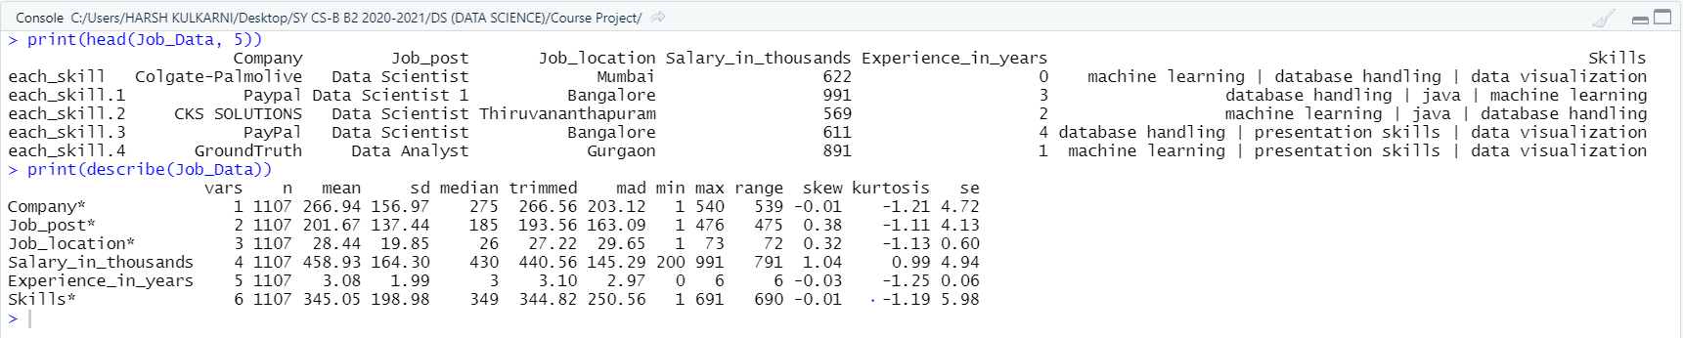

- Applying logistic and KNN algorithms on data.

Job posts available in data –

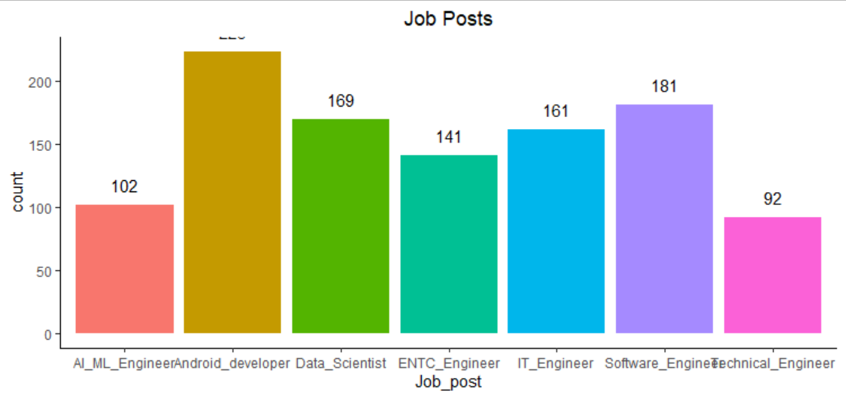

Correlation in features of data –

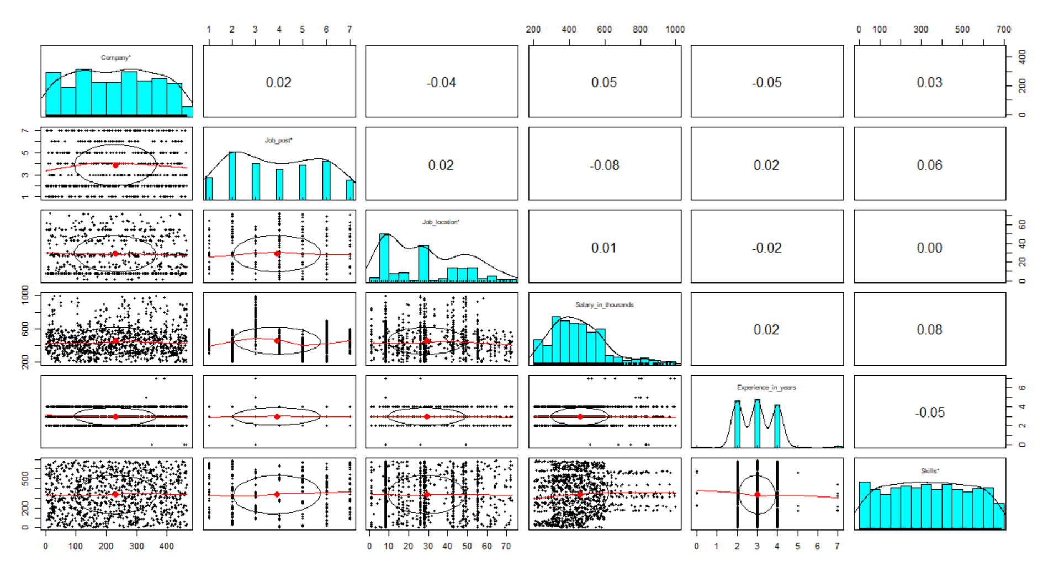

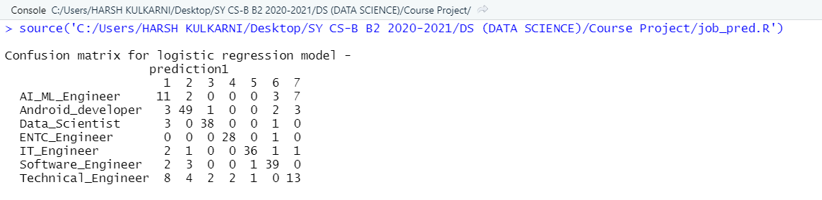

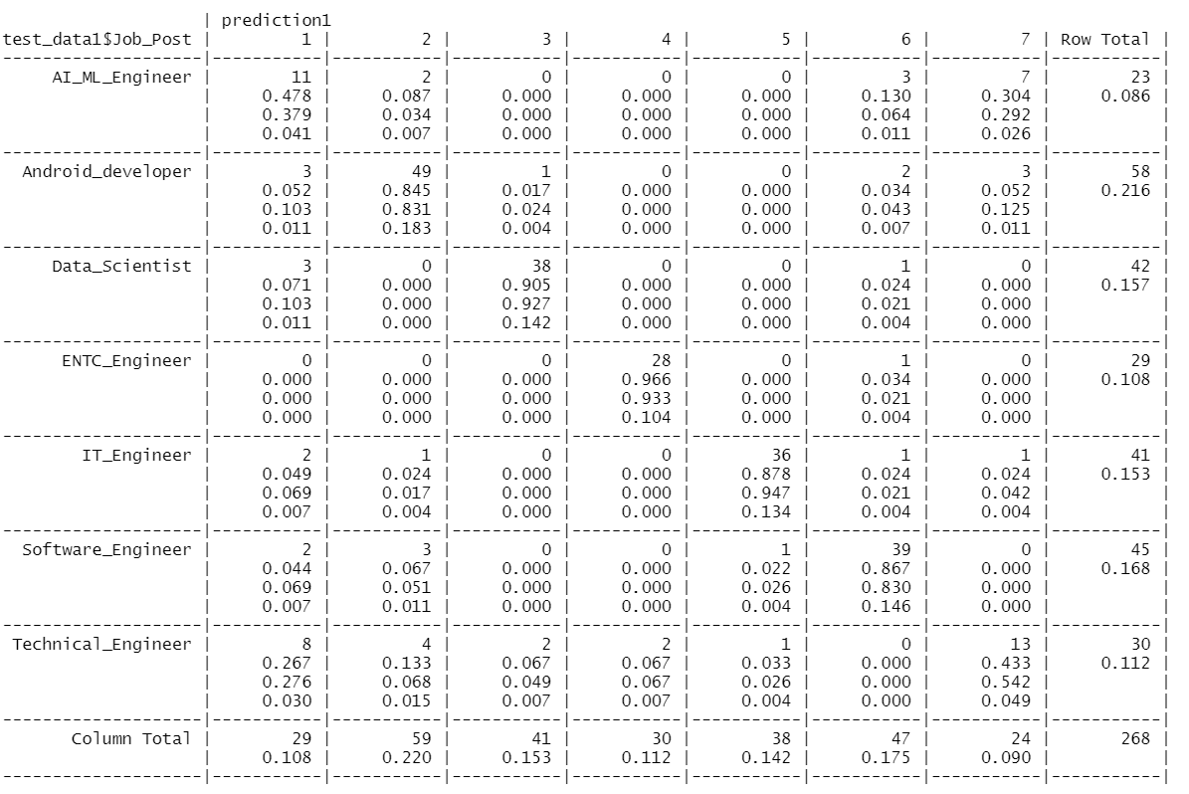

Crosstable for logistic regression

Performance parameters for logistic regression -

Bar chart for Precision of logistic regression model –

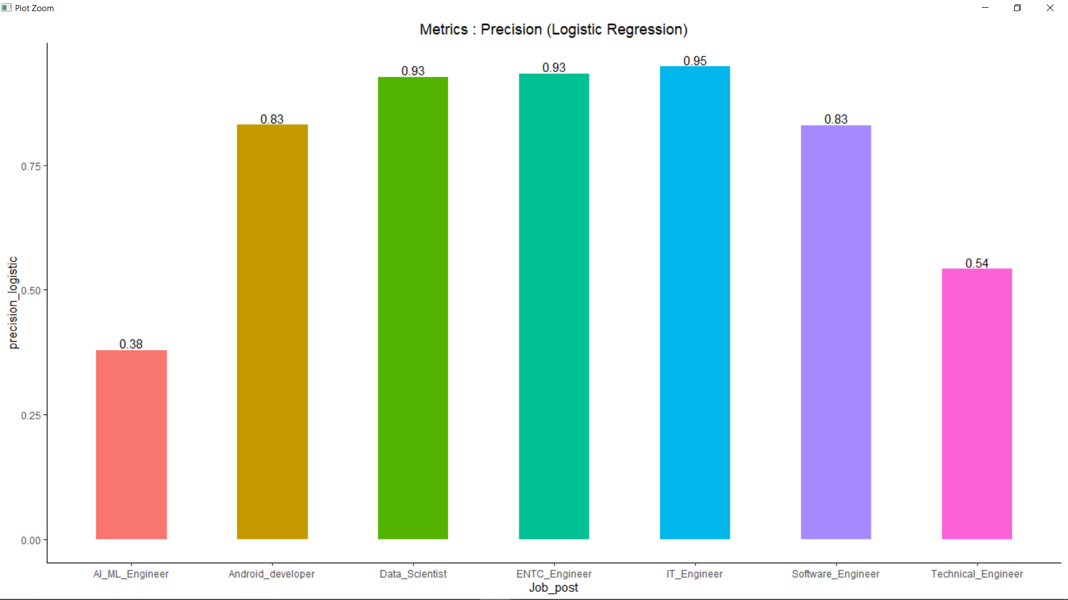

Bar chart for Recall of logistic regression model –

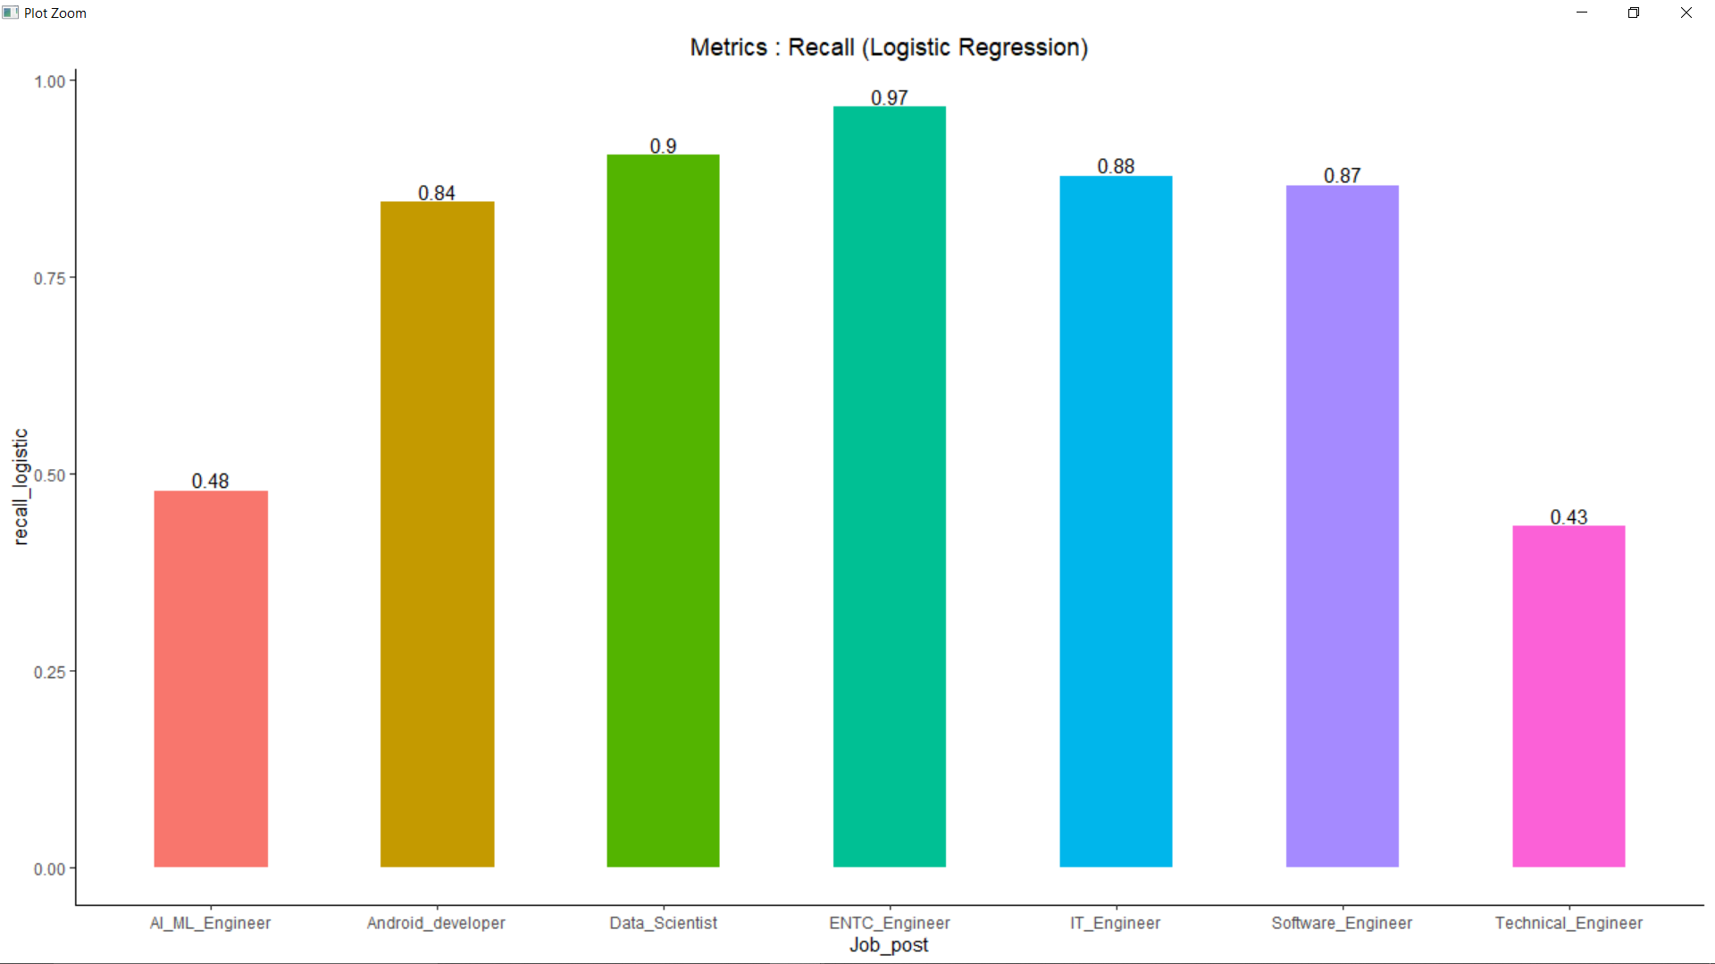

Bar chart for F-score of logistic regression model –

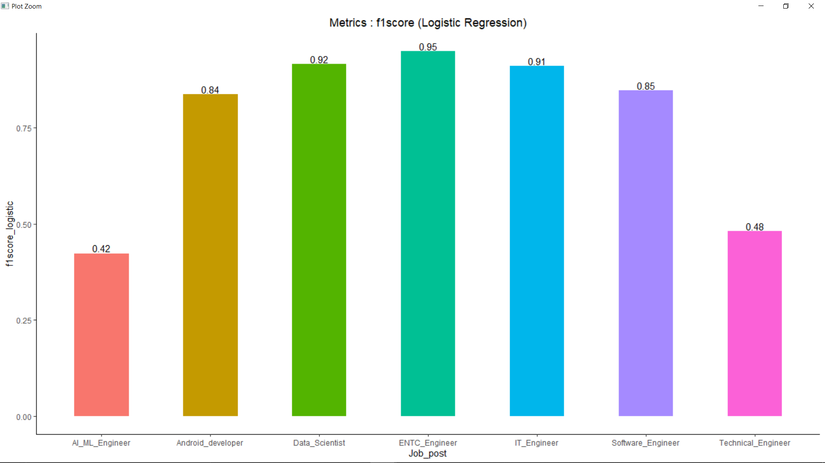

Stacked Bar chart for Precision, Recall and F-score of logistic regression model –

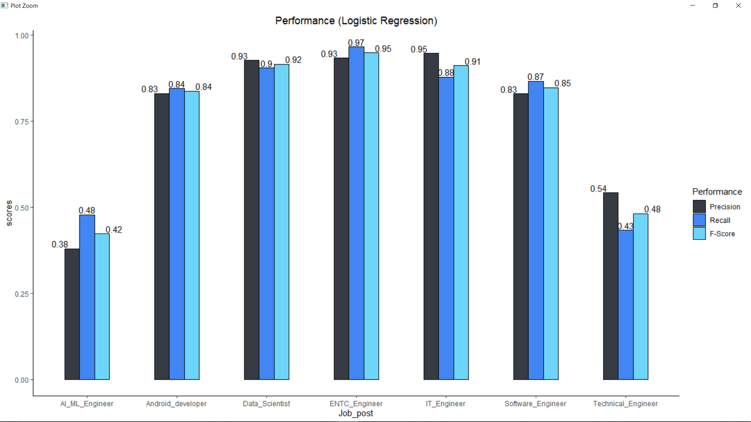

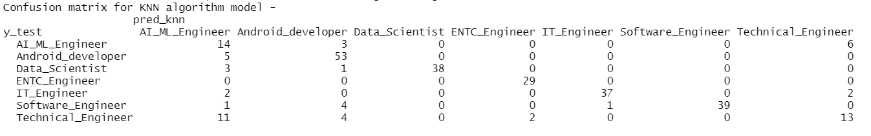

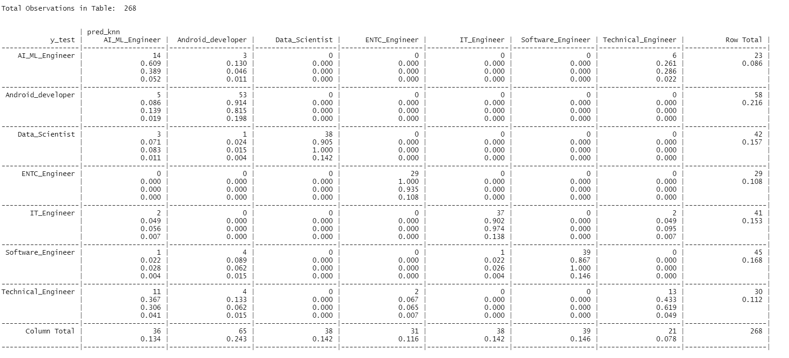

Crosstable for KNN algorithm

Performance parameters for logistic regression -

Bar chart for Precision of KNN algorithm model –

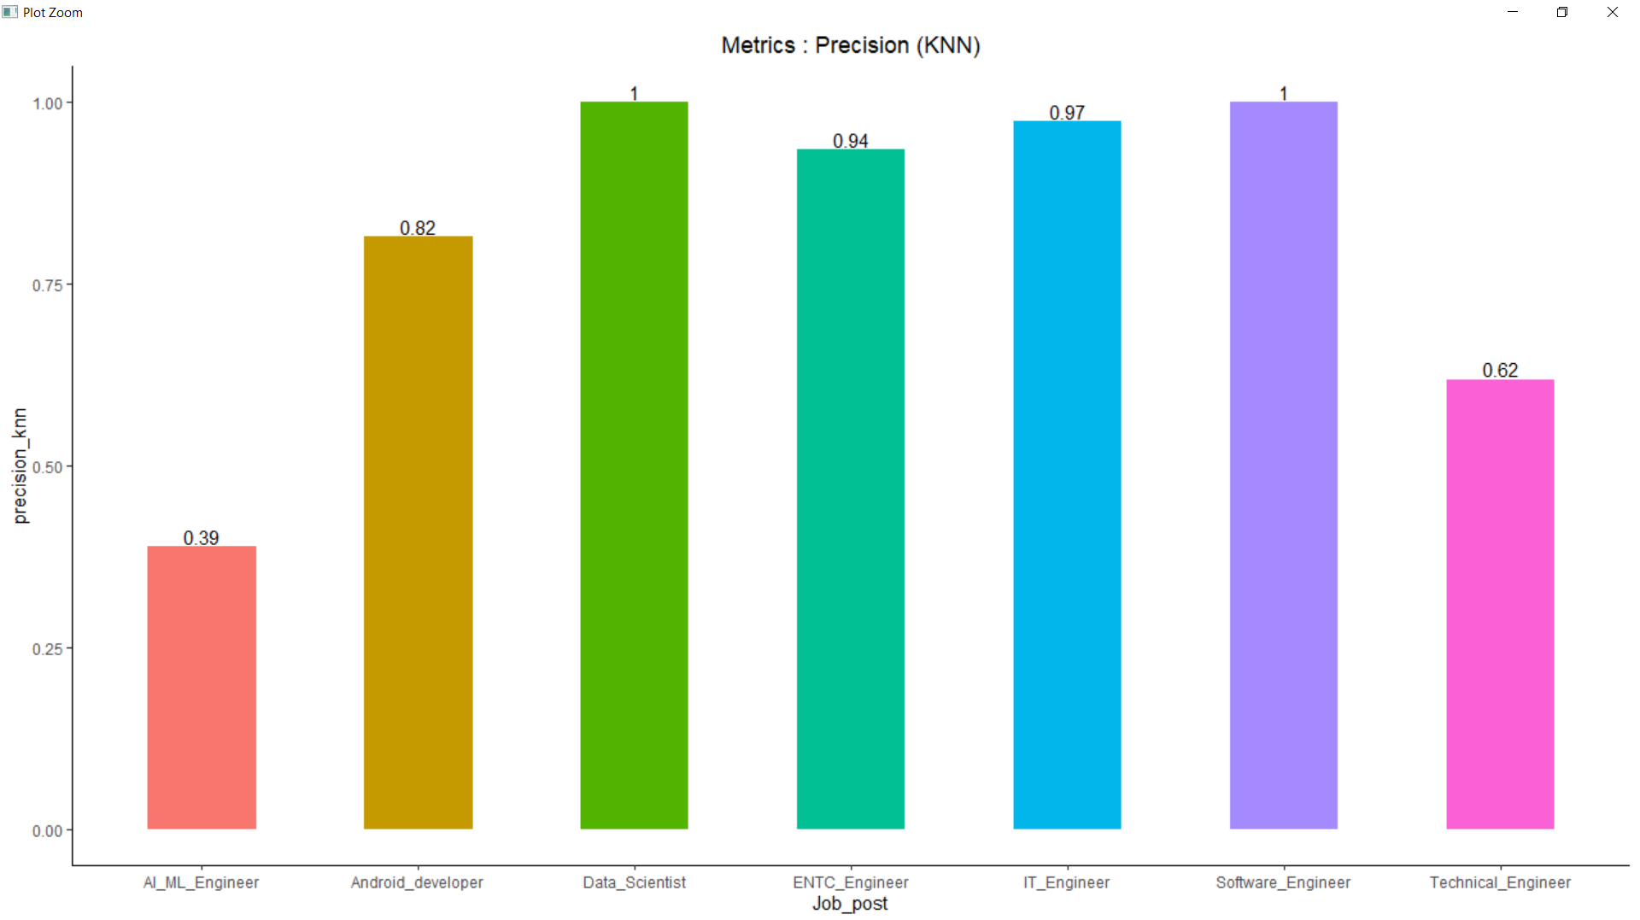

Bar chart for Recall of KNN algorithm model –

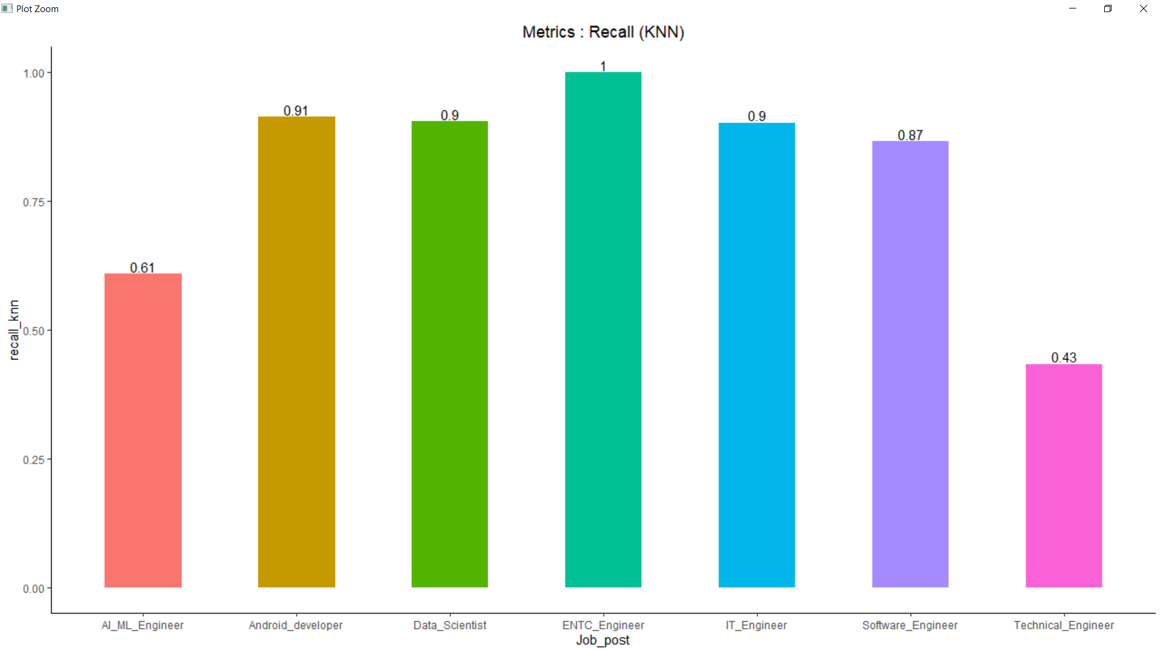

Bar chart for F-score of KNN algorithm model –

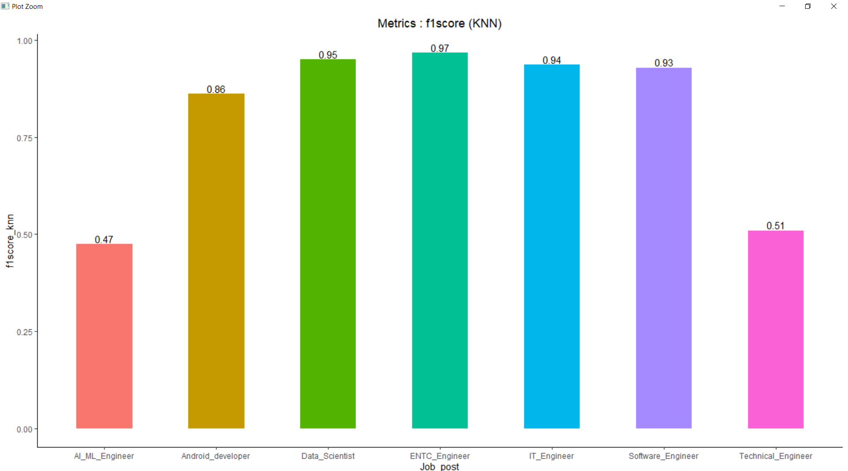

Stacked Bar chart for Precision, Recall and F-score of KNN algorithm model –

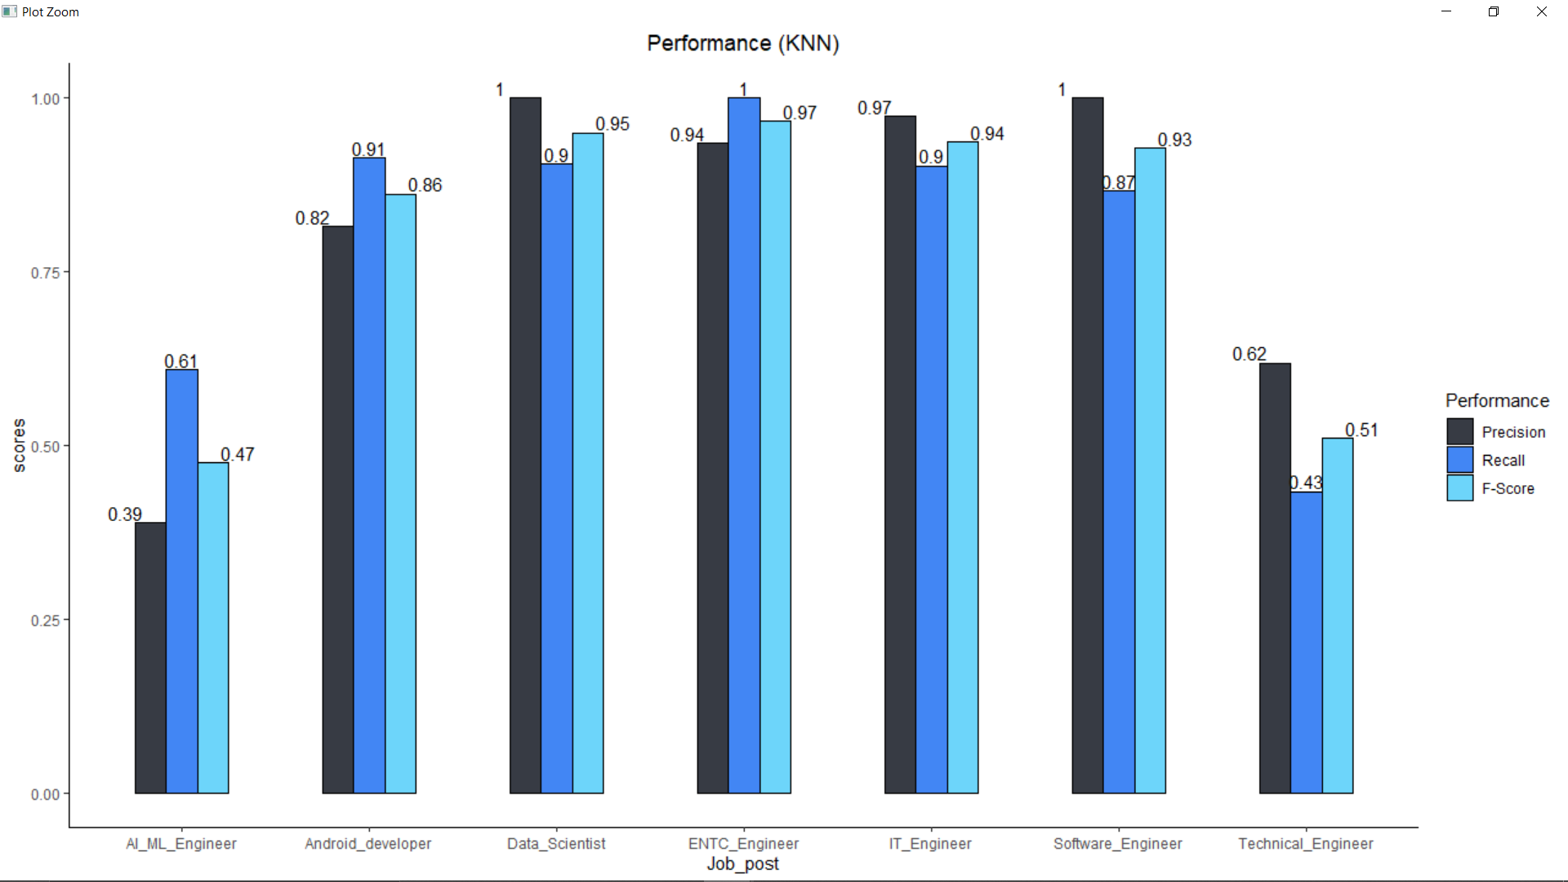

Taking user input and predicting the companies.

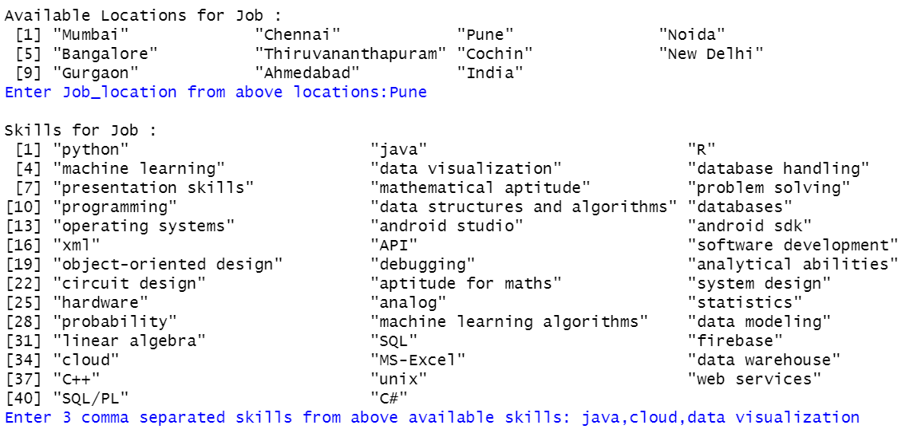

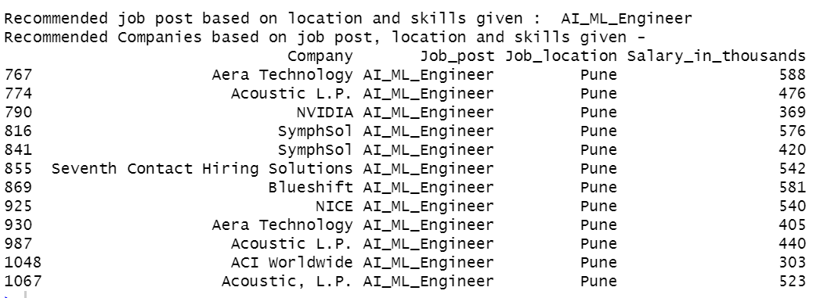

Conclusion:

Web Scraping : As mentioned earlier in the introduction, the website used for scraping is https://www.glassdoor.co.in/index.htm, from this website we were able to collect only the company name, post and location. The job post taken were – Android Developer, AI/ML Engineer, Data Scientist, ENTC Engineer, IT Engineer, Software Engineer and Technical Engineer. Other attributes such as salary, experience, skills were added w.r.t each job post randomly. Also, there was some garbage data in job location, that was also removed. And finally, the dataset was created.

Data visualization : Here we visualized the number of job post present in the dataset by using bar graphs. And then we checked the correlation between the various variables using the pairs.panel command and got a plot showing the correlation matrix. The correlation between the variables was very less most of them were 0.02 which is very less. That means the variables were not related

Data Processing: Now, since our aim was to predict the job post based on user’s skills, location and experience we have to convert the categorical skills and location to numeric. i.e. we have to make the dummy variables for skills and location. So we converted them into the corresponding dummy variables and created a new dataset named as “data1”which included job post and the dummy variables for skills and location.

Classification model: We applied two classification models – Multiple Logistics Regression and KNN. We have gone for multiple logistics regression because we had to predict 7 job post. So first we shuffled the data and spilt the data1 into training and testing. There were approx. 1000 data points in the data so we took 800 as training and 200 as testing.

MLR - So for applying the multiple logistics regression we used the vglm() command from the VGAM library. After applying this command, we got output in the form of probabilities and we selected the largest probability in a row and assigned the respective post to that. New to testing this model on the test data we used the predict() function.

KNN – For applying the KNN we used the knn() command from the class library. There we have to give the train-data in the form of x-train and y-train where y-train contains the job post, and test-data as x-test. From this command we directly get the predicted job post for test data

Performance of models : For comparing the two models we used various precision metrices like accuracy, precision, recall and f-score

MLR – For MLR model we got the accuracy of 79.8 % and the approx. average precision, recall and f-score of all job post is 70%

KNN – For KNN model we got the accuracy of 83% and the approx. average precision, recall and f-score of all job post is 76%

From this we can conclude that for job prediction KNN model gave better results than the MLR. So we deployed the KNN model.

