Flask & MongoDB
DevOps | Assignment
Submitted by: Harshkumar
Objective: Build a Flask application with a JSON API route and a frontend form that stores submitted data in MongoDB Atlas, with proper success and error handling.
GitHub repository: https://github.com/harshkumarpatle37-droid/project_using_flask_-_mongodb_REst-API

Project Setup

Project structure
Files in the project folder
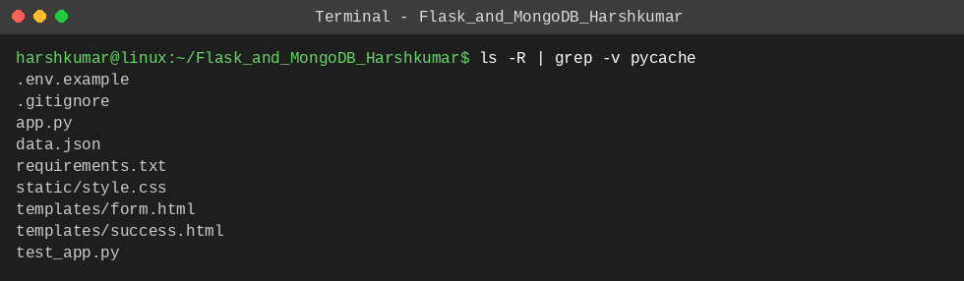
Explanation: app.py holds the Flask application, data.json is the backend file served by /api, templates/ contains the HTML pages, static/ holds the CSS, and test_app.py has automated tests. Secrets are kept out of the code: the Atlas connection string is read from a .env file (a template is provided in .env.example).

Install dependencies
Command: pip install -r requirements.txt
Installing Flask, PyMongo, python-dotenv and dnspython
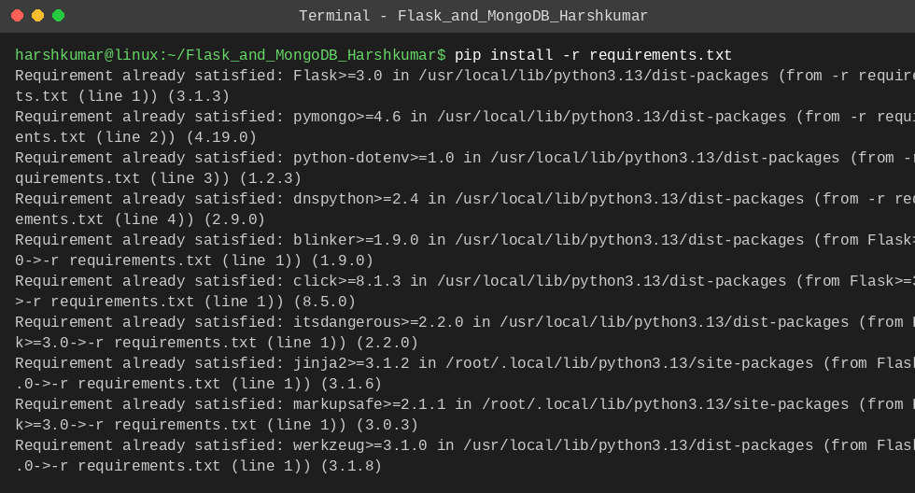
Explanation: requirements.txt lists Flask (web framework), PyMongo (MongoDB driver), python-dotenv (loads MONGO_URI from .env) and dnspython (needed for mongodb+srv:// Atlas URIs).

Task 1: JSON API Route
Requirement: create a Flask application with an /api route that returns a JSON list. The data is stored in a backend file, read from it, and sent as the response.

Backend data file
Command: cat data.json
data.json (the backend file)
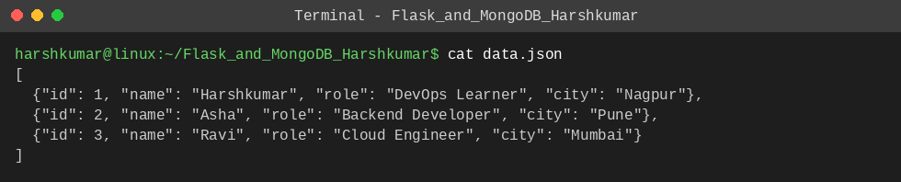
Explanation: The list of records is stored in data.json, which acts as the backend data source.

Flask code for /api
app.py
@app.route("/api")
def api():
"""Read the list from the backend file and send it as a JSON response."""
try:
with open(DATA_FILE, "r", encoding="utf-8") as f:
data = json.load(f)
except (OSError, json.JSONDecodeError) as exc:
return jsonify({"error": f"Could not read data file: {exc}"}), 500
return jsonify(data)

Explanation: The /api route opens data.json, loads it with json.load, and returns it with jsonify, which sets the Content-Type to application/json. If the file is missing or invalid, a JSON error with status 500 is returned instead of crashing.

Running the app and calling /api
Command: python app.py
Flask development server running on http://127.0.0.1:5000
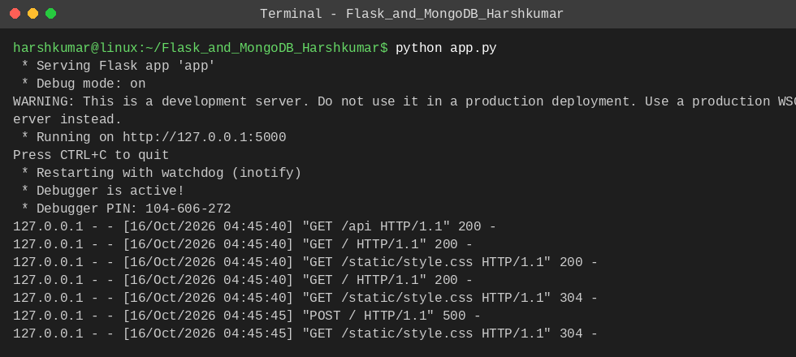
Command: curl -i http://127.0.0.1:5000/api
curl shows HTTP 200, Content-Type: application/json and the JSON list
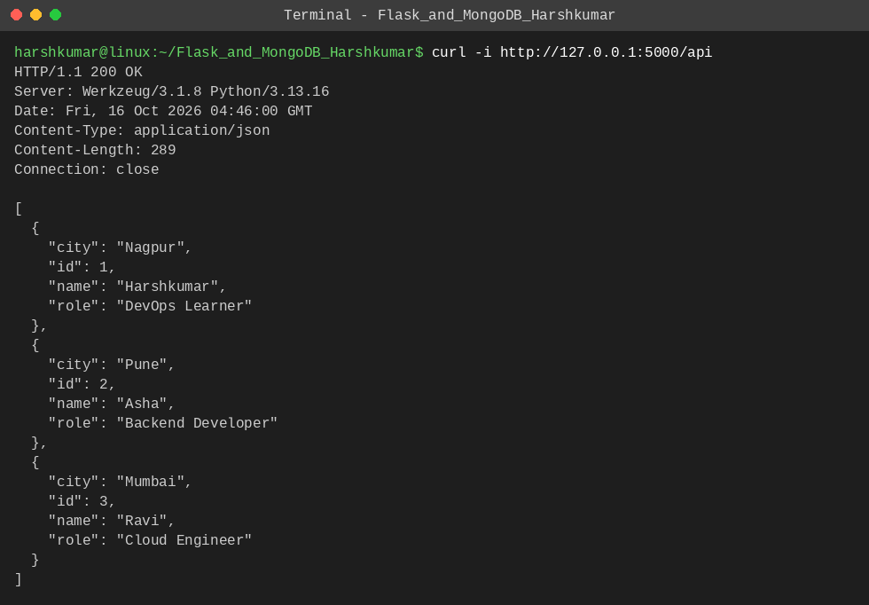
Opening /api in the browser
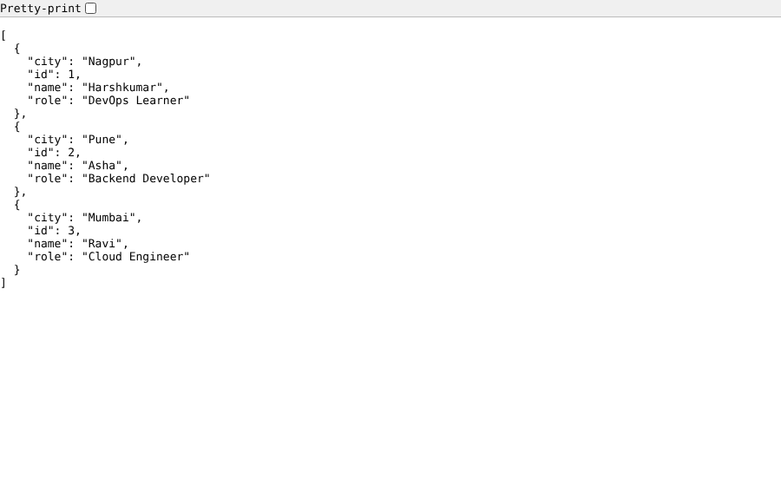
Explanation: The response status is 200 and the content type is application/json, and the body is the list stored in data.json.

Task 2: Frontend Form with MongoDB Atlas
Requirement: a frontend form that inserts data into MongoDB Atlas on submit. On success redirect to another page showing "Data submitted successfully". On error display the error on the same page without redirecting.

MongoDB Atlas configuration
1. Create a free cluster on MongoDB Atlas and a database user. 2. Under Network Access allow your IP address. 3. Use Connect > Drivers to copy the connection string. 4. Copy .env.example to .env and set MONGO_URI to that string (the .env file is git-ignored so the password is never pushed).
app.py
MONGO_URI = os.getenv("MONGO_URI", "")
DB_NAME = os.getenv("DB_NAME", "flask_assignment")
COLLECTION_NAME = os.getenv("COLLECTION_NAME", "submissions")

EMAIL_RE = re.compile(r"^[^@\s]+@[^@\s]+\.[^@\s]+$")

app = Flask(__name__)

_client = None

def get_collection():
"""Return the MongoDB Atlas collection (client is created once)."""
global _client
if not MONGO_URI:
raise RuntimeError("MONGO_URI is not set. Add your Atlas connection string to the .env file.")
if _client is None:
_client = MongoClient(MONGO_URI, serverSelectionTimeoutMS=5000)
return _client[DB_NAME][COLLECTION_NAME]

Explanation: MongoClient is created once from MONGO_URI with a 5 second server selection timeout, so a wrong URI or blocked network fails quickly with a clear error instead of hanging. Data is written to the "submissions" collection of the "flask_assignment" database.

Form route with success redirect and error handling
app.py
@app.route("/", methods=["GET", "POST"])
def index():
if request.method == "GET":
return render_template("form.html", error=None, form={})

form = {
"name": request.form.get("name", "").strip(),
"email": request.form.get("email", "").strip(),
"message": request.form.get("message", "").strip(),
}

# Validation: on error show the message on the same page, no redirect.
if not form["name"] or not form["email"] or not form["message"]:
return render_template("form.html", error="All fields are required.", form=form), 400
if not EMAIL_RE.match(form["email"]):
return render_template("form.html", error="Please enter a valid email address.", form=form), 400

try:
get_collection().insert_one({**form, "created_at": datetime.now(timezone.utc)})
except Exception as exc: # connection failure, auth failure, bad URI, ...
return render_template("form.html", error=f"Database error: {exc}", form=form), 500

# Success: redirect to another page.
return redirect(url_for("success"))

@app.route("/success")
def success():
return render_template("success.html", message="Data submitted successfully")

Explanation: GET / shows the form. The same URL handles the POST: the fields are validated, then insert_one stores the document in Atlas. On success the user is redirected (HTTP 302) to /success. If validation fails or MongoDB raises any exception, the form template is rendered again with the error message and the entered values, so the user stays on the same page and no redirect happens.

Templates
templates/form.html
<!DOCTYPE html>
<html lang="en">
<head>
<meta charset="UTF-8">
<meta name="viewport" content="width=device-width, initial-scale=1">
<title>Submit Data</title>
<link rel="stylesheet" href="{{ url_for('static', filename='style.css') }}">
</head>
<body>
<main class="card">
<h1>Contact Form</h1>
<p class="sub">Your data is stored in MongoDB Atlas.</p>

{% if error %}
<div class="error" role="alert">{{ error }}</div>
{% endif %}

<form method="POST" action="{{ url_for('index') }}">
<label for="name">Name</label>
<input type="text" id="name" name="name" value="{{ form.get('name', '') }}" placeholder="Your name">

<label for="email">Email</label>
<input type="text" id="email" name="email" value="{{ form.get('email', '') }}" placeholder="you@example.com">

<label for="message">Message</label>
<textarea id="message" name="message" rows="4" placeholder="Write something...">{{ form.get('message', '') }}</textarea>

<button type="submit">Submit</button>
</form>
</main>
</body>
</html>

templates/success.html
<!DOCTYPE html>
<html lang="en">
<head>
<meta charset="UTF-8">
<meta name="viewport" content="width=device-width, initial-scale=1">
<title>Success</title>
<link rel="stylesheet" href="{{ url_for('static', filename='style.css') }}">
</head>
<body>
<main class="card">
<div class="success" role="status">{{ message }}</div>
<a class="link" href="{{ url_for('index') }}">Submit another response</a>
</main>
</body>
</html>

Explanation: form.html shows the form and, when an error is passed in, an error box above it. success.html displays the message "Data submitted successfully".

Frontend form
The form page (http://127.0.0.1:5000/)
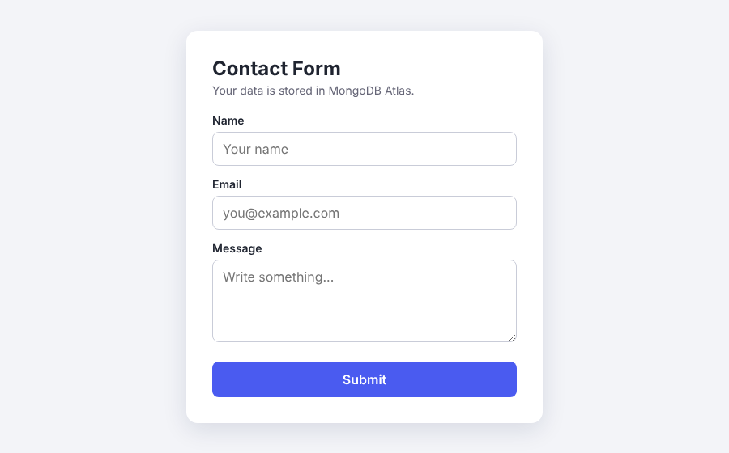
Form filled in with sample data
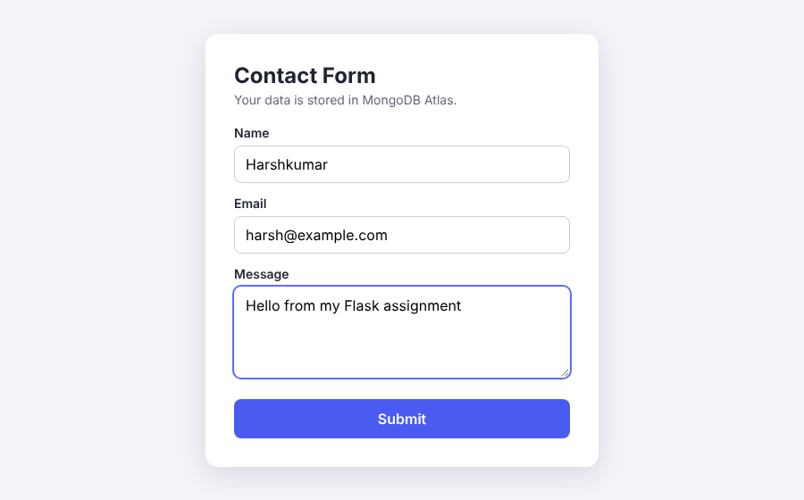

On success: redirect to the success page
After submitting, the browser is redirected to /success and shows "Data submitted successfully"
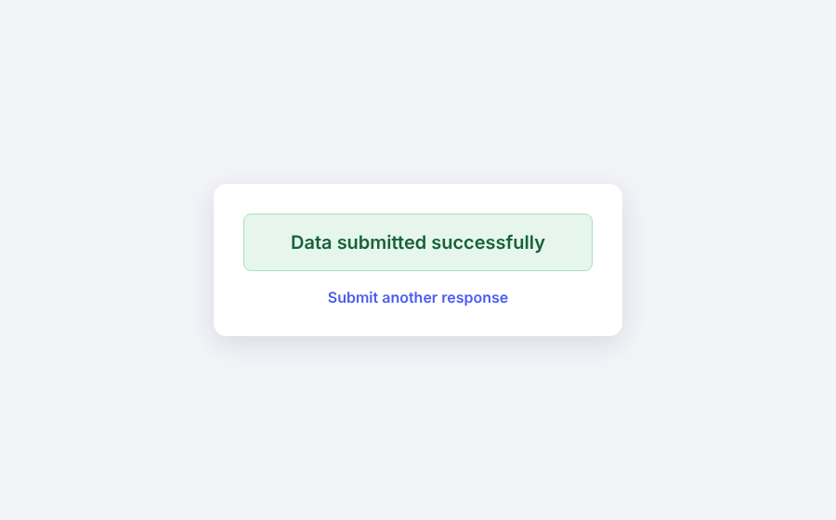
Explanation: The address bar changed from / to /success, confirming the redirect.

On error: shown on the same page, no redirect
Invalid email: the error appears on the same form page and the URL stays /
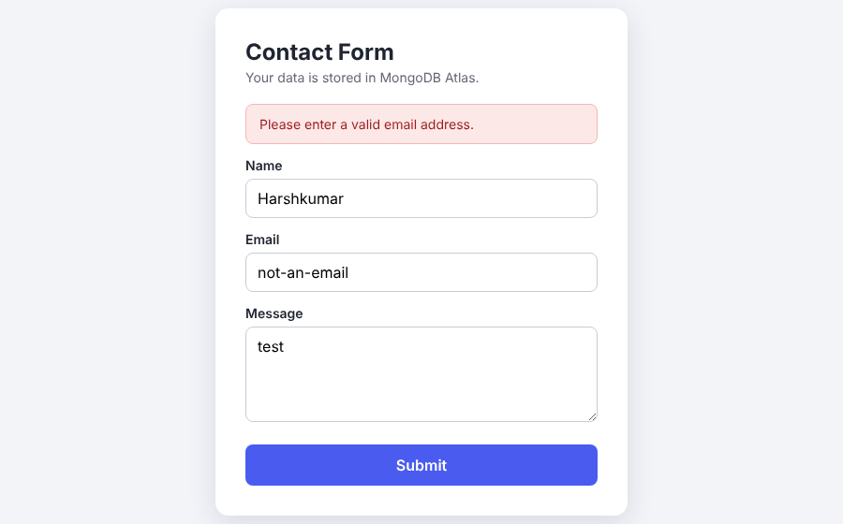
Database not reachable: the database error is displayed on the same page, URL stays /
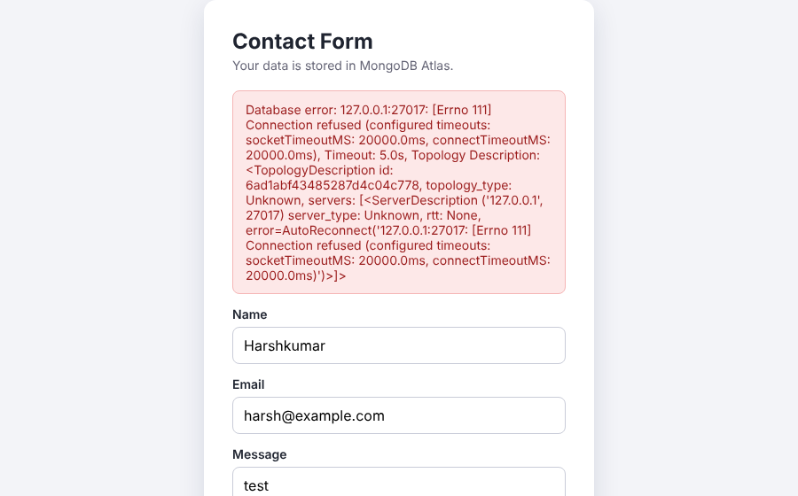
Explanation: In both cases the page is not redirected, the URL remains /, the error is displayed above the form and the values typed by the user are kept.

MongoDB Atlas data
[Add your own screenshot here: Atlas > Browse Collections > flask_assignment.submissions showing the inserted document, after running the app with your MONGO_URI.]

Automated Tests
Command: pytest -v
All 5 tests pass
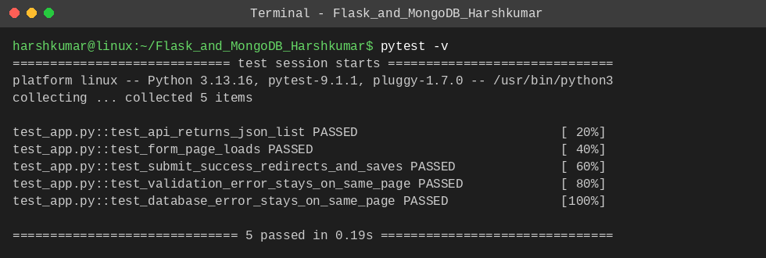
Explanation: The tests check the /api JSON list, the form page, the success redirect with the document being saved, the validation error staying on the same page, and a database failure staying on the same page. An in-memory MongoDB (mongomock) is used in the tests so they run without an Atlas account.

