Linux Basics
DevOps | Assignment
Submitted by: Harshkumar
Objective: Practise essential Linux command-line operations: file and directory management, viewing files, searching, archiving, downloading, permissions, and environment variables.
GitHub repository: <paste your repository URL here>

1. Creating and Renaming Files/Directories

Task 1: Create a directory named test_dir using mkdir.
Command: mkdir test_dir
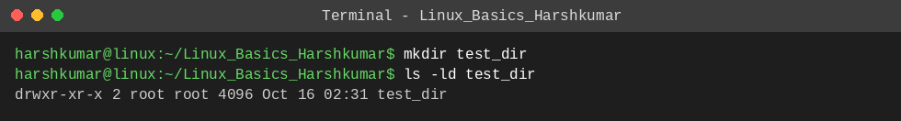
Explanation: mkdir creates a new directory. ls -ld confirms test_dir exists (the leading "d" in drwxr-xr-x marks it as a directory).

Task 2: Inside test_dir, create an empty file called example.txt.
Command: touch test_dir/example.txt
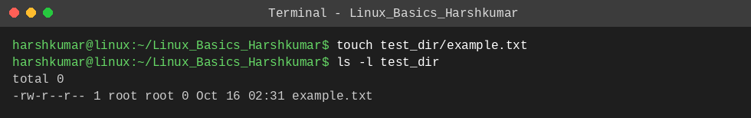
Explanation: touch creates an empty file if it does not exist. ls -l shows example.txt with size 0 bytes.

Task 3: Rename example.txt to renamed_example.txt using mv.
Command: mv test_dir/example.txt test_dir/renamed_example.txt
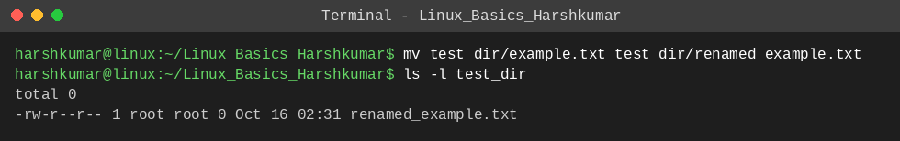
Explanation: mv moves or renames a file. Using the same directory with a new file name renames it; ls -l shows only renamed_example.txt now.

2. Viewing File Contents

Task 4: Use cat to display the contents of /etc/passwd.
Command: cat /etc/passwd
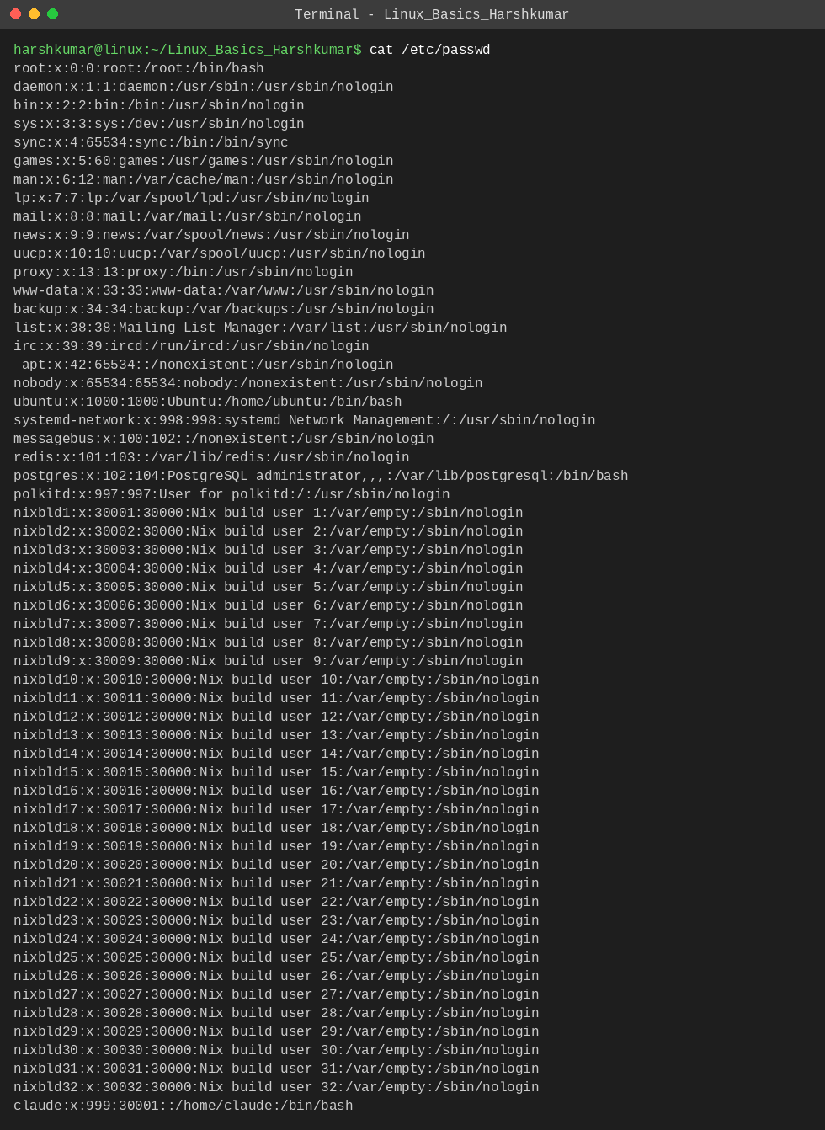
Explanation: cat prints the whole file. Each line is one user account in the format username:password:UID:GID:comment:home:shell.

Task 5: Display only the first 5 lines of /etc/passwd using head.
Command: head -n 5 /etc/passwd
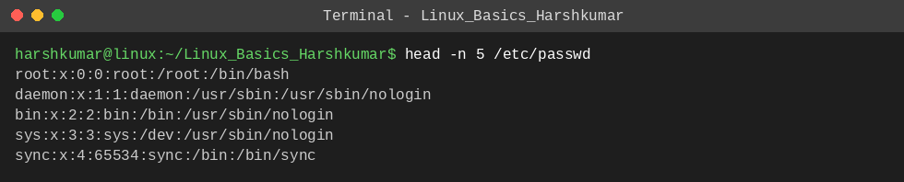
Explanation: head shows the beginning of a file; -n 5 limits the output to the first 5 lines.

Task 6: Display only the last 5 lines of /etc/passwd using tail.
Command: tail -n 5 /etc/passwd
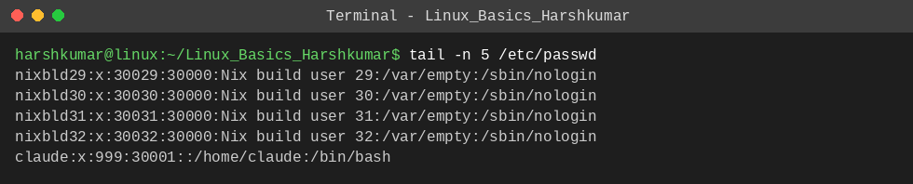
Explanation: tail shows the end of a file; -n 5 limits the output to the last 5 lines.

3. Searching for Patterns

Task 7: Use grep to find all lines containing the word "root" in /etc/passwd.
Command: grep 'root' /etc/passwd
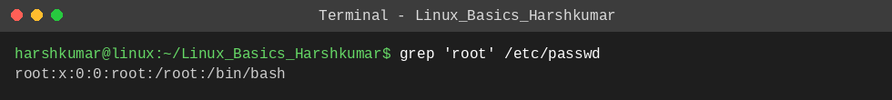
Explanation: grep prints every line that matches the given pattern. Here it returns the line(s) containing "root".

4. Zipping and Unzipping

Task 8: Compress the test_dir directory into a file named test_dir.zip using zip.
Command: zip -r test_dir.zip test_dir
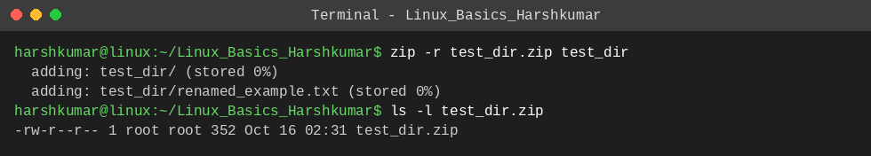
Explanation: zip creates an archive; -r adds the directory recursively, including the files inside it.

Task 9: Unzip test_dir.zip into a new directory named unzipped_dir.
Command: unzip test_dir.zip -d unzipped_dir
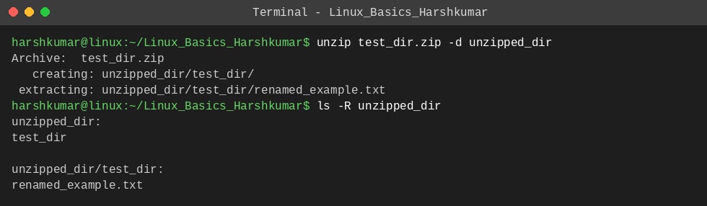
Explanation: unzip extracts an archive; -d unzipped_dir sets the destination directory (created automatically). ls -R lists the extracted contents.

5. Downloading Files

Task 10: Use wget to download a file from a URL.
Command: wget -O sample.txt https://raw.githubusercontent.com/git/git/master/README.md
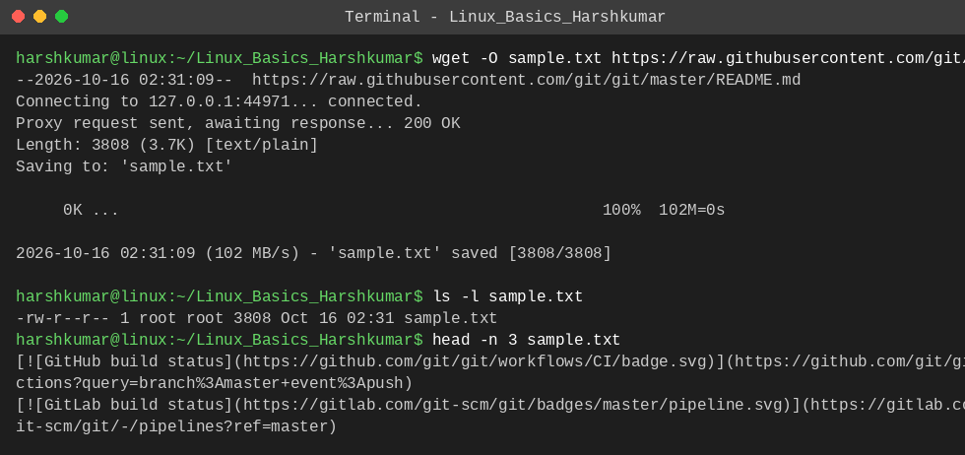
Explanation: wget downloads a file from a URL. A real, publicly available text file is used because example.com/sample.txt is only a placeholder URL; -O sample.txt saves it under that name.

6. Changing Permissions

Task 11: Create a file named secure.txt and change its permissions to read-only for everyone using chmod.
Command: touch secure.txt && chmod 444 secure.txt
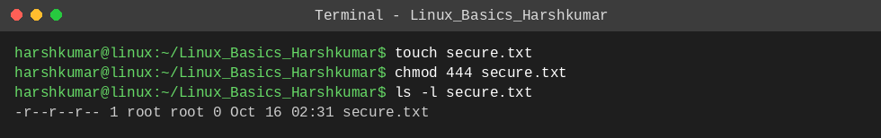
Explanation: chmod 444 gives read (4) permission to owner, group and others with no write or execute, shown as -r--r--r-- in ls -l.

7. Working with Environment Variables

Task 12: Use export to set a new environment variable called MY_VAR with the value "Hello, Linux!".
Command: export MY_VAR="Hello, Linux!"
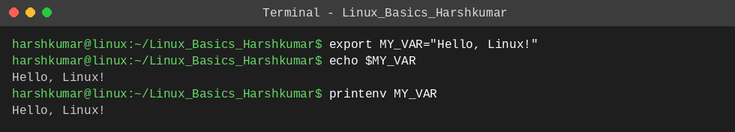
Explanation: export sets a variable and makes it available to child processes. echo $MY_VAR and printenv MY_VAR both print its value.

