Otto Group Product Classification Challenge – Kaggle

PROJECT REPORT

SUBMITTED IN FULFILLMENT OF THE REQUIREMENTS FOR THE AWARD OF

GRADE IN

DATA MINING CS-659

IN

COMPUTER SCIENCE

BY

Akash Vishwanath Babu (G00908341)
Harsh Loomba (G00905405)


DEPARTMENT OF COMPUTER SCIENCE

GEORGE MASON UNIVERSITY

FAIRFAX, VIRGINIA
INTRODUCTION:

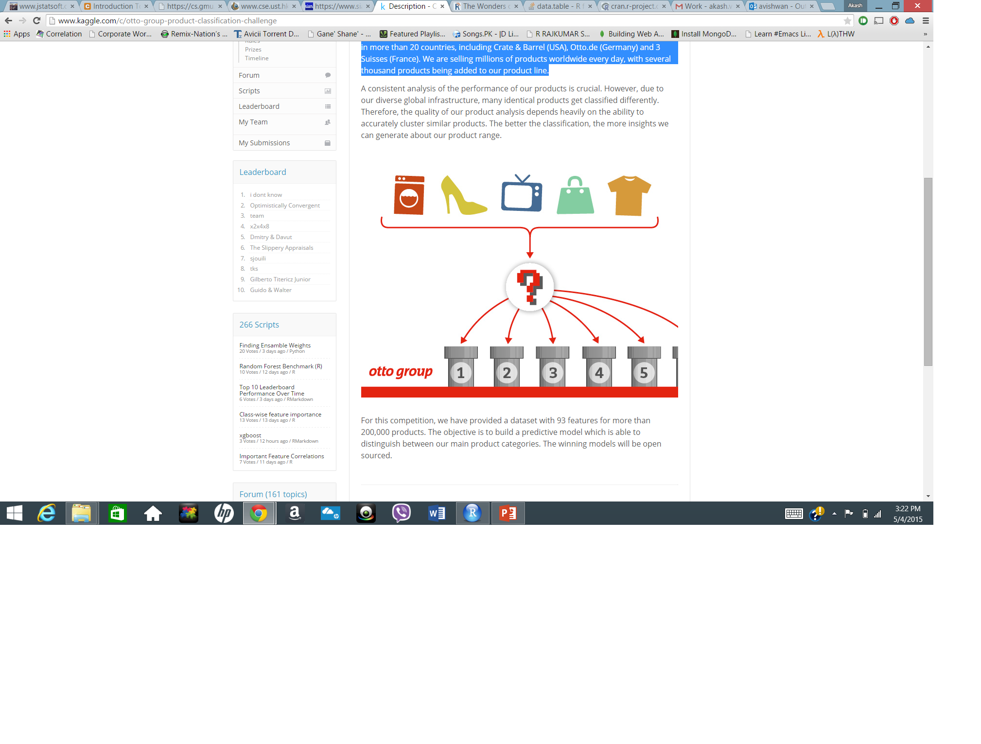

- Problem Statement – Due to the diverse global infrastructure of Otto group, many identical products get misclassified and it’s severely impacting their ability to analyze the performance of their product.
- Objective – We aimed to create different predictive models, using the provided data set which has 93 features for more than 200,000 products, to correctly classify the Otto group products. Consequently, it will improve the quality to analyze the performance of their products.
- Achievement – We have achieved a model which has given 0.5334 logloss and we ranked among top 1410 participants out of the 3200 teams participating. Following are the progressive ranks





Problems Encountered
We first found the appropriate technology which will help us to produce the model in most efficient ways and after realizing many shortfalls of Weka such as it’s slow processing speed and limitation of inherent functionalitites such as automatic garbage collection and on top of all that we had to create a final submission file in the different format for which we would have to create a java file, therefore we deiced to look for the robust tool and finally we landed up R. It gave us a better platform execute our programs and build the models in more faster(using parallelization) and efficient ways.
Data Information
Training data is 340000 and test is 20000
Data sheet has 93 features of type numeric (feet_1 to feet_93) and target class in nominal type.
Following diagram shows the data distribution among the target class (class_1 to class_9). According to the figure, earlier drawn conclusion was to balance the class but eventually seeing the shocking results on the balanced data, we decided not to go for the balanced data. Due to the balanced data, probability of the one row to be misclassified gets increased and therefore balancing the data produced the less accurate data.
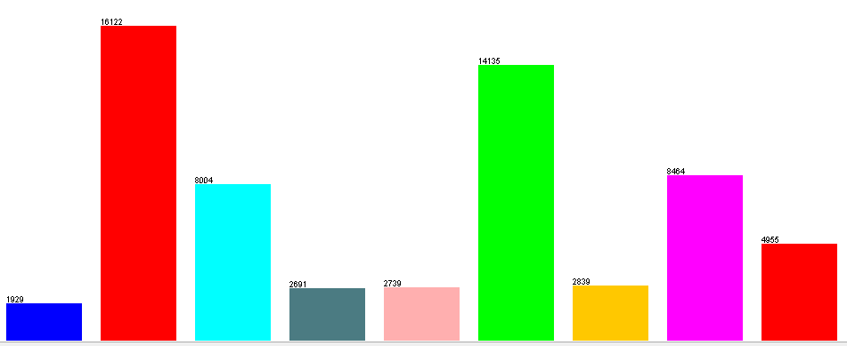
Figure: Data distribution among 9 classes
DATA SUBMISSION FORMAT IN KAGGLE AND THE EVALUTAITON PARAMETER

"id","Class_1","Class_2","Class_3","Class_4","Class_5","Class_6","Class_7","Class_8","Class_9"
1,0.014,0.248,0.206,0.46,0.004,0.024,0.028,0.014,0.002
2,0.018,0.05,0.036,0.02,0.01,0.48,0.018,0.336,0.032

Multi-class logarithmic loss:

where N is the number of products in the test set, M is the number of class labels, log is the natural logarithm, yij is 1 if observation i is in class j and 0 otherwise, and pij is the predicted probability that observation i belongs to class j.

Steps involved in preprocessing the training data
- Due to high dimensionality, visulaization of the data was difficult, so we used the T-SNE algorithm in R to visulaize the data. T-SNE. It visualizes high-dimensional data by giving each datapoint a location in a two or three-dimensional map. It is a variation of Stochastic Neighbor Embedding that allows optimization, and produces significantly better visualizations by reducing the tendency to lump points together in the center of the map that often renders the visualization ineffective and unreadable. t-SNE is good at creating a map that reveals structure and embedding relationships at many different scales. This is particularly important for high-dimensional inter-related data that lie on several different low-dimensional manifolds, such as images of objects from multiple classes seen from multiple viewpoints. t-SNE reveals and informs us a much better insight in a cleaner and readable form of visualization.
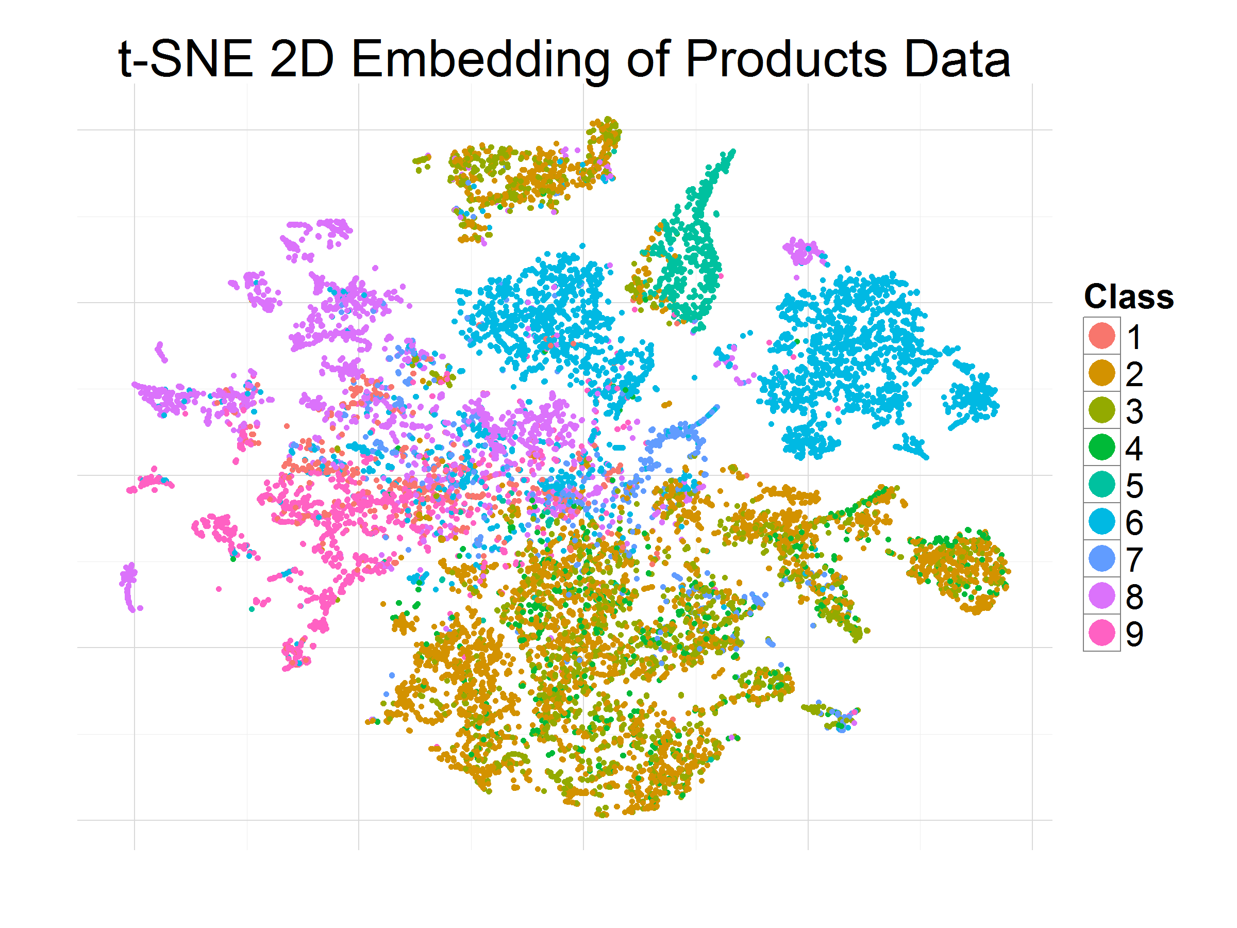
Figure 1 - Otto Group t-SNE Data Visualization
Drawn Conclusion

Data has bright chances to get misclassified as it’s very apparent from the dataset that proximity of the classes are high and therefore classifier should be potential enough to classify the unknown record in the right target class.

- Feature reduction

Since there are only 93 attributes and further reduction could lead to remove the important information, therefore instead of removing the features addition of features are required. Though, ID attribute, which is unique for every data record has been removed.

- Normalize the Data set

Attributes have varied ranges of value set and therefore normalization of the data was required. For Normalization, we have used the Weka and normalized the training/Test data set.

FIRST MODEL –J48

We have used the “caret” package to train this model and the api “train” is a general purpose API to train the models. The syntax of the API is as follows:
Caret::train(classAtrribute, data, method,trControl)
Configurations:
Model: J48
Package used: RWeka
API: J48(classAttribute, data)
FINDINGS: The first model we built for the competition was J48. We used the entire data set (normalized but without addressing the class imbalance problem). We obtained a log loss of 5.4 which is very high. Even though the accuracy for the model is 98% we obtained a very ugly log loss value, which is a clear indication that the model is over-fitted. We thought of tuning the model to see if we can improve our log loss but we decided the skip tuning and going for a better algorithm instead. We did not submit the results to kaggle as we knew we would near the bottom of the table. The worst log loss as observed by the competition is in the range of 34.

NEXT MODEL – C5.0
We decided to go for an improvement of the original C4.5 model which is the C5.0. There are numerous advantages of C5.0 over C4.5. One of them being faster build time for the model. One noticeable advantage is that C5.0 model has inherent boosting and therefore produce better results. The C5.0 model also provides flexibility to produce either a decision tree model or a rule based model. Rule based models are much simpler as the model is a set of rules which are simple if- else statements and are much easier to understand.
We implemented C5.0 with default values, with decision tree model and pruning of the tree enabled. We obtained a log loss of 0.98672 which is significantly less than the original log loss of 5.4 obtained from J48. We submitted the predicted class probabilities to kaggle and we ranked 2244.
We then tuned the model with 20 boosting iterations using a 3 fold cross-validation and found out that the rule based model without winnowing provides a better result but by a very tiny margin. The log loss obtained from this model had logloss of 0.98650.
The comparison between the decision tree model and the rule based model with 20 boosting iterations and their accuracies with and without winnowing are shown below:

We can see that there is not much difference between the rule based model and the decision tree model and also that the both the model perform better without winnowing. In fact in the data set we are working on, what is needed is we need to add to more features rather than removing them. We also observed that we should not address the class imbalance in this case as the log loss worsened when we uploaded the model trained with smoted data set.
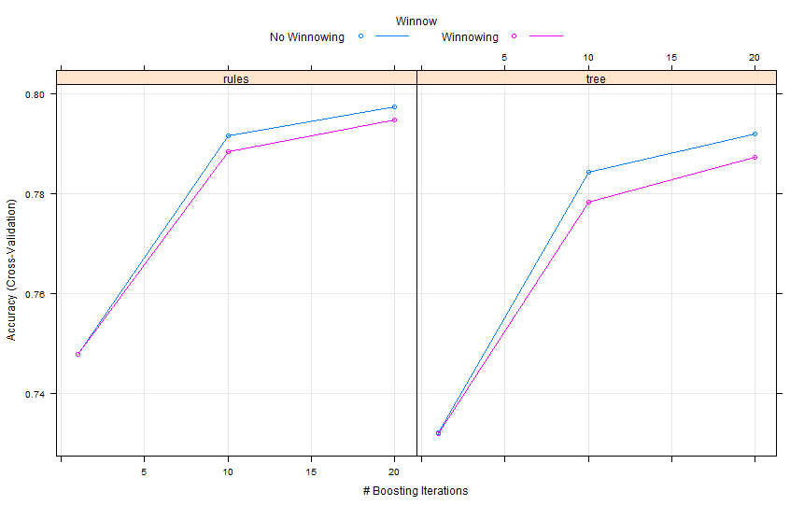
Figure – Accuracy with C 5.0 Model with winnow/without winnow

C5.0 R PARTIAL CODE
library('C50')
library('caret')
ctrl <- trainControl(method=”cv”, number = 3) ##3 fold CV
c5mdl <-train(target~.,data=fullData,method = "C5.0",trControl = ctrl)
c5CVPreds <- predict(c5mdl,testData,type="prob")
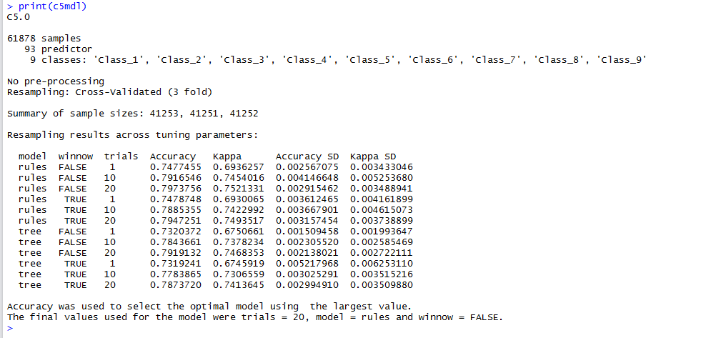
Figure – summary C 5.0
THIRD MODEL- NEURAL NETWORKS
We decided to build a neural network classifier as these are usually compared against a decision tree model. We wanted to observe if a neural network is better or a decision tree would fare much better as it would in most cases. We have used the package “nnet” for building the neural network classifiers.
## code snippet
neuralModel <- nnet(target~.,data=fullData,maxit = 100,decay=0) ##model assumed 2 hidden layers
Results: The first attempt of building a neural network yielded us a log loss of 1.40266 which indicates that it might not be suitable. But nueral networks require quite a large number of iterations to train with the data. The default values for the max number of iterations would seem to be too small for the neural network to be refined, which explains the high log loss.
We decided to tune the model with a 3 fold cross validation as high number of cross validations can overfit the model. We were predicted the following parameter values for decay, size and also the model contained 3 hidden layers. We used this model to predict the probabilities for instances in the test data and uploaded it on kaggle to find that indeed training the neural network helps as we obtained a log loss of 0.90546. One other thing we noticed is that it seems to be performing better than C5.0 rule based model as well(compared to log loss).
Tuned model 1 : decay=0, size = 5, 3 fold cross validation and 3 hidden layers
log loss obtained : 0.90546
As we found that training the neural net would definitely benefit us in the competition, we decided to go one step further and see if a 10 fold CV would help us or go against us. The suggested parameters for size and decay were the same and 3 hidden layers as before but due to the number of iterations which were increased due to the 10 fold CV, the model we obtained was significantly better than the previously trained model as we obtained a log loss of 0.72592.
Tuned model 2 : decay=0, size =5, 10 fold cross validation and 3 hidden layers (skeptical at first but went ahead with it)
log loss obtained : 0.72592
We came across a thread in kaggle forums for the otto group product classification page that few users were building log linear models using neural networks and obtaining better log loss. We decided to give that a try and we trained our log linear model and obtained the number of max iterations(maxit) as 666 and we uploaded the precited probabilities to find that this model is definitely better as we obtained a log loss of 0.63514 which is 0.2 above the benchmark for log linear model using neural nets in kaggle. The advantage of using the “nnet” package is that it already contains the api to create log linear models using neural nets.
LogLinear Model using Neural Network : tuned to get maxit = 666
log loss obtained : 0.63514
SUMMARY OF TUNED MODEL:

Disadvantages OF Neural Net

- Often converge on a local minima, “missing the big picture” – Explain in 2-3 lines
- Often over-fit if training goes too long, might consider noise as a pattern (bad) – Explain in 2-3 lines
Advantages Support Vector Machines
- Global minima rather than a local one – It implies it produces a unique solution for classifying the data unlike NNET that suffers from the existence of multiple local minima solution.
- Does not depend on dimensionality of input space, less prone to over-fitting – With the help of kernel tuning dimensions are of least concerns. Kernels like RBF kernel map data to infinite dimensional spaces. Due to Kernel trick, mapping and producing such high dimensional representation is not a computationally daunting task. It pretty much bypass this computation cheaply.
- Unlike ANNs, the computational complexity of SVMs does not depend on the dimensionality of the input space. ANNs use empirical risk minimization, whilst SVMs use structural risk minimization

NEXT ATTEMPT WITH SUPPORT VECTOR MACHINE (SVM)

Due to the aforementioned advantage of SVM over NNET, we moved to SVM and found the pertaining packages named “e1071” in R of SVM implementation. Corresponding API is svm().

SVM R CODE SNIPPET:

svmachine <- svm(target~.,data=fullData,kernel = "radial",probability = TRUE)

Conclusion: After configured SVM with RBF kernal, we attained the log loss of 0.66744. This logloss has been obtained only after setting the sngle paramter kernel, therefore SVM produced good results but comapred to other tuned models the reults are not so promising.

FINAL ATTEMPT WITH RANDOM FOREST

After using single classifiers, we finally moved to ensemble classifier. Random forest build model consists of many decision trees and outputs the class that is the mode of the class’s output by individual trees. Each tree is built from a separate random sample of the data using bootstrap sampling. So you can build hundreds of trees each from a separate bootstrap sample of the data. So we gain diversity from examining different examples in the data. In a standard tree, each split is created after examining every variable and picking the best split from all the variables. Random Forests selects a random subset of variables for *every split*. By convention, the number of variables to consider is sqrt(M) where M is the number of candidate inputs. So if you have 100 input variables, you select a random 10 of those for every single split. This forces the trees to find alternative ways to predict the target variable. For random forest model, package “randomforest” has been used and API - randomForest(classAttribute, data, mtry, ntree). Feature importance is used by random forest model at the time of building the model. Following is the graph depicting the features according to the rank.
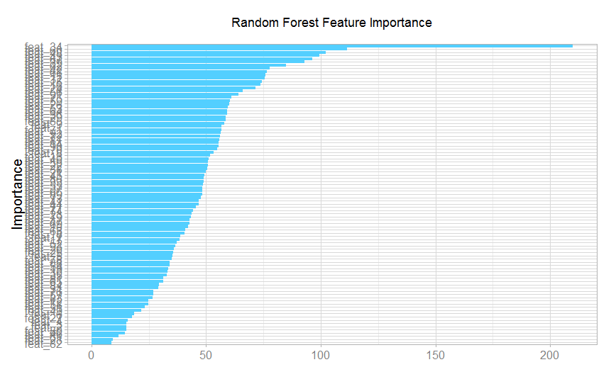
Figure – Feature importance

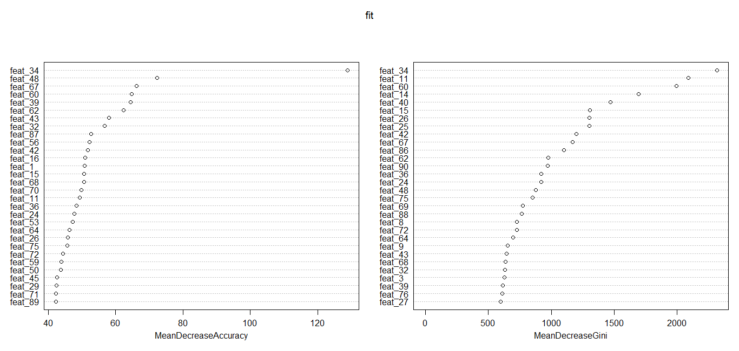
Figure – Mean Decrease accuracy/Gini against features

Random Forest Model with untuned parameters –

To check the potential of random forest alogirthm, we built the random forest model without tuning any parameter and executed the model with the default values. The following is the screenshot of the code snippet.

fit <- randomForest(as.factor(target) ~ ., data=train2,importance=TRUE)

Results: With default parameters, we got log loss 0.60015 which encouraged us to tune the model further with different parameters.

Random Forest Model With tuned paramer ntree as 380 -
This time we set the depth of the tree to control the overfitting and below is the screenshot of the code snippet
fit <- randomForest(as.factor(target) ~ ., data=train2,importance=TRUE, ntree=380)
Results – After initiating ntree, which is the depth of the tree, parameter as 380 our logloss took good leap and and we attained logloss -55954. Eventually we increased our “ntree” parameter further to 480 and we got further improvement improvement by obtaining logloss as 0.55755.
Random forest model with Mtry parameter and ntree parameter tuned
We decided to tune Mtry parameter along with ntree as 500. With M-Try setting , we setup the number of features random forest tries (randomly selected) at each decision point in a tree based on their importance. Following is the code snippet

fit <- randomForest(as.factor(target) ~ ., data=train2,mtry=18,importance=TRUE, ntree=500)

Results : We attained logloss of 0.55233 and following grapth depicts the reduction of error rate as Mtry number increases. 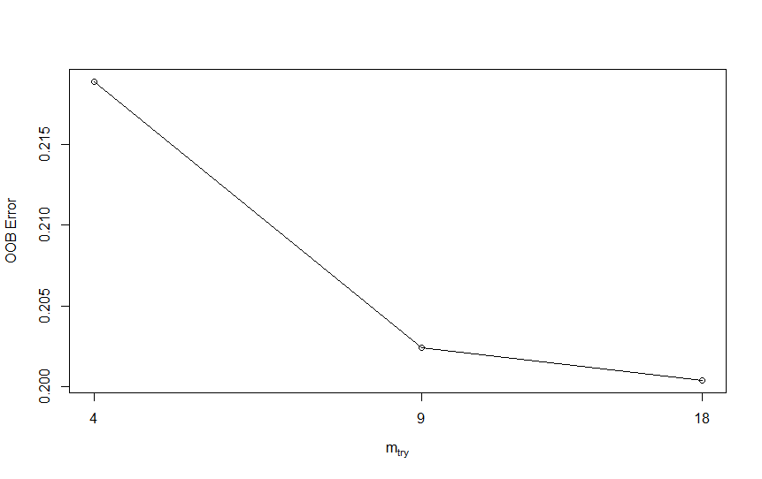

Figure: OOB error vs mtry graph

Conclusion

Viewing all the results from different models Random forest gave best model to classify the Otto group data records. Random forest seems well suited to the data record. However, further logloss could be reduced by ensemble more classifier and reduce the error rate. But in current situation Random forest seems promising and yield satifactory results

Our Submission Details on Kaggle

