**BT 307 Lab 05**

1. Harsh Arora
2. 200106034
3. 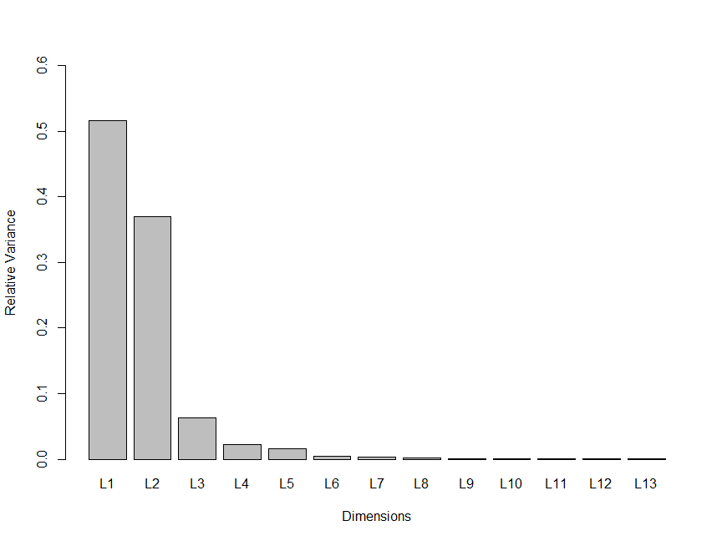
4. PC1 & PC2
5. 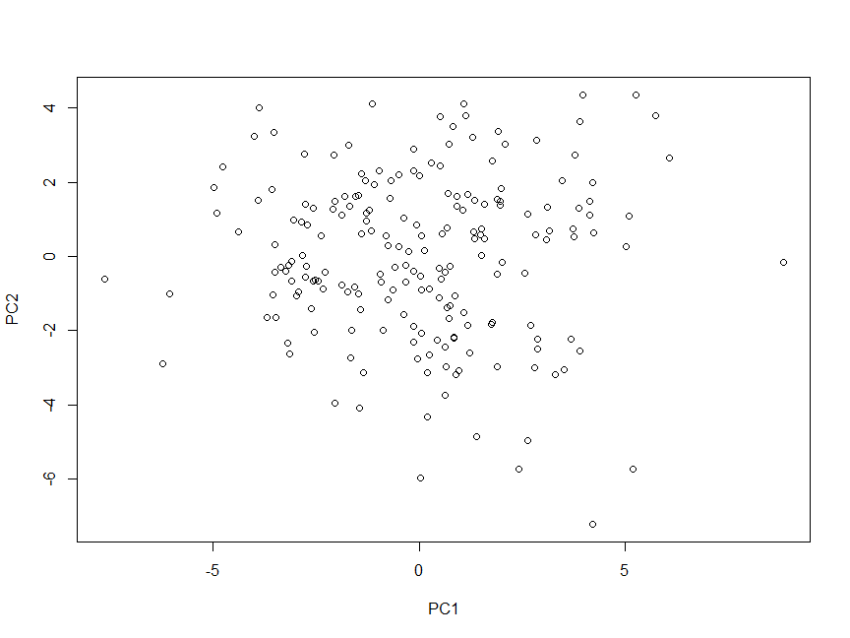
6. AreaShape_Area has the maximum positive contribution for PC1 & AreaShape_FormFactor has the maximum positive contribution for PC2