
A Report on
GREEN ROUTE: A GAMIFIED CAMPUS
SUSTAINABILITY & SMART WASTE
MANAGEMENT ENGINE
Under Subject of
Innovation and Design Thinking - I
Semester - III
Department of Information Technology
Submitted by
Jishu(2502031030139)
Dhruvin(2502031000022)
Nakul(T2602100330060)
Harsh(2502031000010)
Kushal(2502031000033)

Prof. Deepika shrivastav | Dr. Vikas Tulshyan
Internal Guide | Head of the Department

ACKNOWLEDGEMENT
We are heartily thankful to our supervisor, Prof. [Insert Guide Name], whose encouragement, supervision, and support from the preliminary to the concluding level enabled us to develop an understanding of the subject. We offer our regards and thanks to all those who supported us in any respect during the completion of the project and to our college for providing resources and materials.
We would like to extend our gratitude to Dr. Vikas Tulshyan, Head of the Information Technology Department, College of Technology, Silver Oak University, Ahmedabad, for his continuous encouragement and motivation.
Last but not the least, we are greatly indebted to everyone who has been associated with our project at any stage, including those whose names do not find a place in this acknowledgement.
Yours Sincerely,
Jishu(2502031030139)
Dhruvin(2502031000022)
Nakul(T2602100330060)
Harsh(2502031000010)
Kushal(2502031000033)

ABSTRACT
"Green Route" is a full-stack web application designed to improve City waste management by connecting facility logistics with Citizen engagement. Traditional City sanitation often relies on static collection schedules, which can lead to overflowing bins, wasted staff time, and limited motivation for students to participate in sustainable practices.
Green Route provides a dual-interface ecosystem. The Citizen Portal uses gamification features such as RPG-style ranks, daily quests, points, and leaderboards to encourage Citizens to dispose of waste properly and scan QR codes at smart-bin locations. The Admin Portal provides facility staff with an interactive map showing campus bin statuses.
The application uses a Python FastAPI backend, a SQLite database, SQLAlchemy ORM, and a frontend built with HTML5, CSS3, and JavaScript. Leaflet.js supports interactive campus mapping. A Nearest Neighbor routing heuristic calculates an efficient collection order for bins marked as full, helping staff avoid unnecessary visits. By combining engagement mechanisms with algorithmic route planning, Green Route aims to support a cleaner, smarter, and more sustainable campus.

LIST OF FIGURES
Figure No. | Figure Name | Page No.
1 | Main App Dashboard | 9
2 | Citizen Dashboard | 9
3 | Smart Drivers View | 9
4 | Points Scanner | 10

LIST OF TABLES
Table No. | Table Name | Page No.
1 | Sustainable Development Goals (SDGs) Addressed | 6-7
2 | Hardware and Software System Requirements | 7-8

TABLE OF CONTENT
 | ACKNOWLEDGEMENT | i
 | ABSTRACT | ii
 | LIST OF FIGURES | iii
 | LIST OF TABLES | iv
1 | INTRODUCTION | 1
1.1 | Problem Summary
1.2 | Purpose
1.3 | Scope
1.4 | Technical and Literature Review
2 | SYSTEM REQUIREMENT STUDY
2.1 | User Characteristics
2.2 | Hardware and Software Characteristics
2.2.1 | Hardware Requirements
2.2.2 | Software Requirements
3 | PROTOTYPE/MODEL/IMPLEMENTATION
3.1 | Details of Prototype
3.2 | Images of Prototype
4 | CANVAS
5.1 | AEIOU Canvas
5.2 | Ideation Canvas
5.3 | Product Development Canvas
5 | LIMITATION AND FUTURE ENHANCEMENT
6 | CONCLUSION
 | REFERENCES
 | APPENDIX

1. INTRODUCTION

1.1 Problem Summary
City environments generate substantial waste in concentrated areas, but traditional waste collection often follows fixed schedules rather than actual bin conditions. This creates several problems:
- Cleaning staff spend valuable working hours checking bins that are already empty.
- Bins in high-traffic areas may overflow before the next scheduled collection, creating unhygienic conditions.
- Citizens often lack motivation and feedback that would encourage correct waste disposal and recycling.

1.2 Purpose
The purpose of Green Route is to digitize campus waste infrastructure. By tracking bin status and calculating efficient collection routes, the system aims to reduce unnecessary collection effort. Its gamified reward system is intended to make responsible waste disposal more engaging and rewarding for students.

1.3 Scope
The current project focuses on a university campus and supports two main user groups:
- Students/Citizens: use a mobile web browser to scan QR codes, complete daily eco-quests, earn points, and track their leaderboard position.
- Administrators/Staff: use a desktop dashboard to monitor bin fullness across the campus and generate optimized collection routes.

1.4 Technical and Literature Review
The application follows a modern web architecture. The backend uses Python FastAPI for API services, with SQLite and SQLAlchemy ORM for relational data management. The frontend uses HTML5, CSS3, and vanilla JavaScript, with a Glassmorphism-style interface. Leaflet.js provides open-source interactive mapping. The routing engine uses a Nearest Neighbor heuristic, a commonly described approach for finding an approximate solution to local routing problems related to the Travelling Salesperson Problem.
Table 1: Sustainable Development Goals (SDGs) Addressed
SDG Goal | Description | Project Implementation
Goal 11 | Sustainable cities and communities | Enhances local campus waste infrastructure through digital tracking and smart management.
Goal 12 | Responsible consumption & production | Encourages students to actively participate in proper waste sorting and recycling via gamified incentives.
Goal 13 | Climate action | Reduces the operational carbon footprint by using algorithms to shorten the physical travel distance of cleaning staff.

2. SYSTEM REQUIREMENT STUDY

2.1 User Characteristics
Citizen (Student): The student interface should be quick, mobile-responsive, and visually engaging. Students interact with QR scanning simulation, quest boards, and leaderboards. The application provides visual feedback, such as points and confetti animations, after relevant interactions.
Admin (Facilities Staff): The administration interface emphasizes clear information and efficient controls. Staff need to view the Leaflet map, change bin status between Empty and Full, and run the route optimization process with a single action.

2.2 Hardware and Software Characteristics

2.2.1 Hardware Requirements
- Server side: a standard server, PC, or cloud-hosting environment capable of running Python.
- Client side — citizens: a smartphone with a working camera and a modern web browser.
- Client side — administrators: a desktop or laptop computer with an internet connection.

2.2.2 Software Requirements
- Backend: Python 3.x, FastAPI, Uvicorn, SQLAlchemy, and SQLite.
- Frontend: HTML5, CSS3, and JavaScript (ES6+).
- Libraries and map services: Leaflet.js and OpenStreetMap map tiles.
- Development tools: Visual Studio Code, Git, and a web browser such as Chrome, Edge, or Firefox.
Component | Technology / Requirement | Description
Backend Framework | Python 3.x, FastAPI | High-performance asynchronous server engine to handle API requests.
Database | SQLite, SQLAlchemy ORM | Lightweight relational database to store user profiles, points, and bin coordinates.
Frontend Stack | HTML5, CSS3, JavaScript | Creates the responsive, glassmorphism UI for both Citizen and Admin portals.
Mapping Library | Leaflet.js, OpenStreetMap | Renders the interactive campus map and draws the algorithmic collection routes.
Client Hardware | Smartphone / Desktop PC | Requires a standard web browser (Chrome, Safari, Edge) and internet connection.

3. PROTOTYPE / MODEL / IMPLEMENTATION

3.1 Details of Prototype
The prototype connects an interactive frontend to a backend service. It demonstrates the main user flows for students and administrators while allowing bin status and collection routing to be tested without dedicated physical hardware.
Database Models: The SQLite database contains two primary tables. The Users table tracks user-related information such as points, ranks, and credentials. The Bins table stores bin coordinates and fullness status.
API Endpoints: REST endpoints support user login, leaderboard sorting, bin-status changes, and route optimization. Examples in the supplied project report include /users/login and /bins/{bin_id}/status.
Algorithmic Routing: When an administrator requests a route, the backend retrieves bins marked as full, selects a starting coordinate, and repeatedly chooses the nearest unvisited full bin using Euclidean distance. The resulting ordered route is returned to the frontend, where Leaflet.js draws a dashed red path on the dashboard.

3.2 Images of Prototype
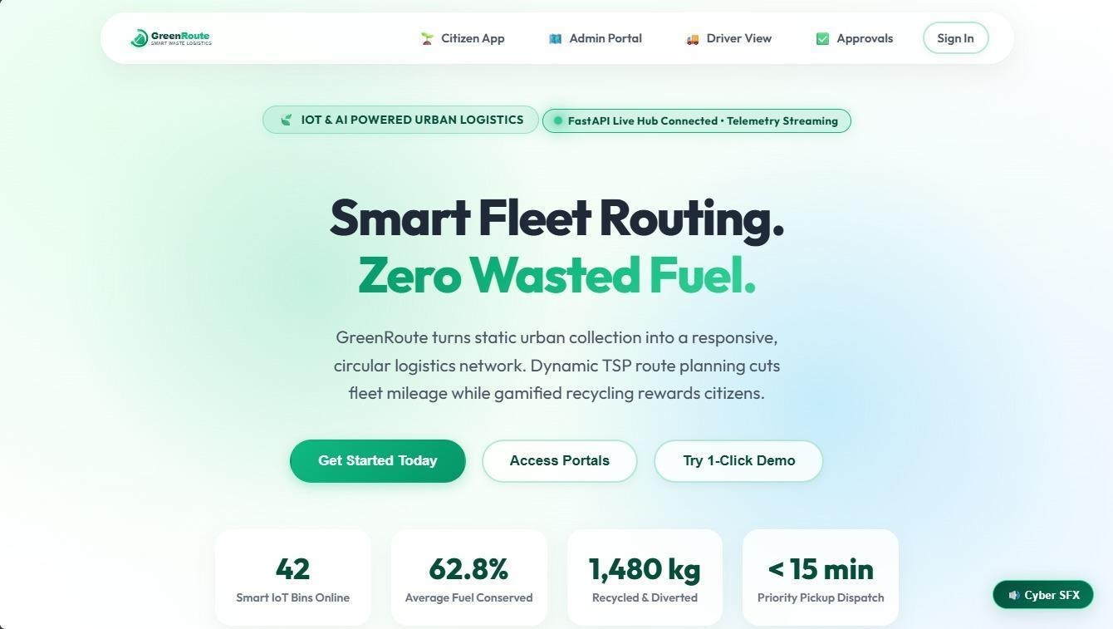
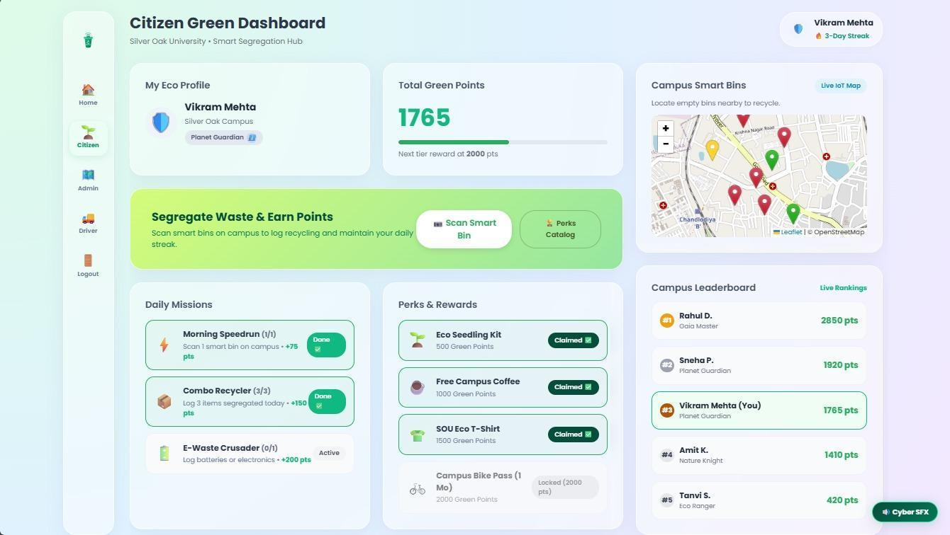
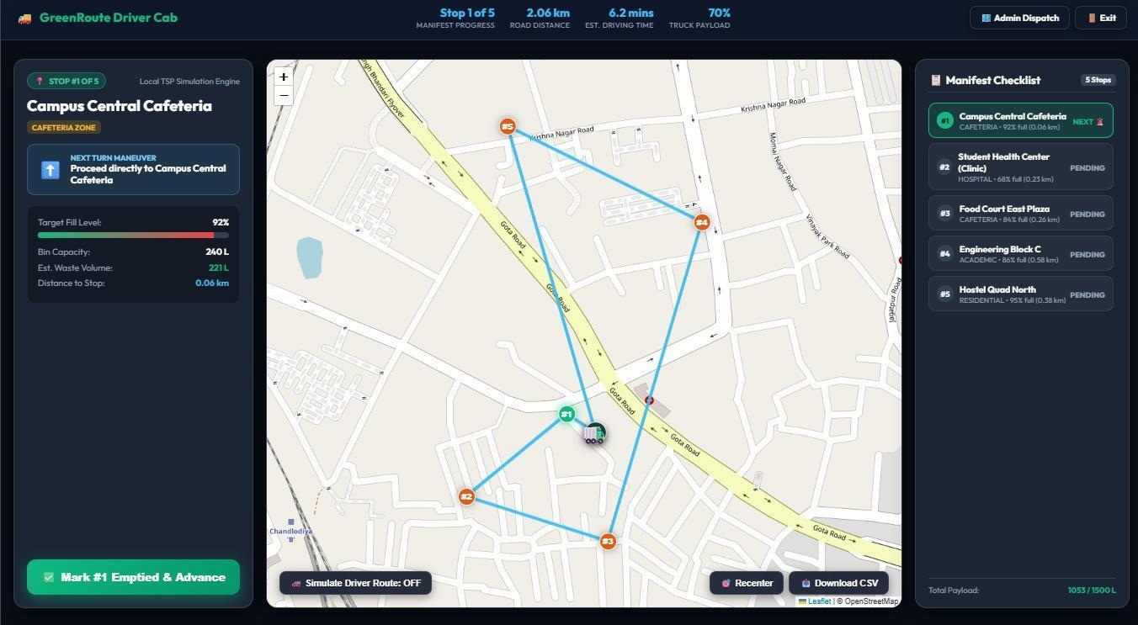
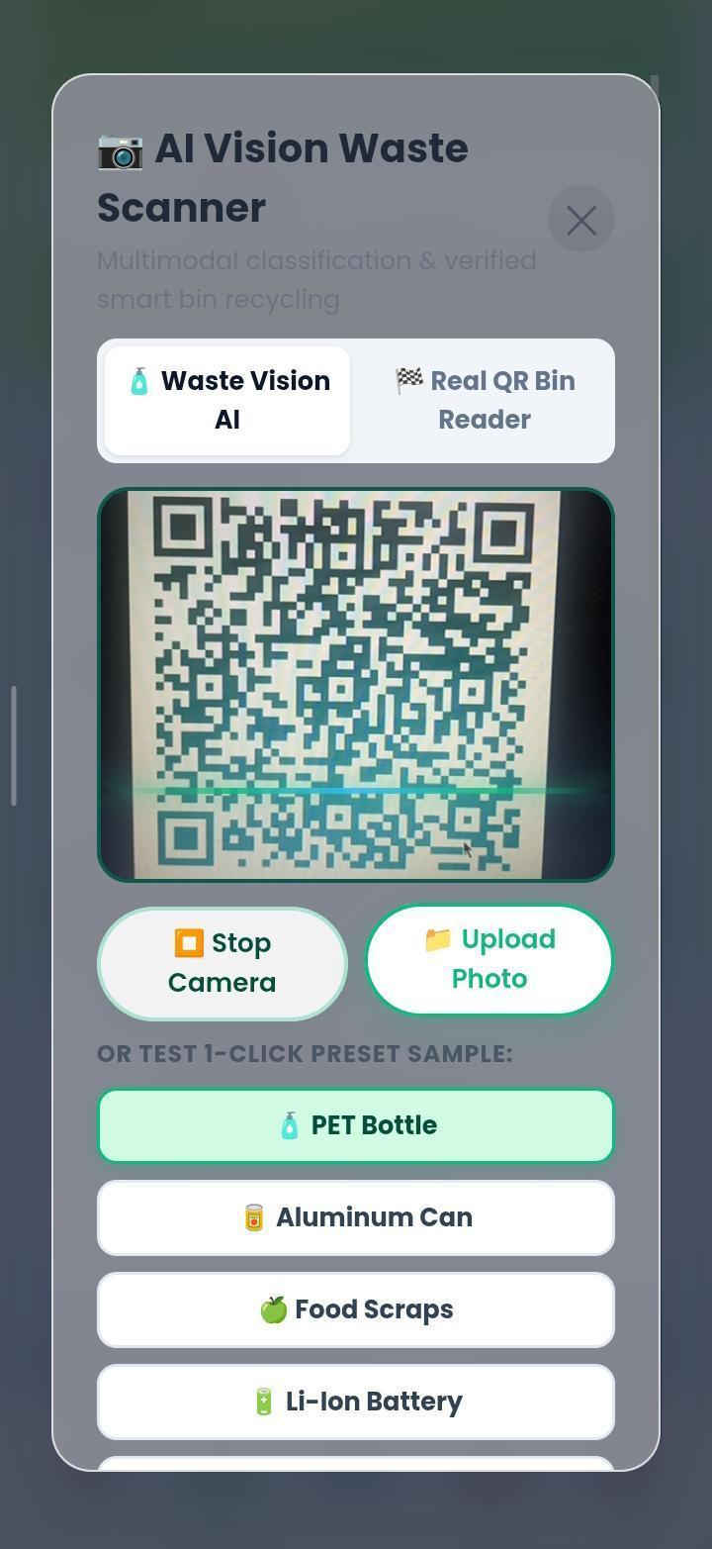

4. CANVAS

4.1 AEIOU Canvas
Activities: Disposing of waste, scanning QR codes, checking leaderboards, monitoring the campus map, and generating collection routes.
Environments: Campus grounds, cafeterias, library corridors, and administrative facility offices.
Interactions: Student-to-bin interaction during physical disposal; student-to-app interaction when claiming rewards; and admin-to-app interaction when updating bin status.
Objects: Smart bins, QR codes, smartphones, and desktop computers.
Users: University students, faculty, cleaning staff, and facility managers.
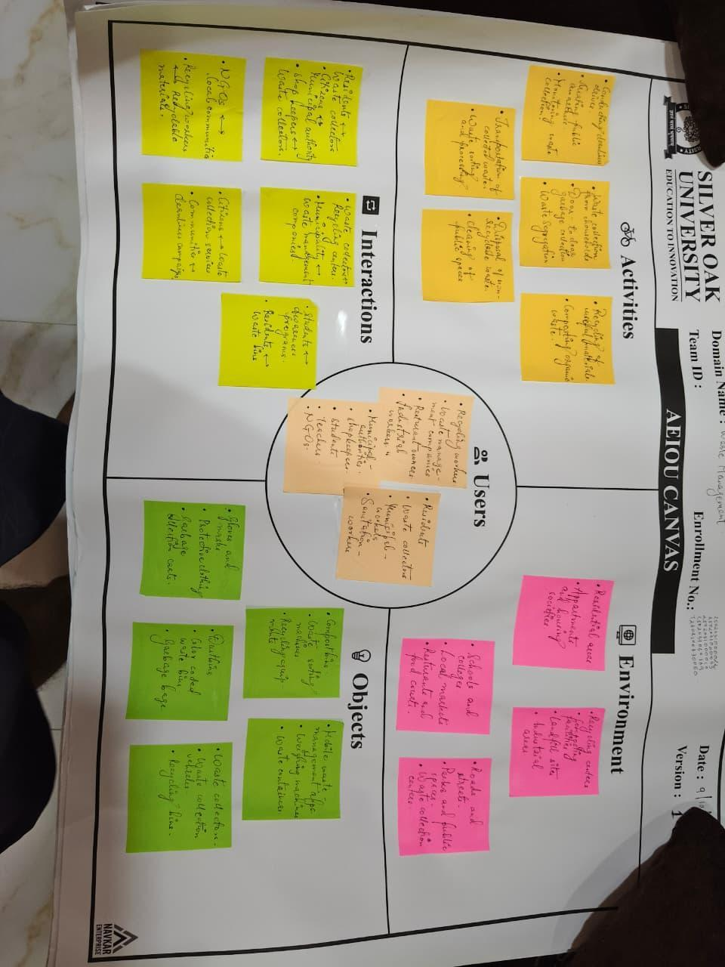

4.2 Ideation Canvas
The central ideation was to combine behavioral psychology through gamification with mathematical approaches to logistics. Brainstorming led to an RPG-style ranking system, with tiers such as “Novice Sprout” and “Gaia Master,” intended to encourage continued participation rather than one-time use.
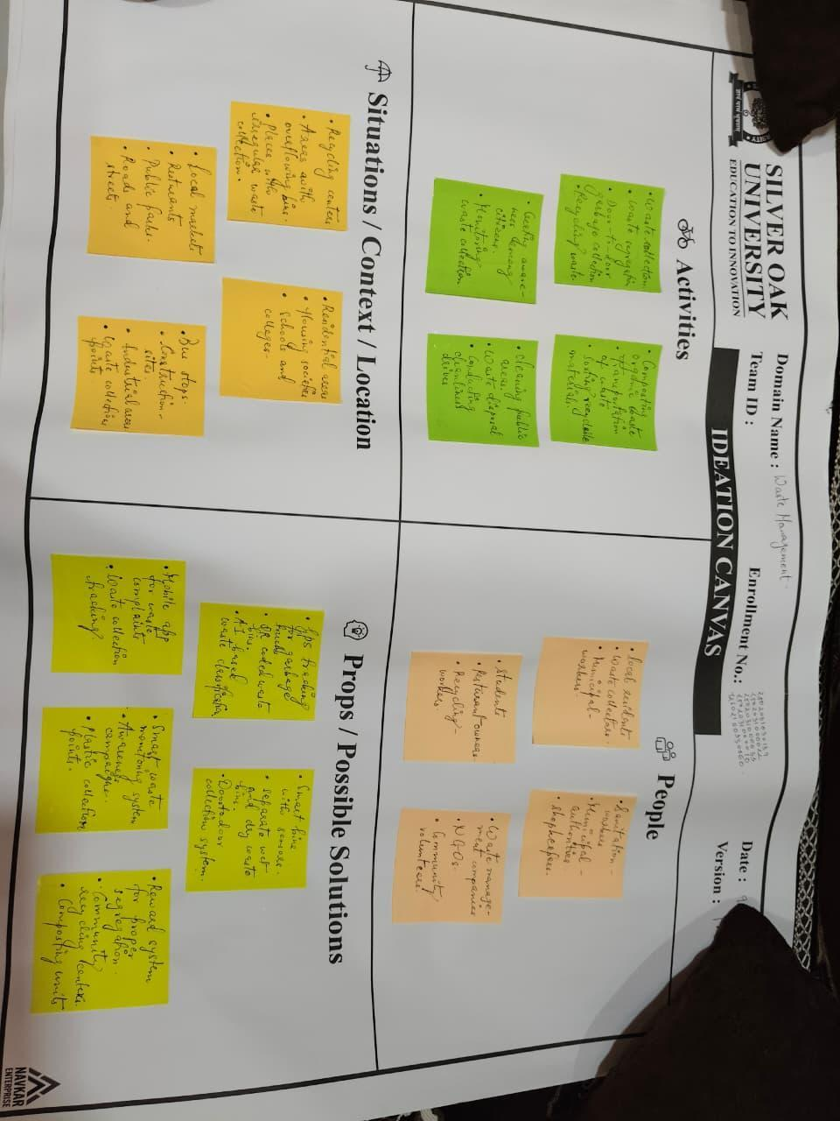

4.3 Product Development Canvas
The Minimum Viable Product (MVP) prioritized a software-first approach. Rather than building expensive physical hardware at the beginning, the team developed a full-stack web application in which bin fullness can be changed digitally. This enables the routing algorithm and gamification features to be tested and refined before integrating physical devices.
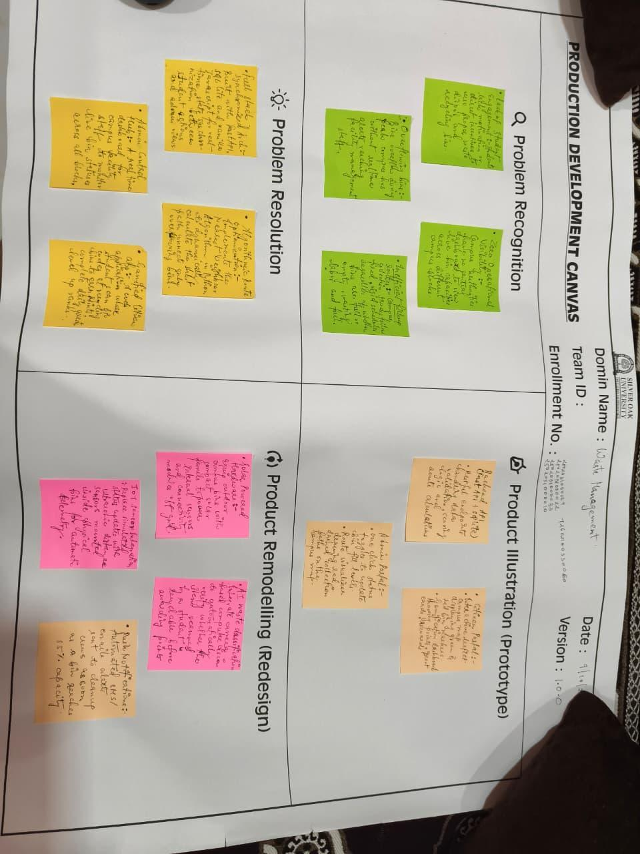
5. LIMITATION AND FUTURE ENHANCEMENT

Limitations of Current System
The current prototype relies on manual input to determine bin capacity. An administrator or user must change a bin to “Full” for the routing algorithm to include it. QR scanning is also a software simulation and does not yet process physical cryptographic QR codes.

Future Enhancements (IoT Integration)
A primary future enhancement is to extend the software into an Internet of Things (IoT) ecosystem. Ultrasonic sensors, such as HC-SR04, connected to microcontrollers such as ESP32 could be installed inside campus bins. The sensors could measure waste levels and send updates to the FastAPI backend over Wi-Fi when a bin reaches a configured threshold, such as 90% capacity. This would reduce the need for manual monitoring.

6. CONCLUSION
Green Route demonstrates how web development and algorithmic thinking can address a localized campus infrastructure problem. A FastAPI and SQLite backend, combined with a Leaflet.js frontend, provides a connected workflow for students and administrators.
Gamification addresses the human aspect of sustainability by encouraging participation, while the Nearest Neighbor routing heuristic aims to reduce unnecessary collection effort. The project aligns with the aims of Sustainable Development Goals 11, 12, and 13 by supporting a smarter, cleaner, and more optimized campus environment.

REFERENCES
[1] FastAPI Documentation. (n.d.). FastAPI: High performance, easy to learn, fast to code. https://fastapi.tiangolo.com/
[2] Leaflet.js. (n.d.). Leaflet: An open-source JavaScript library for mobile-friendly interactive maps. https://leafletjs.com/
[3] SQLAlchemy Documentation. (n.d.). The Database Toolkit for Python. https://www.sqlalchemy.org/
[4] OpenStreetMap Foundation. (n.d.). OpenStreetMap Data. https://www.openstreetmap.org/
[5] Larrañaga, P., et al. (1999). “Genetic algorithms for the travelling salesperson problem: A review of representations and operators.” Artificial Intelligence Review.

APPENDIX
APPENDIX A: Core API Endpoints (FastAPI)

POST /users/auth: Authenticates Citizens and Facilities Admins, managing session states.

GET /bins/telemetry: Retrieves real-time spatial coordinates and current fill-levels for rendering on the Leaflet.js campus map.

POST /citizens/scan: Processes QR code verifications for smart bin recycling and allocates Green Points, applying multiplier bonuses for specific categories like E-Waste or Plastics.

GET /routes/dynamic-tsp: Executes the fleet routing logic and returns an optimized array of waypoints for the driver's manifest.

APPENDIX B: Priority TSP Routing Heuristic

The dynamic routing engine calculates the optimal collection path using a Nearest Neighbor algorithmic approach to minimize fleet mileage:

Threshold Filtering: Identifies target bins based on current capacity telemetry (Standard bins ≥ 80% full; Priority zones like clinics or cafeterias ≥ 60% full).

Distance Calculation: Computes the Euclidean distance from the dispatch hub (or current driver node) to all unvisited target bins.

Path Generation: Selects the nearest unvisited node, appends it to the turn-by-turn manifest, and repeats the calculation until all critical bins are routed.

APPENDIX C: Gamification & Rewards Matrix

Rank Progression: Ranks scale dynamically (e.g., from Novice Sprout to Gaia Master) based on cumulative Green Points to encourage long-term student retention.

Daily Missions: Rotating objectives such as "Combo Recycler" (logging multiple segregated items) or "Morning Speedrun" to build daily engagement streaks.

Perks Catalog: Points act as a localized currency redeemable for university perks (e.g., Eco Seedling Kits at 500 points, Campus Coffee at 1000 points, and SOU Eco T-Shirts at 1500 points).

APPENDIX D: Proposed IoT Hardware Architecture (Future Scope)

Microcontroller: ESP32 modules utilized for edge processing and Wi-Fi telemetry streaming.

Sensors: HC-SR04 Ultrasonic distance sensors mounted inside bins to measure volumetric fill rates in real-time.

Power Management: Solar-powered modules for outdoor campus bins to ensure continuous, off-grid telemetry streaming to the FastAPI hub.

