INTEGRATION

Section 1 — Prerequisites

Hardware Requirements
- Microcontroller: ESP32 DevKitC v4 development board.
- Audio Input: INMP441 I2S MEMS microphone module.
- Audio Output: MAX98357A I2S Class-D amplifier module.
- User Controls: 3 × tactile push-button switches with 3 × 10 kΩ pull-up resistors.
- Prototyping: Standard solderless breadboard and solid-core jumper wires.

Software Stack
- Framework: Espressif IoT Development Framework (ESP-IDF v5.x).
- Build Tools: CMake version 3.16+ and Ninja build generator.

Mandatory Working Baselines
Do not attempt integration until you have verified these conditions with your team leads:
- Clean Mic Captures: mic.c / mic.h reads from the INMP441 and provides uncorrupted, floating-point audio data blocks.
- Clean Amp Playback: amp.c / amp.h consumes floating-point blocks and outputs clean audio to the speaker without crackles or clock distortion.
- Standalone Math Compilation: All filter libraries (biquad.c, low_pass.c, equalizer.c, etc.) compile successfully standalone on a host PC framework without warnings or errors.

Project Directory Layout
Your workspace directory tree must match this repository tracking layout exactly:
┌───────────────────────────────────────┐
│ C_implementation │
│ ├── Band_Pass │
│ ├── biquad │
│ ├── CMakeLists.txt │
│ ├── CMakeSettings.json │
│ ├── common_types │
│ ├── delay │
│ ├── dsp_types │
│ ├── equalizer │
│ ├── gain │
│ ├── high_pass │
│ ├── limiter │
│ ├── low_pass │
│ ├── main_test.c │
│ ├── pipeline_control │
│ └── preset │
│ │
│ esp32_firmware │
│ ├── build │
│ ├── CMakeLists.txt │
│ ├── components │
│ ├── main │
│ ├── Outputs │
│ ├── sdkconfig │
│ └── sdkconfig.old │
└───────────────────────────────────────┘



Master Signal Flow Reference Diagram
This architectural diagram maps out the path an audio block travels through physical hardware pins, normalization tracks, and real-time DSP layers. Use this master flow map to trace data types and scaling operations throughout this integration guide.
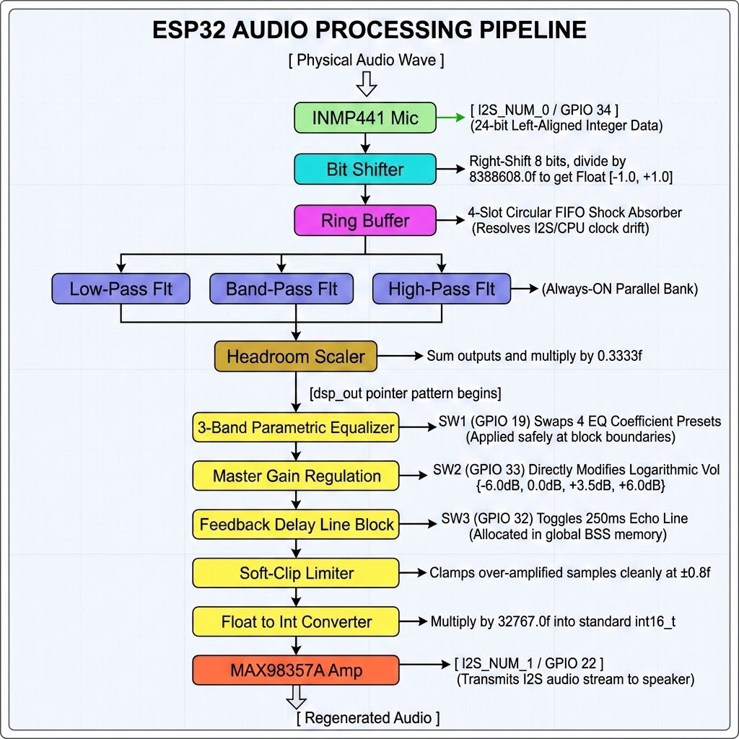

Section 2 — Build System Setup

1. Objective & Placement
The objective of Section 2 is to configure the ESP-IDF build system to discover and compile modular engineering blocks, called components. By default, the build generator only scans inside the local esp32_firmware/components path. To link the implementation team's DSP filter libraries cleanly without making redundant local file copies, you inject external paths using the EXTRA_COMPONENT_DIRS variable inside your project's root CMakeLists.txt file.
Each individual component directory relies on a local CMakeLists.txt file executing idf_component_register() to declare its compilation properties according to this reference matrix:

Argument Name | Purpose | Impact on Failure
SRCS | List of explicit C source files (.c) to compile. | Files are omitted from compilation.
INCLUDE_DIRS | Path to public header files (.h); use . for the current folder. | External modules cannot locate headers.
REQUIRES | List of component dependencies required by this module. | Compilation fails with unresolvable header errors.

The build system resolves compilation priority by evaluating this dependency graph topology in reverse order:

2. Minimal Code Snippet

Project Root Configuration (esp32_firmware/CMakeLists.txt)
Inject external folders directly into the environment parameters before resolving the standard project macros:
cmake_minimum_required(VERSION 3.16)

# Inject external mathematical algorithm directories directly into the build environment
set(EXTRA_COMPONENT_DIRS
../C_implementation/low_pass
../C_implementation/high_pass
../C_implementation/Band_Pass
../C_implementation/biquad
../C_implementation/equalizer
../C_implementation/delay
../C_implementation/gain
../C_implementation/limiter)

include($ENV{IDF_PATH}/tools/cmake/project.cmake)
set(CMAKE_C_FLAGS "${CMAKE_C_FLAGS} -Wno-error=unused-variable -Wno-error=unused-const-variable")
project(esp32_audio_DSP)

Sub-Component Configuration Example (C_implementation/low_pass/CMakeLists.txt)
Declare local library dependencies using the explicit architecture arguments:

idf_component_register( SRCS "low_pass.c" INCLUDE_DIRS "." REQUIRES common biquad )

Critical Constraint: Case-Sensitivity Matching
Component names resolved by CMake must match the literal folder names on your disk exactly. If your physical repository folder is named Band_Pass, listing a lowercase band_pass entry inside a REQUIRES statement will break the build engine.

Verification Sequence
- Navigate to your target project folder through your command line shell and flush the build cache:
cd ~/esp/esp32_audio_DSP/esp32_firmware
idf.py reconfigure
- Monitor the terminal generation logs. Verify that your external DSP modules are discovered and listed explicitly right before the build track completes:
-- Component names: amp audio_pipeline Band_Pass biquad common delay equalizer...
-- Configuring done
-- Generating done
-- Build files have been written to: .../esp32_firmware/build
- If a specific module name is missing from the indexed array listing, cross-check the relative directory paths defined inside your root EXTRA_COMPONENT_DIRS block.

Section 3 — audio_config.h — Central Configuration
To prevent configuration mismatches between your hardware drivers and the DSP filter libraries, the system establishes audio_config.h as the Single Source of Truth. Every structural component must include this header file to ensure timing, pins, and coefficients remain synchronized.

System Constraints Matrix
The temporal, memory, and structural bounds of our real-time environment are governed by five central parameters:

Constant Name | Defined Value | Significance | Operational Impact
AUDIO_SAMPLE_RATE | 16000 (16 kHz) | Voice bandwidth. | Nyquist limit: 8 kHz.
AUDIO_BLOCK_SIZE | 256 Samples | Frames per cycle. | Deadline: <16ms to avoid audio dropouts.
RING_BUFFER_SLOTS | 4 Slots | 1024 total samples. | 64ms intentional latency.
EQ_NUM_PRESETS | 4 Presets | Profile sizing factor. | Sets bounds for EQ arrays.
GAIN_STEPS | 4 Steps | Volume lookup factor. | Sets logarithmic gain bounds.

Core Configuration File (main/include/audio_config.h)
Populate your centralized header configuration file with these synchronized macros:

#ifndef AUDIO_CONFIG_H
#define AUDIO_CONFIG_H

// Real-Time Audio Stream Parameters
#define AUDIO_SAMPLE_RATE 16000
#define AUDIO_BLOCK_SIZE 256
#define RING_BUFFER_SLOTS 4
#define EQ_NUM_PRESETS 4
#define GAIN_STEPS 4

// Always-ON Baseline Pre-Filter Coefficients {b0, b1, b2, a1, a2}
#define COEFFS_BASELINE_LP { 0.00312629f, 0.00625258f, 0.00312629f, -1.79158896f, 0.80409412f }
#define COEFFS_BASELINE_BP { 0.12491506f, 0.00000000f, -0.12491506f, -1.66451047f, 0.75016988f }
#define COEFFS_BASELINE_HP { 0.51627979f, -1.03255959f, 0.51627979f, -0.85540037f, 0.20971880f }

// 3-Band Equalizer Preset 0: Flat Profile Matrix
#define EQ_LP_PRESET_0 { 0.00312629f, 0.00625258f, 0.00312629f, -1.79158896f, 0.80409412f }
#define EQ_BP_PRESET_0 { 0.12491506f, 0.00000000f, -0.12491506f, -1.66451047f, 0.75016988f }
#define EQ_HP_PRESET_0 { 0.51627979f, -1.03255959f, 0.51627979f, -0.85540037f, 0.20971880f }

// 3-Band Equalizer Preset 1: Bass Boost Profile Matrix
#define EQ_LP_PRESET_1 { 0.00554263f, 0.01108527f, 0.00554263f, -1.77860502f, 0.80077556f }
#define EQ_BP_PRESET_1 { 0.03822972f, 0.00000000f, -0.03822972f, -1.94301883f, 0.94902703f }
#define EQ_HP_PRESET_1 { 0.98347477f, -1.96694954f, 0.98347477f, -1.96667652f, 0.96722256f }

// Hardware Pin Routing Allocations
#define PIN_MIC_WS 25
#define PIN_MIC_SCK 26
#define PIN_MIC_SD 34
#define PIN_AMP_WS 14
#define PIN_AMP_BCK 27
#define PIN_AMP_DO 22
#define GPIO_SWITCH1 19 // SW1: Cycles 4 EQ presets
#define GPIO_SWITCH2 33 // SW2: Cycles 4 Master Gain steps
#define GPIO_SWITCH3 32 // SW3: Toggles Feedback Delay line

#endif // AUDIO_CONFIG_H

Note on Per-Band EQ Gain Structs
Alongside raw filter coefficients, each preset maps decibel scaling variables directly to its low, mid, and high bands through an eq_gain_config_t structure. This lets you scale or suppress specific frequency ranges relative to one another.

Hardware Pin Mapping (GPIO Layout)
This table defines the physical copper routing pathways between the ESP32 DevKitC and your peripheral components:

Hardware Block | Signal Role | ESP32 Pin | Module Label
INMP441  Microphone | I2S_WS (Word Select) | GPIO 25 | WS
 | I2S_SCK (Serial Clock) | GPIO 26 | SCK
 | I2S_SD (Serial Data Out) | GPIO 34 | SD
MAX98357A  Amplifier | I2S_WS (Word Select) | GPIO 14 | LRC
 | I2S_BCK (Bit Clock) | GPIO 27 | BCLK
 | I2S_DO (Serial Data In) | GPIO 22 | DIN

Critical Warning: The Pin 35 Trap
Do not attempt to use GPIO 34 through GPIO 39 for tactile switches. These pins are strictly input-only and completely lack internal pull-up or pull-down circuitry.
Enabling GPIO_PULLUP_ENABLE on these lines is silently ignored by the hardware, causing the pins to float electronically, capture environmental electrical noise, and trigger rapid, phantom switch signals. Always route interactive UI controls through pins with full internal pull-up support like GPIO 19, 32, and 33.

Expected Result & System Verification
To verify that your centralized header is globally accessible across all custom component sub-directories without causing circular compiler reference flags, ensure the macro is included in your code modules:
#include "audio_config.h"
Execute a trial compilation from your shell terminal:
idf.py build

Expected Results
- The build process should complete successfully without "undeclared identifier" errors, confirming that all components can locate and access the centralized configuration header.

Verification Checkpoint
If your folder search paths are cleanly configured inside CMake, the project generator will compile smoothly. If compilation halts with an error: 'AUDIO_BLOCK_SIZE' undeclared here error log, verify that #include "audio_config.h" has been explicitly stated at the top of that specific throwing source module.

Section 4 — Stage 1: Mic → Ring Buffer → Amp (Passthrough)

1. Objective & Placement
The primary objective of Stage 1 is to establish a verified hardware baseline. By passing raw audio data unmodified from the input peripheral to the output amplifier, you isolate low-level I2S configuration and wiring issues before introducing floating-point DSP mathematical operations.
The architecture of this foundational real-time baseline stage tracks data along a direct hardware-to-software line:

A 4-slot ring buffer acts as an electronic shock absorber, absorbing slight variations in CPU processing times and decoupling the strict 16ms hardware timing from your main application thread. On startup, the system encounters a brief window where the memory blocks are empty. To prevent the speaker from emitting harsh startup noise, an internal Underflow Guard checks the buffer status; if the read status is not valid, it immediately executes a memory clearing operation to insert silence until the microphone DMA channels fill the initial memory slots.

2. Minimal Code Snippet

Custom Pipeline Frame Handler (audio_pipeline.c)
Configure your processing function to shuttle audio blocks directly across your system buffers without applying filter alterations:
#include "audio_pipeline.h"
#include "audio_config.h"
#include "mic.h"
#include "amp.h"
#include "ring_buffer.h"
#include <string.h>
static float input_block[AUDIO_BLOCK_SIZE];
static float rb_out[AUDIO_BLOCK_SIZE];
STATUS audio_Process(audio_hdl *hdl)
{
if (!hdl) return STATUS_NOT_OK;
// 1. Fetch a 256-sample block of float data from the microphone I2S channel
mic_Process(hdl->mic, input_block, AUDIO_BLOCK_SIZE);
// 2. Transfer data through FIFO; apply Underflow Guard if queue is empty
if (rb_Process(hdl->rb, input_block, rb_out, AUDIO_BLOCK_SIZE) != STATUS_OK)
{
memset(rb_out, 0, AUDIO_BLOCK_SIZE * sizeof(float));
}
// 3. Output the raw, unmodified block directly to the amplifier I2S channel
amp_Process(hdl->amp, rb_out, AUDIO_BLOCK_SIZE);
return STATUS_OK;
}
Synchronized Application Main Execution (main/main.c)
Structure your primary runtime thread to call the block execution function on loop

#include "freertos/FreeRTOS.h"
#include "freertos/task.h"
#include "audio_pipeline.h"
#include <stdio.h>
void app_main(void)
{
printf("[BOOT] Starting Stage 1 Passthrough Baseline...\n");
audio_hdl pipeline_handle;
if (audio_Open(&pipeline_handle) != STATUS_OK || audio_Initialize(&pipeline_handle) != STATUS_OK)
{
printf("[ERROR] Hardware pipeline initialization failed!\n");
return;
}
printf("[MAIN] System running. Passthrough link established.\n");
while (1)
{
// Executes block routing. mic_Process handles execution timing
// by naturally blocking the loop for 16ms while waiting for hardware DMA data.
audio_Process(&pipeline_handle);
}
}

Critical Real-Time Warning: The vTaskDelay Timing Bottleneck
Never insert vTaskDelay(1) or any manual sleep functions inside your primary while(1) processing loop.
FreeRTOS delays use a fixed 10ms timing window. Because your entire 256-sample audio frame must complete processing within an absolute 16ms real-time deadline, losing 10ms to an artificial sleep command leaves the CPU with only 6ms to perform tracking tasks. This causes severe buffer underflows and immediate audio dropout. mic_Process() handles thread sleep intervals naturally by blocking execution until the hardware pins indicate a fresh block is ready.

3. Verification Checkpoint

Expected Behavior
The firmware operates as a transparent digital pipeline. Audio signals captured by the microphone play back instantly through the speaker with no acoustic coloring. Because the 4-slot ring buffer caches data frames to prevent dropouts, you will observe an inherent, normal latency profile of approximately 64ms.

Step-by-Step Verification Sequence
- Secure the ESP32 connection to your host workstation and execute the deployment sequence:
idf.py build flash monitor
- Verify that the system registers a clean initialization log free of I2S configuration warnings:
[BOOT] Starting Stage 1 Passthrough Baseline...
[MAIN] System running. Passthrough link established.
- Snap your fingers near the microphone sensor. The speaker should immediately output a crisp, uncorrupted reproduction of the sound. If you hear clear audio without crackling or clicking, your physical hardware and core buffer layers are fully functional.

Section 5 — Stage 2: Add Hardcoded Biquad Filters (Always ON)

1. Objective & Placement
The objective of Stage 2 is to implement the always-on parallel baseline pre-filter bank for real-time signal conditioning. These filters run continuously on every audio block to shape the raw microphone response, remove high-frequency hiss, isolate the vocal range, and cut out low-frequency environmental noise before the signal hits user-controlled effects.
Data paths split from the ring buffer into three concurrent cascaded biquad stages before being scaled and recombined:

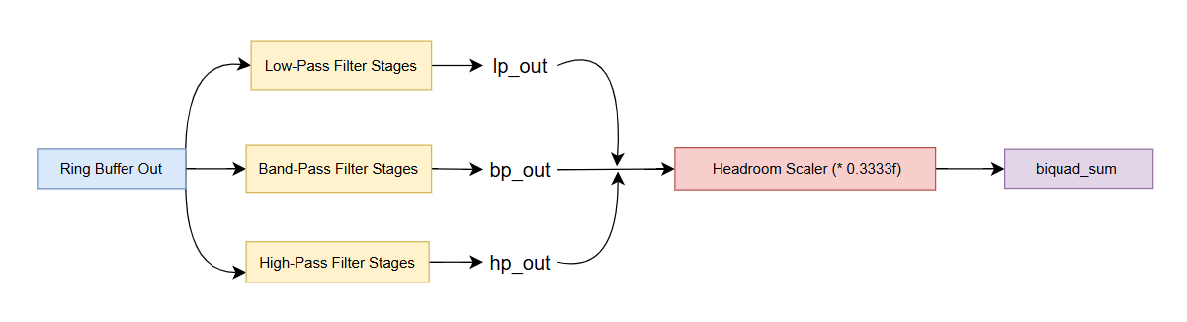

To prevent digital overflow and clipping distortion when combining the outputs, the summation node scales the merged signals by a factor of exactly 0.3333f. Sharp frequency cutting is achieved by passing each split stream through a two-stage biquad cascade using static configuration structures.

2. Minimal Code Snippet

Conditioned Signal Chain Implementation (audio_pipeline.c)
Configure your file-scope tracking blocks and parallel execution matrix within your main pipeline file:

#include "audio_pipeline.h"
#include "audio_config.h"
#include "mic.h"
#include "amp.h"
#include "ring_buffer.h"
#include "low_pass.h"
#include "band_pass.h"
#include "high_pass.h"
#include <string.h>

// File-scope static allocations protecting the stack from memory leaks
static float input_block[AUDIO_BLOCK_SIZE];
static float rb_out[AUDIO_BLOCK_SIZE];
static float lp_out[AUDIO_BLOCK_SIZE];
static float bp_out[AUDIO_BLOCK_SIZE];
static float hp_out[AUDIO_BLOCK_SIZE];
static float biquad_sum[AUDIO_BLOCK_SIZE];

static low_pass_hdl_t bq_lp;
static band_pass_hdl_t bq_bp;
static high_pass_hdl_t bq_hp;

static low_pass_config_t bq_lp_cfg = { .coeffs = COEFFS_BASELINE_LP };
static band_pass_config_t bq_bp_cfg = { .coeffs = COEFFS_BASELINE_BP };
static high_pass_config_t bq_hp_cfg = { .coeffs = COEFFS_BASELINE_HP };

STATUS audio_Initialize(audio_hdl *hdl){
// ... Driver peripheral setup code omitted for focus ...

// Initialize tracking registers for the structured filter modules
low_pass_init(&bq_lp, &bq_lp_cfg);
band_pass_init(&bq_bp, &bq_bp_cfg);
high_pass_init(&bq_hp, &bq_hp_cfg);

return STATUS_OK;
}

STATUS audio_Process(audio_hdl *hdl){
if (!hdl) return STATUS_NOT_OK;

mic_Process(hdl->mic, input_block, AUDIO_BLOCK_SIZE);

if (rb_Process(hdl->rb, input_block, rb_out, AUDIO_BLOCK_SIZE) != STATUS_OK)
{
memset(rb_out, 0, AUDIO_BLOCK_SIZE * sizeof(float));
}

// Process raw data block through the 3 pre-filters simultaneously
low_pass_process(&bq_lp, rb_out, lp_out, AUDIO_BLOCK_SIZE);
band_pass_process(&bq_bp, rb_out, bp_out, AUDIO_BLOCK_SIZE);
high_pass_process(&bq_hp, rb_out, hp_out, AUDIO_BLOCK_SIZE);

// Recombine streams using a headroom scaler to avoid digital clipping
for (uint32_t i = 0; i < AUDIO_BLOCK_SIZE; i++)
{
biquad_sum[i] = (lp_out[i] + bp_out[i] + hp_out[i]) * 0.3333f;
}

amp_Process(hdl->amp, biquad_sum, AUDIO_BLOCK_SIZE);

return STATUS_OK;
}


3. Verification Checkpoint

Expected Behavior
The system maintains its real-time processing schedule, but the sound profile changes distinctly. Output audio sounds noticeably warmer, smoother, and heavily filtered. High-frequency background ambient hiss is suppressed, and low-frequency mechanical rumbles or room vibrations are heavily attenuated while vocal clarity is preserved.

Step-by-Step Verification Sequence
- Compile and flash the pipeline firmware update:
idf.py build flash monitor
2. Verify that the startup diagnostic logs show the application initializing successfully:
[BOOT] Starting Stage 2 Hardcoded Filter Assembly...
[MAIN] System running. Parallel filter bank online.

Section 6 — Stage 3: Add EQ with Preset Switching (SW1)

1. Objective & Placement
The objective of Stage 3 is to integrate an interactive 3-Band Parametric Equalizer (EQ) block controlled by physical switch SW1 (GPIO 19). The EQ resides directly after the always-on baseline filter sum (biquad_sum) and before the master gain stage.
To prevent high CPU overhead from moving massive floating-point blocks, the pipeline uses a Zero-Copy Pointer Pattern. A moving tracking pointer (dsp_out) passes data block references directly between processing stages without utilizing slow memory copying routines.
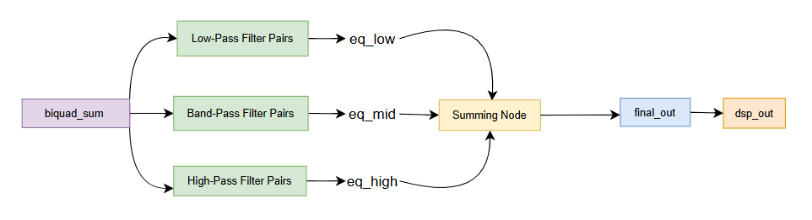

The Block Boundary Safe Zone & Pull-Up Circuit
Updating coefficients inside the running audio streaming window will destabilize filter difference equations and trigger an immediate system lockup. To prevent this, the architecture establishes a Block Boundary Safe Zone. The tactile switch asynchronously schedules changes via a flag variable (eq_preset_pending), and the system executes audio_apply_pending() safely between execution blocks right before calling audio_Process().
To protect the logic line from picking up environmental electromagnetic noise, wire the switch

with a hardware pull-up network:
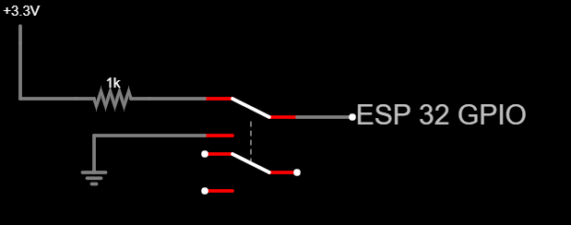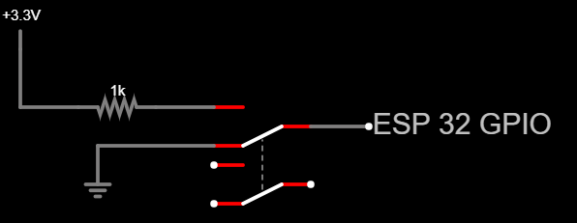

2. Minimal Code Snippet

Zero-Copy Pipeline Traversal Block (audio_pipeline.c)
Incorporate the structural pointer traversal pattern and the multi-band equalizer processing array inside your pipeline source:

#include "audio_pipeline.h"
#include "audio_config.h"
#include "equalizer.h"
#include "gain.h"

static float eq_low[AUDIO_BLOCK_SIZE];
static float eq_mid[AUDIO_BLOCK_SIZE];
static float eq_high[AUDIO_BLOCK_SIZE];
static float final_out[AUDIO_BLOCK_SIZE];

static equalizer_hdl_t eq_hdl;
static eq_gain_track_t eq_gain_hdl; // Maps independent low/mid/high gain sub-handles

STATUS audio_Process(audio_hdl *hdl)
{
// ... Step 1: Mic Capture, Step 2: Ring Buffer, Step 3: Always-ON Filters complete ...
const float *dsp_out = biquad_sum; // Initialize the zero-copy pointer tracking reference

if (hdl->eq_enabled)
{
// 1. Deconstruct the block into Low, Mid, and High spectrum channels
equalizer_process(&eq_hdl, biquad_sum, eq_low, eq_mid, eq_high, AUDIO_BLOCK_SIZE);

// 2. Scale amplitudes independently across frequency domains via per-band gain structs
gain_process(&eq_gain_hdl.low, eq_low, eq_low, AUDIO_BLOCK_SIZE);
gain_process(&eq_gain_hdl.mid, eq_mid, eq_mid, AUDIO_BLOCK_SIZE);
gain_process(&eq_gain_hdl.high, eq_high, eq_high, AUDIO_BLOCK_SIZE);

// 3. Recombine paths into a single output buffer
for (uint32_t i = 0; i < AUDIO_BLOCK_SIZE; i++)
{
final_out[i] = eq_low[i] + eq_mid[i] + eq_high[i];
}
dsp_out = final_out; // Advance tracking pointer reference without dynamic allocations
}

// Send the active tracking pointer block directly to the amplifier channel
amp_Process(hdl->amp, dsp_out, AUDIO_BLOCK_SIZE);
return STATUS_OK;
}


Debounced Switch Monitoring Loop (main/main.c)
Isolate the asynchronous falling-edge button polling check inside your core background thread:

#include "freertos/FreeRTOS.h"
#include "freertos/task.h"
#include "driver/gpio.h"
#include "audio_pipeline.h"

#define DEBOUNCE pdMS_TO_TICKS(200) // 200ms software lock out interval

void app_main(void){
audio_hdl hdl;
// ... Pipeline initialization tracks execute ...

TickType_t last_sw1 = 0;
int prev_sw1 = 1;
uint8_t eq_preset = 0;
uint8_t eq_preset_pending = 0;

while (1)
{
TickType_t now = xTaskGetTickCount();
int s1 = gpio_get_level(GPIO_SWITCH1);

// Detect a clean falling edge (Transition from unpressed 1 to pressed 0)
if (prev_sw1 == 1 && s1 == 0 && (now - last_sw1) > DEBOUNCE)
{
last_sw1 = now;
eq_preset_pending = (eq_preset + 1) % EQ_NUM_PRESETS;
printf("[SW1] EQ preset -> %d\n", eq_preset_pending);
}
prev_sw1 = s1;

// Apply any pending parameters safely outside the I2S timing window
audio_apply_pending(&hdl, eq_preset_pending);

// Naturally blocks for 16ms waiting for hardware DMA lines
audio_Process(&hdl);
}
}


3. Verification Checkpoint

Expected Behavior
Pressing SW1 updates the flag, and the system executes eq_load_preset() at the next block boundary. This routine reads the appropriate profile row from the coefficient matrix blocks and systematically calls low_pass_init(), band_pass_init(), and high_pass_init(). The audio profile changes instantly across flat, bass, mid, and treble profiles without stuttering, dropouts, or crashing.

Step-by-Step Verification Sequence
- Deploy the updated application image using your terminal framework:
idf.py build flash monitor
- Tap SW1 once. Verify that the console logs the preset change immediately without interrupting or distorting the audio stream:
[SW1] EQ preset -> 1
- Speak into the microphone. You should notice a distinctive change in tone (e.g., a bass boost or treble highlight depending on the preset index), confirming the filter coefficients were successfully reloaded at the block boundary.

Section 7 — Stage 4: Add Master Gain (SW2)

1. Objective & Placement
The objective of Stage 4 is to implement a real-time digital volume controller managed by physical switch SW2 (GPIO 33). The Master Gain module is positioned immediately after the 3-band equalizer recombination stage and directly before the delay block.
The zero-copy tracking path advances the signal pointer through the active amplification loop:
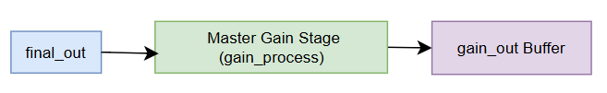

Logarithmic decibel volume changes are converted to linear scaling factor multipliers to manipulate sample amplitudes. Modifying the tracking scalar is an atomic floating-point write operation on the 32-bit ESP32 processor, making it thread-safe to adjust directly from your background button polling routine without deferring updates to block boundaries.

2. Minimal Code Snippet

Master Volume Lookup Reference
The lookup array implements four discrete configuration steps to provide predictable volume shifts:

Gain Step | Decibel Level (GdB) | Linear Multiplier (Alinear) | Acoustic Effect
0 | -6.0 dB | 0.50x | Attenuates audio (cuts amplitude in half)
1 | 0.0 dB | 1.00x | Unity Gain (amplitude unchanged)
2 | +3.5 dB | 1.50x | Moderate amplification (enhances inputs)
3 | +6.0 dB | 2.00x | Maximum amplification (doubles amplitude)

Headroom Management Note
Applying positive gain steps (+3.5 dB or +6.0 dB) can push waveforms past maximum digital boundaries. To protect speakers from square-wave clipping, a downstream soft-clipping limiter automatically clamps over-amplified peaks at $±0.8f$

Gain Regulation Driver (audio_pipeline.c)
Add the volume lookup mechanics and update your core processing loop to host the gain insertion point:

#include "audio_pipeline.h"
#include "audio_config.h"
#include "gain.h"

static float gain_out[AUDIO_BLOCK_SIZE];
static gain_hdl_t master_gain_hdl;
static const float gain_db_steps[GAIN_STEPS] = { -6.0f, 0.0f, 3.5f, 6.0f };

void audio_set_gain(uint8_t index){
if (index >= GAIN_STEPS) return;

gain_config_t gain_cfg;
gain_cfg.gain_db = gain_db_steps[index];

// Re-initialize handle; gain_init computes linear scaling factors internally
gain_init(&master_gain_hdl, &gain_cfg);
}

STATUS audio_Process(audio_hdl *hdl){
// ... Step 1: Mic Capture, Step 2: Ring Buffer, Step 3: EQ blocks execute ...
// Assume 'dsp_out' currently references the active equalizer output buffer

// 4. Master Volume Gain Regulation Stage
gain_process(&master_gain_hdl, dsp_out, gain_out, AUDIO_BLOCK_SIZE);
dsp_out = gain_out; // Advance zero-copy pointer tracking reference

// 5. Output Stage
amp_Process(hdl->amp, dsp_out, AUDIO_BLOCK_SIZE);
return STATUS_OK;
}


Isolated Button Polling Logic (main/main.c)
Insert this standalone debounced polling loop condition to intercept SW2 state transitions directly:

// SW2 — Master Gain Regulation Cycling (Falling edge + Debounce code block)
if (prev_sw2 == 1 && s2 == 0 && (now - last_sw2) > DEBOUNCE){
last_sw2 = now;
gain_step = (gain_step + 1) % GAIN_STEPS;
audio_set_gain(gain_step); // Safe atomic change inside asynchronous track
printf("[SW2] Gain step -> %d\n", gain_step);
}
prev_sw2 = s2;

3. Verification Checkpoint

Expected Behavior
The pipeline boots to Gain Step 1 ($0.0\text{ dB}$ / Unity Gain) by default. Pressing physical switch SW2 (GPIO 33) advances the volume variable round-robin ($0 \rightarrow 1 \rightarrow 2 \rightarrow 3 \rightarrow 0$), immediately stepping the output volume down or up without introducing digital clicks, pops, or stutters into the stream.

Step-by-Step Verification Sequence
- Compile and transfer the binary payload to the microcontroller package:
idf.py build flash monitor
- Speak into the microphone at a continuous, sustained volume and press SW2.
- Verify that the monitoring console logs the falling-edge event immediately:
[SW2] Gain step -> 2
- Listen closely to the speaker playback. The acoustic output amplitude should scale instantly to match your selected step index while maintaining clear, undistorted signal traits.

Section 8 — Stage 5: Delay Block (SW3)

1. Objective & Placement
The objective of Stage 5 is to implement a Feedback Delay line effect controlled by physical switch SW3 (GPIO 32) as the final link in the digital signal chain. The module receives the volume-adjusted audio block from the Master Gain block and targets data along the final pipeline track:
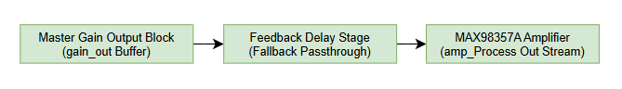
The delay block utilizes an 8192-sample internal buffer requiring 32 KB of static system memory, supporting a maximum echo history window of 512ms. To avoid an immediate stack overflow crash of the 2–4 KB FreeRTOS task workspace, the tracking handle must be allocated permanently at file scope using the static keyword.

Algorithm Validation Status
The implementation team is validating the feedback circular pointer calculations inside delay.c. To keep development safe, SW3 functions as an interactive runtime toggle but runs a safe memory-copy fallback stream until the mathematical filter module is finalized.

2. Minimal Code Snippet

Integrated Stream Pointer Insertion (audio_pipeline.c)
Declare your static global BSS buffers and encapsulate the final echo routing logic inside your processing loop:

#include "audio_pipeline.h"
#include "audio_config.h"
#include "delay.h"
#include <string.h>
static float delay_out[AUDIO_BLOCK_SIZE];
static delay_hdl_t master_delay_hdl;
static bool delay_active = false; // Asynchronous control flag managed by SW3
void audio_Initialize_Delay(void){
delay_config_t delay_cfg;
delay_cfg.delay_seconds = 0.25f; // Establishes a 250ms echo target
delay_cfg.feedback_gain = 0.40f; // Configures a 40% decay attenuation factor
// Initialize global tracking handles inside the safe BSS segment
delay_init(&master_delay_hdl, &delay_cfg);
}
void audio_toggle_delay(void){
delay_active = !delay_active; // Atomic boolean state flip
}
STATUS audio_Process(audio_hdl *hdl){
// ... Step 1-4: Mic Capture, Ring Buffer, Baseline, and EQ Gain steps execute ...
// Assume 'dsp_out' currently references the active volume-regulated gain_out buffer
// 5. Echo Delay Line Stage
if (delay_active)
{
// Safe validation fallback pattern testing user interface control pathways
memcpy(delay_out, dsp_out, AUDIO_BLOCK_SIZE * sizeof(float));
dsp_out = delay_out; // Forward zero-copy reference address
}
// 6. Transmit final processed audio stream blocks to physical I2S Amp
amp_Process(hdl->amp, dsp_out, AUDIO_BLOCK_SIZE);
return STATUS_OK;
}

Asynchronous Switch Event Capture (main/main.c)
Add this debounced tracking block inside your background loop to catch falling-edge events on the SW3 line:

// SW3 — Feedback Delay Line Activation (Falling edge + Debounce code block)
if (prev_sw3 == 1 && s3 == 0 && (now - last_sw3) > DEBOUNCE){
last_sw3 = now;
audio_toggle_delay(); // Safe asynchronous trigger
printf("[SW3] Delay toggled\n");
}
prev_sw3 = s3;

3. Verification Checkpoint

Expected Behavior
The delay module boots deactivated by default. Pressing physical switch SW3 (GPIO 32) captures the edge transition and toggles the state of delay_active. The application executes the buffer mapping fallback seamlessly without dropping audio samples, verifying that your asynchronous background control layer is fully integrated.

Step-by-Step Verification Sequence
- Build the updated pipeline configuration and flash it to the development kit:
idf.py build flash monitor

2. Press SW3 on your breadboard.
3. Confirm the monitoring console prints out the toggle state verification log instantly:
[SW3] Delay toggled
Pressing the button again will toggle the routing block off. The audio stream must maintain continuity without introducing clicking, popping, or thread lockups during state changes.
Section 9 — Full Signal Flow Reference
This reference section maps out the complete real-time lifecycle of an audio block as it travels through physical hardware pins, normalization tracks, and digital signal processing stages. Use this matrix to trace data alignment types, scale steps, and active user interface paths across the entire integrated firmware.

# | Function | Type | Hardware | Pins | Key Operation
1 | Mic Capture | int32_t | INMP441 | WS:25, SCK:26, SD:34 | Capture 24-bit raw PCM
2 | Float Conv. | float | CPU | - | Normalize to [-1.0, 1.0]
3 | Ring Buffer | float | SRAM | - | 4-slot FIFO (latency)
4 | Filters | float | LPF/BPF/HPF | - | Sum & scale (0.33)
5 | EQ Presets | float | EQ Bank | SW1 (19) | Cascaded coefficient reload
6 | Master Gain | float | Gain Block | SW2 (33) | Atomic float multiplication
7 | Delay/Echo | float | Delay Line | SW3 (32) | 32KB static buffer
8 | Amp Output | int16_t | MAX98357A | WS:14, BCK:27, DO:22 | Limit, scale, 16-bit PCM

Graphical Architectural Execution Path
To trace execution or construct system documentation grids, align your pipeline layout to this centralized architectural data path:

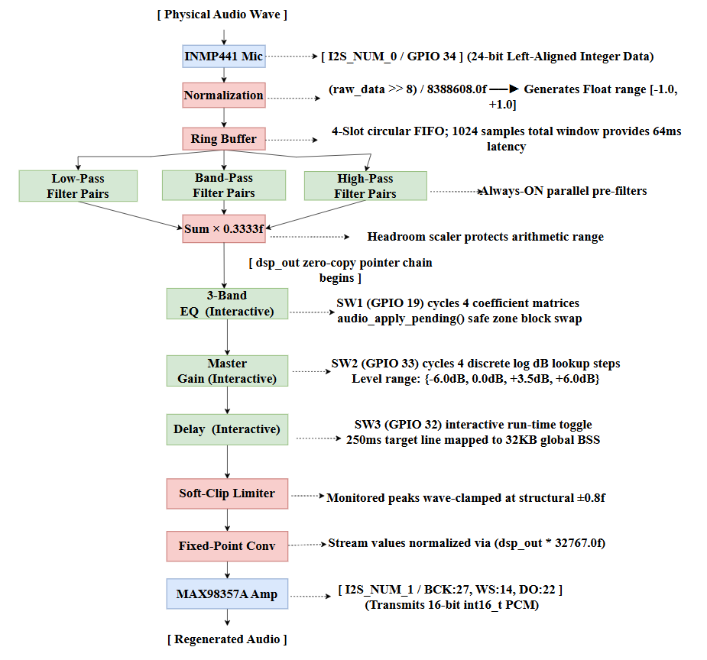

Appendix — Lessons Learned and Common Errors
Real-time embedded digital signal processing operates within a highly sensitive environment. Unlike standard desktop applications, writing code for an embedded system requires navigating strict hardware memory tracks and unyielding real-time execution deadlines. This appendix condenses real-world integration bugs encountered during system testing into an immediate, scannable defect log to protect your pipeline from common pitfalls.

Category 1: Build System & Scope Errors

1. Case-Sensitivity Component Mismatch
- Symptom: Running idf.py build halts immediately with a CMake compilation error stating Component not found: band_pass.
- Fix: Ensure that every dependency listed in your idf_component_register(REQUIRES ...) block matches the case-sensitive folder name on your disk exactly (e.g., change lowercase band_pass to match the physical directory Band_Pass).

2. Local Function Scope Memory Leak
- Symptom: Swapping EQ profiles at runtime causes erratic audio distortion, continuous clicking noises, or sudden LoadProhibited CPU memory panics.
- Fix: Move all filter tracking handles, configuration structures, and coefficient variables completely out of local function bodies and instantiate them at file scope using the static keyword to guarantee permanent memory placement.

Category 2: Memory & Stack Exhaustion

3. Processing Buffer Stack Overflow
- Symptom: The system boots cleanly but triggers an immediate stack exhaustion core crash (Guru Meditation Error: Core 1 panic'ed) the exact millisecond the audio stream starts.
- Fix: Prepend the static keyword prefix to any temporary local workspace arrays inside your custom processing functions (e.g., change float temp[256]; to static float temp[256];) to shift their allocation out of the volatile task stack and into global BSS memory.

4. Delay Line Stack Crash
- Symptom: Instantiating the large 32 KB delay_hdl_t tracking handle or its internal history arrays inside an initialization function causes an immediate task stack crash.
- Fix: Always declare your master delay_hdl_t handle as a static global variable at file scope, forcing the compiler to house the 32 KB block safely within the expansive global BSS memory partition instead of overloading the active stack space.

Category 3: Hardware Peripherals & Wiring Traps

5. Input-Only Pin Electromagnetic Float
- Symptom: A push-button appears permanently stuck at a logic value of 0 or triggers rapid, continuous phantom preset cycles on loop without being physically touched.
- Fix: Avoid using input-only pins GPIO 34–39 for interactive switches since they lack internal pull-up hardware; route user control lines through full-featured pins like GPIO 19, 32, or 33 with GPIO_PULLUP_ENABLE explicitly declared.

6. Switch Short Circuit Board Brownout
- Symptom: Pressing a control switch instantly kills the ESP32, dropping the serial terminal monitor connection and shutting off board status LEDs without printing a crash log.
- Fix: Cross-check your 4-pin tactile switch contacts with a multimeter and re-route your jumper wires diagonally across the active gap to complete a safe path to Ground instead of short-circuiting the 3.3V rail.

7. Permanently Shorted Switch Leg Placement
- Symptom: A physical button press fails to trigger any functional state change in the firmware while the targeted pin continuously reads a fixed logic value of 0.
- Fix: Correct the physical breadboard layout by re-wiring switch contacts across the active mechanical gap (e.g., connecting your input line to Pin A1 and Ground to Pin A2) so the circuit only completes when the button is physically compressed.

Category 4: Real-Time Timing & Deadlocks

8. Core Loop Console Logging Stalls
- Symptom: The pipeline streams audio cleanly but freezes completely the exact millisecond a user interacts with a physical control switch.
- Fix: Completely eliminate printf or other blocking console logging expressions from inside your core real-time processing loop (audio_Process), executing all diagnostic event logs exclusively within the main asynchronous background polling thread in main.c.

9. Live Streaming Coefficient Collisions
- Symptom: Pressing a switch to cycle an EQ profile triggers an immediate system hang or causes the speaker to emit a high-pitched digital screeching noise.
- Fix: Enforce a strict Block Boundary Safe Zone by updating a simple pending flag variable in your button thread and executing audio_apply_pending() to swap filter coefficients safely between processing blocks right before calling audio_Process().

10. vTaskDelay Processing Bottlenecks
- Symptom: The audio stream runs smoothly, but the system skips rapid button presses or feels highly sluggish, requiring you to firmly hold a switch down repeatedly before an event registers.
- Fix: Remove all manual vTaskDelay() or sleep macros from your primary background thread loop, allowing mic_Process() to natively handle timing by blocking task execution via hardware DMA interrupts until a fresh 16ms data block is ready.

