**PROJECT TITLE –BLOOD BANK MANAGEMENT SYSTEM**

**TEAM DETAILS**

|  |  |  |  |
| --- | --- | --- | --- |
| **RollNo** | **Name**  **(FirstnameLastname)** | **EmailId** | **Contact No.** |
| **AU1841130** | **HARSH MANGE** | [**ha**](mailto:ha)**rsh.m2@ahduni.edu.in** | **7016098244** |
| **AU1841134** | **SHARVIL PATEL** | **sharvil.p@ahduni.edu.in** | **6354886802** |
|  |  |  |  |
|  |  |  |  |

**LIST OF DATA FILES USED ALONG WITH THEIR COLUMNS/FORMAT/STRUCTURE**

1. **donor.dat**

|  |  |  |  |
| --- | --- | --- | --- |
| Sr. No. | Name of the Column/Field | Data Type | Sample Data |
| 1 | DONOR Id | Int | 20 |
| 2 | DONOR NAME | char [30] / String | Xyz |
| 3 | WEIGHT | int | 65 |
| 4 | BLOOD GROUP | Char[4]/STRING | A+ |
| 5 | GENDER | Char [10] / String | Male |
| 6 | AGE | **INT** | **18** |

**(2) patient.dat**

|  |  |  |  |
| --- | --- | --- | --- |
| Sr. No. | Name of the Column/Field | Data Type | Sample Data |
| 1 | PATIENT Id | Int | 10 |
| 2 | PATIENT NAME | char [30] / String | Abc |
| 3 | DOCTOR NAME | char [30] / String | Xyz |
| 4 | AGE | int | 30 |
| 5 | WEIGHT | int | 65 |
| 6 | BLOOD GROUP | Char[4]/string | A+ |
| 7 | NO OF BAGS | int | 5 |
| 8 | GENDER | Char[10]/string | Male/female |

**3)donation .dat**

|  |  |  |  |
| --- | --- | --- | --- |
| Sr. No. | Name of the Column/Field | Data Type | Sample Data |
| 1 | BLOOD GROUP | Char bg[4]/string | A+ |
| 2 | NO OF BAGS | Int | 7 |
| 3 |  |  |  |

**PROJECT OUTPUT/SCREENSHOTS**

Screen-1) Login Screen of the Project

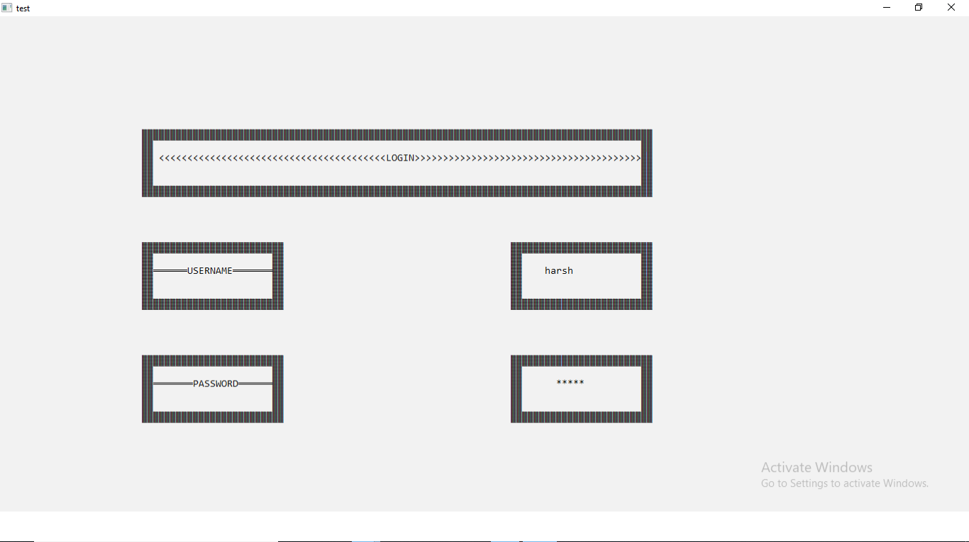

Screen-2)welcome screen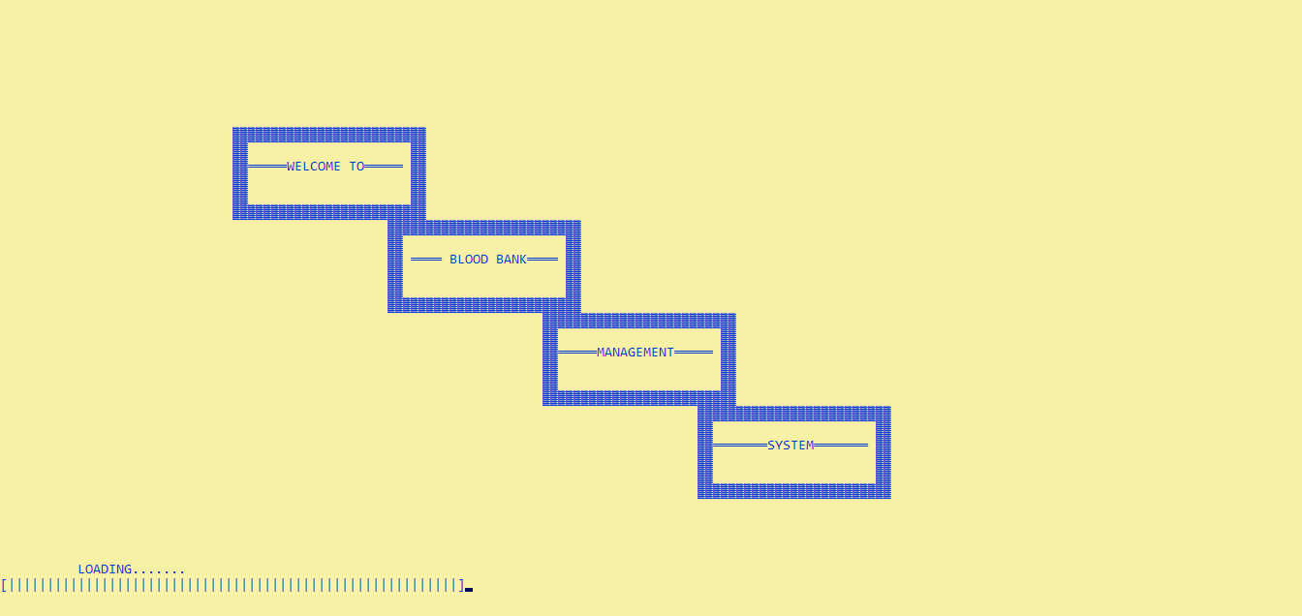

Screen-3) Main Menu of the Project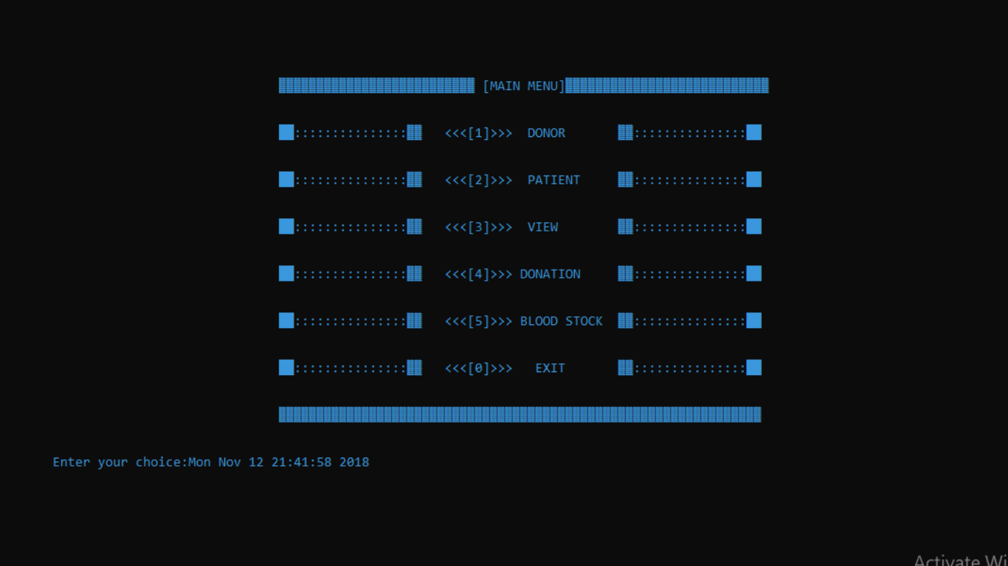

Screen-4) DONOR MENU

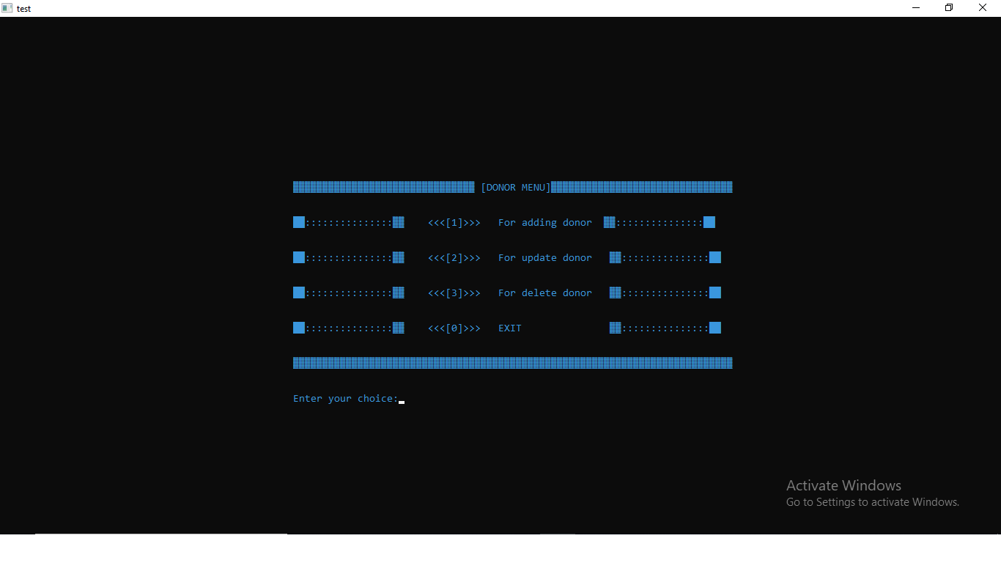

Screen-5) PATIENT MENU

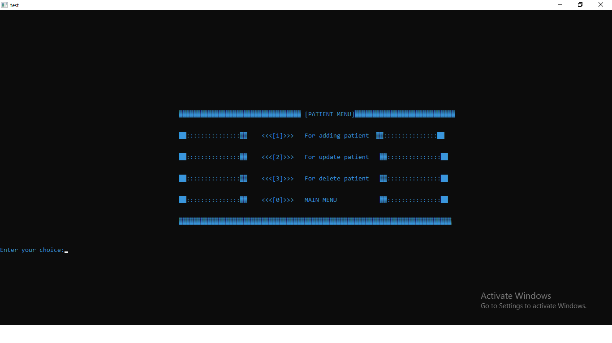

Screen-6)VIEW MENU

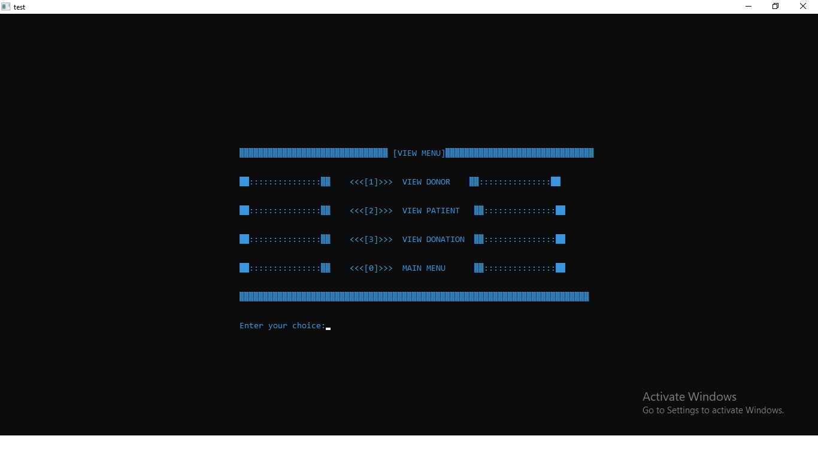

Screen-7) DONATION MENU

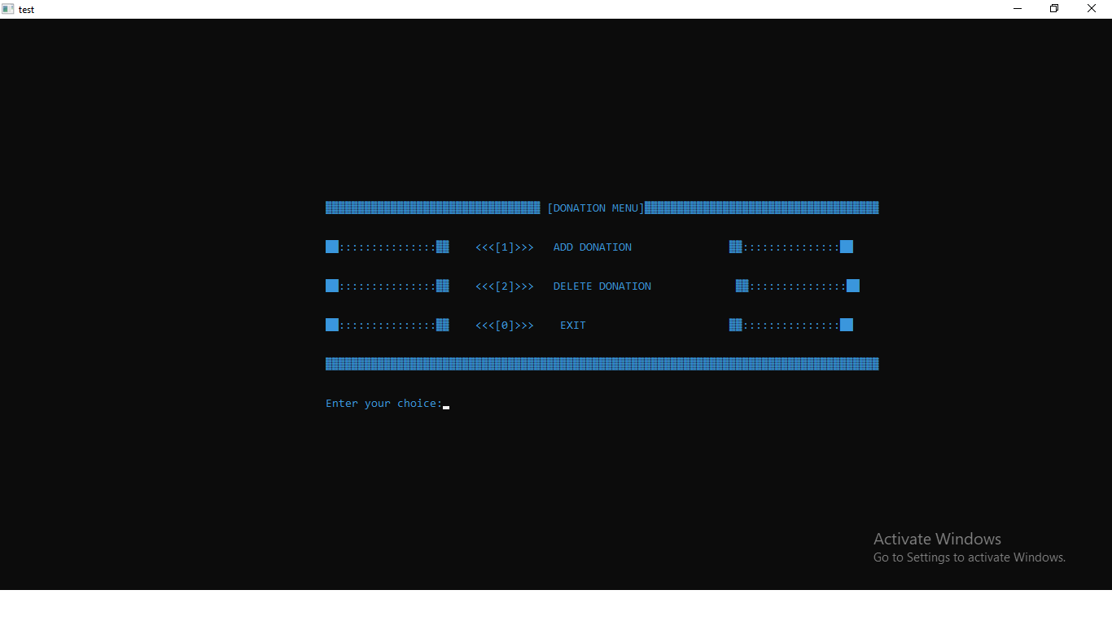

Screen-8) BLOOD STOCK

