**DTL ASSIGNMENT**

**Name –** Harsh Dipak Marke

**Mis** – 112103087

**Div** – 2 **Batch** – S1

1. Making new file and entering text into it
2. Making the file executable
3. Listing all the files in directory
4. Executing the file

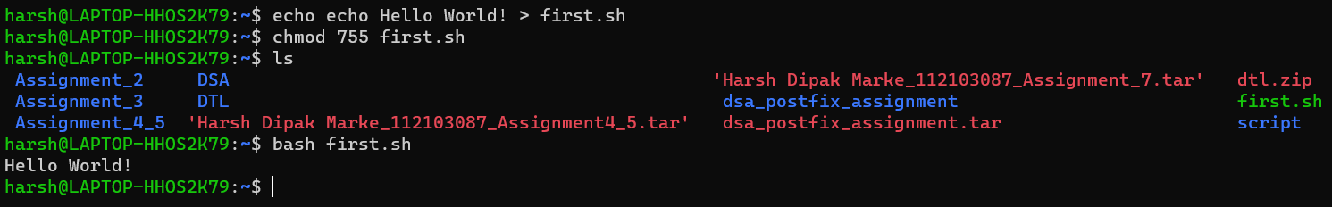

1. Adding multiple lines to a file
2. Changing permission of the file created
3. Listing all the files in the directory
4. Executing the file

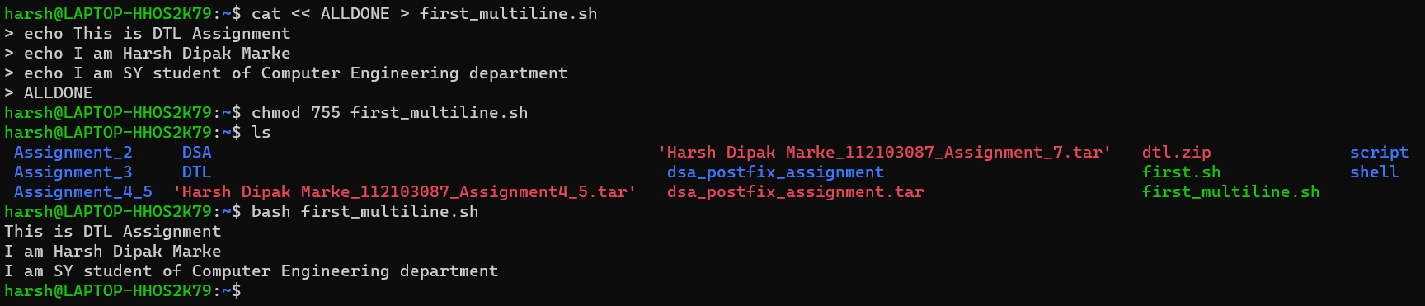

1. Opening Downloads directory
2. Creating a new file with current timestamp
3. Opening the file
4. Changing permissions
5. Listing the files in the directory
6. Executing the file

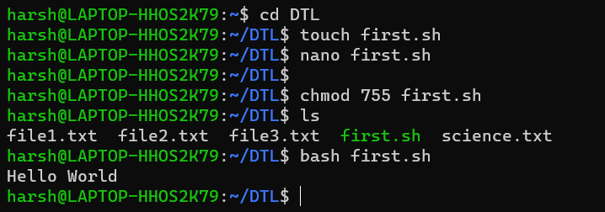

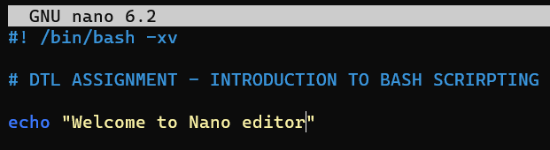

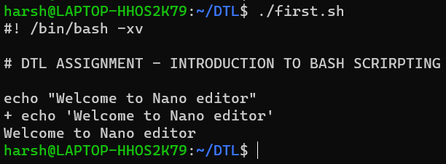

**Special Parameters:**

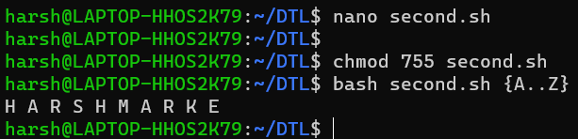

**Exploring all special parameters:**

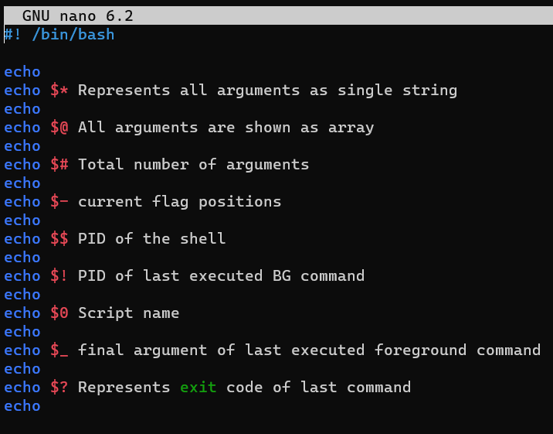

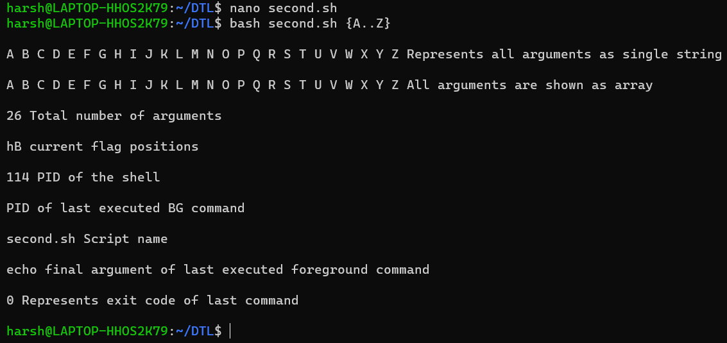

**Bracket Expansion:**

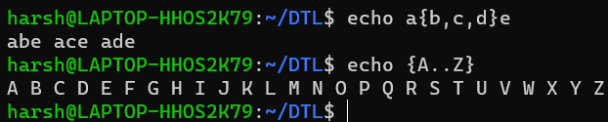

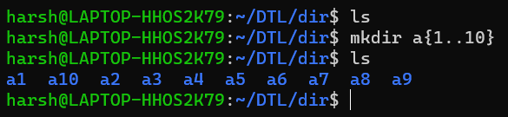

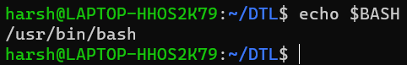

**Using variables:**

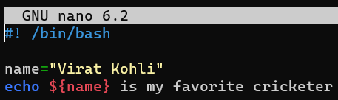

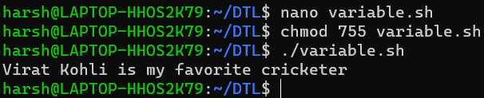

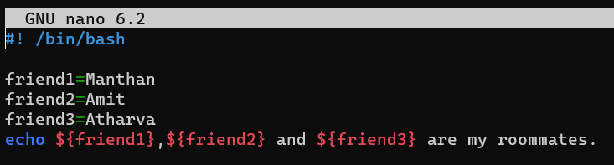

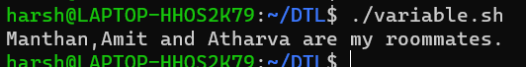

**Arithmetic Expansion:**

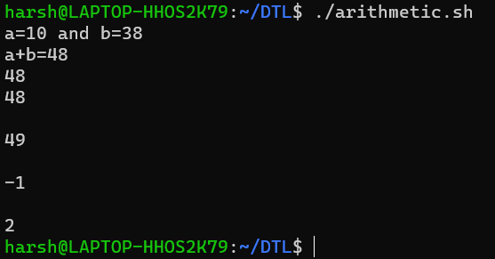

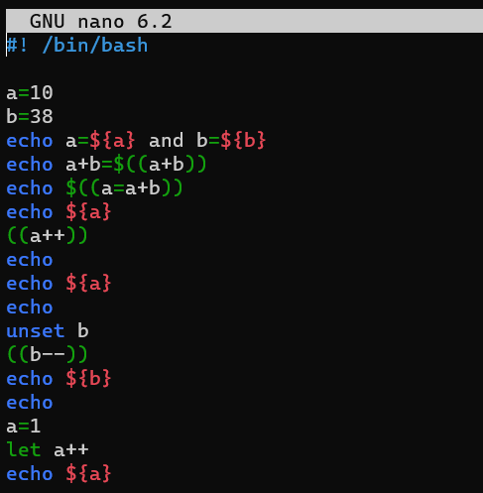

**Command Substitution:**



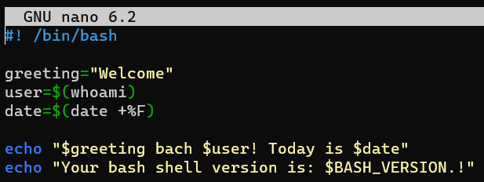

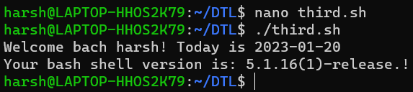

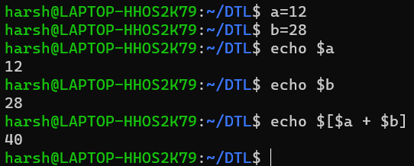

**Creating Backup:**

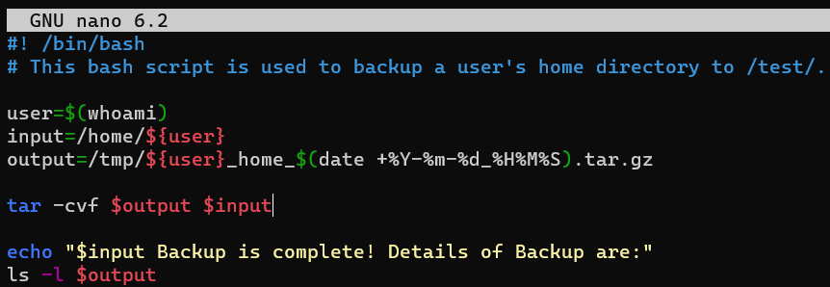



**Environment:**

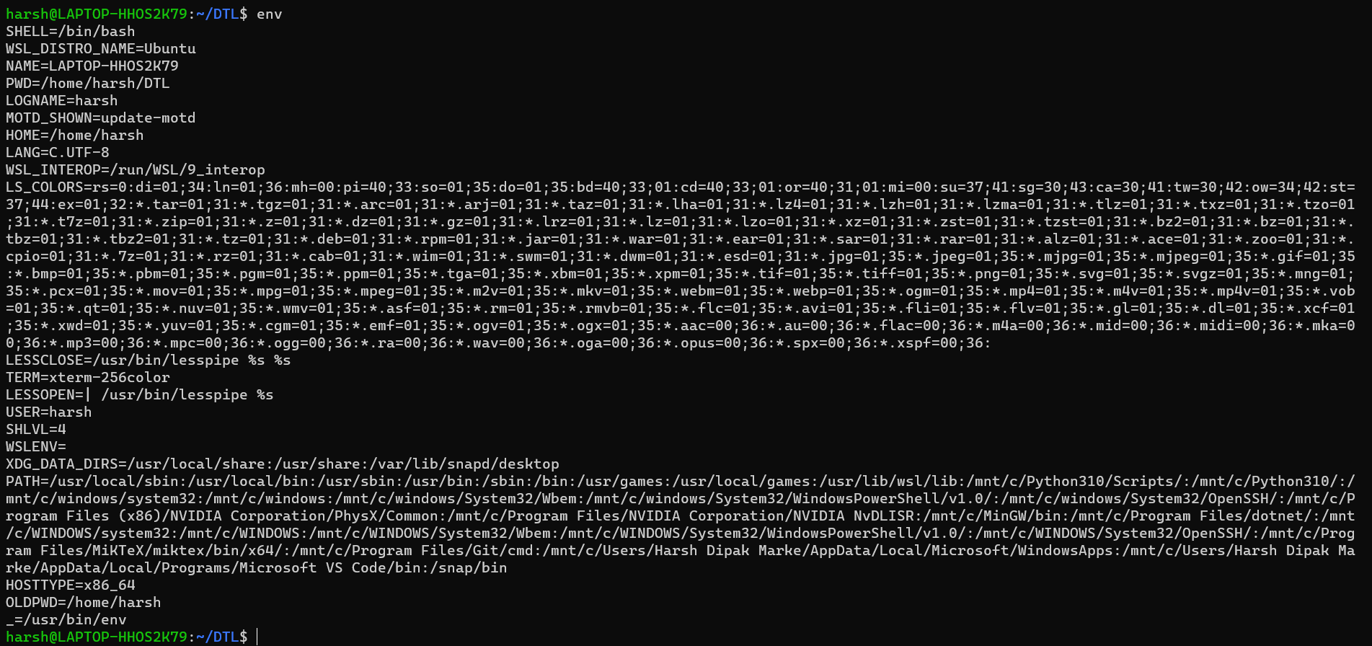



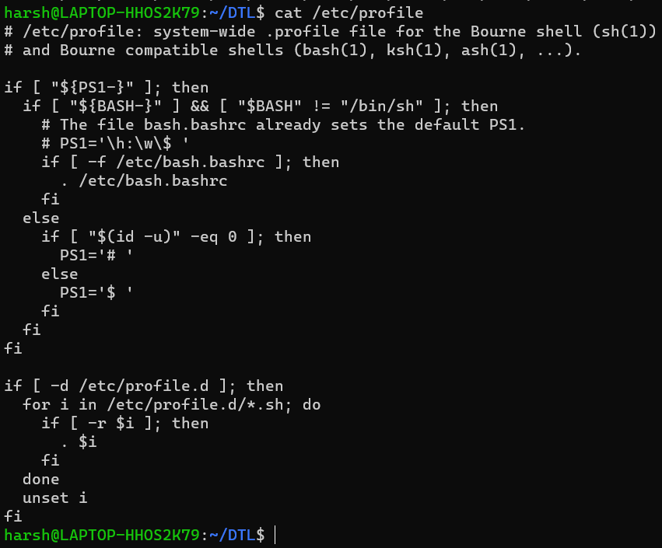

**Input and Output Redirection:**

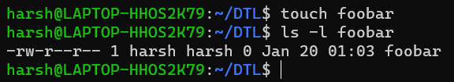

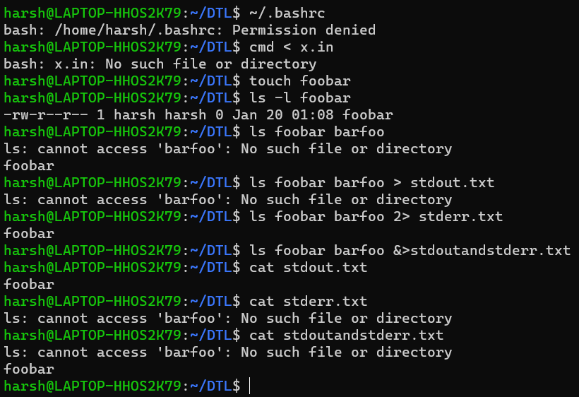

**Functions:**

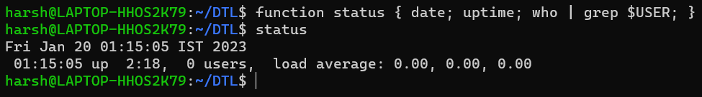

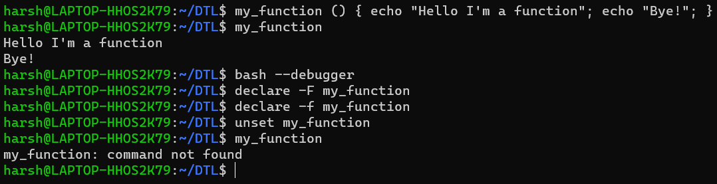

**Numeric and String comparison:**

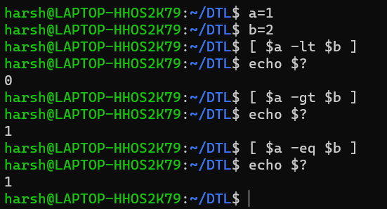

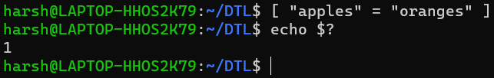

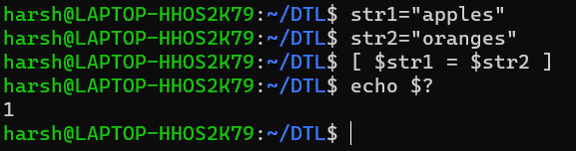

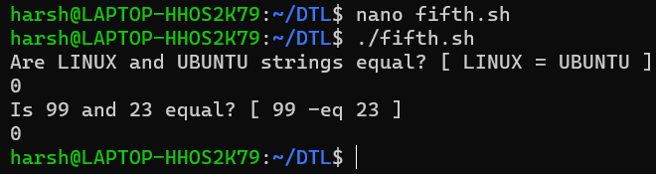

**Conditional statements:**

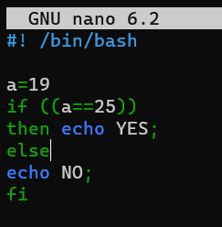

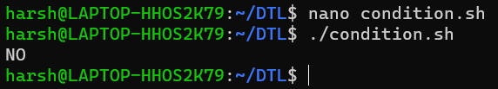

**Arithmetic Expression:**

