PROJECT REPORT
A12 – LTI SYSTEM PROPERTY VERIFIER GUI
Signals and Systems | MATLAB GUI Project
Submitted by
Harshvardhan Mayani
Department of Electronics and Communication Engineering
Adit College
Academic Year: 2026–2027
Guided by: __________________________

Abstract
The LTI System Property Verifier GUI is a MATLAB-based educational project that displays the properties of selected discrete-time systems. The user selects a system from a drop-down menu and clicks the “Verify System” button. The GUI displays whether the selected system is linear, time-invariant, causal, and stable. The project demonstrates MATLAB GUI controls and callback programming. The current code uses predefined results for four example systems; it does not automatically analyze arbitrary equations.

1. Introduction
A discrete-time system transforms an input signal x[n] into an output signal y[n]. In Signals and Systems, system properties such as linearity, time invariance, causality, and BIBO stability help describe and classify system behaviour. This project uses a simple MATLAB graphical user interface (GUI) to present the classifications of selected examples in an easy-to-understand form.

2. Objectives
- To understand the basic properties of discrete-time systems.
- To develop a simple MATLAB GUI with a drop-down menu and verification button.
- To display the classifications of four example systems.
- To understand GUI controls and callback functions in MATLAB.
- To demonstrate a system that is linear but time-varying: y[n] = n x[n].

3. Software and System Requirements
- Software: MATLAB.
- Hardware: A computer that can run a supported MATLAB version.
- GUI components: Figure window, text labels, pop-up menu, and push button.
- No external hardware is required.

4. Theoretical Background

4.1 Linearity
A system is linear if it satisfies the superposition property for arbitrary inputs x₁[n], x₂[n] and constants a, b:
T{a x₁[n] + b x₂[n]} = aT{x₁[n]} + bT{x₂[n]}

4.2 Time Invariance
A system is time-invariant if shifting the input by n₀ samples causes the output to shift by the same amount. If T{x[n]} = y[n], then T{x[n − n₀]} must equal y[n − n₀].

4.3 Causality
A system is causal if its output depends only on present and past input samples, not on future samples. For an LTI system, the impulse response must be zero for n < 0.

4.4 BIBO Stability
A system is BIBO stable if every bounded input produces a bounded output.

5. Systems Included in the GUI
System | Linear | Time-invariant | Causal | Stable
y[n] = x[n − 2] | Yes | Yes | Yes | Yes
y[n] = x²[n] | No | Yes | Yes | Yes
y[n] = n x[n] | Yes | No | Yes | No
y[n] = x[n − 1] | Yes | Yes | Yes | Yes

6. Analytical Derivation

6.1 Linearity of y[n] = n x[n]
Let T{x[n]} = n x[n]. For arbitrary inputs x₁[n], x₂[n] and constants a and b:
T{a x₁[n] + b x₂[n]} = n(a x₁[n] + b x₂[n])
= a n x₁[n] + b n x₂[n]
= aT{x₁[n]} + bT{x₂[n]}.
Therefore, the system is linear.

6.2 Time Invariance of y[n] = n x[n]
For the shifted input x[n − n₀], the output is n x[n − n₀]. Shifting the original output gives y[n − n₀] = (n − n₀)x[n − n₀]. These expressions are generally different; therefore, the system is time-varying (not time-invariant).

6.3 Stability
Choose the bounded input x[n] = 1. The output becomes y[n] = n, which is unbounded. Therefore, the system is not BIBO stable.

7. Viva Question: Is y[n] = x[2n] Time-Invariant?
No. The original output is y[n] = x[2n]. If the input is shifted by n₀, the output becomes x[2n − n₀]. Shifting the original output gives y[n − n₀] = x[2n − 2n₀]. These expressions are generally unequal, so the system is not time-invariant.

8. GUI Design and Operation
The GUI contains a title label, a drop-down menu, a “Verify System” push button, and a result area. The user selects one of the four systems and clicks the button. The callback function verify reads the selected menu value, chooses the corresponding predefined result, and displays the properties.

8.1 Important MATLAB Commands
Command / Property | Purpose
uicontrol | Creates GUI controls such as labels, menus, and buttons.
String | Sets displayed text or menu options.
Position | Defines component location and size as [x, y, width, height].
FontSize | Sets the text size.
Tag | Identifies a GUI component for later lookup.
Callback | Runs a function after an action, such as a button click.
findobj | Finds GUI objects using properties such as Tag.
switch | Selects a code branch based on the menu selection.
sprintf | Creates the multiline result text.
set | Updates a GUI component property.

9. Algorithm
- Start MATLAB and clear the command window, workspace, and open figures.
- Create the GUI figure and title label.
- Create a pop-up menu containing four example systems.
- Create the Verify System button and result text area.
- When the button is clicked, execute the verify callback.
- Find the menu and result label using their Tag properties.
- Use a switch statement to select the predefined property results.
- Display the selected system’s classifications in the result area.

10. Applications
- Learning and revising discrete-time system properties.
- Demonstrating MATLAB GUI programming.
- Supporting Signals and Systems laboratory discussions.
- Introducing the classification of discrete-time systems.

11. Advantages and Limitations

Advantages
- The GUI is simple and easy to use.
- It displays the classification of a selected system quickly.
- It demonstrates MATLAB GUI controls and callback functions.
- It helps students revise Signals and Systems concepts.

Limitations
- Only four predefined systems are available in the current version.
- Users cannot enter arbitrary system equations.
- Results are predefined and are not calculated automatically.
- Automatic test-signal analysis and plots are not implemented.

12. Conclusion
The LTI System Property Verifier GUI is an introductory MATLAB project for studying linearity, time invariance, causality, and stability. It demonstrates how a simple interface can display predefined classifications for selected discrete-time systems. The analytical example y[n] = n x[n] shows that a system can be linear but time-varying and not BIBO stable. The project could be extended to accept equations and perform automatic verification.

13. References
- Signals and Systems course notes.
- MATLAB documentation for figure, uicontrol, callback functions, findobj, and set.

14. MATLAB GUI Output Screenshots
The following screenshots show the results for the four systems included in the LTI System Property Verifier GUI.
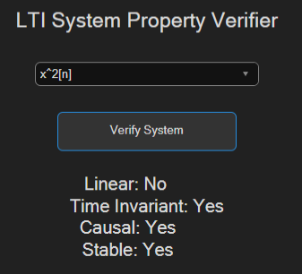  Output 1: y[n] = x²[n] | 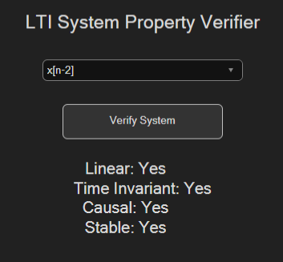  Output 2: y[n] = x[n−2]
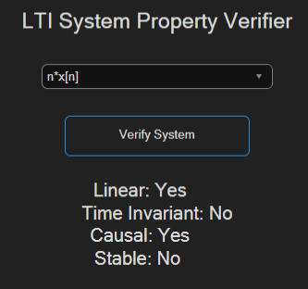  Output 3: y[n] = n·x[n] | 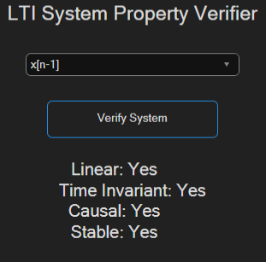  Output 4: y[n] = x[n−1]

