**Report on Assignment**

**Done by-**  Harshmeet Singh Chandhok

+91 8390808189

[harshmeetchandhok@outlook.com](mailto:harshmeetchandhok@outlook.com)

**Introduction-** Built chatbot using neural network (used pytorch), NLP techniques and Zomato API and deployed it using Flask, HTML, CSS, Bootstrap and Javascript.

**Steps-**

**1.** Used Zomato Api and made methods for getting location, location information and searching hotels based on cuisine.

**2.** Made intents and stored it in json file in format of tags, patterns, response and context.

**3.** Used intents.json file to train neural network over the data processed from the json file using NLP techniques- Bag of Words(BOW), Stemming(using porterstemmer), tokenizing(using nltk).

**4.** Now binding all together methods and neural network model together- the input from the user will classify where the input should belong to the particular tag mean in which intent it should go.

**5.** Beautifulsoup is also used to extract the users current location applied that location access should be turned on such that it will scrape out loation from google search.

**6.** Further the model and code is deployed on flask and UI provided by HTML, CSS,Bootstrap and Javascript.

**7.** Wanted to deploy it over heroku but due to size going to 886 MB and free account only has 500 MB limit so this part remained.

**8.** For running the project just run app.py applied all the requirements installed.

**9.** Some of the screenshots are given below for the working project.

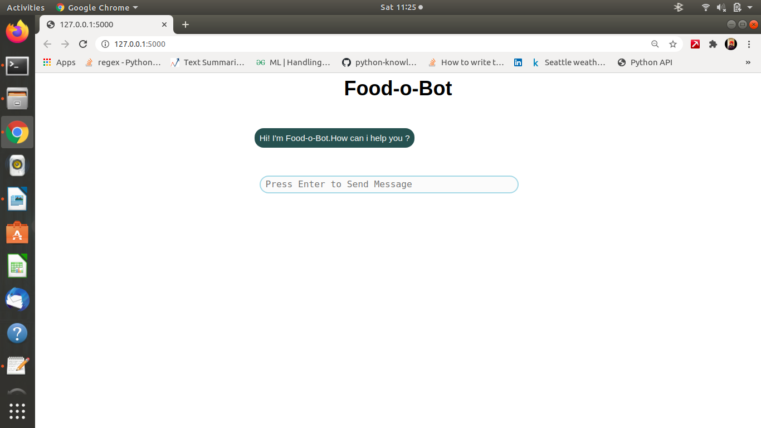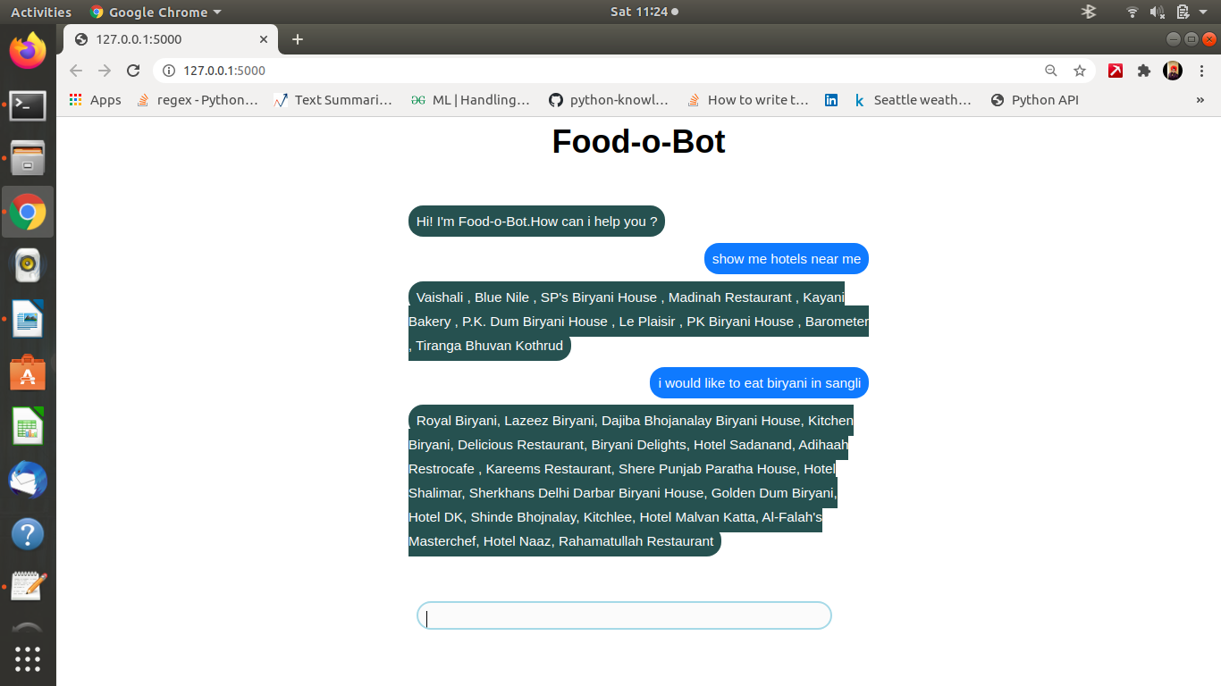

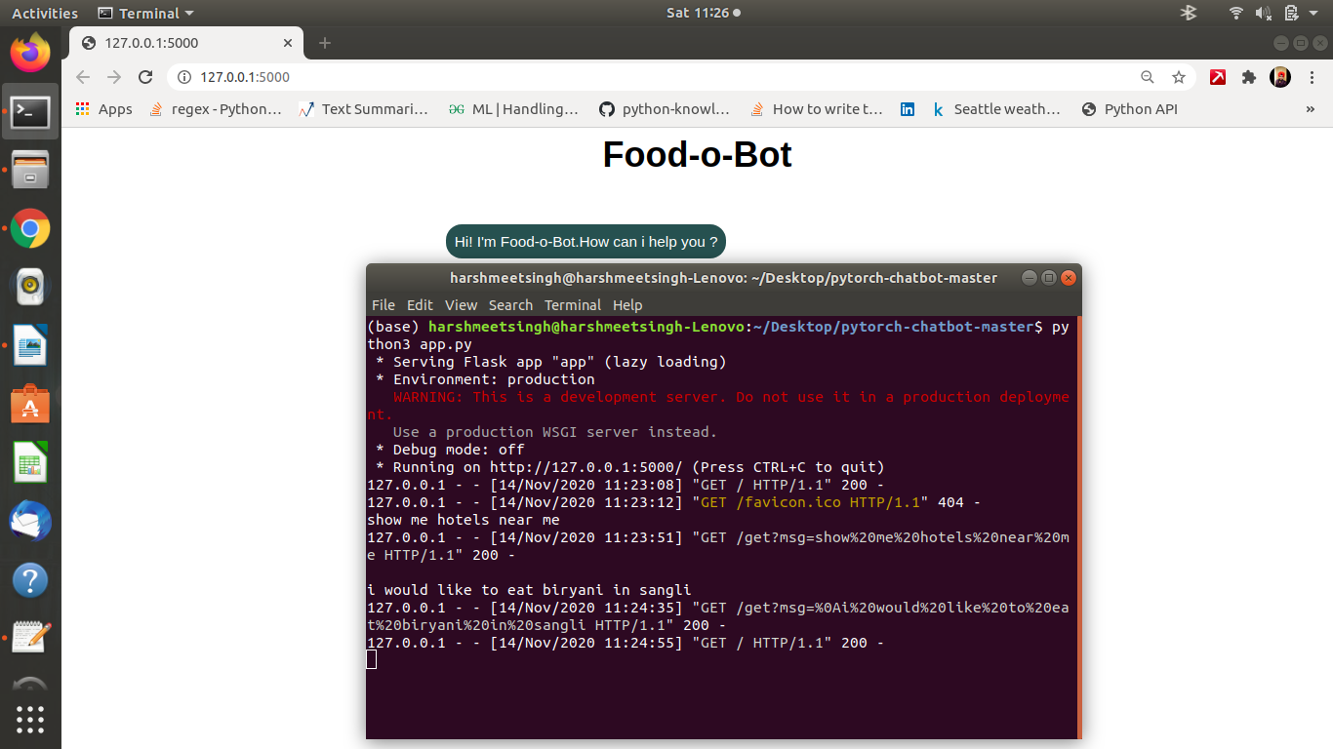

**10.**  Further UI can be more enhanced .