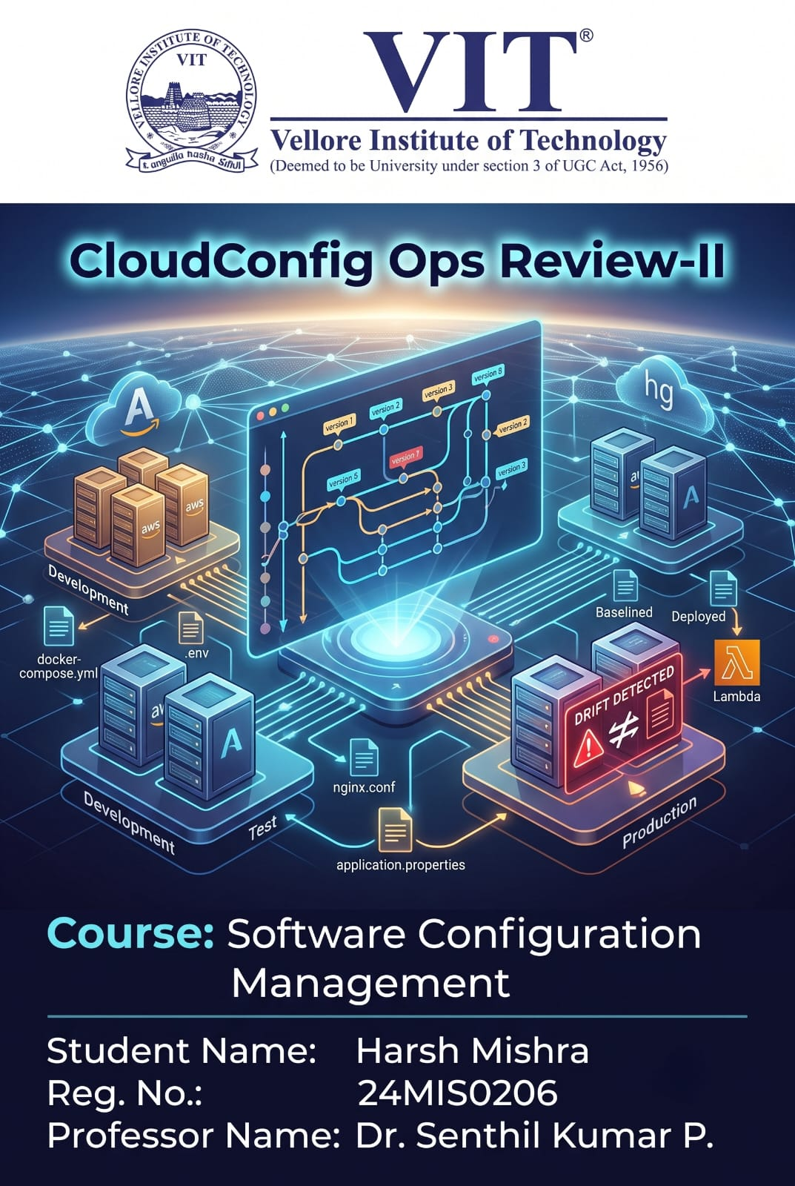

1. SCM Status Accounting and Information Gathering

Tracking Status
Configuration Status Accounting (CSA) is the SCM function that records and reports what state every Configuration Item (CI) is in at any given time — what version it's at, who owns it, whether it has been reviewed, and whether it is part of an approved baseline. In CloudConfig Ops, every CI (.env.production, docker-compose.yml, nginx.conf, application.properties, config.json, deployment.yaml, .env.staging, prometheus.yml, Caddyfile) is registered with a fixed metadata record — Configuration ID, Name, Version, Environment, Owner, Status, Last Modified Date, and Baseline Information — stored in the metadata database (Amazon RDS – PostgreSQL).
Status is not updated by hand. A Mercurial commit hook fires automatically whenever a developer commits a change to a CI, and this pushes an update into the metadata table so the CI's status is always in sync with the actual revision history in the Mercurial repository. Each CI moves through a defined lifecycle:
Draft → Pending Review → Approved → Baselined → Deployed
A change can also be Rejected during review (returning it to Draft for rework) or Rolled Back after deployment (returning it to a previously Baselined state). Together, the Mercurial revision log (hg log, hg parents, hg tags) and the RDS metadata table let the platform answer status-accounting questions on demand — for example, "What version of nginx.conf is currently approved for Production?" or "Which CIs are waiting on reviewer sign-off right now?"

Current State
The table below is a representative snapshot of the Configuration Status Register at the current stage of the project, showing all nine tracked Configuration Items.
CI Name | Version | Environment | Status | Owner | Baseline Tag
.env.production | v1.4.2 | Production | Approved | Dev Team | baseline-prod-1.4
nginx.conf | v2.1.0 | Production | Baselined | Ops Team | baseline-prod-2.1
docker-compose.yml | v1.0.0 | Development | Draft | Dev Team | —
application.properties | v1.1.0 | Testing | Pending Review | Dev Team | —
config.json | v2.0.1 | Production | Approved | Dev Team | baseline-prod-2.0
deployment.yaml | v3.0.0 | Production | Baselined | Ops Team | baseline-prod-3.0
.env.staging | v1.0.3 | Testing | Approved | Dev Team | baseline-test-1.0
prometheus.yml | v1.2.0 | Production | Baselined | Ops Team | baseline-prod-1.2
Caddyfile | v1.0.0 | Development | Draft | Dev Team | —
As of this review, 5 of the 9 Configuration Items have at least one approved baseline, 1 Change Request is pending reviewer approval (application.properties), and 2 CIs are still in initial development (docker-compose.yml, Caddyfile). No rollback has been required so far.

Reports
Two report formats are generated directly from the status-accounting data. The first is a point-in-time Configuration Status Report (the register shown above); the second is a Change History Report that logs every revision against its originating Change Request.

Sample Change History Report:
Rev. (hash) | CI Changed | Author | Change Description | Approval Status
a3f8e1 | nginx.conf | Rachel | Updated reverse-proxy routing for API service | Approved
b7c2d4 | .env | Andrew | Rotated database connection string | Approved
e9f1a0 | docker-compose.yml | John | Added Redis cache service | Pending Review
c4d8b2 | deployment.yaml | Blake | Increased replica count for Production | Approved

Automation
Status accounting in CloudConfig Ops is largely automated rather than maintained manually:
- Mercurial commit hooks fire on every commit and notify the FastAPI backend of the new revision.
- The FastAPI backend parses the hg log output for that revision and updates the corresponding CI record in Amazon RDS, so the status register never falls out of sync with the actual repository.
- The React dashboard reads directly from this live metadata table, so Developers, Reviewers, and Ops always see current status without refreshing a spreadsheet.
- A scheduled job (triggered by Amazon CloudWatch on a fixed interval) regenerates the Configuration Status Report and Change History Report automatically and stores them for the audit trail.

2. Configuration Verification and Auditing

Verification Activities
Before a Configuration Item is trusted as part of an approved baseline, CloudConfig Ops runs it through a set of verification checks:
- Format/syntax validation appropriate to the file type — YAML validation for docker-compose.yml and deployment.yaml, JSON validation for config.json, syntax checking for nginx.conf, and key-value format checks for .env and application.properties.
- Metadata completeness check — a Change Request cannot be submitted unless every required metadata field (Configuration ID, Name, Version, Environment, Owner) is filled in.
- Reviewer sign-off verification — confirms that the person approving a change is not the same person who submitted it, enforcing separation of duties.
- Baseline integrity check — confirms the Mercurial tag applied to a baseline points to the exact revision that was actually reviewed, with no last-minute unreviewed edits slipped in afterward.
- Drift verification — the live configuration on each target EC2 instance (Dev, Test, Production) is periodically checked against the approved Mercurial baseline.

Audits
Two standard SCM audit types are applied in this project, at two different points in the workflow:
Functional Configuration Audit (FCA): verifies that a Configuration Item actually does what its Change Request said it would, before it is accepted as an approved baseline. In this project, the Reviewer performs the FCA at the Change Request stage — for example, checking that an updated nginx.conf correctly routes traffic to the intended backend service on the Test EC2 instance, or that a revised docker-compose.yml successfully brings up all declared services without error. This is a functional, requirement-facing check performed before Baseline Creation.
Physical Configuration Audit (PCA): verifies that the deployed configuration on a target server physically matches the approved baseline recorded in Mercurial — checking the "as-deployed" state against the "as-documented" state. In this project, the PCA is implemented as the platform's automated Drift Detection function: an AWS Lambda script computes a file hash of each live CI on the Dev/Test/Production EC2 instances and compares it against the hash of the approved baseline revision stored in Mercurial and RDS. A mismatch is logged as configuration drift. Unlike the FCA, this PCA runs automatically on a EventBridge-triggered schedule (e.g., every 30 minutes) rather than only at manual review checkpoints.

Checklists
Sample Functional Configuration Audit (FCA) checklist:
# | Checklist Item | Result
1 | Configuration change matches the description in its Change Request | ☐ Pass ☐ Fail
2 | Configuration file is syntactically valid for its file type | ☐ Pass ☐ Fail
3 | Configuration functions correctly when applied to the Dev/Test target environment | ☐ Pass ☐ Fail
4 | No unrelated or unauthorized changes are bundled into the same revision | ☐ Pass ☐ Fail
5 | Reviewer is a different person from the Developer who submitted the change | ☐ Pass ☐ Fail
Sample Physical Configuration Audit (PCA) checklist:
# | Checklist Item | Result
1 | Live file hash on the target server matches the approved baseline hash | ☐ Pass ☐ Fail
2 | CI metadata (version, status) in RDS matches the deployed revision | ☐ Pass ☐ Fail
3 | Mercurial baseline tag exists and points to the correct revision | ☐ Pass ☐ Fail
4 | No manual or untracked edits found on the target server since last deployment | ☐ Pass ☐ Fail
5 | Any detected drift has been logged and a corrective Change Request opened | ☐ Pass ☐ Fail
6 | An automated alert is dispatched to the Ops Team when a hash mismatch is detected | ☐ Pass ☐ Fail

3. SCM Standards and Process Improvement Models

Standards Identification
Four established standards and process models are relevant to how CloudConfig Ops structures its SCM practice:
- CMMI (Configuration Management process area, Maturity Level 2): defines practices for identifying CIs, establishing baselines, controlling changes, and performing configuration audits.
- ITIL (Service Asset and Configuration Management, and Change Enablement, ITIL 4): maintains a Configuration Management Database (CMDB) of CI attributes and governs changes through a formal, authorized Change Enablement process.
- COBIT (BAI10 – Manage Configuration, under the Build, Acquire and Implement domain): requires a complete, controlled configuration repository with defined baselines, linked to the MEA (Monitor, Evaluate, Assess) domain for compliance monitoring.
- SWEBOK (Software Configuration Management Knowledge Area): defines five core SCM activities — SCM Process Management, Software Configuration Identification, Software Configuration Control, Software Configuration Status Accounting, and Software Configuration Auditing.

Project Application
Each of these maps directly onto a concrete part of CloudConfig Ops rather than staying abstract:
- CMMI's "establish baselines" and "perform configuration audits" practices are implemented as Mercurial tagging for baseline creation, plus the FCA/PCA process described in Section 2.
- ITIL's CMDB concept is realized as the CI metadata table in Amazon RDS (Configuration ID, Name, Version, Environment, Owner, Status, Baseline Info); ITIL's Change Enablement authorization gate is realized as the platform's Change Request & Reviewer Approval workflow.
- COBIT BAI10's configuration repository and change control map to the Mercurial repository (the authoritative configuration repository) governed by the approval workflow; COBIT's MEA monitoring objective maps to the Audit & Reporting module and the automated drift-detection function.
- SWEBOK's five SCM activities map one-to-one onto the platform: Configuration Identification → the CI metadata schema; Configuration Control → the Change Request & Approval Engine; Status Accounting → the status register and reports (Section 1); Configuration Auditing → the FCA/PCA process (Section 2); SCM Process Management → the end-to-end Configuration Control workflow established in Review-1.

Quality Support
Applying these practices supports configuration control and overall software quality in concrete ways:
- Reduces configuration drift and unplanned deployment failures by catching mismatches (via the PCA-style hash check) before they cause an outage, rather than after.
- Improves traceability — every CI change is linked to a Reviewer, a Change Request, and a specific Mercurial revision, satisfying the traceability expectations behind CMMI and ITIL.
- Strengthens compliance posture — the status reports and audit trail give auditors concrete evidence of who changed what and when, supporting the kind of monitoring COBIT's MEA domain asks for.
- Enforces separation of duties (Developer vs Reviewer), a core control expected under CMMI and ITIL change management, reducing the risk of an unreviewed change reaching Production.
- Replaces ad hoc manual editing with a consistent, repeatable process aligned to SWEBOK's SCM activities, which directly improves the reliability of deployments over time.

4. SCM Automation

Tools
CloudConfig Ops is built around one core SCM engine plus a set of AWS services that automate the surrounding version-control, verification, and status-accounting work.
Tool / Service | Role in SCM Automation
Mercurial (Hg) | Core distributed version control engine for every Configuration Item — commits, revisions, tags, and baselines.
Mercurial commit hooks | Fire automatically on every commit to trigger a status update and notify the backend, removing the need for manual status updates.
React (frontend) | Dashboard and UI for Configuration Item management, Change Request submission, and Reviewer approval.
FastAPI (Python backend) | REST API layer that coordinates Mercurial operations, updates CI metadata, enforces the Change Request & Approval workflow, and pushes the approved file to target servers via SSH (Paramiko).
Amazon EC2 | Hosts the React frontend, FastAPI backend, and the Mercurial repository; separate lightweight EC2 instances act as the Dev, Test, and Production target servers.
Amazon RDS (PostgreSQL) | Stores CI metadata, Change Requests, approvals, and deployment/audit history — the project's CMDB-style data store.
AWS Lambda | Runs the custom Python drift-detection script: hashes each live configuration file on the target EC2 instances and compares it against the approved baseline hash (the automated PCA).
Amazon CloudWatch | Captures execution logs for the backend and Lambda functions; provides monitoring dashboards and metric alarms.
AWS IAM | Issues the roles and policies that let the FastAPI backend and Lambda functions securely connect to the target EC2 instances to read and audit files.
Amazon VPC | Keeps EC2-to-RDS traffic on a private network, so the database is never exposed to the public internet.
Amazon EventBridge | Schedules periodic Lambda drift-detection runs and captures real-time Security Group change events via CloudTrail for instant drift alerts.
Amazon DynamoDB | Stores the desired-state baseline definitions and drift event logs — a fast NoSQL layer for real-time PCA checks and incident recording.
Amazon SNS | Sends instant email alerts to the Ops team when configuration drift is detected by the Lambda function.
Amazon S3 | Stores compliance reports and drift-detection output generated by the Lambda function for long-term audit retention.
Together, these tools automate the three SCM functions that are hardest to sustain manually: status accounting (Mercurial hooks + FastAPI + RDS), physical configuration auditing (Lambda hash-based drift detection on an EventBridge schedule), and access control around who can reach the target servers at all (IAM + VPC).

