NAME : HARSH MISHRA
REGISTER NUMBER: 24MIS0206
AGILE JENKINS LAB WORK

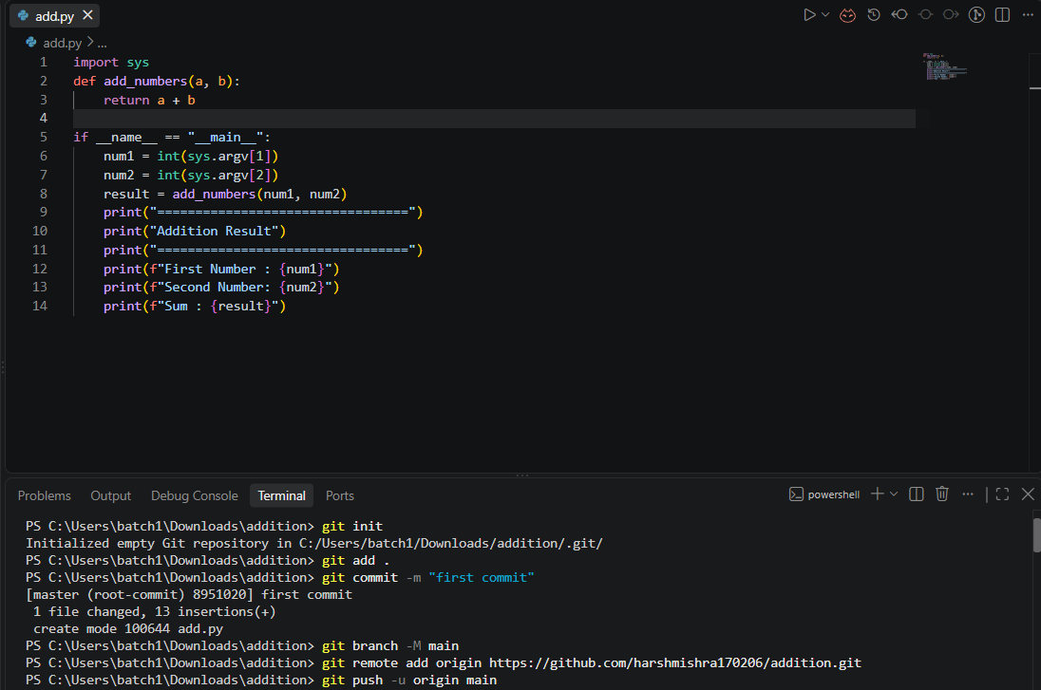

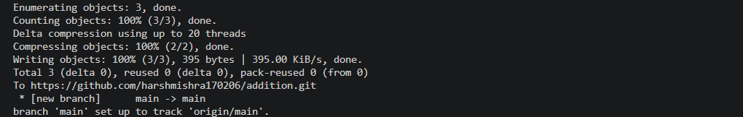

GITHUB SCREENSHOT:

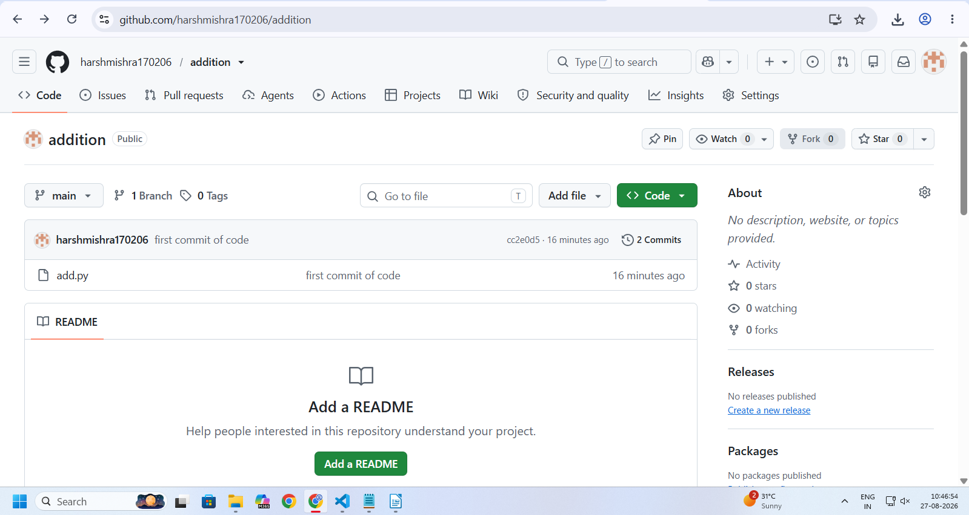

JENKINS PROJECT CREATION:
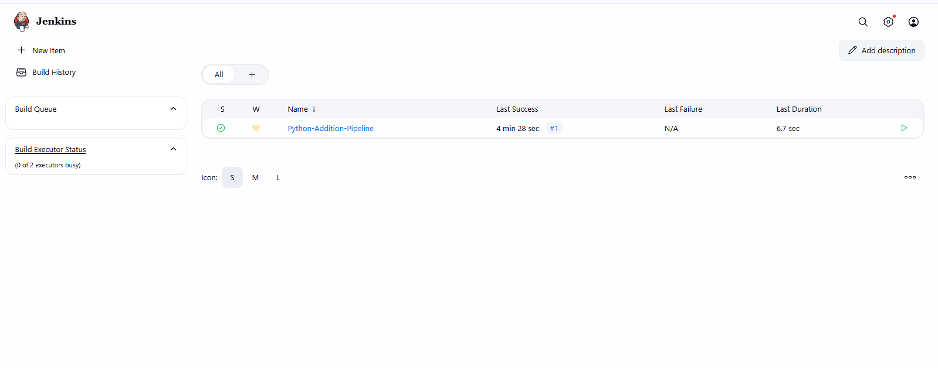
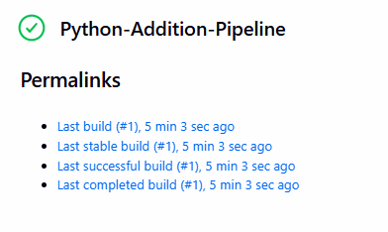

JENKINS SCRIPT GENERATOR:
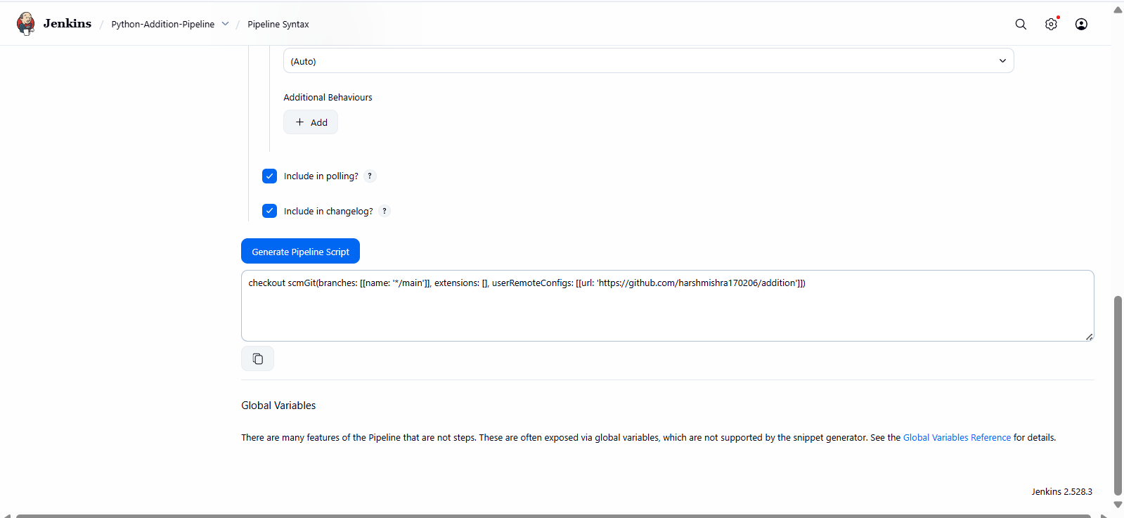

SCRIPT:
pipeline {
agent any
parameters {
string(name: 'BRANCH_NAME',
defaultValue: 'main',
description: 'Git branch')
string(name: 'NUM1',
defaultValue: '10',
description: 'First Number')
string(name: 'NUM2',
defaultValue: '20',
description: 'Second Number')
}
stages {
stage('Checkout') {
steps {
checkout scmGit(branches: [[name: '*/main']], extensions: [], userRemoteConfigs: [[url: 'https://github.com/harshmishra170206/addition']])
}
}
stage('Addition Build') {
steps {
bat "python add.py ${params.NUM1} ${params.NUM2}"
}
}
}
}

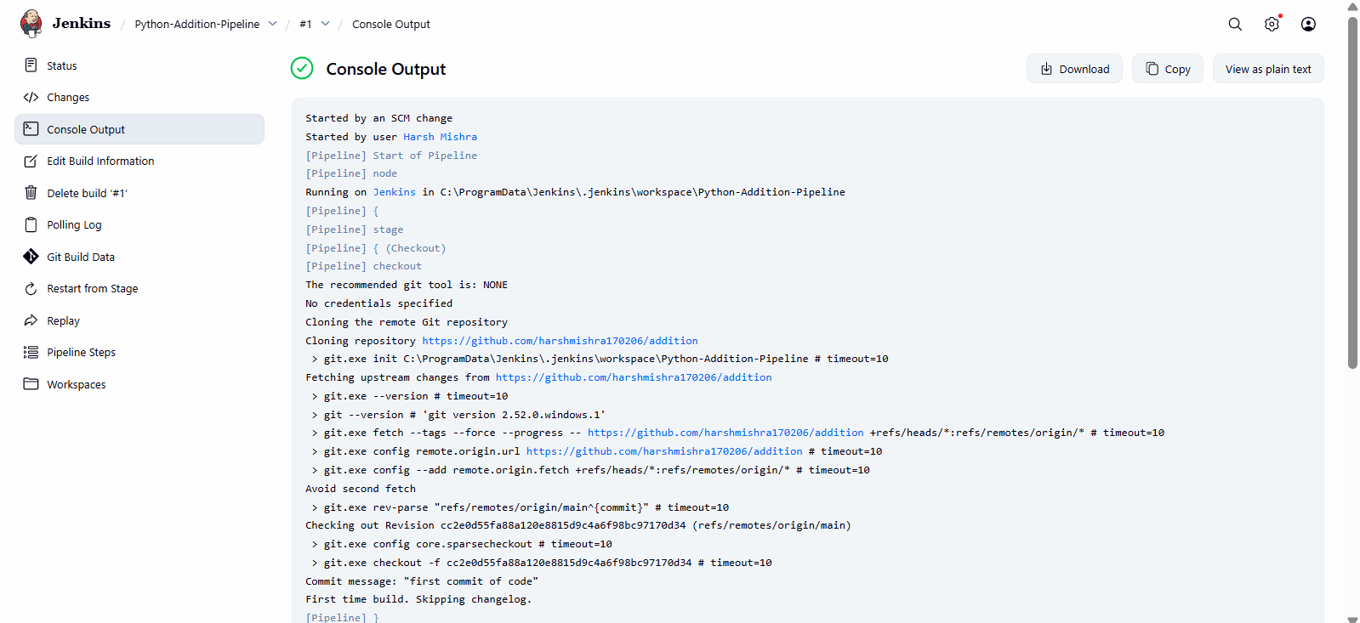
JENKINS CONSOLE OUTPUT:

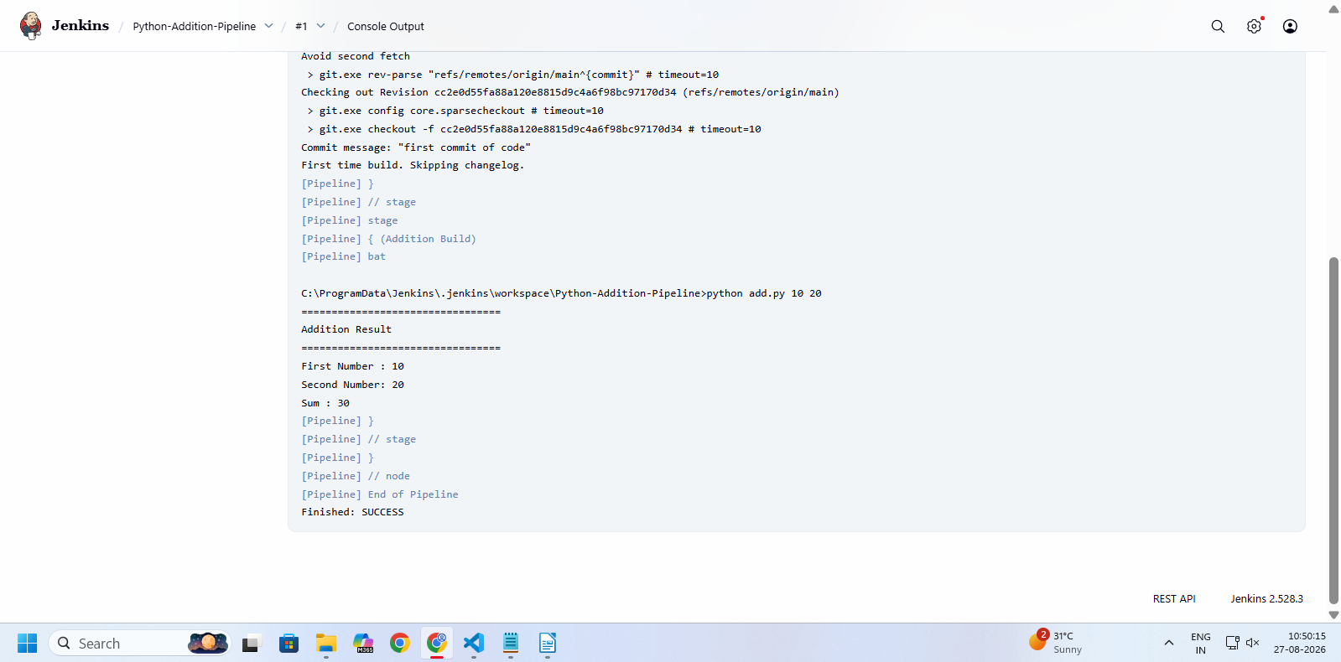

TASK 1:

USING SCRIPT GENERATOR:
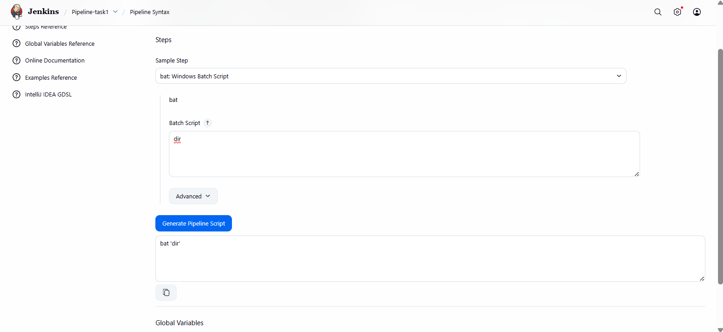

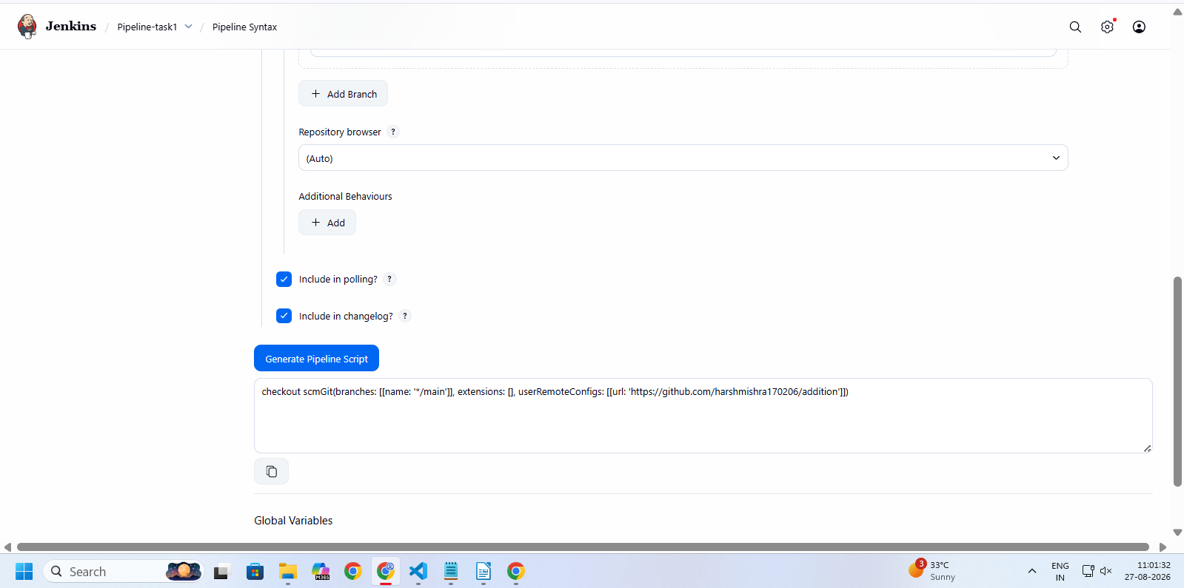

SCRIPT:

pipeline {
agent any
stages {
stage('Checkout Code') {
steps {
checkout scmGit(branches: [[name: '*/main']], extensions: [], userRemoteConfigs: [[url: 'https://github.com/harshmishra170206/addition']])
}
}
stage('Show Files') {
steps {
bat 'dir'
}
}
}
}

JENKINS CONSOLE OUTPUT:

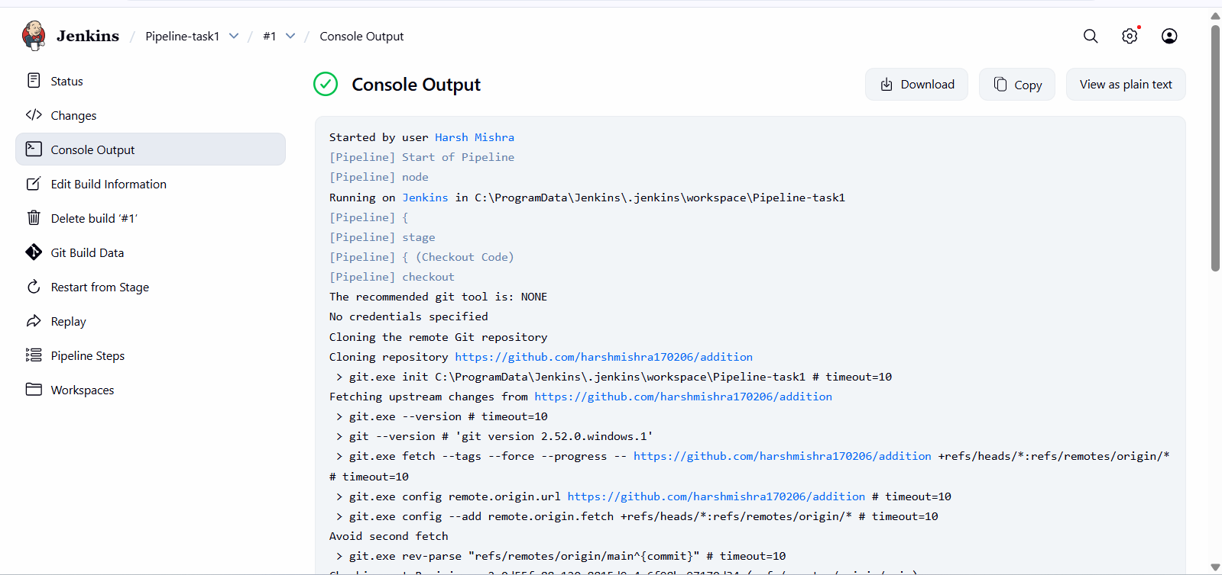
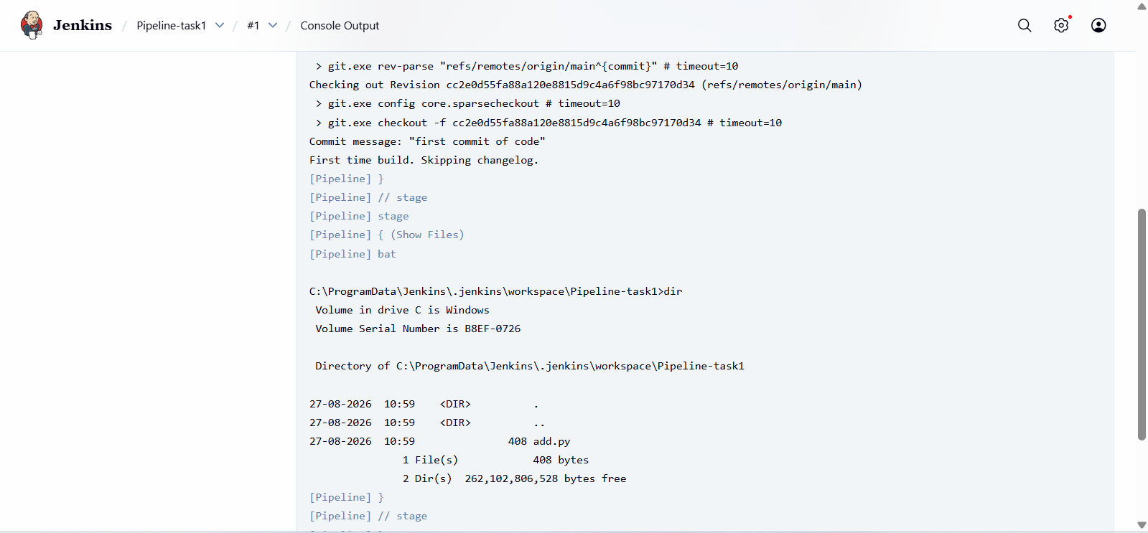

TASK 2:

USING SCRIPT GENERATOR:
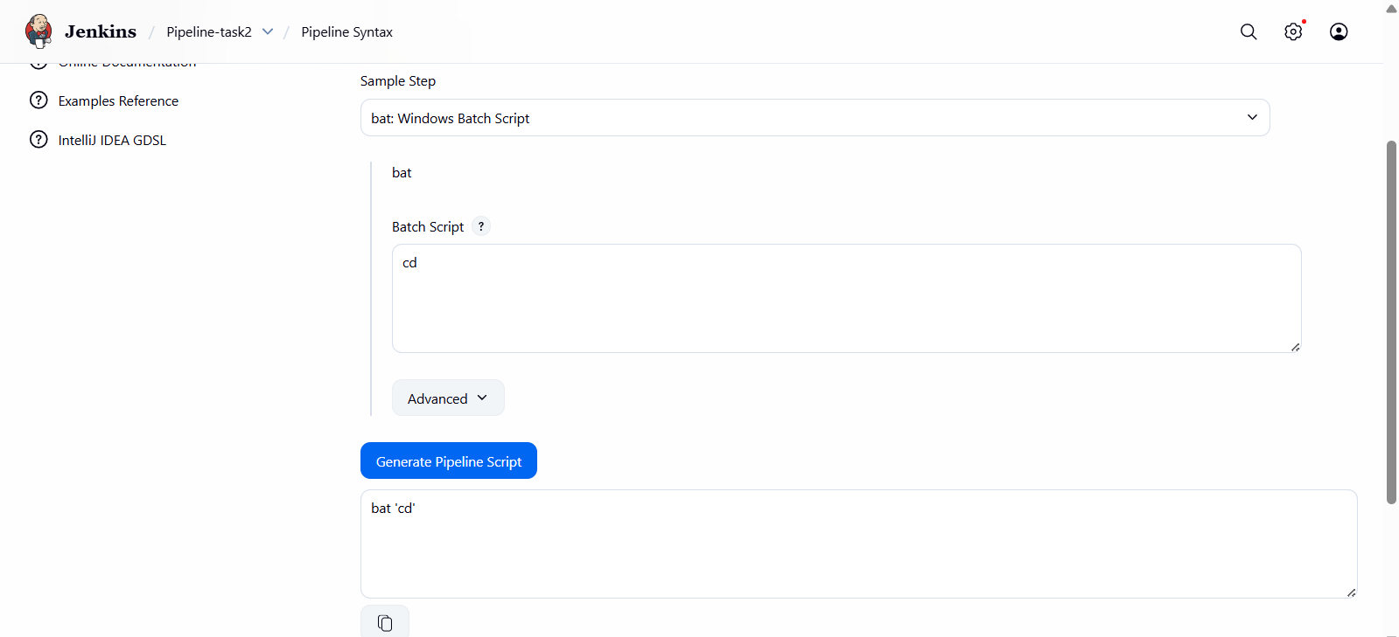



SCRIPT:
pipeline {
agent any
stages {
stage('Checkout Code') {
steps {
checkout scmGit(branches: [[name: '*/main']], extensions: [], userRemoteConfigs: [[url: 'https://github.com/harshmishra170206/addition']])

}
}
stage('Print Directory') {
steps {
bat 'cd'
}
}
}
}

JENKINS CONSOLE OUTPUT:
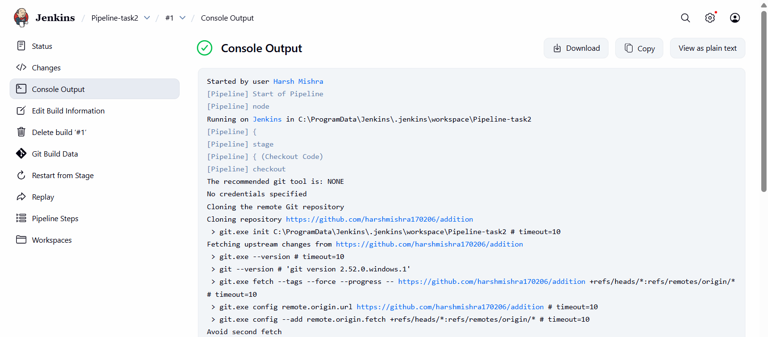

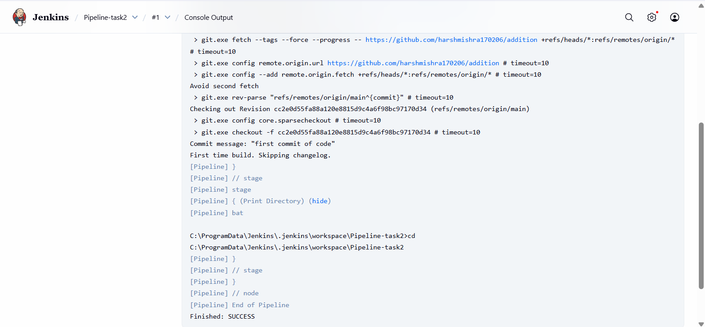

TASK 3:
USING SCRIPT GENERATOR:
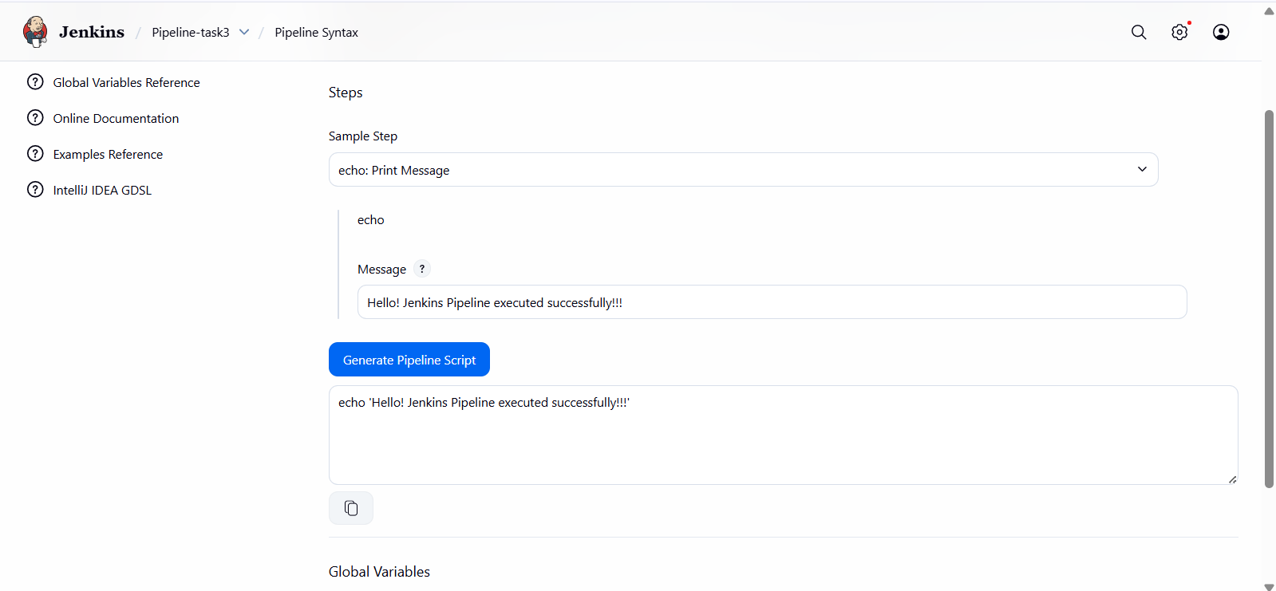



SCRIPT:
pipeline {
agent any
stages {
stage('Checkout Code') {
steps {
checkout scmGit(branches: [[name: '*/main']], extensions: [], userRemoteConfigs: [[url: 'https://github.com/harshmishra170206/addition']])

}
}
stage('Print Message') {
steps {
echo 'Hello! Jenkins Pipeline executed successfully'
}
}
}
}

JENKINS CONSOLE OUTPUT:
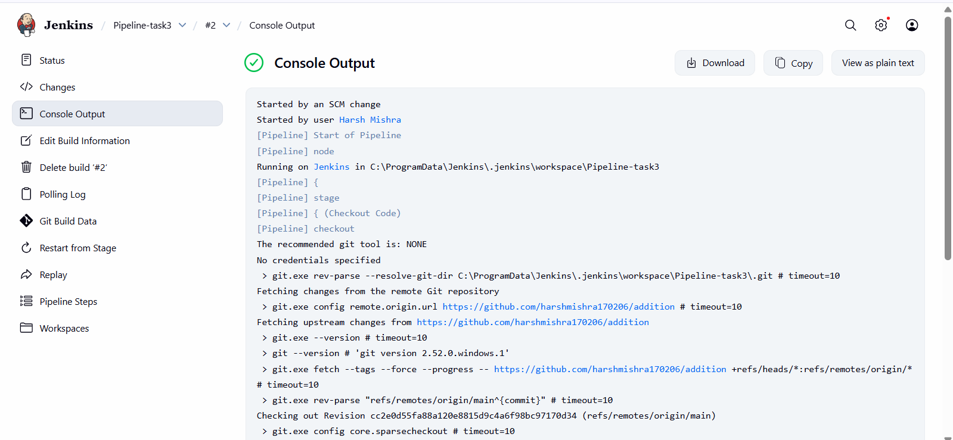
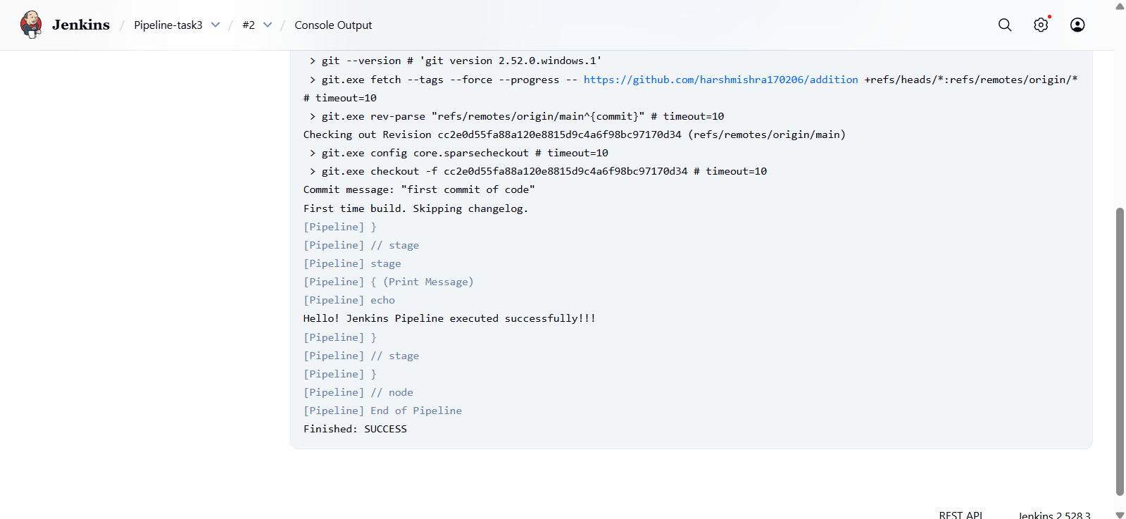

TASK 5:

USING SCRIPT GENERATOR:
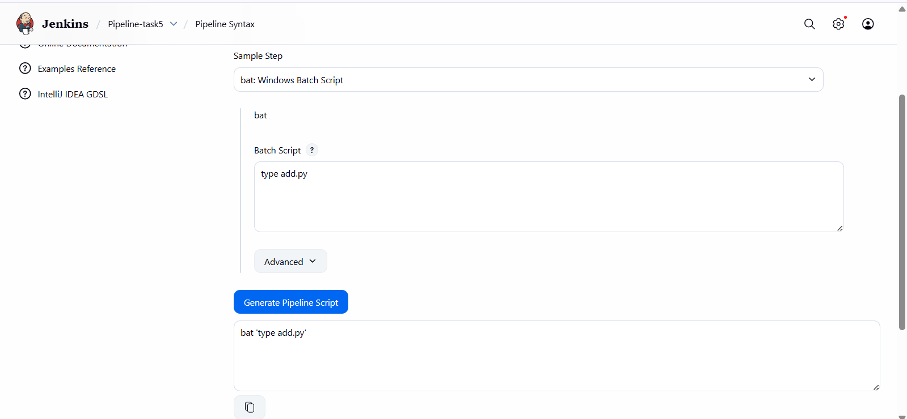


SCRIPT:
pipeline {
agent any
stages {
stage('Checkout Code') {
steps {
checkout scmGit(branches: [[name: '*/main']], extensions: [], userRemoteConfigs: [[url: 'https://github.com/harshmishra170206/addition']])
}
}
stage('Read File') {
steps {
bat 'type add.py'
}
}
}
}
JENKINS CONSOLE OUTPUT:
