NAME : HARSH MISHRA
REG NO: 24MIS0206
GIT BRANCHING PRACTICE

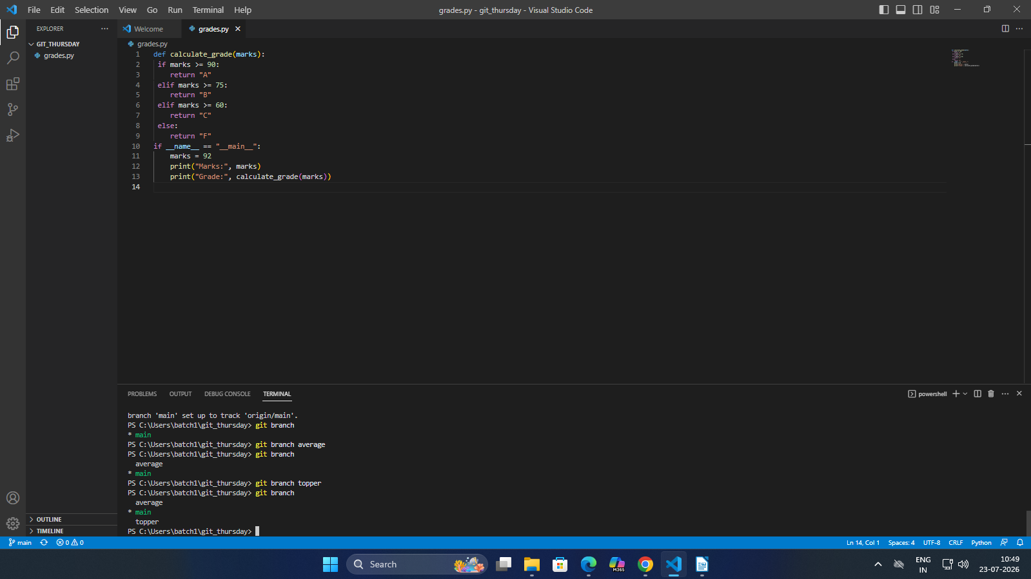

added two branches

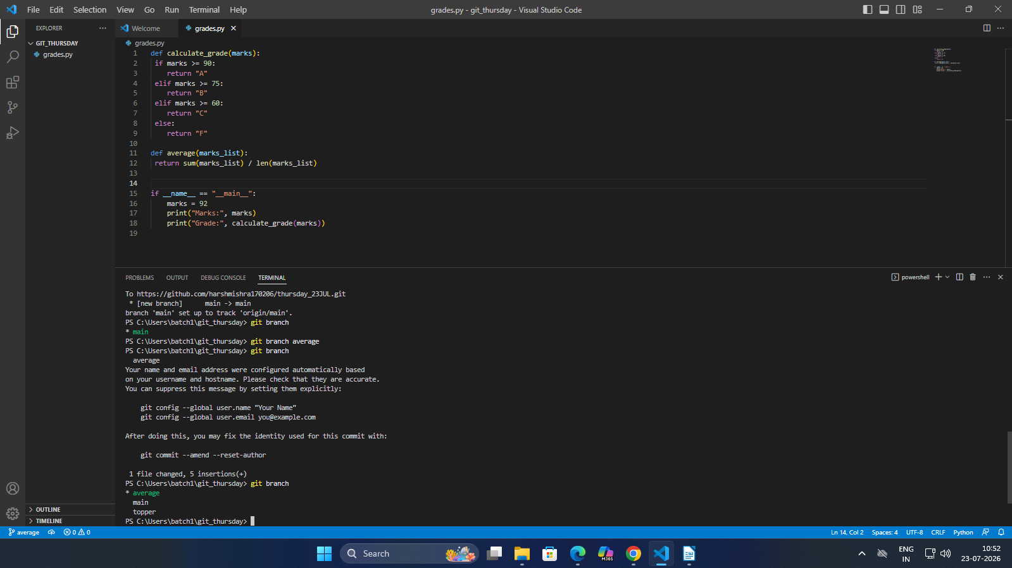

added average function in average branch

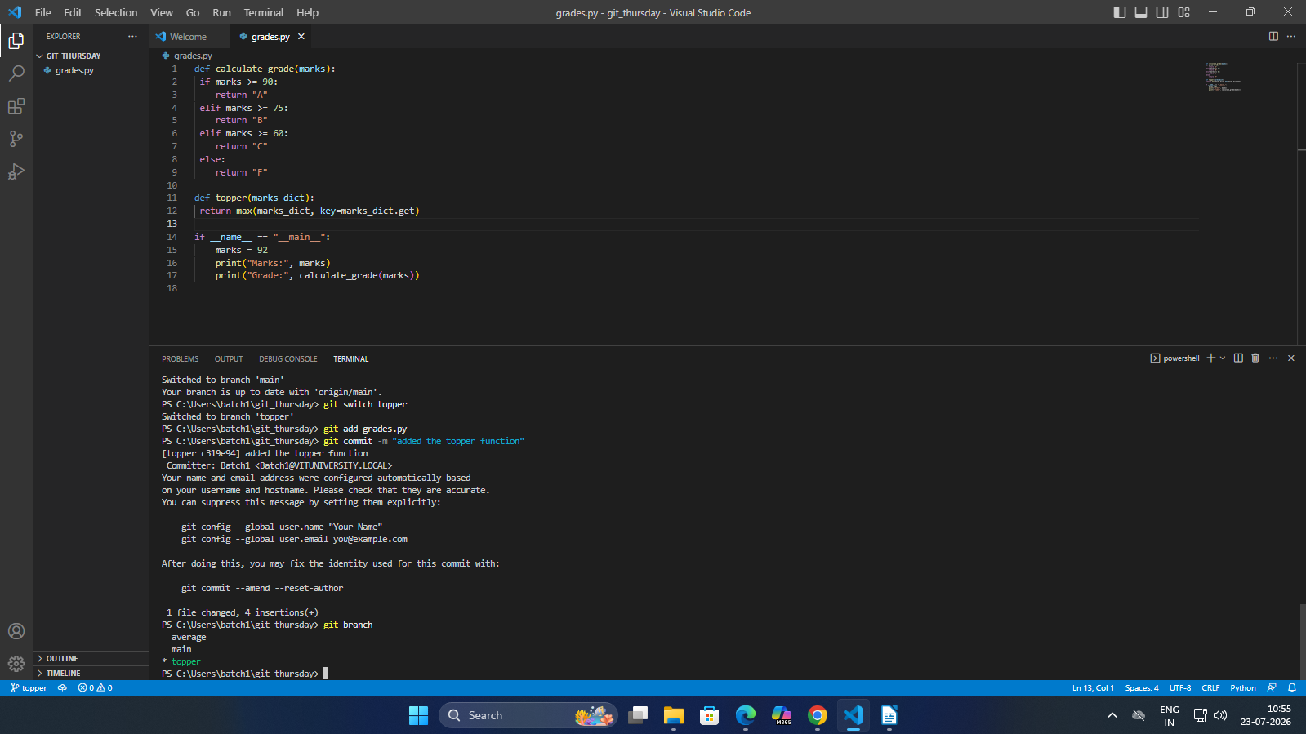

added the function to the topper branch and added

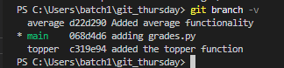

seeing the branch log history
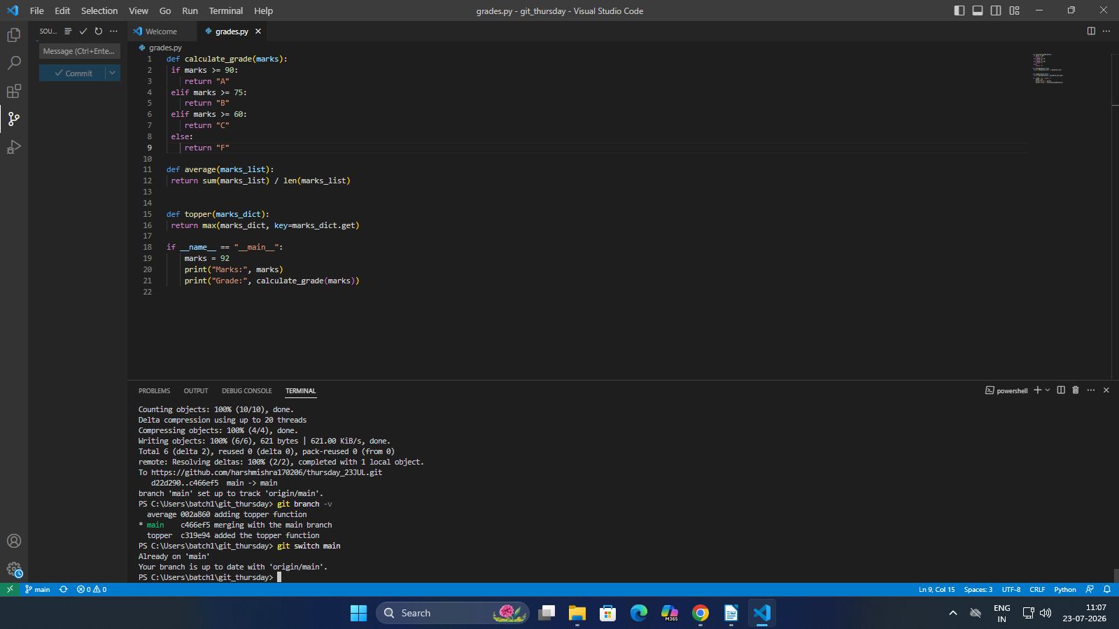

main branch after merging the two branches average and topper
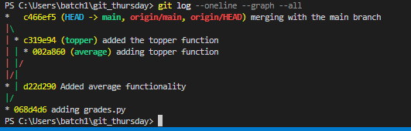

visualizing the branch history

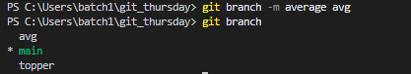

renaming the branch average to avg

